look at this from an historical perspective, we have seen a great expansion of technologies in recent years that give increasing power to the end user. The move towards more interactive communications media and away from broadcast media then has profound implications for education (as for society at large).

However, technologies are becoming more complex, and able to serve a wide range of functions. In particular the Internet is not so much a single medium as an integrating framework for many different media and technologies with different and often opposite characteristics.

#### 7.5.3 Applying the dimension to educational media

In Figure 7.5.2, I have placed some common technologies, classroom media and online media along the broadcast/interactive communications continuum.

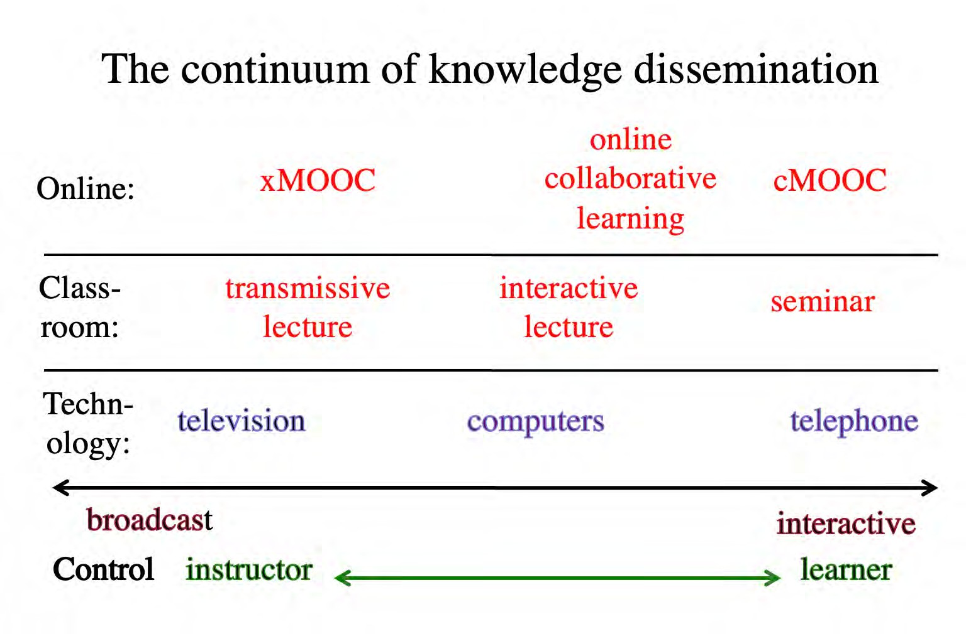

*Figure 7.5.2 The broadcast interactive communication dimension*

When doing this exercise, it is important to note that:

* there is no general normative or evaluative judgement about the continuum. Broadcasting is an excellent way of getting information in a consistent form to a large number of people; interactive communication works well when all members of a group have something equal to contribute to the process of knowledge development and dissemination. The judgement of the appropriateness of the medium or technology will very much depend on the context, and in particular the resources available and the general philosophy of teaching to be applied;
* where a particular medium or technology is placed on the continuum will depend to some extent on the actual design, use or application. For instance, if the lecturer talks for 45 minutes and allows 10 minutes for discussion, an interactive

lecture might be further towards broadcasting than if the lecture session is more of a question and answer session;

* I have placed ‘computers’ in the middle of the continuum. They can be used as a broadcast medium, such as for transmitting content, or they can be used interactively, such as for online discussion. Their actual placement on the continuum therefore will depend on how we choose to use computers in education;
* the important decision from a teaching perspective is deciding on the desired balance between ‘broadcasting’ and ‘discussion’ or interaction. That should then be one factor in driving decisions about the choice of appropriate technologies;
* the continuum is a heuristic device to enable a teacher to think about what medium or technology will be most appropriate within any given context, and not a firm analysis of where different types of educational media or technology belong on the continuum.

Thus where a medium or technology ‘fits’ best on a continuum of broadcast vs interaction is one factor to be considered when making decisions about media or technology for teaching and learning.

#### 7.5.4 The significance of the Internet

Broadcast/interactive and synchronous/asynchronous are two separate dimensions. By placing them in a matrix design, we can then assign different technologies to different quadrants, as in Figure 7.5.3 below. (I have included only a few – you may want to place other technologies on this diagram):

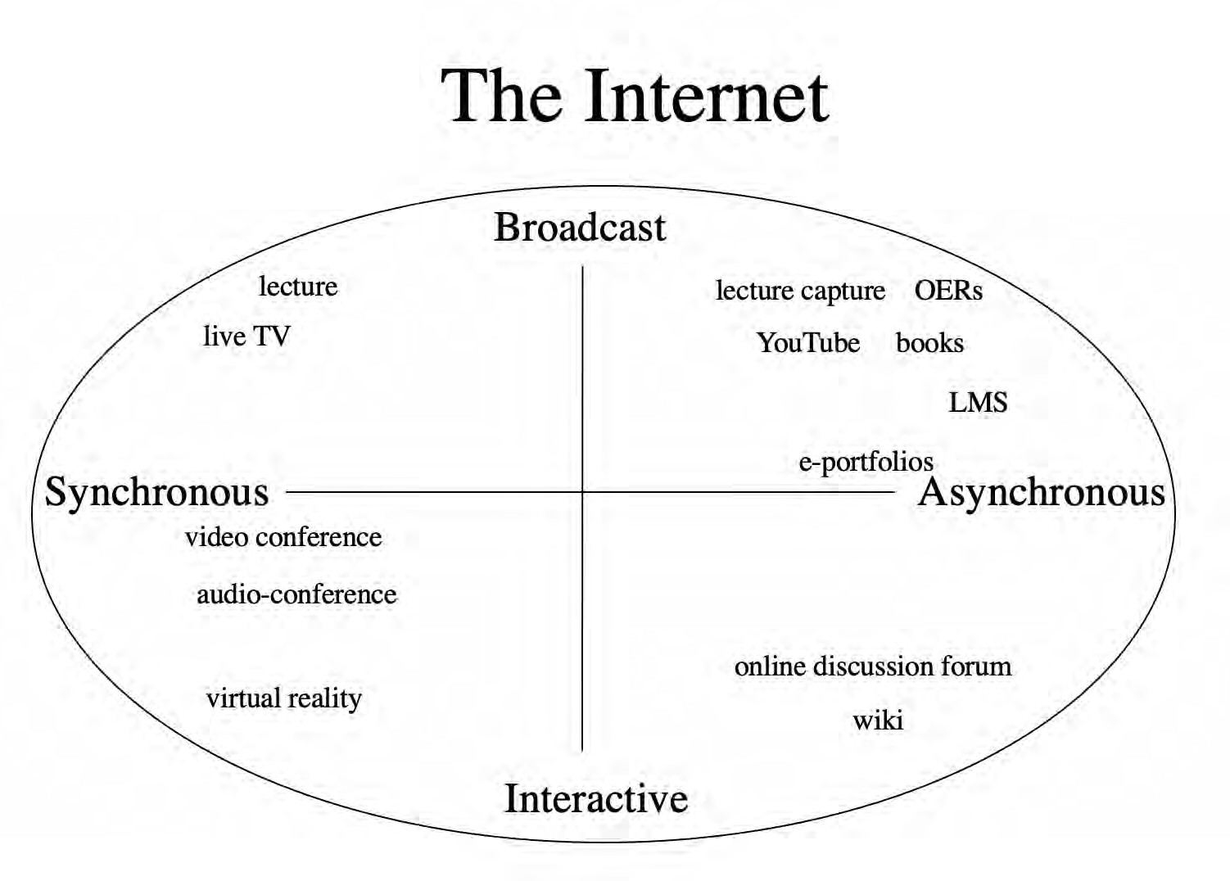

*Figure 7.5.3 How the Internet integrates media*

Why the Internet is so important is that it is an encompassing medium that embraces all these other media and technologies, thus offering immense possibilities for teaching and learning. This enables us, if we wish, to be very specific about how we design our teaching, so that we can exploit all the characteristics or dimensions of technology to fit almost any learning context through this one medium.

From the list below:

* a blog
* online collaborative learning
* Twitter
* virtual worlds
* a podcast
* an open textbook

1. Determine which is a medium and which a technology, or which could be both, and under what conditions.
2. Decide where, from your experience, each medium or technology should be placed on Figure 7.5.3. Write down why.
3. Which were easy to categorize and which difficult?
4. How useful is this continuum in making decisions about which medium or technology to use in your teaching? What would help you to decide?

My analysis can be accessed by clicking here.

*Activity 7.5 Broadcast or interactive?*

# Media richness

[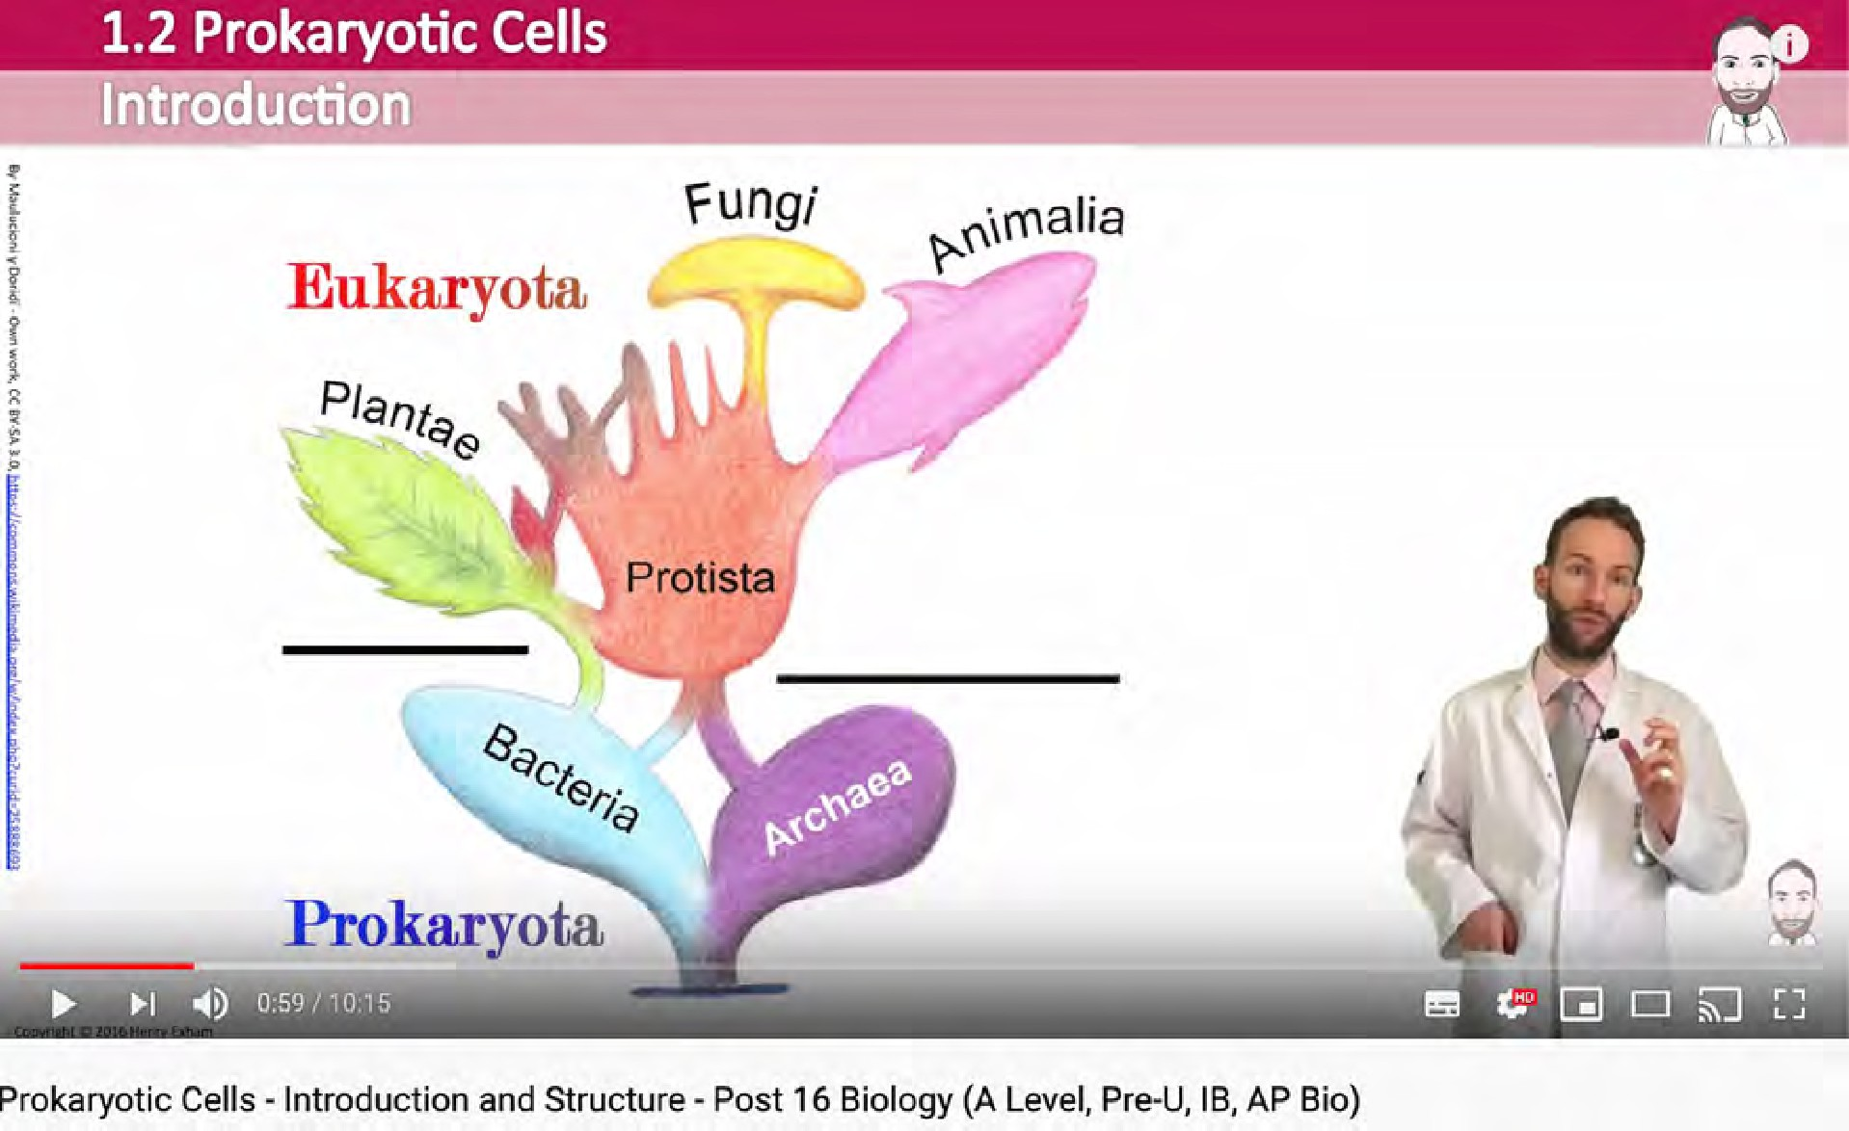](https://www.youtube.com/watch?v=LYgpHNiyLKM)

*Figure 7.7.1 Making sense of biology. Click on the image to see a good example of rich media in use. Image: Mr Exham.com*

#### The historical development of media richness

In Section 7.2, ‘A short history of educational technology’, the development of different media in education was outlined, beginning with oral teaching and learning, moving on to written or textual communication, then to video, and finally computing. Each of these means of communication has usually been accompanied by an increase in the richness of the medium, in terms of how many senses and interpretative abilities are needed to process information.

Another way of defining the richness of media is by the symbol systems employed to communicate through the medium. Thus textual material from an early stage incorporated graphics and drawings as well as words. Television or video incorporates audio as well as still and moving images. Computing now can incorporate text, audio, video, animations, simulations, computing, and networking, all through the Internet.

#### The continuum of media richness

**[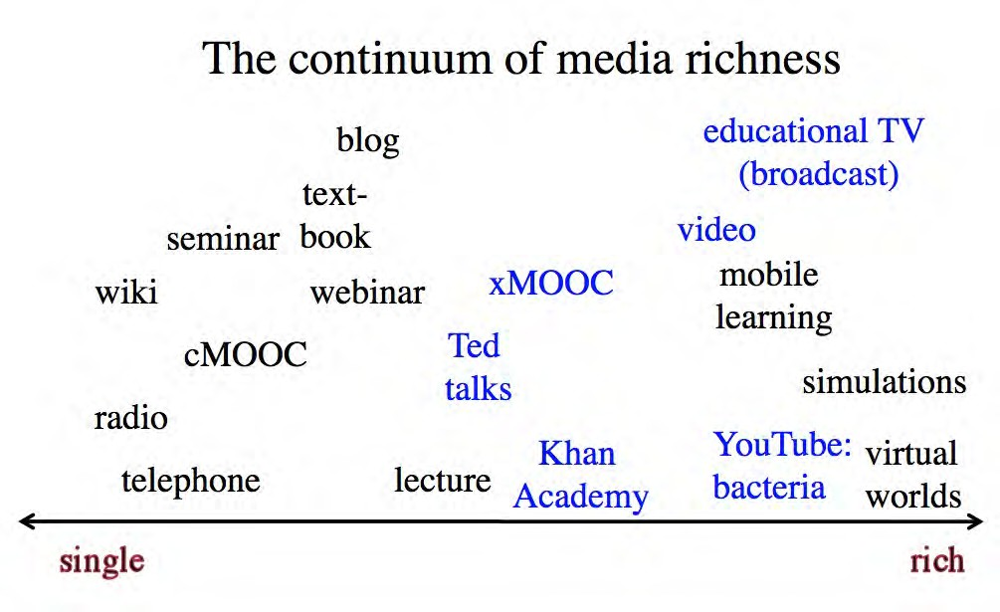](http://opentextbc.ca/teachinginadigitalage/wp-content/uploads/sites/29/2015/03/Media-richness-2.jpg)**

*Figure 7.7.2 The continuum of media richness*

Once again then there is a continuum in terms of media richness, as illustrated in Figure

7.7.2 above. Also once again, design of a particular medium can influence where on the continuum it would be placed. For instance in Figure 7.7.2, different forms of teaching using video are represented in blue. Ted Talks, a televised lecture, and often xMOOCs are usually mainly talking heads. The Khan Academy uses dynamic graphics as well as voice over commentary, and MrExham’s [YouTube video on prokaryotic cells](https://www.youtube.com/watch?v=LYgpHNiyLKM) uses colour

graphics and animation as well as a ‘talking head’ commentary. Educational television broadcasts are likely to use an even wider range of video techniques.

However, although the richness of video can be increased or decreased by the way it is used, video is always going to be richer in media terms than radio or textbooks. Radio is never going to be a rich medium in terms of its symbols systems because it depends on a single medium, audio, and even talking head video is richer symbolically than radio.

There is no normative or evaluative judgment here. Radio can be ‘rich’ in the sense of fully exploiting the characteristics or symbol systems of the medium. A well produced radio program is more likely to be educationally effective than a badly produced video. But in terms of representation of knowledge, the possibilities of radio in terms of media richness will always be less than the possibilities of video.

#### The educational value of media richness

But how rich should media be for teaching and learning? From a teaching perspective, rich media have advantages over a single medium of communication, because rich media enable the teacher to do more. For example, many activities that previously required learners to be present at a particular time and place to observe processes or procedures such as demonstrating mathematical reasoning, experiments, medical procedures, or stripping a carburetor, can now be recorded and made available to learners to view at any time. Sometimes, phenomena that are too expensive or too difficult to show in a classroom can be shown through animation, simulations, video recordings or virtual reality.

Furthermore, each learner can get the same view as all the other learners, and can view the process many times until they have mastery. Good preparation before recording can ensure that the processes are demonstrated correctly and clearly. The combination of voice over video enables learning through multiple senses. Even simple combinations, such as the use of audio over a sequence of still frames in a text, have been found more effective than learning through a single medium of communication (see for instance, Durbridge, [1984](https://www.taylorfrancis.com/books/e/9781315738598)). The Khan Academy videos have exploited very effectively the power of audio combined with dynamic graphics. Computing adds another element of richness, in the ability to network learners or to respond to learner input.

From a learner’s perspective, though, some caution is needed with rich media. Two particularly important concepts are cognitive overload and Vygotsky’s Zone of Proximal Development. Cognitive overload results when students are presented with too much information at too complex a level or too quickly for them to properly absorb it (Sweller, [1988](https://www.sciencedirect.com/science/article/abs/pii/0364021388900237)). Vygotsky’s Zone of Proximal Development or ZPD (Vygotsky, [1934](https://www.springer.com/gp/book/9780306424410)) is the difference between what a learner can do without help and what can be done with help. Rich media may contain a great deal of information compressed into a very short time period and its value will depend to a large extent on the learner’s level of preparation for interpreting it.

For instance, a documentary video may be valuable for demonstrating the complexity of human behaviour or complex industrial systems, but learners may need either preparation in terms of what to look for, or to identify concepts or principles that may be illustrated within the documentary. On the other hand, interpretation of rich media is a skill that can be explicitly taught through demonstration and examples (Bates and Gallagher, 1977). Although YouTube videos are limited in length to around eight minutes mainly for technical reasons, they are also more easily absorbed than a continuous video of 50 minutes. Thus again design is important for helping learners to make full educational use of rich media.

#### Simple or rich media?

It is a natural tendency when choosing media for teaching to opt for the ‘richest’ or most powerful medium. Why would I use a podcast rather than a video? There are in fact several reasons:

* + - * cost and ease of use: it may just be quicker and simpler to use a podcast, especially if it can achieve the same learning objective;
      * there may be too many distractions in a rich medium for students to grasp the essential point of the teaching. For instance, video recording a busy intersection to look at traffic flow may include all kinds of distractions for the viewer from the actual observation of traffic patterns. A simple diagram or an animation that focuses only on the phenomenon to be observed might be better;
      * the rich medium may be inappropriate for the learning task. For instance, if students are to follow and critique a particular argument or chain of reasoning, text may work

better than a video of a lecturer with annoying mannerisms talking about the chain of reasoning.

In general, it is tempting always to look for the simplest medium first then only opt for a more complex or richer medium if the simple medium can’t deliver the learning goals as adequately. However, consideration needs to be given to media richness as a criterion when making choices about media or technology, because rich media may enable learning goals to be achieved that would be difficult with a simple medium.

This is the last of the characteristics of media and technology that can influence decisions about teaching and learning. The next section will provide an overview and summary.

#### References

Bates, A. and Gallagher, M. (1977) *Improving the Effectiveness of Open University Television Case-Studies and Documentaries* Milton Keynes: The Open University I.E.T. Papers on Broadcasting, No. 77 (out of print – copies available from [tony.bates@ubc.ca).](mailto:tony.bates@ubc.ca)

Durbridge, N. (1984) Audio cassettes, in Bates, A. (ed.) [*The Role of Technology in Distance*](https://www.taylorfrancis.com/books/e/9781315738598)[*Education*](https://www.taylorfrancis.com/books/e/9781315738598)London: Routledge (re-published in 2014)

Sweller, J. (1988) [Cognitive load during problem solving: effects on learning](https://onlinelibrary.wiley.com/doi/abs/10.1207/s15516709cog1202_4), *Cognitive Science*, Vol. 12

Vygotsky, L.S. (1987). Thinking and speech, in R.W. Rieber & A.S. Carton (eds.), [*The collected*](https://www.springer.com/gp/book/9780306424410)[*works of L.S. Vygotsky, Volume 1: Problems of general psychology (pp. 39–285)*](https://www.springer.com/gp/book/9780306424410). New York: Plenum Press. (Original work published 1934.)

1. What media are you using at the moment for teaching? Where would you place these on the ‘richness’ continuum? What benefits might there be to your teaching in changing your media to either increase or decrease the richness of media you are using?
2. Do you agree that: ‘*it is a useful guideline always to look for the simplest medium first*‘.
3. How important do you think the richness of medium is when making decisions about the use of media

*Activity 7.7 How rich is your medium?*

and technology?

4. Do you agree with the placement of different media on this continuum in Figure 7.7.2. If not, why not?

I provide no feedback for this activity.

# Understanding the foundations of educational media

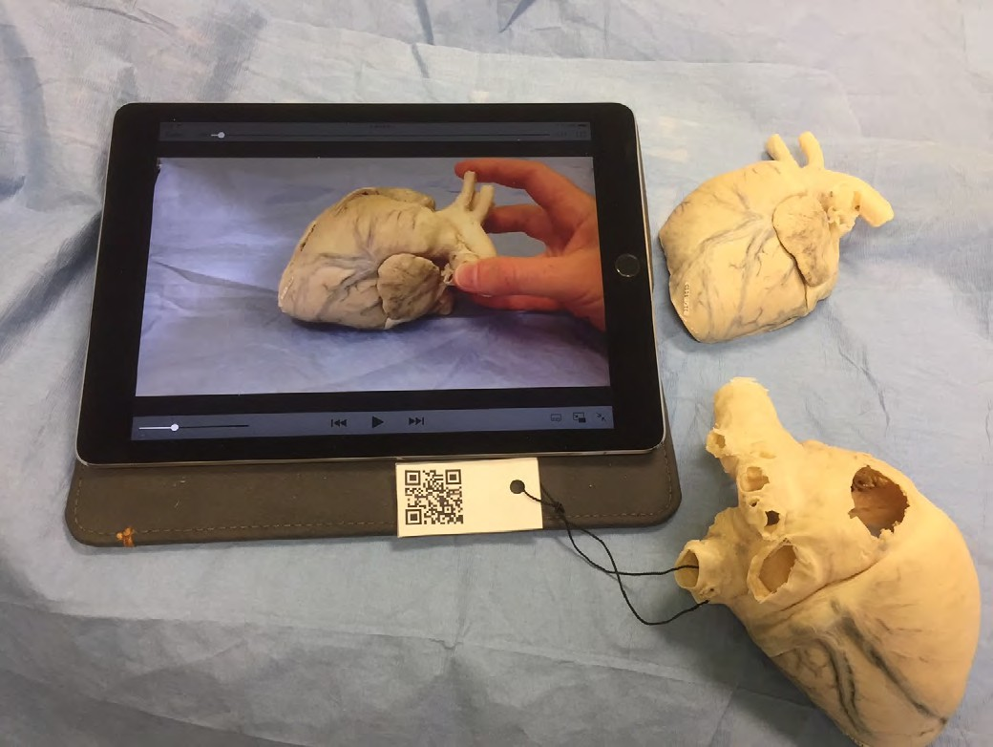

*Figure 7.8 Video explanation of a (plastinated) dog’s heart: note the QR code which enables students to access the video from their own phones or tablets. Image: Dr. Sue Dawson, University of Prince Edward Island*

I am aware that this chapter may appear somewhat abstract and theoretical, but in any subject domain, it is important to understand the foundations that underpin practice. This applies with even more force to understanding media and technology in education,

because it is such a dynamic field that changes all the time. What seem to be the major media developments this year are likely to be eclipsed by new developments in technology next year. In such a shifting sea, it is therefore necessary to look at some guiding concepts or principles that are likely to remain constant, whatever changes take place over the years.

So in summary here are the main points that I have been emphasising throughout this chapter.

###### Key Takeaways

1. Technologies are merely tools that can be used in a variety of ways. What matters more is how technologies are applied. The same technology can be applied in different ways, even or especially in education. So in judging the value of a technology, we need to look more closely at the ways in which it is being or could be used. In essence this means focusing more on media – which represent the more holistic use of technologies – than on individual tools or technologies themselves, while still recognising that technology is an essential component of almost all media.
2. By focusing on media rather than technologies, we can then include face-to-face teaching as a medium, enabling comparisons with more technology-based media to be made along a number of dimensions or characteristics.
3. Recognising that in education media are usually used in combination, the six key building blocks of media are:
   1. face-to-face teaching
   2. text
   3. (still) graphics
   4. audio (including speech)
   5. video
   6. computing (including animation, simulations and virtual reality)
4. Media differ in terms of their formats, symbols systems, and cultural values. These unique features are increasingly referred to as the affordances of media or technology. Thus different media can be used to assist learners to learn in different ways and achieve different outcomes, thus also individualising learning more.
5. There are many dimensions along which some technologies are similar and others are different. By focusing on these dimensions, we have a basis for analysing new media and technologies, to see where they ‘fit’ within the existing landscape, and to evaluate their potential benefits or limitations for teaching and learning.
6. There are probably other characteristics or dimensions of educational media that might also be identified, but I believe these three key characteristics or dimensions to be the most important:
   1. synchronous (live) vs asynchronous (recorded)
   2. broadcast vs interactive

3. single vs rich media

1. However, the identification of where a particular medium fits along any specific characteristic or dimension will depend in most cases on how that medium is designed. At the same time, there is usually a limit to how far a technology can be forced along one of these dimensions; there is likely to be a single, ‘natural’ position on each dimension, subject to good design, in terms of exploiting the educational affordances of the medium.
2. These characteristics or dimensions of media then need to be evaluated against the learning goals and outcomes desired, while recognising that a new educational medium or application might enable goals to be achieved that had not been previously considered possible.
3. Over time, media have tended to become more interactive, asynchronous, and ‘rich’, thus offering teachers and learners more powerful tools for teaching and learning.
4. The Internet is an extremely powerful medium because through a combination of tools and media it can encompass all the characteristics and dimensions of educational media.
5. Take one of the courses you are teaching at the moment. How could you make your teaching more interactive, asynchronous, and rich in media? What media or technologies would help you do this?
6. Write down what you would see as (a) the advantages (b) the disadvantages of changing your teaching in this way.
7. Do you think applying the three dimensions described here will be useful when deciding whether or not to use a new technology? If not, why not?

The next chapter should provide more feedback on your answers.

*Activity 7.8 Analysing your current use of technology*

## CHAPTER 8: PEDAGOGICAL DIFFERENCES BETWEEN MEDIA

1. To identify the main pedagogical characteristics of the following media:
   * text;
   * audio;
   * video;
   * computing.

(Chapter 9 explores the potential and limitations of new, emerging technologies.)

1. To provide a framework of analysis for determining appropriate pedagogical roles for different media.
2. To enable you to apply that analysis to any particular module of teaching

*Purpose of the chapter*

#### What is covered in this chapter

* 8.1 Thinking about the pedagogical differences of media
* 8.2 Text
* 8.3 Audio
* 8.4 Video
* 8.5 Computing
* 8.6 A framework for analysing the pedagogical characteristics of educational media

Also in this chapter you will find the following activities:

* Activity 8.1 Thinking about the pedagogical differences between media
* Activity 8.2 Identifying the unique pedagogical characteristics of text
* Activity 8.3 Identifying the unique pedagogical characteristics of audio
* Activity 8.4 Identifying the unique pedagogical characteristics of video
* Activity 8.5 Identifying the unique pedagogical characteristics of computing
* Activity 8.6 Choosing media for a teaching module

###### Key Takeaways

There is a very wide range of media available for teaching and learning. In particular:

* + text, audio, video, computing and social media all have unique characteristics that make them useful for teaching and learning;
  + the choice or combination of media will need to be determined by:
    - the overall teaching philosophy behind the teaching;
    - the presentational and structural requirements of the subject matter or content;
    - the skills that need to be developed in learners;
    - and not least by the imagination of the teacher or instructor (and increasingly learners themselves) in identifying possible roles for different media;
  + learners now have powerful tools through social media for creating their own learning materials or for demonstrating their knowledge;
  + courses can be structured around individual students’ interests, allowing them to seek appropriate content and resources to support the development of negotiated competencies or learning outcomes;.
  + content is now increasingly open and freely available over the Internet; as a result learners can seek, use and apply information beyond the bounds of what a professor or teacher may dictate;
  + students can create their own online personal learning environments;
  + many students will still need a structured approach that guides their learning;
  + teacher presence and guidance is likely to be necessary to ensure high quality learning via social media;
  + teachers need to find the middle ground between complete learner freedom and over-direction to enable learners to develop the key skills needed in a digital age.

# Thinking about the pedagogical differences of media

[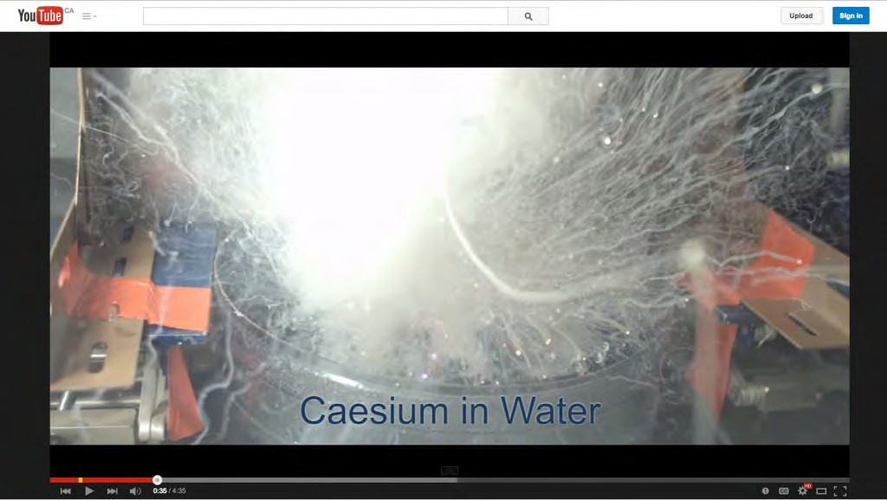](https://www.youtube.com/watch?v=5I4rxfnCtxY&list=PL9eEsN9D48mf4GGDAn1_zr-rmXv_Wmjuz&index=3)

*Figure 8.1.1 Is slow motion a unique characteristic of video and film? Image: Pouring mercury into liquid nitrogen: University of Nottingham Click on image to see video*

#### Identifying the pedagogical differences between media

In the last chapter, I identified three core dimensions of media and technology along which any technology can be placed. In the next two chapters, I will discuss a method for deciding which media to use when teaching. In this chapter I will focus primarily on the pedagogical differences between media. In the following chapter I will provide a model or set of criteria to use when making decisions about media and technology for teaching.

#### First steps

Embedded within any decision about the use of technology in education and training will be assumptions about the learning process. We have already seen earlier in this book how different epistemological positions and theories of learning affect the design of teaching, and these influences will also determine a teacher’s or an instructor’s choice of appropriate media. Thus, the first step is to decide what and how you want to teach.

This has been covered in depth through Chapters 2-5, but in summary, there are five critical questions that need to be asked about teaching and learning in order to select and use appropriate media/technologies:

* what is my underlying epistemological position about knowledge and teaching?
* what are the desired learning outcomes from the teaching?
* what teaching methods will be employed to facilitate the learning outcomes?
* what are the unique educational characteristics of each medium/technology, and how well do these match the learning and teaching requirements?
* what resources are available?

This chapter focuses on the fourth of these questions, but they are best not asked sequentially, but in a cyclical or iterative manner, as media affordances may suggest alternative teaching methods or even the possibility of learning outcomes that had not been initially considered. When the unique pedagogical characteristics of different media are considered, this may lead to some changes in what content will be covered and what skills will be developed. Therefore, at this stage, decisions on content and learning outcomes should still be tentative.

#### Identifying the unique educational characteristics of a medium

Different media have different potential or ‘affordances’ for different types of learning. One of the arts of teaching is often finding the best match between media and desired learning outcomes. Before exploring this relationship, I will give a brief summary of the substantial amount of excellent past research on this topic (see, for instance, Trenaman,

[1967](https://www.amazon.com/Communication-comprehension-J-M-Trenaman/dp/B0000CNO5B); Olson and Bruner, 1974; Schramm, [1977](https://www.abebooks.co.uk/book-search/title/big-media-little-media/author/schramm/); Salomon, [1979](https://www.amazon.com/Interaction-Media-Cognition-Learning-Exploration/dp/0805815457), 1981; Clark, [1983](https://journals.sagepub.com/doi/10.3102/00346543053004445); Bates, [1984](https://www.amazon.com/Broadcasting-Education-Evaluation-Media-Studies/dp/009463680X);

Koumi, [2006](https://www.routledge.com/Designing-Video-and-Multimedia-for-Open-and-Flexible-Learning-1st-Edition/Koumi/p/book/9780415383035); Berk, [2009](https://www.researchgate.net/publication/228349436_Multimedia_Teaching_with_Video_Clips_TV_Movies_YouTube_and_mtvU_in_the_College_Classroom); Mayer, [2020](https://www.cambridge.org/highereducation/books/multimedia-learning/FB7E79A165D24D47CEACEB4D2C426ECD#overview)).

This research has indicated that there are three core elements that need to be considered when deciding what media to use:

* content;
* content structure;
* skills.

Olson and Bruner (1974) claim that learning involves two distinct aspects: acquiring knowledge of facts, principles, ideas, concepts, events, relationships, rules and laws; and using or working on that knowledge to develop skills. Again, this is not necessarily a sequential process. Identifying skills then working back to identify the concepts and principles needed to underpin the skills may be another valid way of working. In reality, learning content and skills development will often be integrated in any learning process. Nevertheless, when deciding on media use, it is useful to make a distinction between *content* and *skills.*

##### The representation of content

Media differ in the extent to which they can *represent* different kinds of content, because they vary in the symbol systems (text, sound, still pictures, moving images, etc.) that they use to encode information (Salomon, [1979](https://www.amazon.com/Interaction-Media-Cognition-Learning-Exploration/dp/0805815457)). We saw in the previous chapter that different media are capable of combining different symbol systems. Differences between media in the way they combine symbol systems influence the way in which different media represent content. Thus there is a difference between a direct experience, a written description, a televised recording, and a computer simulation of the same scientific experiment. Different symbol systems are being used, conveying different kinds of information about the same experiment. For instance, our concept of heat can be derived from touch, mathematical symbols (800 celsius), words (random movement of particles), animation, or observance of experiments. Our ‘knowledge’ of heat is as a result not static, but developmental. A large part of learning requires the mental integration of content acquired through different media and symbol systems. For this reason, deeper

understanding of a concept or an idea is often the result of the integration of content derived from a variety of media sources (Mayer, [2020](https://www.cambridge.org/highereducation/books/multimedia-learning/FB7E79A165D24D47CEACEB4D2C426ECD#overview)).

Media also differ in their ability to handle *concrete* or *abstract* knowledge. Abstract knowledge is handled primarily through language. While all media can handle language, either in written or spoken form, media vary in their ability to represent concrete knowledge. For instance, television can show concrete examples of abstract concepts, the video showing the concrete ‘event’, and the sound track analyzing the event in abstract terms. Well-designed media can help learners move from the concrete to the abstract and back again, once more leading to deeper understanding.

##### Content structure

Media also differ in the way they *structure* content. Books, the telephone, radio, podcasts and face-to-face teaching all tend to present content linearly or sequentially. While these media can represent parallel activities (for example, in print, different chapters may deal with events that occur simultaneously but from different perspectives) such activities still have to be presented sequentially. Computers and television are more able to present or simulate the inter-relationship of multiple variables simultaneously occurring. Virtual reality is an exceptionally powerful example of this. Computers can also handle branching or alternative routes through information, but usually within closely defined limits.

Subject matter varies a great deal in the way in which information needs to be structured. Subject areas (for example, natural sciences, history) structure content in particular ways determined by the internal logic of the subject discipline. This structure may be very tight or logical, requiring particular sequences or relationships between different concepts, or very open or loose, requiring learners to deal with highly complex material in an open- ended or intuitive way.

If media then vary both in the way they present information symbolically and in the way they handle the structures required within different subject areas, media which best match the required mode of presentation and the dominant structure of the subject matter need to be selected. Consequently, different subject areas will require a different balance of media. This means that subject experts should be deeply involved in decisions

about the choice and use of media, to ensure that the chosen media appropriately match the presentational and structural requirements of the subject matter.

##### The development of skills

Media also differ in the extent to which they can help develop different skills. Skills can range from intellectual to psychomotor to affective (emotions, feelings). Koumi ([2015](https://www.tandfonline.com/doi/full/10.1080/2331186X.2015.1045218)) has used Krathwohl’s ([2002](https://www.depauw.edu/files/resources/krathwohl.pdf)) revision of Bloom’s Taxonomy of Learning Objectives ([1956](https://www.uky.edu/~rsand1/china2018/texts/Bloom%20et%20al%20-Taxonomy%20of%20Educational%20Objectives.pdf)) to assign affordances of text and video to learning objectives using Krathwold’s classification of learning objectives.

*Comprehension* is likely to be the minimal level of intellectual learning outcome for most education courses. Some researchers (for example, Marton and Säljö, [1976](https://www.ed.ac.uk/institute-academic-development/learning-teaching/staff/advice/researching/publications/experience-of-learning)) make a distinction between surface and deep comprehension. At the highest level of skills comes the *application* of what one has comprehended to new situations. Here it becomes necessary to develop skills of analysis, evaluation, and problem solving.

Thus a first step is to identify learning objectives or outcomes, in terms of both content and skills, while being aware that the use of some media may result in new possibilities in terms of learning outcomes.

#### Pedagogical affordances – or unique media characteristics?

‘Affordances’ is a term originally developed by the psychologist James Gibson ([1977](https://onlinelibrary.wiley.com/doi/abs/10.1002/bs.3830260313)) to describe the perceived possibilities of an object in relation to its environment (for example, a door knob suggests to a user that it should be turned or pulled, while a flat plate on a door suggests that it should be pushed.). The term has been appropriated by a number of fields, including instructional design and human-machine interaction.

Thus the pedagogical affordances of a medium relate to the possibilities of using that medium for specific teaching purposes. It should be noted that an affordance depends on the subjective interpretation of the user (in this case a teacher or instructor), and it is often possible to use a medium in ways that are not unique to that medium. For instance

video can be used for recording and delivering a lecture. In that sense there is a similarity in at least one affordance for a lecture and a video. Also students may choose not to use a medium in the way intended by the instructor. For instance, Bates and Gallagher (1977) found that some social science students objected to documentary-style television programs requiring application of knowledge or analysis rather than presentation of concepts.

Others (such as myself) have used the term ‘unique characteristics’ of a medium rather than affordances, since ‘unique characteristics’ suggest that there are particular uses of a medium that are less easily replicated by other media, and hence act as a better discriminator in selecting and using media. For instance, using video to demonstrate in

slow motion a mechanical process is much more difficult (but not impossible) to replicate in other media. In what follows, my focus is more on unique or particular rather than general affordances of each medium, although the subjective and flexible nature of media interpretation makes it difficult to come to any hard and fast conclusions.

I will now attempt in the next sections to identify some of the unique pedagogical characteristics of the following media:

* text;
* audio;
* video;
* computing;
* social media
* emerging technologies, in particular, virtual/augmented reality, serious games and artificial intelligence.

Technically, face-to-face teaching should also be considered a medium, but I will look specifically at the unique characteristics of face-to-face teaching in Chapter 11, where I discuss different modes of delivery.

#### Purpose of the exercise

Before starting on the analysis of different media, it is important to understand my goals in this chapter. I am NOT trying to provide a definitive list of the unique pedagogical

characteristics of each medium. Because context is so important and because the science is not strong enough to identify unequivocally such characteristics, I am suggesting in the following sections *a way of thinking* about the pedagogical affordances of different media. To do this, I will identify what I think are the most important pedagogical characteristics of each medium.

However, individual readers may well come to different conclusions, depending particularly on the subject area in which they are working. The important point is for teachers and instructors to think about what each medium could contribute educationally within their subject area, and that requires a strong understanding of both the needs of their students and the nature of their subject area, as well as the key pedagogical features of each medium.

#### A shaggy dog story about media affordances

Listen to the podcast below for an illustration of the differences between media.

Podcast 8.1 Click play on the above podcast (41 seconds).

*One or more interactive elements has been excluded from this version of the text. You can view them online here:* [*https://pressbooks.bccampus.ca/teachinginadigitalagev3m/?p=259#audio-259-1*](https://pressbooks.bccampus.ca/teachinginadigitalagev3m/?p=259&audio-259-1)

#### References

Bates, A. (1984) [*Broadcasting in Education: An Evaluation*](https://www.amazon.com/Broadcasting-Education-Evaluation-Media-Studies/dp/009463680X)London: Constables

Bates, A. and Gallagher, M. (1977) *Improving the Effectiveness of Open University Television Case-Studies and Documentaries* Milton Keynes: The Open University, I.E.T. Papers on Broadcasting, No. 77 (out of print – copies available from [tony.bates@ubc.ca)](mailto:tony.bates@ubc.ca)

Berk, R.A. (2009) [Multimedia teaching with video clips: TV, movies, YouTube and mtvU in](https://www.researchgate.net/publication/228349436_Multimedia_Teaching_with_Video_Clips_TV_Movies_YouTube_and_mtvU_in_the_College_Classroom)

[the college classroom](https://www.researchgate.net/publication/228349436_Multimedia_Teaching_with_Video_Clips_TV_Movies_YouTube_and_mtvU_in_the_College_Classroom), *International Journal of Technology in Teaching and Learning*, Vol. 91, No. 5

Bloom, B. S.; Engelhart, M. D.; Furst, E. J.; Hill, W. H.; Krathwohl, D. R[.](http://en.wikipedia.org/wiki/David_Krathwohl) (1956). [*Taxonomy of*](http://www.reden.ch/f7info/infolisten/zb_did_meth_bloom_01s.pdf)[*educational objectives: The classification of educational goals. Handbook I: Cognitive*](http://www.reden.ch/f7info/infolisten/zb_did_meth_bloom_01s.pdf)[*domain.*](http://www.reden.ch/f7info/infolisten/zb_did_meth_bloom_01s.pdf)New York: David McKay Company

Clark, R. (1983) [Reconsidering research on learning from media](https://journals.sagepub.com/doi/10.3102/00346543053004445) *Review of Educational Research*, Vol. 53. No. 4

Gibson, J.J. (1979) [*The Ecological Approach to Visual Perception*](https://onlinelibrary.wiley.com/doi/abs/10.1002/bs.3830260313)Boston: Houghton Mifflin

Koumi, J. (2006) [*Designing video and multimedia for open and flexible learning*](https://www.routledge.com/Designing-Video-and-Multimedia-for-Open-and-Flexible-Learning-1st-Edition/Koumi/p/book/9780415383035)*.*

London: Routledge.

Koumi, J. (2015) [Learning outcomes afforded by self-assessed, segmented video-print](https://www.tandfonline.com/doi/full/10.1080/2331186X.2015.1045218) [combinations](https://www.tandfonline.com/doi/full/10.1080/2331186X.2015.1045218) *Cogent Education*, Vol. 2, No.1

Krathwohl, D.R. (2002) [*A Revision of Bloom’s Taxonomy: An Overview*](https://www.depauw.edu/files/resources/krathwohl.pdf)in *Theory into Practice,* Vol. 41, No. 4, College of Education, The Ohio State University.

Marton, F. and Säljö, R. (1997) Approaches to learning, in [*Marton, F., Hounsell, D. and*](https://www.worldcat.org/title/experience-of-learning/oclc/12123325)[*Entwistle, N. (eds.) The experience of learning*](https://www.worldcat.org/title/experience-of-learning/oclc/12123325)[*:*](http://www.ed.ac.uk/schools-departments/institute-academic-development/learning-teaching/staff/advice/researching/publications/experience-of-learning)Edinburgh: Scottish Academic Press

Mayer, R. E. (2020) [*Multimedia learning* (3rd ed)](https://www.cambridge.org/highereducation/books/multimedia-learning/FB7E79A165D24D47CEACEB4D2C426ECD#overview). New York: Cambridge University Press

Olson, D. and Bruner, J. (1974) ‘Learning through experience and learning through media’, in Olson, D. (ed.) *Media and Symbols: the Forms of Expression* Chicago: University of Chicago Press (out of print)

Salomon, G. (1979) [*Interaction of Media, Cognition and Learning*](https://www.amazon.com/Interaction-Media-Cognition-Learning-Exploration/dp/0805815457)San Francisco: Jossey- Bass

Salomon, G. (1981) *Communication and Education* Beverly Hills CA/London: Sage (out of print)

Schramm, W. (1977) [*Big Media, Little Media*](https://www.abebooks.co.uk/book-search/title/big-media-little-media/author/schramm/)Beverly Hills CA/London: Sage Trenaman, J. (1967) [*Communication and Comprehension*](https://www.amazon.com/Communication-comprehension-J-M-Trenaman/dp/B0000CNO5B)London: Longmans

1. Examine one of your lessons or courses.
   * Can you think of content that would best be presented through video or audio rather than through talking or text? What content is still better offered through talking or a textbook? What are your reasons? Are they pedagogical or for other reasons?
   * can you think of a skill that you are teaching that could be better developed by students through the use of media that you are not currently using?
   * can you think of new learning outcomes that you could achieve through the use of media?

There is no feedback from me on this activity, but the following chapter may help.

*Activity 8.1 Thinking about the pedagogical differences between media*

# Text

[](http://opentextbc.ca/teachinginadigitalage/wp-content/uploads/sites/29/2015/01/Katherine-reading.jpg)

*Figure 8.2.1 There’s nothing like a good book – or is there? Image: Tony Bates, 2010*

#### The unique pedagogical features of text

Ever since the invention of the Gutenberg press, print has been a dominant teaching technology, arguably at least as influential as the spoken word of the teacher. Even today, textbooks, mainly in printed format, but increasingly also in digital format, still play a major role in formal education, training and distance education. Many fully online

courses still make extensive use of text-based learning management systems and online asynchronous discussion forums.

Why is this? What makes text such a powerful teaching medium, and will it remain so, given the latest developments in information technology?

##### 8.2.1.2 Presentational features

Text can come in many formats, including printed textbooks, text messages, novels, magazines, newspapers, scribbled notes, journal articles, essays, novels, online asynchronous discussions and so on.

The key symbol systems in text are written language (including mathematical symbols) and still graphics, which would include diagrams, tables, and copies of images such as photographs or paintings. Colour is an important attribute for some subject areas, such as chemistry, geography and geology, and art history.

Some of the unique presentational characteristics of text are as follows:

* text is particularly good at handling *abstraction and generalisation*, mainly through written language;
* text enables *the linear sequencing of information in a structured format*;
* text can *present and separate empirical evidence or data from the abstractions*, conclusions or generalisations derived from the empirical evidence;
* text’s linear structure enables *the development of coherent, sequential argument or discussion*;
* at the same time text can *relate evidence to argument and vice versa*;
* text’s recorded and permanent nature enables *independent analysis and critique of its content*;
* still graphics such as graphs or diagrams enable knowledge to be presented differently from written language, either *providing concrete examples of abstractions or offering a different way of representing the same knowledge*.

There is some overlap of each of these features with other media, but no other medium

combines all these characteristics, or is as powerful as text with respect to these characteristics.

Earlier (Chapter 2, Section 2.7.3) I argued that academic knowledge is a specific form of knowledge that has characteristics that differentiate it from other kinds of knowledge, and particularly from knowledge or beliefs based solely on direct personal experience. Academic knowledge is a second-order form of knowledge that seeks abstractions and generalizations based on reasoning and evidence.

Fundamental components of or criteria for academic knowledge are:

* codification: knowledge can be consistently represented in some form (words, symbols, video);
* transparency: the source of the knowledge can be traced and verified;
* reproduction: knowledge can be reproduced or have multiple copies;
* communicability: knowledge must be in a form such that it can be communicated and challenged by others.

Text meets all four criteria above, so it is an essential medium for academic learning.

##### 7.2.1.2 Skills development

Because of text’s ability to handle abstractions, and evidence-based argument, and its suitability for independent analysis and critique, text is particularly useful for *developing the higher learning outcomes required at an academic level, such as analysis, critical thinking, and evaluation*.

It is less useful for showing processes or developing manual skills, for instance.

#### The book and knowledge

**[](http://media-podcast.open.ac.uk/feeds/3088_outsidethebook/33897_literary_viid05.m4v)**

*Figure 8.2.2 What is a book? From scrolls to paperbacks to e-books, this one minute video portrays the history and future of books. Click to see the video from the UK Open University (© Open University, 2014)*

Although text can come in many formats, I want to focus particularly on the role of the book, because of its centrality in academic learning. The book has proved to be a remarkably powerful medium for the development and transmission of academic knowledge, since it meets all four of the components required for presenting academic knowledge, but to what extent can new media such as blogs, wikis, multimedia, and social media replace the book in academic knowledge?

New media can in fact handle just as well some of these criteria, and provide indeed added value, such as speed of reproduction and ubiquity, but the book still has some unique qualities. A key advantage of a book is that it allows for the development of a sustained, coherent, and comprehensive argument with evidence to support the argument. Blogs can do this only to a limited extent (otherwise they cease to be blogs and become online articles or a digital book).

Quantity is important sometimes and books allow for the collection of a great deal of evidence and supporting argument, and allow for a wider exploration of an issue or theme, within a relatively condensed and portable format. A consistent and well supported

argument, with evidence, alternative explanations or even counter positions, requires the extra ‘space’ of a book. Above all, books can provide coherence or a sustained, particular position or approach to a problem or issue, a necessary balance to the chaos and confusion of the many new forms of digital media that constantly compete for our attention, but in much smaller ‘chunks’ that are overall more difficult to integrate and digest.

Another important academic feature of text is that it can be carefully scrutinised, analysed and constantly checked, partly because it is largely linear, and also permanent once published, enabling more rigorous challenge or testing in terms of evidence, rationality, and consistency. Multimedia in recorded format can come close to meeting these criteria, but text can also provide more convenience and in media terms, more simplicity. For instance I repeatedly find analysing video, which incorporates many variables and symbol systems, more complex than analysing a linear text, even if both contain equally rigorous (or equally sloppy) arguments.

##### The form and function of a book

Does the form or technological representation of a book matter any more? Is a book still a book if downloaded and read on an iPad or Kindle, rather than as printed text?

For the purposes of knowledge acquisition, it probably isn’t any different. Indeed, for study purposes, a digital version is probably more convenient because carrying an iPad around with maybe hundreds of books downloaded on it is certainly preferable to carrying around the printed versions of the same books. There are still complaints by students about the difficulties of annotating e-books, but this will almost certainly become a standard feature available in the future.

If the whole book is downloaded, then the function of a book doesn’t change much just because it is available digitally. However, there are some subtle changes. Some would argue that scanning is still easier with a printed version. Have you ever had the difficulty of finding a particular quotation in a digital book compared with the printed version? Sure, you can use the search facility, but that means knowing exactly the correct words or the name of the person being quoted. With a printed book, I can often find a quotation just by flicking the pages, because I am using context and rapid eye scanning to locate the source,

even when I don’t know exactly what I am looking for. On the other hand, searching when you do know what you are looking for (e.g. a reference by a particular author) is much easier digitally.

When books are digitally available, users can download only the selected chapters that are of interest to them. This is valuable if you know just what you want, but there are also dangers. For instance in my book on the strategic management of technology (Bates and Sangrà, 2011), the last chapter summarizes the rest of the book. If the book had been digital, the temptation then would be to just download the final chapter. You’d have all the important messages in the book, right? Well, no. What you would be missing is the evidence for the conclusions. Now the book on strategic management is based on case studies, so it would be really important to check back with how the case studies were interpreted to get to the conclusions, as this will affect the confidence you would have as a reader in the conclusions that were drawn. If just the digital version of only the last chapter is downloaded, you also lose the context of the whole book. Having the whole book gives readers more freedom to interpret and add their own conclusions than just having a summary chapter.

In conclusion, then, there are advantages and disadvantages of digitizing a book, but the essence of a book is not greatly changed when it becomes digital rather than printed. I have also written about [the advantages of publishing an online academic textbook,](https://www.tonybates.ca/2015/06/10/writing-an-online-open-textbook-is-it-worth-it/) based on my own experience of writing the first edition of this book, which is now available in 10 languages and has been downloaded over 500,000 times since 2015. For another perspective on this, see Clive Shepherd’s blog: [Weighing up the benefits of traditional](http://clive-shepherd.blogspot.com/2010/08/weighing-up-benefits-of-traditional.html?utm_source=feedburner&utm_medium=feed&utm_campaign=Feed%3A%2BCliveOnLearning%2B%28Clive%2BShepherd%29&utm_content=Google%2BInternational) [book publishing](http://clive-shepherd.blogspot.com/2010/08/weighing-up-benefits-of-traditional.html?utm_source=feedburner&utm_medium=feed&utm_campaign=Feed%3A%2BCliveOnLearning%2B%28Clive%2BShepherd%29&utm_content=Google%2BInternational).

##### A new niche for books in academia

We have seen historically that new media often do not entirely replace an older medium, but the old medium finds a new ‘niche’. Thus television did not lead to the complete demise of radio. Similarly, I suspect that there will be a continued role for the book in academic knowledge, enabling the book (whether digital or printed) to thrive alongside new media and formats in academia.

However, books that retain their value academically will likely need to be much more

specific in their format and their purpose than has been the case to date. For instance, I see no future for books consisting mainly of a collection of loosely connected but semi- independent chapters from different authors, unless there is a strong cohesion and edited presence that provides an integrated argument or consistent set of data across all the chapters. Most of all, books may need to change some of their features, to allow for more interaction and input from readers, and more links to the outside world. It is much more unlikely though that books will survive in a printed format, because digital publication allows for many more features to be added, reduces the environmental footprint, and makes text much more portable and transferable.

Lastly, this is not an argument for ignoring the academic benefits of new media. The value of graphics, video and animation for representing knowledge, the ability to interact asynchronously with other learners, and the value of social networks, are all under- exploited in academia. But text and books are still important.

#### Text and other forms of knowledge

I have focused particularly on text and academic knowledge, because of the traditional importance of text and printed knowledge in academia. The unique pedagogical characteristics of text though may be less for other forms of knowledge. Indeed, multimedia may have many more advantages in vocational and technical education.

In the k-12 or school sector, text and print are likely to remain important, because reading and writing are likely to remain essential in a digital age, so the study of text (digital and printed) will remain important if only for developing literacy skills.

Indeed, one of the limitations of text is that it requires a high level of prior literacy skills for it to be used effectively for teaching and learning, and indeed much of teaching and learning is focused on the development of skills that enable rigorous analysis of textual materials. Indeed reading ability is one of the core skills identified for the 21st century. Reading and writing literacy is somewhat under attack with the use of truncated language in text messages, automated spelling correction, and emotive symbols in social media. However, we should be giving as much attention to developing literacy skills in using and interpreting multimedia in a digital age.

#### Assessment

If text is critical for the presentation of knowledge and development of skills in your subject area, what are the implications for assessment? If students are expected to develop the skills that text appears to develop, then presumably text will be an important medium for assessment. Students will need to demonstrate their own ability to use text to present abstractions, argument and evidence-based reasoning.

In such contexts, composed textual responses, such as essays or written reports, are likely to be necessary, rather than multiple-choice questions or multimedia reports.

#### More evidence, please

Although there has been extensive research on the pedagogical features of other media such as audio, video and computing, text has generally been treated as the default mode, the base against which other media are compared. As a result print in particular is largely taken for granted in academia. We are now though at the stage where we need to pay much more attention to the unique characteristics of text in its various formats, in relation to other media. Until though we have more empirical studies on the unique characteristics of text and print, text will remain central to at least academic teaching and learning.

#### References

Koumi, J. (1994) [Media comparisons and deployment: a practitioner’s view](https://onlinelibrary.wiley.com/doi/abs/10.1111/j.1467-8535.1994.tb00088.x) *British Journal of Educational Technology*, Vol. 25, No. 1.

Koumi, J. (2006) [*Designing video and multimedia for open and flexible*](https://www.routledge.com/Designing-Video-and-Multimedia-for-Open-and-Flexible-Learning-1st-Edition/Koumi/p/book/9780415383035)[*learning*](https://www.routledge.com/Designing-Video-and-Multimedia-for-Open-and-Flexible-Learning-1st-Edition/Koumi/p/book/9780415383035)*.* London: Routledge.

Koumi, J. (2015) [Learning outcomes afforded by self-assessed, segmented video-print](https://www.tandfonline.com/doi/full/10.1080/2331186X.2015.1045218) [combinations](https://www.tandfonline.com/doi/full/10.1080/2331186X.2015.1045218) *Cogent Education*, Vol. 2, No.1

Manguel, A. (1996) [*A History of Reading*](https://books.google.ca/books/about/A_History_of_Reading.html?id=e_3gAAAAMAAJ&redir_esc=y)London: Harper Collins

#### Other reading

Although there are many publications on text, in terms of typography, structure, and its historical influence on education and culture, I could find no publications where text is compared with other modern media such as audio or video in terms of its pedagogical characteristics, although Koumi (2015) has written about text in combination with audio, and Albert Manguel’s book is also fascinating reading from an historical perspective.

However, I am sure that my lack of references is due to my lack of scholarship in the area. If you have suggestions for readings, please send me an email. Also, a study of the unique pedagogical characteristics of text in a digital age might make for a very interesting and valuable Ph.D. thesis.

###### Activity 8.2 Identifying the unique pedagogical characteristics of text

1. Take one of the courses you are teaching. What key presentational aspects of text are important for this course? Is text the best medium for representing knowledge in your subject area; if not, what concepts or topics would be best represented through other media?
2. Look at the skills listed in Section 1.2 of this book. Which of these skills would best be developed through the use of text rather than other media? How would you do this using text-based teaching?
3. What do you think about books for learning? Do you think the book is dead or about to become obsolete? If you think books are still valuable for learning, what changes, if any, do you think should be made to academic books? What would be lost if books were entirely replaced by new media? What would be gained?
4. Under what conditions would it be more appropriate for students to be assessed through written essays and under what conditions would multimedia portfolios be more appropriate for assessment?
5. Can you think of any other unique pedagogical characteristics of text? For feedback on this activity, click on the podcast below:

*One or more interactive elements has been excluded from this version of the text. You can view them online here:* [*https://pressbooks.bccampus.ca/teachinginadigitalagev3m/?p=263#audio-263-1*](https://pressbooks.bccampus.ca/teachinginadigitalagev3m/?p=263&audio-263-1)

# Audio

*Figure 8.3.1 Image: © InnerFidelity, 2012*

*Sounds, such as the noise of certain machinery, or the background hum of daily life, have an associative as well as a pure meaning, which can be used to evoke images or ideas relevant to the main substance of what is being taught. There are, in other words, instances where audio is essential for efficiently mediating certain kinds of information.*

Durbridge, [1984](https://www.routledge.com/The-Role-of-Technology-in-Distance-Education-Routledge-Revivals/Bates/p/book/9781138828070)

#### Audio: the unappreciated medium

We have seen that oral communication has a long history, and continues today in classroom teaching and in general radio programming. In this section though I am focusing primarily on recorded audio, which I will argue is a very powerful educational medium when used well.

There has been a good deal of research on the unique pedagogical characteristics of audio. At the UK Open University course teams had to bid for media resources to supplement specially designed printed materials. Because media resources were developed initially by the BBC, and hence were limited and expensive to produce, course teams (in conjunction with their allocated BBC producer) had to specify how radio or television would be used to support learning. In particular, the course teams were asked to identify what teaching functions television and radio would uniquely contribute to the teaching. After allocation and development of a course, samples of the programs were evaluated in terms of how well they met these functions, as well as how the students responded to the programming.

In later years, the same approach was used when production moved to audio and video cassettes.

This process of identifying unique roles then evaluating the programs allowed the OU, over a period of several years, to identify which roles or functions were particularly appropriate to different media (Bates, [1984)](https://www.amazon.com/Broadcasting-Education-Evaluation-Media-Studies/dp/009463680X). Koumi ([2006](https://www.routledge.com/Designing-Video-and-Multimedia-for-Open-and-Flexible-Learning-1st-Edition/Koumi/p/book/9780415383035)), himself a former BBC/OU producer, followed up on this research and identified several more key functions for audio and video. Over a somewhat similar period, Richard Mayer, at the University of California at Santa Barbara, was conducting his own research into the use of multimedia in education (Mayer, [2020](https://www.cambridge.org/highereducation/books/multimedia-learning/FB7E79A165D24D47CEACEB4D2C426ECD#overview)).

Although there have been continuous developments of audio technology, from audio- cassettes to Sony Walkman to podcasts, the pedagogical characteristics of audio have remained remarkably constant over a fairly long period.

#### Presentational features

Although audio can be used on its own, it is often used in combination with other media, particularly text. On its own, it can present:

* *spoken language* (including foreign languages) for analysis or practice;
* *music*, either as a performance or for analysis;
* *a condensed argument* that may:
  + reinforce points made elsewhere in the course;
  + introduce new points not made elsewhere in the course;
  + provide an alternative viewpoint to the perspectives in the rest of the course;
  + analyse or critique materials elsewhere in the course;
  + summarize or condense the main ideas or major points covered in the course;
  + provide new evidence in support of or against the arguments or perspectives covered elsewhere in the course;
* *interviews* with leading researchers or experts;
* *discussion* between two or more people to provide various views on a topic;
* *primary audio sources*, such as bird song, children talking, eye witness accounts, or recorded performances (drama, concerts);
* *analysis of primary audio sources*, by playing the source followed by analysis;
* *‘breaking news’* that emphasizes the relevance or application of concepts within the course;
* *the instructor’s personal spin* on a topic related to the course.

Audio however has been found to be particularly ‘potent’ when combined with text, because it enables students to use both eyes and ears in conjunction. Audio has been found to be especially useful for:

* *explaining or ‘talking through’ materials presented through text*, such as mathematical equations, reproductions of paintings, graphs, statistical tables, and even physical rock samples.

This technique was later further developed by [Salman Khan](https://www.khanacademy.org/), but using video to combine voice-over (audio) explanation with visual presentation of mathematical symbols, formulae, and solutions.

#### Skills development

Because of the ability of the learner to stop and start recorded audio, it has been found to be particularly useful for:

* enabling students through repetition and practice to *master certain auditory skills or techniques* (e.g. language pronunciation, analysis of musical structure, mathematical computation);
* getting students *to analyse primary audio sources*, such as children’s use of language, or attitudes to immigration from recordings of interviewed people;
* *changing student attitudes* by:
  + presenting material in a novel or unfamiliar perspective;
  + by presenting material in a dramatized form, enabling students to identify with someone with a different perspective.

#### Strengths and weaknesses of audio as a teaching medium

First, some advantages:

* it is much easier to make an audio clip or podcast than a video clip or a simulation;
* audio requires far less bandwidth than video or simulations, hence downloads quicker and can be used over relatively low bandwidths;
* it is easily combined with other media such as text, mathematical symbols, and graphics, allowing more than one sense to be used and allowing for ‘integration’;
* some students prefer to learn by listening compared with reading;
* audio combined with text can help develop literacy skills or support students with low levels of literacy;
* audio provides variety and another perspective from text, a ‘break’ in learning that refreshes the learner and maintains interest;
* Nicola Durbridge, in her research at the Open University, found that audio increased distance students’ feelings of personal ‘closeness’ with the instructor compared with video or text, i.e. it is a more intimate medium.

In particular, added flexibility and learner control means that students will often learn better from pre-prepared audio recordings combined with accompanying textual material (such as a web site with slides) than they will from a live classroom lecture.

There are also of course disadvantages of audio:

* audio-based learning is difficult for people with a hearing disability;
* creating audio is extra work for an instructor;
* audio is often best used in conjunction with other media such as text or graphics thus adding complexity to the design of teaching;
* recording audio requires at least a minimal level of technical proficiency;
* spoken language tends to be less precise than text.

Increasingly video is now being used to combine audio over images, such as in the Khan Academy, but there are many instances, such as where students are studying from prescribed texts, where recorded audio works better than a video recording.

So let’s hear it for audio!

#### References

Bates, A. (1984) [*Broadcasting in Education: An Evaluation*](https://www.amazon.com/Broadcasting-Education-Evaluation-Media-Studies/dp/009463680X)London: Constables

Bates, A. (2005) [*Technology, e-Learning and Distance Education*](http://www.routledge.com/books/details/9780415284370/)London/New York: Routledge

Durbridge, N. (1984) Audio-cassettes, in Bates, A. (ed.) [*The Role of Technology in Distance*](https://www.routledge.com/The-Role-of-Technology-in-Distance-Education-Routledge-Revivals/Bates/p/book/9781138828070)[*Education*](https://www.routledge.com/The-Role-of-Technology-in-Distance-Education-Routledge-Revivals/Bates/p/book/9781138828070)London/New York: Croom Hill/St Martin’s Press

EDUCAUSE Learning Initiative (2005) [*Seven things you should know about…*](http://www.educause.edu/ir/library/pdf/ELI7003.pdf)[*podcasting*](http://www.educause.edu/ir/library/pdf/ELI7003.pdf)Boulder CO: *EDUCAUSE*, June

Koumi, J. (2006). [*Designing video and multimedia for open and flexible learning*](https://www.routledge.com/Designing-Video-and-Multimedia-for-Open-and-Flexible-Learning-1st-Edition/Koumi/p/book/9780415383035)*.*

London: Routledge.

Mayer, R. E. (2020) [*Multimedia learning* (3rd ed)](https://www.cambridge.org/highereducation/books/multimedia-learning/FB7E79A165D24D47CEACEB4D2C426ECD#overview). New York: Cambridge University Press

Postlethwaite, S. N. (1969) [*The Audio-Tutorial Approach to Learning*](https://eric.ed.gov/?id=ED033857)Minneapolis: Burgess Publishing Company

Salmon, G. and Edirisingha, P. (2008) [*Podcasting for Learning in Universities*](http://www.amazon.ca/Podcasting-Learning-Universities-Gilly-Salmon/dp/0335234291#reader_0335234291)Milton Keynes: Open University Press

1. Take one of the courses you are teaching. What key presentational aspects of audio could be important for this course?
2. Look at the skills listed in Section 1.2 of this book. Which of these skills would best be developed through the use of audio rather than other media? How would you do this using audio-based teaching?
3. Under what conditions would it be more appropriate for students to be assessed by asking them to make an audio recording? How could this be done under assessment conditions?
4. To what extent do you think redundancy or duplication between different media is a good thing? What are the disadvantages of covering the same topic through different media?
5. Can you think of any other unique pedagogical characteristics of audio? Click on the podcast below for feedback on this activity:

*Activity 8.3 Identifying the unique pedagogical characteristics of audio*

*One or more interactive elements has been excluded from this version of the text. You can view them online here:* [*https://pressbooks.bccampus.ca/teachinginadigitalagev3m/?p=265#audio-265-1*](https://pressbooks.bccampus.ca/teachinginadigitalagev3m/?p=265&audio-265-1)

# Video

[](https://www.youtube.com/watch?v=eemKhtgXhjA)

*Figure 8.4.1 An OpenLearn video from the Open University on communications technologies in developing countries. Click on the image to play the video*

#### More power, more complexity

Although there have been massive changes in video technology over the last 25 years, resulting in dramatic reductions in the costs of both creating and distributing video, the unique educational characteristics are largely unaffected. (More recent computer- generated media such as simulations, will be analysed under ‘Emerging Technologies’, in Chapter 9).

Video is a much richer medium than either text or audio, as in addition to its ability to offer text and sound, it can also offer dynamic or moving pictures. Thus while it can offer all the affordances of audio, and some of text, it also has unique pedagogical

characteristics of its own. Once again, there has been considerable research on the use of video in education, and again I will be drawing on research from the Open University (Bates, [1984](https://www.amazon.com/Broadcasting-Education-Evaluation-Media-Studies/dp/009463680X); [2005](https://www.routledge.com/Technology-e-learning-and-Distance-Education-2nd-Edition/Bates/p/book/9780415284370); Koumi, [2006](https://www.routledge.com/Designing-Video-and-Multimedia-for-Open-and-Flexible-Learning-1st-Edition/Koumi/p/book/9780415383035)) as well as from Mayer ([2020](https://www.cambridge.org/highereducation/books/multimedia-learning/FB7E79A165D24D47CEACEB4D2C426ECD#overview)).

Click on the links to see examples for many of the characteristics listed below.

#### Presentational features

Video can be used to:

* demonstrate experiments or phenomena, particularly:
  + where *equipment or phenomena to be observed are large, microscopic, expensive,*

*inaccessible, dangerous, or difficult to observe* without special equipment (see [an](https://www.youtube.com/watch?v=YvSkXd_VVYk&feature=player_embedded&!) [example from the University of Nottingham](https://www.youtube.com/watch?v=YvSkXd_VVYk&feature=player_embedded&!));

* + where *resources are scarce, or unsuitable for student experimentation* (e.g. live animals, human body parts) (see [an example of the anatomy of the brain, from](https://www.youtube.com/watch?v=xB7rXw_3gVY&feature=youtu.be) [the University of British Columbia](https://www.youtube.com/watch?v=xB7rXw_3gVY&feature=youtu.be));
  + where *the experimental design is complex* (for example, [testing whether wild](https://www.youtube.com/watch?v=ugRc5jx80yg) [sharks are more attracted to blood than fish oil](https://www.youtube.com/watch?v=ugRc5jx80yg))
  + where there is *an element of risk or danger in conducting the experiment* ([see an](https://www.youtube.com/watch?v=7e4aIZ75Mcs) [example demonstrating the conservation of momentum)](https://www.youtube.com/watch?v=7e4aIZ75Mcs)
  + where *the experimental behaviour may be influenced by uncontrollable but observable variables*; see for instance see [Quantum Mechanics and the Double](https://www.youtube.com/watch?v=nmxwVU88Bd8) [Slit experiment](https://www.youtube.com/watch?v=nmxwVU88Bd8)
* illustrate *principles involving dynamic change or movement* (see [an example](https://www.youtube.com/watch?v=1_SwKG4Zt60&feature=youtu.be) [explaining exponential growth from a course at UBC](https://www.youtube.com/watch?v=1_SwKG4Zt60&feature=youtu.be));
* illustrate *abstract principles through the use of specially constructed physical models*, for instance [an animation of a normal curve of distribution](https://www.youtube.com/watch?v=wEjHLxCHBII);
* illustrate *principles involving three-dimensional space*, for example, see [this video](https://www.youtube.com/watch?v=RhhOvgHJMhM&ab_channel=UniwersytetWarszawski) [from the University of Warsaw, Poland](https://www.youtube.com/watch?v=RhhOvgHJMhM&ab_channel=UniwersytetWarszawski) (in English)
* demonstrate *changes over time* through the use of animation, slow-motion, or speeded-up video (see [an example of](http://diy.open.ubc.ca/Video/) [how haemophilus influenzae cells take up DNA](http://diy.open.ubc.ca/Video/), from UBC);
* demonstrate *correct procedures* in health, safety, repairs and maintenance (for an

example, see [Brady’s EMR Skills Video](https://www.youtube.com/watch?v=HVeBt9b819M))

* *substitute for a field visit*, by:
  + providing students with an accurate, comprehensive visual picture of a site, in order to place the topic under study in context; for instance see [the Bodo](https://www.youtube.com/watch?v=ritMYfvzrQg) [aboriginal archeological site in Alberta](https://www.youtube.com/watch?v=ritMYfvzrQg)
  + demonstrating the relationship between different elements of a system under study (e.g. production processes, ecological balance); for example, see the [paper-making process](https://www.youtube.com/watch?v=E4C3X26dxbM)
  + by identifying and distinguishing between different classes or categories of phenomena at the site (e.g. [in forest ecology](https://www.youtube.com/watch?v=TDq5hUVsGc4));
  + to observe differences in scale and process between laboratory and mass- production techniques;
  + through the use of models, animations or simulations, to teach certain advanced scientific or technological concepts (such as theories of relativity or quantum physics) without students having to master highly advanced mathematical techniques; see for instance ‘[Einstein’s Theory of Relativity Made Easy](https://www.youtube.com/watch?v=30KfPtHec4s).’
* bring students *primary resource or case-study material*, i.e. recording of naturally occurring events which, through editing and selection, demonstrate or illustrate principles covered elsewhere in a course;
* demonstrate *ways in which abstract principles or concepts developed elsewhere in the course have been applied to real-world problems*, for example, [innovative stormwater](https://www.youtube.com/watch?v=emQ8p6LGByU) [management](https://www.youtube.com/watch?v=emQ8p6LGByU) in the University of British Columbia’s Master of Land and Water Management;
* *synthesise a wide range of variables into a single recorded event*, e.g. to suggest how real world problems can be resolved; see for instance [We WILL Fix Climate Change](https://www.youtube.com/watch?v=LxgMdjyw8uw&ab_channel=Kurzgesagt%E2%80%93InaNutshell)
* *demonstrate decision-making processes or decisions ‘in action’* (e.g. triage in an emergency situation) by:
  + recording the decision-making process as it occurs in real contexts; see [Start](https://www.youtube.com/watch?v=4NHSAZW0d5Y&t=172s) [Triage](https://www.youtube.com/watch?v=4NHSAZW0d5Y&t=172s)
  + recording ‘staged’ simulations, dramatisation or role-playing, as in the scenarios in Ryerson University’s [Therapeutic Communication and Mental Health](https://de.ryerson.ca/games/nursing/mental-health/game.html%23/video/0/0/0) [Assessment Program](https://de.ryerson.ca/games/nursing/mental-health/game.html%23/video/0/0/0)
* *demonstrate correct procedures* in using tools or equipment (including safety procedures); see [10 Safety Tips: Welding](https://www.youtube.com/watch?v=OYd11w1Dz_w&ab_channel=Howcast)
* *demonstrate methods or techniques of performance* (e.g. mechanical skills such as

[stripping and re-assembling a carburetor](https://www.youtube.com/watch?v=DWBtTcCKqrs), sketching, drawing or [painting techniques](https://www.google.com/search?q=Video%2Bhow%2Bto%2Buse%2Bwatercolours&oq=Video%2Bhow%2Bto%2Buse%2Bwatercolours&aqs=chrome..69i57j0.6929j0j8&sourceid=chrome&ie=UTF-8&kpvalbx=_LgBmYuOMAdy60PEPr-C56AY13), or [dance](https://www.google.com/search?safe=active&ei=Z3xkXYzfAdP9-gSe96voCg&q=ballet%2Bdance%2Bfor%2Bbeginners&oq=Video%2Bon%2Bballet%2Bdancing&gs_l=psy-ab.1.0.0i71l7.0.0..8995...0.2..0.0.0.......0......gws-wiz.STvQEXu9Xc8&kpvalbx=_cXxkXZbCCYz0-gSrhqbgAg36));

* record and archive transient events that are crucial to topics in a course, but which may disappear or be destroyed in the near future, such as, for instance, street graffiti or condemned buildings (see [an example about neon lights in Vancouver](https://www.youtube.com/watch?v=ejUaawSE_0A&feature=youtu.be));
* *demonstrate practical activities to be carried out by students*, on their own (for example, see [32 cool experiments to do at home](https://www.youtube.com/watch?v=DzenPGjWtPk)).

[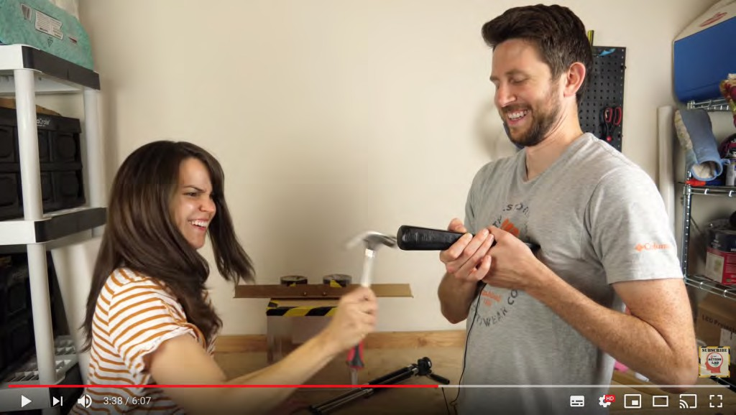](https://www.youtube.com/watch?v=7e4aIZ75Mcs)

*Figure 8.4.2 Don’t do this yourself at home! Video on the conservation of momentum*

#### Skills development

This usually requires the video to be integrated with student activities. The ability to stop, rewind and replay video becomes crucial for skills development, as student activity usually takes place separately from the actual viewing of the video. This may mean thinking through carefully activities for students related to the use of video.

If video is not used directly for lecturing, research clearly indicates that students generally

need to be guided as to what to look for in video, at least initially in their use of video for learning. There are various techniques for relating concrete events with abstract principles, such as through audio narration over the video, using a still frame to highlight the observation, or repeating a small section of the program. Bates and Gallagher (1977) found that using video for developing higher order analysis or evaluation was a teachable skill that needs to be built into the development of a course or program, to get the best results.

Typical uses of video for skills development include:

* enabling students to *recognize naturally occurring phenomena or classifications* (e.g. [classroom teaching strategies](https://www.youtube.com/watch?v=oNxCporOofo), [symptoms of mental illness](https://www.youtube.com/watch?v=wWem_VOIoRw), [classroom behaviour](https://www.youtube.com/watch?v=u-0AlHFcQfk)) in context;
* enabling students to *analyse a situation*, using principles either introduced in the video recording or covered elsewhere in the course, such as a textbook or lecture; for example, [possible raw material on managing domestic violence,](https://www.youtube.com/watch?v=rwKCItttsrs&feature=youtu.be)
* *interpreting artistic performance* (e.g. drama, [spoken poetry](http://movingpoems.com/), [movies](https://www.ranker.com/list/best-film-analysis-youtube-channels/youtuber), [paintings](https://www.youtube.com/watch?v=wmj3AEjilPg), [sculpture](https://vimeo.com/131546394), or other works of art);
* *analysis of music composition*, through the use of [musical performance](https://www.youtube.com/watch?v=o6_lbrlehsg), narration and graphics;
* *testing* the applicability or relevance of *abstract concepts or generalisations in real world contexts* (see for example [the European Space Agency’s video on climate](https://www.youtube.com/watch?v=ezAZ5WVAOyI) [change](https://www.youtube.com/watch?v=ezAZ5WVAOyI))
* *looking for alternative explanations* for real world phenomena.

There are many ways in which video can be used for skills development. Nevertheless, however video is used for skill development, as well as the demonstration of the skill, attention must be paid to ensuring opportunities for student practice and feedback, probably using other media, although it is now increasingly easy for students to make their own videos to demonstrate their skill.

[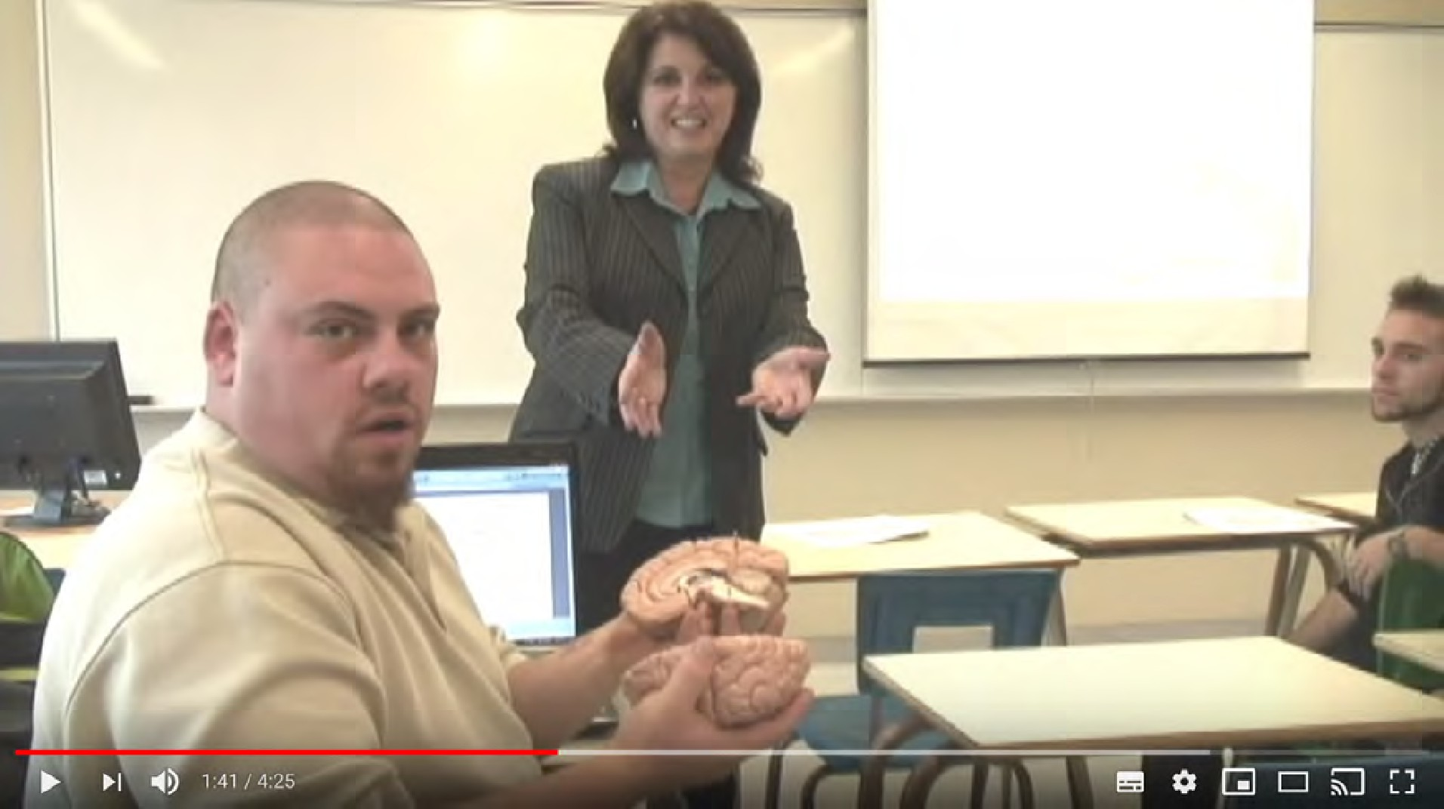](https://www.youtube.com/watch?v=oNxCporOofo)

*Figure 8.4.3 Demonstrating teaching strategies: kinesthetic learning. Click on the image to see the video*

#### The affective impact of video

Well-produced and well-designed video can also have a powerful emotional effect on learners. It is a particularly important medium for students who have grown up in a digital age. Students more easily identify with topics or approaches that are represented through video presentations, especially if they can identify with the context or with characters within the video (see, for instance, the use of video [for social workers on how to conduct](https://de.ryerson.ca/games/nursing/mental-health/game.html%23/video/0/0/-1) [home visits where the spouse may have been physically abused by their partner](https://de.ryerson.ca/games/nursing/mental-health/game.html%23/video/0/0/-1)). The emotional impact of video is particularly valuable where from an instructional point of view you need to change a student’s perspective on a topic (see, for instance, [We WILL Fix](https://www.youtube.com/watch?v=LxgMdjyw8uw&ab_channel=Kurzgesagt%E2%80%93InaNutshell) [Climate Change](https://www.youtube.com/watch?v=LxgMdjyw8uw&ab_channel=Kurzgesagt%E2%80%93InaNutshell)).

Video can therefore combine both educational goals/learning objectives AND student engagement, which is one reason why it is such a powerful teaching medium. The emotional impact of video though is an affordance that instructors need to use with

care. It often needs to be backed up with other activities, such as discussion, analysis or reflection.

#### Strengths and weaknesses of digital video as a teaching medium

One factor that makes video powerful for learning is its ability to show the relationship between concrete examples and abstract principles, with usually the sound track relating the abstract principles to concrete events shown in the video. Video is particularly useful for recording events or situations where it would be too difficult, dangerous, expensive or impractical to bring students to such events.

Thus its main *strengths* are as follows:

* there is a wide variety of high quality educational videos in all subject areas freely available online for use by instructors and students;
* video can directly link concrete events and phenomena to abstract principles and vice versa;
* students can stop and start digital videos, and thus integrate activities with the video presentation;
* video can provide an alternative approach to the presentation of content that can help students having difficulties in learning abstract concepts;
* video can combine text and audio as well as visual images. Providing information in a variety of information channels helps different kinds of learners and also results in deeper understanding for all learners;
* a video can add substantial interest to a course by linking it to real world issues;
* video can be used to develop many of the higher level intellectual and practical skills needed in a digital age;
* mobile phones, low cost cameras and free editing software enables educational video to be cheaply produced by both instructors and students;
* students can use video to demonstrate their learning in practice

It should also be remembered that in addition to the features listed above, video can incorporate many of the features of audio as well.

The main *weaknesses* of video are:

* many instructors and teachers have no knowledge or experience in using video other than for recording lecturing;
* the availability of free material for educational use is improving all the time, but currently finding appropriate and free videos that meet the specific needs of a teacher or instructor can be time-consuming or such material may just not be available or reliable. Links also often go dead after a while, affecting the reliability of outsourced video;
* there may be copyright issues, both in making and using video for educational purposes. It may be necessary to ask your institutional library to check on copyright before using media produced outside the institution, and your institution may have policies regarding videos produced in-house that need to be followed;
* creating original material that exploits the unique characteristics of video is time- consuming, and still relatively expensive, because it usually needs professional video production;
* to get the most out of educational video, students need specially designed activities that often will have to sit outside the video itself;
* students often reject videos that require them to do analysis or interpretation; they often prefer direct instruction that focuses primarily on comprehension. Such students need to be trained to use video differently, which requires time to be devoted to developing such skills.

#### Assessment

If video is being used to develop the skills outlined in Section 8.4.3, then it is essential that these skills are assessed and count for grading. Indeed, one possible means of assessment might be to ask students to analyse or interpret a selected video, or even to develop their own media project, using video they themselves have collected or produced, using their own devices.

#### Conclusion

Video is not being used enough in education. It has tremendous teaching power and there is now a great deal of readily available video material that can be accessed and downloaded from the Internet. However, when video is used in teaching, it is often an afterthought or an ‘extra’, rather than an integral part of the design, or is used merely to replicate a classroom lecture, rather than exploiting the unique characteristics of video.

Furthermore, a video clip or program rarely stands on its own as a teaching resource. It will usually need to be put into context and students will often need guidance on how to use the video material in their studies – for instance, what to look for, and how it relates to the rest of the course. Usually video will need some prior preparation and follow-up work by the students which in turn will need feedback from the instructor. Nevertheless, video should now be a standard part of most instructors’ teaching repertoire.

#### References

Bates, A. (1984) [*Broadcasting in Education: An Evaluation*](https://www.amazon.com/Broadcasting-Education-Evaluation-Media-Studies/dp/009463680X)suitable material available: Constables

Bates, A. (2005) [*Technology, e-Learning and Distance Education*](https://www.routledge.com/Technology-e-learning-and-Distance-Education-2nd-Edition/Bates/p/book/9780415284370)London/New York: Routledge

Bates, A. and Gallagher, M. (1977) *Improving the Effectiveness of Open University Television Case-Studies and Documentaries* Milton Keynes: The Open University, I.E.T. Papers on Broadcasting, No. 77 (out of print – copies available from [tony.bates@ubc.ca)](mailto:tony.bates@ubc.ca)

Koumi, J. (2006). [*Designing video and multimedia for open and flexible*](https://www.routledge.com/Designing-Video-and-Multimedia-for-Open-and-Flexible-Learning-1st-Edition/Koumi/p/book/9780415383035)[*learning*](https://www.routledge.com/Designing-Video-and-Multimedia-for-Open-and-Flexible-Learning-1st-Edition/Koumi/p/book/9780415383035)*.* London: Routledge

Mayer, R. E. (2020). [Multimedia learning (3rd ed)](https://www.cambridge.org/highereducation/books/multimedia-learning/FB7E79A165D24D47CEACEB4D2C426ECD#overview)[.](https://www.cambridge.org/core/books/multimedia-learning/7A62F072A71289E1E262980CB026A3F9) New York: Cambridge University Press

The University of British Columbia also provides two annotated bibliographies of digital multimedia research. one collated at UBC and one by the University of Central Florida.

###### Activity 8.4 Identifying the unique pedagogical characteristics of video

1. Take one of the courses you are teaching. What key presentational aspects of video could be important for this course?
2. Look at the skills listed in Section 1.2 of this book. Which of these skills would best be developed through the use of video rather than other media? How would you do this using video-based teaching?
3. Under what conditions would it be more appropriate for students to be assessed by asking them to analyse or make their own video recording? How could this be done under assessment conditions?
4. Type in the name of your topic + video into Google.
   * How many videos come up?
   * What’s their quality like?
   * Could you use any of them in your teaching?
   * If so, how would you integrate them into your course?
   * Could you make a better video on the topic?
   * What would enable you to do this?

Here are some criteria I would apply to what you find:

* + it is relevant to what you want to teach;
  + it demonstrates clearly a particular topic or subject and links it to what the student is intended to learn;
  + it is short and to the point;
  + the example is well produced (clear camera work, good presenter, clear audio);
  + it provides something that you could not do easily yourself;
  + it is freely available for non-commercial use.

For feedback on this activity, and some further comments on the value of video, click on the podcast below:

*One or more interactive elements has been excluded from this version of the text. You can view them online here:* [*https://pressbooks.bccampus.ca/teachinginadigitalagev3m/?p=270#audio-270-1*](https://pressbooks.bccampus.ca/teachinginadigitalagev3m/?p=270&audio-270-1)

# Computing

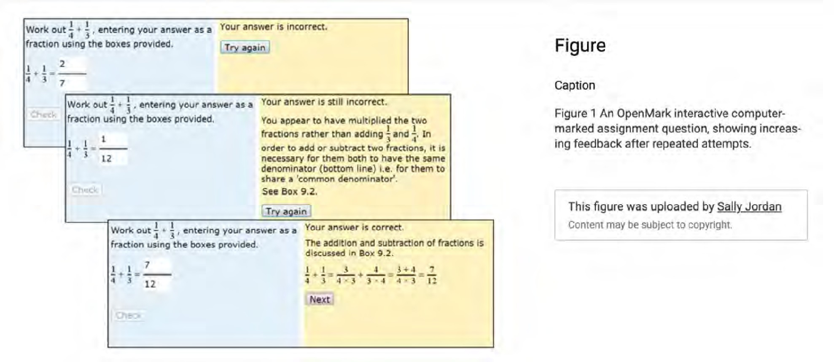

*Figure 8.5.1 A an interactive computer-marked assignment from the UK Open University. Image: Jordan (2011)*

#### A volatile and comprehensive medium

It is debatable whether computing should be considered a medium, but I am using the term ‘computing’ broadly, and not in the technical sense of writing code. I am using it in the sense of using a computer for designing or undertaking learning activities. The Internet in particular is an all-embracing medium that accommodates text, audio, video and computing, as well as providing other elements such as distributed communication and acces to educational opportunities. Computing is also still an area that is fast developing, with new products and services emerging all the time. Indeed, I will treat recent developments in social media and some emerging technologies separately from computing, although technically they are sub-categories of computing. Once again, though, social media and some emerging technologies contain affordances that are not so prevalent in more conventional computing-based learning environments.

In such a volatile medium, it would be foolish to be dogmatic about unique media

characteristics, but once again, the purpose of this chapter is not to provide a definitive analysis, but a way of thinking about technology that will facilitate an instructor’s choice and use of technology. The focus is: what are the pedagogical affordances of computing that are different from those of other media (other than the important fact that it can embrace all the other media characteristics)?

Although there has been a great deal of research into computers in education, there has been less focus on the specifics of its pedagogical media characteristics, although a great deal of interesting research and development has taken place and continues in human- machine interaction and to a lesser extent in artificial intelligence.

#### Presentational features

**[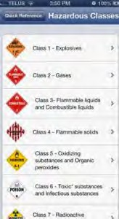](http://opentextbc.ca/teachinginadigitalage/wp-content/uploads/sites/29/2015/01/JIBC-mobile-web-page-2.jpg)**

*Figure 8.5.2 Screen size can be a real presentational limitation with smaller, mobile devices*

Presentation is not really where the educational strength of computing lies. It can represent text, audio and video reasonably well. Screen size can be a real presentational limitation with smaller, mobile devices, although tablets such as the iPad are a major advance in screen quality.

However, unlike the other media, computing enables the end user to interact directly with the medium, to the extent that the end user (in education, the student) can add to, change or interact with the content, at least to a certain extent. Also, more controversially, computing can automatically collect end-user responses for analytics. In this sense, computing comes closer to a complete, if virtual, learning environment.

Thus in presentational terms computing can be used to:

* create and present original teaching content in a rich and varied way (using a combination of text, audio, video, webinars and end-user interaction, including assignments);
* enable access to other sources of secondary ‘rich’ content through the Internet;
* enable students to communicate both synchronously and asynchronously with the instructor and other students;
* structure and manage content through the use of web sites, learning management systems, video servers, and other similar technologies;
* create virtual worlds or virtual environments/contexts through technology such as animations, simulations, augmented or virtual reality, and serious games;
* set multiple-choice tests, automatically mark such tests, and provide immediate feedback to learners;
* enable learners digitally to submit written (essay-type), or multimedia (project- based) assignments through the use of e-portfolios.

The presentational features of social media, simulations and games, and artificial development, although closely linked, will be discussed in Chapter 9.

#### Skills development

Skills development in a computing environment will once again depend very much on the epistemological approach to teaching. Computing can be used to focus on comprehension

and understanding, through a behaviourist approach to computer-based learning (present/test/feedback). However, the communications element of computing also enables more constructivist approaches, through online student discussion and student- created multimedia work.

Thus computing can be used to:

* develop and test student comprehension of content through computer-based learning/testing;
* develop computer coding and other computer-based skills;
* develop skills of reasoning, evidence-based argument, and collaboration through instructor-moderated online discussion forums;
* enable students to create their own artefacts/online multimedia work through the use of e-portfolios, thus improving their digital communication skills as well as assessing better what they have learned;
* develop skills of knowledge management and problem-solving, by requiring students to find, analyse, evaluate and apply content, accessed through the Internet, to real world problems;
* develop spoken and written language skills through both presentation of language and through communication with other students and/or native language speakers via the Internet
* collect data on end-user/student interactions with computer and associated equipment such as mobile phones and tablets for:
  + learning analytics, which can be used to identify weaknesses in the design of the teaching, and student success and failure regarding learning outcomes, including skills development, as well as identifying at-risk students,
  + adaptive learning, offering learners alternative routes through learning materials, providing an element of personalisation,
  + assessment (including monitoring),
  + automated or human feedback.

These affordances are in *addition* to the affordances that other media can support within a broader computing environment.

#### Strengths and weaknesses of computing as a teaching

**medium**

Many teachers and instructors avoid the use of computing because they fear it may be used to replace them, or because they believe it results in a very mechanical approach to teaching and learning. This is not helped by misinformed computer scientists, politicians and industry leaders who argue that computers can replace or reduce the need for humans in teaching. Both viewpoints show a misunderstanding of both the sophistication and complexity of teaching and learning, and the flexibility and advantages that computing can bring to teaching.

So here are some of the advantages of computing as a teaching medium:

* it is a very powerful teaching medium in terms of its unique pedagogical characteristics, in that it can combine the pedagogical characteristics of text, audio, video and computing in an integrated manner;
* its unique pedagogical characteristics are useful for teaching many of the skills learners need in a digital age;
* computing can enable learners to have more power and choice in accessing and creating their own learning and learning contexts;
* computing can enable learners to interact directly with learning materials and receive immediate feedback, thus, when well designed, increasing the speed and depth of their learning;
* computing can enable anyone with Internet access and a computing device to study or learn at any time or place;
* computing can enable regular and frequent communication between student, instructors and other students;
* computing is flexible enough to be used to support a wide range of teaching philosophies and approaches;
* computing can help with some of the ‘grunt’ work in assessment and tracking of student performance, freeing up an instructor to focus on the more complex forms of assessment and interaction with students.

On the other hand, the disadvantages of computing are:

* many teachers and instructors often have no training in or awareness of the strengths and weaknesses of computing as a teaching medium;
* some students may have difficulty in accessing appropriate equipment such as computers or the Internet, or may not have the appropriate skills to use computers for learning. Such students are often from low income families or living in remote areas. Special arrangements, such as loan of equipment, may be necessary for such students;
* computing is too often oversold as a panacea for education; it is a powerful teaching medium, but it needs to be managed and controlled by educators;
* the traditional user interface for computing, such as pull-down menus, cursor screen navigation, touch control, and an algorithmic-based filing or storage system, while all very functional, are not intuitive and can be quite restricting from an educational point of view. Voice recognition and search interfaces such as Siri and Alexa are an advance, and have potential for education, but at present they have not been used extensively as educational tools (at least by instructors);
* there is a tendency for computer scientists and engineers to adopt behaviourist approaches to the use of computing for education, which not only alienates constructivist-oriented teachers and learners, but also underestimates or underuses the true power of computing for teaching and learning;
* despite computing’s power as a teaching medium, there are many aspects of teaching and learning that require direct interaction between a student and teacher – and between students – even or especially in a fully online environment (see Chapter 4, Section 4) . The importance of face-to-face, human-to-human contact is probably greater the younger or the less mature the learner, but there will still be many learning contexts where face-to-face contact is necessary or highly desirable even for older or mature learners (this is discussed more in Chapter 11, Section

4). The importance of frequent face-to-face teacher-student interaction is also probably less than many instructors believe, but more than many advocates of computer learning understand. It is not either/or, but finding the right balance in the right context.

* computing needs the input and management of teachers and educators, and to some extent learners, to determine the conditions under which computing can best operate as a teaching medium; and teachers need to be in control of the decisions on when and how to use computing for teaching and learning;
* to use computing well, teachers need to work closely with other specialists, such as instructional designers and computer scientists.

The issue around the value of computing as a medium for teaching is less about its

pedagogical value and more about control. Because of the complexity of teaching and learning, it is essential that the use of computing for teaching and learning is controlled and managed by educators. As long as teachers and instructors have control, and have the necessary knowledge and training about the pedagogical advantages and limitations of computing, then computing is an essential medium for teaching in a digital age.

#### Assessment

There is a tendency to focus assessment in computing on multiple choice questions and ‘correct’ answers. Although this form of assessment has its value in assessing comprehension and for testing a limited range of mechanical procedures, computing also supports a wider range of assessment techniques, from learner-created blogs and wikis to e-portfolios. These more flexible forms of computer-based assessment are more in alignment with measuring the knowledge and skills that many learners will need in a digital age. Computer-marked assessment is discussed in more detail in Chapter 9.4

#### Reference

Jordan, S. (2011) [Using interactive computer‐based assessment to support beginning](https://www.researchgate.net/publication/233279437_Using_interactive_computer-based_assessment_to_support_beginning_distance_learners_of_science) [distance learners of science](https://www.researchgate.net/publication/233279437_Using_interactive_computer-based_assessment_to_support_beginning_distance_learners_of_science) *Open Learning*, Vol. 26, No. 2

1. Take one of the courses you are teaching. What key presentational aspects of computing could be important for this course?
2. Look at the skills listed in Section 1.2 of this book. Which of these skills would best be developed through the use of computing rather than other media? How would you do this using computer-based teaching?
3. Under what conditions would it be more appropriate in any of your courses for students to be assessed by asking them to create their own multimedia project portfolios rather than through a written exam? What assessment conditions would be necessary to ensure the authenticity of a student’s work? Would this form of assessment be extra work for you?
4. What are the main barriers to your using computing more in your teaching? Philosophical? Practical? Lack of

*Activity 8.5 Identifying the unique pedagogical characteristics of computing*

training or confidence in technology use? Or lack of institutional support? What could be done to remove some of these barriers?

For feedback on some of these questions, click on the podcast below:

*One or more interactive elements has been excluded from this version of the text. You can view them online here:* [*https://pressbooks.bccampus.ca/teachinginadigitalagev3m/?p=274#audio-274-1*](https://pressbooks.bccampus.ca/teachinginadigitalagev3m/?p=274&audio-274-1)

# A framework for analysing the pedagogical characteristics of educational media

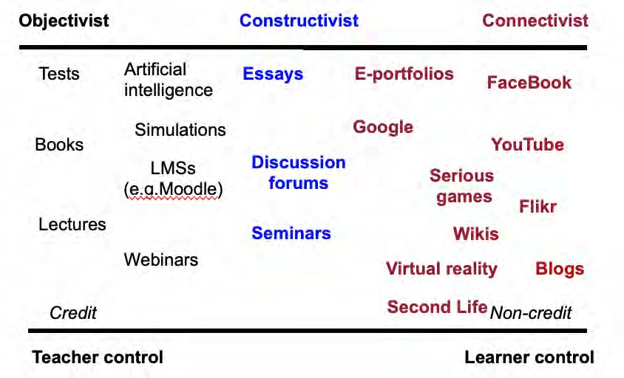

*Figure 8.6.1 Analysis of different media by pedagogical criteria (adapted from Bates, 2011)*

#### Brief summary of pedagogical differences in media

I will now summarise the unique pedagogical characteristics of the different media discussed in this chapter.

Figure 8.6.1 presents a diagrammatic analysis of various learning media (including some to

8.6 A framework for analysing the pedagogical characteristics of

be discussed in the next chapter). I have arranged them primarily by where they fit along an epistemological continuum of objectivist (black), constructivist (blue) and connectivist (red), but also I have used two other dimensions, teacher control/learner control, and credit/non-credit. Note that this figure also enables traditional teaching modes, such as lectures and seminars, to be included and compared. Figure 8.6.1 represents my personal interpretation of these media, and other teachers or instructors may well re-arrange the diagram differently, depending on their particular applications of these tools.

Not all tools or media are represented here (for example, audio and video or MOOCs). The position of any particular tool in the diagram will depend on its actual use. Learning management systems can be used in a constructivist way, and blogs can be very teacher- controlled, if the teacher is the only one permitted to use a blog on a course. Badia et al (2011) have shown that educational design and the situational use of technology very much influence whether specific affordances or unique characteristics of a medium are successfully exploited. Student preferences or pre-dispositions can inhibit or support the successful implementation of specific affordances of different media (for instance, computer science students’ preferences for adaptive learning rather than the communication and discussion affordances of a learning management system – Arenas, 2015).

However, the aim here is not to provide a cast-iron categorization of the affordances of different educational media, but to provide a framework for teachers in deciding which tools and media are most likely to suit a particular teaching approach. Indeed, other teachers may prefer a different set of pedagogical values as a framework for analysis of the different media and technologies.

However, to give an example from Figure 8.6.1, a teacher may use an LMS to organize a set of resources, guidelines, procedures and deadlines for students, who then may use several of the social media (see next chapter), such as photos from mobile phones to collect data. The teacher provides a space and structure on the LMS for students’ learning materials in the form of an e-portfolio, to which students can load their work. Students in small groups can use discussion forums or FaceBook to work on projects together.

The example above is in the framework of a course for credit, but the framework would also fit the non-institutional or informal approach to the use of social media for learning, with a focus on tools such as FaceBook, blogs and YouTube. These applications would be

much more learner driven, with the learner deciding on the tools and their uses. The most powerful examples are connectivist or cMOOCs, as we saw in Chapter 5.

The next chapter looks at a range of emerging technologies and Chapter 10 provides suggestions on how to make decisions on choice of media.

#### References

Arenas, E. (2015) [Affordances of Learning Technologies in Higher Education Multicultural](https://pdfs.semanticscholar.org/17a4/638de9c2018a364c22e70bf20f343513229b.pdf) [Environments](https://pdfs.semanticscholar.org/17a4/638de9c2018a364c22e70bf20f343513229b.pdf) *The Electronic Journal of e-Learning* Volume 13 No. 4 (pp 217-227)

Badia, A., Barberà, E., Guasch, T., Espasa, A. (2011). [Technology educational affordance:](https://pdfs.semanticscholar.org/0a5c/bdb6c5449eab63808c481f80af5f7d1e493e.pdf) [Bridging the gap between patterns of interaction and technology usage](https://pdfs.semanticscholar.org/0a5c/bdb6c5449eab63808c481f80af5f7d1e493e.pdf) in: *Digital Education Review*, Vol.19, pp 20-35

Bates, A. (2011) Understanding Web 2.0 and its implications for e-learning, in Lee, M. and McCoughlin, C. (eds.) [*Web 2.0-based E-learning: applying social informatics for tertiary*](https://www.amazon.com/Web-2-0-Based-Learning-Informatics-Reference/dp/1605662941)[*teaching*](https://www.amazon.com/Web-2-0-Based-Learning-Informatics-Reference/dp/1605662941)Hershey PA: Information Science

**Key takeaways**

the overall teaching philosophy behind the teaching;

the presentational and structural requirements of the subject matter or content; the skills that need to be developed in learners;

and not least by the imagination of the teacher or instructor (and increasingly learners themselves)

in identifying possible roles for different media;

◦

◦

◦

◦

There is a very wide range of media available for teaching and learning. In particular:

* text, audio, video, computing, social media and other emerging technologies all have unique characteristics that make them useful for teaching and learning;
* the choice or combination of media will need to be determined by:

*Chapter 8: Key Takeaways*

* content is now increasingly open and freely available over the Internet; as a result learners can seek, use and apply information beyond the bounds of what a professor or teacher may dictate;
* many students will still need a structured approach that guides their learning

1. Take a module or main topic of a course you are teaching. Identify the key learning outcomes, in terms of skills to be taught, then the content area to be covered.
2. Then look through the key characteristics of each of the media in this chapter, and think how each medium might be used to teach your module. Use your analysis from Activities 8.2 to 8.5. Make a list of the functions you have chosen and their relationship to content and skills in the module.
3. Using Figure 8.8.1, allocate a range of tools and media that you might consider using and place them on the continuum.
4. Are you still happy with your choice?

Don’t worry – we haven’t finished yet. Following chapters will provide a way to make decisions on a more realistic basis. The main purpose here is to get you thinking about possible uses of different media in your subject area.

There is no feedback offered for this activity. Chapter 10 should give some guidance as to the appropriateness of your answers.

*Activity 8.6 Choosing media for a teaching module*

## CHAPTER 9: EMERGING TECHNOLOGIES

social media simulations and games

augmented and virtual reality

artificial intelligence

◦

◦

◦

◦

1. To explore the educational potential and limitations of new or emerging technologies, in particular:

*Purpose of the chapter*

#### What is covered in this chapter

* 9.1 Social media
* 9.2 Serious games and gamification
* 9.3 Virtual and augmented reality
* 9.4 Artificial intelligence
* 9.5 Emerging technologies: conclusion and summary

Also in this chapter you will find the following activities:

* Activity 9.1 Identifying the unique pedagogical characteristics of social media
* Activity 9.2 Using and designing serious games
* Activity 0.3 Using and designing VR and AR
* Activity 9.4 Assessing artificial intelligence
* Activity 9.5 Assessing and developing applications of emerging technologies

###### Key Takeaways

* + learners now have powerful tools through social media for creating their own learning materials or for demonstrating their knowledge;
  + students can now use social media to create their own online personal learning environments;
  + teacher presence and guidance is still likely to be necessary to ensure high quality learning via social media;
  + teachers need to find the middle ground between complete learner freedom and over-direction to enable learners to use social media to develop the key skills needed in a digital age.
  + simulations, serious games, and augmented/virtual reality can improve student motivation and teach tasks that would be difficult otherwise;
  + serious games, AR and VR, and AI have substantial costs involved in creating new applications, but have great potential as open educational resources;
  + AI’s value as a medium for learning has been limited to date and there are serious ethical, privacy and transparency issues in the application of AI to teaching and learning that still need to be addressed;
  + AI may have more potential for disruption outside the formal education system. If successful, commercial use of AI for teaching and learning could provide an existential challenge to public education

# Social media

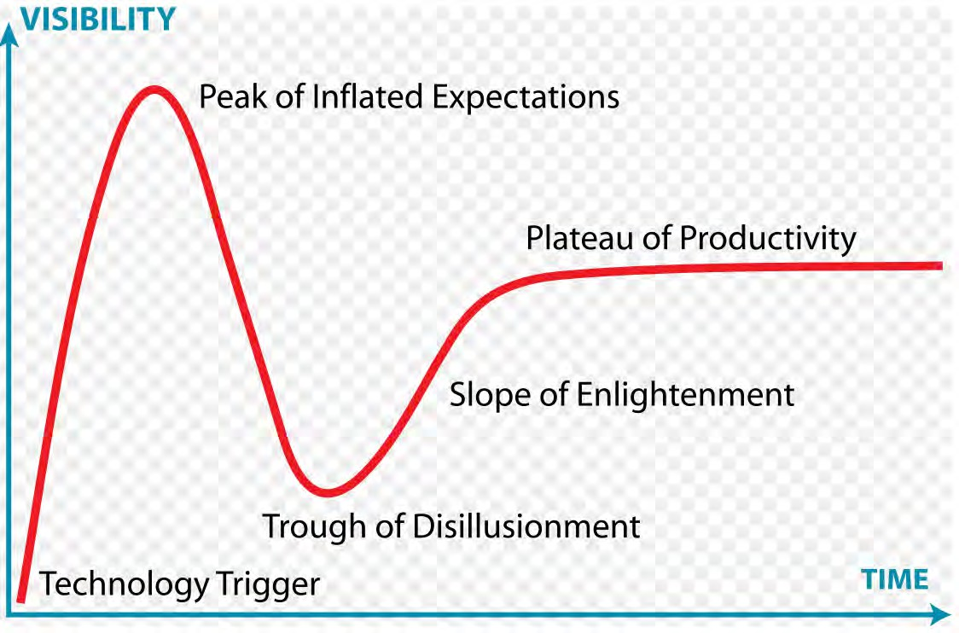

*Figure 9.1.1 The Gartner Hype Cycle for Emerging Technologies. Image: Wikimedia Commons, 2019*

#### The challenge of emerging technologies

It is not uncommon for a school principal, a college VP Education, or a university president to go to a conference and come back thrilled about the potential of the latest technology for teaching and learning. They are victims of what the consulting firm Gartner calls the hype cycle.

A new technology triggers excitement, the media picks up on it, the technology reaches a peak of inflated expectations, it starts to get more widely applied, disillusionment sinks

in when faced with the realities of implementation, then the technology starts to find its niche as better understanding of its strengths and weaknesses emerge, eventually reaching a plateau of productivity, where it works well within its limits. MOOCs are an excellent example of this, with most knowledgeable observers in 2019 placing them towards the top of the slope of enlightenment or just emerging on to the plateau of productivity (see, for instance, [Web Courseworks, 2018](https://webcourseworks.com/elearning-predictions-hype-curve-2018/)).

New technologies that have educational applications are constantly emerging. For instance in the first edition of this book (written in 2015) there was no extensive discussion of artificial intelligence, virtual reality or serious games, yet seven years later they are now at the forefront of many discussions about the future of digital learning, which is why this chapter has been added. There are several other technologies that could be included, but many of these will be subsumed under artificial intelligence.

I will not be able to go into depth about any of these three technologies (each deserves its own book), but they are significant enough to bring them to your attention. Once again, I will focus on their potential affordances, although it must be recognised that with all emerging technology, it may take time to identify all their advantages and disadvantages.

#### Social media

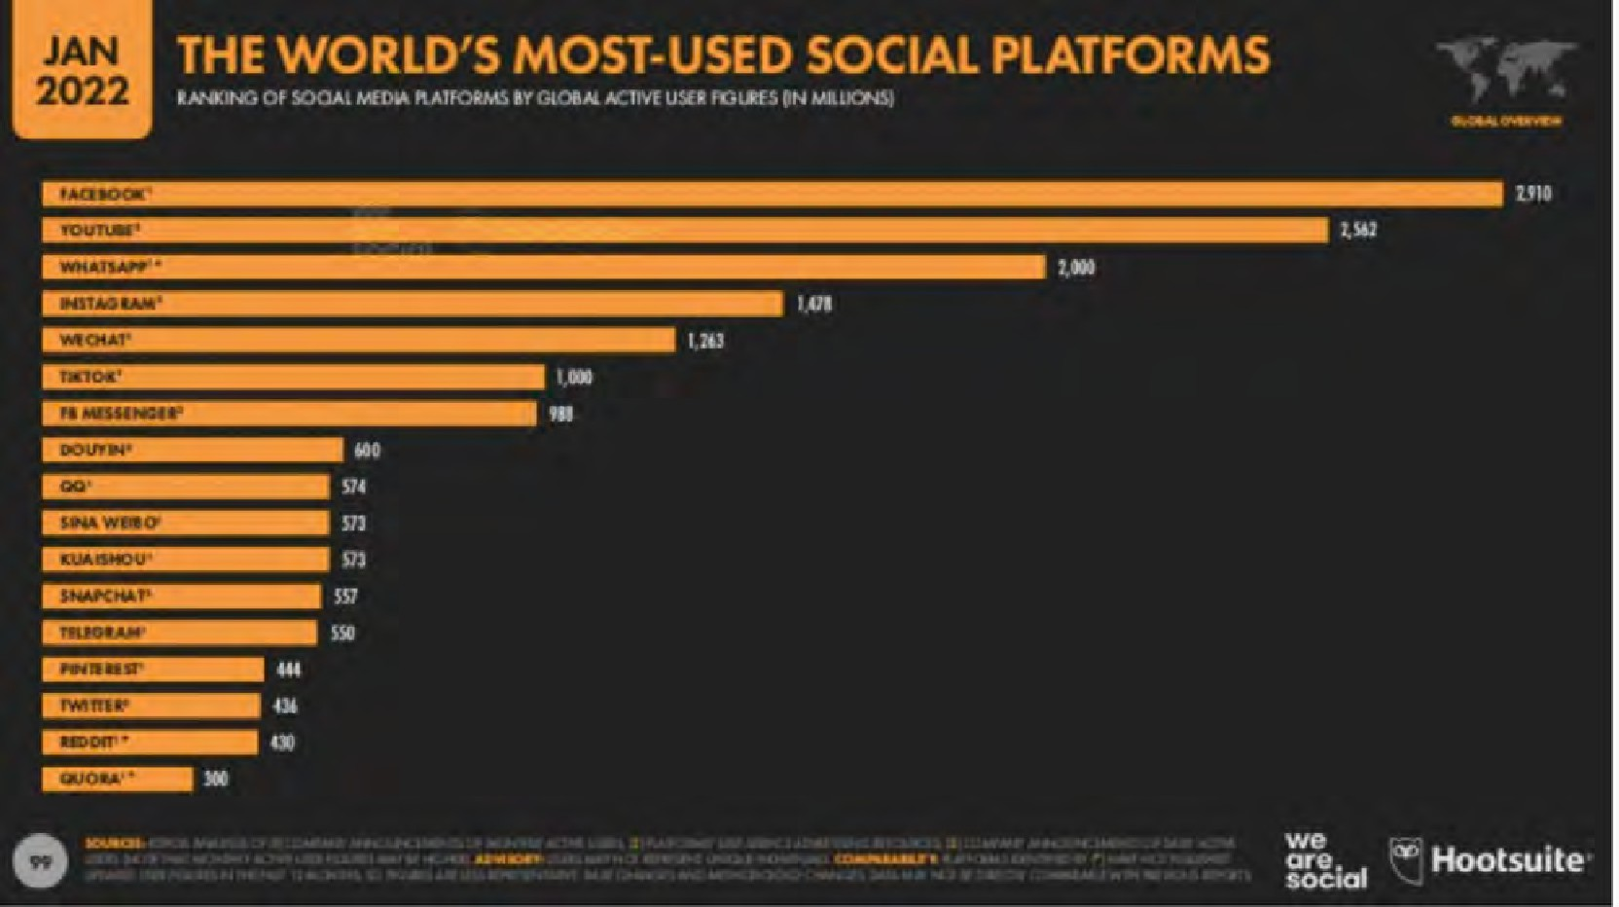

Figure 9.1.2 Image: Dave Chaffey, [Smart Insights](https://www.smartinsights.com/wp-content/uploads/2022/01/Worlds-most-used-social-media-platforms-2022.png), 2022

Although social media are mainly Internet-based and hence a sub-category of computing, there are enough significant differences between educational social media use and computer-based learning or online collaborative learning to justify treating social media as a separate medium, although of course social media are dependent and often fully integrated with other forms of computing. The main difference is in the extent of control over learning that social media offer to learners.

#### What are social media?

Around 2005, a new range of web tools began to find their way into general use, and increasingly into educational use. These can be loosely described as social media, as

they reflect a different culture of web use from the former ‘centre-to-periphery’ push of institutional web sites.

Here are some of the tools and their uses. Most examples below illustrate educational applications or sites. (There are many more possible examples):

Table 9.1.3 Social Media

|  |  |  |  |  |  |
| --- | --- | --- | --- | --- | --- |
|  | **Type of tool** |  | **Examples** |  | **Applic** |
|  | Blogs |  | [Stephen’s Web](https://www.downes.ca/)  [Online Learning and Distance Education Resources](https://www.tonybates.ca/) |  | Allows or an |
|  |  |  |  |  |  |
|  |  |  |  |  |  |
|  | Wikis |  | [Wikipedia](https://en.wikipedia.org/wiki/Online_learning_in_higher_education)  UBC Math Exam Resources |  | An ‘op comm |
|  |  |  |  |  |  |
|  | Social networking |  | [Facebook](https://www.facebook.com/business/learn/all-training-courses) [LinkedIn](https://www.linkedin.com/learning/) [WhatsApp](https://www.whatsapp.com/) [WeChat](https://www.wechat.com/) |  | A socia play or |
|  |  |  |  |  |  |
|  | Multimedia archives |  | [Podcasts](https://onlinelearninglegends.castos.com/podcasts/691/episodes) [YouTube](https://www.youtube.com/watch?v=0S2j6vYAAsY&ab_channel=CommonwealthofLearning) [Vimeo](https://vimeo.com/508950418) [TikTok](https://www.tiktok.com/en/) [Flickr](https://www.flickr.com/photos/der/) [iTunes](https://www.apple.com/ca/education/ipad/itunes-u/)  [Curated OER repositories](https://merlot.org/merlot/) |  | Allows images |

The main educational feature or affordance of social media is that they empower the end user to access, create, disseminate and share information easily in a user-friendly, open environment. Usually the only direct cost is the time of the end-user. There are often few controls over content, other than those normally imposed by a state or government (such as libel or pornography). One feature of such tools is to empower the end-user – the learner or customer – to self-access and manage data (such as online banking) and to form personal networks (for example through FaceBook). For these reasons, some have called social media the ‘democratization’ of the web, although at the same time it could be argued that social media are now heavily commercialised through advertising, and there are major concerns about end-users’ privacy and the use of social media for disseminating false information and manipulating individual behaviour.

|  |  |  |  |  |
| --- | --- | --- | --- | --- |
| Multiple player online games |  | [Battlegrounds](https://na.battlegrounds.pubg.com/) [Minecraft](https://www.minecraft.net/en-us) [Division Derby](https://www.mathplayground.com/ASB_Division_Derby.html) |  | Enable repres |
|  |  |  |  |  |
| Virtual worlds |  | [Second Life](https://secondlife.com/destinations/learning) [The Sandbox](https://www.thesandboxgame.com/education) [Upland](https://www.upland.me/) |  | Real-ti people |
|  |  |  |  |  |
| Mobile learning |  | [Downloadable apps via online app stores](https://www.educationalappstore.com/) |  | Enable and on |

In general, social media tools are based on very simple software, in that they have relatively few lines of code. As a result, new tools and applications (‘apps’) are constantly emerging, and their use is either free or very low cost. For a good broad overview of the use of social media in education, see Lee and McCoughlin ([2011](https://www.tandfonline.com/doi/abs/10.1080/08923647.2010.545602)).

#### General affordances of social media

The concept of ‘affordances’ is frequently used in discussions of social media. McLoughlin & Lee ([2011](https://www.tandfonline.com/doi/abs/10.1080/08923647.2010.545602)) identify the following ‘affordances’ associated with social media (although they use the term web 2.0) in general:

* + - * connectivity and social rapport;
      * collaborative information discovery and sharing;
      * content creation;
      * knowledge and information aggregation and content modification.

However, we need to specify more directly the unique pedagogical characteristics of social media.

#### Presentational characteristics

Social media enable:

* + - * networked multimedia communication between self-organising groups of learners;
      * access to rich, multimedia content available over the Internet at any time or place, as long as there is a suitable Internet connection;
      * learner-generated multimedia materials;
      * opportunities to expand learning beyond ‘closed’ courses and institutional boundaries.

#### Skills development

Social media,when well designed within an educational framework, can help with the development of the following skills (click on each to see examples):

* + - * [digital literacy:](http://digitaltattoo.ubc.ca/) this web site was designed by the Library at the University of British Columbia to enable students to manage their digital identity;
      * independent and self-directed learning: this is a Wiki built by UBC math graduate students to provide assistance to undergraduate students in their exams;
      * collaboration/collaborative learning/teamwork; this was a class project to build Wikipedia entries on Latin American literature by a third year undergraduate class at UBC;
      * [internationalisation/development of global citizens;](https://www.globalcitizen.org/en/)
      * [networking and other inter-personal skills](https://www.meetup.com/en-AU/);
      * [knowledge management](https://met.ubc.ca/courses/etec-522/); students at UBC use social media to research emerging technologies and build a possible educational business around the technology
      * [decision-making in specific contexts](https://www.jibc.ca/simulation-studio) (for example, emergency management, law enforcement).

#### Strengths and weaknesses of social media

Some of the advantages of social media are as follows:

* + - * they can be extremely useful for developing some of the key skills needed in a digital age, such as digital communication skills;
      * they can enable teachers to set online group work, based on cases or projects, and students can collect data in the field using social media such as mobile phones and apps such as [Questogo](http://questogo.appstor.io/);
      * learners can post media-rich assignments either individually or as a group;
      * these assignments when assessed can be loaded by the learner into their own personal learning environment or e-portfolios for later use when seeking employment or transfer to graduate school;
      * learners can take more control over their own learning, as we have seen in connectivist MOOCs in Chapter 5 Section 3.2
      * through the use of blogs and wikis, courses and learning can be thrown open to the world, adding richness and wider perspectives to learning.

However, many students are not, at least initially, independent learners (see Candy, [1991](https://www.amazon.com/Self-Direction-Lifelong-Learning-Comprehensive-Education/dp/1555423035)). Many students come to a learning task without the necessary skills or confidence to study independently from scratch (Moore and Thompson, [1990](https://eric.ed.gov/?id=ED330321)). They need structured support, structured and selected content, and recognized accreditation. The advent of

new tools that give students more control over their learning will not necessarily change their need for a structured educational experience. However, learners can be taught the skills needed to become independent learners (Moore, [1973](https://www.tandfonline.com/doi/abs/10.1080/00221546.1973.11776906); Marshall and Rowland, [1993](https://www.amazon.com/Guide-Learning-Independently-Lorraine-Marshall/dp/0335203663)). Social media can make the learning of how to learn much more effective but still only in most cases within an initially structured environment.

The use of social media raises the inevitable issue of quality. How can learners differentiate between reliable, accurate, authoritative information, and inaccurate, biased or unsubstantiated information, if they are encouraged to roam free? What are the implications for expertise and specialist knowledge, when everyone has a view on everything? As Andrew Keen ([2007](https://www.amazon.ca/Cult-Amateur-MySpace-user-generated-destroying/dp/0385520816)) has commented, ‘we are replacing the tyranny of experts with the tyranny of idiots.’ Not all information is equal, nor are all opinions.

These are key challenges for the digital age, but as well as being part of the problem, social media can also be part of the solution. Teachers can consciously use social media for the development of knowledge management and the responsible use of social media, but the development of such knowledge and skills through the use of social media will need a teacher-supported environment. Many students look for structure and guidance in their learning, and it is the responsibility of teachers to provide it. We therefore need a middle ground between the total authority and control of the teacher, and the complete anarchy of the children roaming free on a desert island in the novel “Lord of the Flies” (Golding, [1954](https://www.abebooks.com/book-search/title/lord-flies/author/golding/publisher/faber/)). Social media allow for such a middle ground, but only if as teachers we have a clear pedagogy or educational philosophy to guide our choices and use of the technology.

For more on social media, see Chapter 10, Section 8.

#### References

Bates, A. (2011) ‘Understanding Web 2.0 and Its Implications for e-Learning’ in Lee, M. and McCoughlin, C. (eds.) [*Web 2.0-Based E-Learning*](https://www.tandfonline.com/doi/abs/10.1080/08923647.2010.545602)Hershey NY: Information Science Reference

Candy, P. (1991) [*Self-direction for lifelong learning*](https://www.amazon.com/Self-Direction-Lifelong-Learning-Comprehensive-Education/dp/1555423035)San Francisco: Jossey-Bass Golding, W. (1954) [*The Lord of the Flies*](https://www.abebooks.com/book-search/title/lord-flies/author/golding/publisher/faber/)London: Faber and Faber

Keen, A. (2007) [*The Cult of the Amateur: How Today’s Internet is Killing our*](https://www.amazon.ca/Cult-Amateur-MySpace-user-generated-destroying/dp/0385520816)[*Culture*](https://www.amazon.ca/Cult-Amateur-MySpace-user-generated-destroying/dp/0385520816)New York/London: Doubleday

Lee, M. and McCoughlin, C. (eds.) [*Web 2.0-Based E-Learning*](https://www.tandfonline.com/doi/abs/10.1080/08923647.2010.545602)Hershey NY: Information Science Reference

Marshall, L. and Rowland, F. (1993) [*A Guide to learning independently*](https://www.amazon.com/Guide-Learning-Independently-Lorraine-Marshall/dp/0335203663)Buckingham UK: Open University Press

McCoughlin, C. and Lee, M. (2011) ‘Pedagogy 2.0: Critical Challenges and Responses to Web 2.0 and Social Software in Tertiary Teaching’, in Lee, M. and McCoughlin, C. (eds.) [*Web 2.0-Based E-Learning*](https://www.tandfonline.com/doi/abs/10.1080/08923647.2010.545602)Hershey NY: Information Science Reference

Moore,M. (1973) [Toward a Theory of Independent Learning and Teaching](https://www.tandfonline.com/doi/abs/10.1080/00221546.1973.11776906), *Journal of Higher Education*, Volume 44, No. 9

Moore, M. and Thompson, M. (1990) [*The Effects of Distance Education: A Summary*](https://eric.ed.gov/?id=ED330321)[*of the Literature*](https://eric.ed.gov/?id=ED330321)University Park, PA: American Center for Distance Education, Pennsylvania State University

###### Activity 9.1 Identifying the unique pedagogical characteristics of social media

1. Take one of your courses, and analyse how social media could be used in your course. In particular:
   * what new learning outcomes could the use of social media help develop?
   * would it be better just to add social media to the course or to re-design it around social media?
2. I have offered only a cursory list of the unique pedagogical characteristics of social media. Can you think of others that have not already been covered in this section?
3. How does this chapter influence your views on students bringing their own devices to class?
4. Are you (still) skeptical about the value of social media in education? What do you see as its downsides?

For feedback on some of these questions and some more general points about social media in education, click on the podcast below.

*One or more interactive elements has been excluded from this version of the text. You can view them online here:* [*https://pressbooks.bccampus.ca/teachinginadigitalagev3m/?p=282#audio-282-1*](https://pressbooks.bccampus.ca/teachinginadigitalagev3m/?p=282&audio-282-1)

# Serious games and gamification

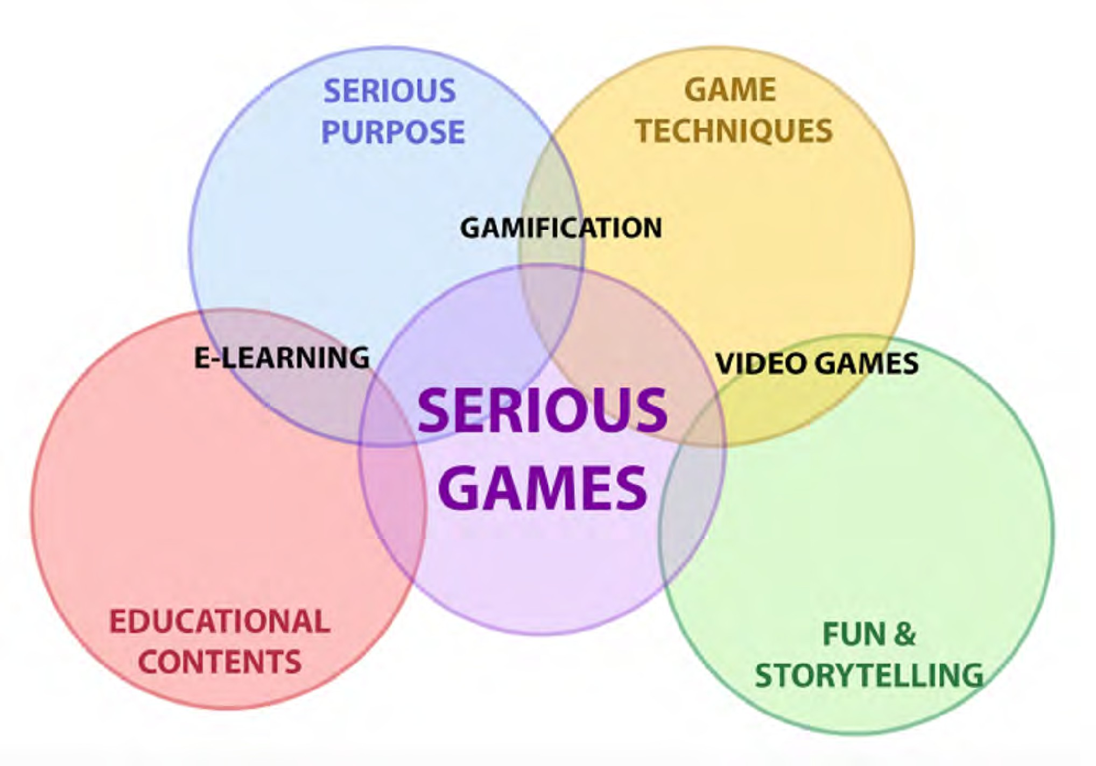

Figure 9.2.1 The context of serious games. Image: Hydra Interactive, 2021

#### Serious games

Gartner’s hype cycle is best considered as a way of thinking about emerging technologies, rather than as a factual representation of their development. For instance, serious games are more of a slow burner. There have never been vastly inflated expectations about their likely impact on education; indeed for a long time they have been written off as too

expensive or not appropriate for serious education. However, that view has been changing in recent years.

#### What are serious games?

There are several different definitions of serious games. I have included two definitions that cover both educational and corporate settings.

The Ministry of Education and Training, Victoria, Australia states ([2017](https://www.education.vic.gov.au/about/programs/learningdev/Pages/expired/techgames.aspx)):

*a serious game in an educational setting is considered to be a purposeful learning environment that targets key curriculum areas for explicit learning. Serious games are games or game-like interactive systems developed with game technology and design principles for a primary purpose other than pure entertainment.*

Zhonggen ([2019](https://www.hindawi.com/journals/ijcgt/2019/4797032/)) provides this definition in his comprehensive review of the research on serious games:

***Serious games*** *are referred to as entertaining tools with a purpose of education, where players cultivate their knowledge and practice their skills through overcoming numerous hindrances during gaming.*

It is important to distinguish between serious games, game-based learning and gamification because of the differences in their purpose, approach and impact on learning.

* **Game-based learning** refers to *“the pedagogical approach of utilizing games in education”* (Anastasiadis, Lampropoulos and Siakas, [2018](https://ijasre.net/index.php/ijasre/article/view/814))
* **Gamification** is defined as the *“use of game design elements in non-game contexts”*

(Deterding et al., [2011](http://gamification-research.org/wp-content/uploads/2011/04/01-Deterding-Sicart-Nacke-OHara-Dixon.pdf))

Note that serious games are not necessarily digital. However, whether digital or not, they are governed by similar principles of of design, such as mechanics, dynamics and aesthetics (Hunicke et al., [2004](https://citeseerx.ist.psu.edu/viewdoc/download?doi=10.1.1.79.4561&rep=rep1&type=pdf)).

#### Why use serious games?

The main reasons offered for using games in education are to:

* improve students’ motivation to learn,
* engage learners more deeply in the learning process,
* improve learning outcomes,
* improve attendance and participation.

However, an extensive review of the literature conducted by Dichev and Dicheva in [2017](https://educationaltechnologyjournal.springeropen.com/articles/10.1186/s41239-017-0042-5) found that research remains inconclusive on these assumptions. They also found that:

* the practice of gamifying learning has outpaced researchers’ understanding of its mechanisms and methods;
* insufficient high quality evidence exists to support the long-term benefits of serious games in an educational context;
* a limited understanding that how to gamify an activity depends on the specifics of the educational context.

Dichev and Dicheva do conclude though that their study does not mean that gamification *cannot* be used successfully in a learning context; rather better designs and more research are needed.

Other research tends to be more positive. Hamari et al. ([2016](https://www.researchgate.net/publication/280294047_Challenging_games_help_students_learn_An_empirical_study_on_engagement_flow_and_immersion_in_game-based_learning)) and Clark et al. ([2016](https://journals.sagepub.com/doi/10.3102/0034654315582065)) found sufficient evidence that, when well designed, and under the right conditions, serious games significantly enhanced student learning relative to nongame conditions.

Zhonggen ([2019](https://www.hindawi.com/journals/ijcgt/2019/4797032/)) found among the ‘ *huge number of findings in serious game assisted learning, most …are supportive, coupled with a few negative results*.’ However, the main benefits tended to be in the affective domain (student ‘happiness’ and improved social learning and communication) rather than in immediately improved cognitive learning outcomes, except in science (improved retention and holistic understanding), architecture and medicine/health. In the latter, games helped children with autism to learn. Zhonggen reports:

‘*Generally, … medical science has recently witnessed clearly more studies on serious game*

*assisted learning compared with other fields and most of studies in medical science supported use of serious games*.’

#### Examples of serious games

The Digital Education Strategies team (DES) at Toronto Metropolitan University (formerly Ryerson University) has participated in the development of several virtual games simulations including:

**Games-based learning**: Toronto Metropolitan University’s Academic Integrity office, in collaboration with DES, developed a digital learning game called Academic Integrity in Space to motivate students to complete self-study training and to learn about the academic integrity, values and behaviours expected of students. The game development team’s objectives were to create a well-designed digital game to meet the learning objectives of making choices, learning by doing, and experiencing situations first-hand, through role-playing.

[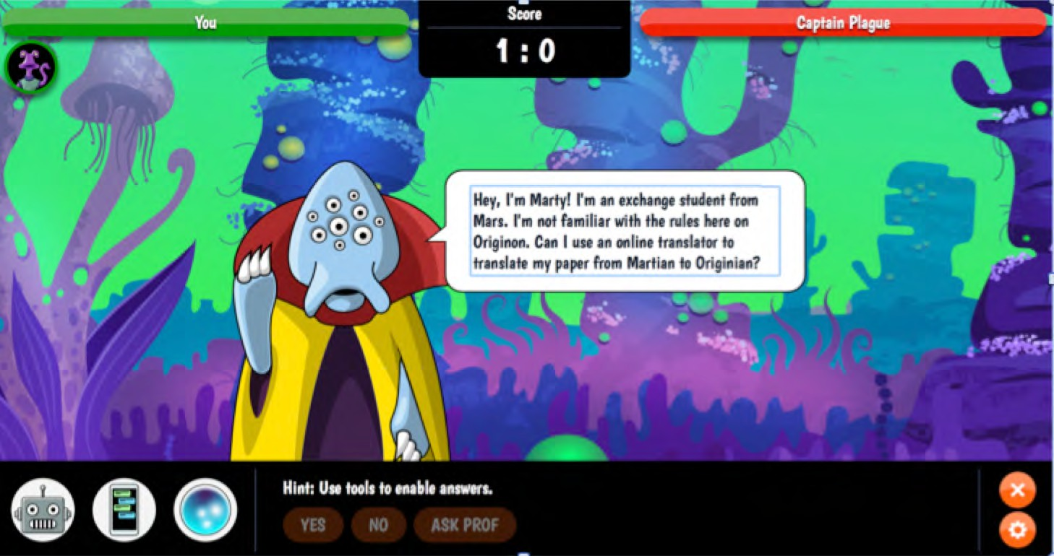](http://de.ryerson.ca/games/aio/)

*Figure 9.2.2 Academic Integrity game, Ryerson University. Click on image to play game*

**Video Game Simulation**: A Home Visit game promotes the application of knowledge and skills related to establishing a therapeutic nurse-client relationship and completing a mental health assessment. Students assume the role of a community health nurse assigned to complete a home visit. Video is used to create an authentic experience, and students have to respond to particularly challenging situations, based on procedures taught elsewhere in the course. Depending on the student response, further video segments are used to provide feedback and to continue to scenarios to test the next appropriate procedure.

[](https://de.ryerson.ca/games/nursing/mental-health/game.html%23/video/0/0/-1)

*Figure 9.2.3 Home visit video game, Ryerson University. Click on image to see video.*

Instructors from Centennial College, Toronto Metropolitan University and George Brown College have developed a series of open access video game simulations through a [virtual](https://de.ryerson.ca/games/nursing/hospital/) [healthcare experience portal](https://de.ryerson.ca/games/nursing/hospital/).

[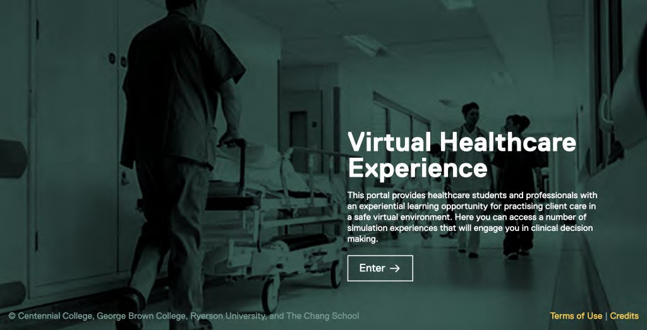](https://de.ryerson.ca/games/nursing/hospital/)

*Figure 9.2.4 The Virtual Healthcare Experience (click on image to view)*

**Gamification:** Kyle Geske, an instructor at Red River College, Winnipeg, has developed [a games-based approach to teaching web design](https://teachonline.ca/pockets-innovation/games-based-approach-teaching-web-design-red-river-college-manitoba-canada). In his elective course on Full Stack Development of web sites, students have to design a project according to principles provided by the instructor. At each stage of the design process within the project students gain marks, and compete throughout the course with other students, who can see the marks at each stage for all the other students. A student can ‘level up’ their mark by going back and improving on each of the steps of the design. This approach has resulted in an increase in the average end of course grade compared to the more traditional classroom methods. Note this course involves elements of gaming, such as competition, and ‘levelling up’, without using games themselves.

#### Designing serious games

Zhonggen’s review of the literature ([2019](https://www.hindawi.com/journals/ijcgt/2019/4797032/)) highlighted the importance of the following in effective games design:

•backstory and production,

•realism,

•artificial intelligence and adaptivity,

•interaction,

•feedback and debriefing,

•ease of use,

•surprises.

Building on prior research, and under the leadership of Naza Djafarova, the Digital Education Strategies team (DES) at the G. Raymond Chang School for Continuing Education at Toronto Metropolitan University developed [a practical design guide](https://de.ryerson.ca/games/research/) for serious game-based learning, based on a games research process. This guide is an open educational resource and is designed to serve three purposes:

* provide a conceptual framework to guide game design within multidisciplinary teams in higher education;
* offer a methodological guide to running a participatory workshop focused on the pre-production phase of the game development process;
* share resources by making the guide and the design of the workshop available as open educational resources.

The games design methodology is an adaptation of the Design, Play, and Experience (DPE) Framework, developed by Winn ([2009](https://www.igi-global.com/book/handbook-research-effective-electronic-gaming/459)). The game development process consists of three phases:

* the **pre-production phase**, during which brainstorming among team members takes place, leading to the design of a paper prototype of the game;
* the **production phase**, when the game is developed; and
* the **post-production phase**, during which the game is tested and refined before being offered to learners.

The Digital Education Strategies team utilized the Design, Play and Experience model to identify four essential educational game elements:

* **Learning** refers to the content to be learned by players through the game with specific and measurable learning outcomes;
* **Storytelling** refers to the background story of the game and includes a description of the character(s), the setting, and the ultimate goal of the game;
* **Gameplay** refers to the way in which the player interacts with the game, or with other players (if a multiplayer game). It encapsulates the type of activity (e.g., puzzle, trivia, etc.) found in the game;
* User Experience refers to the player’s emotions and attitudes while playing the game, as well as how the player interacts with the game.

Figure 9.2.5 provides a more detailed representation of the various components of the Ryerson serious game design methodology.

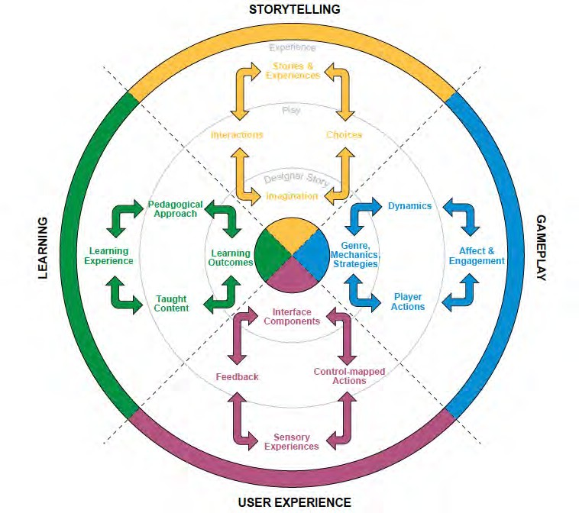

*Figure 9.2.5 Serious game design methodology, from Djafarova er al., 2018*

The Digital Education Strategies’ report suggests a workshop approach to serious games design, in which all the key stakeholders (content experts, instructional designers, media producers, and so forth) are involved. Brainstorming in the early stages of design is considered essential. Also built into the design is testing and user feedback before releasing the game.

There are probably other effective design approaches, but the above approach highlights the essential multi-disciplinary approach of serious games design.

#### Unique educational characteristics of serious games

These still need to be clearly identified and validated, but two rather different claims are made for serious games:

* the first is that they can increase student motivation and engagement;
* the second is that games can be particularly useful for developing the following skills:
  + problem solving
  + communication skills
  + decision-making

within specific contexts that approximate to the real world.

#### Strengths and weaknesses

In terms of the hype cycle, serious games are somewhere along the slope of enlightenment. There is not the research yet to move them into the plateau of productivity, but there is enough evidence from practice that they are gaining traction in education.

However, there are a number of reasons why serious games have not become more prevalent in education. The first is philosophical. There is resistance to the idea of games because some see serious games as an oxymoron. How can a game be serious? Many instructors fear that learning could easily be trivialised through games or that games can cover only a very limited part of what learning should be about – it can’t all be fun; that is not the purpose of education. Similarly, many professional game designers are not interested in developing serious games because they fear that if the primary goal is learning and not enjoyment, a focus on education risks killing the main element of a game: being fun to play.

A more pragmatic reason is cost and quality. The assumed high cost of video games has so far acted as a deterrent in education. There is no obvious business plan to justify the investment. The best selling video games for entertainment for instance cost millions

of dollars to produce, on a scale similar to mainstream movies. If games are produced cheaply, won’t the quality – in terms of production standards, narrative/plot, visuals, and learner engagement – suffer, thus making them unattractive for learners?

However, probably the main reason serious games are not more prevalent in education is that most educators simply do not know enough about serious games: what exists, how they can be used, nor how to design them. Experience suggests that there are many possible and realistic applications for serious games in education. There is some evidence (see for instance, Arnab, [2014](https://onlinelibrary.wiley.com/doi/abs/10.1111/bjet.12113)) that effective serious games can be developed at very little cost.

Nevertheless, there is always a high degree of risk in serious games design. There is no sure way of predicting in advance that a new game will be successful. Some low- cost simple games can work well; some expensively produced games can easily flop. This means careful testing and feedback during development. So serious games should be more seriously considered for teaching in a digital age – but their application needs to be done carefully and professionally.

Thus serious games are a relatively high risk, high return activity for teaching in a digital age. Success in serious games means building on best practices in games design, both within and outside education, sharing costs and experience, and collaboration between institutions and games development teams. However, as teaching in a digital age moves more and more towards high-level skills development, experiential learning, and problem- solving in real world contexts, serious games are bound to play an increasingly important role.

#### References

Anastasiadis, T. et al. (2018) [Digital Game-based Learning and Serious Games in Education](https://ijasre.net/index.php/ijasre/article/view/814)

*International Journal of Advances in Scientific Research and Engineering*, Vol. 4, No. 12

Arnab, S. et al. (2014) [Mapping learning and game mechanics for serious games analysis](https://onlinelibrary.wiley.com/doi/abs/10.1111/bjet.12113).

*British Journal of Educational Technology*, Vol. 46, No. 2, pp 391–411

Clark, D. et al. (2016) [Digital Games, Design, and Learning: A Systematic Review and Meta-](https://journals.sagepub.com/doi/10.3102/0034654315582065) [Analysis](https://journals.sagepub.com/doi/10.3102/0034654315582065) *Review of Educational Research,* Vol. 86, No. 1

Deterding, S. et al. (2011) [Gamification: Using Game Design Elements in Non-Gaming](http://gamification-research.org/wp-content/uploads/2011/04/01-Deterding-Sicart-Nacke-OHara-Dixon.pdf) [Contexts](http://gamification-research.org/wp-content/uploads/2011/04/01-Deterding-Sicart-Nacke-OHara-Dixon.pdf) in *PART 2-Proceedings of the 2011 annual conference extended abstracts on Human Factors in Computing Systems* Vancouver BC: CHI

Dichev, C. and Dicheva Computers in Human D. (2017) [Gamifying education: what is](https://educationaltechnologyjournal.springeropen.com/articles/10.1186/s41239-017-0042-5) [known, what is believed and what remains uncertain: a critical review](https://educationaltechnologyjournal.springeropen.com/articles/10.1186/s41239-017-0042-5) *International Journal of Educational Technology in Higher Education*, Vol. 14, No. 9

Djafarova, N. et el. (2018) [*The Art of Serious Game Design*](https://de.ryerson.ca/games/research/)Toronto ON: Chang School of Continuing Studies, Ryerson University

Hamari, J., et al. (2016) [Challenging games help students learn: An empirical study on](https://www.researchgate.net/publication/280294047_Challenging_games_help_students_learn_An_empirical_study_on_engagement_flow_and_immersion_in_game-based_learning) [engagement, flow and immersion in game-based learning](https://www.researchgate.net/publication/280294047_Challenging_games_help_students_learn_An_empirical_study_on_engagement_flow_and_immersion_in_game-based_learning) *Computers in Human Behavior*, Vol. 54

Hunicke, R., LeBlanc, M., & Zubek, R. (2004). MDA: [A formal approach to game design](https://citeseerx.ist.psu.edu/viewdoc/download?doi=10.1.1.79.4561&rep=rep1&type=pdf) [and game research](https://citeseerx.ist.psu.edu/viewdoc/download?doi=10.1.1.79.4561&rep=rep1&type=pdf), in *Proceedings of the Challenges in Game AI Workshop*, San Jose CA: Nineteenth National Conference on Artificial Intelligence

Winn, B. (2009) ‘The design, play and experience framework’, in R. Ferdig (Ed.)[,](https://www.igi-global.com/book/handbook-research-effective-electronic-gaming/459) [*Handbook of*](https://www.igi-global.com/book/handbook-research-effective-electronic-gaming/459)[*research on effective electronic gaming in education*.](https://www.igi-global.com/book/handbook-research-effective-electronic-gaming/459) Hershey, PA: IGI Global (pp. 388–401).

Zhonggen, Y. (2019) [A Meta-Analysis of Use of Serious Games in Education over a Decade](https://www.hindawi.com/journals/ijcgt/2019/4797032/),

*International Journal of Computer Games Technology*, vol. 2019, Article ID 4797032

1. What are your views on serious games and gamification? Do you think they are useful approaches to teaching in a digital age, or are they just a gimmick that avoids the real challenges of learning, especially at a higher education level?
2. Take a look at the Toronto Metropolitan University’s ‘Art of Serious Games Design’. Is this a model that could be used at your institution? Who would lead this effort? With what learning goals or outcomes could this process help in your program? What would be the main barrier to doing this?
3. What other approaches could be taken to getting serious games used in your teaching?

Click on the podcast below for feedback on this activity:

Activity 9.2 Using and designing serious games

*One or more interactive elements has been excluded from this version of the text. You can view them online here:* [*https://pressbooks.bccampus.ca/teachinginadigitalagev3m/?p=289#audio-289-1*](https://pressbooks.bccampus.ca/teachinginadigitalagev3m/?p=289&audio-289-1)

# Virtual and augmented reality

[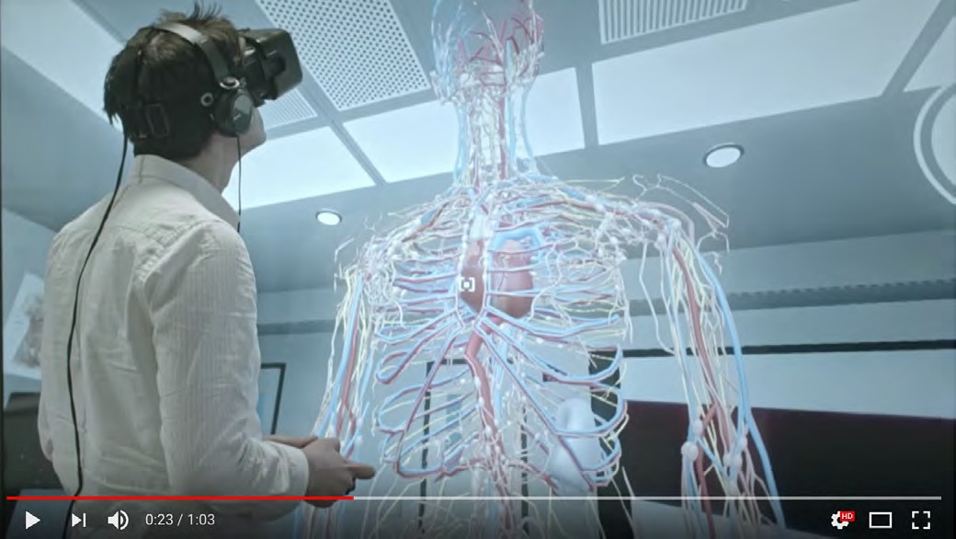](https://www.youtube.com/watch?v=CbynyhJ2PI0&ab_channel=VRTree)

Figure 9.3.1 Human Anatomy through Virtual Reality (click on image to see video)

As with serious games, virtual and augmented reality are technologies that have been around for some time while making a relatively small impact on education in their earlier development. However, more recent technological developments have moved virtual worlds from two-dimensions (such as [Second Life](https://secondlife.com/)) into three-dimensional, deeply immersive environments. This has brought more attention to their potential in education (for a good overview of the history and potential of augmented and virtual reality in education, see Elmqadden, [2019](https://online-journals.org/index.php/i-jet/article/view/9289/5456)).

#### What are virtual, augmented and mixed reality?

A simple definition of these technologies is ‘*human immersion in a synthetic world*‘ (Seidel

and Chatelier, [1997](https://link.springer.com/book/10.1007%2F978-1-4899-0038-8)). [The Franklin Institute](https://www.fi.edu/difference-between-ar-vr-and-mr#targetText%3DAugmented%20reality%20(AR)%20adds%20digital%2Cshuts%20out%20the%20physical%20world) provides the following more detailed definitions that attempt to distinguish between the different types of ‘synthetic’ worlds:

***Augmented reality (AR)*** *adds digital elements to a live view often by using the camera on a smartphone. Examples of augmented reality experiences include* [*Snapchat lenses*](https://lensstudio.snapchat.com/lenses/) *and the game* [*Pokémon Go*](https://pokemongolive.com/en/)*.*

***Virtual reality (VR)*** *implies a complete immersion experience that shuts out the physical world. Using VR devices such as* [*HTC Vive*](https://www.vive.com/us/)*,* [*Meta Quest 2*](https://store.facebook.com/ca/quest/products/quest-2/) *or* [*Google Cardboard,*](https://vr.google.com/cardboard/) *users can be transported into a number of real-world and imagined environments such as the middle of a squawking penguin colony or even the back of a dragon.*

*In a* ***mixed reality (MR)*** *experience, which combines elements of both AR and VR, real- world and digital objects interact. Mixed reality technology is just now starting to take off, with* [*Microsoft’s HoloLens*](https://www.microsoft.com/en-us/hololens) *one of the most notable early mixed reality apparatuses.*

I will use the term ‘immersive technologies’ for all these technologies. However, verbal descriptions will always be somewhat inadequate in describing what are essentially multi- sensory experiences, combining vision, hearing and movement. These technologies are something that need to be experienced rather than explained if they are to be better understood.

#### Why use immersive technologies?

There are several reasons why these technologies are beginning to be used more in education:

* the recent development of relatively low cost and easily wearable end-user technology (headsets in particular);
* deep immersion into three-dimensional, highly realistic learning environments that are strongly compelling/motivating for the end user;
* the ability for end users to manipulate objects within the three dimensional environment;
* more powerful cloud computing technology that allows for the development of more complex and more realistic learning environments, combined with more advanced

developments in mobile technologies and high-speed wireless networks;

* the potential for developing a range of skills and knowledge that would be difficult, impossible or dangerous in real-world environments.

#### Examples of immersive environments in education

Looking at the challenges above, it may be wondered why anyone would bother with immersive technologies in education. However, the potential benefits have barely been explored. I provide examples here that demonstrate both the potential benefits and how some immersive environments can be developed relatively easily. (For a more systematic review of VR applications in higher or post-secondary education, see Radianti et al., [2020](https://www.sciencedirect.com/science/article/pii/S0360131519303276?dgcid=rss_sd_oa&b32))

##### Virtual reality

In the Department of Chemistry at the University of Bristol in England, Dr. David Glowacki and his team in their VR laboratory created an interactive molecular dynamics modelling tool in the form of [Nano Simbox VR](https://isci.itch.io/nsb-imd), which allowed anyone to visit and play within the invisible molecular world (O’Connor et al., [2018](https://advances.sciencemag.org/content/4/6/eaat2731)). The main aim of this particular project was to provide an intuitive feeling of the way molecules operate in multiple dimensions to enable researchers and students to have a better understanding of how nano worlds operate, leading to better hypotheses for testing within this particular domain.

As the authors state in the article:

*From a modeling perspective, the nanoscale represents an interesting domain, because the objects of study ( for example, molecules) are invisible to the naked eye, and their behavior is governed by physical forces and interactions significantly different from those forces and interactions that we encounter during our day-to-day phenomenological experience. In domains like this, which are imperceptible to the naked eye, effective models are vital to provide the insight required to make research progress….molecular systems typically have thousands of degrees of freedom. As a result, their motion is characterized by a*

*complicated, highly correlated, and elegant many-body dynamical choreography, which is non-intuitive compared to the more familiar mechanics of objects that we encounter in the everyday physical world. Their combined complexity, unfamiliarity, and importance make molecules particularly interesting candidates for investigating the potential of new digital modeling paradigms.*

Glowacki and his team in Science Advances (O’Connor et al., [2018](https://advances.sciencemag.org/content/4/6/eaat2731)) describe how the VR app enabled researchers to:

* + - * + easily “grab” individual C60 atoms and manipulate their real-time dynamics to pass the C60 back and forth between each other.
        + take hold of a fully solvated benzylpenicillin ligand and interactively guide it to dock

it within the active site of the TEM-1 β-lactamase enzyme (with both molecules fully flexible and dynamic) and generate the correct binding mode ([*33*](http://advances.sciencemag.org/content/4/6/eaat2731#ref-33)), a process that is important to understanding antimicrobial resistance

* + - * + guide a methane molecule (CH4) through a carbon nanotube, changing the screw sense of an organic helicene molecule,
        + tie a knot in a small polypeptide [17-alanine (17-ALA)

[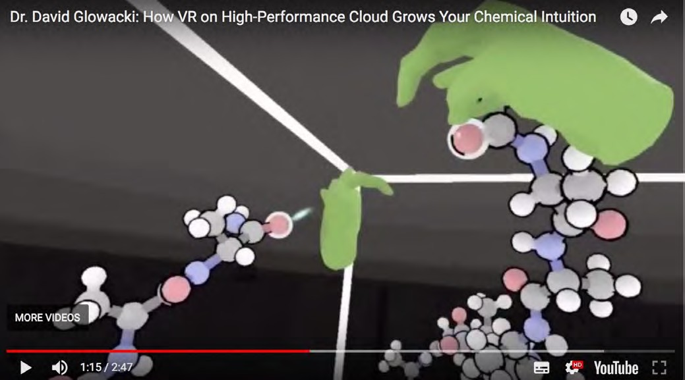](https://www.youtube.com/watch?v=vJ10_sltxfc)

*Figure 9.3.2 The use of virtual reality to foster chemical intuition, developed by Dr. David Glowacki at the University of Bristol. Click on the image to see the video.*

Building dynamic models that operate not only in real time but also in three dimensions can require not only specialized virtual reality equipment, but more importantly massive amounts of computing power to handle the visual representation and modelling of highly complex, interactive dynamic molecular processes. However, through the use of cloud computing and faster networks, building such models has now become a reality, enabling not only such models to be represented but allowing some degree of real-time manipulation by researchers in different locations but within the same time-frame. The main advantage of the use of a cloud platform is to allow the scaling up of modelling from simple to much more complex dynamic nano interactions and the synchronous sharing of the virtual reality experience with multiple users.

Not all applications of VR though need massive computing power. Other exploratory uses of virtual reality are

* + - * + for students [to find their way round a complex campus](https://teachonline.ca/pockets-innovation/carleton-virtual)
        + in architecture/space planning, allowing clients to understand in three dimensions the final ‘look’ of a building design by virtually walking through it (Brandaõ et al., [2018](https://link.springer.com/chapter/10.1007/978-3-319-91803-7_6#targetText%3DBroadly%2C%20virtual%20reality%20(VR)%2Creal%20presence%20in%20those%20spaces)). [Google Blocks,](https://vr.google.com/blocks/) a free software program for developing 3D models, is one tool that can support this kind of application.
        + in music: at the University of British Columbia, Dr. Jonathan Girard is exploring [the](http://eml.ubc.ca/projects/interactive-orchestra/) [use of VR for learning how to conduct an orchestra](http://eml.ubc.ca/projects/interactive-orchestra/) (the virtual orchestra ‘responds’ to the hand gestures of the conductor)
        + in medicine and health: researchers at UBC are exploring [the use of VR for pain](https://blogs.ubc.ca/arvrha/) [management](https://blogs.ubc.ca/arvrha/)

##### Augmented reality

Augmented reality is a simpler immersive technology than virtual reality, often based on apps for mobile phones. For instance, students in the University of British Columbia’s APBI 200 Introduction to Soil Science learn about the effects of topography on the formation of different soil types. The department has developed the [Soil TopARgraphy](http://eml.ubc.ca/projects/soil-topargraphy/) app, which allows viewing and manipulating a terrain model in the Kamloops region of British Columbia. Students learn how topography impacts the distribution of soil orders through its effects on microclimate (i.e. temperature and water). Students are able to view the

terrain model with a color-coded elevation map or a satellite image on their mobile phones. Furthermore, students can tap on flags to read about different soil orders, view images, and take a self-study quiz to reinforce their understanding.

For this project, UBC’s Emerging Media Lab built two mobile apps, an AR viewer for students (Android and iOS) and an editor for the instructor (Android). The AR viewer is the app described above to view a predefined terrain. The instructor can customize contents with the supplementary editor app. They can update soil location on terrain, description, image, and quizzes

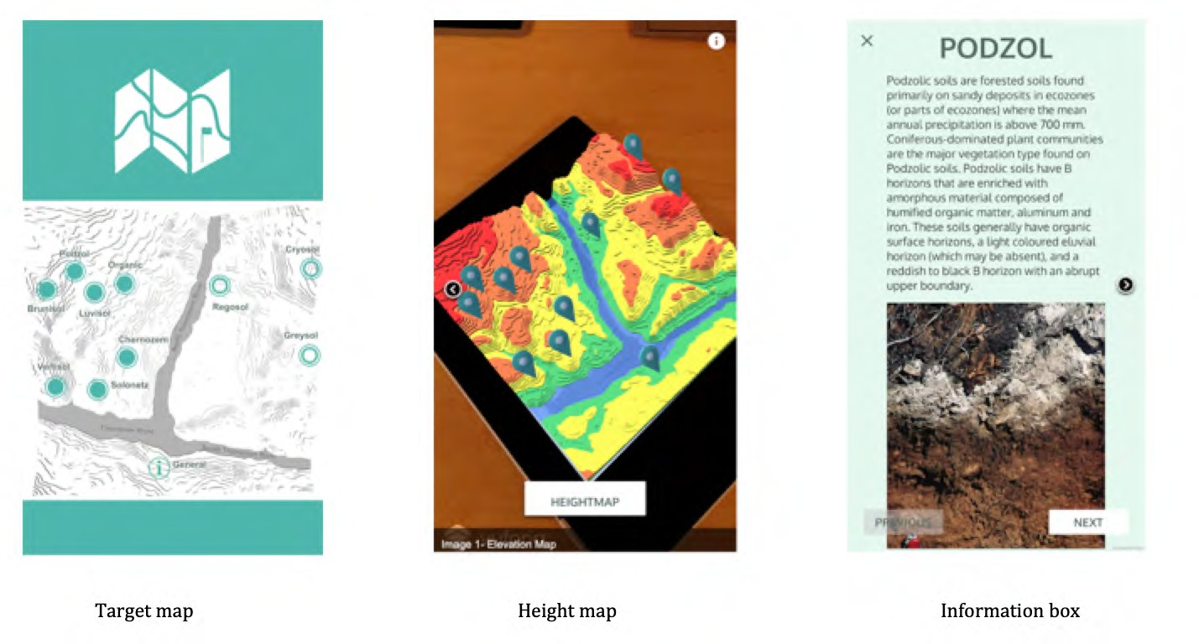

Figure 9.3.3 Screen images from Soil TopARgraphy Other examples of AR applications from UBC:

* + - * + Dr. Patrick Walls is developing [a mobile phone-based app](http://eml.ubc.ca/projects/math-world/) that helps students visualise multivariable functions, in order to learn the underlying concepts at a deeper level much more quickly.
        + in GEOG 498: Geographies in the Middle East, students learn about the history of the

Syrian Civil War and its ongoing developments. The instructor, Dr. Siobhán McPhee, has developed [a mobile app](https://eml.ubc.ca/projects/journey-with-me/?login) that follows the stories of five Syrian refugees who eventually reached Vancouver. Students are forced to make choices (or given a lack of choice), wait, and run/walk with the app to be able to progress the narrative of the experience. [The purpose of this project is to evoke empathy and help students](https://events.ubc.ca/teaching-empathy/) [understand the emotional consequences of the Syrian Civil War.](https://events.ubc.ca/teaching-empathy/) This app also applies some gamification principles as well.

#### Designing immersive educational environments

This technology is so recent that there are few or no accepted best practices developed yet for educational use. Most educational applications to date have been deliberately exploratory in nature. However, there are several stages of development required that will apply to all educational applications of these technologies:

* identify start-up costs and possible sources of funding: this is not likely to be a cheap exercise, at least initially; for this reason, several universities, such as the [University of British Columbia](https://eml.ubc.ca/), and [Drexel University](http://digm.drexel.edu/acelab/irl-launch/), have set up their own emerging technologies research labs to experiment with educational applications;
* define learning outcomes/objectives: what is the learner expected to learn? In the early stages of development this may be both a brainstorming exercise (preferably including students/end-users) and an iterative process, because the full potential of the technology is not always clear in first applications. In particular, the instructor needs to have a clear vision of what might be possible using an immersive technology. Thus some familiarity with the technology is essential before starting design;
* determine where the use of this technology fits within the overall design of a course/program: in other words, what knowledge and skills will be developed within the immersive environment, and how does this integrate with what is being taught in the rest of the course/program?
* decide between using an existing immersive design/learning environment that can be applied or adapted relatively easily for ‘local’ use; or designing a new immersive environment from scratch. The latter is obviously more expensive and time- consuming and will require a high level of expertise; as a result the pay-off from

design from scratch (improved learning outcomes/return on investment) needs to be worth the effort;

* choice of appropriate/affordable technology. Headsets or mobile apps are the least expensive part of the use of immersive technologies. The main cost will be in developing or adapting the ‘augmented’ or ‘virtual’ world. However, as with serious games, there can be an intermediary step, where an existing ‘world’ can be licensed and adapted for local use (see for instance, [Lightwave](https://www.lightwave3d.com/try/)). In some cases, open access immersive worlds are available for use or adaptation, although they are not common (see [OpenSimulator,](http://opensimulator.org/wiki/Main_Page) [Art of Illusion](http://www.artofillusion.org/), or [MayaVerse](https://medium.com/%40enrico.speranza/mayaverse-open-source-immersive-virtual-world-manifesto-7e2b9a586a02), for examples.). Often students can be used to help with programming and design of the environment, as part of their studies, but they will need direction as well as the opportunity to offer creative ideas. Truly interactive virtual worlds where learners/users make decisions and the consequences are ‘programmed’ into the learning environment may require large amounts of computing capacity, such as cloud computing;
* to be effective, the VR environment has to be as authentic or realistic as possible. This means paying as much attention to creating the specific learning context. It will be necessary to decide what parts of the learning will best be done outside the VR/ AR experience, and which inside. For instance, the procedures for monitoring the state of a nuclear reactor, for identifying critical incidents, for deciding whether or not or when to shut down the reactor, and for actually shutting down the reactor must also be built in to the learning process. Most of this may be taught outside the VR context, but VR can be used to test or develop the skills of applying this knowledge in a realistic, challenging context. In other words, the VR experience needs to be embedded within a broader learning context or environment;
* testing and adaptation: design, at least initially, needs to be an iterative process, where ideas are developed and tried, and feedback received and incorporated into the design;
* assessment: this can be a particular challenge, particularly if new learning outcomes result from the experience. How can assessment best capture what students have learned? Will assessment take place within the ‘virtual’ world, in the real world, or in some other way (and if so, how authentic will such an assessment be)?
* in what ways could the new immersive environment be scaled up to enable costs to be recovered?
* evaluation: what is the best way to evaluate the success or limitations of the design and application of the immersive world? How best to disseminate the knowledge and experience gained?

These may appear formidable challenges, but the potential benefits could be considerable.

#### The unique characteristics of immersive technologies

The development of fully immersive technologies is so recent that it is premature to try to identify all the educational affordances that are unique to this medium. New applications are being explored all the time. Most of the evidence is qualitative, based on people’s personal experience of using the technology. Empirical evidence that validates specific educational affordances of VR/AR in terms of improved learning outcomes is currently lacking. However, the *potential* of VR/AR in terms of assisting learning can be identified.

First of all, many of the affordances or educational characteristics of other media, and in particular video, will apply to VR and AR, but often more intensely, because of the immersive experience.

Virtual and augmented reality applications can provide students with a deep, intuitive understanding of phenomena that are otherwise difficult if not impossible to achieve in other ways. This enables students who often struggle with the abstract nature of an academic subject to understand in more concrete terms what the abstractions mean or represent. This intuitive understanding is critical not only for deeper understanding but also for breakthroughs in research and applications of science.

Educational applications where the cost of alternative or traditional ways of learning are too expensive or too dangerous, will be particularly suitable for virtual reality applications. Examples might be emergency management, such as shutting down an out-of-control nuclear reactor, or defusing a bomb, or managing a fire on an oil tanker, or exploring inside the physical structure of a human brain. In particular, VR would be appropriate for learning in contexts where real environments are not easily accessible, or where learners need to cope with strong emotions when making decisions or operating under pressure in real time.

AR, which is often easier to design and implement, enables learners to practice applications of knowledge in semi-realistic contexts.

However, at the time of writing we are just beginning to understand the potential of this medium. Over time, the educational affordances of this medium will become much clearer.

#### Strengths and weaknesses

VR is not just a fad that will disappear. There are already a large number of commercial applications, mainly in entertainment and public relations, but also increasingly for specific areas of education and training. There is already a lot of excellent, off-the-shelf software for creating VR environments, and the cost of hardware is dropping rapidly (although good quality headsets and other equipment are still probably too expensive for required use by large numbers of students).

The fields of application of this technology are unlimited: training in the use of complex equipment, simulation of surgical procedures, architectural design testing, the reconstruction of sites in archeology, virtual museum visits, treatment of pain and phobias, and many other possibilities.

To enable the more emotional aspects of decision making to be handled, the immersive experience needs to be realistic. This will probably require high quality media production. Thus VR may often need to be combined with simulation design, quality media production and powerful computing to be educationally effective, again pushing up the cost. For these reasons, medicine is a particularly likely area for development, where traditional training costs are really high or where training is difficult to provide with real patients.

Once again, though, applications will tend to be very specific to the needs of a particular subject area. This means designers must include subject specialists with a deep understanding of the field who can combine the power of the technology with the needs of learners in a particular learning context. VR in particular requires instructors with imagination and creativity, working with other professionals such as media producers, learners themselves, as well as specialists in VR design.

What has inhibited widespread educational use of earlier two-dimensional VR developments such as Second Life has been the high cost and difficulty of creating the graphics and contexts for learning. Thus even if the hardware and software costs for VR are low enough for individual student use, the high production costs of creating realistic educational contexts and scenarios are likely to inhibit its general use.

Some caution is also needed in assuming that people will behave the same in real life as they do in VR environments. Gallup et al. (2019) found a major difference in the influence of social factors within real-world and virtual environments: social cues in actual reality

appear to dominate and supersede those in VR. One of the authors, Alan Kingstone, concluded:

*“Using VR to examine how people think and behave in real life may very well lead to conclusions that are fundamentally wrong. This has profound implications for people who hope to use VR to make accurate projections regarding future behaviours. For example, predicting how pedestrians will behave when walking amongst driverless cars, or the decisions that pilots will make in an emergency situation. Experiences in VR may be a poor proxy for real life.”*

Rolfsen, [2019](https://news.ubc.ca/2019/01/24/people-think-and-behave-differently-in-virtual-reality-than-they-do-in-real-life/)

This means we need more experimentation. This is still a relatively new technology, and there may be very simple ways to use it in education that are not costly and meet needs that cannot be easily met in traditional teaching or with other existing technology. For this to happen, though, educators, software developers, and media producers need to come together to play, experiment, test and evaluate.

Nevertheless, VR and AR are exciting technologies with the potential to change radically conventional learning processes.

#### References

Brandaõ, G. et al. (2018) [Virtual Reality as a Tool for Teaching Architecture](https://link.springer.com/chapter/10.1007/978-3-319-91803-7_6#targetText%3DBroadly%2C%20virtual%20reality%20(VR)%2Creal%20presence%20in%20those%20spaces) in *Design, User Experience, and Usability: Designing Interactions* Las Vegas NV: Proceedings of 7th International Conference, DUXU 2018, held as Part of HCI International 2018,

Connolly, B. (2018) [How virtual reality is transforming learning at the University of](https://www.cio.com/article/202009/how-virtual-reality-is-transforming-learning-at-the-university-of-newcastle.html) [Newcastle,](https://www.cio.com/article/202009/how-virtual-reality-is-transforming-learning-at-the-university-of-newcastle.html) CIO, 8 March

Elmqadden, N. (2019) [Augmented Reality and Virtual Reality in Education: Myth or Reality?](https://online-journals.org/index.php/i-jet/article/view/9289/5456)

*International Journal of Emerging Technologies in Learning*, Vol. 14, No. 3

Gallup, A. et al. (2019) [Contagious yawning in virtual reality is affected by actual, but not](https://www.nature.com/articles/s41598-018-36570-2.epdf) [simulated, social presence](https://www.nature.com/articles/s41598-018-36570-2.epdf) Nature: Scientific Reports, 22 January

O’Connor, M. et al. (2018) [Sampling molecular conformations and dynamics in a multiuser](http://advances.sciencemag.org/content/4/6/eaat2731) [virtual reality framework](http://advances.sciencemag.org/content/4/6/eaat2731), *Science Advances*, Vol. 4, No.6, 29 June

Radianti, J. et al. (2020) [A systematic review of immersive virtual reality applications for](https://www.sciencedirect.com/science/article/pii/S0360131519303276?dgcid=rss_sd_oa&b32) [higher education: Design elements, lessons learned, and research agenda](https://www.sciencedirect.com/science/article/pii/S0360131519303276?dgcid=rss_sd_oa&b32) *Computers & Education*, Vol. 147, April

Rolfson, E. (2019) [People think and behave differently in virtual reality than they do in real](https://news.ubc.ca/2019/01/24/people-think-and-behave-differently-in-virtual-reality-than-they-do-in-real-life/) [life](https://news.ubc.ca/2019/01/24/people-think-and-behave-differently-in-virtual-reality-than-they-do-in-real-life/) *UBC News, 24 January*

Seidel, R. and Chatelier, P. (1997) [*Virtual Reality, Training’s Future?: Perspectives on Virtual*](https://link.springer.com/book/10.1007%2F978-1-4899-0038-8)[*Reality and Related Emerging Technologies*](https://link.springer.com/book/10.1007%2F978-1-4899-0038-8)Berlin: Springer Science & Business Media

###### Activity 9.3 Using and designing VR and AR

* Go to YouTube and type in ‘[Virtual Reality](https://www.youtube.com/results?search_query=virtual%2Breality%2Bin%2Beducation) in Education’ in the search box (I found about 20 examples). Do any of these videos suggest a way in which VR could be used in the area in which you are teaching (assuming that the resources were available)?
* What are the advantages of VR over video? What can it do educationally that would be more difficult to do using video?
* Your head of department has just come back from a conference and has seen a demonstration of VR. He is very excited and wants the department to ‘become the leader in the state in the use of VR for teaching.’ What questions would you ask of him? (Assume you will still keep your job afterwards!)

Click on the podcast below for my feedback and my personal views on VR for teaching and learning.

*One or more interactive elements has been excluded from this version of the text. You can view them online here:* [*https://pressbooks.bccampus.ca/teachinginadigitalagev3m/?p=294#audio-294-1*](https://pressbooks.bccampus.ca/teachinginadigitalagev3m/?p=294&audio-294-1)

# Artificial intelligence



*Figure 9.4.1 Image: Applift*

#### Focusing on AI’s affordances for teaching and learning

Artificial intelligence (AI) is a daunting topic as there are so many issues with respect to its use in education. AI is also currently going through yet another period of extreme hype as a panacea for education, currently being at the top of the peak of inflated expectations, but this hype is driven mainly by successful applications outside the field of education, such as in finance, marketing and medical research. Furthermore the term ‘AI’

is increasingly being used (incorrectly) as a general term for any complex computational activity.

Even in education, there are very different possible areas of application of AI. Zeide ([2019](https://er.educause.edu/articles/2019/8/artificial-intelligence-in-higher-education-applications-promise-and-perils-and-ethical-questions)) makes a very useful distinction between institutional, student support and instructional applications (Figure 9.4.2 below).

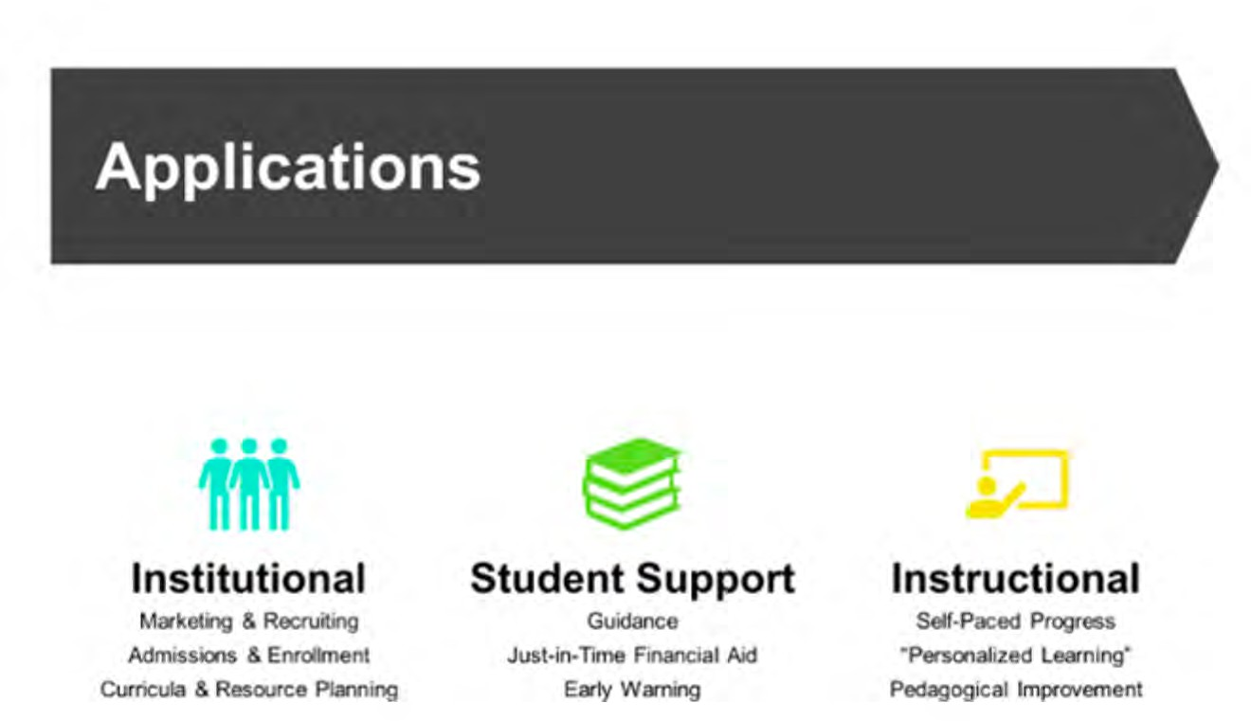

*Figure 9.4.2 AI applications in education Image: © Zeide, 2019*

Although AI applications for institutional or student support purposes are very important, this chapter is focused on the pedagogical affordances of different media and technologies (what Zeide calls ‘instructional’ applications). In particular, the focus in this section will be on the role of AI as a form of media or technology for teaching and learning, its pedagogical affordances, and its strengths and weaknesses in this area.

Moreover, AI is really a sub-set of computing. Thus all the general affordances of computing in education set out in Chapter 8, Section 5 will apply to AI. This section aims

to tease out the extra potential that AI can offer in teaching and learning. This will mean particularly focusing on its role as a medium rather than a general technology in teaching, which means looking at a wider context than just the computational aspects of AI, in particular its pedagogical role.

#### What is artificial intelligence?

The original definition of artificial intelligence by McCarthy (1956, cited in Russell & Norvig, [2010](https://www.pearson.com/us/higher-education/program/Russell-Artificial-Intelligence-A-Modern-Approach-3rd-Edition/PGM156683.html)) is:

*every aspect of learning or any other feature of intelligence can in principle be so precisely described that a machine can be made to simulate it. An attempt will be made to find how to make machines use language, form abstractions and concepts, solve kinds of problems now reserved for humans, and improve themselves.*

Zawacki-Richter et al. ([2019](https://educationaltechnologyjournal.springeropen.com/articles/10.1186/s41239-019-0171-0)), in a review of the literature on AI in higher education, report that those authors that defined artificial intelligence tended to describe it as:

*intelligent computer systems or intelligent agents with human features, such as the ability to memorise knowledge, to perceive and manipulate their environment in a similar way as humans, and to understand human natural language.*

Klutka et al. (2018) also defined AI in terms of what it can do in higher education (Figure 9.4.3 below):

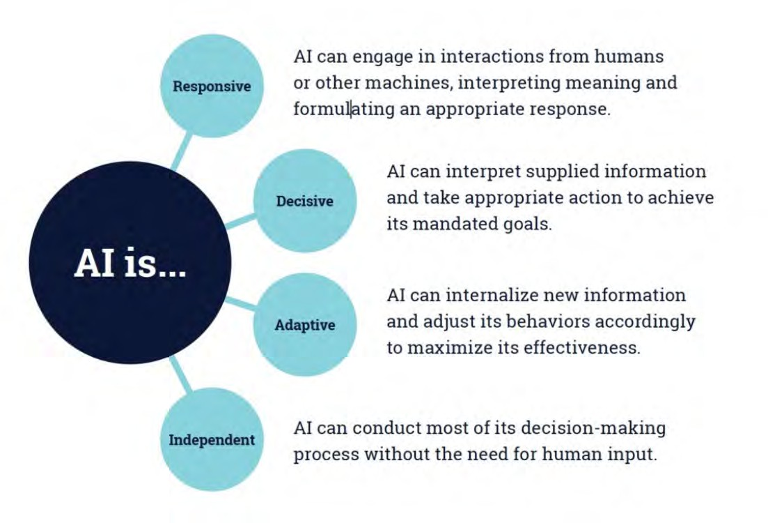

*Figure 9.4.3 What AI can do in education Image: Klutka et al. (2018)*

There are three basic computing requirements that set ‘modern’ AI apart from other computing applications:

* access to massive amounts of data;
* computational power on a large scale to manage and analyze the data;
* powerful and relevant algorithms for the data analysis.

#### Why use artificial intelligence for teaching and learning?

There are two somewhat different goals for the general use of artificial intelligence. The first is to increase the efficiency of a system or organization, primarily by reducing the high costs of labour, namely by replacing relatively expensive human workers with

relatively less costly machines (automation). Politicians, entrepreneurs and policy makers increasingly see a move to automation as a way of reducing the costs of education. However, in education in particular, teachers and instructors are the main cost.

The second is to increase the effectiveness of teaching and learning, in economic terms to increase outputs: better learning outcomes and greater benefits for the same or more cost. With this goal, AI would be used alongside or supporting teachers and instructors.

Klutka et al. ([2018](https://www.learninghouse.com/knowledge-center/research-reports/artificial-intelligence-in-higher-education/)) provided a general statement of the potential of AI in higher education ‘instruction’ through Figure 9.4.4:

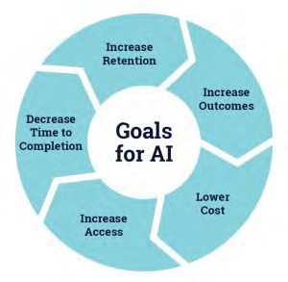

*Figure 9.4.4 Goals for AI in higher education instruction Image: Klutka et al. (2018)*

These are understandable goals, but we shall see later in this section that such goals to date are mainly aspirational rather than real.

In terms of this book, a key focus is on developing the knowledge and skills required by learners in a digital age. The key test then for artificial intelligence is to what extent it can assist in the development of these higher level skills.

#### Affordances and examples of AI use in teaching and learning

Zawacki-Richter et al. ([2019](https://educationaltechnologyjournal.springeropen.com/articles/10.1186/s41239-019-0171-0)) in a review of the literature on AI in education initially identified 2,656 research papers in English or Spanish, then narrowed the list down by eliminating duplicates, limiting publication to articles in peer-reviewed journals published between 2007 and 2018, and eliminating articles that turned out in the end not to be about the use of AI in education. This resulted in a final 145 articles which were then analysed. Zawacki-Richter et al. then classified these 145 papers into different uses of AI in education. This section draws heavily on this classification. (It should be noted that within the 145 articles, only 92 were focused on instruction/student support. The rest were on institutional uses such as identifying at risk students before admission).

The Zawacki-Richter study offers one insight into the main ways that AI has been used in education for teaching and learning over the ten years between 2007 and 2018, the closest we can come to ‘affordances’. First, three main general ‘instructional’ categories (with considerable overlap) from the study are provided below, followed by some specific examples. (I have omitted Zawacki-Richter et al.’s category of profiling and prediction concerned with administrative issues such as admissions, course scheduling, and early warning systems for students at risk.)

##### Intelligent tutoring systems (29 out of 92 articles reviewed by Zawacki-Richter et al.)

Intelligent tutoring systems:

* + - * + provide teaching content to students and, at the same time, support them by giving adaptive

feedback and hints to solve questions related to the content, as well as detecting students’ difficulties/errors when working with the content or the exercises;

* + - * + curate learning materials based on student needs, such as by providing specific recommendations regarding the type of reading material and exercises done, as well as personalised courses of action;
        + facilitate collaboration between learners, for instance, by providing automated feedback, generating automatic questions for discussion, and the analysis of the process.

##### Assessment and evaluation (36 out of 92)

AI supports assessment and evaluation through:

* + - * + automated grading;
        + feedback, including a range of student-facing tools, such as intelligent agents that provide students with prompts or guidance when they are confused or stalled in their work;
        + evaluation of student understanding, engagement and academic integrity.

##### Adaptive systems and personalization (27 out of 92)

AI enables adaptive systems and the personalization of learning by:

* + - * + teaching course content then diagnosing strengths or gaps in student knowledge, and providing automated feedback;
        + recommending personalized content;
        + supporting teachers in learning design by recommending appropriate teaching strategies based on student performance;
        + supporting representation of knowledge in concept maps.

Klutka et al. ([2018](https://www.learninghouse.com/knowledge-center/research-reports/artificial-intelligence-in-higher-education/)) identified several uses of AI for teaching and learning in universities in the USA.

* + - * + [ECoach](https://ai.umich.edu/blog-posts/ecoach-personalized-learning-software-powered-by-people/)[,](https://ai.umich.edu/portfolio/e-coach/) developed at the University of Michigan, provides formative feedback for a variety of mainly large classes in the STEM field. It tracks students progress through a course and directs them to appropriate actions and activities on a personalized basis
        + [sentiment analysis](https://www.insidehighered.com/digital-learning/article/2018/02/20/sentiment-analysis-allows-instructors-shape-course-content?mc_cid=0dc77a9abc&mc_eid=8fd1b71572) (using students’ facial expressions to measure their level of engagement in studying),
        + [an application to monitor student engagement in discussion forums](https://www.forbes.com/sites/amitchowdhry/2017/11/20/packback-is-building-a-i-to-enhance-university-learning/#280d228e2921), and
        + [organizing commonly shared mistakes in exams into groups](https://www.gradescope.com/) for the instructor to respond once to the group rather than individually.

##### Chatbots

A chatbot is programming that simulates the conversation or ‘chatter’ of a human being through text or voice interactions (Rouse, [2018](https://searchcustomerexperience.techtarget.com/definition/chatbot)). Chatbots in particular are a tool used to automate communications with students. Bayne ([2014](https://www.tandfonline.com/doi/full/10.1080/13562517.2015.1020783)) describes one such application in a MOOC with 90,000 subscribers. Much of the student activity took place outside the Coursera platform within social media. The five academics teaching the MOOC were all active on Twitter, each with large networks, and Twitter activity around the MOOC hashtag (#edcmooc) was high across all instances of the course (for example, a total of around 180,000 tweets were exchanged on the first offering of the MOOC). A ‘Teacherbot’ was designed to roam the tweets using the course Twitter hashtag, using keywords to identify ‘issues’ then choosing pre-designed responses to these issues, which often entailed directing students to more specific research on a topic. For a review of research on chatbots in education, see Winkler and Söllner ([2018](https://www.researchgate.net/publication/324112615_Unleashing_the_Potential_of_Chatbots_in_Education_A_State-Of-The-Art_Analysis/figures?lo=1)[).](https://www.alexandria.unisg.ch/254848/1/JML_699.pdf)

##### Automated essay grading

Thompson [(2022)](https://assess.com/automated-essay-scoring/) provides a simple explanation, aimed mainly at teachers, of how automated essay scoring (AES) works.

*The first and most critical thing to know is that there is not an algorithm that “reads” the student essays. Instead, you need to* ***train*** *an algorithm….You have to actually grade the essays (or at least a large sample of them) and then use that data to fit a machine learning algorithm.*

This means identifying the rubrics you use in grading essays. You then mark a large number of essays to determine the weight (say on a five point scale) that you assign to each rubric to grade each assignment. You try several AI automated essay grading models and run your assignments through those models a number of times to see which correlates best with your own grading. The models will in fact ‘learn’ to get better the more essays you run through them.

As Thompson puts it:

*There is a trade-off between simplicity and accuracy. Complex models might be accurate but take days to run. A simpler model might take 2 hours but with a 5% drop in accuracy….The general consensus in research is that AES algorithms work as well as a second human, and therefore serve very well in that role. But you shouldn’t use them as the only score.*

Natural language processing (NLP) artificial intelligence systems – often called automated essay scoring engines – are now either the primary or secondary grader on standardized tests in at least 21 states in the USA (Feathers, [2019](https://www.vice.com/en_us/article/pa7dj9/flawed-algorithms-are-grading-millions-of-students-essays)). According to Feathers:

*Essay-scoring engines don’t actually analyze the quality of writing. They’re trained on sets of hundreds of example essays to recognize patterns that correlate with higher or lower human-assigned grades. They then predict what score a human would assign an essay, based on those patterns.*

Feathers though claims that research from psychometricians and AI experts show that these tools are susceptible to a common flaw in AI: bias against certain demographic groups (see Ongweso, [2019](https://www.vice.com/en_us/article/8xzwgx/racial-bias-in-ai-isnt-getting-better-and-neither-are-researchers-excuses)).

Lazendic et al. ([2018)](https://www.nap.edu.au/docs/default-source/default-document-library/naplan-online-aes-research-report-final.pdf?sfvrsn=0) offer a detailed account of the plan for machine grading in Australian high schools. They state:

*It is …crucially important to acknowledge that the human scoring models, which are developed for each NAPLAN writing prompt, and their consistent application, ensure and maintain the validity of NAPLAN writing assessments. Consequently, the statistical*

*reliability of human scoring outcomes is fundamentally related to and is the key evidence for the validity of NAPLAN writing marking.*

In other words, the marking must be based on consistent human criteria. However, it was announced later (Hendry, [2018](https://www.itnews.com.au/news/govts-dump-naplan-robo-marking-plans-482044)) that Australian education ministers agreed not to introduce automated essay marking for NAPLAN writing tests, heeding calls from teachers’ groups to reject the proposal.

Perelman ([2013)](http://journalofwritingassessment.org/article.php?article=69) developed a computer program called the BABEL generator that patched together strings of sophisticated words and sentences into meaningless gibberish essays. The nonsense essays consistently received high, sometimes perfect, scores when run through several different scoring engines. See also Mayfield, [2013,](http://eliterate.us/si-ways-the-edx-announcement-gets-automated-essay-grading-wrong/) for a thoughtful analysis of the issues in the automated marking of writing. For a good description of where automated essay scoring is headed, see Kumar and Boulanger ([2020](https://www.frontiersin.org/articles/10.3389/feduc.2020.572367/full)).

AES may eventually have potential for marking massive numbers of assignments for nation-wide standard examinations such as the NAPLAN in Australia or the General Certificate of Secondary Education in the U.K., but such methods are still impractical for most individual teachers or instructors. At the time of writing, despite considerable pressure to use automated essay grading for standardized exams, the technology still has many questions lingering over it.

##### Online proctoring

Especially as a result of the Covid-19 pandemic, there has been a rapid increase in the use of AI-based proctoring services to verify whether students taking exams at home are cheating. There is a surprisingly large number of online proctoring companies, such as Examity, Mercer/Mettle, Proctortrack, OnVUE (from Pearson Publishing), Meazure Learning (formerly ProctorU), and Proctorio. These use cameras installed either in the students’ computer or provided by the proctoring company to be used in th students’ home or wherever the exam is taken. Most online proctoring comes in two forms: live, with a remote person watching (usually contracted by the proctoring company); or automated. Sometimes there is a mix of both.

Increasingly, these services use AI to identify possible proxies for cheating behaviour, such as

* + - * + the students’ face not matching a photo ID uploaded prior to the exam,
        + ‘distraction’: movement of the student during the exam beyond the limit of the camera
        + other people in the room
        + extraneous human sound
        + books or other documents on the desk
        + a 360 degree view of the room where the student is taking the exam.

Some companies create, through the use of AI, a ‘credibility index’ as a result. Students usually have to provide personal data, such as name, address, student number and sometimes credit card information. Students – or even the institution or school requiring the use of the proctoring service – have no control over the use of this personal data, which can be and is often shared with third parties.

The sensitive information collected by online proctoring companies has raised many concerns among students – and parents, who are automatically excluded from the exam process.

Nigam et al. (2021) systematically reviewed 43 papers on AI- and non-AI based proctoring systems published between 2015 and 2021. were listed out from the year 2015 to 2021. They report:

*‘Our analysis …reveals that security issues associated with AIPS are multiplying and are a cause of legitimate concern. Major issues include security and privacy concerns, ethical concerns, trust in AI-based technology, lack of training among usage of technology, cost and many more. It is difficult to know whether the benefits of these online proctoring technologies outweigh their risks. The most reasonable conclusion we can reach in the present is that the ethical justification of these technologies and their various capabilities requires us to rigorously ensure that a balance is struck between these concerns and the possible benefits.’*

Online proctoring is a good example of trying to adapt 19th century methods to 21st century technology. Online assessment is discussed more fully in Chapter 6.8.4, which indicated that assessment can be done differently with online learning, using for instance

continuous assessment, as student learning is automatically tracked through an LMS, or ePortfolios, which allow students to create an authentic digital portfolio of work. What should be avoided is the intrusiveness, lack of privacy, and lack of transparency that come with AI-based proctoring services.

#### Strengths and weaknesses

There are several ways to assess the value of the teaching and learning affordances of particular applications of AI in teaching and learning:

* is the application based on the three core features of ‘modern’ AI: massive data sets, massive computing power; powerful and relevant algorithms?
* does the application have clear benefits in terms of affordances over other media, and particularly general computing applications?
* does the application facilitate the development of the skills and knowledge needed in a digital age?
* is there unintended bias built into the algorithms? Does it appear to discriminate against certain categories of people?
* is the application ethical in terms of student and teacher/instructor privacy and their rights in an open and democratic society?
* are the results of the application ‘explainable’? For example, can a teacher or instructor or those responsible for the application understand and explain to students how the results or decisions made by the AI application were reached?

These issues are addressed below.

##### Is it really a ‘modern’ AI application in teaching and learning?

Looking at the Zawacki-Richter et al. study and many other research papers published in peer-reviewed journals, very few so-called AI applications in teaching and learning meet the criteria of massive data, massive computing power and powerful and relevant

algorithms. Much of the intelligent tutoring within conventional education is what might be termed ‘old’ AI: there is not a lot of processing going on, and the data points are relatively small. Many so-called AI papers focused on intelligent tutoring and adaptive learning are really just general computing applications.

Indeed, so-called intelligent tutoring systems, automated multiple-choice test marking, and automated feedback on such tests have been around since the early 1980s. The closest to modern AI applications appear to be automated essay grading of standardised tests administered across an entire education system, and use of AI in online proctoring. However there are major problems with both such applications. More development is clearly needed to make automated essay grading and AI-based online proctoring more reliable and secure.

The main advantage that Klutka et al. ([2018](https://www.learninghouse.com/knowledge-center/research-reports/artificial-intelligence-in-higher-education/)) identify for AI is that it opens up the possibility for higher education services to become scalable at an unprecedented rate, both inside and outside the classroom. However, it is difficult to see how ‘modern’ AI could be used within the current education system, where class sizes or even whole academic departments, and hence data points, are relatively small, in terms of the numbers needed for ‘modern’ AI. It cannot be said to date that modern AI has been tried, and failed, in teaching and learning; it’s not really even been tried.

Applications outside the current formal education systems are more realistic, for MOOCs, for instance, or for corporate training on an international scale, or for distance teaching universities with very large numbers of students. The requirement for massive data does suggest that the whole education system could be massively disrupted if the necessary scale could be reached by offering modern AI-based education *outside* the existing education systems, for instance by large Internet corporations that could tap into and use personal data from their massive markets of consumers.

However, there is still a long way to go before AI makes that feasible. This is not to say that there could not be such applications of modern AI in the future, but at the moment, in the words of the old English bobby, ‘Move along, now, there’s nothing to see here.’

However, for the sake of argument, let’s assume that the definition of AI offered here is too strict and that most of the applications discussed in this section are examples of AI. How do these applications of AI meet the other criteria above?

##### Do the applications facilitate the development of the skills and knowledge needed in a digital age?

This does not seem to be the case in most so-called AI applications for teaching and learning today. They are heavily focused on content presentation and testing for understanding and comprehension. In particular, Zawacki-Richter et al. make the point that most AI developments for teaching and learning – or at least the research papers – are by computer scientists, not educators. Since AI tends to be developed by computer scientists, they tend to use models of learning based on how computers or computer networks work (since of course it will be a computer that has to operate the AI). As a result, such AI applications tend to adopt a very behaviourist model of learning: present/test/ feedback. Lynch ([2017](https://buzzrobot.com/how-ai-will-destroy-education-20053b7b88a6)) argues that:

*If AI is going to benefit education, it will require strengthening the connection between AI developers and experts in the learning sciences. Otherwise, AI will simply ‘discover’ new ways to teach poorly and perpetuate erroneous ideas about teaching and learning.*

Comprehension and understanding are indeed important foundational skills, but AI so far is not helping with the development of higher order skills in learners of critical thinking, problem-solving, creativity and knowledge-management. Indeed, Klutka et al. ([2018](https://www.learninghouse.com/knowledge-center/research-reports/artificial-intelligence-in-higher-education/)) claim that that AI can handle many of the routine functions currently done by instructors and administrators, freeing them up to solve more complex problems and connect with students on deeper levels*.* This reinforces the view that the role of the instructor or teacher needs to move away from content presentation, content management and testing of content comprehension – all of which can be done by computing – towards skills development. The good news is that AI used in this way supports teachers and instructors, but does not replace them. The bad news is that many teachers and instructors will need to change the way they teach or they will become redundant.

##### Is there unintended bias in the algorithms?

It could be argued that all AI does is to encapsulate the existing biases in the system. The problem though is that this bias is often hard to detect in any specific algorithm, and that AI tends to scale up or magnify such biases. These are issues more for institutional uses

of AI, but machine-based bias can discriminate against students in a teaching and learning context as well, and especially in automated assessment.

##### Is the application ethical?

There are many potential ethical issues arising from the use of AI in teaching and learning, mainly due to the lack of transparency in the AI software, and particularly the assumptions embedded in the algorithms. The literature review by Zawacki-Richter et al. (2019) concluded:

*…a stunning result of this review is the dramatic lack of critical reflection of the pedagogical and ethical implications as well as risks of implementing AI applications in higher education*.

What data are being collected, who owns or controls it, how is it being interpreted, how will it be used? Policies will need to be put in place to protect students and teachers/ instructors (see for instance the U.S. Department of Education’s [student data policies](https://studentprivacy.ed.gov/sites/default/files/resource_document/file/Policies%20for%20Users%20of%20Student%20Data%20Checklist.pdf) for schools or British Columbia’s Ministry of Advanced Education and Skills Training’s [Digital](https://etug.ca/wp-content/uploads/2022/06/AEST-Digital-Learning-Strategy-Consultation-Draft-June-2022.pdf) [Learning Strategy](https://etug.ca/wp-content/uploads/2022/06/AEST-Digital-Learning-Strategy-Consultation-Draft-June-2022.pdf)). Students and teachers/instructors need to be involved in such policy development.

##### Are the results explainable?

The biggest problem with AI generally, and in teaching and learning in particular, is the lack of transparency. Why did it give me this grade? Why I am directed to this reading rather than that one or re-directed to a reading I didn’t understand the first time?? Why isn’t my answer acceptable? Lynch ([2017](https://buzzrobot.com/how-ai-will-destroy-education-20053b7b88a6)) argues that most data collected about student learning is indirect, inauthentic, lacking demonstrable reliability or validity, and reflecting unrealistic time horizons to demonstrate learning.

‘*current examples of AIEd often rely on …. poor proxies for learning, using data that is easily collectable rather than educationally meaningful*.’

#### Conclusions

##### Dream on, AI enthusiasts

In terms of what AI is actually doing now for teaching and learning, the dream is way beyond the reality. What works well in finance or marketing or astronomy does not necessarily translate to teaching and learning contexts. In doing the research for this section, it proved very difficult to find any compelling examples of AI for teaching and learning, compared with serious games or virtual reality. It is always hard to prove a negative, but the results to date of applying AI to teaching and learning are extremely limited and disappointing (see, for instance, Brooks, [2021](https://er.educause.edu/articles/2021/6/educause-quickpoll-results-artificial-intelligence-use-in-higher-education?utm_source=Selligent&utm_medium=email&utm_campaign=er_content_alert_newsletter&utm_content=1-12-22&utm_term=_&m_i=ql0qyLqb7NRI734Hxp7zW17YHfx4hQS_iGR1dCyexnEyHu_wuH663dC2pmFAmaDX4WAZIjjr7KXkDHRi2lmrZ7xFlPMStn8qqv&M_BT=5551576762)).

This is mainly due to the difficulty of applying ‘modern’ AI at scale in a very fragmented system that relies heavily on relatively small class sizes, programs, and institutions. Probably for modern AI to ‘work’, a totally different organizational structure for teaching and learning would be needed. But be careful what you wish for.

There is a strong affective or emotional influence in learning. Students often learn better when they feel that the instructor or teacher cares. In particular, students want to be treated as individuals, with their own interests, ways of learning, and some sense of control over their learning. Although at a mass level human behaviour is predictable and to some extent controllable, each student is an individual and will respond slightly differently from other students in the same context. Because of these emotional and personal aspects of learning, students need to relate in some way to their teacher or instructor. Learning is a complex activity where only a relatively minor part of the process can be effectively automated. Learning is an intensely human activity, that benefits enormously from personal relationships and social interaction. This relational aspect of learning can be handled equally well online as face-to-face, but it means using computing to support communication as well as delivering and testing content acquisition.

##### Not fit for purpose

Above all, AI has not progressed to the point yet where it can support the higher levels

of learning required in a digital age or the teaching methods needed to do this, although other forms of computing or technology, such as simulations, games and virtual reality, can.

In particular AI developers have been largely unaware that learning is developmental and constructed, and instead have imposed an old and less appropriate method of teaching based on behaviourism and an objectivist epistemology. However, to develop the skills and knowledge needed in a digital age, a more constructivist approach to learning is needed. There has been no evidence to date that AI can support such an approach to teaching, although it may be possible.

##### The real agenda of AI advocates

AI advocates often argue that they are not trying to replace teachers but to make their life easier or more efficient. This should be taken with a pinch of salt. The key driver of AI applications is cost-reduction, which means reducing the number of teachers, as this is the main cost in education. In contrast, the key lesson from all AI developments is that we will need to pay increased attention to the affective and emotional aspects of life in a robotic-heavy society, so teachers will become even more important.

Another problem with artificial intelligence is that the same old hype keeps going round and round. The same arguments for using artificial intelligence in education go back to the 1980s. Millions of dollars went into AI research at the time, including into educational applications, with absolutely no payoff.

There have been some significant developments in AI since then, in particular pattern recognition, access to and analysis of big data sets, powerful algorithms, leading to formalized decision-making within limited boundaries. The trick though is to recognise exactly what kind of applications these new AI developments are good for, and what they cannot do well. In other words, the context in which AI is used matters, and needs to be taken account of. Teaching and learning is a particularly difficult environment then for AI applications.

##### Defining AI’s role in teaching and learning

Nevertheless, there is plenty of scope for useful applications of AI in education, but only if there is continuing dialogue between AI developers and educators as new developments in AI become available. But that will require being very clear about the purpose of AI applications in education and being wide awake to the unintended consequences.

In education, AI is still a sleeping giant. ‘Breakthrough’ applications of AI for teaching and learning are probably not going to come from the mainstream universities and colleges, but from outside the formal post-secondary system, through organizations such as LinkedIn, lynda.com, Amazon or Coursera, that have access to large data sets that make the applications of AI scalable and worthwhile (to them). However, this would pose an existential threat to public schools, colleges and universities. The issue then becomes: what system is best to protect and sustain the individual in a digital age: multinational corporations using AI for teaching and learning; or a public education system with human teachers using AI as a support for learners?

The key question then is whether technology should aim to replace teachers and instructors through automation, or whether technology should be used to empower not only teachers but also learners. Above all, who should control AI in education: educators, students, computer scientists, or large corporations? These are indeed existential questions if AI does become immensely successful in reducing the costs of teaching and learning: but at what cost to us as humans? Fortunately AI is not yet in a position to provide such a threat; but it may well do so soon.

#### References

Bayne, S. (2014) [Teacherbot: interventions in automated teaching](https://www.tandfonline.com/doi/full/10.1080/13562517.2015.1020783) *Teaching in Higher Education*, Vol. 20. No.4

Brooks, D.C. (2021) [EDUCAUSE QuickPoll Results: Artificial Intelligence Use in Higher](https://er.educause.edu/articles/2021/6/educause-quickpoll-results-artificial-intelligence-use-in-higher-education?utm_source=Selligent&utm_medium=email&utm_campaign=er_content_alert_newsletter&utm_content=1-12-22&utm_term=_&m_i=ql0qyLqb7NRI734Hxp7zW17YHfx4hQS_iGR1dCyexnEyHu_wuH663dC2pmFAmaDX4WAZIjjr7KXkDHRi2lmrZ7xFlPMStn8qqv&M_BT=5551576762) [Education](https://er.educause.edu/articles/2021/6/educause-quickpoll-results-artificial-intelligence-use-in-higher-education?utm_source=Selligent&utm_medium=email&utm_campaign=er_content_alert_newsletter&utm_content=1-12-22&utm_term=_&m_i=ql0qyLqb7NRI734Hxp7zW17YHfx4hQS_iGR1dCyexnEyHu_wuH663dC2pmFAmaDX4WAZIjjr7KXkDHRi2lmrZ7xFlPMStn8qqv&M_BT=5551576762), *EDUCAUSE Review*, June 11

Feathers, T. (2019) [Flawed Algorithms Are Grading Millions of Students’ Essays](https://www.vice.com/en_us/article/pa7dj9/flawed-algorithms-are-grading-millions-of-students-essays),

*Motherboard: Tech by Vice*, 20 August

Hendry, J. (2018) [Govts dump NAPLAN robo marking plans](https://www.itnews.com.au/news/govts-dump-naplan-robo-marking-plans-482044) *itnews*, 30 January

Klutka, J. et al. (2018) Artificial Intelligence in Higher Education: Current Uses and Future Applications Louisville Ky: Learning House (accessed 19 April, 2019, but no longer available.)

Koumar, V. and Boulanger, D. (2020) [Explainable Automated Essay Scoring: Deep Learning](https://www.frontiersin.org/articles/10.3389/feduc.2020.572367/full) [Really Has Pedagogical Value](https://www.frontiersin.org/articles/10.3389/feduc.2020.572367/full) *Frontiers in Education*, 6 October

Lazandic, G., Justus, J.-A., and Rabinowitz, S. (2018) [*NAPLAN Online Automated Scoring*](https://www.nap.edu.au/docs/default-source/default-document-library/naplan-online-aes-research-report-final.pdf?sfvrsn=0)[*Research Program: Research Report*](https://www.nap.edu.au/docs/default-source/default-document-library/naplan-online-aes-research-report-final.pdf?sfvrsn=0), Canberra, Australia: Australian Curriculum, Assessment and Reporting Authority

Lynch, J. (2017) [How AI will destroy education](https://buzzrobot.com/how-ai-will-destroy-education-20053b7b88a6), *buZZrobot*, 13 November (accessed 15 February, 2019 – no longer available.)

Mayfield, E. (2013) [Six ways the edX Announcement Gets Automated Essay Grading](https://eliterate.us/si-ways-the-edx-announcement-gets-automated-essay-grading-wrong/) [Wrong](https://eliterate.us/si-ways-the-edx-announcement-gets-automated-essay-grading-wrong/), *e-Literate*, April 8

Nigam, A., Pasricha, R., Singh, T. and Churi, P. (2021) [A Systematic Review on AI-based](https://link.springer.com/article/10.1007/s10639-021-10597-x) [Proctoring Systems: Past, Present and Future,](https://link.springer.com/article/10.1007/s10639-021-10597-x) *Education and Information Technologies*, Vol. 26, June 23

Ongweso jr. E. (2019) [Racial Bias in AI Isn’t Getting Better and Neither Are Researchers’](https://www.vice.com/en_us/article/8xzwgx/racial-bias-in-ai-isnt-getting-better-and-neither-are-researchers-excuses) [Excuses](https://www.vice.com/en_us/article/8xzwgx/racial-bias-in-ai-isnt-getting-better-and-neither-are-researchers-excuses) *Motherboard: Tech by Vice, July 29*

Perelman. L. (2013) [Critique of Mark D. Shermis & Ben Hamner,](https://escholarship.org/uc/item/7qh108bw) [Contrasting State-of-the-](http://journalofwritingassessment.org/article.php?article=69) [Art Automated Scoring of Essays: Analysis](http://journalofwritingassessment.org/article.php?article=69), *Journal of Writing Assessment*, Vol. 6, No.1

Rouse, M. (2019) [What is chatbot?](http://searchcrm.techtarget.com/definition/chatbot) *Techtarget Network Customer Experience*, 5 January

Russell, S. and Norvig, P. (2010) [*Artificial Intelligence – A Modern Approach*](https://www.pearson.com/us/higher-education/program/Russell-Artificial-Intelligence-A-Modern-Approach-3rd-Edition/PGM156683.html)New Jersey: Pearson Education

Thompson, N. (2022) [What is automated essay scoring?](https://assess.com/automated-essay-scoring/), *ASC,* April 22

Winkler, R. & Söllner, M. (2018): [Unleashing the Potential of Chatbots in Education: A State-](https://www.researchgate.net/publication/324112615_Unleashing_the_Potential_of_Chatbots_in_Education_A_State-Of-The-Art_Analysis/figures?lo=1) [Of-The-Art Analysis](https://www.researchgate.net/publication/324112615_Unleashing_the_Potential_of_Chatbots_in_Education_A_State-Of-The-Art_Analysis/figures?lo=1). *Academy of Management Annual Meeting (AOM)* Chicago: Illinois

Zawacki-Richter, O. er al. (2019) [Systematic review of research on artificial intelligence](https://educationaltechnologyjournal.springeropen.com/articles/10.1186/s41239-019-0171-0)

[applications in higher education – where are the educators?](https://educationaltechnologyjournal.springeropen.com/articles/10.1186/s41239-019-0171-0) *International Journal of Technology in Higher Education* Vo.16, No. 39

Zeide, E. (2019) [Artificial Intelligence in Higher Education: Applications, Promise and](https://er.educause.edu/articles/2019/8/artificial-intelligence-in-higher-education-applications-promise-and-perils-and-ethical-questions) [Perils, and Ethical Questions](https://er.educause.edu/articles/2019/8/artificial-intelligence-in-higher-education-applications-promise-and-perils-and-ethical-questions) *EDUCAUSE Review*, Vol. 54, No. 3, August 26

* what do you think about AI for teaching and learning? Is it so esoteric that you can safely not worry about it? Or do you feel you need to be better informed about that it can and cannot do?
* do you agree with the three minimum requirements for modern AI: large data sets, powerful computing capacity, and powerful algorithms? Are there other possible applications of AI that do not need to meet these three criteria?
* can you think of areas of teaching and learning that could generate large data sets even in a class of 30?
* what other skills beside comprehension could AI facilitate? How would it do this?

Click on the podcast below to get some feedback on these questions, plus some of my personal thoughts on AI and teaching and learning:

*Activity 9.4 Assessing artificial intelligence*

*One or more interactive elements has been excluded from this version of the text. You can view them online here:* [*https://pressbooks.bccampus.ca/*](https://pressbooks.bccampus.ca/teachinginadigitalagev3m/?p=300&audio-300-1)

[*teachinginadigitalagev3m/?p=300#audio-300-1*](https://pressbooks.bccampus.ca/teachinginadigitalagev3m/?p=300&audio-300-1)

# Emerging technologies: conclusion and summary

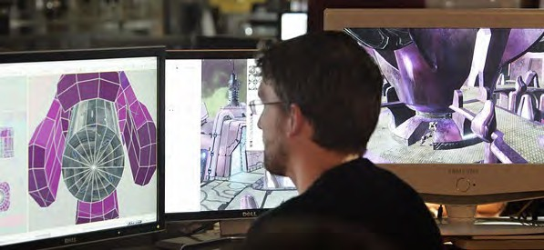

*Figure 9.5.1 Video games designer at work*

#### Comparing the four emerging technologies

This chapter has looked at four very different emerging technologies: social media, serious games; immersive technologies; and artificial intelligence. Each has the potential to influence profoundly teaching and learning in a digital age.

Social media have a wide range of possible applications, particularly to enable students to create or generate their own work and to work collaboratively at a distance. Both serious games and immersive technologies such as virtual and augmented reality will be extremely valuable in ‘niche’ areas of teaching and learning. They both have the potential to develop some of the higher order learning skills of problem solving, analysis, intuitive thinking, and creative thinking, and also can be used to develop affective skills, such as empathy.

However, neither serious games nor immersive technologies are likely to be ‘core’

technologies that will be extensively used across all forms of teaching. Also both need significant investment of time and possibly money if they are to be of good quality for teaching purposes. In particular, they will need a multi-disciplinary team approach to design and development. Therefore it will be essential to choose the right kind of project, such as topics that are difficult to teach using other methods, or projects aimed at learners who struggle with more conventional teaching methods. Above all, it will be necessary to identify and exploit the optimum educational affordances of these two technologies.

Artificial intelligence is somewhat different to the other three emerging technologies. Artificial intelligence to date manages well the presentation and testing of content acquisition, comprehension and understanding, but so far has not shown much promise in supporting the development or assessment of the higher level cognitive skills needed in a digital age. However, by focusing on supporting learners’ comprehension and understanding, AI can free up human teachers and instructors to focus their time on the development of these higher order skills. Again, this emphasises the importance of teachers and instructors moving their focus away from content delivery – which AI can increasingly manage well – and focusing more on teaching methods that support higher order skills development.

Furthermore these four technologies are not really separate and unrelated but will become increasingly integrated. AI applications could improve the power and range of both serious games and virtual reality. Games can be designed within a virtual reality. The extent to which these technologies become feasible in education will depend heavily on applications outside education which can then be carried over and adapted for educational purposes.

Again though we come back to three critical issues:

* what are the educational goals of the application?
* to what extent does the application help with the development of higher order cognitive and/or affective skills?
* what are the costs and organizational implications of such applications within education?

#### Lessons to be learned from the use of emerging technologies

New technology developments show no sign of slowing down. Over time, other new technologies will emerge as well as or within the four technologies discussed in this section. Educators will continue to be challenged to incorporate these new technologies as they emerge. In responding to this challenge, the following needs to be considered:

1. New technologies are not necessarily better than existing technologies for teaching. They may however offer new opportunities for teaching differently, and may enable new or better learning outcomes, as well as improving on existing learning outcomes.
2. Old technologies rarely disappear completely as a result of popular new technologies. Older technologies become more focused and find a niche that they serve best.
3. Most educators will be best served by not jumping on the latest technology bandwagon, but should wait a couple of years for a particular technology to reach at least the Gartner ‘slope of enlightenment’ before experimenting with the new technology.
4. More important than the general characteristics of a new technology is its design and application in education; in other words, how does it perform as an educational medium? Being a big success in the financial sector for instance does not mean a technology will be automatically appropriate for education. Indeed, the technology may need to be heavily adapted or modified to be useful in the educational sector.
5. Given the rate of change and the number of new technologies entering the market, educators need a strong framework or set of criteria for selecting and evaluating technologies, not just emerging technologies but also existing technology. This will be discussed in the next chapter.

###### Activity 9.5 Assessing and developing applications of emerging technologies

* + Are there other emerging technologies that you would have chosen over these four – or within these four broad categories are there particular applications that you think are or will be important for teaching in the future?
  + How do you think teachers/instructors should react to emerging technologies? Ignore them? Wait for others in education to try them first? Or should they jump in and try a new technology as soon as possible?
  + Some institutions such as UBC and Drexel University have set up emerging media labs to encourage faculty to experiment with new technologies. What other methods could be used to encourage teachers and instructors to experiment with new technologies?

For feedback on this activity, and my personal observations on these four emerging technologies, click on the podcast below:

*One or more interactive elements has been excluded from this version of the text. You can view them online here:* [*https://pressbooks.bccampus.ca/*](https://pressbooks.bccampus.ca/teachinginadigitalagev3m/?p=303&audio-303-1)

[*teachinginadigitalagev3m/?p=303#audio-303-1*](https://pressbooks.bccampus.ca/teachinginadigitalagev3m/?p=303&audio-303-1)

## CHAPTER 10: CHOOSING AND USING MEDIA IN EDUCATION

The main purpose of this chapter is to provide a framework for making effective decisions about the choice and use of media for teaching and learning. The framework used is the SECTIONS model, which stands for:

* S tudents
* E ase of use
* C osts
* T eaching functions
* I nteraction
* O rganisational issues
* N etworking
* S ecurity and privacy

Another model, SAMR, will also be introduced, as a possible way of evaluating the eventual choice and design of teaching adopted.

On completion of this chapter, you should be able to choose appropriate media and technology for any subject that you may be teaching, and be able to justify your decision.

*Purpose of the chapter*

#### What is covered in this chapter

* 10.1 Models for media selection
* 10.2 Students
* 10.3 Ease of Use
* 10.4 Cost
* 10.5 Teaching and media selection
* 10.6 Interaction
* 10.7 Organisational issues
* 10.8 Networking (and novelty)
* 10.9 Security and privacy
* 10.10 Deciding
* 10.11 The SAMR model

Also in this chapter you will find the following activities:

* Activity 10.1 Making a preliminary decision
* Activity 10.2 Knowing your students
* Activity 10.3 Ease of use
* Activity 10.4 How will cost affect your decision about what media to use?
* Activity 10.5 Multimedia design principles
* Activity 10.6 Using media to promote student activity.
* Activity 10.7 Organisational issues (no activity)
* Activity 10.8 Networking (and novelty)
* Activity 10.9 Security and privacy
* Activity 10.10 Choosing media and technologies
* Activity 10.11 Assessing the SAMR model

1. Selecting media and technologies is a complex process, involving a very wide range of interacting variables.
2. There is currently no generally accepted theory or process for media selection. The SECTIONS model however provides a set of criteria or questions the result of which can help inform an instructor when making decisions about which media or technologies to use. The SAMR model offers one possible way to assess the power of your media selection decision-making.
3. Because of the wide range of factors influencing media selection and use, an inductive or intuitive approach to decision-making, informed by a careful analysis of all the criteria in the SECTIONS framework, is one practical way to approach decision-making about media and technologies for teaching and learning.
4. However, media selection needs to be integrated within the broader framework of course design.

*Chapter 10 Key Takeaways*

# Models for media selection

[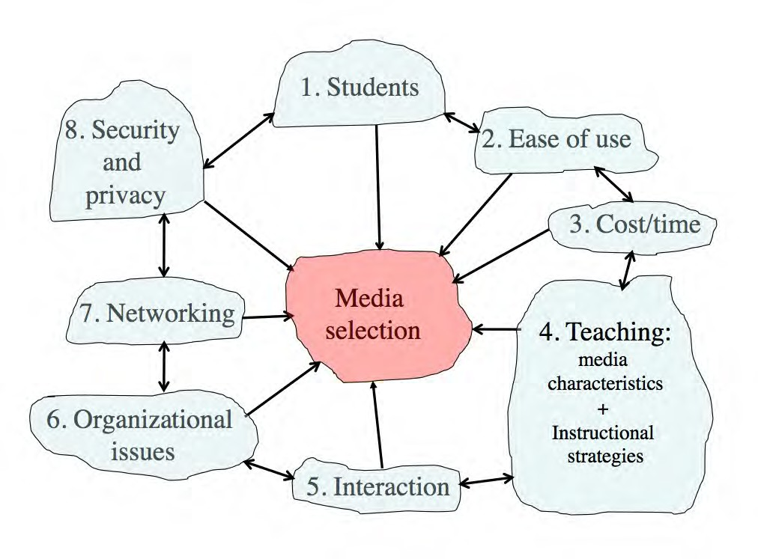](http://opentextbc.ca/teachinginadigitalage/wp-content/uploads/sites/29/2015/03/SECTIONS-model-2.jpg)

*Figure 10.1.1 The SECTIONS model*

#### What the literature tells us

Given the importance of the topic, there is relatively little literature on how to choose appropriate media or technologies for teaching. There was a flurry of not very helpful publications on this topic in the 1970s and 1980s, but relatively little since (Baytak, [undated](https://www.academia.edu/1285461/Media_Selection_and_Design_A_Case_in_Distance_Education)). Indeed, Koumi ([1994)](https://onlinelibrary.wiley.com/doi/abs/10.1111/j.1467-8535.1994.tb00088.x) stated that:

there does not exist a sufficiently practicable theory for selecting media

appropriate to given topics, learning tasks and target populations . . . the most common practice is not to use a model at all. In which case, it is no wonder that allocation of media has been controlled more by practical economic and human/ political factors than by pedagogic considerations (p. 56).

Mackenzie ([2002](http://elearning.fit.hcmup.edu.vn/~longld/References%20for%20TeachingMethod%26EduTechnology%20-%20Tai%20lieu%20PPDH%20%26%20Cong%20Nghe%20Day%20Hoc/(Book)%20-%20Sach%20tham%20khao%20-%20Technology-enhanced%20Learning%20(TEL)/2005%20McKenzie%20-%20Multiple%20Intelligences%20and%20Instructional%20Technology.pdf)) comments in a similar vein:

When I am discussing the current state of technology with teachers around the country, it becomes clear that they feel bound by their access to technology, regardless of their situation. If a teacher has a television-computer

setup, then that is what he or she will use in the classroom. On the other hand, if there is an LCD projector hooked up to a teacher demonstration station in a fully equipped lab, he or she will be more apt to use that set up. Teachers have always made the best of whatever they’ve got at hand, but it’s what we have to work with. Teachers make due.

Mackenzie ([2002](http://elearning.fit.hcmup.edu.vn/~longld/References%20for%20TeachingMethod%26EduTechnology%20-%20Tai%20lieu%20PPDH%20%26%20Cong%20Nghe%20Day%20Hoc/(Book)%20-%20Sach%20tham%20khao%20-%20Technology-enhanced%20Learning%20(TEL)/2005%20McKenzie%20-%20Multiple%20Intelligences%20and%20Instructional%20Technology.pdf)) has suggested building technology selection around Howard Gardner’s multiple intelligences theory (Gardner, [1983](https://www.amazon.ca/Frames-Mind-Theory-Multiple-Intelligences/dp/0465024335/ref%3Dasc_df_0465024335/?tag=googleshopc0c-20&linkCode=df0&hvadid=292953695483&hvpos=1o1&hvnetw=g&hvrand=11800804732809664815&hvpone&hvptwo&hvqmt&hvdev=c&hvdvcmdl&hvlocint&hvlocphy=9001554&hvtargid=pla-432330388706&psc=1), [2006](https://www.amazon.ca/Multiple-Intelligences-Horizons-Theory-Practice/dp/0465047688)), following the following sequence of decisions:

learner → teaching objective → intelligences → media choice.

Mackenzie then allocates different media to support the development of each of Gardner’s intelligences. Gardner’s theory of multiple intelligences has been widely tested and adopted, and Mackenzie’s allocations of media to intelligences make sense intuitively, but of course it is dependent on teachers and instructors applying Gardner’s theory to their teaching.

A review of more recent publications on media selection suggests that despite the rapid developments in media and technology over the last 20 years, my ACTIONS model (Bates, [1995](https://www.amazon.com/Technology-Learning-Distance-Education-Routledge/dp/0415127998)) is one of the major models still being applied, although with further amendments and additions (see for instance, Baytak, [undated](https://www.academia.edu/1285461/Media_Selection_and_Design_A_Case_in_Distance_Education); Lambert and Williams, [1999](https://participativelearning.org/pluginfile.php/538/mod_resource/content/3/Lambert%2C%20Williams%20-%201999%20-%20A%20Model%20for%20Selecting%20Educational%20Technologies%20to%20Improve%20Student%20Learning.pdf); Koumi, [2006](https://www.routledge.com/Designing-Video-and-Multimedia-for-Open-and-Flexible-Learning-1st-Edition/Koumi/p/book/9780415383035)). Indeed, I myself modified the ACTIONS model, which was developed for distance education, to the SECTIONS model to cover the use of media in campus-based as well as distance education (Bates and Poole, [2003](https://www.amazon.ca/Effective-Teaching-Technology-Higher-Education/dp/0787960349)).

Patsula ([2002](http://www.patsulamedia.com/usefo/usableword/report20020201_mediaselection_criteria.shtml)) developed a model called CASCOIME which includes some of the criteria in the Bates models, but also adds additional and valuable criteria such as socio-political

suitability, cultural friendliness, and openness/flexibility, to take into account international perspectives. Zaied ([2007](http://ccis2k.org/iajit/PDF/vol.4%2Cno.2/8-Zaied.pdf)) conducted an empirical study to test what criteria for media selection were considered important by faculty, IT specialists and students, and identified seven criteria. Four of these matched or were similar to Bates’ criteria. The other three were student satisfaction, student self-motivation and professional development, which are more like conditions for success and are not really easy to identify before making a decision.

Koumi ([2006](https://www.routledge.com/Designing-Video-and-Multimedia-for-Open-and-Flexible-Learning-1st-Edition/Koumi/p/book/9780415383035)) and Mayer ([2020](https://www.cambridge.org/highereducation/books/multimedia-learning/FB7E79A165D24D47CEACEB4D2C426ECD#overview)) have come closest to to developing models of media selection. Mayer has developed twelve principles of multimedia design based on extensive research, resulting in what Mayer calls a cognitive theory of multimedia learning. (For an excellent application of Mayer’s theory, see UBC Wikis.) Koumi ([2015](https://www.tandfonline.com/doi/full/10.1080/2331186X.2015.1045218#.VZPD1fm6dNA)) more recently has developed a model for deciding on the best mix and use of video and print to guide the design of xMOOCs.

Mayer’s approach is valuable at a more micro-level when it comes to designing specific multimedia educational materials, as is Koumi’s work. Mayer’s cognitive theory of multimedia design suggests the best combination of words and images, and rules to follow such as ensuring coherence and avoiding cognitive overload. When deciding to use a specific application of multimedia, it provides very strong guidelines. It is nevertheless more difficult to apply at a macro level. Because Mayer’s focus is on cognitive processing, his theory does not deal directly with the unique pedagogical affordances or characteristics of different media. Neither Mayer nor Koumi address non- pedagogical issues in media selection, such as cost or access. Mayer and Koumi’s work

is not so much competing as complementary to what I am proposing. I am trying to identify which media (or combinations of media) to use in the first place. Mayer’s theory then would guide the actual design of the application. I will discuss Mayer’s twelve principles further in Section 5 of this chapter, which deals with teaching functions.

Puentedura’s SAMR model ([2014](https://www.commonsense.org/education/articles/samr-and-blooms-taxonomy-assembling-the-puzzle)), discussed later in this chapter, is valuable for assessing the choice of a particular medium, but it focuses solely on pedagogical issues, particularly in terms of whether the choice augments or transforms learning. Although this is a powerful criterion for media selection, the SAMR model does not take into account other essential factors in media selection, such as cost or ease of use. It is though a useful way to assess decisions on media selection, once decisions have been made.

It is not surprising that there are not many models for media selection. The models developed in the 1970s and 1980s took a very reductionist, behaviourist approach to media selection, resulting in often several pages of decision-trees, which are completely impractical to apply, given the realities of teaching, and yet these models still included no recognition of the unique affordances of different media. More importantly, technology is subject to rapid change, there are competing views on appropriate pedagogical approaches to teaching, and the context of learning varies so much. Finding a practical, manageable model founded on research and experience that can be widely applied has proved to be challenging.

#### Why we need a model

At the same time, every teacher, instructor, and increasingly learner, needs to make decisions in this area, often on a daily basis. A model for technology selection and application is needed therefore that has the following characteristics:

* it will work in a wide variety of learning contexts;
* it allows decisions to be taken at both a strategic, institution-wide level, and at a tactical, instructional, level;
* it gives equal attention to educational and operational issues;
* it will identify critical differences between different media and technologies, thus enabling an appropriate mix to be chosen for any given context;
* it is easily understood, pragmatic and cost-effective;
* it will accommodate new developments in technology.

For these reasons, then, I will continue to use the Bates’ SECTIONS model, with some modifications to take account of recent developments in technology, research and theory. The SECTIONS model is based on research, has stood the test of time, and has been found to be practical. SECTIONS stands for:

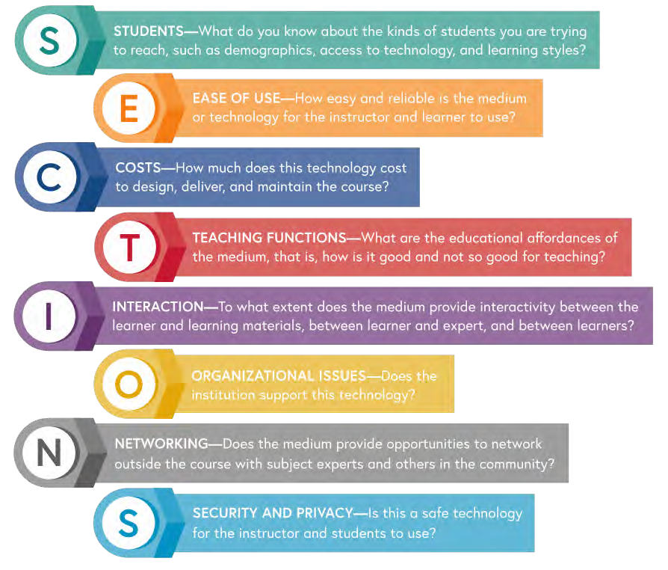

*Figure 10.1.2 Image: Sheila Jagannathan, World Bank, 2020*

I will discuss each of these criteria in the following sections, and will then suggest how to apply the model.

#### References

Bates, A. (1995) [*Technology, Open Learning and Distance Education*](https://www.amazon.com/Technology-Learning-Distance-Education-Routledge/dp/0415127998)London/New York: Routledge

Bates, A. and Poole, G. (2003) [*Effective Teaching with Technology in Higher Education*](https://www.amazon.ca/Effective-Teaching-Technology-Higher-Education/dp/0787960349)San Francisco: Jossey-Bass/John Wiley and Son

Baytak, A.(undated) [Media selection and design: a case in distance education](https://www.academia.edu/1285461/Media_Selection_and_Design_A_Case_in_Distance_Education) *Academia.edu*

Gardner, H. (1983) [*Frames of Mind: The Theory of Multiple Intelligences*](https://www.amazon.ca/Frames-Mind-Theory-Multiple-Intelligences/dp/0465024335/ref%3Dasc_df_0465024335/?tag=googleshopc0c-20&linkCode=df0&hvadid=292953695483&hvpos=1o1&hvnetw=g&hvrand=11800804732809664815&hvpone&hvptwo&hvqmt&hvdev=c&hvdvcmdl&hvlocint&hvlocphy=9001554&hvtargid=pla-432330388706&psc=1)New York: Basic Books

Gardner, H. (2006) [*Multiple Intelligences: New Horizons and Theory in Practice*](https://www.amazon.ca/Multiple-Intelligences-Horizons-Theory-Practice/dp/0465047688)New York: Basic Books

Koumi, J. (1994). [Media comparisons and deployment: A practitioner’s view](https://onlinelibrary.wiley.com/doi/abs/10.1111/j.1467-8535.1994.tb00088.x) *British Journal of Educational Technology*, Vol. 25, No. 1

Koumi, J. (2006). [*Designing video and multimedia for open and flexible*](https://www.routledge.com/Designing-Video-and-Multimedia-for-Open-and-Flexible-Learning-1st-Edition/Koumi/p/book/9780415383035)[*learning*](https://www.routledge.com/Designing-Video-and-Multimedia-for-Open-and-Flexible-Learning-1st-Edition/Koumi/p/book/9780415383035)London: Routledge

Koumi, J. (2015) [Learning outcomes afforded by self-assessed, segmented video–print](https://www.tandfonline.com/doi/full/10.1080/2331186X.2015.1045218#.VZPD1fm6dNA) [combinations](https://www.tandfonline.com/doi/full/10.1080/2331186X.2015.1045218#.VZPD1fm6dNA) *Cogent Education*, Vol. 2, No.1

Lambert, S. and Williams R. (1999) [*A model for selecting educational technologies to improve*](https://participativelearning.org/pluginfile.php/538/mod_resource/content/3/Lambert%2C%20Williams%20-%201999%20-%20A%20Model%20for%20Selecting%20Educational%20Technologies%20to%20Improve%20Student%20Learning.pdf)[*student learning*](https://participativelearning.org/pluginfile.php/538/mod_resource/content/3/Lambert%2C%20Williams%20-%201999%20-%20A%20Model%20for%20Selecting%20Educational%20Technologies%20to%20Improve%20Student%20Learning.pdf)Melbourne, Australia: HERDSA Annual International Conference, July

Mackenzie, W. (2002) [*Multiple Intelligences and Instructional Technology: A Manual for*](http://elearning.fit.hcmup.edu.vn/~longld/References%20for%20TeachingMethod%26EduTechnology%20-%20Tai%20lieu%20PPDH%20%26%20Cong%20Nghe%20Day%20Hoc/(Book)%20-%20Sach%20tham%20khao%20-%20Technology-enhanced%20Learning%20(TEL)/2005%20McKenzie%20-%20Multiple%20Intelligences%20and%20Instructional%20Technology.pdf)[*Every Mind*](http://elearning.fit.hcmup.edu.vn/~longld/References%20for%20TeachingMethod%26EduTechnology%20-%20Tai%20lieu%20PPDH%20%26%20Cong%20Nghe%20Day%20Hoc/(Book)%20-%20Sach%20tham%20khao%20-%20Technology-enhanced%20Learning%20(TEL)/2005%20McKenzie%20-%20Multiple%20Intelligences%20and%20Instructional%20Technology.pdf)Eugene, Oregon: ISTE

Mayer, R. E. (2020) [*Multimedia Learning* (3rd ed)](https://www.cambridge.org/highereducation/books/multimedia-learning/FB7E79A165D24D47CEACEB4D2C426ECD#overview). New York: Cambridge University Press.

Patsula, P. (2002) [Practical guidelines for selecting media: An international perspective](http://www.patsulamedia.com/usefo/usableword/report20020201_mediaselection_criteria.shtml) *The Useableword Monitor*, February 1

Puentedura, R. (2014) [SAMR and Bloom’s Taxonomy: Assembling the Puzzle](https://www.commonsense.org/education/articles/samr-and-blooms-taxonomy-assembling-the-puzzle) *common sense education*, September 24

UBC Wikis (2014)*Documentation: Design Principles for Multimedia* Vancouver BC: University of British Columbia

Zaied, A. (2007) A Framework for Evaluating and Selecting Learning Technologies [*The*](http://ccis2k.org/iajit/PDF/vol.4%2Cno.2/8-Zaied.pdf)[*International Arab Journal of Information Technology*](http://ccis2k.org/iajit/PDF/vol.4%2Cno.2/8-Zaied.pdf), Vol. 4, No. 2

1. Choose a course that you are teaching or may be teaching. Identify what media or technologies you might be interested in using. Keep a note of your decision and your reasons for your choice of media/technologies.

When you have finished reading this chapter you will be asked to do a final activity (Activity 10.10) and then you can compare your answers to both this activity and Activity 10.10 after reading the whole chapter.

There is no feedback provided for this activity.

*Activity 10.1 Making a preliminary decision on media selection*

# Students



*Figure 10.2.1 The Malaysian Ministry of Education announced in 2012 that it will enable students to bring handphones to schools under strict guidelines*

*Image: © NewStraightsTimes, 2012*

The first criterion in the SECTIONS model is students. At least three issues related to students need to be considered when choosing media and technology:

* student demographics;
* access; and
* differences in how students learn.

#### Student demographics

One of the fundamental changes resulting from mass higher education is that university and college teachers must now teach an increasingly diverse range of students. This increasing diversity of students presents major challenges for all teachers, not just post- secondary teachers. However, it has been less common for instructors at a post- secondary level to vary their approach within a single course to accommodate to learner differences, but the increasing diversity of students now requires that all courses should be developed with a wide variety of approaches and ways to learn if all students in the course are to be taught well.

In particular, it is important to be clear about the needs of the target group. First and second year students straight from high school are likely to require more support and help studying at a university or college level. They are likely to be less independent as learners, and therefore it may be a mistake to expect them to be able to study entirely through the use of technology. However, technology may be useful as a support for classroom teaching, especially if it provides an alternative approach to learning from the face-to- face teaching, and is gradually introduced, to prepare them for more independent study later in a program.

On the other hand, for students who have already been through higher education as a campus student, but are now in the workforce, a program delivered entirely by technology at a distance is likely to be attractive. Such students will have already developed successful study skills, will have their own community and family life, and will welcome the flexibility of studying this way.

Third and fourth year undergraduate students may appreciate a mix of classroom-based and online study or even one or two fully online courses, especially if some of their face- to-face classes are closed to further enrolments, or if students are working part-time to help cover some of the costs of being at college.

Lastly, within any single class or group of learners, there will be a wide range of differences in prior knowledge, language skills, and preferred study styles. The intelligent use of media and technology can help accommodate these differences. In particular, if you are trying to reach students in remote areas, or homeless or poor people, or students with physical disabilities, then this too should influence your choice of technology. Indeed, for most courses, there is likely to be a mix of different student needs, which suggests that a

multi-media approach (including on-campus face-to-face teaching) will be necessary to accommodate all student needs.

So, once again, it is important to know your students, and to keep this in mind when making decisions about what media or technology to use. This will be discussed further in Chapter 11 Section 3.

#### Access

Of all the criteria in determining choice of technology, this is perhaps the most discriminating. No matter how powerful in educational terms a particular medium or technology may be, if students cannot access it in a convenient and affordable manner they cannot learn from it. Thus video streaming may be considered a great way to get lectures to students off campus, but if they do not have Internet access at home, or if it takes four hours or a day’s wages to download, then forget it. Difficulty of access is a particular restriction on using xMOOCs in developing countries or video conferencing such as Zoom for students with poor Internet access. Even if potential learners have Internet or mobile phone access, which 2.9 billion globally still do not (ITU, [2021](https://www.itu.int/en/ITU-D/Statistics/Pages/stat/default.aspx)), it often costs a day’s wages to download a single YouTube video.

Any teacher or instructor intending to use computers, tablets or mobile phones for teaching purposes needs answers to a number of questions:

* what is the institutional policy with regard to students’ access to a computer, tablets or mobile phones?
* can students use any device or is there a limited list of devices that the institution will support?
* is the medium or software chosen for teaching compatible with all makes of devices students might use?
* is the network adequate to support any extra students that this initiative will add?
* who else in the institution needs to know that you are requiring students to use particular devices?

If students are expected to provide their own devices (which increasingly makes sense):

* what kind of device do they need: one at home with Internet access or a portable that they can bring on to campus – or one that can be used both at home and on campus?
* what kind of applications will they need to run on their device(s) for study purposes?
* will they be able to use the same device(s) across all courses, or will they need different software/apps and devices for different courses?
* what skills will students need in operating the devices and the apps that will be run on them?
* if students do not have the skills, would it still be worth their learning them, and will there be time set aside in the course for them to learn these skills?

Students (as well as the instructor) need to know the answers to these questions before they enrol in a course or program. In order to answer these questions, you and your department must know what students will use their devices for. There is no point in requiring students to go to the expense of purchasing a laptop computer if the work they are required to do on it is optional or trivial. This means some advance planning on your part:

* what are the educational advantages that you see in student use of a particular device?
* what will students need to do on the device in your course?
* is it really essential for them to use a device in these ways, or could they easily manage without the device? In particular, how will assessment be linked to the use of the device?

It will really help if your institution has good policies in place for student technology access (see Section 7 of this chapter). If the institution does not have clear policies or infrastructure for supporting the technologies you want to use, then your job is going to be a lot harder.

The answer to the question of access and the choice of technology will also depend somewhat on the mandate of the institution and your personal educational goals. For instance, highly selective universities can require students to use particular devices, and can help the relatively few students who have financial difficulties in purchasing and using specified devices. If though the mandate of the institution is to reach learners denied access to conventional institutions, equity groups, the unemployed, the working

poor, or workers needing up-grading or more advanced education and training, then it becomes critical to find out what technology they have access to or are willing to use. If an institution’s policy is open access to anyone who wants to take its courses (which covers most publicly funded school systems), the availability of equipment already in the *home* (usually purchased for entertainment or work purposes) becomes of paramount importance.

Another important factor to consider is access for student with disabilities. This may mean providing textual or audio options for deaf and visually impaired students respectively. Fortunately there are now well established practices and standards under the general heading of Universal Design standards. Universal Design is defined as follows:

*Universal Design for Learning, or UDL, refers to the deliberate design of instruction to meet the needs of a diverse mix of learners. Universally designed courses attempt to meet all learners’ needs by incorporating multiple means of imparting information and flexible methods of assessing learning. UDL also includes multiple means of engaging or tapping into learners’ interests. Universally designed courses are not designed with any one particular group of students with a disability in mind, but rather are designed to address the learning needs of a wide-ranging group.*

Brokop, F. ([2008](https://www.norquest.ca/NorquestCollege/media/pdf/centres/learning/Accessibility-to-E-Learning-for-Persons-With-Disabilities-Strategies%2C-Guidelines-and-Standards.pdf))

Most institutions with a centre for supporting teaching and learning will be able to provide assistance to faculty to ensure the course meets universal design standards. For instance, BCcampus has produced an [accessibility toolkit](https://opentextbc.ca/accessibilitytoolkit) (Coolidge et l., [2018](https://opentextbc.ca/accessibilitytoolkit/)) and Norquest College, Alberta, has published [a detailed guide to ensuring online materials are](https://www.norquest.ca/NorquestCollege/media/pdf/centres/learning/Accessibility-to-E-Learning-for-Persons-With-Disabilities-Strategies%2C-Guidelines-and-Standards.pdf) [accessible for persons with disabilities.](https://www.norquest.ca/NorquestCollege/media/pdf/centres/learning/Accessibility-to-E-Learning-for-Persons-With-Disabilities-Strategies%2C-Guidelines-and-Standards.pdf)

#### Student differences with respect to learning with technologies

It may seem obvious that different students will have different preferences for different kinds of technology or media. The design of teaching would cater for these differences. Thus if students are ‘visual’ learners, they would be provided with diagrams and illustrations. If they are auditory learners, they will prefer lectures and podcasts. It might

appear then that identifying dominant learning styles should provide strong criteria for media and technology selection. However, it is not as simple as that.

McLoughlin ([1999](https://ajet.org.au/index.php/AJET/article/view/1859)), in a thoughtful review of the implications of the research literature on learning styles for the design of instructional material, concluded that instruction could be designed to accommodate differences in both cognitive-perceptual learning styles and Kolb’s ([1984](https://www.amazon.com/Experiential-Learning-Experience-Source-Development/dp/0133892409/ref%3Ddp_ob_title_bk)) experiential learning cycle. In a study of new intakes conducted over several years at the University of Missouri-Columbia, using the Myers-Briggs inventory, Schroeder ([1993](https://www.tandfonline.com/doi/abs/10.1080/00091383.1993.9939900)) found that new students think concretely, and are uncomfortable with abstract ideas and ambiguity.

However, a major function of a university education is to develop skills of abstract thinking, and to help students deal with complexity and uncertainty. Perry ([1970](https://www.amazon.com/Forms-Ethical-Intellectual-Development-College/dp/0787941182)) found that learning in higher education is a developmental process. It is not surprising then that many students enter college or university without such ‘academic’ skills. Indeed, there are major problems in trying to apply learning styles and other methods of classifying learner differences to media and technology selection and use. Laurillard ([2001](https://www.amazon.co.uk/Rethinking-University-Teaching-Routledge-2001/dp/B00DHO14WY/ref%3Dsr_1_fkmr0_2?s=books&ie=UTF8&qid=1402428736&sr=1-2-fkmr0&keywords=Laurillard%2C%2BD.%2B%282001%29%2BRethinking%2BUniversity%2BTeaching%3A%2BA%2BConversational%2BFramework%2Bfor%2Bthe%2BEffective%2BUse%2Bof%2BLearning%2BTechnologies)) makes the point that looking at learning styles in the abstract is not helpful. Learning has to be looked at in context. Thinking skills in one subject area do not necessarily transfer well to another subject area. There are ways of thinking that are specific to different subject areas. Thus logical-rational thinkers in science do not necessarily make thoughtful husbands, or good literary critics.

Part of a university education is to understand and possibly challenge predominant modes of thinking in a subject area. While learner-centered teaching is important, students need to understand the inherent logic, standards, and values of a subject area. They also need to be challenged, and encouraged to think outside the box. In particular, at a university level we need strategies to gradually move students from concrete learning based on personal experience to abstract, reflective learning that can then be applied to new contexts and situations. Technology can be particularly helpful for that, as we saw in Chapter 8.

Thus when designing courses, it is important to offer a range of options for student learning within the same course. One way to do this is to make sure that a course is well structured, with relevant ‘core’ information easily available to all students, but also to make sure that there are opportunities for students to seek out new or different content. This content should be available in a variety of media such as text, diagrams, audio, video, and computing, with concrete examples explicitly related to

underlying principles. The increasing availability of open educational resources (discussed in Chapter 12.2) makes the provision of this ‘richness’ of possible content much more viable.

Similarly, technology enables a range of learner activities to be made available, such as researching readings on the Web, online discussion forums, synchronous presentations, assessment through e-portfolios, and online group work. The range of activities increases the likelihood that a variety of learner preferences are being met, and also encourages learners to involve themselves in activities and approaches to learning where they may initially feel less comfortable. Thus it is important to ensure that students have a wide range of media (text, audio, video, computing) within a course or program.

Lastly, one should be careful in the assumptions made about student preferences for learning through digital technologies. On the one hand, technology ‘boosters’ such as Mark Prensky ([2001](http://www.marcprensky.com/writing/Prensky%20-%20Digital%20Natives%2C%20Digital%20Immigrants%20-%20Part1.pdf)) and Don Tapscott ([2008](https://www.amazon.ca/Grown-Up-Digital-Generation-Changing/dp/0071508635)) have argued that today’s ‘digital natives’ are different from previous generations of students. They argue that today’s students live within a networked digital universe and therefore expect their learning also to be all digitally networked. It is also true that professors in particular tend to underestimate students’ access to advanced technologies (professors are often late adopters of new technology), so you should always try to find up-to-date information on what devices and technologies students are currently using, if you can.

On the other hand, it is also dangerous to assume that all students are highly ‘digital literate’ and are demanding that new technologies should be used in teaching. Jones and Shao ([2011](http://oro.open.ac.uk/30014/)) conducted a thorough review of the literature on ‘digital natives’, with over 200 appropriate references, including surveys of relevant publications from countries in Europe, Asia, North America, Australia and South Africa. They concluded that:

* students vary widely in their use and knowledge of digital media;
* the gap between students and their teachers in terms of digital literacy is not fixed, nor is the gulf so large that it cannot be bridged;
* there is little evidence that students enter university with demands for new technologies that teachers and universities cannot meet;
* students will respond positively to changes in teaching and learning strategies that include the use of new technologies that are well conceived, well explained and properly embedded in courses and degree programmes. However there is no evidence of a pent-up demand amongst students for changes in pedagogy or of a

demand for greater collaboration;

* the development of university infrastructure, technology policies and teaching objectives should be choices about the kinds of provision that the university wishes to make and not a response to general statements about what a new generation of students are demanding;
* the evidence indicates that young students do not form a generational cohort and they do not express consistent or generationally organised demands, thus challenging general assumptions about the differences between post-millennials, millennials, Generation X and boomers in the way that they learn.

Graduating students that have been interviewed about learning technologies at the University of British Columbia made it clear that they will be happy to use technology for learning so long as it contributes to their success (in the words of one student, ‘if it will get me better grades’) but the students also made it clear that it was the instructor’s responsibility to decide what technology was best for their studies.

It is also important to pay attention to what Jones and Shao are *not* saying. They are not saying that social media, personal learning environments, or collaborative learning are inappropriate, nor that the needs of students and the workforce are unchanging or unimportant, but the use of these tools or approaches should be driven by a holistic look at the needs of all students, the needs of the subject area, and the learning goals relevant to a digital age, and not by an erroneous view of what a particular generation of students are demanding.

In summary, one great advantage of the intelligent application of technology to teaching is that it provides opportunities for students to learn in a variety of ways, thus adapting the teaching more easily to student differences. Thus, the first step in media selection is to know your students, their similarities and differences, what technologies they already have access to, and what digital skills they already possess or lack that may be relevant for your courses. This is likely to require the use of a wide range of media within the teaching to accommodate these differences.

#### The information you need about your students

It is critical to know your students. In particular, you need the following information to provide an appropriate context for decisions about media and technology:

1. What is the mandate or policy of your institution, department or program with respect to student access in general (selective vs open; accommodation of disabilities, etc.)? How will students who do not have access to a chosen technology be supported?
2. What are the likely demographics of the students you will be teaching? How appropriate is the technology you are thinking of using for these students?
3. If your students are to be taught at least partly off campus, to which technologies are they likely to have convenient and regular access at home or work?
4. If students are to be taught at least partly on campus, what is – or should be – your or your department’s policy with regard to students’ access to devices in class?
5. What digital skills do you expect your students to have before they start the program?
6. If students are expected to provide their own access to technology, will you be able to provide unique teaching experiences that will justify the purchase or use of such technology?
7. What prior approaches to learning are the students likely to bring to your program? How suitable are such prior approaches to learning likely to be to the way you need to teach the course? How could technology be used to cater for student differences in learning?

There are many different ways to get the information needed to answer these questions. In many cases, you will still have to make decisions on insufficient evidence, but the more accurate information you have about your potential students, the better your likely choice of media and technology. Almost certainly, though, you will have a variety and diversity of students, so the design of your teaching will need to accommodate this.

### References

Brokop, F. (2008) [*Accessibility to E-Learning for Persons With Disabilities: Strategies,*](https://www.norquest.ca/NorquestCollege/media/pdf/centres/learning/Accessibility-to-E-Learning-for-Persons-With-Disabilities-Strategies%2C-Guidelines-and-Standards.pdf)[*Guidelines, and Standards*](https://www.norquest.ca/NorquestCollege/media/pdf/centres/learning/Accessibility-to-E-Learning-for-Persons-With-Disabilities-Strategies%2C-Guidelines-and-Standards.pdf)Edmonton AB: NorQuest College

Coolidge, A. et al (2018) [B.C. Open Textbook Accessibility Toolkit](http://opentextbc.ca/accessibilitytoolkit/) Victoria BC: BCcampus

International Telecommunications Union (2021) [Statistics: Individuals Using the Internet](https://www.itu.int/en/ITU-D/Statistics/Pages/stat/default.aspx) Geneva Switzerland: ITU

Jones, C. and Shao, B. (2011) [*The Net Generation and Digital Natives: Implications for Higher*](http://oro.open.ac.uk/30014/)[*Education*](http://oro.open.ac.uk/30014/)Milton Keynes: Open University/Higher Education Academy

Kolb. D. (1984) [*Experiential Learning: Experience as the source of learning and development*](https://www.amazon.com/Experiential-Learning-Experience-Source-Development/dp/0133892409/ref%3Ddp_ob_title_bk)

Englewood Cliffs NJ: Prentice Hall

Laurillard, D. (2001) [*Rethinking University Teaching: A Conversational Framework for the*](http://www.amazon.co.uk/Rethinking-University-Teaching-Routledge-2001/dp/B00DHO14WY/ref%3Dsr_1_fkmr0_2?s=books&ie=UTF8&qid=1402428736&sr=1-2-fkmr0&keywords=Laurillard%2C%2BD.%2B%282001%29%2BRethinking%2BUniversity%2BTeaching%3A%2BA%2BConversational%2BFramework%2Bfor%2Bthe%2BEffective%2BUse%2Bof%2BLearning%2BTechnologies)[*Effective Use of Learning Technologies*](http://www.amazon.co.uk/Rethinking-University-Teaching-Routledge-2001/dp/B00DHO14WY/ref%3Dsr_1_fkmr0_2?s=books&ie=UTF8&qid=1402428736&sr=1-2-fkmr0&keywords=Laurillard%2C%2BD.%2B%282001%29%2BRethinking%2BUniversity%2BTeaching%3A%2BA%2BConversational%2BFramework%2Bfor%2Bthe%2BEffective%2BUse%2Bof%2BLearning%2BTechnologies)New York/London: Routledge

McCoughlin, C. (1999) [The implications of the research literature on learning styles for the](https://ajet.org.au/index.php/AJET/article/view/1859) [design of instructional material](https://ajet.org.au/index.php/AJET/article/view/1859) *Australian Journal of Educational Technology*, Vol. 15, No. 3

Norquest College (2008) [Accessibility to E-Learning for Persons With Disabilities:](https://www.norquest.ca/NorquestCollege/media/pdf/centres/learning/Accessibility-to-E-Learning-for-Persons-With-Disabilities-Strategies%2C-Guidelines-and-Standards.pdf) [Strategies, Guidelines, and Standards](https://www.norquest.ca/NorquestCollege/media/pdf/centres/learning/Accessibility-to-E-Learning-for-Persons-With-Disabilities-Strategies%2C-Guidelines-and-Standards.pdf) Edmonton AB: Norquest College

Perry, W. (1970) [*Forms of intellectual development and ethical development in the college*](https://www.amazon.com/Forms-Ethical-Intellectual-Development-College/dp/0787941182)[*years: a scheme*](https://www.amazon.com/Forms-Ethical-Intellectual-Development-College/dp/0787941182)New York: Holt, Rinehart and Winston

Prensky, M. (2001) ‘[*Digital natives, Digital Immigrant*](http://www.marcprensky.com/writing/Prensky%20-%20Digital%20Natives%2C%20Digital%20Immigrants%20-%20Part1.pdf)*s*’ On the Horizon Vol. 9, No. 5

Schroeder, C. (1993) [New students – new learning styles](https://www.tandfonline.com/doi/abs/10.1080/00091383.1993.9939900), *Change,* Sept.-Oct Tapscott, D. (2008) [*Grown Up Digital*](https://www.amazon.ca/Grown-Up-Digital-Generation-Changing/dp/0071508635)New York: McGraw Hill

* How many of the questions in Section 10.2.4 can you answer off the top of your head?

*Activity 10.2: Knowing your students*

* What additional information do you need, and where can you find it?

There is no feedback provided on these questions.

# Ease of Use

[](http://opentextbc.ca/teachinginadigitalage/wp-content/uploads/sites/29/2015/04/computer-frustration-2.jpg)

*Figure 10.3.1 Technology reliability is important! Image: © pixgood.com*

#### Keep it simple

In most cases, the use of technology in teaching is a means, not an end. Therefore it is important that students and teachers do not have to spend a great deal of time on learning how to use educational technologies, or on making the technologies work. The exceptions of course are where technology is the area of study, such as computer science or engineering, or where learning the use of software tools is critical for some aspects

of the curriculum, for instance computer-aided design in architecture, spreadsheets in business studies, and geographical information systems in geology. In most cases, though, the aim of the study is not to learn how to use a particular piece of educational technology, but the study of history, mathematics, or biology.

One advantage of face-to-face teaching is that it needs relatively little advance preparation time compared with for instance developing a fully online course. Media and technologies vary in their capacity for speed of implementation and flexibility in up- dating. For instance, blogs are much quicker and easier to develop and distribute than virtual reality. Teachers and instructors then are much more likely to use technology that is quick and easy to use, and students likewise will expect such features in technology they are to use for studying. However, what’s ‘easy’ for instructors and students to use will depend on their digital literacy.

#### Computer and information literacy

If a great deal of time has to be spent by the students and teachers in learning how to use for instance software for the development or delivery of course material, this distracts from the learning and teaching. Of course, there is a basic set of literacy skills that will be required, such as the ability to read and write, to use a keyboard, to use word processing software, to navigate the Internet and use Internet software, and increasingly to use mobile devices. These generic skills though could be considered pre-requisites. If students have not adequately developed these skills in school, then an institution might provide preparatory courses for students on these topics.

It will make life a lot easier for both teachers and students if an institution has strategies for supporting students’ use of digital media. For instance, the [Digital Tattoo](http://digitaltattoo.ubc.ca/) project jointly operated by at the University of British Columbia and the University of Toronto, prepares students for learning online in a number of ways:

* setting out the opportunities and risks of social media;
* advice on how to protect their privacy;
* how to make the most of connecting, networking and online searching;
* how to prevent cyber-bullying;
* maintaining a professional online presence;
* introducing students to a range of technologies that could be used for their learning, such as learning management systems, open educational resources, MOOCs and e- portfolios;
* explaining what’s involved in studying online or at a distance.

If your institution does not have something similar, then you could direct your students to the Digital Tattoo site, which is fully open.

It is not only students though who may need prior preparation. Technology can be too seductive. You can start using it without fully understanding its structure or how it works. Even a short period of training – an hour of less – on how to use common technologies such as a learning management system or video-conferencing could save you a lot of time and more importantly, enable you to see the potential value of all features and not just those that you stumble across.

#### Orientation

A useful standard or criterion for the selection of course media or software is that ‘novice’ students (students who have never used the software before) should be studying within 20 minutes of logging on. This 20 minutes may be needed to work out some of the key functions of the software that may be unfamiliar, or to work out how the course Web site is organized and navigated.

This is more of an orientation period though than learning new skills of computing. If there is a need to introduce new software that may take a little time to learn, for instance, a synchronous ‘chat’ facility, or video streaming, it should be introduced at the point where it is needed. It is important though to provide time within the course for the students to learn how to do this.

#### Interface design

The critical factor in making technology transparent is the design of the interface between

the user and the machine. Thus an educational program or indeed any Web site should be well structured, intuitive for the user to use, and easy to navigate.

Interface design is a highly skilled profession, and is based on a combination of scientific research into how humans learn, an understanding of how operating software works, and good training in graphic design. This is one reason why it is often wise to use software or tools that have been well established in education, because these have been tested and been found to work well.

The traditional generic interface of computers – a keyboard, mouse, and graphic user interface of windows and pull-down menus and pop-up instructions – is still extremely crude, and not isomorphic with most people’s preferences for processing information. It places very heavy emphasis on literacy skills and a preference for visual learning. This can cause major difficulties for students with certain disabilities, such as dyslexia or poor eyesight. However, in recent years, interfaces have started to become more user friendly, with touch screen and voice activated interfaces.

Nevertheless a great deal of effort often has to go into the adaptation of existing computer or mobile interfaces to make them easy to use in an educational context. The Web is just as much a prisoner of the general computer interface as any other software environment, and the educational potential of any Web site is also restricted by its algorithmic or tree- like structure. For instance, it does not always suit the inherent structure of some subject areas, or the preferred way of learning of some students.

There are several consequences of these interface limitations for teachers and instructors:

* it is really important to choose teaching software or other technologies that are intuitively easy to use, both by the students in particular, but also for the teacher/ instructor in creating materials and interacting with students;
* when creating materials for teaching, the teacher needs to be aware of the issues concerning navigation of the materials and screen lay-out and graphics. While it is possible to add stimulating features such as audio and animated graphics, this comes at the cost of bandwidth. Such features should be added only where they serve a useful educational function, as slow delivery of materials is extremely frustrating for learners, who will normally have slower Internet access that the teacher creating the materials. Furthermore, web-based layout on desktop or laptop computers does not

automatically transfer to the same dimensions or configurations on mobile devices, and mobile devices have a wide range of standards, depending on the device. Given that the design of Web-based materials requires a high level of specialized interface design skill, it is preferable to seek specialist help, especially if you want to use software or media that are not standard institutionally supported tools. This is particularly important when thinking of using new mobile apps, for instance;

* third, we can expect in the next few years some significant changes in the general computer interface with the development of speech recognition technology, adaptive responses based on artificial intelligence, and the use of haptics (e.g. hand- movement) to control devices. Changes in basic computer interface design could have as profound an impact on the use of technology in teaching as the Internet has.

#### Reliability

The reliability and robustness of the technology is also critical. Most of us will have had the frustration of losing work when our word programming software crashes or working ‘in the cloud’ and being logged off in the middle of a piece of writing. The last thing you want as a teacher or instructor is lots of calls from students saying they cannot get online access, or that their computer keeps crashing. (If the software locks up one machine, it will probably lock up all the others!) Technical support can be a huge cost, not just in paying technical staff to deal with service calls, but also in lost time of students and teachers.

‘Innovation in teaching’ will certainly bring rewards these days as institutions jostle for position as innovative institutions. It is often easier to get funding for new uses of technology than funding to sustain older but successful technologies. Although podcasts combined with a learning management system can be a very low-cost but highly effective teaching medium if good design is used, they are not sexy. It will usually be easier to get support for much more costly and spectacular technologies such as xMOOCs or virtual reality.

On the other hand, there is much risk in being too early into a new technology. Software may not be fully tested and reliable, or the company supporting the new technology may go out of business. Students are not guinea pigs, and reliable and sustainable service is

more important to them than the glitz and glamour of untried technology. It is best to wait for at least a year for new apps or software to be fully tested in general applications before adopting them for teaching. It is wise then not to rush in and buy the latest software update or new product – wait for the bugs to be ironed out. Also if you plan to use a new app or technology that is not generally supported by the institution, check first with IT services to ensure there are not security, privacy or institutional bandwidth issues. Thus it is better to be at the leading edge, just behind the first wave of innovation, rather than at the bleeding edge.

A feature of online learning is that peak use tends to fall outside normal office hours. Thus it is really important that your course materials sit on a reliable server with high- speed access and 24 hour, seven days a week reliability, with automatic back-up on a separate, independent server located in a different building. Ideally, the servers should be in a secure area (with for instance emergency electricity supply) with 24 hour technical support, which probably means locating your servers with a central IT service or ‘in the cloud’, which means it is all the more important to ensure that materials are safely and independently backed up.

However, the good news is that most commercial educational software products such as learning management systems and video conferencing, as well as servers, are very reliable. Open source software too is usually reliable but probably slightly more at risk of technical failure or security breaches. If you have good IT support, you should receive very few calls from students on technical matters. The main technical issue that instructors face these days appears to be software up-grades to learning management systems, or even more disrupting, an institution-wide change of the learning management system. This often means moving course materials from one version of the software to the new version. This can be costly and time-consuming, particularly if the new version is substantially different from the previous version. Overall, though, reliability should not be an issue.

#### Summary

In summary, ease of use requires professionally designed commercial or open source course software, specialized help in graphics, navigation and screen design for your course materials, and strong technical support for server and software management and maintenance. Certainly in North America, most higher education institutions now provide

IT and other services focused specifically on supporting technology-based teaching. In school systems, support for standard learning management systems and video- conferencing is likely to be provided centrally, although it is useful to have at least one person in each school who has technical expertise to support other teachers. However, without such central or local professional support, a great deal of your time as a teacher will be spent on technical issues, and to be blunt, if you do not have easy and convenient access to such support, you would be wise not to get heavily committed to technology- based teaching until that support is available.

#### Questions for consideration

Ease of use is another critical factor in the successful use of technology for teaching. Some of the questions then that you need to consider are:

1. How intuitively easy to use, both by students and by yourself, is the technology you are considering?
2. How reliable is the technology?
3. How easy is it to maintain and upgrade the technology?
4. The company that is providing the critical hardware or software you are using: is it a stable company that is not likely to go out of business in the next year or two, or is it a new start-up? What strategies are in place to secure any digital teaching materials you create should the organisation providing the software or service cease to exist?
5. Do you have adequate technical and professional support, both in terms of the technology and with respect to the design of materials?
6. How fast developing is this subject area? How important is it to regularly change the teaching materials? Which technology will best support this?
7. To what extent can changes in software or technology be handed over to someone else to manage, and/or how essential is it for you to do them yourself?
8. What rewards am I likely to get for using new technology in my teaching? Will use of a new technology be the only thing in my teaching that will be innovative, or can I also change my way of teaching with this technology to get better results?
9. What are the risks in using this technology?
10. What would be the main challenges of just putting a web-cam in the classroom and recording a lecture on your computer for streaming later for students who can’t get to class?
11. How would you rank these technologies for ease of use (a) by you as a teacher/instructor (b) by

students?:

▪

▪

▪

▪

▪

a learning management system

live video (e.g. a streamed, live lecture using video-conferencing software such as Zoom, GoToMeeting, Microsoft Team)

books

virtual reality

a podcast (a digital audio recording)

Click on the podcast below for my feedback on this activity:

*Activity 10.3: Ease of use*

*One or more interactive elements has been excluded from this version of the text. You can view them online here:* [*https://pressbooks.bccampus.ca/*](https://pressbooks.bccampus.ca/teachinginadigitalagev3m/?p=314&audio-314-1)

[*teachinginadigitalagev3m/?p=314#audio-314-1*](https://pressbooks.bccampus.ca/teachinginadigitalagev3m/?p=314&audio-314-1)

# Cost

[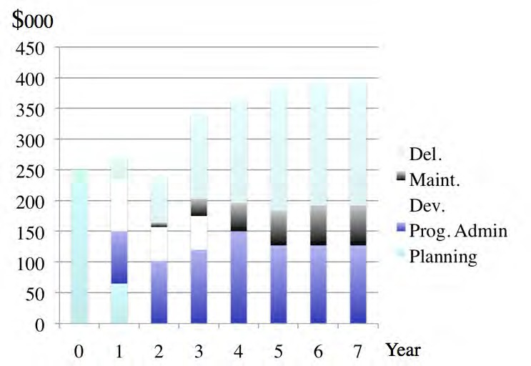](http://opentextbc.ca/teachinginadigitalage/wp-content/uploads/sites/29/2015/03/MET-costs-2.jpg)

Figure 10.4.1 Total cost of a fully online masters’ course over 7 years (from Bates and Sangrà, 2011). For an explanation of this graph, click on the podcast below

*One or more interactive elements has been excluded from this version of the text. You can view them online here:* [*https://pressbooks.bccampus.ca/teachinginadigitalagev3m/?p=318#audio-318-1*](https://pressbooks.bccampus.ca/teachinginadigitalagev3m/?p=318&audio-318-1)

#### A revolution in media

Until as recently as ten years ago, cost was a major discriminator affecting the choice

of technology (Hülsmann, [2000](http://www.c3l.uni-oldenburg.de/literat/t-costs.pdf), [2003](http://www.c3l.uni-oldenburg.de/cde/webvol6.pdf); Rumble, [2001](https://www.researchgate.net/publication/228481358_The_costs_and_costing_of_networked_learning); Bates, [2005](https://www.routledge.com/Technology-e-learning-and-Distance-Education/Bates/p/book/9780415284370)). For instance, for educational purposes, audio (lectures, radio, audio-cassettes) was far cheaper than print, which in turn was far cheaper than most forms of computer-based learning, which in turn was far cheaper than video (television, cassettes or video-conferencing). All these media were usually seen as either added costs to regular teaching, or too expensive to use to replace face-to-face teaching, except for purely distance education on a fairly large scale.

However, there have been dramatic reductions in the cost of developing and distributing all kinds of media (except face-to-face teaching) in the last ten years, due to several factors:

* rapid developments in consumer technologies such as smartphones that enable text, audio and video to be both created and transmitted by end users at low cost;
* compression of digital media, enabling even high bandwidth video or television to be carried over wireless, landlines and the Internet at an economic cost (at least in economically advanced countries);
* improvements in media software, making it relatively easy for non-professional users to create and distribute all kinds of media;
* increasing amounts of media-based open educational resources, which are already developed learning materials that are free for teachers and students alike to use.

The good news then is that in general, and in principle, *cost should no longer be an automatic discriminator in the choice of media*. If you are happy to accept this statement at face value, than you can skip the rest of this chapter. *Choose the mix of media that best meets your teaching needs, and don’t worry about which medium is likely to cost more*. Indeed, a good case could be made that it would now be cheaper to replace face-to-face teaching with purely online learning, if cost was the only consideration.

In practice however costs can vary enormously both between and within media, depending once again on context and design. Since the main cost from a teacher’s perspective is their time, it is important to know what are the ‘drivers’ of cost, that is, what factors are associated with increased costs, depending on the context and the medium being used. These factors are less influenced by new technological developments, and can therefore be seen as ‘foundational’ principles when considering the costs of educational media.

Unfortunately there are many different factors that can influence the actual cost of using

media in education, which makes a detailed discussion of costs very complex (for a more detailed treatment, see Bates and Sangrà, [2011](https://www.wiley.com/WileyCDA/WileyTitle/productCd-0470584726%2CminiSiteCd-JBHIGHERED.html)). As a result, I will try to identify the main cost drivers, then provide a table that provides a simplified guide to how these factors influence the costs of different media, including face-to-face teaching. This guide again should be considered as a heuristic device, so see this section as Media Costs 101.

#### Cost categories

The main cost categories to be considered in using educational media and technologies, and especially blended or online learning, are as follows:

##### Development

These are the costs needed to pull together or create learning materials using particular media or technologies. There are several sub-categories of development costs:

* + - * + *production costs*: making a video or building a course section in a learning management system, or creating a virtual world. Included in these costs will be the time of specialist staff, such as web designers or media or computer specialists, as well as any costs in web design or video production;
        + *your time as an instructor*: the work you have to do as part of developing or producing materials. This will include planning/course design as well as development. Your time is money, and probably the largest single cost in using educational technologies, but more importantly, if you are developing learning materials you are not doing other things, such as research or interacting with students, so there is a real cost, even if it is not expressed in dollar terms;
        + *copyright clearance* if you are using third party materials such as photos or video clips. Again, this is more likely to be thought of as time in finding and clearing copyright more than money;
        + probably the cost of an *instructional designer* in terms of their time.

Development costs are usually *fixed* or ‘once only’ and are independent of the number of

students. Once media are developed, they are usually scalable, in that once produced, they can be used by any number of learners without increased development costs. Using open educational resources can greatly reduce media development costs on an average per user basis.

##### Delivery

This includes the cost of the educational activities needed during offering the course and would include instructional time spent interacting with students, instructional time spent on marking assignments, and would include the time of other staff supporting delivery, such as teaching assistants, adjuncts for additional sections and instructional designers and technical support staff.

Because of the cost of human factors such as instructional time and technical support needed in media-based teaching, delivery costs tend to increase as student numbers increase, and also have to be repeated each time the course is on offer. In other words, they are *recurrent*.

##### Maintenance costs

Once materials for a course are created, they need to be maintained. Urls go dead, set readings may go out of print or expire, and more importantly new developments in the subject area may need to be accommodated. Thus once a course is offered, there are ongoing maintenance costs.

Instructional designers and/or media professionals can manage some of the maintenance, but nevertheless teachers or instructors will need to be involved with decisions about content replacement or updating. Maintenance is not usually a major time consumer for a single course, but if an instructor is involved in the design and production of several online courses, maintenance time can build to a significant amount.

Maintenance costs are usually independent of the number of students, but are dependent on the number of courses an instructor is responsible for, and are recurrent each year.

##### Overheads

These include infrastructure or overhead costs, such as the cost of licensing a learning management system, lecture capture technology and servers for video streaming. These are real costs but not ones that can be allocated to a single course but will be shared across a number of courses. Overheads are usually considered to be institutional costs and, although important, probably will not influence a teacher’s decision about which media to use, provided these services are already in place and the institution does not directly charge for such services.

However, if a new online program is to be offered on a full cost-recovery basis, then other institutional overheads will also need to be added. Some will be the same as for on-campus courses (for example, a contribution towards the President’s Office), but other overheads applied to on-campus students, such as building maintenance, will not apply to a fully online program (which is the main reason that the net cost of an online program is usually less than that of a campus-based program).

#### Cost drivers

The primary factors that drive cost are:

* the development/production of materials;
* the delivery of materials;
* number of students/scalability;
* the experience of an instructor working with the medium;
* whether the instructor develops materials alone (self-development) or works with professionals.

Production of technology-based materials such as a video program, or a Web site, is a *fixed* cost, in that it is not influenced by how many students take the course. However, production costs can vary depending on the design of the course. Engle ([2014](https://open.library.ubc.ca/cIRcle/collections/ubccommunityandpartnerspublicati/52387/items/1.0107914)) showed that depending on the method of video production, the development costs for a MOOC could vary by a factor of six (the most expensive production method – full studio production – being six times that of an instructor self-recording on a laptop).

Nevertheless, once produced, the cost is independent of the number of students. Thus the more expensive the course to develop, the greater the need to increase student numbers to reduce the average cost per student. (Or put another way, the greater the number of students, the more reason to ensure that high quality production is used, whatever the medium). In the case of MOOCs (which tend to be almost twice as expensive to develop as an online course for credit using a learning management system – University of Ottawa, [2013](https://www.uottawa.ca/vice-president-academic/sites/www.uottawa.ca.vice-president-academic/files/e-learning-working-group-report.pdf)) the number of learners is so great that the average cost per student is very small. Thus there are opportunities for economies of scale from the development of digital material, provided that student course enrolments can be increased (which may not always be the case). This can be described as the potential for the *scalability* of a medium.

Similarly, there are costs in teaching the course once the course is developed. These tend to be *variable* costs, in that they increase as class size increases. If student-teacher interaction, through online discussion forums and assignment marking, is to be kept to a manageable level, then the teacher-student ratio needs to be kept relatively low (for instance, between 1:25 to 1:40, depending on the subject area and the level of the course). The more students, the more time a teacher will need to spend on delivery, or additional contract instructors will need to be hired. Either way, increased student numbers generally will lead to increased costs. MOOCs are an exception. Their main value proposition is that they do not provide direct learner support, so have zero delivery costs. However, this is probably the reason why such a small proportion of participants successfully complete MOOCs.

There may be benefits then for a teacher or for an institution in spending more money up front for interactive learning materials if this leads to less demand for teacher-student interaction. For instance, a mathematics course might be able to use automated testing and feedback and simulations and diagrams, and pre-designed answers to frequently asked questions, with less or even no time spent on individual assignment marking or communication with the teacher. In this case it may be possible to manage teacher- student ratios as high as 1:200 or more, without significant loss of quality.

Also, experience in using or working with a particular medium or delivery method is also important. The first time an instructor uses a particular medium such as podcasting, it takes much longer than subsequent productions or offerings. Some media or technologies though need much more effort to learn to use than others. Thus a related cost driver is whether the instructor works alone (self-development) or works with media professionals.

Self-developing materials will usually take longer for an instructor than working with professionals.

There are advantages in teachers and instructors working with media professionals when developing digital media. Media professionals will ensure the development of a quality product, and above all can save teachers or instructors considerable time, for instance through the choice of appropriate software, editing, and storage and streaming of digital materials. Instructional designers can help in suggesting appropriate applications of different media for different learning outcomes. Thus as with all educational design, a team approach is likely to be more effective, and working with other professionals will help control the time teachers and instructors spend on media development.

Lastly, design decisions are critical. Costs are driven by design decisions within a medium. For instance, cost drivers are different between lectures and lab classes in face-to-face teaching. Similarly, video can be used just to broadcast and record talking heads, as in video-c0nferencing or video streaming (low development cost), or can be used to exploit the affordances of the medium (see Chapter 8), such as demonstrating processes or location shooting (higher development cost). Computing has a wide and increasing range of possible designs, including online collaborative learning (OCL), computer-based learning, animations, simulations or virtual worlds, each with a different cost implication.

Figure 10.4.2 attempts to capture the complexity of cost factors, focusing mainly on the perspective of a teacher or instructor making decisions. Again, this should be seen as a heuristic device, a way of thinking about the issue. Other factors could be added (such as social media, or maintenance of materials). I have given my own personal ratings for each cell, based on my experience. I have taken conventional teaching as a medium or ‘average’ cost, then ranked cells as to whether there is a higher or lower cost factor for the particular medium. Other readers may well rate the cells differently.

|  |  |  |  |  |  |  |  |
| --- | --- | --- | --- | --- | --- | --- | --- |
|  | | [Cost drive.rs (for instructo.rs)](http://opentextbc.ca/teachinginadigitalage/wp-content/uploads/sites/29/2015/03/Cost-drivers-2.jpg) | | | | | |
|  | [*,develop-*](http://opentextbc.ca/teachinginadigitalage/wp-content/uploads/sites/29/2015/03/Cost-drivers-2.jpg)  [***mimt***](http://opentextbc.ca/teachinginadigitalage/wp-content/uploads/sites/29/2015/03/Cost-drivers-2.jpg) | [*deliv,ery*](http://opentextbc.ca/teachinginadigitalage/wp-content/uploads/sites/29/2015/03/Cost-drivers-2.jpg) | [***SDtd-***](http://opentextbc.ca/teachinginadigitalage/wp-content/uploads/sites/29/2015/03/Cost-drivers-2.jpg)  [***abie,***](http://opentextbc.ca/teachinginadigitalage/wp-content/uploads/sites/29/2015/03/Cost-drivers-2.jpg) | [***,experi-***](http://opentextbc.ca/teachinginadigitalage/wp-content/uploads/sites/29/2015/03/Cost-drivers-2.jpg)  [***ence***](http://opentextbc.ca/teachinginadigitalage/wp-content/uploads/sites/29/2015/03/Cost-drivers-2.jpg) | [*selfdev..*](http://opentextbc.ca/teachinginadigitalage/wp-content/uploads/sites/29/2015/03/Cost-drivers-2.jpg) |
| [**Medium**](http://opentextbc.ca/teachinginadigitalage/wp-content/uploads/sites/29/2015/03/Cost-drivers-2.jpg) | [***Pace-***](http://opentextbc.ca/teachinginadigitalage/wp-content/uploads/sites/29/2015/03/Cost-drivers-2.jpg)  [***,tlJ--:face***](http://opentextbc.ca/teachinginadigitalage/wp-content/uploads/sites/29/2015/03/Cost-drivers-2.jpg) | [lectures](http://opentextbc.ca/teachinginadigitalage/wp-content/uploads/sites/29/2015/03/Cost-drivers-2.jpg) | [medium](http://opentextbc.ca/teachinginadigitalage/wp-content/uploads/sites/29/2015/03/Cost-drivers-2.jpg) | [medium](http://opentextbc.ca/teachinginadigitalage/wp-content/uploads/sites/29/2015/03/Cost-drivers-2.jpg) | [partly](http://opentextbc.ca/teachinginadigitalage/wp-content/uploads/sites/29/2015/03/Cost-drivers-2.jpg) | [low](http://opentextbc.ca/teachinginadigitalage/wp-content/uploads/sites/29/2015/03/Cost-drivers-2.jpg) | [low](http://opentextbc.ca/teachinginadigitalage/wp-content/uploads/sites/29/2015/03/Cost-drivers-2.jpg) |
| [semi- n.ars](http://opentextbc.ca/teachinginadigitalage/wp-content/uploads/sites/29/2015/03/Cost-drivers-2.jpg) | [low](http://opentextbc.ca/teachinginadigitalage/wp-content/uploads/sites/29/2015/03/Cost-drivers-2.jpg) | [hjg,-h](http://opentextbc.ca/teachinginadigitalage/wp-content/uploads/sites/29/2015/03/Cost-drivers-2.jpg)  [1'](http://opentextbc.ca/teachinginadigitalage/wp-content/uploads/sites/29/2015/03/Cost-drivers-2.jpg) | [no](http://opentextbc.ca/teachinginadigitalage/wp-content/uploads/sites/29/2015/03/Cost-drivers-2.jpg) | [merHmn](http://opentextbc.ca/teachinginadigitalage/wp-content/uploads/sites/29/2015/03/Cost-drivers-2.jpg) | [low](http://opentextbc.ca/teachinginadigitalage/wp-content/uploads/sites/29/2015/03/Cost-drivers-2.jpg) |
| [***Print***](http://opentextbc.ca/teachinginadigitalage/wp-content/uploads/sites/29/2015/03/Cost-drivers-2.jpg) | [books](http://opentextbc.ca/teachinginadigitalage/wp-content/uploads/sites/29/2015/03/Cost-drivers-2.jpg) | [Mgh](http://opentextbc.ca/teachinginadigitalage/wp-content/uploads/sites/29/2015/03/Cost-drivers-2.jpg) | [high](http://opentextbc.ca/teachinginadigitalage/wp-content/uploads/sites/29/2015/03/Cost-drivers-2.jpg) | [yes.](http://opentextbc.ca/teachinginadigitalage/wp-content/uploads/sites/29/2015/03/Cost-drivers-2.jpg) | [hlgh](http://opentextbc.ca/teachinginadigitalage/wp-content/uploads/sites/29/2015/03/Cost-drivers-2.jpg) | [high](http://opentextbc.ca/teachinginadigitalage/wp-content/uploads/sites/29/2015/03/Cost-drivers-2.jpg) |
| [***Audio***](http://opentextbc.ca/teachinginadigitalage/wp-content/uploads/sites/29/2015/03/Cost-drivers-2.jpg) | [pod-](http://opentextbc.ca/teachinginadigitalage/wp-content/uploads/sites/29/2015/03/Cost-drivers-2.jpg)  [casts](http://opentextbc.ca/teachinginadigitalage/wp-content/uploads/sites/29/2015/03/Cost-drivers-2.jpg) | [low](http://opentextbc.ca/teachinginadigitalage/wp-content/uploads/sites/29/2015/03/Cost-drivers-2.jpg) | [low](http://opentextbc.ca/teachinginadigitalage/wp-content/uploads/sites/29/2015/03/Cost-drivers-2.jpg) | [yes](http://opentextbc.ca/teachinginadigitalage/wp-content/uploads/sites/29/2015/03/Cost-drivers-2.jpg) | [.lo,w](http://opentextbc.ca/teachinginadigitalage/wp-content/uploads/sites/29/2015/03/Cost-drivers-2.jpg) | [low](http://opentextbc.ca/teachinginadigitalage/wp-content/uploads/sites/29/2015/03/Cost-drivers-2.jpg) |
| [***V*··*i*·*'d*·.,m**](http://opentextbc.ca/teachinginadigitalage/wp-content/uploads/sites/29/2015/03/Cost-drivers-2.jpg) | [talking heads](http://opentextbc.ca/teachinginadigitalage/wp-content/uploads/sites/29/2015/03/Cost-drivers-2.jpg) | [m�dium](http://opentextbc.ca/teachinginadigitalage/wp-content/uploads/sites/29/2015/03/Cost-drivers-2.jpg) | [Low](http://opentextbc.ca/teachinginadigitalage/wp-content/uploads/sites/29/2015/03/Cost-drivers-2.jpg) | [yes](http://opentextbc.ca/teachinginadigitalage/wp-content/uploads/sites/29/2015/03/Cost-drivers-2.jpg) | [lo,w](http://opentextbc.ca/teachinginadigitalage/wp-content/uploads/sites/29/2015/03/Cost-drivers-2.jpg) | [medjum](http://opentextbc.ca/teachinginadigitalage/wp-content/uploads/sites/29/2015/03/Cost-drivers-2.jpg) |
| [affo,rd-](http://opentextbc.ca/teachinginadigitalage/wp-content/uploads/sites/29/2015/03/Cost-drivers-2.jpg)  [anoes](http://opentextbc.ca/teachinginadigitalage/wp-content/uploads/sites/29/2015/03/Cost-drivers-2.jpg) | [Mgh](http://opentextbc.ca/teachinginadigitalage/wp-content/uploads/sites/29/2015/03/Cost-drivers-2.jpg) | [low](http://opentextbc.ca/teachinginadigitalage/wp-content/uploads/sites/29/2015/03/Cost-drivers-2.jpg) | [*ye*](http://opentextbc.ca/teachinginadigitalage/wp-content/uploads/sites/29/2015/03/Cost-drivers-2.jpg) | [high](http://opentextbc.ca/teachinginadigitalage/wp-content/uploads/sites/29/2015/03/Cost-drivers-2.jpg) | [hig;h.](http://opentextbc.ca/teachinginadigitalage/wp-content/uploads/sites/29/2015/03/Cost-drivers-2.jpg) |
| [***Com-***](http://opentextbc.ca/teachinginadigitalage/wp-content/uploads/sites/29/2015/03/Cost-drivers-2.jpg)  [***putlny***](http://opentextbc.ca/teachinginadigitalage/wp-content/uploads/sites/29/2015/03/Cost-drivers-2.jpg) | [OCL](http://opentextbc.ca/teachinginadigitalage/wp-content/uploads/sites/29/2015/03/Cost-drivers-2.jpg) | [low](http://opentextbc.ca/teachinginadigitalage/wp-content/uploads/sites/29/2015/03/Cost-drivers-2.jpg) | [Mgh](http://opentextbc.ca/teachinginadigitalage/wp-content/uploads/sites/29/2015/03/Cost-drivers-2.jpg) | [no](http://opentextbc.ca/teachinginadigitalage/wp-content/uploads/sites/29/2015/03/Cost-drivers-2.jpg) | [medium](http://opentextbc.ca/teachinginadigitalage/wp-content/uploads/sites/29/2015/03/Cost-drivers-2.jpg) | [**low**](http://opentextbc.ca/teachinginadigitalage/wp-content/uploads/sites/29/2015/03/Cost-drivers-2.jpg) |
| [CBL](http://opentextbc.ca/teachinginadigitalage/wp-content/uploads/sites/29/2015/03/Cost-drivers-2.jpg) | [Mgh](http://opentextbc.ca/teachinginadigitalage/wp-content/uploads/sites/29/2015/03/Cost-drivers-2.jpg) | [low](http://opentextbc.ca/teachinginadigitalage/wp-content/uploads/sites/29/2015/03/Cost-drivers-2.jpg) | [yes](http://opentextbc.ca/teachinginadigitalage/wp-content/uploads/sites/29/2015/03/Cost-drivers-2.jpg) | [rn -dium](http://opentextbc.ca/teachinginadigitalage/wp-content/uploads/sites/29/2015/03/Cost-drivers-2.jpg) | [m.edj1_un](http://opentextbc.ca/teachinginadigitalage/wp-content/uploads/sites/29/2015/03/Cost-drivers-2.jpg) |
| [ans. or](http://opentextbc.ca/teachinginadigitalage/wp-content/uploads/sites/29/2015/03/Cost-drivers-2.jpg)  [fms](http://opentextbc.ca/teachinginadigitalage/wp-content/uploads/sites/29/2015/03/Cost-drivers-2.jpg) | [high](http://opentextbc.ca/teachinginadigitalage/wp-content/uploads/sites/29/2015/03/Cost-drivers-2.jpg) | [low](http://opentextbc.ca/teachinginadigitalage/wp-content/uploads/sites/29/2015/03/Cost-drivers-2.jpg) | [yes](http://opentextbc.ca/teachinginadigitalage/wp-content/uploads/sites/29/2015/03/Cost-drivers-2.jpg) | [hi,gh](http://opentextbc.ca/teachinginadigitalage/wp-content/uploads/sites/29/2015/03/Cost-drivers-2.jpg) | [Mg;h.](http://opentextbc.ca/teachinginadigitalage/wp-content/uploads/sites/29/2015/03/Cost-drivers-2.jpg) |
| [virtual](http://opentextbc.ca/teachinginadigitalage/wp-content/uploads/sites/29/2015/03/Cost-drivers-2.jpg)  [worlds](http://opentextbc.ca/teachinginadigitalage/wp-content/uploads/sites/29/2015/03/Cost-drivers-2.jpg) | [hi,gh](http://opentextbc.ca/teachinginadigitalage/wp-content/uploads/sites/29/2015/03/Cost-drivers-2.jpg) | [1ow](http://opentextbc.ca/teachinginadigitalage/wp-content/uploads/sites/29/2015/03/Cost-drivers-2.jpg) | [?](http://opentextbc.ca/teachinginadigitalage/wp-content/uploads/sites/29/2015/03/Cost-drivers-2.jpg) | [h�gh](http://opentextbc.ca/teachinginadigitalage/wp-content/uploads/sites/29/2015/03/Cost-drivers-2.jpg) | [high](http://opentextbc.ca/teachinginadigitalage/wp-content/uploads/sites/29/2015/03/Cost-drivers-2.jpg) |

*Figure 10.4.2 Cost drivers for educational media*

Although the time it takes to develop and deliver learning using different technologies is likely to influence an instructor’s decision about what technology to use, it is not a simple equation. For instance, developing a good quality online course using a mix of video and text materials may take much more of the instructor’s time to prepare than if the course was offered through classroom teaching. However, the online course may take less time in delivery over several years, because students may be spending more time on task online, and less time in direct interaction with the instructor. Once again, we see that design is a critical factor in how costs are assessed.

In short, from an instructor perspective, time is the critical cost factor. Technologies that take a lot of time to use are less likely to be used than those that are easy to use and thus save time. But once again design decisions can greatly affect how much time teachers or instructors need to spend on any medium, and the ability of teachers and students to create their own educational media is becoming an increasingly important factor.

#### Issues for consideration

##### Video lectures vs LMS: cost factors

In recent years, university faculty have generally gravitated more to lecture capture and video conferencing for online course delivery, particularly in institutions where online or distance learning is relatively new, because it is ‘simpler’ to do than redesign and create mainly text based materials in learning management systems. Lecture capture or videoconferencing also more closely resemble the traditional classroom method, so less change is required of the instructor.

Pedagogically though (depending on the subject area) videoconferencing or lecture capture may be less effective than an online course using collaborative learning and online discussion forums. Also, from an institutional perspective, video-conferencing and/or

lecture capture have a much higher technology cost than a learning management system. And, of course, videoconferencing or lecture capture are often used in conjunction with an LMS. What different technologies tend to do though is change the spread of an instructors time between development and delivery. Media such as an LMS can have higher initial development costs but much lower annual delivery and maintenance costs than face-to-face teaching, for instance.

##### The student factor

Also, students themselves can now use their own devices to create multimedia materials for project work or for assessment purposes in the form of e-portfolios. Media allow instructors, if they wish, to move a lot of the hard work in teaching and learning from themselves to the students. Media allow students to spend more time on task, and low cost, consumer media such as mobile phones or tablets enable students themselves to create media artefacts, enabling them to demonstrate their learning in concrete ways. This does not mean that instructor ‘presence’ is no longer needed when students are studying online, but it does enable a shift in where and how a teacher or instructor can spend their time in supporting learning.

#### Conclusion

Cost is a critical factor influencing media choice. For instructors, the main cost will be their time. However it is important to look at time over the length of a course over several years, not just in the initial production or preparation of materials. Carefully produced media may take more time in production, but can save a great deal of time in delivery, especially if student activities and automated feedback can be built into the design. This is why some institutions have a special fund for innovative teaching or technology-based teaching and learning, to free up instructor time for design and development.

Media also differ considerably in the balance of costs between development, delivery, maintenance and overheads. Face-to-face teaching has minimal development costs, but heavy delivery costs in terms of instructor time; an LMS-based online course has more

of an equal balance between development and delivery costs. Serious games usually have high development costs but very low delivery costs.

Whatever the balance, cost is still a critical factor in media choice.

#### References

Bates, A. (2005) [*Technology, e-Learning and Distance Education*](https://www.routledge.com/Technology-e-learning-and-Distance-Education/Bates/p/book/9780415284370)London/New York: Routledge

Bates, A. and Sangrà, A. (2011) [*Managing Technology in Higher Education*](https://www.wiley.com/WileyCDA/WileyTitle/productCd-0470584726%2CminiSiteCd-JBHIGHERED.html)San Francisco: Jossey-Bass

Engle, W. (2104) [*UBC MOOC Pilot: Design and Delivery*](https://open.library.ubc.ca/cIRcle/collections/ubccommunityandpartnerspublicati/52387/items/1.0107914)Vancouver BC: University of British Columbia

Hülsmann, T. (2000) [*The Costs of Open Learning: A Handbook*](http://www.c3l.uni-oldenburg.de/literat/t-costs.pdf)Oldenburg: Bibliotheks- und Informationssytem der Universität Oldenburg

Hülsmann, T. (2003) [Costs without camouflage: a cost analysis of Oldenburg University’s](http://www.c3l.uni-oldenburg.de/cde/webvol6.pdf)

[two graduate certificate programs offered as part of the online Master of Distance](http://www.c3l.uni-oldenburg.de/cde/webvol6.pdf) [Education (MDE): a case study](http://www.c3l.uni-oldenburg.de/cde/webvol6.pdf), in Bernath, U. and Rubin, E., (eds.) *Reflections on Teaching in an Online Program: A Case Study* Oldenburg, Germany: Bibliothecks-und Informationssystem der Carl von Ossietsky Universität Oldenburg

Rumble, G. (2001) [The Cost and Costing of Networked Learning](https://www.researchgate.net/publication/228481358_The_costs_and_costing_of_networked_learning) *Journal of Asynchronous Learning Networks*, Volume 5, Issue 2

University of Ottawa (2013) [*Report of the e-Learning Working Group*](https://www.readkong.com/page/report-of-the-e-learning-working-group-9915438)Ottawa ON: The University of Ottawa

1. Are concerns about the possible cost/demands on your time influencing your decisions on what media to use? If so in what ways? Has this section on costs changed your mind?

*Activity 10.4 How will cost affect your decision about what media to use?*

1. How much time do you spend preparing lectures? Could that time be better spent preparing learning materials, then using the time saved from delivering lectures on interaction with students (online and/or face-to-face)?
2. What kind of help can you get in your institution from instructional designers and media professionals for media design and development? What media decisions will the answer to this question suggest to you? For instance, if you are in a k-12 school with little or no chance for professional support, what kind of media and design decisions are you likely to make?
3. If you were filling in the cells for Figure 10.4.2, what differences would there be with my entries? Why?
4. In Figure 10.4.2, add the following media: e-portfolios (in computing) and add another section under computing: social media. Add blogs, wikis and cMOOCs. How would you fill in the cells for each of these for development, delivery, etc.? Are there other media you would also add?
5. Do you agree with the statement: *It would now be cheaper to replace face-to-face teaching with purely online learning, if cost was the only consideration*? What are the implications for your teaching if this is really true? What considerations would still justify face-to-face teaching?

For my feedback on some of these questions, click on the podcast below:

*One or more interactive elements has been excluded from this version of the text. You can view them online here:* [*https://pressbooks.bccampus.ca/teachinginadigitalagev3m/?p=318#audio-318-2*](https://pressbooks.bccampus.ca/teachinginadigitalagev3m/?p=318&audio-318-2)

# Teaching and media selection

[](http://opentextbc.ca/teachinginadigitalage/wp-content/uploads/sites/29/2015/03/Tony-talking-head.jpg)

*Figure 10.5.1 People do not necessarily learn better … when the speaker’s image is added to the screen (Mayer,* [*2020*](https://www.cambridge.org/highereducation/books/multimedia-learning/FB7E79A165D24D47CEACEB4D2C426ECD#overview)*).*

#### Teaching as a weak discriminator in media selection

Chapter 8 was exclusively focused on the best uses of each medium. Most teachers and instructors would put the effectiveness of a medium for teaching and learning as the first criterion for media selection. If the technology is not educationally effective, why would you use it? Why do we need the other parts of the SECTIONS model?

However, if a student cannot access or use a technology, there will be no learning from that technology, no matter how useful the educational affordances or how well the medium is designed. Furthermore, motivated teachers will overcome educational weaknesses or shortcomings in a particular technology, or conversely teachers inexperienced in using media will often under-exploit the potential of a medium (such as using video for talking heads).

Similarly, students will respond differently to different technologies due to preferred learning styles or differences in motivation. Students who work hard can overcome poor use of learning technologies. It is not surprising then that with so many variables involved, teaching and learning is a relatively weak discriminator for selecting and using technologies. Access (and ease of use) are stronger *discriminators* than teaching effectiveness in selecting media. This explains why teaching that does not really exploit the educational affordances of a medium can often still get good results. Nevertheless, ideally one should try to make best use of the pedagogical features of a medium because when it is then combined with the other SECTIONS criteria, the teaching is likely to be more effective.

#### Questions for consideration

Therefore, it is not enough to focus just on the design of multimedia materials, as important as design is, even considering just the pedagogical context. The choice and use of media need to be related to other factors (what Mayer calls ‘boundary conditions’), such as individual differences between learners, the complexity of the content, and the desired learning outcomes. Thus when considering media from a strictly teaching perspective, the following questions need to be considered:

1. Who are my students?
2. What content needs to be covered?
3. What are the desired learning outcomes from the teaching in terms of skills development?
4. What instructional strategies or approaches to learning do I plan using?
5. What are the unique pedagogical characteristics of different media (Chapters 7, 8, and 9)? How might different media help with the presentation of content and

development of student skills in this course?

1. What is the best way to present the content to be covered in this course? How can media help with the presentation of content? Which media for what content?
2. What skills am I trying to develop on this course? How can media help students with the development of the requisite skills for this course? Which media for which skills?
3. What principles do I need to use when designing multimedia materials for their most effective use?

Working through these questions is likely to be an iterative rather than a sequential process. Depending on the way you prefer to think about and make decisions, it may help to write down the answers to each of the questions, but going through the process of thinking about these questions is probably more important, leaving you with the freedom to make choices on a more intuitive basis, having first taken all these – and other – factors into consideration.

#### References

Mayer, R. E. (2020) [*Multimedia Learning* (3rd ed)](https://www.cambridge.org/highereducation/books/multimedia-learning/FB7E79A165D24D47CEACEB4D2C426ECD#overview). New York: Cambridge University Press.

There is no activity for this section – see activities for Chapters 8 and 9

*Activity 10.5*

# Interaction

[](http://opentextbc.ca/teachinginadigitalage/wp-content/uploads/sites/29/2014/12/Online-student-2.jpg)

*Figure 10.6.1 Computers enable learners to interact with learning materials (also ‘inherent’ interaction)*

The fifth element of the SECTIONS model for selecting media is interaction. How do different media enable interaction? The extent to which a medium enables interaction – and the kind of interaction – is critically important, as there is now an overwhelming amount of research evidence to suggest that students learn best when they are ‘active’ in their learning. But what does this mean? And what role can or do new technologies play in supporting active learning?

#### Types of learner interaction

There are three different ways learners can interact when studying (Moore, [1989](https://www.tandfonline.com/doi/abs/10.1080/08923648909526659)), and each of these ways requires a somewhat different mix of media and technology.

##### Interaction with learning materials

This is the interaction generated when students work on a particular medium, such as a printed textbook, a learning management system, or a short video clip, without direct intervention from an instructor or other students. This interaction can be ‘reflective’, without any overt actions, or it can be ‘observable’, in the form of an assessed response, such as a multiple choice test, or as notes to assist memory and comprehension. Interaction with learning materials is a key component of ‘cognitive presence’ in Garrison, Anderson and Archer’s Community of Inquiry ([2000](https://www.sciencedirect.com/science/article/abs/pii/S1096751600000166)).

*Computer technology* can greatly facilitate learners’ interaction with learning resources. Self-administered online tests can provide feedback to students on their comprehension or coverage of a subject area. Such tests can also provide feedback to teachers on topic areas where students are having difficulty, and can also be used for grading of students on their comprehension. Using standard test software built into learning management systems, students can be automatically assessed and graded on their comprehension of course materials. More advanced activities might include composing music using software that converts musical notation to audio, entering data to test concepts through online simulations, or participating in games or decision-making scenarios controlled by the computer. Thus computer-managed learner interaction is particularly good for developing comprehension and understanding of concepts and procedures, but it has limitations in developing the higher order learning skills of analysis, synthesis and critical thinking, without additional human intervention of some kind.

There are other ways besides computer-managed learning to facilitate interaction between learners and learning material. *Textbooks* may include activities set by the author (as in this textbook), or instructors can set student activities around set readings. Other student activities might include reading text or watching videos embedded in a learning management system, conducting a structured approach to finding and analyzing web-

based materials, or downloading and editing information from the web to create e- portfolios of work. These activities may or may not be assessed, although evidence suggests that students, and in particular students studying online, tend to focus more an assessed activities.

In other words, with good design and adequate resources, technology-based instruction can provide high levels of student interaction with the learning materials. There are strong economic advantages in exploiting the possibilities of learners’ interaction with learning materials, because intense student-interaction with learning resources increases the time students spend on learning (‘time-on-task’), which tends to lead to increased learning (see Means et al., [2010](https://www2.ed.gov/rschstat/eval/tech/evidence-based-practices/finalreport.pdf)). Perhaps more importantly, such activity, when well designed, can reduce the time the teacher needs to spend on interacting with each student.

##### Interaction between students and teacher

[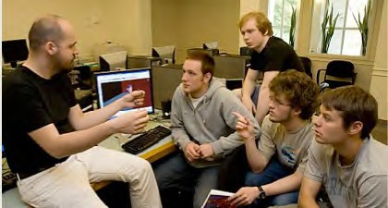](http://opentextbc.ca/teachinginadigitalage/wp-content/uploads/sites/29/2014/08/Tutorial-2.jpg)

*Figure 10.6.2 Student-teacher interaction Image: © Joseph Mehling, DartmouthLife, 2007*

Student-teacher interaction is often needed though in order to develop many of the

higher order learning outcomes, such as analysis, synthesis, and critical thinking. This is particularly important for developing academic learning, where students are challenged to question ideas, and to acquire deep understanding. This often requires dialogue and conversation, either one-on-one between instructor and students, or between an instructor and a group of students. The role of the teacher in for instance either face- to-face seminars or online collaborative learning is therefore critical. Student-teacher interaction is a key component of ‘teacher presence’ in Garrison, Anderson and Archer’s Community of Inquiry ([2000](https://www.sciencedirect.com/science/article/abs/pii/S1096751600000166)).

Some technologies, such as online discussion forums, enable or encourage such dialogue or discourse between students and instructors at a distance. The main limitation of student-teacher interaction is that it can be time-demanding for the teacher, and therefore does not scale easily.

##### Student – student interaction

[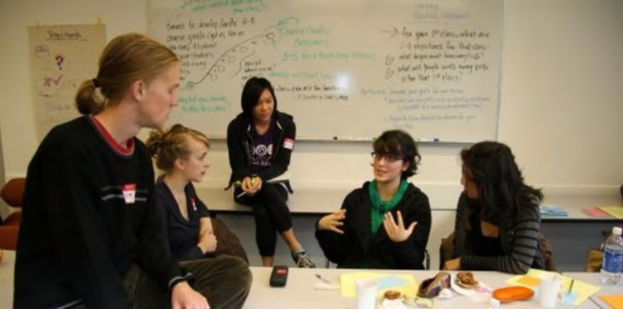](http://opentextbc.ca/teachinginadigitalage/wp-content/uploads/sites/29/2014/12/Student-seminar-2.jpg)

*Figure 10.6.3 A student directed seminar at UBC Image: © University of British Columbia, 2014*

High quality student-student interaction can be provided equally well both in face-to-face

and online learning contexts. Asynchronous online discussion forums built into learning management systems can enable this kind of interaction. Connectivist MOOCs and communities of practice also enable student-student interaction. Student-student interaction is a key component of ‘social presence’ in Garrison, Anderson and Archer’s Community of Inquiry ([2000](https://www.sciencedirect.com/science/article/abs/pii/S1096751600000166)).

Again though quality depends on good design. Merely putting students together in a group, whether online or face-to-face, is not likely to lead to either high levels of participation or high quality learning without careful thought being given to the educational goals of discussion within a course, the topics for discussion and their relationship to assessment and learning outcomes, and without strong preparation of the students by the instructor for self-directed discussions (see Chapter 4, Section 4[,](http://opentextbc.ca/teachinginadigitalage/chapter/6-5-online-collaborative-learning/) for more on this.)

In a technologically rich learning environment, then, a key decision for a teacher or course designer is choosing the best mix of these three different kinds of interaction, taking into consideration the epistemological approach, the amount of time available for both students and instructor, and the desired learning outcomes. Technology can enable all three kinds of interaction.

#### The interactive characteristics of media and technologies

Different technologies can enhance or inhibit each of the three types of interactivity outlined above. This again means looking at the dimension of interactivity as it applies to different media and technology. This dimension has three components or points on the dimension in terms of the extent an active response from a user is required when a medium or technology is used for teaching.

##### Inherent interactivity

Some media are inherently ‘active’ in that they ‘push’ learners to respond (a true ‘affordance.’). An example is adaptive learning, where students cannot progress to the next stage of learning without interacting through a test that ascertains whether they

have learned sufficiently to progress to the next stage, or what ‘corrective’ learning they still need to do. Behaviourist computer-based learning is inherently interactive, as it forces learners to respond. Technologies that control how a learner responds are often associated with more behaviourist approaches to teaching and learning.

##### Designed interactivity

Although some media or technologies are not inherently interactive, they can be explicitly designed to encourage interaction with learners. For instance, although a web page is not inherently interactive, it can be designed to be interactive, by adding a comment box or by requiring users to enter information or make choices. In particular, teachers or instructors can add or suggest activities within a particular medium. A podcast can be designed so that students stop the podcast every few minutes to do an activity based on the content of the podcast. This approach can be applied just as much to textbooks, where activities can be included, as to web pages.

In many cases, though, a medium will require the intervention of a teacher or instructor both to set activities around the learning materials and to provide appropriate feedback, thus adding to rather than reducing the workload of instructors. Thus where instructors have to intervene either to design activities or to provide feedback, the cost or time demands on the instructor are likely to be greater than if the other two kinds of interaction are used.

##### User-generated interactivity

Some media may not have explicit interaction built in, but end users may still voluntarily interact with the medium, either cognitively and/or through some physical response. For instance someone in an art gallery may cognitively or emotionally respond to a particular painting (while others may just glance at it or pass it by). Students may choose to make sketches or drawings from the painting. Learners may respond in similar ways to reading a novel or poem.

The creators of the work may in fact deliberately design the work to encourage reflection

or analysis, but not in explicit ways, leaving the interpretation of a work to the viewer or reader. (This of course is a constructivist approach to learning.) Media that encourage learners independently to be active without the necessary intervention of a teacher or instructor also have cost advantages, although the quality of the interaction will be more difficult to monitor or assess.

##### Who’s in control?

Thus one dimension of interactivity is control: to what extent is interaction controlled or enabled by the technology, by the creators/instructors, or by the users/learners? It can be seen that this is a complex dimension, once again influenced by epistemological positions, and also by design decisions on the teacher’s part. These categories of interactivity are in no way ‘fixed’, with different levels or types of interaction possible within the same medium or technology. In the end, interaction needs to be linked to desired learning outcomes. What kind of interaction will best lead to a particular type of learning outcome, and what technology or medium best provides this kind of interaction?

#### Interaction and feedback

Feedback is an important aspect of interaction, and timely and appropriate feedback on learner activities is often essential for effective learning. In particular, to what extent is feedback possible within a particular medium? Although for instance a learner may respond actively to a poem in a book, feedback on that interaction is usually not available just from the reading. Some other medium will need to be used to provide that feedback, such as a face-to-face poetry class or an online discussion forum.

On the other hand, with computer-based learning, once a student has responded to a multiple-choice question, the computer can mark the question and give almost instant feedback. However, with some technologies such as print, providing appropriate or immediate feedback to learners on their activities may be difficult or impossible. Although ‘model’ or ‘correct’ answers might be provided in a text on another page, quality

feedback on activities must be provided by a teacher or instructor when using a printed medium.

Thus media and technologies again differ in their capacity to provide various kinds of feedback. From a teaching perspective, it is important to be clear about what kind of feedback is likely to be most effective, and then the most effective way to provide that feedback. In particular, under what circumstances is it appropriate to automate feedback, and when should feedback be provided by a teacher/instructor, or perhaps a teaching assistant, or even by other students?

#### Analysing the interactive qualities of different media

In Figure 10.6.4 I have analysed the interactive qualities of different educational media along two different dimensions: different types of student interaction; and characteristics of the medium, in terms of whether interaction is built into the medium, or needs to be added through deliberate design, or whether it is left to the learner to decide how to interact.

[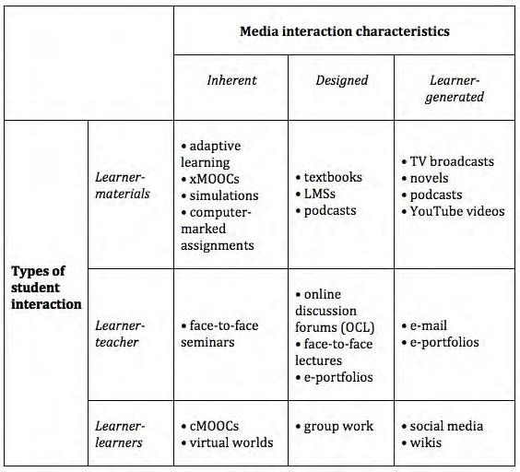](http://opentextbc.ca/teachinginadigitalage/wp-content/uploads/sites/29/2015/03/media-interaction-2.jpg)

*Figure 10.6.4 Media and student interaction*

I have allocated a number of different media here according to the type of learner activity they help generate. The actual location though of some of these media will be dependent on design decisions made by the instructor. For instance, a podcast could be accompanied by an activity (designed), or just be a straight broadcast, with the student left to interpret its meaning and purpose in the course (learner-generated). In some cases, an activity may be triggered by one medium (such as a podcast) but the actual activity and the feedback may take place in another medium (such as through an online assessment).

#### Summary

Thus it can be seen that media and technology are somewhat slippery when it comes to categorising them in terms of interaction, because instructors and learners often have a choice in how the medium will actually be used, and that will affect how learner interaction and feedback takes place within a single medium. Thus once again the quality of the design of the interactive experiences is as important as the medium of choice for enabling the activity, although an inappropriate choice of technology can reduce the level of activity and/or the quality of the interactions. In reality teachers and learners are likely to use a combination of media and technologies to ensure high quality interaction. However, using a number of different media is likely to increase cost and workload for both instructors and learners.

Once again, there is no evaluative judgement on my part in terms of which media or characteristics provide the ‘best’ interactivity. The choice of medium should depend on the kind of activities that are judged important by a teacher or instructor within the overall context of the teaching. The purpose of this analysis is to sensitize you to the differences between educational media in generating or facilitating different types of interaction, so that you can make informed decisions. In this case, though, there are no clear media or technology ‘winners’ in terms of interaction. Design decisions are likely to be more important than technology choice. Nevertheless, technology can enable students separated from their instructors still to get quality activities and feedback, and when appropriately used, technology used to support activities can result in more time on task for students.

#### Questions for consideration

1. In terms of the skills you are trying to develop, what kinds of interaction will be most useful? What media or technology could you use to facilitate that kind of interaction?
2. In terms of the effective use of your time, what kinds of interaction will produce a good balance between on the one hand student comprehension and student skills development, and on the other the amount of time you will be interacting personally or online with students?

#### References

Garrison, R., Anderson, T. and Archer, W. (2000) [Critical Inquiry in a Text-Based](https://www.sciencedirect.com/science/article/abs/pii/S1096751600000166) [Environment: Computer Conferencing in Higher Education](https://www.sciencedirect.com/science/article/abs/pii/S1096751600000166) *The Internet and Higher Education*, Vol. 2, Nos 2-3

Means, B. et al. (2009) [*Evaluation of Evidence-Based Practices in Online Learning: A Meta-*](http://www2.ed.gov/rschstat/eval/tech/evidence-based-practices/finalreport.pdf)[*Analysis and Review of Online Learning Studies*](http://www2.ed.gov/rschstat/eval/tech/evidence-based-practices/finalreport.pdf)Washington, DC: US Department of Education

Moore, M.G. (1989) [Three types of interaction](https://www.tandfonline.com/doi/abs/10.1080/08923648909526659) *American Journal of Distance Education*, Vol.3, No.2

###### Activity 10.6 Using media to promote student activity

* 1. Go to YouTube and type in your subject area into the ‘search’ box.
  2. Choose a YouTube video from the list that comes up that you might recommend to your students to watch.
  3. What kind of interaction would the YouTube video require from your students? Does it force them to respond in some way (inherent)?
  4. In what way are they likely to respond to the YouTube on their own, e.g. make notes, do an activity, think about the topic (learner-generated)?
  5. What activity could you suggest that they do, after they have watched the YouTube video (designed)? What type of knowledge or skill would that activity help develop? What medium or technology would students use to do the activity?
  6. How would students get feedback on the activity that you set? What medium or technology would they and/or you use for getting and giving feedback on their activity?
  7. How much work for you would that activity cause? Would the work be both manageable and worthwhile? Could the activity be scaled for larger numbers of students?
  8. How could the YouTube video have been designed to generate more or better activity from viewers or students?

There is no feedback from me for this activity, which requires user-generated activity (that is, you have to do the work!)

# Organisational issues

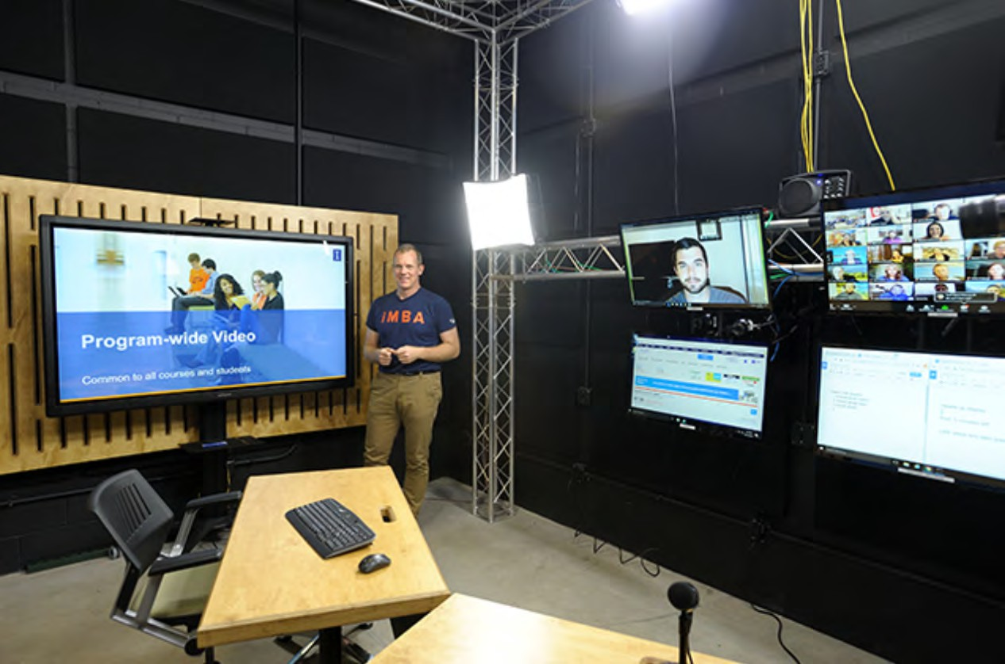

*Figure 10.7.1 A video production studio at University of Illinois Urbana-Champaign Image: UIUC. Just as important as the technical facilities are the media professionals who can help with the design of good quality educational videos.*

#### Institutional readiness for teaching with technology

One of the critical issues that will influence the selection of media by teachers and instructors is:

* the way the institution structures teaching activities;
* the instructional and technology services already in place;
* the support for media and technology use that their institution provides.

If an institution is organised around a set number of classroom periods every day, and the use of physical classrooms, the teachers are likely to focus mainly on classroom delivery. As Mackenzie was quoted in Chapter 10 Section 1:

‘*Teachers have always made the best of whatever they’ve got at hand, but it’s what we have to work with. Teachers make due*.’

The reverse is equally true. If the school or university does not support a particular technology, teachers and instructors quite understandably won’t use it. Even if the technology is in place, such as a learning management system or a video production facility, if instructors are not trained or oriented to its use and potential, then it will either be under used or not used at all. Furthermore, if ‘core’ technologies’ such as learning management systems or lecture capture facilities are not properly managed or if the services are understaffed, teachers and instructors lose patience and confidence in the technology.

Because of the inertia in institutions, there is often a bias towards those technologies that can be introduced with the minimum of organisational change, although these may not be the technologies that would have maximum impact on learning. These organisational challenges are extremely difficult, and are often major reasons for the slow implementation of new technologies for teaching in education (see Marshall, [2006,](https://www.educationcounts.govt.nz/publications/tertiary_education/e-learning/58139) for a method for assessing the readiness of institutions for online learning).

Most institutions that have successfully introduced media and technology for teaching on a large scale have recognized the need for adequate professional support for faculty, by providing instructional designers, media designers and IT support staff to support teaching and learning. Some institutions also provide funding for innovative teaching projects.

#### Work with professionals

**[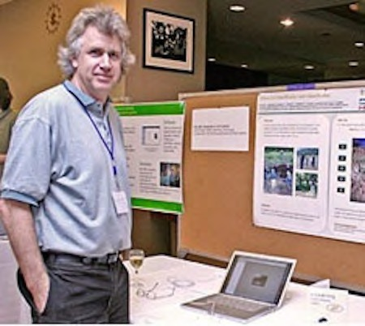](http://opentextbc.ca/teachinginadigitalage/wp-content/uploads/sites/29/2015/01/Chris-Crowley-2.jpg)**

*Figure 10.7.2 Chris Crowley is an Instructional Designer/Project Manager for UBC’s Centre for Teaching, Learning and Technology. He is involved in the design, development and delivery of online courses and learning resources in a number of subject areas including Soil Science.*

Even those experienced in using media for teaching and learning would be wise to work with instructional designers and professional media producers when creating any of the media discussed in this chapter (with the possible exception of social media). It is important for the choice of technology to be driven by educational goals, rather than starting with a particular medium or technology in mind.

There are several reasons for working with professionals:

* they understand the technology and as a result will enable you to develop a better product more quickly than working alone;
* two heads are better than one: working collaboratively will result in new and better

ideas about how you could be using the medium;

* instructional designers and professional media producers will usually be familiar with project management and budgeting for media production, enabling resources to be developed in time and on budget. This is important as it is easy for teachers or instructors to get sucked into spending far more time than necessary on producing media.

The key point here is that although it is now possible for teachers and instructors to produce reasonably good quality audio and video on their own, they will always benefit from the input of professionals in media production.

#### Questions for consideration

1. How much and what kind of help can I get from the institution in choosing and using media for teaching? Is help easily accessible? How good is the help? Do the support people have the media professionalism I will need? Are they up to date in the use of new technologies for teaching?
2. Is there possible funding available to ‘buy me out’ for a semester and/or to fund a teaching assistant so I can concentrate on designing a new course or revising an existing course? Is there funding for media production?
3. To what extent will I have to follow ‘standard’ technologies, practices and procedures, such as using a learning management or video-conferencing system, or will I be encouraged and supported to try something new?
4. Are there already suitable media resources freely available that I can use in my teaching, rather than creating everything from scratch? Can I get help from the library for instance in identifying these resources and dealing with any copyright issues (see Chapter 12, Section 2)?

If the answers are negative for each of these questions, you would be wise to set very modest goals initially for using media and technology.

Nevertheless the good news is that it is increasingly easy to create and manage your own media such as web sites, blogs, wikis, podcasts and simple video production using a desktop computer or even a mobile phone. Furthermore students themselves are often

capable and interested in participating or helping with creating learning resources, if given the chance. Getting students involved in media production is a very good way for them to get a deeper understanding of a subject. Above all, there is an increasing amount of really good educational media coming available for free use for educational purposes, as we shall see in Chapter 12, so it is not necessary always to create media from scratch.

Other organisational issues will be discussed in more detail in Chapter 14 but clearly the amount of support you can get from your organisation is a key criterion in choosing and using media.

#### References

Bates, A. and Sangrà, A. (2011) [*Managing Technology in Higher Education*](https://www.wiley.com/WileyCDA/WileyTitle/productCd-0470584726%2CminiSiteCd-JBHIGHERED.html)San Francisco: Jossey-Bass

Marshall, S. (2009) [*E-Learning Maturity Model Version Two: New Zealand Tertiary*](https://www.educationcounts.govt.nz/publications/tertiary_education/e-learning/58139)[*Institution E-Learning Capability: Informing and Guiding E-Learning Architectural Change*](https://www.educationcounts.govt.nz/publications/tertiary_education/e-learning/58139)[*and Development*](https://www.educationcounts.govt.nz/publications/tertiary_education/e-learning/58139)Wellington NZ: Victoria University of Wellington

There is no activity provided for this section. The issues covered here are discussed in more depth in Bates and Sangrà (2011).

*Activity 10.7:*

# Networking (and novelty)

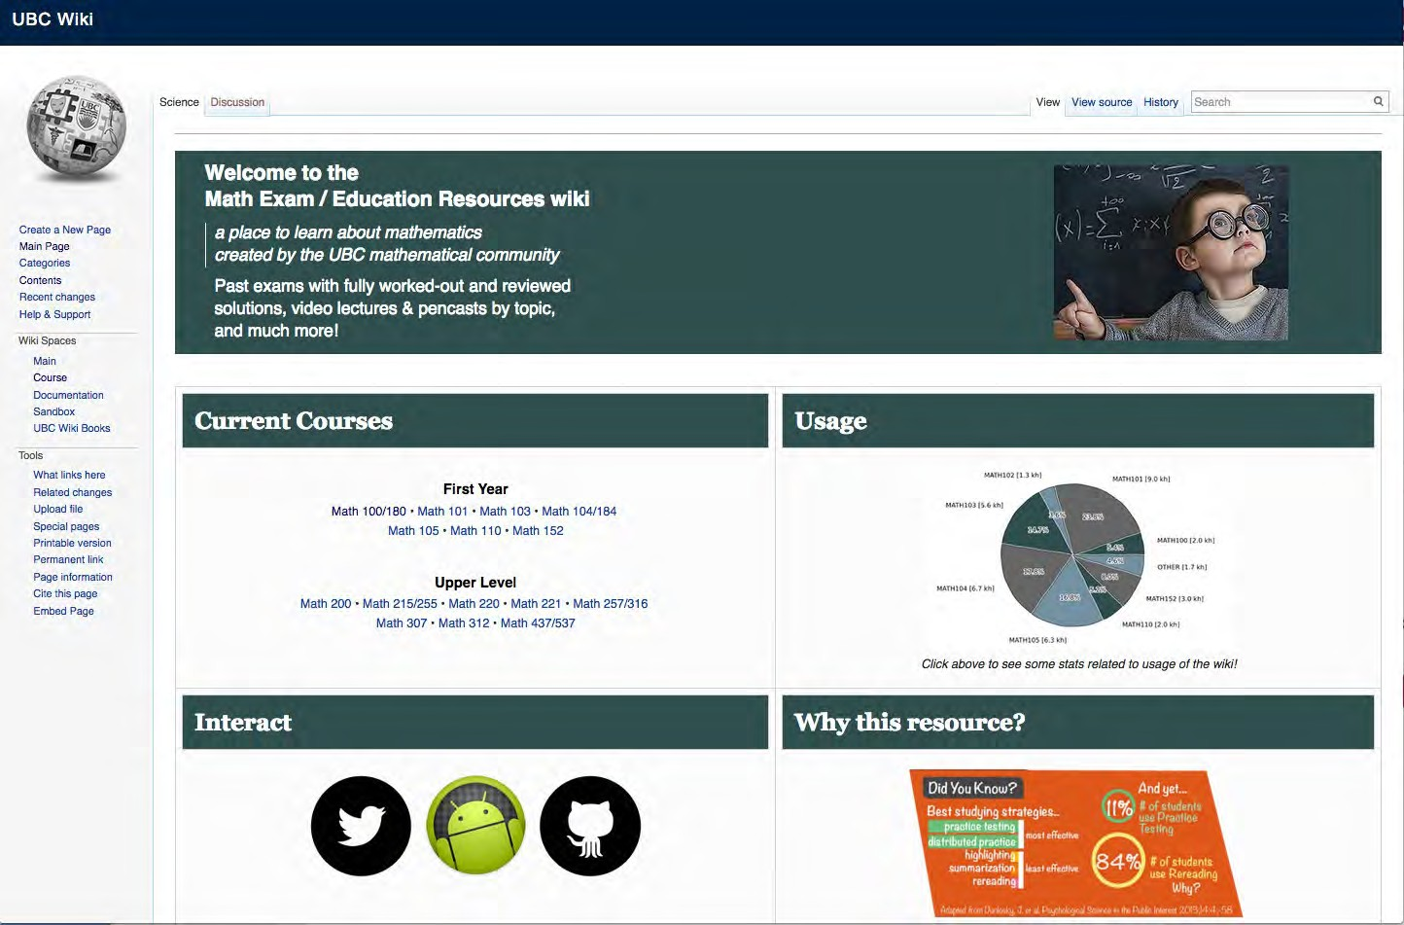

*Figure 10.8.1 UBC’s Math Exam Wiki (click on image to go to web page)*

#### Networking and novelty in course design

In earlier versions of the SECTIONS model, ‘N’ stood for novelty. This was to recognise the importance of teachers and instructors trying something new to improve on their practice, in this case to try a new technology and see how well it worked for them. Also the ‘hype’ surrounding new developments in technology often provides a supportive environment for innovative teaching. This is still an important issue; without experiment

and trying new ways of teaching and new technologies for teaching, there will be no improvement in practice.

However, more recent developments in social media raise another, increasingly important, question that needs to be asked when selecting media:

*how important is it to enable learners to network beyond a course, with others such as subject specialists, professionals in the field, and relevant people in the community? Can the course, or student learning, benefit from such external connections?*

If the answer to this is an affirmative, then this will affect what media to use, and in particular will suggest the use of social media such as blogs, wikis, Facebook, LinkedIn, or Google Chat.

#### Five ways to use social media for networking in education

Five different ways social media are influencing the application of networking in course design are described below.

##### Supplementing ‘standard’ learning technologies

Some instructors are combining social media for external networking with ‘standard’ institutional technologies such as a learning management system or video delivery. The LMS, which is password protected and available only to the instructor and other enrolled students, allows for ‘safe’ communication within the course. The use of social media allows for connections with the external world (contributions can still be screened by the course blog or wiki administrator by monitoring and approving contributions.)

For instance, a course on Middle Eastern politics could have an internal discussion forum focused on relating current events directly to the themes and issues that are the focus of the course, but students may manage their own, public wiki that encourages contributions from Middle East scholars and students, and indeed anyone from the general public.

Comments may end up being moved into and out of the more closed class discussion forum as a result.

##### Exclusive use of social media for credit courses

Other instructors are moving altogether away from ‘standard’ institutional technology such as learning management systems and lecture capture into the use of social media for managing the whole course. For instance, UBC’s course [ETEC 522](http://blogs.ubc.ca/etec522sept13/) uses WordPress, YouTube videos and podcasts for instructor and student contributions to the course. Indeed the choice of social media on this course changes every year, depending on the focus of the course, and new developments in social media. Jon Beasley-Murray at the University of British Columbia built a whole course around students creating a high level (featured-article) Wikipedia entry on Latin American literature (Latin American literature WikiProject – see Beasley-Murray, 2008).

##### Student generated learning resources

This is a particularly interesting development where students themselves use social media to create resources to help other students. For instance, graduate math students at UBC have created the Math Exam/Education Resources wiki, which provides ‘*past exams with fully worked-out and reviewed solutions, video lectures & pencasts by topic*‘. Such sites are open to anyone needing help in their studying, not just UBC students. The project involves voluntary collaboration between graduate students for the benefit of undergraduate students.

##### Self-managed learning groups

cMOOCs are an obvious example of self-managed learning groups using social media such as webinars, blogs and wikis.

##### Instructor-led open educational resources

YouTube in particular is becoming increasingly popular for instructors to use their knowledge to create resources available to anyone. The best example is still the [Khan](https://www.khanacademy.org/) [Academy](https://www.khanacademy.org/), but there are many other examples, such as MIT’s [OpenCourseWare](https://ocw.mit.edu/index.htm). xMOOCs are another example. This will be discussed more in Chapter 12.

Once again, the decision to ‘open up’ teaching is as much a philosophical or value decision as a technology decision, but the technology is now there to encourage and enable this philosophy.

#### Questions for consideration

1. How important is it to enable learners to network beyond a course, with others such as subject specialists, professionals in the field, and relevant people in the community? Can the course, or student learning, benefit from such external connections?
2. If this is important, what’s the best way to do this? Use social media exclusively? Integrate it with other standard course technology? Delegate responsibility for its design and/or administration to students or learners?
3. What is the best way to manage risk when using social media. so students aren’t subjected to abusive comments from the public, to their privacy being violated, or to their social media being hacked?

#### References

Beasley-Murray, J. (2008) Was introducing Wikipedia to the classroom an act of madness leading only to mayhem if not murder? *Wikipedia,* March 18

1. How could you use social media in one of your courses to enable students in the course to connect to the outside world? How would it improve their learning? What would be the risks as well as the benefits?

For my feedback on this, click on the podcast below:

*Activity 10.8: Networking (and novelty)*

*One or more interactive elements has been excluded from this version of the text. You can view them online here:* [*https://pressbooks.bccampus.ca/*](https://pressbooks.bccampus.ca/teachinginadigitalagev3m/?p=334&audio-334-1)

[*teachinginadigitalagev3m/?p=334#audio-334-1*](https://pressbooks.bccampus.ca/teachinginadigitalagev3m/?p=334&audio-334-1)

# Security and privacy

[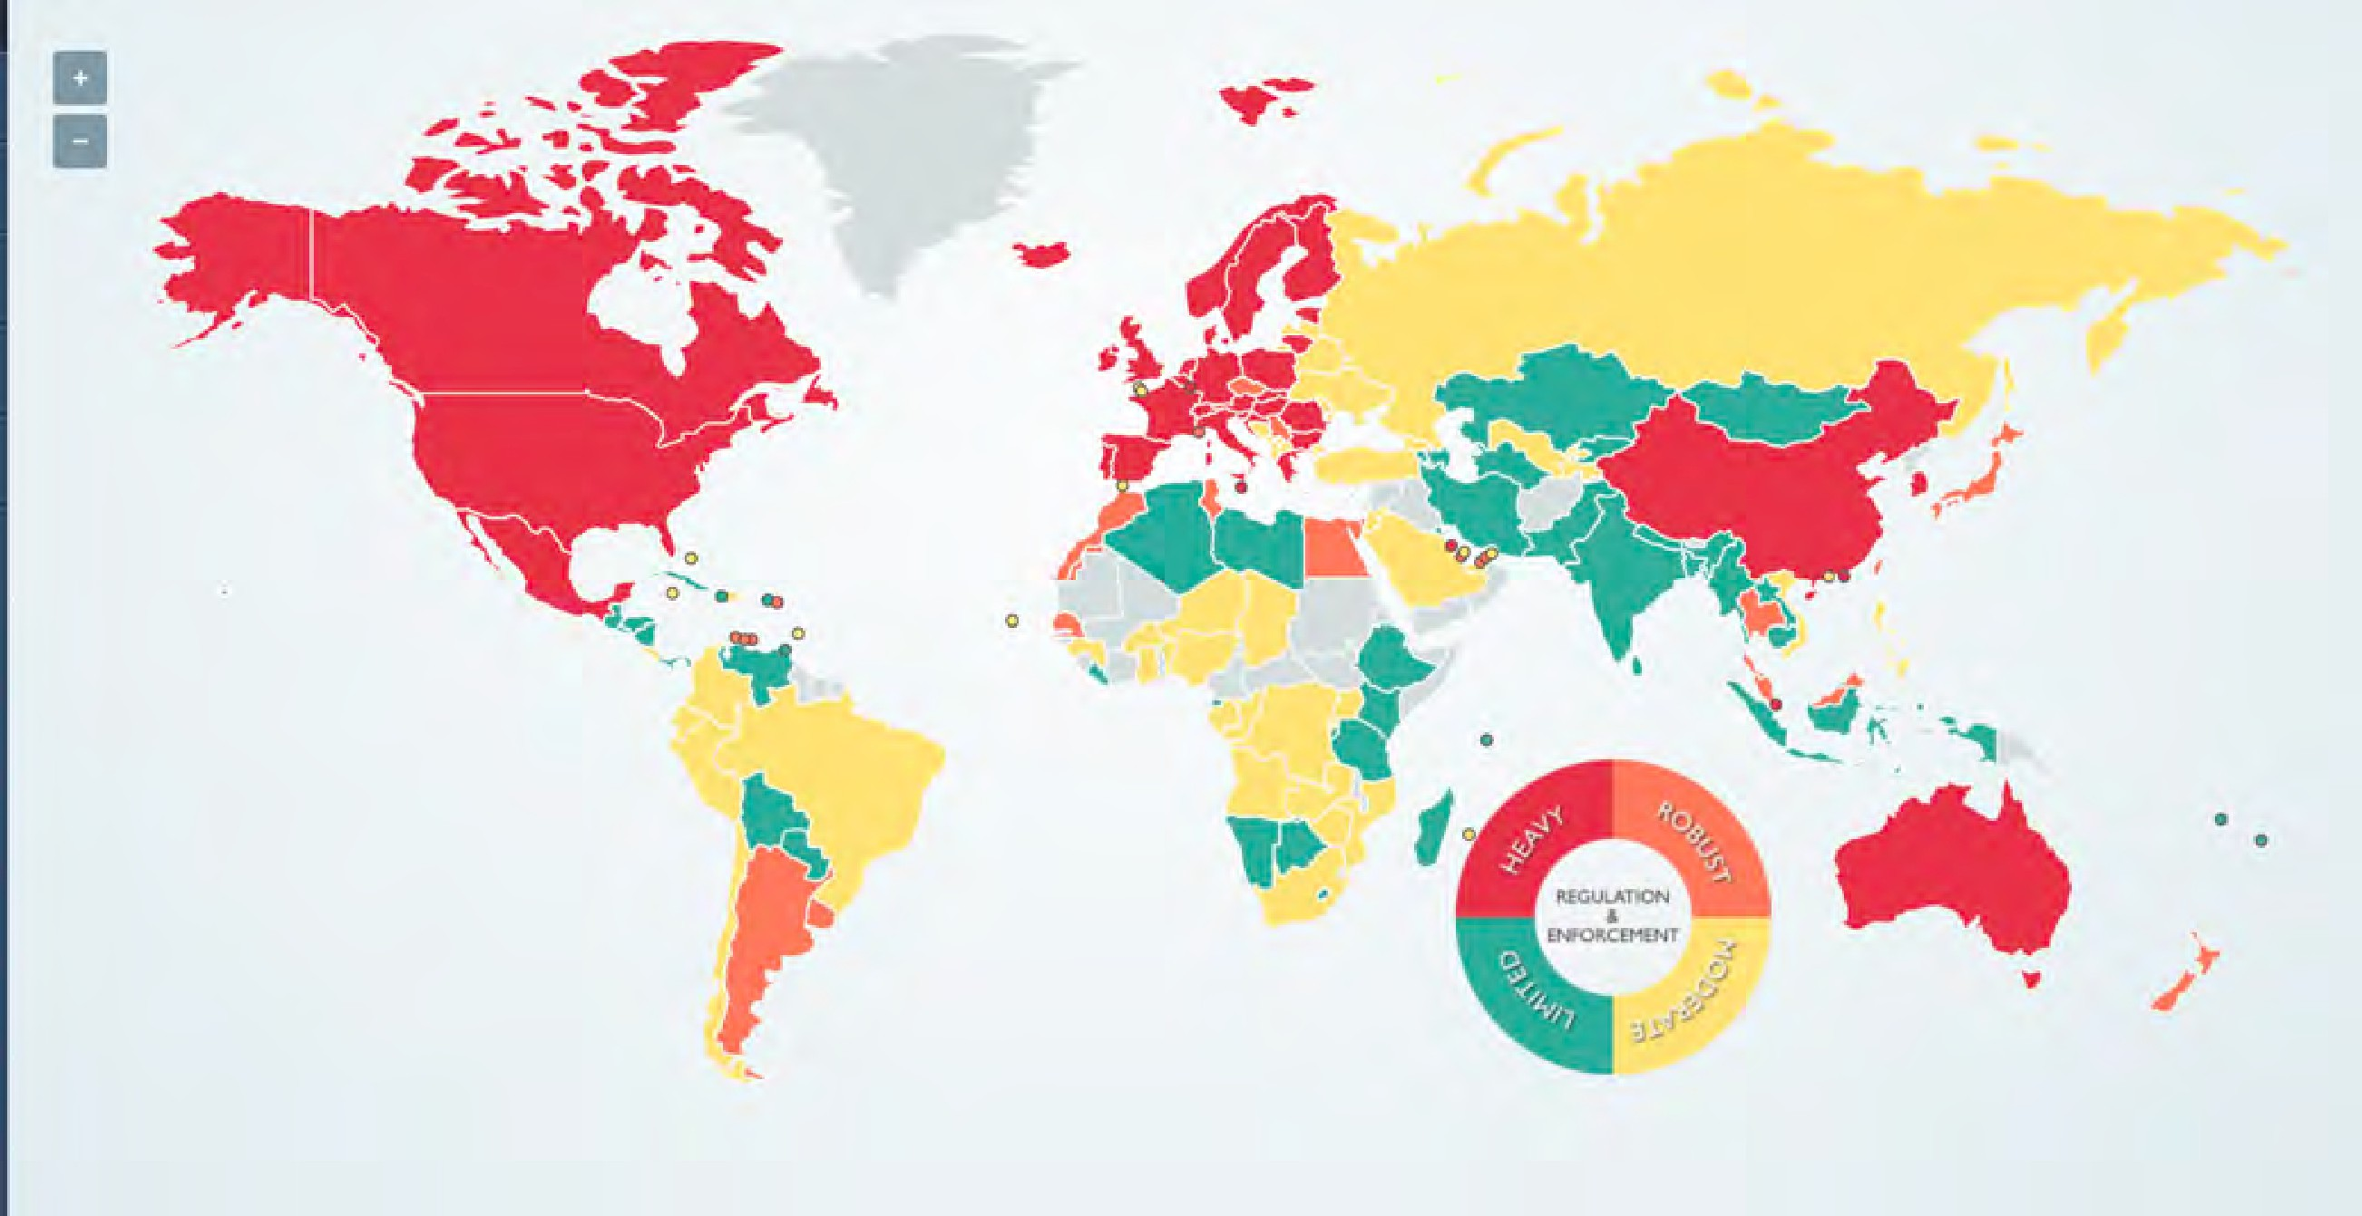](https://www.dlapiperdataprotection.com/)

Figure 10.9.1 Strength of data protection laws. Click on image for more information.

Image: © 2022 DLA Piper

‘S’ too is a change from the earlier ACTIONS model, where ‘S’ stood for speed, in terms of how quickly a technology enabled a course to be developed. However, the issues previously raised under speed have also been included in SECTIONS ‘Ease of Use’ (Chapter 10, Section 3). This allows ‘Speed’ to be replaced with ‘Security and privacy’, issues which have become increasingly important for education in a digital age.

#### The need for privacy and security when teaching

Teachers, instructors and students need a private place to work online. Instructors want to be able to criticize politicians or corporations without fear of reprisal; students may want to keep rash or radical comments from going public or will want to try out perhaps

controversial ideas without having them spread all over Facebook. Institutions want to protect students from personal data collection for commercial purposes by private companies, tracking of their online learning activities by government agencies, or marketing and other unrequested commercial or political interruption to their studies. In particular, institutions want to protect students, as far as possible, from online harassment or bullying. Creating a strictly controlled environment enables institutions to manage privacy and security more effectively. For a good example of a simple, transparent set of policies for privacy, see [University of British Columbia’s Privacy Fact Sheet.](https://universitycounsel.ubc.ca/files/2015/05/Fact-Sheet-Overview-of-Privacy.pdf)

Learning management systems provide password protected access to registered students and authorised instructors. Learning management systems were originally housed on servers managed by the institution itself. Password protected LMSs on secure servers have provided that protection. Institutional policies regarding appropriate online behaviour can be managed more easily if the communications are managed ‘in-house.’

#### Cloud based services and privacy

However, in recent years, more and more online services have moved ‘to the cloud’, hosted on massive servers whose physical location is often unknown even to the institution’s IT services department. Contract agreements between an educational institution and the cloud service provider are meant to ensure security and back-ups.

Nevertheless, Canadian institutions and privacy commissioners have been particularly wary of data being hosted out of country, where it may be accessed through the laws of another country. There has been concern that Canadian student information and communications held on cloud servers in the USA may be accessible via the U.S. Patriot Act. For instance, Klassen (2015 – no longer available) wrote:

*]Social media companies are almost exclusively based in the United States, where the provisions of the Patriot Act apply no matter where the information originates. The Patriot Act allows the U.S. government to access the social media content and the personally identifying information without the end users’ knowledge or consent. The government of British Columbia, concerned with both the privacy and security of personal information, enacted a stringent piece of legislation to protect the personal information of British Columbians. The Freedom of Information*

*and Protection of Privacy Act (FIPPA) mandates that no personally identifying information of British Columbians can be collected without their knowledge and consent, and that such information not be used for anything other than the purpose for which it was originally collected. [but see note at end of this section]*

Concerns about student privacy have increased even more when it became known that countries were sharing intelligence information, so there remains a risk that even student data on Canadian-based servers may well be shared with foreign countries.

Bishop (2011 – no longer available) discussed the risks to institutions in using Facebook:

* privacy is different from security, in that security is primarily a technical, hence mainly an IT, issue. Privacy needs a different set of policies that involves a much wider range of stakeholders within an institution, and hence a different (and more complex) governance approach from security;
* many institutions do not have a simple, transparent set of policies for privacy, but different policies set by different parts of the institution. This will inevitably lead to confusion and difficulties in compliance;
* there is a whole range of laws and regulations that aim to protect privacy; these cover not only students but also staff; privacy policy needs to be consistent across the institution and be compliant with such laws and regulation;
* Facebook’s current privacy policy (2011) leaves many institutions using Facebook at a high level of risk of infringing or violating privacy laws – merely writing some kind of disclaimer will in many cases not be sufficient to avoid breaking the law. *[but see note at end of this section]*

[The controversy at Dalhousie University](https://cdn.dal.ca/content/dam/dalhousie/pdf/cultureofrespect/DalhousieDentistry-TaskForceReport-June2015.pdf) where dental students used Facebook for violent sexist remarks about their fellow women students is an example of the risks endemic in the use of social media.

In 2019, the U.S. Federal Trade Commission imposed [a US$5 billion](https://www.ftc.gov/news-events/news/press-releases/2019/07/ftc-imposes-5-billion-penalty-sweeping-new-privacy-restrictions-facebook) penalty and sweeping new privacy restrictions on Facebook. *‘Despite repeated promises to its billions of users worldwide that they could control how their personal information is shared, Facebook undermined consumers’ choices*, said FTC Chairman Joe Simons’. I leave it to you to judge whether this will be sufficient to protect students’ private data from being exploited by social media companies.

#### The need for balance

Although there may well be some areas of teaching and learning where it is essential to operate behind closed doors, such as in some areas of medicine or areas related to public security, or in discussion of sensitive political or moral issues, in general though there have been relatively few privacy or security problems when teachers and instructors have opened up their courses, have followed institutional privacy policies, and above all where students and instructors have used common sense and behaved ethically. Nevertheless, as teaching and learning becomes more open and public, the level of risk does increase.

#### Questions for consideration

1. What student information am I obliged to keep private and secure? What are my institution’s policies on this?
2. What is the risk that by using a particular technology my institution’s policies concerning privacy could easily be breached? Who in my institution could advise me on this?
3. What areas of teaching and learning, if any, must I keep behind closed doors, available only to students registered in my course? Which technologies will best allow me to do this?

**Note:** In November 2021, the Government of British Columbia enacted Bill 22 to make significant changes to the *Freedom of Information and Protection of Privacy Act.* As a result of Bill 22, public bodies may now disclose personal information outside Canada ‘provided they comply with applicable regulations.’ This is an attempt to take account of the increasing use of cloud services. The BC Privacy Commissioner [was very unhappy](https://www.oipc.bc.ca/public-comments/3592) [about these changes](https://www.oipc.bc.ca/public-comments/3592). Privacy is clearly an area where governments are struggling to keep up with technological developments. All the more reason to be cautious.

#### References

Bishop, J. (2011) Facebook Privacy Policy: Will Changes End Facebook for Colleges? *The Higher Ed CIO*, October 4 – no longer available; see note above]

Federal Trade Commission (2019) [FTC Imposes $5 billion Penalty and Sweeping New](https://www.ftc.gov/news-events/news/press-releases/2019/07/ftc-imposes-5-billion-penalty-sweeping-new-privacy-restrictions-facebook) [Privacy Restrictions on Facebook](https://www.ftc.gov/news-events/news/press-releases/2019/07/ftc-imposes-5-billion-penalty-sweeping-new-privacy-restrictions-facebook) Washington DC: Federal Trade Commission

Klassen, V. (2015) *Privacy and Cloud-Based Educational Technology in British Columbia* Vancouver BC: BCCampus [Retrieved from BCcampus website: [http://www.bccampus.ca/assets/Content/Whitepapers/Background-Paper-](http://www.bccampus.ca/assets/Content/Whitepapers/Background-Paper-Privacy-and-Ed-Tech.pdf) [Privacy-and-Ed-Tech.pdf](http://www.bccampus.ca/assets/Content/Whitepapers/Background-Paper-Privacy-and-Ed-Tech.pdf) in 2017 – no longer available; see note below]

See also:

Bates, T. (2011) [Cloud-based educational technology and privacy: a Canadian perspective](http://www.tonybates.ca/2011/03/25/cloud-based-educational-technology-and-privacy-a-canadian-perspective/),

*Online Learning and Distance Education Resources*, March 25

1. Who in your institution can advise you on the institution’s policy or the state law on the use of social media or indeed any network outside your institution’s private internal network(s)?

Click on the podcast for my personal comments on this issue:

*Activity 10.9: Security and Privacy*

*One or more interactive elements has been excluded from this version of the text. You can view them online here:* [*https://pressbooks.bccampus.ca/*](https://pressbooks.bccampus.ca/teachinginadigitalagev3m/?p=337&audio-337-1)

[*teachinginadigitalagev3m/?p=337#audio-337-1*](https://pressbooks.bccampus.ca/teachinginadigitalagev3m/?p=337&audio-337-1)

# Deciding

[](http://opentextbc.ca/teachinginadigitalage/wp-content/uploads/sites/29/2015/03/SECTIONS-model-2.jpg)

*Figure 10.10 The SECTIONS model*

If you’ve worked your way right through the last three chapters, you are probably feeling somewhat overwhelmed by all the factors to take into consideration when selecting media. It is a complex issue, but if you have read all the previous sections, you are already in a good position to make well informed decisions. Let me explain.

#### Deductive versus inductive decision-making

Many years ago, when I first developed the ACTIONS model, I was approached by a good friend who worked for a large international computer company. (This was so long ago that data were entered to computers using punched cards). We sat down over a cup of coffee, and he outlined his plan. Here’s how the conversation went.

*Pierre.* Tony. I’m very excited about your model. We could take it and apply it in every school and university in the world.

*Tony*. Really? Now how would you do that?

*Pierre*. Well, you have a set of questions that teachers have to ask for each of the criteria. There is probably a limited set of answers to these questions. You could either work out what those answers are, or collect answers from a representative sample of teachers. You could then give scores to each technology depending on the answers they give. So when a teacher has to make a choice of technology, they would sit down, answer the questions, then depending on their answers, the computer would calculate the best choice of technology. Voilà!

*Tony*. I don’t think that’s going to work, Pierre.

*Pierre*: But why not?

*Tony*. I’m not sure, but I have a gut feeling about this.

*Pierre*. A gut feeling? My English is not so good. What do you mean by a gut feeling?

*Tony*. Pierre, your English is excellent. My response is not entirely logical, so let me try and think it through now, both for you and me, why I don’t think this will work. First, I’m not sure there is a limited number of possible answers to each question, but even if there is, it’s not going to work.

*Pierre*. Well, why not?

*Tony.* Because I’m not sure how a teacher would score their response to each question and in any case there’s going to be interaction between the

the answers to the questions. It’s not the addition of each answer that will determine what technology they might use, but how those answers combine. From a computing point of view, there could be very many different combinations of answers, and I’m not sure what the significant combinations are likely to be with regard to choosing each technology.

*Pierre*. But we have very big and fast computers, and we can simplify the process through algorithms.

*Tony*. Yes, but you have to take into account the context in which teachers will make media selections. They are going to be making decisions about media all the time, in many different contexts. It’s just not practical to sit down at a computer, answer all the questions, then wait for the computer’s recommendation.

*Pierre*. But won’t you give this a try? We can work through all these problems.

*Tony*. Pierre, I really appreciate your suggestion, but my gut tells me this won’t work, and I really don’t want to waste your time or mine on this.

*Pierre*. Well, what are you going to tell teachers then? How will they make their decisions?

*Tony*. I will tell them to use their gut instinct, Pierre – when they have read and applied the ACTIONS model.

This really is a true story, although the actual words spoken may have been different. The fact that we do have artificial intelligence these days that technically could do this hasn’t changed my mind, because what we have in this scenario is a conflict between deductive reasoning (Pierre) and inductive reasoning (Tony).

##### Deductive reasoning

With deductive reasoning, you would do what Pierre suggests: start without any prior conceptions about which technology to use, answer each of the questions I posed at the end of each part of the SECTIONS model, then write down all the possible technologies

that would fit the answers to each question, see what technology would best match each of the questions/criteria, and ‘score’ each technology on a recommended scale for each criterion. You would then try to find a way to add all those answers together, perhaps by using a very large matrix, and then end up with a decision about what technology to use.

A major problem though is that every teacher and every learning context is somewhat different each time a decision needs to be made. Experienced teachers in particular will bring a whole lot of knowledge with them – ideas about effective teaching methods, knowledge of the students, the requirement of the content and the skills they are trying to develop at the moment of decision, and above all the context in which the medium will be used (home, classroom, etc.) – before they have to make a decision.

##### Inductive reasoning

My solution is very different from Pierre’s. Mine is a more inductive approach to decision making.

***Inductive reasoning*** *is a method of reasoning in which a body of observations is considered to derive a general principle. It consists of making broad generalizations based on specific observations. Inductive reasoning is distinct from deductive reasoning. If the premises are correct, the conclusion of a deductive argument is certain; in contrast, the truth of the conclusion of an inductive argument is* [*probable*](https://en.wikipedia.org/wiki/Probable)*, based upon the evidence given.*

[*Wikipedia, 2022*](https://en.wikipedia.org/wiki/Inductive_reasoning)

In terms of selecting media, you probably start with a number of possible technologies in mind at the beginning of the process (hypotheses – or your gut feeling). My suggested process is start with your gut feeling about which technologies you’re thinking of using, but keeping an open mind, then move through all the questions suggested in each of the SECTIONS criteria (that is, collecting evidence for or against your initial ‘gut feeling’.) You then start building more evidence to support or reject the use of a particular medium or technology. By the end of the process you have a ‘probabilistic’ view of what combinations of media will work best for you and why. This is not an exercise you would have to do in detail or even consciously every time. Once you have done it just a few times, the choice of

medium or technology in each ‘new’ situation will be quicker and easier, because the brain stores all the previous information and you have a framework (the SECTIONS model) for organising new information as it arrives and integrating it with your previous knowledge.

##### Rapid decision-making

Now you’ve read this chapter you already have a set of questions for consideration (I have listed them all together in Appendix 1 for easy reference). You are now in the same position as the king who asked the alchemist how to make gold. ‘It’s easy’, said the alchemist, ‘so long as you don’t think about elephants.’ Well, having read the three chapters on media in full, you now have the elephants in your head. It will be difficult to ignore them. The brain is in fact a wonderful instrument for making intuitive or inductive decisions of this kind. The trick though is to have all this information somewhere in your head, so you can pull it all out when you need it. The brain does this very quickly. Your decisions won’t always be perfect, but they will be a lot better than if you hadn’t already thought about all these issues, and in life, rough but ready usually beats perfect but late.

#### Grounding media selection within a course development framework

Media selection does not happen in a vacuum. There are many other factors to consider when designing teaching. In particular, embedded within any decision about the use of technology in education and training will be assumptions about the learning process. We have already seen earlier in this book how different epistemological positions and theories of learning affect the design of teaching, and these influences will also determine a teacher’s or an instructor’s choice of appropriate media. Media selection is just one part of the course design process. It has to fit within the broader framework of course design.

In Figure 10.10.2 below, Hibbitts and Travin’s modification of the ADDIE model (see Chapter 4, Section 3) presents the following learning and technology development model that incorporates the various stages of course design:

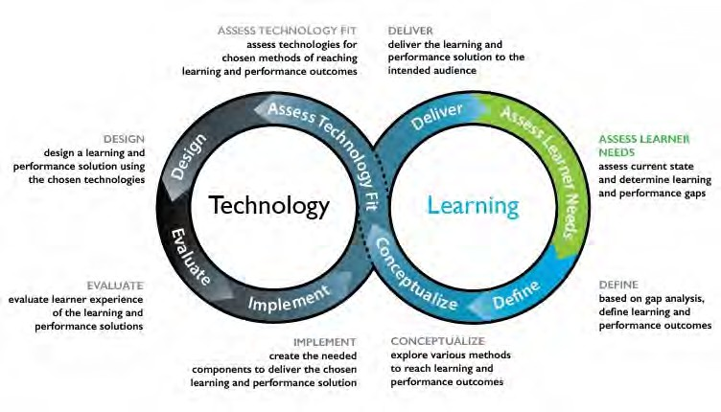

*Figure 10.10.2 Hibbitts and Travin’s Learning + technology development model*

The SECTIONS model is strategy that could be used for assessing the technology fit within this course development process. Whether you are using ADDIE or an agile design approach, then, media selection will be influenced by the other factors in course design, adding more information to be considered. This will all be mixed in with your knowledge of the subject area and its requirements, your beliefs and values about teaching and learning, and a lot of emotion as well.

All this further reinforces the inductive approach to decision making that I have suggested. Don’t underestimate the power of your brain – it’s far better than a computer for this kind of decision-making. But it’s important to have the necessary information, as far as possible. So if you skipped a part of this chapter, or the previous two chapters on media, you might want to go back over it!

#### Addendum: the corporate training market



*How well does the SECTIONS model fit the corporate training market? For a my personal response to this question, please click on the podcast below. It suggests a way to approach media selection in a variety of different contexts*

*One or more interactive elements has been excluded from this version of the text. You can view them online here:* [*https://pressbooks.bccampus.ca/teachinginadigitalagev3m/?p=340#audio-340-1*](https://pressbooks.bccampus.ca/teachinginadigitalagev3m/?p=340&audio-340-1)

1. Choose the same course that you chose for Activity 10.1.
2. Go to Appendix 1, and see how many of the questions you can answer. Use Chapter 10 to help, if necessary, including your answers to some the activities in Chapters 8 and 9.

*Activity 10.10: Choosing media and technologies*

3. When you have answered as many questions as you can from Appendix 1, what media or technologies will you now think of using. How does this differ from your original list? If there are changes, why?

Again, no feedback is provided as each context will be different.

1. Selecting media and technologies is a complex process, involving a very wide range of interacting variables.
2. There is currently no generally accepted theory or process for media selection. The SECTIONS model however provides a set of criteria or questions that can help inform an instructor when making decisions about which media or technologies to use.
3. Because of the wide range of factors influencing media selection and use, an inductive or intuitive approach to decision-making, informed by a careful analysis of all the criteria in the SECTIONS framework, is one practical way to approach decision-making about media and technologies for teaching and learning.
4. However, media selection needs to be integrated within the broader framework of course design.

*Chapter 10 Key Takeaways*

# Assessing media affordances: the SAMR model

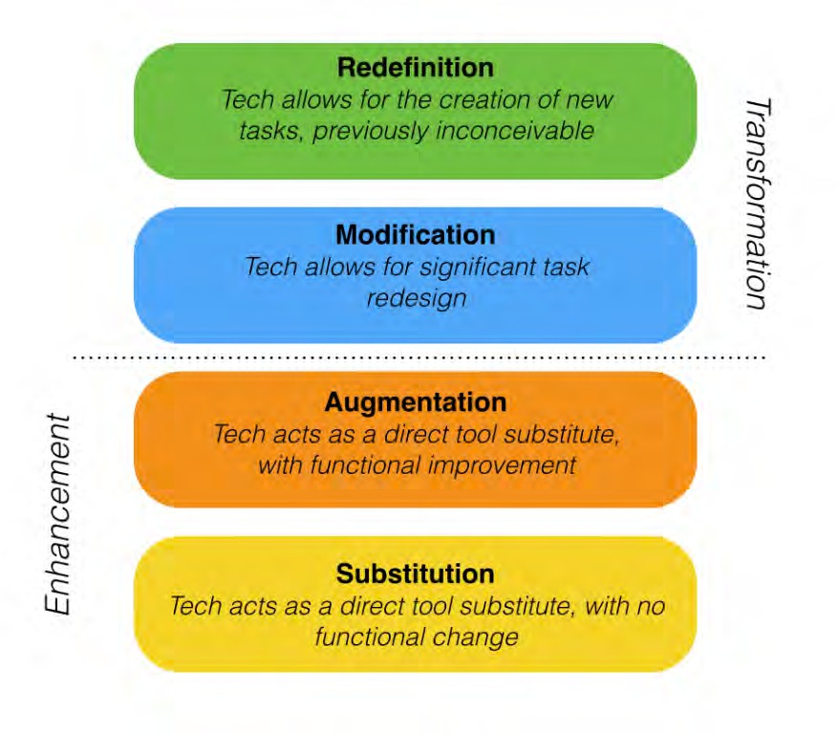

*Figure 10.11.1 The SAMR model Image: Ruben Puentedura*

#### Exploiting the affordances of a medium

It has been noted in several of the preceding chapters (for example, Chapter 7, Section 4

and Chapter 8, Section 4,) that video technology can be used as a straight replacement for a face-to-face lecture by merely substituting the face-to-face delivery with online delivery. The mode of delivery has changed but not the pedagogy. The full affordances of the medium of video have not been exploited.

On the other hand, using video to show a documentary can bring powerful examples of situations to which can be applied the ideas and concepts covered in an academic course. A documentary thus has the potential to make better use of the affordances of video than recording a lecture because the learning experience from watching a documentary is different from watching a lecture; at the same time, using a documentary video will require a different approach to teaching than using a lecture and will probably have different outcomes. With the video lecture students will focus on comprehension and understanding; with the documentary the students’ focus will be on analysing and critiquing the material.

#### The SAMR model

A good way to assess whether a particular application of media or technology is making full use of the affordances of a medium is to apply the SAMR model developed by Dr. Ruben Puentedura, a technology consultant based in the USA.

Puentedura suggests four ‘levels’ of technology application in education:

* **substitution**: *a direct tool substitute, with no functional change*, for example, a video recording of a classroom lecture on water quality, made available for downloading by students; students are assessed on the content of the lecture by written exams at the end of the course.
* **augmentation**: *a direct tool substitute, with functional improvement*, for example, the video lecture is embedded in an LMS, and edited into four sections, with online multiple-choice questions at the end of each section for students to answer.
* **modification**: *significant task redesign*, for example, the instructor provides video recordings of water being tested, and asks students to analyse each of the recordings in terms of the principles taught in the course in the form of essay-type questions that are assessed.
* **redefinition**: *creation of new tasks*, *inconceivable without the use of technology,* for

example, the instructor provides readings and online guidance through the LMS, and students are asked to record with their mobile phones how they selected samples of water for testing quality, and integrate their findings and analysis in the form of an

e-portfolio of their work.

In the first two levels, substitution and augmentation, video is used to enhance the method of teaching but it is only where video is used in the final two stages, modification and redefinition, that teaching is actually transformed. Significantly, Puentedura links the modification and transformation levels to the development of Bloom’s higher order ’21st century’ skills such as analysis, evaluation and creativity (Puentedura, [2014)](https://www.commonsense.org/education/articles/samr-and-blooms-taxonomy-assembling-the-puzzle). For a more detailed description of the model and how it works, see the video: [Introduction to the](https://www.commonsense.org/education/videos/introduction-to-the-samr-model) [SAMR model.](https://www.commonsense.org/education/videos/introduction-to-the-samr-model)

#### Strengths and limitations of the model

First, I was unable to find any research that validated this model. It has a powerful feel of common sense behind it, but it would be good to see it more empirically validated, although there are many examples of its actual use, particularly in teacher education in the k-12 sector (you can find some examples collected by Kelly Walsh [here](https://www.emergingedtech.com/2015/04/examples-of-transforming-lessons-through-samr/). For a more critical response to the SAMR model, see Linderoth, 2013).

Second, while the model is a useful means of evaluating whether a use of technology merely enhances or radically changes teaching, it doesn’t help much with the hard part, and that is imagining the transformative ways in which a technology could be used in the first place. Nevertheless it is a good heuristic device to get you to think about the best way to use technology in teaching, and perhaps more importantly, how to assess the potential in your choice of technology.

Third, there will be situations where substitution and augmentation will still be a perfectly justifiable use of technology, for instance for students with disabilities, or to increase accessibility to learning materials.

On balance, it is a very useful model by which an instructor can evaluate a potential or actual use of technology. In particular it focuses on the way students will need to interact

with the technology and the ways technology can be used to assist the development of 21st century skills.

#### References

Linderoth, J. (2013) Open letter to Dr. Ruben Puentedura *Spelvetenskapliga betraktelser*, 17 October

Puentedura, R. (2014) [SAMR and Bloom’s Taxonomy: Assembling the Puzzle](https://www.commonsense.org/education/articles/samr-and-blooms-taxonomy-assembling-the-puzzle) *common sense education*, September 24

1. If you are using any technology in your teaching, where does it fit in the SAMR framework in comparison with in-person teacher-student interaction? What could you change to make the technology ‘move up the ladder’?
2. Do you *have to* exploit fully the affordances of a medium? If so, why?

For feedback on this activity, click on the podcast below

*Activity 10.11: Assessing the SAMR model*

*One or more interactive elements has been excluded from this version of the text. You can view them online here:* [*https://pressbooks.bccampus.ca/*](https://pressbooks.bccampus.ca/teachinginadigitalagev3m/?p=343&audio-343-1)

[*teachinginadigitalagev3m/?p=343#audio-343-1*](https://pressbooks.bccampus.ca/teachinginadigitalagev3m/?p=343&audio-343-1)

## CHAPTER 11: MODES OF DELIVERY

When you have completed this chapter you should be able to:

* determine the most appropriate mode of delivery for any course or program you wish to offer;
* determine what factors should influence this decision;
* better identify the role of classroom teaching when students can now increasingly study most things online.

*The purpose of the chapter*

### What is covered in this chapter

* 11.1 The continuum of technology-based learning
* 11.2 Comparing modes of delivery
* 11.3 Which mode? Student needs
* 11.4 Choosing between face-to-face and online teaching on campus
* 11.5 The future of the campus

Also in this chapter you will find the following activities:

* Activity 11.1 Where on the continuum are your courses?
* Activity 11.2 Defining the ‘magic of the campus’
* Activity 11.3 Knowing your students
* Activity 11.4 Deciding on the mode of delivery
* Activity 11.5 Redesigning your classroom space

###### Key Takeaways from this chapter

* 1. There is a continuum of technology-based learning, from ‘pure’ face-to-face teaching to fully online programs. Every teacher or instructor needs to decide where on the continuum a particular course or program should be.
  2. We do not have good research evidence or theories to make this decision, although we do have growing experience of the strengths and limitations of online learning. What is particularly missing is an evidence- based analysis of the strengths and limitations of face-to-face teaching when online learning is also available.
  3. In the absence of good theory, I have suggested four factors to consider when deciding on mode of delivery, and in particular the different uses of face-to-face and online learning in blended courses:
     + student characteristics and needs;
     + your preferred teaching strategy, in terms of methods and learning outcomes;
     + the pedagogical and presentational requirements of the subject matter, in terms of (a) content and (b) skills;
     + the resources available to you as an instructor (including your time).
  4. The move to blended or hybrid learning in particular means rethinking the use of the campus and the facilities needed fully to support learning in a hybrid mode.

# The continuum of technology-based learning

[](http://opentextbc.ca/teachinginadigitalage/wp-content/uploads/sites/29/2015/02/99B-2.jpg)

*Figure 11.1 Why get on the bus when you can study online? (UBC bus loop)*

In Chapters 7 to 10, the use of media incorporated into a particular course or program was explored. In Chapter 12 the focus will be on deciding when and how to adopt an approach that incorporates ‘open-ness’ in its design and delivery. In this chapter, the focus is on deciding whether a whole course or program should be offered partly or wholly online.

#### The continuum of digital learning

Until quite recently, there were two distinct methods of delivering educational courses:

* in-person, on-campus teaching, in both schools and post-secondary educational institutions
* fully distance, where students did not come to campus but studied generally at home.

Now, however, with the development of online and digital learning, there is a wide variety of ways in which to study. Indeed there is a continuum of technology-based learning:

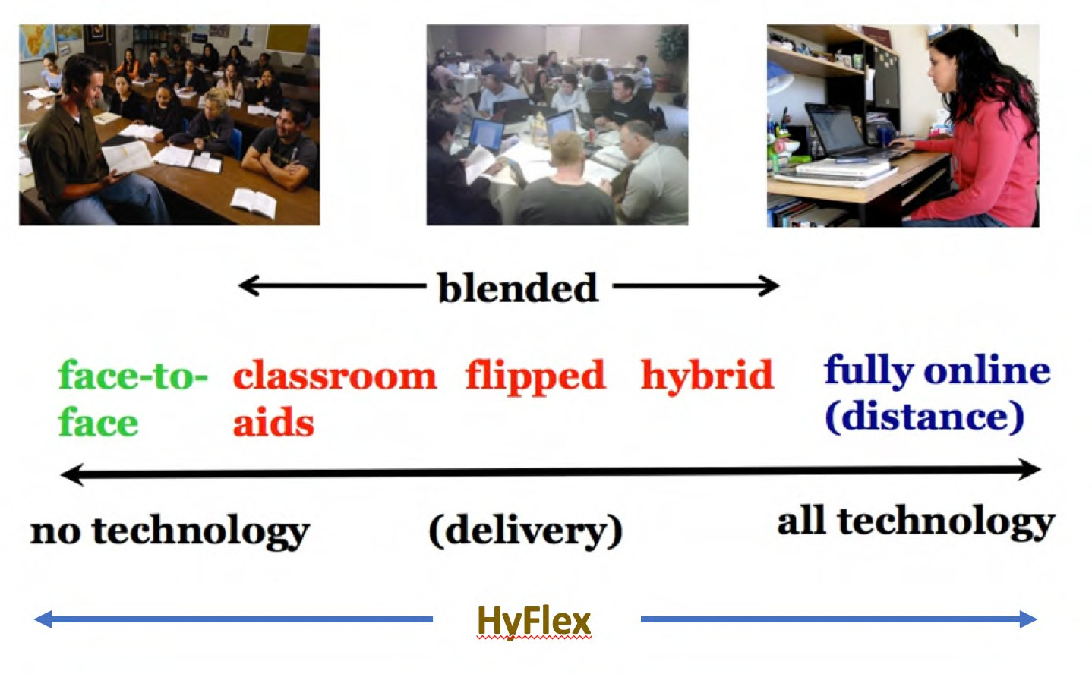

*Figure 11.1.2 The continuum of technology-based learning (modes of delivery).*

Online learning, blended learning, flipped learning, hybrid learning, flexible learning, hyflex learning, open learning and distance education are all terms that are often used interchangeably, but there are significant differences in meaning. At the time of writing it is possible to identify at least the following modes of delivery:

#### Classroom teaching

This is teaching where no technology at all is used, which is very rare these days. Indeed it could be argued that desks, blackboards, and classrooms are just one form of technology. However, that technology was pre-digital.

##### Digital classroom aids

This is technology used as classroom aids; typical examples are the use of an overhead projector or a video shown in a classroom, or Powerpoint slides and/or clickers in a lecture. These digital technologies enhance the traditional teaching method but do not change it (substitution or augmentation, in the SAMR model).

#### Blended learning

Blended learning encompasses a wide variety of designs:

* the use of *a learning management system to support classroom teaching*, for storing learning materials, providing a course schedule of topics, for online discussion, and for submitting student assignments, but teaching is still delivered mainly through classroom sessions;
* the use of *lecture capture for flipped classrooms*, where students watch the lecture via streamed video then come to class for discussion or other work; see for instance [a calculus course](https://teachonline.ca/pockets-innovation/developing-blended-learning-course-engaged-learning-calculus) offered at Queen’s University, Canada;
* *alternating or parallel modes*: one semester face-to-face on campus and two semesters online (one model at [Royal Roads University](http://www.royalroads.ca/about)); in the school system, most courses are on campus but students take can take some courses online;
* *hybrid* or *flexible* learning requiring the redesign of teaching so that students can do the majority of their learning online, coming to campus only for very specific face- to-face teaching, such as labs or hands-on practical work, that cannot be done satisfactorily online (for examples, see 11.1.3.1 below);
* *hyflex learning*: students are given choice in how they participate in the course and engage with material in the mode that works best for them over the course and from session to session (see 11.1.3.2 below).

in 2018, instructors in nearly three–quarters of all Canadian post-secondary institutions and almost 90% of universities were integrating online with classroom teaching. Of the institutions that responded that they were not yet offering blended/hybrid courses, the majority reported that they planned to in the future (Johnson, [2019](http://www.cdlra-acrfl.ca/wp-content/uploads/2020/07/2019_national_en.pdf)). Barbour et al. (2021) reported that the vast majority of school jurisdictions in Canada do not formally track participation in blended learning programs.

##### Hybrid learning

There is an important development within blended learning that deserves special mention, and that is the total re-design of campus-based classes that takes greater advantage of the potential of technology, which I call *hybrid learning,* with online learning combined with focused small group face-to-face interactions or mixing online and physical lab experiences. In such designs, the amount of face-to-face contact time is usually reduced, for instance from three classes a week to one, to allow more time for students to study online, or the time instructors spend in class presenting material is reduced, with the content available online and instructors using their time supporting students’ learning in class.

In hybrid learning the whole learning experience is re-designed, with a transformation of teaching on campus built around the use of technology. For instance:

* + - * + Virginia Tech many years ago created a [successful program for first and second year](http://www.emporium.vt.edu/) [math teaching](http://www.emporium.vt.edu/) called the Math Emporium, built around 24 x 7 computer-assisted learning supported by ‘roving’ instructors and teaching assistants (Robinson and Moore, [2006](https://www.educause.edu/ir/library/pdf/pub7102.Pdf)). The Math Emporium is still going strong today;
        + The University of British Columbia launched in 2013 what it calls [a flexible](http://flexible.learning.ubc.ca/) [learning initiative](http://flexible.learning.ubc.ca/) focused on *developing, delivering, and evaluating learning experiences that promote effective and dramatic improvements in student achievement. Flexible learning enables pedagogical and logistical flexibility so that*

*students have more choice in their learning opportunities, including when, where, and what they want to learn*

* + - * + the use of *lecture capture for flipped classrooms*, where students watch the lecture via streamed video then come to class for discussion or other work; see for instance [a calculus course](https://teachonline.ca/pockets-innovation/developing-blended-learning-course-engaged-learning-calculus) offered at Queen’s University, Canada;
        + in the school (k-12) system, there are pockets of schools and teachers who have integrated online learning with their classroom teaching (Arnett, [2021](https://www.bostonglobe.com/2022/01/13/opinion/better-way-do-online-learning/)). One model is to replace most class lectures and teacher-led direct instruction with online lessons. Students then work through the lessons primarily in class with their teachers on hand to provide support. These schools measure students’ mastery of specific learning objectives to give the students a clearer picture of both their strengths and their areas for growth. It is students’ individual progress, not the semester calendar, that determines when they move on to new material. Teachers allow and encourage students to revise work and repeat assessments until they reach mastery. At the same time, students can outpace the semester calendar if they work hard or if certain concepts come easily to them. This is a hybrid learning version of competency-based learning (see Chapter 4, Section 5).

##### HyFlex learning

This is a recent development (Milman et al., [2020](https://library.educause.edu/resources/2020/7/7-things-you-should-know-about-the-hyflex-course-model)). A HyFlex class makes class meetings and materials available so that students can access them online or in-person, during or after class sessions. All students, regardless of the path taken, should achieve the same learning objectives. In HyFlex courses, students can choose from one of three participation paths:

* + - * + participate in face-to-face synchronous class sessions in-person (in a classroom)
        + participate in face-to-face class sessions via video conference (e.g., Zoom)
        + participate fully asynchronously via an LMS or other asynchronous technology ([Columbia University Centre for Teaching and Learning](https://ctl.columbia.edu/resources-and-technology/teaching-with-technology/teaching-online/hyflex/)).

##### Summary

Thus ‘blended learning’ can mean minimal rethinking or redesign of classroom teaching, such as the use of classroom aids, or complete redesign as in flexibly designed courses, which aim to identify the unique pedagogical characteristics of face-to-face teaching, with online learning providing flexible access for the rest of the learning.

#### (Fully) online learning

Fully online learning, with no classroom or on-campus teaching, is one form of distance education, including:

* courses for credit, which will usually cover the same content, skills and assessment as a campus-based version, but are available only to students admitted to a program;
* non-credit courses offered only online, such as courses for continuing professional education;
* fully open courses, such as MOOCs.

More than one third of higher education students in the USA now take at least one fully online course for credit, and about 15 per cent of students are taking only online courses (Seaman et al., [2018](https://babson.qualtrics.com/jfe/form/SV_djbTFMIjZGYDNVb)). In Canadian post-secondary institutions, approximately eight per cent of all credit course registrations were fully online in 2017 (Donovan et. al., [2018](http://www.cdlra-acrfl.ca/wp-content/uploads/2020/07/2018_national_en.pdf)). Enrolments in fully online courses for credit were increasing steadily in both Canada and the USA at a rate between five to ten per cent per annum over the ten years previous to Covid-19.

Based on actual and estimated enrolment data, the number of students engaged in K–12 distance and online learning in 2020-2021 in Canada was 7.3% of the overall K–12 student population (Barbour et al., [2021](https://k12sotn.ca/wp-content/uploads/2022/06/StateNation21.pdf), p.7), although this varied from province/territory to province/territory, from Alberta with 13.3% to Nunavut with 0.1%.

#### A rapidly evolving phenomenon

These forms of education, once considered somewhat esoteric and out of the mainstream of conventional education, were increasingly taking on greater significance and in some cases becoming mainstream themselves, before the Covid-19 pandemic hit. The pandemic has merely accelerated these trends (see, for instance, Fayed and Cummings, [2021](https://link.springer.com/book/10.1007/978-3-030-74088-7)).

As teachers and instructors become more familiar and confident with online learning and new technologies, there will be more innovation in integrating online and face-to- face teaching. New forms of blended, hybrid and online learning will emerge over time, as instructors, teachers and institutional managers continue to experiment to increase enrolments, improve learning outcomes, and provide greater flexibility for students and instructors. However, what is clear is that the introduction of digital technologies is having a profound effect on not only the delivery but also the design of teaching and learning.

#### Decisions, decisions!

These developments open up a whole new range of decisions for instructors. Every instructor now needs to decide:

* what kind of course or program should I be offering?
* how do I design or implement such courses?
* what factors should influence this decision?
* what is the role of classroom teaching when students can now increasingly study most things online?

This chapter aims to help you answer these questions.

#### References

Arnett, T. (2021) [A better way to do online learning](https://www.bostonglobe.com/2022/01/13/opinion/better-way-do-online-learning/), *Boston Globe*, January 13

Barbour, M., LaBonte, R. and Nagle, J. (2021) [*State of the Nation: K-12 e-Learning in Canada,*](https://k12sotn.ca/wp-content/uploads/2022/06/StateNation21.pdf)[*2021 edition*](https://k12sotn.ca/wp-content/uploads/2022/06/StateNation21.pdf)Halfmoon Bay, BC: The Canadian eLearning Network

Donovan, T. et al. (2018) [*Tracking Online and Distance Education in Canadian Universities*](http://www.cdlra-acrfl.ca/wp-content/uploads/2020/07/2018_national_en.pdf)[*and Colleges: 2018*](http://www.cdlra-acrfl.ca/wp-content/uploads/2020/07/2018_national_en.pdf)Halifax NS: Canadian Digital Learning Research Association

Fayed, I. and Cummings, J. (2021) [*Teaching in the Post Covid 19 Era*](https://link.springer.com/book/10.1007/978-3-030-74088-7)Springer: Cham, Switzerland, 764 pp

Johnson, N. (2019)[Tracking Online Education in Canadian Universities and Colleges:](http://www.cdlra-acrfl.ca/wp-content/uploads/2020/07/2019_national_en.pdf) [National Survey of Online and Digital Learning 2019 National Report](http://www.cdlra-acrfl.ca/wp-content/uploads/2020/07/2019_national_en.pdf) Halifax NS: Canadian Digital Learning Research Association

Milman, N. et al. (2020) [7 things you should know about the HyFlex course model](https://library.educause.edu/resources/2020/7/7-things-you-should-know-about-the-hyflex-course-model),

*EDUCAUSE Review*, July 7

Robinson, B. and Moore, A. (2006) ‘Chapter 42: Virginia Tech: the Math Emporium’ in Oblinger, D. (ed.), [*Learning Spaces*](https://www.educause.edu/ir/library/pdf/pub7102.Pdf)Boulder CO: EDUCAUSE

Seaman, J., Allen, I., and Seaman, J. (2018) [*Grade Increase: Tracking Distance Education in*](https://babson.qualtrics.com/jfe/form/SV_djbTFMIjZGYDNVb)[*the United States*](https://babson.qualtrics.com/jfe/form/SV_djbTFMIjZGYDNVb)Wellesley MA: The Babson Survey Research Group

1. If you are currently teaching, where on the continuum is each of your courses? How easy is it to decide? Are there factors that make it difficult to decide where on the continuum any of your courses should fit?
2. How was it decided what the mode of delivery would be for the courses you teach? If you decided, what were the reasons for the location of each course on the continuum?
3. Are you happy with the decision(s)?

3. What kind of students do you have in each type of course? There is no feedback provided on this activity

*Activity 11.1 Where on the continuum are your courses?*

# Comparing modes of delivery

[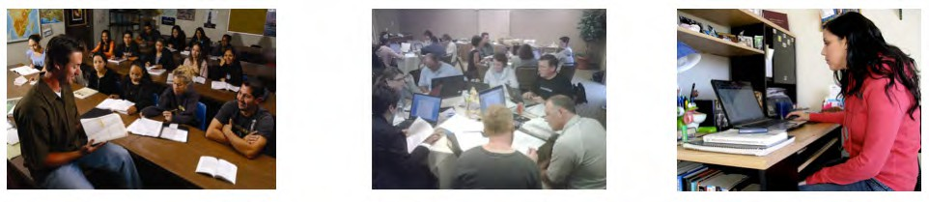](http://opentextbc.ca/teachinginadigitalage/wp-content/uploads/sites/29/2015/02/Comparing-modes-2.jpg)

*Figure 11.2.1 Which is the best?*

Many surveys have found that a majority of teachers and faculty still believe that online learning or distance education is inevitably inferior in quality to classroom teaching (see for instance Allen and Seaman, [2012,](https://www.bayviewanalytics.com/reports/conflicted.pdf) and Jaschik and Lederman, [2014](https://www.insidehighered.com/sites/default/server_files/files/IHE-FacTechSurvey2014%20final.pdf)), although over time, as they become more directly exposed to online learning, faculty are slowly becoming more positive about online learning (see for instance, Lederman, [2019](https://www.insidehighered.com/news/survey/professors-slow-steady-acceptance-online-learning-survey)). In fact, there is no scientifically-based evidence to support the opinion that online learning is inferior in quality to face-to-face teaching. The evidence points in general to no significant differences, and if anything research suggests that blended or hybrid learning has some advantages over face-to-face teaching in terms of learning performance (see, for example, Means et al., [2010](https://www2.ed.gov/rschstat/eval/tech/evidence-based-practices/finalreport.pdf)).

#### The influence of distance education on online learning

We can learn a great deal from earlier developments in distance education. Although the technology is different, fully online learning is, after all, just another version of distance education.

Much has been written about distance education (see, for instance, Wedemeyer, [1981](https://trove.nla.gov.au/work/25014103?selectedversion=NBD2004939); Peters, [1983](http://oops.uni-oldenburg.de/550/2/petdis02.pdf); Holmberg, [1989](https://www.amazon.com/Practice-Distance-Education-Routledge-Studies/dp/0415112923); Keegan, [1990](https://www.amazon.com/Theoretical-Principles-Distance-Education-Routledge/dp/0415089425); Moore and Kearsley, [1996](https://www.amazon.ca/Distance-Education-Systems-Online-Learning/dp/1111520992); Peters, [2002](http://oops.uni-oldenburg.de/550/2/petdis02.pdf); Bates,

[2005](https://www.routledge.com/product/isbn/9780415284370?source=igodigital); Evans et al., [2008](https://trove.nla.gov.au/work/32022735?selectedversion=NBD43316248)) but in concept, the idea is quite simple: students study in their own time, at the place of their choice (home, work or learning centre), and without face- to-face contact with a teacher. However, students are ‘connected’, today usually through the Internet, with an instructor, adjunct faculty or tutor who provides learner support and student assessment.

Distance education has been around a very long time. It could be argued that in the Christian religion, St. Paul’s epistle to the Corinthians was an early form of distance education (53-57 AD). The first distance education degree was offered by correspondence by the University of London (UK) in 1858. Students were mailed a list of readings, and took the same examination as the regular on-campus students. If students could afford it, they hired a private tutor, but the Victorian novelist Charles Dickens called it the People’s University, because it provided access to higher education to students from less affluent backgrounds. The program still continues to this day, but is now called the [University of](https://london.ac.uk/worldwide) [London (Worldwide),](https://london.ac.uk/worldwide) with more than 50,000 students in 180 countries.

In North America, historically many of the initial land-grant universities, such as Penn State University, the University of Wisconsin, and the University of New Mexico in the USA, and Memorial University, University of Saskatchewan and the University of British Columbia in Canada, had state- or province-wide responsibilities. As a result these institutions have a long history of offering distance education programs, mainly as continuing education for farmers, teachers, and health professionals scattered across the whole state or province. These programs have now been expanded to cover undergraduate and professional masters students. Australia is another country with an extensive history of both k-12 and post-secondary distance education.

Qualifications received from most of these universities carry the same recognition as degrees taken on campus. For instance, the University of British Columbia, which has been offering distance education programs since 1936, makes no distinction on student transcripts between courses taken at a distance and those taken on campus, as both kinds of students take the same examinations.

Another feature of distance education, pioneered by the British Open University in the 1970s, but later adopted and adapted by North American universities that offered distance programs, is a course design process, based on the ADDIE model, but specially adapted to serve students learning at a distance. This places a heavy emphasis on defined learning outcomes, production of high quality multimedia learning materials, planned student

activities and engagement, and strong learner support, even at a distance. As a result, campus-based universities that offered distance education programs were well placed for the move into online learning in the 1990s, and for the rapid switch to emergency remote learning during Covid-19 (see for instance Fox, et al., [2020](https://www.everylearnereverywhere.org/resources/time-for-class-covid-19-edition/)). These universities have found that in general, students taking the online programs do almost as well as the on-campus students (course completion rates are usually within 5-10 per cent of the on-campus students – see [Ontario, 2011](http://www.tonybates.ca/wp-content/uploads/Fact-Sheet-Feb-22-Final.pdf)), which is somewhat surprising as the distance students often have full-time jobs and families.

It is important to acknowledge the long and distinguished pedigree of distance education from internationally recognised, high quality institutions, because commercial diploma mills, especially in the USA, have given distance education an unjustified reputation of being of lower quality. As with all teaching, distance education can be done well or badly. However, where distance education has been professionally designed and delivered by high quality public institutions, it has proved to be very successful, meeting the needs of many working adults, students in remote areas who would otherwise be unable to access education on a full-time basis, or on-campus students wanting to fit in an extra course or with part-time jobs whose schedule clashes with their lecture schedule. However, universities, colleges and even schools have been able to do this only by meeting high quality design standards.

At the same time, there has also been a small but very influential number of campus- based teachers and instructors who quite independently of distance education have been developing best practices in online or computer-supported learning. These include Roxanne Hiltz and Murray Turoff ([1978](https://www.amazon.com/Network-Nation-Revised-Communication-Computer/dp/0262581205)) who were experimenting with online or blended learning as early as the late 1970s at the New Jersey Institute of Technology, and Linda Harasim ([2017](https://www.routledge.com/Learning-Theory-and-Online-Technologies-2nd-Edition/Harasim/p/book/9781138860001)) at Simon Fraser University, who all focused particularly on online collaborative learning and knowledge construction within a campus or school environment.

There is also plenty of evidence that teachers and instructors in many schools, colleges and universities new to online learning have not adopted these best practices, instead merely transferring lecture-based classroom practice to blended and online learning, often with poor or even disastrous results. This too became apparent during Covid 19 (see, for instance, Fayed and Cummings, [2021,](https://link.springer.com/book/10.1007/978-3-030-74088-7) and Barbour et. al, [2021](https://k12sotn.ca/wp-content/uploads/2022/06/StateNation21.pdf), pp.-12-17)).

#### What the research tells us

There have been thousands of studies comparing face-to-face teaching to teaching with a wide range of different technologies, such as televised lectures, computer-based learning, and online learning, or comparing face-to-face teaching with distance education. With regard to online learning there have been several meta-studies. A meta-study combines the results of many ‘well-conducted scientific’ studies, usually studies that use the matched comparisons or quasi-experimental method (Means et al., [2010](https://www2.ed.gov/rschstat/eval/tech/evidence-based-practices/finalreport.pdf); Barnard et al., [2014](https://www.tandfonline.com/doi/abs/10.1080/01587919.2015.957433)). Nearly all such ‘well-conducted’ meta-studies find no or little significant difference between the modes of delivery, in terms of the effect on student learning or performance. For instance, Means et al. ([2010](https://www2.ed.gov/rschstat/eval/tech/evidence-based-practices/finalreport.pdf)), in a major meta-analysis of research on blended and online learning for the U.S. Department of Education, reported:

*In recent experimental and quasi-experimental studies contrasting blends of online and face-to-face instruction with conventional face-to-face classes, blended instruction has been more effective, providing a rationale for the effort required to design and implement blended approaches. When used by itself, online learning appears to be as effective as conventional classroom instruction, but not more so.*

Means et al. attributed the slightly better performance of blended learning to students spending more time on task. This highlights a common finding, that where differences have been found, they are often attributed to factors other than the mode of delivery. Tamim et al. ([2011](https://journals.sagepub.com/doi/abs/10.3102/0034654310393361)) identified ‘well-conducted’ comparative studies covering 40 years of research. Tamim et al. found there is a slight tendency for students who study with technology to do better than students who study without technology. However, the measured difference was quite weak, and the authors state:

*it is arguable that it is aspects of the goals of instruction, pedagogy, teacher effectiveness, subject matter, age level, fidelity of technology implementation, and possibly other factors that may represent more powerful influences on effect sizes than the nature of the technology intervention.*

Research into any kind of learning is not easy; there are just so many different variables or conditions that affect learning in any context. Indeed, it is the *variables* we should

be examining, not just the technological delivery. In other words, we should be asking a question first posed by Wilbur Schramm as long ago as [1977](https://www.amazon.com/Big-Media-Little-Technologies-Communication/dp/0803907400):

*What kinds of learning can different media best facilitate, and under what conditions?*

In terms of making decisions then about mode of delivery, we should be asking, not which is the best method overall, but:

*What are the most appropriate conditions for using face-to-face, blended or fully online learning respectively?*

Fortunately, there is much research and best practice that provides guidance on that question, at least with respect to blended and online learning (see, for instance, Anderson, [2008](http://www.aupress.ca/index.php/books/120146); Picciano et al., [2013](https://www.routledge.com/Blended-Learning-Research-Perspectives-Volume-2-1st-Edition/Picciano-Dziuban-Graham/p/book/9780415632515); Halverson et al., [2012](https://www.tandfonline.com/doi/abs/10.1080/01587919.2012.723166); Zawacki-Richter and Anderson, [2014](http://www.aupress.ca/index.php/books/120233)). Ironically, what we lack is good research on the unique potential of *face-to-face teaching* in a digital age when so much can also be done just as well online.

#### Challenging the supremacy of face-to-face teaching

Although there has been a great deal of mainly inconclusive research comparing online learning with face-to-face teaching in terms of student learning, there is very little evidence or even theory to guide decisions about what is best done online and what is best done face-to-face in a blended learning context, or about the circumstances or conditions when fully online learning is in fact a better option than classroom teaching. Generally the assumption appears to have been that face-to-face teaching is the default option by virtue of its superiority, and online learning is used only when circumstances prevent the use of face-to-face teaching, such as when students cannot get to the campus due to bad weather, when classes are so large that interaction with students is at a minimum, or schools and campuses are closed during a pandemic.

However, online learning has now become so prevalent and effective in so many contexts that it is time to ask:

*what are the unique characteristics of face-to-face teaching that make it pedagogically different from online learning?*

It is possible of course that there is nothing pedagogically unique about face-to-face teaching, but given the rhetoric around ‘the magic of the campus’ (Sarma, [2013](https://linc.mit.edu/linc2013/proceedings/LINC-2013-Proceedings.pdf)) and the hugely expensive fees associated with elite campus-based teaching, or indeed the high cost of publicly funded campus-based education, it is about time that we had some evidence-based theory about what makes face-to-face teaching so special. This will be discussed further in Section 5 of this chapter.

In the meantime, a method for determining which mode of delivery (face-to-face, blended or online) will be discussed in the next sections.

### References

Allen, I, and Seaman, J. (2012)[*Conflicted: Faculty and Online Education*](https://www.bayviewanalytics.com/reports/conflicted.pdf), Babson Survey Research Group

Anderson, T. (ed.) (2008) [*The Theory and Practice of Online Learning*](http://www.aupress.ca/index.php/books/120146)Athabasca AB: Athabasca University Press

Barbour, M., LaBonte, R. and Nagle, J. (2021) [*State of the Nation: K-12 e-Learning in Canada,*](https://k12sotn.ca/wp-content/uploads/2022/06/StateNation21.pdf)[*2021 edition*](https://k12sotn.ca/wp-content/uploads/2022/06/StateNation21.pdf)Halfmoon Bay, BC: The Canadian eLearning Network

Bates, A.W. (2005) [*Technology, e-Learning and Distance Education*](https://www.routledge.com/product/isbn/9780415284370?source=igodigital)London/New York: Routledge

Bernard, R. et al. (2014) [Detecting bias in meta-analyses of distance education research:](https://www.tandfonline.com/doi/abs/10.1080/01587919.2015.957433) [big pictures we can rely on](https://www.tandfonline.com/doi/abs/10.1080/01587919.2015.957433) *Distance Education* Vol. 35, No. 3

Evans, T., Haughey, M. and Murphy, D. (2008) [*International Handbook of Distance*](https://trove.nla.gov.au/work/32022735?selectedversion=NBD43316248)[*Education*](https://trove.nla.gov.au/work/32022735?selectedversion=NBD43316248)Bingley UK: Emerald Publishing

Fayed, I. and Cummings, J. (2021) [*Teaching in the Post Covid 19 Era*](https://link.springer.com/book/10.1007/978-3-030-74088-7)Springer: Cham, Switzerland, 764 pp

Fox, K., Bryant, G., Lin, N., Srinivasan, N. (2020). [Time for Class – COVID-19 Edition](https://www.everylearnereverywhere.org/resources/time-for-class-covid-19-edition/) [Part 1: A National Survey of Faculty during COVID-19](https://www.everylearnereverywhere.org/resources/time-for-class-covid-19-edition/). *Tyton Partners and Every Learner Everywhere*, July 8, 32 pp.

Halverson, L. R., Graham, C. R., Spring, K. J., & Drysdale, J. S. (2012) [An analysis of high](https://www.tandfonline.com/doi/abs/10.1080/01587919.2012.723166) [impact scholarship and publication trends in blended learning](https://www.tandfonline.com/doi/abs/10.1080/01587919.2012.723166) *Distance Education*, Vol. 33, No. 3

Harasim, L. (2017) [*Learning Theory and Online Technologies 2nd edition*](https://www.routledge.com/Learning-Theory-and-Online-Technologies-2nd-Edition/Harasim/p/book/9781138860001)New York/London: Taylor and Francis

Hiltz S., and Turoff M.(1978) [Network Nation: Human communication via](https://www.amazon.com/Network-Nation-Revised-Communication-Computer/dp/0262581205) [computer](https://www.amazon.com/Network-Nation-Revised-Communication-Computer/dp/0262581205) Reading, MA: Addison Wesley

Holmberg, B. (1989) [*Theory and Practice of Distance Education*](https://www.amazon.com/Practice-Distance-Education-Routledge-Studies/dp/0415112923)New York: Routledge

Jaschik, S. and Lederman, D. (2014) [*The 2014 Inside Higher Ed Survey of Faculty Attitudes to*](https://www.insidehighered.com/sites/default/server_files/files/IHE-FacTechSurvey2014%20final.pdf)[*Technology*](https://www.insidehighered.com/sites/default/server_files/files/IHE-FacTechSurvey2014%20final.pdf)Washington DC: Inside Higher Ed

Keegan, D. (ed.) (1990) [*Theoretical Principles of Distance Education*](https://www.amazon.com/Theoretical-Principles-Distance-Education-Routledge/dp/0415089425)London/New York: Routledge

Lederman, D. (2019) [Professors’ Slow, Steady Acceptance of Online Learning: A Survey](https://www.insidehighered.com/news/survey/professors-slow-steady-acceptance-online-learning-survey)

*Inside Higher Education*, 30 October

Means, B. et al. (2010) [*Evaluation of Evidence-Based Practices in Online Learning: A Meta-*](http://www2.ed.gov/rschstat/eval/tech/evidence-based-practices/finalreport.pdf)[*Analysis and Review of Online Learning Studies*](http://www2.ed.gov/rschstat/eval/tech/evidence-based-practices/finalreport.pdf)Washington, DC: US Department of Education

Moore, M. and Kearsley, G. (1996) [*Distance Education: A Systems View*](https://www.amazon.ca/Distance-Education-Systems-Online-Learning/dp/1111520992)Belmont CA: Wadsworth

Ontario (2011) [*Fact Sheet Summary of Ontario eLearning Surveys of Publicly Assisted PSE*](http://www.tonybates.ca/wp-content/uploads/Fact-Sheet-Feb-22-Final.pdf)[*Institutions*](http://www.tonybates.ca/wp-content/uploads/Fact-Sheet-Feb-22-Final.pdf)Toronto: Ministry of Training, Colleges and Universities

Peters, O. (1983) [Distance education and industrial production](http://www.c3l.uni-oldenburg.de/cde/found/peters67.htm), in Sewart et al. (eds.)

*Distance Education: International Perspectives* London: Croom Helm

Peters, O. (2002) [*Distance Education in Transition: New Trends and Challenges*](http://oops.uni-oldenburg.de/550/2/petdis02.pdf)Oldenberg FGR: Biblothecks- und Informationssystem der Universität Oldenberg

Picciano, A., Dziuban, C. and & Graham, C. (eds.) (2013) [*Blended Learning: Research*](https://www.routledge.com/Blended-Learning-Research-Perspectives-Volume-2-1st-Edition/Picciano-Dziuban-Graham/p/book/9780415632515)[*Perspectives, Volume 2*](https://www.routledge.com/Blended-Learning-Research-Perspectives-Volume-2-1st-Edition/Picciano-Dziuban-Graham/p/book/9780415632515). New York: Routledge

Sarma, S. (2013) [*The Magic Beyond the MOOCs*](https://linc.mit.edu/linc2013/proceedings/LINC-2013-Proceedings.pdf)Boston MA: LINC 2013 conference (recorded presentation)

Schramm, W. (1977) [*Big Media, Little Media*](https://www.amazon.com/Big-Media-Little-Technologies-Communication/dp/0803907400)Beverley Hills CA/London: Sage

Sarma, S. (2013) [*The Magic Beyond the MOOCs*](https://linc.mit.edu/linc2013/proceedings/LINC-2013-Proceedings.pdf)Boston MA: LINC 2013 conference (recorded presentation)

Tamim, R. et al. (2011) [What Forty Years of Research Says About the Impact of Technology](https://journals.sagepub.com/doi/abs/10.3102/0034654310393361) [on Learning: A Second-Order Meta-Analysis and Validation Study](https://journals.sagepub.com/doi/abs/10.3102/0034654310393361) *Review of Educational Research*, Vol. 81, No. 1

Wedemeyer, C. (1981) [*Learning at the Back Door: Reflections on Non-traditional Learning in*](https://trove.nla.gov.au/work/25014103?selectedversion=NBD2004939)[*the Lifespan*](https://trove.nla.gov.au/work/25014103?selectedversion=NBD2004939)Madison: University of Wisconsin Press

Zawacki-Richter, O. and Anderson, T. (eds.) (2014) [*Online Distance Education: Towards a*](http://www.aupress.ca/index.php/books/120233)[*Research Agenda*](http://www.aupress.ca/index.php/books/120233)Athabasca AB: AU Press, pp. 508

1. Can you define the ‘magic of the campus’? What is it about face-to-face teaching that makes it special, compared with teaching online? Write down the three things you think are the most important.
2. Could you do the same for teaching online? If not, what are the things that make the campus special? Click on the podcast below for some feedback on these questions

*Activity 11.2 Defining the magic of the campus*

*One or more interactive elements has been excluded from this version of the text. You can view them online here:* [*https://pressbooks.bccampus.ca/teachinginadigitalagev3m/?p=351#audio-351-1*](https://pressbooks.bccampus.ca/teachinginadigitalagev3m/?p=351&audio-351-1)

# Which mode? Student needs

[](http://opentextbc.ca/teachinginadigitalage/wp-content/uploads/sites/29/2015/02/Students-in-small-group-online-2.jpg)

*Figure 11.3.1 Who are your students? Image: UBC Library*

When making choices about mode of delivery, teachers and instructors need to ask the following four questions:

* who are – or could be – my students?
* what is my preferred teaching approach?
* what are the content and skills that I need to teach?
* what resources will I have to support my decision?

As always, start with the learners.

#### Fully online/distance learners

Research (see for instance [Dabbagh, 2007](http://www.editlib.org/p/22904/)) has repeatedly shown that fully online courses suit some types of student better than others:

* older, more mature students;
* students with already high levels of education;
* part-time students who are working and/or with families.

This applies not only to MOOCs (see Chapter 5) and other non-credit courses, but even more so to courses and programs for credit. There are in fact several different markets for online learning.

##### School/k-12 students

Some online and distance learning is now quite common in many jurisdictions for students in the last two years of high school. Such students may be in smaller schools that lack specialist teachers in science, for instance, or students who are unable to attend school for health or personal reasons.

The Ontario provincial government at one point wanted all high school students to take at least four high school credits out of 30 online (Laucius, [2019](https://ottawacitizen.com/news/local-news/ontario-is-poised-to-require-every-high-school-student-take-four-online-courses-what-does-it-mean)), but this was primarily an attempt to save money on teachers and was later reduced to two credits due to public resistance to the idea. Nevertheless there is a small but important group of k-12 students who will benefit from online and distance education.

##### Undergraduate online students

Today, ‘distance’ is more likely to be psychological or social, rather than geographical. For instance, from survey data regularly collected from students at the University of British Columbia (UBC):

* + - * + less than 20 per cent give reasons related to distance or travel for taking an online course;
        + most of the more than 10,000 or so UBC students (there are over 60,000 students in total) taking at least one fully online course are not truly distant. The majority (over 80 per cent) live in the Greater Vancouver Metropolitan Area, within 90 minutes commute time to the university, and almost half within the relatively compact City of Vancouver. Comparatively few (less than 10 per cent) live outside the

province (although this proportion is slowly growing each year);

* + - * + two thirds of UBC’s online students have paid work of one kind or another;
        + many undergraduate students in their fourth year take an online course because the face-to-face classes are ‘capped’ because of their large size, or because they are short of the required number of credits to complete a degree. Taking a course online allows these students to complete their program without having to come back for another year;
        + the main reason for most UBC students taking fully online courses is the flexibility they provide, given the work and family commitments of students and the difficulty caused by timetable conflicts for face-to-face classes.

In the USA, almost one in three undergraduate students is taking at least one online course (Allen and Seaman, [2017](http://onlinelearningsurvey.com/reports/digtiallearningcompassenrollment2017.pdf)). At an undergraduate level, students are likely to take a maximum of three to four online courses as part of a regular campus-based degree program at universities and up to five online courses at two year colleges, in Canada (Donovan et al., [2018](http://www.cdlra-acrfl.ca/wp-content/uploads/2020/07/2018_national_en.pdf)).

Until recently in North America, there were few undergraduate programs offered entirely online, except in specialist institutions such as the open universities in Canada (Athabasca, Téluq, Thompson Rivers Open Learning) and University of Phoenix, Western Governors University, and University of Maryland University College in the USA. However, in recent years a number of specialist online undergraduate programs have started to be offered, such as the [Bachelor of Mining Engineering Technology](https://mine.queensu.ca/Undergraduate-Studies/btech/) for working miners at Queen’s University, Canada

This suggests that fully online courses are suitable for more experienced students with a strong motivation to take such courses because of the impact they have on their quality of life. In general, online students need more self-discipline in studying and a greater motivation to study to succeed. This does not mean that other kinds of students cannot

benefit from online learning, but extra effort needs to go into the design and support of such students online.

##### Graduate online students

Although in the USA, the proportion of students taking distance education courses at a graduate level overall is almost the same (17 per cent) as those taking on-campus graduate courses – 15 per cent – the proportion of students taking distance education courses at a graduate level is much higher for private, not-for profit – 37 per cent, and for-profit institutions – 28 per cent (Allen and Seaman, [2017](http://onlinelearningsurvey.com/reports/digtiallearningcompassenrollment2017.pdf)). (As in Canada – Donovan. et al., [2018](http://www.cdlra-acrfl.ca/wp-content/uploads/2020/07/2018_national_en.pdf) – distance education now is almost synonymous with fully online learning in the USA).

The most rapid area of growth in online courses is for masters programs aimed at working professionals. So far, apart from MBAs and teacher education, public universities tend to be relatively slow in recognising the importance of this market, which at worse could be self-financing, and at best could bring in much needed additional revenues. The for-profit universities, though, such as the University of Phoenix, Laureate University and Capella University, and especially some of the private, not-for-profit universities in the USA, have been quicker to move into this market.

##### Lifelong learners

Fully online courses really suit working professionals. In a digital age, the knowledge base is continually expanding, jobs change rapidly, and hence there is strong demand for on-going, continuing education, often in ‘niche’ areas of knowledge. Online learning is a convenient and effective way of providing such lifelong learning.

Lifelong learners are often working with families and really appreciate the flexibility of studying fully online. They often already have higher education qualifications such as a first degree, and therefore have learned how to study successfully. They may be engineers looking for training in management, or professionals wanting to keep up to date in their professional area. They are often better motivated, because they can see a direct link between the new course of study and possible improvement in their career prospects.

They are therefore ideal students for online courses (even though they may be older and less tech savvy than students coming out of high school).

Following the pandemic, in 2022 the School of Continuing Studies at Toronto Metropolitan (formerly Ryerson) University moved all its former on-campus courses online, following a survey of its students. (Most of its students had to commute into the centre of the city from the suburbs in the Greater Toronto Area for its face-to-face classes.)

In recent years, there has been growing interest in micro-credentials, short, online courses that cover a particular area of knowledge or competency, often linked to local employer demand (for more about micro-credentials, see Contact North, [2020](https://teachonline.ca/tools-trends/ten-facts-you-need-know-about-micro-credentials)).

What is important for lifelong learners is that the courses are technically well designed, in that learners do not need to be highly skilled in using computers to be able to study the courses.

##### Remote learners

Often it is also assumed that isolated or remote learners are the main market for distance or fully online learners in that they are a long way away from any local school, college or university. Certainly in Canada, there are such students and the ability to study locally rather than travel great distances can be very appealing. However, in many remote rural areas, Internet access can be difficult, with either slow satellite connections or telephone- based, slow-speed modems. Remote learners will also struggle if there is no easily accessible or culturally appropriate local support for their studies.

Since the vast majority of online learners are urban, living within one hour’s travel of a college or university campus, it is the flexibility rather than the distance that matters to these learners.

##### Changing demographics

One other factor to consider is the impact of changing demographics. In the USA, overall

higher education enrolments declined by 3 per cent between 2012-2015, while distance education enrolments increased by 4 per cent over the same period (Allen and Seaman, [2017](http://onlinelearningsurvey.com/reports/digtiallearningcompassenrollment2017.pdf)).

In jurisdictions where the school-age population is starting to decline, expanding into lifelong learning markets may be essential for maintaining student enrolments. Although the rate of growth in distance education/online learning is not spectacular, it may eventually turn out to be a way to keep some academic departments alive.

##### New business models

However, to make lifelong learning online programs work, institutions need to make some important adjustments. In particular there must be incentives or rewards for faculty to move in this direction and there needs to be some strategic thinking about the best way to offer such programs.

The University of British Columbia has developed a series of very successful, fully online, self-financing professional masters’ programs. Students can initially try one or two courses in the [Graduate Certificate in Rehabilitation](https://mrsc.ubc.ca/graduate-certificate-in-rehabilitation-gcr/) before applying to [the master’s](https://mrsc.ubc.ca/master-of-rehabilitation-science-mrsc/) [program](https://mrsc.ubc.ca/master-of-rehabilitation-science-mrsc/). The certificate can be completed in less than two years while working full- time, and paying per course rather than for a whole Master’s year, providing the flexibility needed by lifelong learners. UBC also partnered with [Tec de Monterrey](https://tec.mx/en) in Mexico, with the same program being offered in English by UBC and in Spanish by Tec de Monterrey, as a means of kick-starting its very successful [Master in Educational Technology](http://met.ubc.ca/) program, which, when it opened, doubled the number of graduate students in UBC’s Faculty of Education, and is still running now almost 20 years after its initial offering. We shall see these examples are important when we examine the development of modular programming in Section 12.5.2.

Online learning also offers the opportunity to offer programs where an institution has unique research expertise but insufficient local students to offer a full master’s program. By going fully online, perhaps in partnership with another university with similar expertise but in a different jurisdiction, it may be able to attract students from across the country or even internationally, enabling the research to be more widely disseminated

and to build a cadre of professionals in newly emerging areas of knowledge – again an important goal in a digital age.

#### Blended learning learners

In terms of blended learning, the ‘market’ is less clearly defined than for fully online learning. The benefit for students is increased flexibility, but they will still need to be relatively local in order to attend the campus-based sessions. The main advantage is for the 50 per cent or more of students, at least in Canada, who are working more than 15 hours a week (Marshall, [2010](https://www150.statcan.gc.ca/n1/pub/75-001-x/2010109/article/11341-eng.htm)) to help with the cost of their education and to keep their student debt as low as possible. Also, blended learning provides an opportunity for the gradual development of independent learning skills, as long as this is an intentional teaching strategy.

The research also suggests that these skills of independent learning need to be developed while students are on campus. In other words, online learning, in the form of blended learning, should be deliberately introduced and gradually increased as students work through a program, so by the time they graduate, they have the skills to continue to learn independently – a critical skill for the digital age. In general, it is not a good idea to offer fully online courses in the early years of a university or college career, unless they are exceptionally well designed with a considerable amount of online learner support – and hence are likely to be expensive to mount, if they are to be successful.

As well as the benefits of more flexibility for students, especially those working part- time, the academic benefits of blended learning are being better understood. These will be discussed in more detail in the next section. At this point, there is evidence that in Canada, at least, more and more institutions are seeing a move by instructors to blended or hybrid learning, providing the advantages of both online and face-to-face teaching (Donovan et al., [2018](http://www.cdlra-acrfl.ca/wp-content/uploads/2020/07/2018_national_en.pdf)). This trend has been greatly accelerated during Covid-19, as more teachers and instructors gained experience in online learning.

#### Face-to-face learners

In schools, a clear lesson from emergency remote learning during the Covid pandemic is that the younger the student, the more important is in-person contact with a teacher and other students. This is an essential part of social and personal development for young children and cannot easily be substituted through online learning. Nevertheless, specially targeted use of computers or tablets under the direction and supervision of a teacher can still be useful for developing certain skills from an early age, such as digital literacy.

Many students coming straight from high school will be looking for social, sporting and cultural opportunities that a campus-based education provides. Also students lacking self-confidence or experience in studying are likely to prefer face-to-face teaching, providing that they can access it in a relatively personal way.

However, pedagogical or academic reasons for preference for face-to-face teaching by freshmen and women are less clear, particularly if students are faced with very large classes and relatively little contact with professors in the first year or so of their programs. In this respect, smaller, regional institutions, which generally have smaller classes and more face-to-face contact with instructors, have an advantage. Also, blended or flipped learning is increasingly being used for very large classes, with lectures available online, and smaller groups meeting face-to-face with an instructor or teaching assistants.

We shall see later in this chapter that blended and fully online learning offer the opportunity to re-think the whole campus experience so that better support is provided to on-campus learners in their early years in post-secondary education. More importantly, as more and more studying is done online, universities and colleges will be increasingly challenged to identify the unique pedagogical advantages of coming to campus, so that it will still be worthwhile for students to get on the bus to campus every morning.

#### Know your learners

It is therefore very important to know what kind of students you will be teaching. For some students, it will be better to enrol in a face-to-face class but be gradually introduced

to online study within a familiar classroom environment. For other students, the only way they will take the course will be if it is available fully online. It is also possible to mix and match face-to-face and online learning for some students who want the campus experience, but also need a certain amount of flexibility in their studying. Going online may enable teachers or instructors to reach a wider market (critical for departments with low or declining enrolments) or to meet strong demand from working professionals. In reality, of course, there is likely to be a mix of different kinds of students with different needs in every course (hence the interest in HyFlex courses.) Nevertheless, it is critical to ask, especially when planning new courses or programs: who are (or could be) your students? What kind of course will work best for them?

We shall see that identifying the likely student market for a course or program is the strongest factor in deciding on mode of delivery.

### References

Allen, I. and Seaman, J. (2017) [Digital Learning Compass: Distance Education Enrollment](http://onlinelearningsurvey.com/reports/digtiallearningcompassenrollment2017.pdf) [Report 2017](http://onlinelearningsurvey.com/reports/digtiallearningcompassenrollment2017.pdf) Babson Survey Research Group/eLiterate/WCET

Dabbagh, N. (2007) [The online learner: characteristics and pedagogical implications](http://www.citejournal.org/vol7/iss3/general/article1.cfm)

*Contemporary Issues in Technology and Teacher Education*, Vol. 7, No.3

Donovan, T. et al. (2018) [*Tracking Online and Distance Education in Canadian Universities*](http://www.cdlra-acrfl.ca/wp-content/uploads/2020/07/2018_national_en.pdf)[*and Colleges: 2018*](http://www.cdlra-acrfl.ca/wp-content/uploads/2020/07/2018_national_en.pdf)Halifax NS: Canadian Digital Learning Research Association

Laucius, J. (2019) [Ontario is poised to require every high school student take four online](https://ottawacitizen.com/news/local-news/ontario-is-poised-to-require-every-high-school-student-take-four-online-courses-what-does-it-mean) [courses](https://ottawacitizen.com/news/local-news/ontario-is-poised-to-require-every-high-school-student-take-four-online-courses-what-does-it-mean). What does it mean? *Ottawa Citizen*, March 22

Marshall, K. (2010) [Employment patterns of post-secondary students](https://www150.statcan.gc.ca/n1/pub/75-001-x/2010109/article/11341-eng.htm) Perspectives on Labour and Income Ottawa ON: Statistics Canada, September

1. Choose one of your courses. Do you know the key student demographics: age, gender, children with single or working moms, children with learning difficulties who may need extra work, learners with language difficulties, how many students are working, single or with families? If not how could you get this information?
2. If you had this information, would it change the way you teach, and in particular the mode of delivery?
3. If you are teaching a face-to-face class, are there other kinds of students who would be interested in taking your course if it was online?

There is no feedback on this activity.

*Activity 11.3 Knowing your students*

# Choosing between face-to-face and online teaching on campus



*Figure 11.4.1 What should students enrolled in campus courses do online? Image: Emily Carr University of Art and Design, 2018*

Analysing student demographics may help to decide whether or not a course or program should be either campus-based or fully online, but we need to consider more than just student demographics to make the decision about what to do online and what to do on campus for the majority of campus-based courses and programs that will increasingly have an online component.

#### A suggested method

##### Finding an approach based on successful experience

It should be stated up front that there is no generally agreed theory or even best practices for making this decision. The default mode has been that face-to-face teaching must be inherently superior, and you only go online if you must. However, we have seen that online learning has over the last ten years or so demonstrated clearly that many areas of knowledge can be taught just as well or better online. I will look therefore to examples where there has been a conscious decision to identify the relative affordances of different media, including face-to-face teaching. The area where this becomes most clear is in the teaching of science.

I am going to draw on a method used initially at the U.K. Open University for designing distance education courses and programs in science in the 1970s. The challenge was to decide what was best done in print, on television, via home experiment kits, and finally in a one week residential hands-on summer school at a traditional university. Since then, Dietmar Kennepohl and Lawton Shaw, of Athabasca University, have edited an excellent book about teaching science online ([Kennepohl and Shaw, 2010](http://www.aupress.ca/index.php/books/120162)). Also, the Colorado Community College System has used a combination of [remotely operated labs](https://wcetfrontiers.org/2015/04/07/nanslo-web-based-labs/) [for student practical work](https://wcetfrontiers.org/2015/04/07/nanslo-web-based-labs/), combined with home kits, for teaching online introductory science courses (Schmidt and Shea, [2015](https://wcetfrontiers.org/2015/04/07/nanslo-web-based-labs/)).

Each of these initiatives has adopted a pragmatic method for making decisions about what must be done face-to-face and what can be done online. What each of these approaches had in common was trusting the knowledge and experience of subject experts who are willing to approach this question in an open-minded way, and working with instructional designers or media producers on an equal footing.

From these experiences, I have extracted one possible process for determining when to go online and when not to, on purely pedagogical grounds, for a course that is being designed from scratch in a blended delivery mode. It is based on a five step process:

1. identify the overall instructional approach/pedagogy required
2. identify the main content to be covered
3. identify the main skills to be taught
4. analyse the resources available
5. analyse the most appropriate mode of delivery for each of the learning objectives identified above

I will choose a subject area at random: hematology (the study of blood), in which I am not an expert. But here’s what I would suggest if I was working with a subject specialist in this area.



*Figure 11.4.2 Can the study of hematology be done online? Image: CC Wikimedia Commons: National Cancer Institute, USA*

The example in this section is drawn from higher education, but a similar approach could be followed in the k-12 system. The main challenge for teachers will be resources (see 11.4.2 below), but the approach, the way of thinking about making decisions, should still work when teaching school children.

##### **Step 1**: identify the main instructional approach.

This is discussed in some detail in Chapters 2 to 4, but here are the kinds of decision to be considered:

[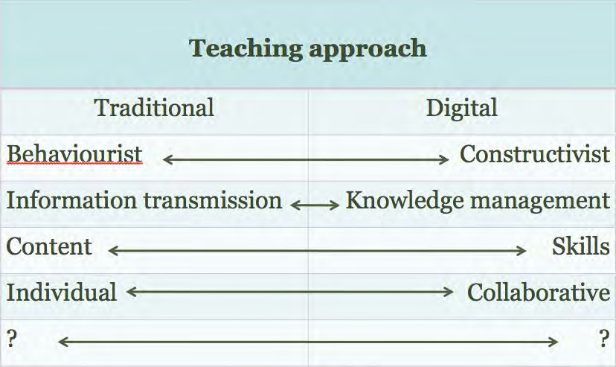](http://opentextbc.ca/teachinginadigitalage/wp-content/uploads/sites/29/2015/02/Teaching-approaches-2.jpg)

*Figure 11.4.3 Which teaching approach?*

This should lead to a general plan or approach to teaching that identifies the teaching methods to be used in some detail. In the example of hematology, the instructor wants to take a more constructivist approach, with students developing a critical approach to the subject matter. In particular, she wants to relate the course specifically to certain issues, such as security in handling and storing blood, factors in blood contamination, and developing student skills in analysis and interpretation of blood samples.

##### **Step 2**. Identify the main content to be covered

*Content* covers facts, data, hypotheses, ideas, arguments, evidence, and description of things (for instance, showing or describing the parts of a piece of equipment and their relationship). What do they need to know in this course? In hematology, this will mean understanding the chemical composition of blood, what its functions are, how it circulates through the body, descriptions of the relevant parts of cell biology, what external factors may weaken its integrity or functionality, the equipment used to analyse blood and how the equipment works, principles, theories and hypotheses about blood clotting, the relationship between blood tests and diseases or other illnesses, and so on.

In particular, what are the presentational requirements of the content in this course? Dynamic activities need to be explained, and representing key concepts in colour will almost certainly be valuable. Observations of blood samples under many degrees of magnitude will be essential, which will require the use of a microscope.

There are now many ways to represent content: text, graphics, audio, video and simulations. For instance, graphics, a short video clip, or photographs down a microscope can show examples of blood cells in different conditions. Increasingly this content is already available over the web for free educational use (for instance, see the American Society of Hematology’s [video library](https://www.youtube.com/user/ASHWebmaster)). Creating such material from scratch is more expensive, but is becoming increasingly easy to do with high quality, low cost digital recording equipment. Using a carefully recorded video of an experiment will often provide a better view than students will get crowding around awkward lab equipment.

##### **Step 3**. Identify the main skills to be developed during the course

*Skills* describe how content will be applied and practiced. This might include analysis of the components of blood, such as the glucose and insulin levels, the use of equipment (where ability to use equipment safely and effectively is a desired learning outcome), diagnosis, interpreting results by making hypotheses about cause and effect based on theory and evidence, problem-solving, and report writing.

Developing *skills* online can be more of a challenge, particularly if it requires manipulation of equipment and a ‘feel’ for how equipment works, or similar skills that require tactile sense. (The same could be said of skills that require taste or smell). In our hematology example, some of the skills that need to be taught might include the ability to analyse analytes or particular components of blood, such as insulin or glucose, to interpret results, and to suggest treatment. The aim here would be to see if there are ways these skills can also be taught effectively online. This would mean identifying the skills needed, working out how to develop such skills (including opportunities for practice) online, and how to assess such skills online.

Let’s call Steps 2 and 3 the key learning objectives for the course.

##### **Step 4**: Analyse the most appropriate mode for each learning objective

Then create a table as in Figure 11.4.4:

[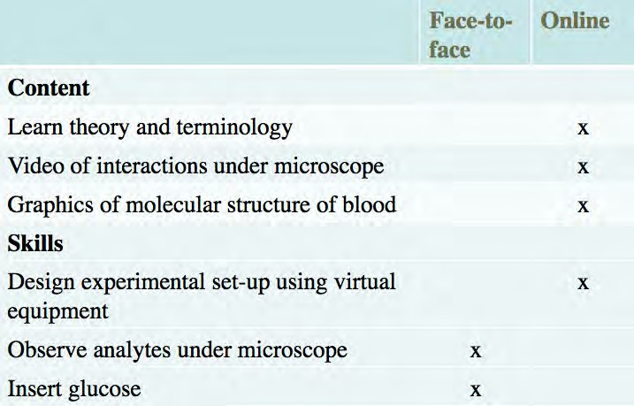](http://opentextbc.ca/teachinginadigitalage/wp-content/uploads/sites/29/2015/02/Haematology-table.jpg)

*Figure 11.4.4 Allocating mode of delivery*

In this example, the instructor is keen to move as much as possible online, so she can spend as much time as possible with students, dealing with laboratory work and answering questions about theory and practice. She was able to find some excellent online videos of several of the key interactions between blood and other factors, and she was also able to find some suitable graphics and simple animations of the molecular structure of blood which she could adapt, as well as creating with the help of a graphics designer her own graphics. Indeed, she found she had to create relatively little new material or content herself.

The instructional designer also found some software that enabled students to design their own laboratory set-up for certain elements of blood testing which involved combining virtual equipment, entering data values and running an experiment. However, there were still some skills that needed to be done hands-on in the laboratory, such as inserting glucose and using a ‘real’ microscope to analyse the chemical components of blood.

However, the online material enabled the instructor to spend more time in the lab with students.

It can be seen in this example that most of the content can be delivered online, together with a critically important skill of designing an experiment, but some activities still need to be done ‘hands-on’. This might require one or more evening or weekend sessions in a lab for hands-on work, thus delivering most of the course online, or there may be so much hands-on work that the course may have to be a hybrid of 50 per cent hands-on lab work and 50 per cent online learning.

With the development of animations, simulations and online remote labs, where actual equipment can be remotely manipulated, it is becoming increasingly possible to move even traditional lab work online. At the same time, it is not always possible to find exactly what one needs online, although this will improve over time. In other subject areas such as humanities, social sciences, and business, it is much easier to move the teaching online.

This is a crude method of determining the balance between face-to-face teaching and online learning for a blended learning course, but at least it’s a start. It can be seen that these decisions have to be relatively intuitive, based on instructors’ knowledge of the subject area and their ability to think creatively about how to achieve learning outcomes online. However, we have enough experience now of teaching online to know that in most subject areas, a great deal of the skills and content needed to achieve quality learning outcomes can be taught online. It is no longer possible to argue that the default decision must always be to do the teaching in a face-to-face manner.

Thus every instructor now needs to ask the question: if I can move most of my teaching online, what are the unique benefits of the campus experience that I need to bring into my face-to-face teaching? Why do students have to be here in front of me, and when they are here, am I using the time to best advantage?

#### Analyse the resources available

There is one more consideration besides the type of learners, the overall teaching method,

and making decisions based on pedagogical grounds, and that is to consider the resources available.

##### The time of the teacher or instructor

In particular, the key resource is the time of the teacher or instructor. Careful consideration is needed about how best to spend the limited time available. It may be all very well to identify a series of videos as the best way to capture some of the procedures for blood testing, but if these videos do not already exist in a format that can be freely used, shooting video specially for this one course may not be justified, in terms of either the time the teacher or instructor would need to spend on video production, or the costs of making the videos with a professional crew.

Time to learn how to do online teaching is especially important. There is a steep learning curve and the first time will take much longer than subsequent online courses. Some form of training or professional development for teachers or instructors thinking of moving online or into blended learning is needed before they embark on blended or online learning. Sometimes in post-secondary education instructors can get some release time (up to one semester from one class) in order to do the design and preparation for an online course, or a re-designed hybrid course. This however is not always possible, but one thing we do know. Teacher or instructor workload is a function of course design. Well designed online courses should require less rather than more work from an instructor.

##### 11.4.2.2. Learning technology support staff.

If your institution has a service unit for faculty development and training, instructional designers and web designers for supporting teaching, use them. Such staff are often qualified in both educational sciences and computer technology. They have unique knowledge and skills that can make your life much easier when teaching online. (This will be discussed further in Chapter 14.)

The availability and skill level of learning technology support from the institution or school board is a critical factor. Can you get the support of an instructional designer and media

producers? If not, it is likely that much more will be done face-to-face than online, unless you are already very experienced in online learning.

##### Readily available technology

Most institutions and increasingly most school districts now have a learning management system such as Brightspace or Moodle, or a video-conferencing system for transmitting or recording lessons. But increasingly, instructors in post-secondary education will need access to media producers who can create videos, digital graphics, animations, simulations, web sites, and access to blog and wiki software. Without access to such technology support, instructors are more likely to fall back on tried and true classroom teaching.

##### Colleagues experienced in blended and online learning

It really helps if there are experienced colleagues in the school or department who understand the subject discipline and have done some online teaching. They will perhaps even have some materials already developed, such as graphics, that they will be willing to share.

##### Money

Are there resources available to buy you out for one semester to spend time on course design? Many post-secondary institutions have development funds for innovative teaching and learning, and there may be external grants for creating new open educational resources, for instance. This will increase the practicality and hence the likelihood of more of the teaching moving online.

We shall see that as more and more learning material becomes available as open educational resources, teachers and instructors will be freed up from mainly content

presentation to focusing on more interaction with students, both online and face to face. However, although open educational resources are becoming increasingly available, they may not exist in the topics required or they may not be of adequate quality in terms of either content or production standards (see Chapter 12.2 for more on OERs).

The extent to which these resources are available will help inform you on the extent to which you will be able to go online and meet quality standards. In particular, you should think twice about going online if none of the resources listed above is going to be available to you.

#### The case for multiple modes

Increasingly, it is becoming difficult to separate markets for particular courses or programs. Although the majority of students taking a first year university course are likely to be coming straight from high school, some will not. There may be a minority of students who left high school directly for work, or went to a two year college to get vocational training, but now find they need a degree. Especially in professional graduate programs, students may be a mix of those who have just completed their bachelor’s course and are still full-time students, and those that are already in the work-force but need the specialist qualification. There will be a mix of students in third and fourth year undergraduate courses, some of whom will be working over 15 hours a week, and others who are studying more or less full time. In theory, then, it may be possible to identify a particular market for mainly face-to-face, blended or fully online learning, but in practice most courses are likely to have a mix of students with different needs.

If, though, as seems likely, more and more courses will end up as blended learning, then it is worth thinking about how courses could be designed to serve multiple markets. For instance, if we take our hematology course, it could be offered to full-time third year undergraduate students studying biology, or it could also be offered either on its own or with other related courses as a certificate in blood management for nurses working in hospitals. It might also be useful for students studying medicine who have not taken this particular course as an undergraduate, or even for patients with conditions related to their blood levels, such as diabetes.

If for instance our instructor developed a course where students spent approximately 50

per cent of their time online and the rest on campus, it may eventually be possible to design this for other markets as well, with perhaps practical work for nurses being done in the hospital under supervision, or just the online part being offered as a short MOOC for patients. For some courses (perhaps not hematology), it may be possible to offer the course wholly online, in blended format or wholly face-to-face. This would allow the same course to reach several different markets.

#### Questions for consideration in choosing modes of delivery

In summary, here are some questions to consider, when designing a course from scratch:

1. What kind of learners are likely to take this course? What are their needs? Which mode(s) of delivery will be most appropriate to these kinds of learners? Could I reach more or different types of learners by choosing a particular mode of delivery?
2. What is my view of how learners can best learn on this course? What is my preferred method(s) of teaching to facilitate that kind of learning on this course?
3. What is the main content (facts, theory, data, processes) that needs to be covered on this course? How will I assess understanding of this content?
4. What are the main skills that learners will need to develop on this course? What are the ways in which they can develop/practice these skills? How will I assess these skills?
5. How can technology help with the presentation of content on this course?
6. How can technology help with the development of skills on this course?
7. When I list the content and skills to be taught, which of these could be taught:
   * fully online
   * partly online and partly face-to-face
   * can only be taught face-to-face?
8. What resources do I have available for this course in terms of:
   * professional help from instructional designers and media producers;
   * possible sources of funding for release time and media production;
   * good quality open educational resources.
9. What kind of classroom space will I need to teach the way I wish? Can I adapt existing spaces or will I need to press for major changes to be made before I can teach the way I want to?
10. In the light of the answers to all these questions, which mode of delivery makes most sense?

#### References

Kennepohl, D. and Shaw, L. (eds.) (2010) [*Accessible Elements: Teaching Science Online and*](http://www.aupress.ca/index.php/books/120162)[*at a Distance*](http://www.aupress.ca/index.php/books/120162)Athabasca AB: Athabasca University Press

Schmidt, S. and Shea, P. (2015) [*NANSLO Web-based Labs: Real Equipment, Real Data, Real*](https://wcetblog.wordpress.com/2015/04/07/nanslo-web-based-labs/)[*People!*](https://wcetblog.wordpress.com/2015/04/07/nanslo-web-based-labs/)WCET Frontiers

1. Try following the process above for a possible new course that you would like to teach or for revising a course you are already teaching.

There is no feedback on this activity.

*Activity 11.4 Deciding on the mode of delivery*

# The future of the campus

[](http://opentextbc.ca/teachinginadigitalage/wp-content/uploads/sites/29/2015/02/The-magic-of-the-campus-2.jpg)

*Figure 11.5.1 The magic of the campus? Image: © Cambridge Advanced Studies Program, Cambridge University, U.K., 2015*

As more and more teaching is moved online, even for campus-based students, it will become increasingly important to think about the function of face-to-face teaching and the use of space on campus.

#### Identifying the unique characteristics of face-to-face teaching in a digital world

Sanjay Sarma, Director of MIT’s Office of Digital Learning, made an attempt at MIT’s LINC 2013 conference to identify the difference between campus-based and online learning, and in particular MOOCs. He made the distinction between MOOCs as open courses available to anyone, reflecting the highest level of knowledge in particular subject areas, and the ‘magic’ of the on-campus experience, which he claimed is distinctly different from the online experience (Sarma, [2013](https://linc.mit.edu/linc2013/proceedings/LINC-2013-Proceedings.pdf)).

He argued that it is difficult to define or pin down the magic that takes place on-campus, but referred to:

* ‘in-the-corridor’ conversations between faculty and staff;
* hands-on engineering with other students outside of lectures and scheduled labs;
* the informal learning that takes place between students in close proximity to one another.

There are a couple of other characteristics that Sarma hinted at but did not mention explicitly in his presentation:

* the very high standard of the students admitted to MIT, who ‘push’ each other to even higher standards;
* the importance of the social networks developed by students at MIT that provide opportunities later in life.

However, we should look beyond the ‘magic’ of the campus and focus on the reality of the benefits and limitations – the affordances – of face-to-face teaching. This was discussed in detail in Chapter 7, Section 4. Unfortunately, this is not a topic that lends itself to easy generalisations. The affordances of face-to-face teaching will vary depending on the context. Each teacher or instructor needs to make this analysis for themselves, within their own contexts.

Easy and frequent access to laboratories is a serious contender for the uniqueness of campus-based learning, as this is difficult to provide online, although there is an increasing number of developments in remote labs and the use of simulations. Opportunities for finding future spouses is another contender. Probably the most important though is access to social contacts that can further your career (see my podcast feedback on Activity 11.2 for more on the ‘unique affordances’ of campus-based teaching.).

I leave it to you to judge whether these are unique features of face-to-face teaching, or whether the key advantages of a campus experience are more specific to expensive and highly selective elite institutions. For most teachers and instructors, though, more concrete and more general pedagogical advantages for face-to-face teaching need to be identified.

#### The law of equal substitution

In the meantime, we should start from the assumption that *from a strictly pedagogical perspective, most courses can be taught equally well online or face-to-face*, what I call the law of equal substitution. This means that other factors, such as cost, convenience for teachers, social networking, the skills and knowledge of the instructor, the type of students, or the context of the campus, will be stronger determinants of whether to teach a course online or on campus than the academic demands of the subject matter. These are all perfectly justifiable reasons for privileging the campus experience.

At the same time, there are likely to be some critical areas where there is a strong pedagogical rationale for students to learn in a face-to-face or hands-on context. In other words, we need to identify the *exceptions* to the law of equal substitution. These unique pedagogical characteristics of campus-based teaching need to be researched more carefully, or at least be more theory-based than at present, but currently there is no powerful or convincing method or rationale to identify what the uniqueness is of the campus experience in terms of learning outcomes. The assumption appears to be that the campus experience must be better, at least for some things, because this is the way we have always done things. We need to turn the question on its head: what is the academic or pedagogical justification for the campus, when students can learn most things online?

#### The impact of online learning on the campus experience

This question becomes particularly important when we examine how an increased move to blended or hybrid learning is going to impact on learning spaces. In some ways, this may turn out to be a ticking time bomb for schools, colleges and universities.

##### Rethinking the design of classrooms

As we move from lectures to more interactive learning in post-secondary education, and to more integration of digital learning with classroom instruction, we will need to think about the spaces in which learning will take place, and how pedagogy, online learning

and the design of learning spaces influence one another. To make it worthwhile for students to come to campus when they can do an increasing amount of their study online, the on-campus activities must be meaningful. If for instance we want students to come to campus for interpersonal communication and intense group work, will there be sufficiently flexible and well-equipped spaces for students to do this, remembering that they will want to combine their online work with their classroom activities?

In essence, new technology, hybrid learning and the desire to engage students and to develop the knowledge and skills needed in a digital age are leading some teachers and architects to rethink the classroom and the way it is used.

[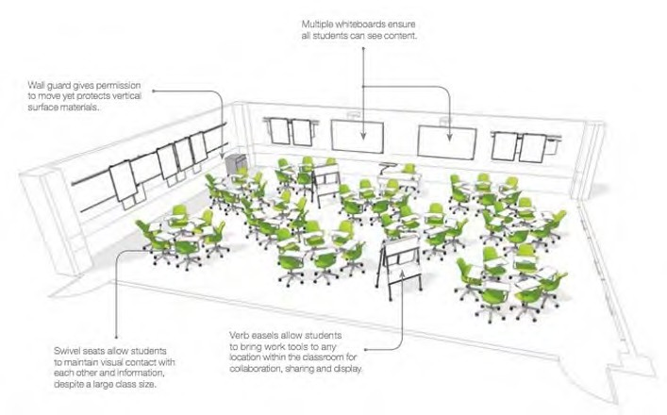](http://opentextbc.ca/teachinginadigitalage/wp-content/uploads/sites/29/2015/02/Steelcase-classroom-2.jpg)

*Figure 11.5.3 Design for an interactive classroom from Steelcase (© Steelcase, 2013)*

[Steelcase](http://www.steelcase.com/en/Pages/Homepage.aspx), a leading American manufacturer of office and educational furniture, is not only conducting impressive research into learning environments, but is way ahead of many of our post-secondary institutions in thinking through the implications of online learning for classroom design. Their [educational research website](http://www.steelcase.com/en/products/category/educational/research/pages/research.aspx), and two of their reports: [Active](https://www.steelcase.com/content/uploads/2015/01/Steelcase-Education-Insights-Guide-Version-4.pdf)

[Learning Spaces](https://www.steelcase.com/content/uploads/2015/01/Steelcase-Education-Insights-Guide-Version-4.pdf) and [Rethinking Space: Sparking Creativity](https://www.steelcase.com/content/uploads/sites/10/2021/01/16-E0000213EN.pdf) are documents that all post- secondary institutions and even k-12 planners should be looking at.

In Active Learning Spaces, Steelcase reports:

*Formal learning spaces have remained the same for centuries: a rectangular box filled with rows of desks facing the instructor and writing board….As a result, today’s students and teachers suffer because these outmoded spaces inadequately support the integration of the three key elements of a successful learning environment: pedagogy, technology and space.*

*Change begins with pedagogy. Teachers and teaching methods are diverse and evolving. From one class to the next, sometimes during the same class period, classrooms need change. Thus, they should fluidly adapt to different teaching and learning preferences. Instructors should be supported to develop new teaching strategies that support these new needs.*

*Technology needs careful integration. Students today are digital natives, comfortable using technology to display, share and present information. Vertical surfaces to display content, multiple projection surfaces and whiteboards in various configurations are all important classroom considerations.*

*Space impacts learning. More than three-quarters of classes include class discussions and nearly 60 percent of all classes include small group learning, and those percentages are continuing to grow. Interactive pedagogies require learning spaces where everyone can see the content and can see and interact with others. Every seat can and should be the best seat in the room. As more schools adopt constructivist pedagogies, the “sage on the stage” is giving way to the “guide on the side.” These spaces need to support the pedagogies and technology in the room to allow instructors who move among teams to provide real-time feedback, assessment, direction and support students in peer-to-peer learning. Pedagogy, technology and space, when carefully considered and integrated, define the new active learning ecosystem.*

In Rethinking Space: Sparking Creativity, Andrew Kim, Steelcase Education Researcher, states:

*Creative work is most effective in learning spaces that support team work flow and sharing of information.*

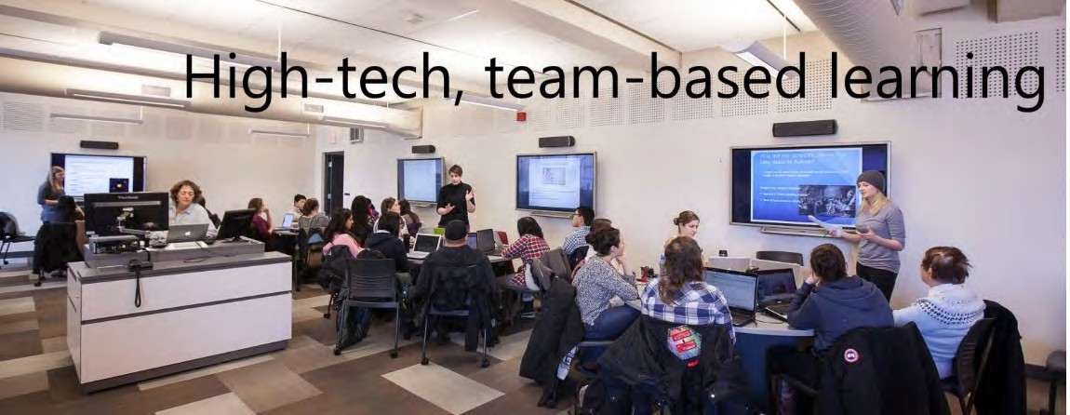

*Figure 11.5.4 Interactive classroom at Queen’s University, Kingston, Ontario*

The design of classroom spaces now needs to take into account that students are doing an increasing amount of their work online (and often outside the classroom). The classroom must support opportunities for accessing, working on, sharing and demonstrating knowledge gained both within and outside the classroom. Thus if the classroom is organized into ‘clusters’ of furniture and equipment to support small group work, these clusters will also require power so students can plug in their devices, wireless Internet access, and the ability to transmit work to shared screens around the room (in other words, a class Intranet). Students also need quiet places or breakout spaces where they can work individually as well as in groups. When faculty are presented with such use of space, they naturally adopt more active learning approaches.

##### The impact of flipped classrooms and hybrid learning on classroom design

These classrooms designs assume that students are learning in relatively small classes. However, we are also seeing the redesign of large lecture classes using hybrid designs such as flipped classrooms. Nevertheless, given the current financial context, we should not assume that the classroom time for these redesigned large lectures classes will be spent in small groups in individual classrooms (there are probably not enough small

classrooms to accommodate these classes which often have over a thousand students). Larger spaces that can be organized into smaller working groups, then easily reconvened into a large, single group, will be needed. What the space for these large classes certainly should *not* be is the raked rows of benches which now are now the norm in most large lecture theatres.

Steelcase is also doing research on appropriate spaces for faculty. For instance, if a university or department is planning a learning commons or common area for students, why not locate faculty offices in the same general area instead of in a separate building? Indeed, a case could be made for integrating faculty office space with more open teaching areas.

##### The impact on capital building plans

It is obvious why a company such as Steelcase is interested in these developments. There is a tremendous commercial opportunity for selling new and better forms of classroom furniture that meets these needs. However, that is the problem. Universities, colleges and especially schools simply do not have the money to move quickly towards new classroom designs, and even if they did, they should do some careful thinking first about:

* + - * + what kind of campus will be needed over the next 20 years, given the rapid moves to hybrid and online learning;
        + how much they need to invest in physical infrastructure when students can do much of their studies online.

Nevertheless, there are several opportunities for at least setting priorities for innovation in classroom design:

* + - * + where new campuses or major buildings are being built or renewed;
        + where large first and second year classes are being redesigned: maybe a prototype classroom design could be tried for one of these large lecture redesigns and tested; if successful the model could be added slowly to other large lecture classes;
        + where a department or program is being redesigned to integrate online learning and classroom teaching in a major way; they would receive priority for funding a new classroom design;
        + all major new purchases of classroom furniture to replace old or worn out equipment should first be subject to a review of classroom designs.

The important point here is that investment in new or adapted physical classroom space should be driven by decisions to change pedagogy/teaching methods. This will mean bringing together academics, IT support staff, instructional designers and staff from facilities, as well as architects and furniture suppliers. Second, as Winston Churchill [said](https://www.parliament.uk/about/living-heritage/building/palace/architecture/palacestructure/churchill/): ‘we shape our buildings and afterwards our buildings shape us.’ Providing teachers and instructors with a flexible, well-designed learning environment is likely to encourage major changes in their teaching; stuffing them into rectangular boxes with rows of desks will do the opposite.

Perhaps most important of all, institutions and school systems need to start re-examining their future growth plans for buildings on campus. In particular:

* + - * + will we need additional classrooms and additional lecture theatre buildings if students will be spending up to half their time studying online or in flipped classes?
        + do we have enough learning areas where large numbers of students can work in small groups and can then quickly reconvene?
        + do we have the technical facilities that will allow students seamlessly to work and study both face-to-face and online, and to share and capture the work when working physically together on campus?
        + would we be better investing in the re-design of existing space rather than building new learning spaces?

What is clear is that institutions and school systems now need to do some hard thinking about online learning, its likely impact on campus teaching, and above all what kind of campus experience we want students to have when they can do much of their studying online. It is this thinking that should shape our investment in buildings, desks and chairs.

#### Re-thinking the role of the campus

If we accept the principle of equal substitution for many academic purposes, then this brings us back to the student on the bus question. If students can learn most things

equally well (and more conveniently) online, what can we offer them on campus that will make the bus journey worthwhile? This is the real challenge that online learning presents.

It is not just a question of what teaching activities need to be done in a face-to-face class or lab, but the whole cultural and social purpose of a school, college or university. Students in many of our large, urban universities have become commuters, coming in just for their lectures, maybe using the learning commons between lectures, getting a bite to eat, then heading home. As we have ‘massified’ our universities, the broader cultural aspects have been lost.

Online and hybrid learning provides a chance to re-think the role and purpose of the whole campus, as well as what we should be doing in classrooms when students have online learning available any time and anywhere. Of course we could just close up shop and move everything online (and save a great deal of money), but we should at least explore what would be lost before doing that.

#### References

Sarma, S. (2013) [*The Magic Beyond the MOOCs*](https://linc.mit.edu/linc2013/proceedings/LINC-2013-Proceedings.pdf)Boston MA: LINC 2013 conference Steelcase Education (undated) [*Active Learning Spaces*](https://www.steelcase.com/content/uploads/2015/01/Steelcase-Education-Insights-Guide-Version-4.pdf)Michigan: Grand Rapids

Steelcase Education (undated) [*Rethinking Space: Sparking Creativity*](https://www.steelcase.com/content/uploads/sites/10/2021/01/16-E0000213EN.pdf)Michigan: Grand Rapids

Where the caretaker determines pedagogy: I worked in one school where every morning the chairs and desks were laid out in neat rows facing the front. The caretaker/janitor would get furious if they were left arranged in any other layout by the end of the day. I therefore spent too much lesson time with students re-arranging the desks for group work then tidying up afterwards. (I was young and didn’t dare defy the caretaker, who was quite formidable).

1. If you were designing from scratch a learning space for a group of 40 students (maximum), what would the learning space look like, given all the potential technology and teaching methods you and the students could be using?

*Activity 11.5 Re-designing your classroom space*

2.If you have a lecture class of 200 students and wanted to change your teaching method, how would you redesign the teaching and what kind of space(s) would you need?

There is no feedback on this activity.

###### Key Takeaways

1. There is a continuum of technology-based learning, from ‘pure’ face-to-face teaching to fully online programs. Every teacher or instructor needs to decide where on the continuum a particular course or program should be.
2. We do not have good research evidence or theories to make this decision, although we do have growing experience of the strengths and limitations of online learning. What is particularly missing is an evidence- based analysis of the strengths and limitations of face-to-face teaching when online learning is also available.
3. In the absence of good theory, I have suggested four factors to consider when deciding on mode of delivery, and in particular the different uses of face-to-face and online learning in blended courses:
   * student characteristics and needs
   * your preferred teaching strategy, in terms of methods and learning outcomes
   * the pedagogical and presentational requirements of the subject matter, in terms of (a) content and (b) skills
   * the resources available to an instructor (including the instructor’s time).
4. The move to blended or hybrid learning in particular means rethinking the use of the campus and the facilities needed fully to support learning in a hybrid mode.

## CHAPTER 12: TRENDS IN OPEN EDUCATION

When you have completed this chapter you should be able to determine:

* how your role as a teacher or instructor is likely to be changed by developments in open learning;
* when you should create your own material and when you should use open educational resources;
* how to maximise the use of digital materials once created, in terms of the design of courses.

*The purpose of this chapter*

#### What is covered in this chapter

* Scenario G: Watershed management
* 12.1 Open learning
* 12.2 Open educational resources (OER)
* 12.3 Open textbooks, open research and open data
* 12.4 Open pedagogy
* 12.5 The implications of ‘open’ for course and program design: towards a paradigm shift?

Also in this chapter you will find the following activities:

* Activity 12.1 Should access to post-secondary education be completely open to everyone?
* Activity 12.2 Deciding on OER
* Activity 12.3 Using other open resources
* Activity 12.4 Contemplating open pedagogy
* Activity 12.5 Building a course that is open in practice and theory

###### Key Takeaways

* 1. Open educational resources offer many benefits but they need to be well designed and embedded within a rich learning environment to be effective.
  2. The increasing availability of OER, open textbooks, open research and open data means that in future, almost all academic content will be open and freely accessible over the Internet.
  3. As a result, students will increasingly look to institutions for learning support and help with the development of skills needed in a digital age rather than with the delivery of content. This will have major consequences for the role of teachers/instructors and the design of courses.
  4. OER and other forms of open education will lead to increased modularization and disaggregation of learning services, which are needed to respond to the increasing diversity of learner needs in a digital age.
  5. MOOCs are essentially a dead end with regard to providing learners who do not have adequate access to education with high quality qualifications. The main value of MOOCs is in providing opportunities for non- formal education and supporting communities of practice.
  6. OER, MOOCs, open textbooks and other digital forms of open-ness are important in helping to widen access to learning opportunities, but ultimately these are enhancements rather than a replacement for a well-funded public education system, which remains the core foundation for enabling equal access to educational opportunities.

# Scenario G: Watershed management

[](http://opentextbc.ca/teachinginadigitalage/wp-content/uploads/sites/29/2015/02/Hart-River-2.jpg)

*Figure 12.G The Hart River, Yukon. Image: ©* [*www.protectpeel.ca*](http://www.protectpeel.ca/)*, CC BY-NC*

Over a number of years, research faculty in the Departments of Land Management and Forestry at the University of Western Canada had developed a range of digital graphics, computer models and simulations about watershed management, partly as a consequence of research conducted by faculty, and partly to generate support and funding for further research.

At a faculty meeting several years ago, after a somewhat heated discussion, faculty members voted, by a fairly small majority, to make these educational resources openly available for re-use for educational purposes under a Creative Commons license that requires attribution and prevents commercial use without specific written permission from the copyright holders, the faculty responsible for developing the artefacts.

What swayed the vote is that the majority of the faculty actively involved in the research wanted to make these resources more widely available. The agencies responsible for funding the work that resulted in the development of the learning artefacts (mainly national research councils) welcomed the move to makes these artefacts more widely available as open educational resources.

Initially, the researchers just put the graphics and simulations up on the research group’s web site. It was left to individual faculty members to decide whether to use these resources in their teaching. Over time, faculty started to introduce these resources into a range of on-campus undergraduate and graduate courses.

After a while, though, word seemed to get out about these OER. Research members began to receive e-mails and phone calls from other researchers around the world. It became clear that there was a network or community of researchers in this field who were creating digital materials as a result of their research, and it made sense to share and re-use materials from other sites. This eventually led to an international web ‘portal’ of learning artefacts on watershed management.

The researchers also started to get calls from a range of different agencies, from government ministries or departments of environment, local environmental groups, First Nations/aboriginal bands, and, occasionally, major mining or resource extraction companies, leading to some major consultancy work for the faculty in the departments. At the same time, the faculty were able to attract further research funding from non-governmental agencies such as the Nature Conservancy and some ecological groups, as well as from their traditional funding source, the national research councils, to develop more OER.

By this time, the departments had access to a fairly large amount of OER. There were already two fourth and fifth level fully online courses built around the OER that were being offered successfully to undergraduate and graduate students. A proposal was therefore put forward to create initially a fully online post-graduate certificate program on watershed management, built around existing OER, in partnership with a university in the USA and another one in Sierra Leone. This certificate program was to be self-funding from tuition fees,

with the tuition fees for the 25 Sierra Leone students to be initially covered by an international aid agency.

The Dean, after a period of hard negotiation, persuaded the university administration that the departments’ proportion of the tuition fees from the certificate program should go directly to the departments, who would hire additional tenured faculty from the revenues to teach or backfill for the certificate, and the departments would pay 25 per cent of the tuition revenues to the university as overheads.This decision was made somewhat easier by a fairly substantial grant from Global Affairs Canada to make the certificate program available in English and French to Canadian mining and resource extraction companies with contracts and partners in African countries.

Although the certificate program was very successful in attracting students from North America, Europe and New Zealand, it was not taken up very well in Africa beyond the partnership with the university in Sierra Leone, although there was a lot of interest in the OER and the issues raised in the certificate courses. After two years of running the certificate, then, the departments made two major decisions:

* another three courses and a research project would be added to the certificate courses, and this would be offered as a fully cost recoverable online master in watershed resource management. This would attract greater participation from managers and professionals in African countries in particular, and provide a recognised qualification that many of the certificate students were requesting;
* drawing on the very large network of external experts now involved one way or another with the researchers, the university would offer a series of MOOCs on watershed management issues, with volunteer experts from outside the university being invited to participate and provide leadership in the MOOCs. The MOOCs would be able to draw on the existing OER.

Five years later, the following outcomes were recorded by the Dean at an international conference on sustainability:

* the online master’s program had doubled the total number of graduate students in her Faculty;
* the master’s program was fully cost-recoverable from tuition fees;
* there were 120 graduates a year from the master’s program;
* the degree completion rate was 64 per cent;
* six new tenured faculty had been hired, plus another six post-doctoral research staff;
* several thousand students had registered and paid for at least one course in the certificate or master’s program, of which 45 per cent were from outside Canada;
* over 100,000 students had taken the MOOCs, almost half from developing countries;
* there were now over 1,000 hours of OER on watershed management available and downloaded many times across the world;
* the university was now internationally recognised as a world leader in watershed management.

Although this scenario is purely a figment of my imagination, it is influenced by real and exciting work being done by the following at the University of British Columbia:

* Dr. Hans Schreier, [Watershed Management Courses](https://mlws.landfood.ubc.ca/), Institute of Resources, Environment and Sustainability, UBC
* [Virtual Soil Science Learning Resources](http://soilweb.landfood.ubc.ca/promo/) (developed by a consortium of British Columbian universities)
* [Graduate Certificate in Technology-Based Learning](http://met.ubc.ca/program-overview/certificate-options/), Faculty of Education, UBC
* [International Master in Educational Technology](http://met.ubc.ca/), Faculty of Education, UBC

# Open learning

[](https://www.youtube.com/watch?v=MOqIotJrFVM)

*Figure 12.1.1 ‘I’m just a committed and even stubborn person who wants to see every child getting quality education…’*

*Malala Yousafzai’s Nobel Prize speech, 2014. Click on image to see the speech.*

In recent years, there has been a resurgence of interest in open learning, mainly related to open educational resources and MOOCs. Although in themselves open educational resources (OER) and MOOCs are important developments, they tend to cloud other developments in open education that are likely have even more impact on education as a whole. It is therefore necessary to step back a little to get a broader understanding of not just OER and MOOCs, but open learning in general. This will help us better understand the significance of MOOCs, OER and other developments in open education, and their likely impact on teaching and learning now and in the future.

#### Open education as a concept

Open education can take a number of forms:

* [*education for all*](https://en.unesco.org/gem-report/report/2015/education-all-2000-2015-achievements-and-challenges): free or very low cost school, college or university education available to everyone within a particular jurisdiction, usually funded primarily through the state;
* *open access to programs* that lead to full, *recognised qualifications*. These are offered by national open universities or more recently by the [OERu](https://oeru.org/);
* *open access to courses or programs* that are *not for formal credit*, although it may be possible to acquire badges or certificates for successful completion. MOOCs are a good example;
* *open educational resources* that instructors or learners can use for free. [MIT’s](https://ocw.mit.edu/index.htm) [OpenCourseware,](https://ocw.mit.edu/index.htm) which provides free online downloads of MIT’s video recorded lectures and support material, is one example;
* *open textbooks*, online textbooks that are free for students to use (such as this one);
* *open research,* whereby research papers are made available online for free downloading (see for instance [Open Research Central](https://openresearchcentral.org/));
* *open data,* that is, data open to anyone to use, reuse, and redistribute, subject only, at most, to the requirement to attribute and share; see for example the World Bank’s [Open Data Bank](https://databank.worldbank.org/home.aspx);
* *open pedagogy*, a method of teaching and learning that builds on principles of open- ness and learner participation

Each of these developments is discussed in more detail in this chapter, except for MOOCs, which are discussed extensively in Chapter 5.

#### Education for all – except higher education

Open education is primarily a goal, or an educational policy. An essential characteristic of open education is the removal of barriers to learning. It can mean no prior qualifications to study, no discrimination by gender, race, age or religion, affordability for everyone, and for students with disabilities, through a determined effort to provide education in a

suitable form that overcomes the disability (for example, audio recordings for students who are visually impaired). Ideally, no-one should be denied access to an open educational program. Thus open learning must be scalable as well as flexible.

##### State-funded schools

State-funded public education for the education of children from around the age of five through to sixteen or in some countries eighteen is the most extensive and widespread form of open education. For example, the British government passed the 1870 Education Act that set the framework for schooling of all children between the ages of 5 and 13 in England and Wales. Although there were some fees to be paid by parents, the Act established the principle that education would be paid for mainly through taxes and no child would be excluded for financial reasons. Schools would be administered by elected local school boards (Living Heritage, [undated](https://www.parliament.uk/about/living-heritage/transformingsociety/livinglearning/school/overview/1870educationact/)).

Over time, access to publicly funded education in most economically developed countries has been widened to include all children up to the age of 18. UNESCO’s [Education for](https://en.unesco.org/gem-report/report/2015/education-all-2000-2015-achievements-and-challenges) [All](https://en.unesco.org/gem-report/report/2015/education-all-2000-2015-achievements-and-challenges) (EFA) movement is a global commitment to provide quality basic education for all children, youth and adults, supported, at least in principle, by 164 national governments. Nevertheless today there are over 250 million of ‘out-of-school’ children, adolescents and youth worldwide (UNESCO, [2018](https://en.unesco.org/news/one-every-five-children-adolescents-and-youth-out-school-worldwide)), or roughly one in five.

##### Post-secondary education

Access to post-secondary or higher education has been more limited than access to schools, partly on financial grounds, but also in terms of ‘merit’. Universities have required those applying for university to meet academic standards determined by prior success in school examinations or institutional entry exams. This has enabled elite universities in particular to be highly selective.

However, after the Second World War, the demand for an educated population, both for social and economic reasons, in most economically advanced countries resulted in the gradual expansion of universities and post-secondary education in general. In most OECD

countries, roughly 35-60 per cent of an age cohort will go on to some form of post- secondary education. Especially in a digital age, there is an increasing demand for highly qualified workers, and post-secondary education is a necessary gateway to most of the best jobs. Therefore there is increasing pressure for full and free open access to post- secondary, higher or tertiary education.

##### The cost of widening access

However, as we saw in Chapter 1, the cost of widening access to ever increasing numbers results in increased financial pressure on governments and taxpayers. Following the financial crisis of 2008, many states in the USA found themselves in severe financial difficulties, which resulted in substantial funding cuts to the U.S. higher education system (see for instance, Rivera, [2012](https://www.latimes.com/archives/la-xpm-2012-aug-28-la-me-0829-college-survey-20120829-story.html)), which in turn resulted in a rapid increase in tuition fees.

It is probably more than coincidental that other forms of open education such as MOOCs and OER arose at a time of increasing cuts to the funding of public education in the USA. Solutions that enable increased access without a proportionate increase in funding or tuition fees are almost desperately being sought by governments and institutions. It is against this background that the renewed interest in open education should be framed.

#### Open access in higher education

##### Open universities

In the 1970s and 1980s, there was a rapid growth in the number of open universities that required no or minimal prior qualifications for entry. In the United Kingdom, for instance, in 1969, less than 10 per cent of students leaving secondary education went on to university. This was when the British government established the [Open University](http://www.open.ac.uk/), a distance teaching university open to all, using a combination of specially designed printed texts, and broadcast television and radio, with one week residential summer schools

on traditional university campuses for the foundation courses (Perry, [1976](https://www.biblio.com/book/open-university-personal-account-walter-perry/d/460514960); Weinbren, [2015](https://manchesteruniversitypress.co.uk/9780719096273/)).

The Open University started in 1971 with 25,000 students in the initial entry intake, and now has over 200,000 registered students. It has been consistently ranked by government quality assurance agencies in the top ten U.K. universities for teaching, and in the top 30 for research, and number one for student satisfaction (out of over 180). It currently has over 200,000 registered students (Weinbren, [2015](https://www.manchesteruniversitypress.co.uk/9780719096273/)). However, it can no longer cover the full cost of its operation from government grants and there is now a range of different fees to be paid. In addition access to higher education has now widened to the point where 50% of a high school cohort now enter some form of higher education in the UK (UK Department of Education, [2018](https://assets.publishing.service.gov.uk/government/uploads/system/uploads/attachment_data/file/744087/Main_text_participation_rates_in_higher_education_2006_to_2017_.pdf)).

There are now nearly 100 publicly funded open universities around the world, including Canada ([Athabasca University](http://en.wikipedia.org/wiki/Athabasca_University) and [Téluq](http://en.wikipedia.org/wiki/T%C3%89LUQ)). These open universities are often very large. The [Open University of China](http://en.ouchn.edu.cn/) has over one million enrolled undergraduate students and

2.4 million junior high school students, [Anadolou Open University](https://www.anadolu.edu.tr/en/open-education/openeducationsystem/open-education-system) in Turkey has over 1.2 million enrolled undergraduate students, the Open University of Indonesia ([Universitas](http://en.wikipedia.org/wiki/Universitas_Terbuka) [Terbuka](http://en.wikipedia.org/wiki/Universitas_Terbuka)) almost half a million, and the [University of South Africa](https://www.unisa.ac.za/sites/corporate/default/Apply-for-admission) 350,000. These large, degree awarding national open universities provide an invaluable service to millions of students who otherwise would have no access to higher education (see Daniel, [1998](https://eric.ed.gov/?id=ED408915), and more recently, Contact North, [2019](https://teachonline.ca/tools-trends/universities), for a good overview).

##### Alternatives to open universities

It should be noted however that there is no publicly funded open university in the USA, which is one reason why MOOCs have received so much attention there. The [Western](http://www.wgu.edu/about_WGU/overview) [Governors’ University](http://www.wgu.edu/about_WGU/overview) is the most similar to an open university, and private, for-profit universities such as the [University of Phoenix](https://www.phoenix.edu/?ef_id=EAIaIQobChMIy8XI8fbv5AIVYiCtBh1xsQZvEAAYASAAEgKP9PD_BwE%3AG%3As&s_kwcid=AL!7696!3!363281969195!e!!g!!phoenix%20of%20university&channel=srch&mktg_prog=national&keyword=phoenix%20of%20university&user2=brand&pvp_campaign=14210_0917_9_95&provider=google&gclid=EAIaIQobChMIy8XI8fbv5AIVYiCtBh1xsQZvEAAYASAAEgKP9PD_BwE) fill a similar niche in the market.

As well as the national open universities, which usually offer their own degrees, there is also the [OERu](http://oeru.org/how-it-works/), which is basically an international consortium of mainly British Commonwealth and U.S. universities and colleges offering open access courses that enable learners either to acquire full credit for transfer into one of the partner universities

or to build towards a full degree, offered by the university from which most credits have been acquired. Students pay a fee for assessment.

#### Limitations of open learning

Open, distance, flexible and online learning are rarely found in their ‘purest’ forms. No teaching system is completely open (minimum levels of literacy are required, for instance). Thus there are always degrees of openness. Openness has particular implications for the use of technology. If no-one is to be denied access, then technologies that are available to everyone need to be used. If an institution is deliberately selective in its students, it has more flexibility with regard to choice of technology. It can for instance require all students who wish to take an online or blended course to have their own computer and Internet access. It cannot do that if its mandate is to be open to all students. Truly open universities then will always be behind the leading edge of educational applications of technology.

Despite the success of many open universities, open universities often lack the status of a campus-based institution. Their degree completion rates are often very low. The U.K. OU’s degree completion rate is 22 per cent (Woodley and Simpson, [2014](http://www.aupress.ca/index.php/books/120233)), but nevertheless still higher for whole degree programs than for most single MOOC courses.

Lastly, some of the open universities have been established for more than 40 years and have not always quickly adapted to changes in technology, partly because of their large size and their substantial prior investment in older technologies such as print and broadcasting, and partly because they do not wish to deny access to potential students who may not have access to the latest technology.

Thus open universities are now increasingly challenged by both an explosion in access to higher education generally, and in the use of online learning by conventional universities. For instance, in Canada, Donovan et. ([2018](http://www.cdlra-acrfl.ca/wp-content/uploads/2020/07/2018_national_en.pdf)) report that nearly all universities and most colleges are now offering fully online courses (although access is still mainly based on prior qualifications). New developments such as MOOCs, and open educational resources, the topic of the next section, are further challenges for open universities.

#### References

Contact North (2019) [*Searchable Directory of More than 65 Open Universities Worldwide*](https://teachonline.ca/tools-trends/universities)

Sudbury ON: Teachonline.ca

Daniel, J. (1998) [*Mega-Universities and Knowledge Media: Technology Strategies for Higher*](https://eric.ed.gov/?id=ED408915)[*Education*](https://eric.ed.gov/?id=ED408915). London: Kogan Page

Donovan, T. et al. (2018) [*Tracking Online and Distance Education in Canadian Universities*](http://www.cdlra-acrfl.ca/wp-content/uploads/2020/07/2018_national_en.pdf)[*and Colleges: 2018*](http://www.cdlra-acrfl.ca/wp-content/uploads/2020/07/2018_national_en.pdf)Halifax NS: Canadian Digital Learning Research Association

Living Heritage (undated) [*Going to school: the 1870 Education Act*](https://www.parliament.uk/about/living-heritage/transformingsociety/livinglearning/school/overview/1870educationact/), London: UK Parliament Perry, W. (1976) [*The Open University*](https://www.biblio.com/book/open-university-personal-account-walter-perry/d/460514960)Milton Keynes: Open University Press

Rivera, C. (2012) Survey offers dire picture of California’s two-year colleges [*Los Angeles*](http://www.latimes.com/news/local/la-me-0829-college-survey-20120829%2C0%2C1087682.story)[*Times*](http://www.latimes.com/news/local/la-me-0829-college-survey-20120829%2C0%2C1087682.story), August 28

U.K. Department of Education (2018) [*Participation Rates in Higher Education: Academic*](https://assets.publishing.service.gov.uk/government/uploads/system/uploads/attachment_data/file/744087/Main_text_participation_rates_in_higher_education_2006_to_2017_.pdf)[*Years 2006/2007 – 2017/2018 (Provisional)*](https://assets.publishing.service.gov.uk/government/uploads/system/uploads/attachment_data/file/744087/Main_text_participation_rates_in_higher_education_2006_to_2017_.pdf)London: Department of Education HE Statistics

UNESCO (2014) *Education for All, 2000-2015: achievements and challenges* Paris FR: The UNESCO 2015 EFA Global Monitoring Report team

UNESCO (2018) [*One in Five Children, Adolescents and Youth is Out of School*](http://uis.unesco.org/sites/default/files/documents/fs48-one-five-children-adolescents-youth-out-school-2018-en.pdf)Paris FR: UNESCO Institute for Statistics Fact Sheet No 42

Weinbren, D. (2015) [*The Open University: A Histor*y](https://manchesteruniversitypress.co.uk/9780719096273/) Manchester UK: Manchester University Press/The Open University

Woodley, A. and Simpson, O. (2014) ‘Student drop-out: the elephant in the room’ in Zawacki-Richter, O. and Anderson, T. (eds.) (2014) [*Online Distance Education: Towards a*](http://www.aupress.ca/index.php/books/120233)[*Research Agenda*](http://www.aupress.ca/index.php/books/120233)Athabasca AB: AU Press, pp. 508

1. Should access to post-secondary or higher education be open to everyone?

*Activity 12.1 Should access to post-secondary education be completely open to anyone?*

If yes, what are reasonable limitations on this principle?

What should be the government’s role, if any, in making this possible?

If your answer is no to the first part of this question, why should education up to post-secondary education be open, but not afterwards? Is it simply money, or are there other reasons?

2. Are open universities still relevant in a digital age?

For my feedback on this activity click on the podcast below:

*One or more interactive elements has been excluded from this version of the text. You can view them online here:* [*https://pressbooks.bccampus.ca/teachinginadigitalagev3m/?p=372#audio-372-1*](https://pressbooks.bccampus.ca/teachinginadigitalagev3m/?p=372&audio-372-1)

# Open educational resources (OER)

[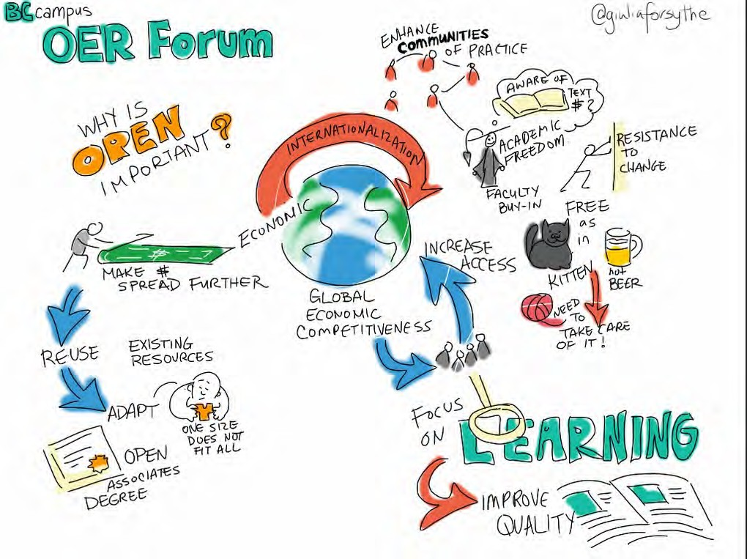](http://opentextbc.ca/teachinginadigitalage/wp-content/uploads/sites/29/2015/02/OER-forum-2.jpg)

*Figure 12.2.1 © Giulia Forsyth, 2012*

Open educational resources are somewhat different from open learning, in that they are primarily content, while open learning includes both content and educational services, such as specially designed online materials, in-built learner support and assessment.

Open educational resources cover a wide range of online formats, including online textbooks, video recorded lectures, YouTube clips, web-based textual materials designed for independent study, animations and simulations, digital diagrams and

graphics, some MOOCs, or even assessment materials such as tests with automated answers. OER can also include Powerpoint slides or pdf files of lecture notes. In order to be open educational resources, though, they must be freely available for at least educational use.

#### Principles of OER

[David Wiley](http://opencontent.org/blog/) is one of the pioneers of OER. He and colleagues have suggested (Hilton et al., [2010](https://www.tandfonline.com/doi/abs/10.1080/02680510903482132)) that there are five core principles (the 5Rs) of open publishing:

* **re-use**: The most basic level of openness. People are allowed to use all or part of the work for their own purposes (for example, download an educational video to watch at a later time);
* **re-distribute:** People can share the work with others (for example, send a digital article by-email to a colleague);
* **revise:** People can adapt, modify, translate, or change the work (for example, take a book written in English and turn it into a Spanish audio book);
* **re-mix:** People can take two or more existing resources and combine them to create a new resource (for example, take audio lectures from one course and combine them with slides from another course to create a new derivative work);
* **retain:** No digital rights management restrictions (DRM); the content is yours to keep, whether you’re the author, an instructor using the material, or a student.

This open textbook you are reading meets all five criteria (it has a CC BY-NC license – see Section 12.2.2 below). Users of OER though need to check with the actual license for re- use, because sometimes there are limitations, as with this book. For example, this book cannot be reproduced for commercial purposes (NC), and the origin of the work must be accurately attributed to the original author (BY), unless written permission from the author is obtained. To protect your rights as an author of OER usually means publishing under a Creative Commons or other open license.

#### Creative Commons licenses

This seemingly simple idea, of [an ‘author’ creating a license enabling people to freely](https://creativecommons.org/share-your-work/) [access and adapt copyright material, without charge or special permission](https://creativecommons.org/share-your-work/), is one of the great ideas of the 21st century. This does not take away the author’s copyright, but the license gives permission automatically for different kinds of use of the material without charge or any paperwork or written permissions.

[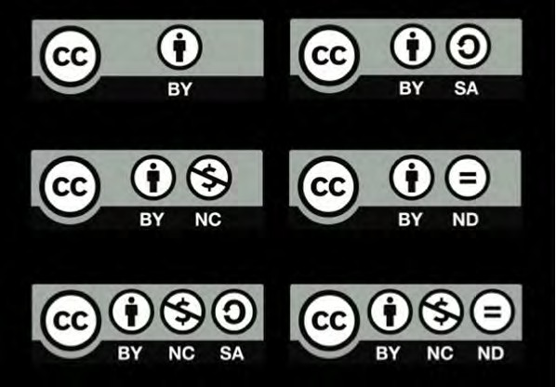](http://opentextbc.ca/teachinginadigitalage/wp-content/uploads/sites/29/2015/02/Creative-Commons-licenses-2.jpg)

*Figure 12.2.2 The spectrum of Creative Commons licenses*

*© The Creative Commons, 2013*

There are several possible Creative Commons licenses:

* **CC BY Attribution**: lets others distribute, remix, tweak, and build upon your work, even commercially, as long as they credit you for the original creation. This is the most accommodating of licenses offered. Recommended for maximum dissemination and use of licensed materials;
* **CC BY-SA**: lets others remix, tweak, and build upon your work even for commercial purposes, as long as they credit you and license their new creations under the identical terms. This is particularly important if your work also includes other people’s materials licensed through the Creative Commons;
* **CC BY-ND**: allows for redistribution, commercial and non-commercial, as long as it is passed along unchanged and in whole, with credit to you;
* **CC BY-NC**: lets others remix, tweak, and build upon your work non-commercially, and although their new works must also acknowledge you and be non-commercial, they don’t have to license their derivative works on the same terms;
* **CC BY-NC-SA**: lets others remix, tweak, and build upon your work non- commercially, as long as they credit you and license their new creations under the identical terms;
* **CC BY-NC-ND**: the most restrictive of the six main licenses, only allowing others to download your works and share them with others as long as they credit you, but they can’t change them in any way or use them commercially.

If you wish to offer your own materials as open educational resources, it is a relatively simple process to choose a licence and apply it to any piece of work (see [Creative](http://creativecommons.org/choose/) [Commons Choose a License](http://creativecommons.org/choose/)). If in doubt, check with a librarian.

#### Sources of OER

There are many ‘repositories’ of open educational resources (see for instance, for post- secondary education, [MERLOT](http://www.merlot.org/merlot/index.htm), [OER Commons](https://www.oercommons.org/), and for k-12, [Edutopia](http://www.edutopia.org/open-educational-resources-guide)).The Open Professionals Education Network has an [excellent guide to finding and using OER](https://open4us.org/find-oer/).

However, when searching for possible open educational resources on the web, check to see whether or not the resource has a Creative Commons license or a statement giving permission for re-use. It may be common practice to use free (no cost) resources without worrying unduly about copyright, but there are risks without a clear license or permission for re-use. For instance, many sites, such as [OpenLearn](http://www.open.edu/openlearn/), allow only individual, personal use for non-commercial purposes, which means providing a link to the site for students rather than integrating the materials directly into your own teaching. If in any doubt about the right to re-use, check with your library or intellectual property department.

#### Limitations of OER

The take-up of OER, other than open textbooks (see next section), by instructors is still relatively low, but it is slowly increasing. For instance, in Canada in 2018, 54% of the institutions surveyed reported that some departments currently use open textbooks and 67% reported that other forms of OER are used in at least some departments (Johnson, [2019](http://www.cdlra-acrfl.ca/wp-content/uploads/2020/07/2019_national_en.pdf)).

##### Quality issues

The main criticism is of the poor quality of many of the OER available at the moment – reams of text with no interaction, often available in PDFs that cannot easily be changed or adapted, crude simulation, poorly produced graphics, and designs that fail to make clear what academic concepts they are meant to illustrate.

Falconer ([2013](https://oerknowledgecloud.org/sites/oerknowledgecloud.org/files/JRC85471.pdf)), in a survey of potential users’ attitudes to OER in Europe, came to the following conclusion:

*The ability of the masses to participate in production of OER – and a cultural mistrust of getting something for nothing – give rise to user concerns about quality. Commercial providers/publishers who generate trust through advertising, market coverage and glossy production, may exploit this mistrust of the free. Belief in quality is a significant driver for OER initiatives, but the issue of scale-able ways of assuring quality in a context where all (in principle) can contribute has not been resolved, and the question of whether quality transfers unambiguously from one context to another is seldom [addressed]. A seal of approval system is not infinitely scale-able, while the robustness of user reviews, or other contextualised measures, has not yet been sufficiently explored.*

If OER are to be taken up by others than the creators of the OER, they will need to be well designed. It is perhaps not surprising then that the most used OER on iTunes University were the Open University’s, until the OU set up its own OER portal, [OpenLearn](http://www.open.edu/openlearn/), which offers as OER mainly textual materials from its courses designed specifically for online, independent study. Once again, design is a critical factor in ensuring the quality of an OER.

##### Instructors’ professional self-image

Hampson ([2013](https://www.tonybates.ca/2013/10/26/examining-the-potential-and-reality-of-open-educational-resources-the-2013-cohere-conference/)) has suggested another reason for the slow adoption of OER, mainly to do with the professional self-image of many faculty. Hampson argues that faculty don’t see themselves as ‘just’ teachers, but creators and disseminators of new or original knowledge. Therefore their teaching needs to have their own stamp on it, which makes them reluctant to openly incorporate or ‘copy’ other people’s work.

OER can easily be associated with ‘packaged’, reproductive knowledge, and not original work, changing faculty from ‘artists’ to ‘artisans’. It can be argued that this reason is absurd – we all stand on the shoulders of giants – but it is the self-perception that’s important, and for research professors, there is a grain of truth in the argument. It makes sense for them to focus their teaching on their own research. But then how many [Richard Feynmans](http://en.wikipedia.org/wiki/Richard_Feynman) are there out there?

##### Free or open?

There is also considerable confusion between ‘free’ (no financial cost) and ‘open’, which is compounded by lack of clear licensing information on many OER. For instance, some Coursera MOOCs are free, but not ‘open’: it is a breach of copyright to re-use the material in most Coursera MOOCs within your own teaching without permission. The edX MOOC platform is open source, which means other institutions can adopt or adapt the portal software, but institutions even on edX tend to retain copyright. However, there are exceptions on both platforms: a few MOOCs do have an open licence.

##### Situating OER

There is also the issue of the context-free nature of OER. Research into learning shows that content is best learned within context (situated learning), when the learner is active, and that above all, when the learner can actively construct knowledge by developing meaning and ‘layered’ understanding. Content is not static, nor a commodity like coal. In other words, content is not effectively learned if it is thought of as shovelling coal

into a truck. Learning is a dynamic process that requires questioning, adjustment of prior learning to incorporate new ideas, testing of understanding, and feedback. These ‘transactional’ processes require a combination of personal reflection, feedback from an expert (the teacher or instructor) and even more importantly, feedback from and interaction with friends, family and fellow learners.

The weakness with open content is that by its nature, at its purest it is stripped of these developmental, contextual and ‘environmental’ components that are essential for effective learning. In other words, OER are just like coal, sitting there waiting to be loaded. Coal of course is still a very valuable product. But it has to be mined, stored, shipped and processed.

More attention needs to be paid to those contextual elements that turn OER from raw ‘content’ into a useful learning experience. This means instructors need to build learning experiences or environments into which the OER will fit. (See Chapter 12, Section 4 for more discussion of this issue)

##### Study the research

For a useful overview of the research on OER, see the [Review Project](http://openedgroup.org/review) from the [Open](http://openedgroup.org/) [Education Group](http://openedgroup.org/). Another important research project is [ROER4D](http://roer4d.org/), which aims to provide evidence-based research on OER adoption across a number of countries in South America, Sub-Saharan Africa and Southeast Asia.

#### How to use OER

Despite these limitations, teachers and instructors are increasingly creating open educational resources, or making resources freely available for others to use under a Creative Commons license. There are increasing numbers of repositories or portals where faculty can access open educational resources. As the quantity of OER expands, it is more likely that teachers and instructors will increasingly be able to find the resources that best suit their particular teaching context.

There are therefore several choices:

* take OER selectively from elsewhere, and incorporate or adapt them into your own courses;
* create your own digital resources for your own teaching, and make them available to others (see for instance [Creating OER and Combining Licenses](https://www.youtube.com/watch?v=Hkz4q2yuQU8&feature=youtu.be) from Florida State University);
* build a course around OER, where students have to find content to solve problems, write reports or do research on a topic (see Scenario G at the beginning of this chapter, and Chapter 12, Section 4.2);
* take a whole course from [OERu](http://oeru.org/), then build student activities and assessment and provide learner support for the course.

Learners can use OER to support any type of learning. For instance, MIT’s OpenCourseWare (OCW) could be used just for interest, or students who struggle with the topics in a classroom lecture for a credit course may well go to OCW to get an alternative approach to the same topic.

#### Still worth the effort

Despite some of the current limitations or weaknesses of OER, their use is likely to grow, simply because it makes no sense to create everything from scratch when good quality materials are freely and easily available. We have seen in Chapter 10 on selecting media that there is now an increasing amount of excellent open material available to teachers and instructors. This will only grow over time. We shall see in Section 12.5 that this is bound to change the way courses are designed and offered. Indeed, OER will prove to be one of the essential features of teaching in a digital age.

#### References

Falconer, I. et al. (2013) [Overview and Analysis of Practices with Open Educational](https://oerknowledgecloud.org/sites/oerknowledgecloud.org/files/JRC85471.pdf)

[Resources in Adult Education in Europe](https://oerknowledgecloud.org/sites/oerknowledgecloud.org/files/JRC85471.pdf) Seville, Spain: European Commission Institute for Prospective Technological Studies

Hampson, K. (2013) [The next chapter for digital instructional media: content as a](https://www.tonybates.ca/2013/10/26/examining-the-potential-and-reality-of-open-educational-resources-the-2013-cohere-conference/) [competitive difference](https://www.tonybates.ca/2013/10/26/examining-the-potential-and-reality-of-open-educational-resources-the-2013-cohere-conference/) Vancouver BC: COHERE 2013 conference

Hilton, J., et al. (2010). [The four R’s of openness and ALMS Analysis: Frameworks for open](https://www.tandfonline.com/doi/abs/10.1080/02680510903482132) [educational resources](https://www.tandfonline.com/doi/abs/10.1080/02680510903482132) *Open Learning: The Journal of Open and Distance Learning, 25*(1), 37–44

Johnson, N. (2019) [National Survey of Online and Digital Learning 2019 National Report](http://www.cdlra-acrfl.ca/wp-content/uploads/2020/07/2019_national_en.pdf) Halifax NS: Canadian Digital learning Research Association

1. Have you used OER in your own course(s)? Was this a positive or negative experience?
2. If you have not used OER, what is/are the main reason(s)? Have you explored to see what is available? What is the quality like? How could they be improved?
3. Under what circumstances would you be prepared to create or convert your own material as OER? There is no feedback provided on this activity.

*Activity 12.2 Deciding on OER*

# Open textbooks, open research and open data

[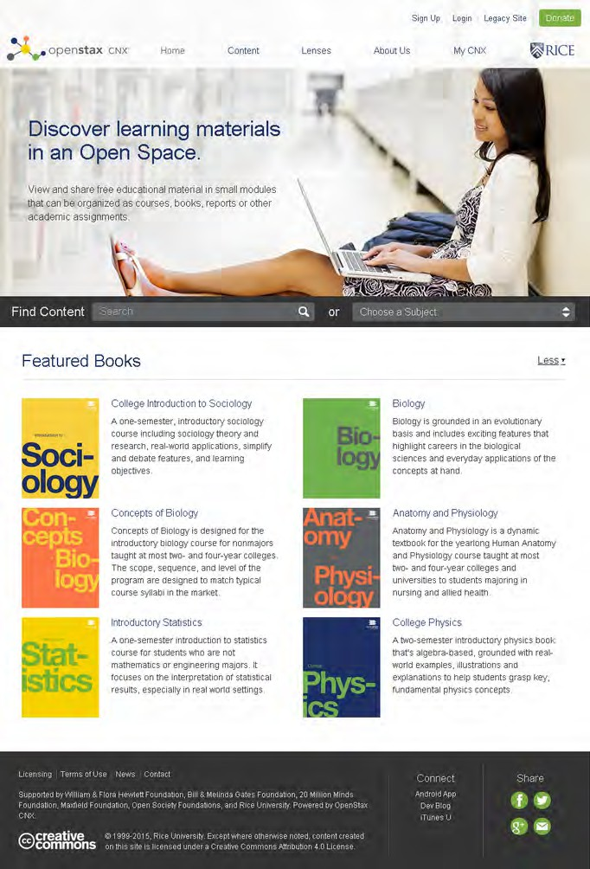](http://opentextbc.ca/teachinginadigitalage/wp-content/uploads/sites/29/2015/02/Open-Stax-2.jpg)

[776 | Chapter 12: Trends in open education](http://opentextbc.ca/teachinginadigitalage/wp-content/uploads/sites/29/2015/02/Open-Stax-2.jpg)

*Figure 12.3.1 Open Stax open textbooks*

#### Open textbooks

Textbooks are an increasing cost to students. Some textbooks cost $200 or more, and in the USA a university undergraduate spends on average between $530 – $640 a year on textbooks (Hill, [2015](https://eliterate.us/how-much-do-college-students-actually-pay-for-textbooks/)), although the cost of *recommended* textbooks is between $968 and

$1221 (Caulfield, [2015](https://hapgood.us/2015/11/09/asking-what-students-spend-on-textbooks-is-the-wrong-question/)).

An open textbook on the other hand is an openly-licensed, online publication free for downloading for educational or non-commercial use. You are currently reading an open textbook. There is an increasing number of sources for open textbooks, such as [OpenStax](http://openstaxcollege.org/) [College](http://openstaxcollege.org/) from Rice University, and the [Open Academics Textbook Catalog](https://open.umn.edu/opentextbooks/) at the University of Minnesota.

In British Columbia, the provincial government funded the [B.C. open textbook project](https://open.bccampus.ca/browse-our-collection/find-open-textbooks/), which operated in collaboration initially with the provinces of [Alberta](http://albertaoer.com/about-us) and Saskatchewan, but now also with other provinces through the [Canada OER Group](https://open.bccampus.ca/what-is-open-education/canadas-open-education-initiatives/). The B.C. open textbook project focuses on making available openly-licensed textbooks in the highest- enrolled academic subject areas and also in trades and skills training. In the B.C. project, as in many of the other sources, all the books are selected, peer reviewed and in some cases developed by local faculty. Often these textbooks are not ‘original’ work, in the sense of new knowledge, but carefully written and well illustrated summaries of current thinking in the different subject areas.

##### Advantages of open textbooks

Students and governments, through grants and financial aid, pay billions of dollars each year on textbooks. Open textbooks can make a significant impact on reducing the cost of education. Approximately 86,000 students in B.C. have saved as much as $9 million since the open textbook project first launched in 2012 and that number continues to grow through advocacy and collaboration with the B.C. post-secondary system (Beattie, [2018](https://bccampus.ca/2018/06/07/open-textbooks-make-education-more-accessible-and-affordable/)).

Cable Green, the Interim CEO of the Creative Commons, has a ‘vision’ for open textbooks: 100 per cent of students have 100 per cent free, digital access to all course materials by day one. That is far from the case today.

Donaldson et al. ([2019)](https://dlss.flvc.org/documents/210036/1314923/2018%2BStudent%2BTextbook%2Band%2BCourse%2BMaterials%2BSurvey%2BReport%2B--%2BFINAL%2BVERSION%2B--%2B20190308.pdf/07478d85-89c2-3742-209a-9cc5df8cd7ea) at the Florida Virtual Campus found in a survey of students in all Florida state universities that due to high costs of textbooks:

* + - * + 64% of students did not purchase the required textbook;
        + 43 percent were taking fewer courses;
        + 23 percent dropped a course;
        + students purchased 3.6 textbooks that were not used during his or her academic career.

There are also other considerations. It is a common sight to see lengthy line-ups at college bookstores all through the first week of the first semester (which eats into valuable study time). Because students may be searching for second-hand versions of the books from other students, it may well be into the second or third week of the semester before students actually get their copy.

So why shouldn’t government pay the creators of textbooks directly, cut out the middleman (commercial publishers), save over 80 per cent on the cost, and distribute the books to students (or anyone else) for free over the Internet, under a Creative Commons license?



*Figure 12.3.2 Open textbooks: no bookstore line-ups! Image: The Saskatoon StarPhoenix*

##### Limitations of open textbooks

Faculty resistance is still a problem for open textbooks. Open textbooks had been adopted in between half and two thirds of all post-secondary institutions in Canada in 2017, and a further 20 per cent were exploring their use. However, this varied considerably by province. In British Columbia, 90 per cent of all post-secondary institutions had adopted open textbooks for some courses; in Saskatchewan and Quebec, less than a third of institutions were using open textbooks (Donovan et al., [2018](http://www.cdlra-acrfl.ca/wp-content/uploads/2020/07/2018_national_en.pdf)). This indicates clearly the impact of government support for open textbooks. Adoption was highest in universities and large institutions. Donovan et al. also found that there was a lack of knowledge and even more so of training for instructors in the use of open textbooks and OER.

Murphy ([2013](https://www.tonybates.ca/2013/10/26/examining-the-potential-and-reality-of-open-educational-resources-the-2013-cohere-conference/)) has questioned the whole idea of textbooks, whether open or not. She sees textbooks as a relic of 19th century industrialism, a form of mass broadcasting. In the 21st century, students should be finding, accessing and collecting digital materials over the Internet. Textbooks are merely packaged learning, with the authors doing the work for students. Nevertheless, it has to be recognized that textbooks are still the basic currency for most forms of education, and while this remains the case, open textbooks are a much better alternative for students than expensive printed textbooks.

Quality also remains a concern. There is an in-built prejudice that ‘free’ must mean poor quality. Thus the same arguments about quality of OER also apply to open textbooks. In particular, the expensive commercially published textbooks usually include in-built activities, supplementary materials such as extra readings, and even assessment questions. Nevertheless, Jhangiani and Jhangiani ([2017](http://www.irrodl.org/index.php/irrodl/article/view/3012/4214)), in a survey of 320 undergraduate students in British Columbia who had actually used an open textbook for one or more of their courses, found that 96 per cent of respondents perceived the quality of their open textbook to be equal or superior to a commercial textbook.

Others (including myself) question the likely impact of ‘open’ publishing on creating original works that are not likely to get subsidized by government because they are either too specialized, or are not yet part of a standard curriculum for the subject; in other words will open publishing impact negatively on the diversity of publishing? What is the incentive for someone now to publish a unique work, if there is no financial reward for the effort? Writing an original, single authored book remains hard work, however it is published.

Although there is now a range of ‘open’ publishing services, there are still costs for an author to create original work. Who will pay, for instance, for specialized graphics, for editing or for review? I have used my blog to get sections of this book reviewed generally, and this has proved extremely useful. Also, one can still approach top quality reviewers for an independent review, as was done for this book (see Appendix 3). I also received free technical support from both BCcampus and Contact North, but other potential open textbook authors may not have that kind of support.

Marketing is another issue. It takes time and specialised knowledge to market books effectively. On the other hand, my experience, having published twelve books commercially, is that publishers are very poor at properly marketing specialised textbooks, expecting the author to mainly self-market, while the publisher still takes

85-90 per cent of all sales revenues. Nevertheless there are still real costs in marketing an open textbook.

How can all these costs be recovered? Much more work still needs to be done to support the open publishing of original work in book format. If so, what does that mean for how knowledge is created, disseminated and preserved? If open textbook publishing is to be successful, new, sustainable business models will need to be developed. In particular, some form of government subsidy or financial support for open textbooks is probably going to be essential.

Nevertheless, although these are all important concerns, they are not insurmountable problems. Just getting a proportion of the main textbooks available to students for free is a major step forward. To see whether or not I felt it worthwhile to write the first edition of this book, see ‘Writing an Online Book: Is it Worth it?’ (Bates, [2015](https://www.tonybates.ca/2015/06/10/writing-an-online-open-textbook-is-it-worth-it/)). Seven years later, I have not changed my mind.

##### Learn how to adopt and use an open textbook

BC campus has mounted a short MOOC on the P2PU portal on [Adopting Open Textbooks](https://p2pu.org/en/courses/2675/adopting-open-textbooks/). Although the MOOC may not be active when you access the site, it still has most of the materials, including videos, available.

#### Open research

Governments in some countries such as the USA, Canada and the United Kingdom are requiring all research published as a result of government funding to be openly accessible in a digital format. In Canada, the Minister of State for Science and Technology announced (February 27, 2015) that:

*The harmonized* [*Tri-Agency Open Access Policy on Publications*](http://www.science.gc.ca/default.asp?lang=En&n=F6765465-1) *requires all peer- reviewed journal publications funded by one of the three federal granting agencies to be freely available online within 12 months.*

Also in Canada, Supreme Court decisions and new legislation in 2014 means that it is much easier to access and use free of charge online materials for educational purposes, although there are still some restrictions.

Commercial publishers, who have dominated the market for academic journals, are understandably fighting back. Where an academic journal has a high reputation and hence carries substantial weight in the assessment of research publications, publishers are charging researchers for making the research openly available. The kudos of publishing in an established journal acts as a disincentive for researchers to publish in less prestigious open journals without having to pay to get published.

However, it can only be a question of time before academics fight back against this system, by establishing their own peer reviewed journals that will be perceived to be of the highest standard by the quality of the papers and the status of the researchers publishing in such journals. Once again, though, open research publishing will flourish only by meeting the highest standards of peer review and quality research, by finding a sustainable business model, and by researchers themselves taking control over the publishing process.

Over time, therefore, we can expect nearly all academic research in journals to become openly available.

#### Open data

The two main sources of open data are from science and government. Following an intense discussion with data-producing institutions in member states, the OECD published in 2007 the [*OECD Principles and Guidelines for Access to Research Data from*](http://www.oecd.org/sti/inno/38500813.pdf)[*Public Funding*](http://www.oecd.org/sti/inno/38500813.pdf). In science, the [Human Genome Project](http://www.sciencedaily.com/releases/2001/02/010214073944.htm) is perhaps the best example of open data, and several national or provincial governments have created web sites to distribute a portion of the data they collect, such as the [B.C. Data Catalogue](http://catalogue.data.gov.bc.ca/dataset) in Canada.

Again, increasing amounts of important data are becoming openly available, providing more resources with high potential for learning.

The significance for teaching and learning of the developments in open access, OER, open textbooks and open data will be explored more fully in the next section.

#### References

Bates, T. (2015) [Writing an online, open textbook: is it worth it?](https://www.tonybates.ca/2015/06/10/writing-an-online-open-textbook-is-it-worth-it/) *Online Learning and Distance Education Resources*, June 10

Beattie, E. (2018) [Open textbooks make education more accessible and affordable](https://bccampus.ca/2018/06/07/open-textbooks-make-education-more-accessible-and-affordable/),

*BCcampus*, June 7

Caulfield, M. (2015) [Asking What Students Spend on Textbooks Is the Wrong](http://hapgood.us/2015/11/09/asking-what-students-spend-on-textbooks-is-the-wrong-question/) [Question](http://hapgood.us/2015/11/09/asking-what-students-spend-on-textbooks-is-the-wrong-question/), *Hapgood*, November 9

Donaldson, R., Opper, J. and Sen, E. (2019) [*2019 Florida Student Textbook and Course*](https://dlss.flvc.org/documents/210036/1314923/2018%2BStudent%2BTextbook%2Band%2BCourse%2BMaterials%2BSurvey%2BReport%2B--%2BFINAL%2BVERSION%2B--%2B20190308.pdf/07478d85-89c2-3742-209a-9cc5df8cd7ea)[*Materials Survey*](https://dlss.flvc.org/documents/210036/1314923/2018%2BStudent%2BTextbook%2Band%2BCourse%2BMaterials%2BSurvey%2BReport%2B--%2BFINAL%2BVERSION%2B--%2B20190308.pdf/07478d85-89c2-3742-209a-9cc5df8cd7ea)Tallahassee: Florida Virtual Campus

Donovan, T. et al. (2018) [*Tracking Online and Distance Education in Canadian Universities*](http://www.cdlra-acrfl.ca/wp-content/uploads/2020/07/2018_national_en.pdf)[*and Colleges: 2018*](http://www.cdlra-acrfl.ca/wp-content/uploads/2020/07/2018_national_en.pdf)Halifax NS: Canadian Digital Learning Research Association

Hill, P. (2015) [How Much Do College Students Actually Pay For Textbooks?](https://eliterate.us/how-much-do-college-students-actually-pay-for-textbooks/) *e-Literate*, March 25

Jhangiani, R. and Jhangiani, S. (2017) [Investigating the Perceptions, Use, and Impact of](http://www.irrodl.org/index.php/irrodl/article/view/3012/4214) [Open Textbooks: A survey of Post-Secondary Students in British Columbia](http://www.irrodl.org/index.php/irrodl/article/view/3012/4214) *International Review of Research in Open and Distributed Learning,* Vol. 18, No.4

Murphy, E. (2013) [*Day 2 panel discussion*](https://www.tonybates.ca/2013/10/26/examining-the-potential-and-reality-of-open-educational-resources-the-2013-cohere-conference/)Vancouver BC: COHERE 2013 conference

OECD (2017) [OECD Principles and Guidelines for Access to Research Data from Public](http://www.oecd.org/sti/inno/38500813.pdf) [Funding](http://www.oecd.org/sti/inno/38500813.pdf) Paris FR: OECD

1. Check with [OpenStax College,](http://openstaxcollege.org/) the [Open Academics Textbook Catalog](https://open.umn.edu/opentextbooks/) and the [B.C. open textbook project](https://collection.bccampus.ca/search/) to see if there are any suitable open textbooks for your subject.
2. What open research journals are there in your subject area? (The help of a librarian may be useful here.) Are the articles of good quality? Could your students use these if they were conducting research in this area?
3. Ask your librarian for help in looking for open data sites that might have useful data that you could use in your teaching. Would students be able to find these data sites by themselves, with just a little guidance (for

*Activity 12.3 Using other open resources*

instance, using Google Search for ‘topic + open access’? How could they or you use this open data in their learning?

There is no feedback from me for this activity.

# Open pedagogy

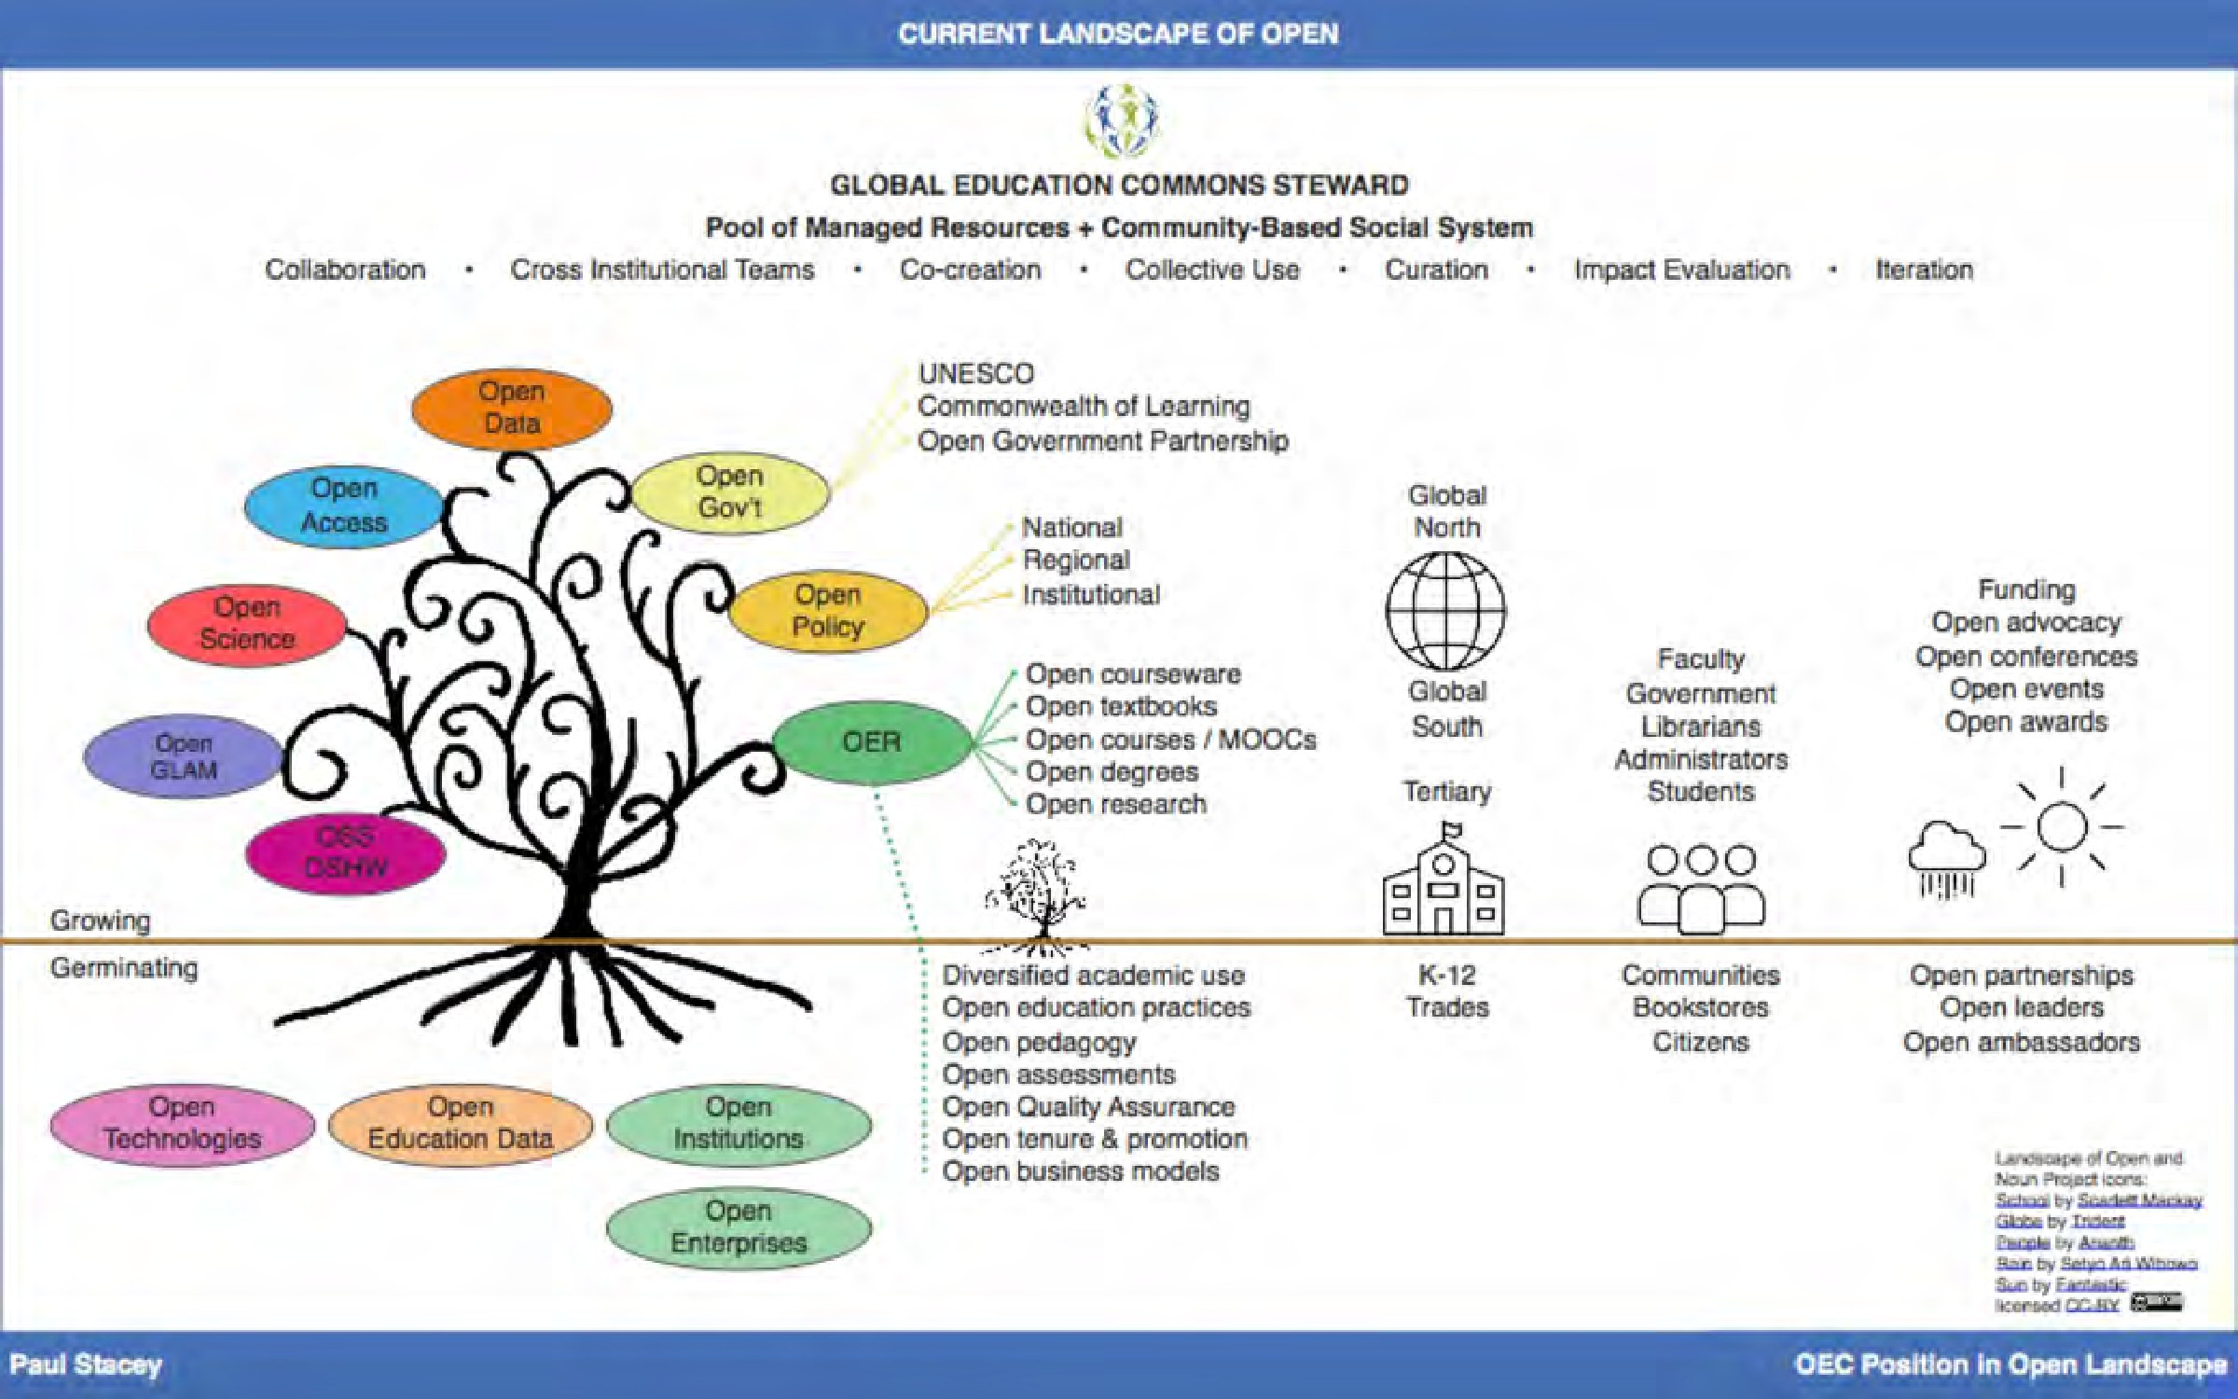

*Figure 12.4.1 Current landscape of Open. Image: Paul Stacey, 2018*

#### What is open pedagogy?

David Wiley ([2013](https://opencontent.org/blog/archives/2975)) originally defined open pedagogy as:

*that set of teaching and learning practices only possible in the context of the free access and 4R permissions characteristic of open educational resources*

It will be seen later in this section that Wiley has since ([2017](https://opencontent.org/blog/archives/4990)) recanted on this definition and indeed questions the whole idea of an open pedagogy. However, this definition was influential in framing the more recent discussion of open pedagogy around the use of

OER (see DeRosa and Jhangiani, [2017](https://press.rebus.community/makingopentextbookswithstudents/chapter/open-pedagogy/), for an excellent discussion about open pedagogy, its origins, and its development since 2013).

Indeed, even in 2019, [BCcampus still defined open pedagog](https://open.bccampus.ca/what-is-open-education/what-is-open-pedagogy/)y as follows:

*Open pedagogy, also known as open educational practices (OEP), is the use of open educational resources (OER) to support learning, or the open sharing of teaching practices with a goal of improving education and training at the institutional, professional, and individual level.*

However, it is now realised that for open educational resources to be widely adopted, as well as to change teaching practice, OER need to be embedded in a much broader ecology of teaching and learning, of which open pedagogy is a critical component. The following [definition from the University of Texas Arlington Libraries](https://libguides.uta.edu/openped) represents this thinking:

*Open pedagogy is the practice of engaging with students as creators of information rather than simply consumers of it. It’s a form of experiential learning in which students demonstrate understanding through the act of creation. The products of open pedagogy are student created and openly licensed so that they may live outside of the classroom in a way that has an impact on the greater community. Open projects frequently result in the creation of open educational resources (OER). OER are free teaching and learning materials that are licensed to allow for revision and reuse. They can be fully self- contained textbooks, videos, quizzes, learning modules, and more.*

I like the above definition because it focuses on student behaviour, where open educational materials are a by-product of their learning, rather than the starting point, although open pedagogy can also embrace OER as a starting point.

Hegarty ([2015](https://upload.wikimedia.org/wikipedia/commons/c/ca/Ed_Tech_Hegarty_2015_article_attributes_of_open_pedagogy.pdf)) describes eight attributes of open pedagogy:

* **participatory technologies**: socially constructed media such as blogs, wikis and other ‘sharing’ social media;
* **people, openness and trust**: students’ willingness to learn is fragile, with participation and interactions unlikely to flourish unless an element of trust can be built (Mak et. al., [2010](https://www.lancaster.ac.uk/fss/organisations/netlc/past/nlc2010/abstracts/PDFs/Mak.pdf));
* **innovation and creativity**: finding new models of teaching and learning that better exploit OER and more emphasis on choosing digital technologies and methods that encourage the sharing of knowledge and resources;
* **sharing ideas and resources**: an open pedagogy needs peers to share willingly within a connected and trusting and professional community;
* **connected community**: a technologically linked community with common interests;
* **learner-generated:** this requires ‘opening up’ the process to empower students to take the lead, solve problems, and work collectively to produce artifacts that they share, discuss, reconfigure, and redeploy
* **reflective practice**: when students and teachers collaborate in partnerships, it facilitates deeper pedagogical reflection
* **peer review:** Conole ([2014](http://www.networkedlearningconference.org.uk/past/nlc2014/abstracts/pdf/conole.pdf)) sees learners as publishers and users of a range of open tools, with peer interactions and critique embedded in the learning experience.

Hegarty also makes the point that it is almost impossible to separate the components of an open pedagogy into neat, segregated dimensions. Components in each of the eight dimensions overlap in many ways.

*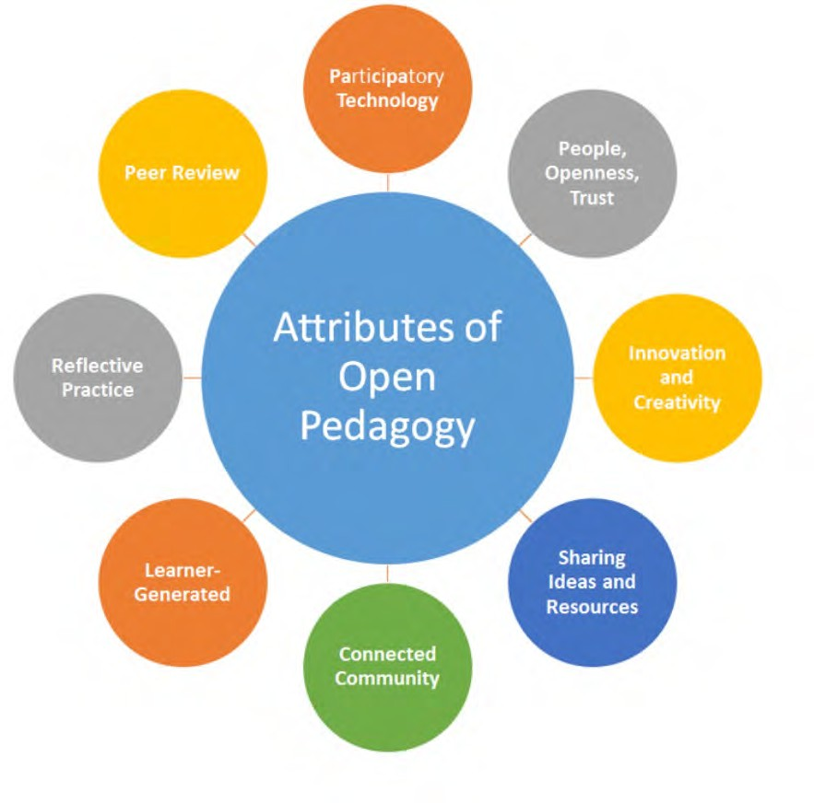Figure 12.4.2 Hegarty’s Attributes of Open Pedagogy. Image: Hegarty, 2015*

DeRosa and Robison ([2017](https://www.ubiquitypress.com/site/chapters/10.5334/bbc.i/)) set out the key idea of open pedagogy in the following:

*By replacing a static textbook — or other stable learning material — with one that is openly licensed, faculty have the opportunity to create a new relationship between learners and the information they access in the course. Instead of thinking of knowledge as something students need to download into their brains, we start thinking of knowledge as something continuously created and revised. Whether students participate in the development and revision of OER or not, this redefined relationship between students and their course ‘texts’ is central to the philosophy of learning that the course espouses. If faculty involve their students in interacting with OER, this relationship becomes even more explicit, as students are expected to critique and contribute to the body of knowledge from which they are learning. In this sense, knowledge is less a product that has distinct beginning and end points and is instead a process in which students can engage, ideally beyond the bounds of the course.*

#### Examples of open pedagogy

There is a close connection between networking, social media such as blogs and wikis, which enable students to create open educational resources, and open pedagogy.

Jon Beasley-Murray’s course where students created a Wikipedia entry on Latin American literature is a good example, as is the Math Exam Resources created by graduate students at UBC (see Chapter 10, Section 8.8.3). This approach is particularly valuable for partly redressing cultural and historical bias, through the organization of [Wikipedia edit-a-](https://www.ubyssey.ca/culture/Indigenous-Writers-Edit-a-Thon-wikipedia/) [thons](https://www.ubyssey.ca/culture/Indigenous-Writers-Edit-a-Thon-wikipedia/). For two examples, see Women in Red/Indigenous Women. and Indigenous Literature Edit-a-Thon.

The Universidad de Guadalajara (Mexico) has an interesting [web site (in English)](https://muraludg.org/topics/open-pedagogy/) that provides a number of examples of open pedagogy from around the world, related to its [Agora](http://udg.theagoraonline.net/) project.

Another practice of open pedagogy are textbook-free degrees, called [Zed Creds or Z-](https://www.veletsianos.com/2019/05/07/zed-creds-at-royal-roads/) [degrees](https://www.veletsianos.com/2019/05/07/zed-creds-at-royal-roads/) but also ZTC (zero textbook cost). Royal Roads University’s [Master of Arts in](http://www.royalroads.ca/prospective-students/master-arts-learning-and-technology) [Learning and Technology](http://www.royalroads.ca/prospective-students/master-arts-learning-and-technology) is the first master of arts degree in Canada to go textbook- free. Students can access all of the course materials through open educational resources,

e-books, journal articles and other free digital resources. These types of courses aim to improve access to education and enhance student outcomes.

Many more examples of open pedagogy in practice can be found in Jhangiani and Biswas- Diener ([2017](https://doi.org/10.5334/bbc)) and in the [Open Pedagogy Notebook.](https://openpedagogy.org/examples/)

Lastly, there is a related movement around open educational infrastructure and technology that challenges educational institutions and students to think about who owns the technology and data being used for teaching and learning and how open education practices can be enabled by open educational technologies (see, for example [OpenETC](https://opened.ca/).)

#### The need to provide a framework to support open educational resources

The search for a pedagogical and organizational framework to support the use of open educational resources has been driven partly by the relative slowness of adoption of OER. To give a simple example, instructors are reluctant to move away from expensive commercial first year textbooks, because these books often come with a wide range of support materials, such as interactive web sites with sample exam questions and answers, multiple-choice questions, and alternative reading. Open textbooks need to come with similar supporting materials, student activities and a wider ‘network’ of support to compete with commercial textbooks.

Paul Stacey, the Director of the [OEGlobal](https://www.oeglobal.org/), has mused ([2018](https://edtechfrontier.com/2018/02/)) that too much focus is given to licensing and content development, and not enough to collectively managing open resources so that they are sustainable and dynamic. He argues that OER, to be effective, need ‘commoning’, which reflects the management and sustainability of common, shared resources and services. He argues for:

* + - * a social system for the long-term stewardship of resources that preserves shared values and community identity;
      * a self-organized system by which communities manage resources (both depletable and and replenishable) with minimal or no reliance on the Market or State. Simply having a community and pool of resources is not enough. There needs to be a set of protocols, values and norms devised by the community to manage its resources.

Open pedagogy could provide an important pedagogical part of such a framework, but Stacey seems to be suggesting that support needs to go beyond pedagogy to a social and management structure.

#### Is open pedagogy a useful construct?

Some of you may feel like Molière’s Bourgeois Gentilhomme after a lesson from his tutor: ‘I have been speaking prose for 40 years and never realised it.’ The concept of ‘open pedagogy’ has been around for a long time, even if it has seen a revival resulting from the development of OER.

Lord Crowther, in a speech presenting the charter of the British Open University in 1969, defined the Open University as:

* + - * open to people: “We took it as axiomatic” said the Planning Committee “that no formal academic qualifications would be required for registration as a student…Anyone could try his or her hand, and only failure to progress adequately would be a bar to continuation of studies.”
      * open to places: “This University has no cloisters – a word meaning closed. We have no courts – or spaces enclosed by buildings….Wherever the English language is spoken or understood, or used as a medium of study, and wherever there are men and women seeking to develop their individual potentialities beyond the limits of the local provision – and I have defined a large part of the world – there we can offer our help.”
      * open to methods: ‘Every new form of human communication will be examined to see how it can be used to raise and broaden the level of human understanding.”
      * open to ideas: “It has been said that there are two aspects of education, both necessary. One regards the individual human mind as a vessel, of varying capacity, into which is to be poured as much as it will hold of the knowledge and experience by which human Society lives and moves. This is the Martha of education – and we shall have plenty of these tasks to perform. But the Mary regards the human mind rather as a fire that has to be set alight and blown with the divine efflatus’.

I am not sure that open pedagogy is the divine efflatus, but Crowther’s understanding of openness in methods is much wider than modern concepts of open pedagogy.

Claude Paquette, following the cultural revolution in Québec, wrote in [1979](https://www.erudit.org/fr/revues/qf/1979-n36-qf1208689/51334ac.pdf):

*Une pédagogie ouverte est centrée sur l’interaction qui existe dans une classe entre l’étudiant et l’environnement éducatif qui lui est proposé….Il s’agit d’une façon de penser et d’une façon d’agir. L’éducateur aura donc pour rôle premier de contribuer à l’aménagement de cet environnement éducatif.*

[My translation: Open pedagogy is focused on the interaction within a class between a learner and the educational environment that is created for him. It is about a way of thinking and a way of acting. The primary role of the teacher then is to contribute to the management of this educational environment.’

Note that there is no mention of free or open educational resources, and the quote could have come straight from Rousseau’s ‘Emile’ ([1972](https://www.amazon.ca/Emile-Education-Jean-jacques-Rousseau/dp/0465019315)). It is the basis for the whole of Chapter 6 in this book.

David Wiley (who was the originator of the term ‘open educational resources’) writes ([2017](https://opencontent.org/blog/archives/4990)):

*“Open” …. does not have anything to say about the nature of learning. …you can’t actually build a pedagogy on a foundation of open (well, not one that isn’t incredibly impoverished). Your foundational commitments in terms of pedagogy should be to an understanding of how learning happens. Once we have made fundamental commitments in terms of a theory of learning, then we can add open to our list of facilitating methods in order get better leverage.*

*I wonder if it isn’t nonsensical to talk about “open pedagogy” at all …… Perhaps we should only use open as a modifier for other pedagogies, like “open constructionist pedagogy” or “open connectivist pedagogy” or “open constructivist pedagogy.” It’s clear in each of those cases how open gives you better leverage in terms of supporting learning.*

Although many of the practices associated with open pedagogy have been around long before open educational resources were created, OER nevertheless make such practices much easier to implement and more powerful. But does this make a new pedagogy?

Morgan ([2017](https://homonym.ca/uncategorized/reflections-on-oer17-from-beyond-content-to-open-pedagogy/)) raises this issue with respect to the project she worked on for the Universidad de Guadalajara’s Agora project.

*The Agora design process was focussed on what an open design would actually be* a means to *which can be summarized as:*

1. *Open as a means to facilitate a faculty* ***culture of collaboration*** *across the university and across disciplines*
2. *Open as a means* ***to connect*** *with a broader, global community*
3. *Open as means to* ***challenge and expand existing understandings*** *of student centre learning*
4. *Open as means to* ***challenge ways of doing****, in this case, the options and possibilities of digital technology and mobile learning*
5. *Open as a means to make the lives of faculty easier in their pursuit of* ***better teaching and learning***
6. *Open as a means to create a* ***sustainable approach*** *to faculty development*

*Ultimately we did create content that fits quite nicely with the 5Rs, but the goal of our open pedagogy design process was not to create OERs as a means towards or even as an essential component of open pedagogy. The Agora was alternatively all of the ‘isms – behaviourism, connectivism, constructivism, constructionism – but the ism doesn’t really matter. Importantly, the open pedagogy design was at times technology-enabled and at times it didn’t use technology or the internet at all. OERs didn’t allow us to practice a different pedagogy, rather the open pedagogy of the Agora was a bricolage of activities and practices that at times resulted in OERs and at times didn’t.*

Pedagogy is primarily about practice: what teachers or learners do. Obviously, practice is and should be driven by ideas and beliefs, but it is different from philosophy. Learner- centred teaching or learners creating knowledge (with or without OER) is a pedagogy; ‘open’ is more of an idea and a value. In other words, looking at the quotations above, open is more a philosophy, a way of thinking, that informs practice, rather than the practice itself. However, this is a somewhat academic distinction. OER is enabling changes in teaching practice. However, I prefer a broader vision for teaching in a digital age than one so closely tied to OER.

#### 12.4.5 Another vision for pedagogy in a digital age

The increasing availability of high quality open content is likely to facilitate the shift from information transmission by the instructor to knowledge management by the learner. Also in a digital age there is a need for greater focus on skills development embedded within a subject domain than on the memorisation of content.

The use of open educational resources could enable these developments in a number of ways, such as:

* a learner-centered teaching approach that focuses on students accessing content on the Internet (and in real life) as part of developing knowledge, skills and competencies defined by the instructor, or learners managing their learning for themselves; however, content would not be restricted to officially designated open educational resources, but to everything on the Internet, because one of the core skills students will need is how to assess and evaluate different sources of information;
* a consortium of teachers or institutions creating common learning materials within a broader program context, that can be shared both within and outside the consortium. However, not only would the content be freely available, but also the underlying instructional principles, learning outcomes, learner assessment strategies, what learner support is needed, learner activities, and program evaluation techniques, so that other instructors or learners can adapt all this to their own context. This approach is already being taken by:
  + the Carnegie Mellon [Open Learning Initiative](http://oli.web.cmu.edu/openlearning/)
  + to some extent by the UK Open University’s [OpenLearn](http://openlearn.open.ac.uk/) project
  + the [Virtual University of Small States of the Commonwealth](https://vussc.col.org/)
  + [OER Africa](http://www.oerafrica.org/)
  + [OERu](https://oeru.org/)

Overall, such developments are likely to lead to a severe reduction in lecture-based teaching and a move towards more project work, problem-based learning and collaborative learning. It will also result in a move away from fixed time and place written examinations, to more continuous, portfolio-based forms of assessment.

The role of the instructor then will shift to providing guidance to learners on where and how to find content, how to evaluate the relevance and reliability of content, what content areas are core and what peripheral, and to helping students analyse, apply and present information, within a strong learning design that focuses on clearly defined learning outcomes, particularly with regard to the development of skills. Students will work mainly online and collaboratively, developing multimedia learning artefacts or demonstrations of their learning, managing their online portfolios of work, and editing and presenting selected work for assessment.

This is a far broader vision of pedagogy than that built around the use of OER.

#### 12.4.6 Conclusion

In summary:

* increasingly, educational resources are becoming more freely and more openly available for teachers and learners;
* OER open up the possibility of greater student participation in the creation as well as the selection of learning materials;
* it is essential to embed OER within a robust and appropriate teaching framework or pedagogy that exploits the potential of OER;
* OER may lead to a new, open pedagogy, but more likely will lead to the greater adoption and adaptation of existing teaching methods that benefit from the potential of OER;
* it is also essential to create organizational environments or management frameworks that encourage and support the development and use of high quality open educational resources; they cannot successfully exist in a vacuum;
* what should drive open educational practices and use of OERs should be a broader vision of teaching and learning that focuses on the knowledge and skills students need in a digital age. OER should be embedded in a wider concept of pedagogy than just ‘open’ pedagogy.

#### References

Conole, G. (2014) [The 7Cs of Learning Design – a new approach to rethinking design](http://www.networkedlearningconference.org.uk/past/nlc2014/abstracts/pdf/conole.pdf) [practice](http://www.networkedlearningconference.org.uk/past/nlc2014/abstracts/pdf/conole.pdf) *9th International Conference on Networked Learning*, Edinburgh

Crowther, G. (1969) This is the Open University, London, UK, 23 July

DeRosa, R. and Jhangiani, R. (2017) [Open Pedagogy](https://press.rebus.community/makingopentextbookswithstudents/chapter/open-pedagogy/), in Mays, E. (ed.) [*A Guide to making*](https://press.rebus.community/makingopentextbookswithstudents/)[*Open Textbooks with Students*](https://press.rebus.community/makingopentextbookswithstudents/), The Rebus Community

DeRosa, R. and Robison, S. (2017) [From OER to Open Pedagogy: Harnessing the Power of](https://doi.org/10.5334/bbc.i) [Open](https://doi.org/10.5334/bbc.i) in Jhangiani, R S. and Biswas-Diener, R. (2017 [*Open: The Philosophy and Practices that*](https://doi.org/10.5334/bbc)[*are Revolutionizing Education and Science*](https://doi.org/10.5334/bbc)London: Ubiquity Press.

Hegarty, B. (2015) [Attributes of open pedagogy: a model for using open educational](https://upload.wikimedia.org/wikipedia/commons/c/ca/Ed_Tech_Hegarty_2015_article_attributes_of_open_pedagogy.pdf) [resources](https://upload.wikimedia.org/wikipedia/commons/c/ca/Ed_Tech_Hegarty_2015_article_attributes_of_open_pedagogy.pdf) *Educational Technology*, July-August

Jhangiani, R. and Biswas-Diener, R. (eds.) (2017) [*Open: The Philosophy and Practices that*](https://doi.org/10.5334/bbc)[*are Revolutionizing Education and Science*](https://doi.org/10.5334/bbc)London: Ubiquity Press.

Mak, S. et al. (2010). [Blogs and forums as communication and learning tools in a MOOC](https://www.lancaster.ac.uk/fss/organisations/netlc/past/nlc2010/abstracts/PDFs/Mak.pdf) in L. Dirckinck-Holmfeld et al. (Eds.), Proceedings of the 7th International Conference on Networked Learning 2010 (pp. 275–284)

Morgan, T. (2017) [Reflections on #OER17 – From Beyond Content to Open Pedagogy](https://homonym.ca/uncategorized/reflections-on-oer17-from-beyond-content-to-open-pedagogy/)

*Explorations in the Ed Tech World,* 13 April

Paquette, C. (1979) [Quelques fondements d’une pédagogie ouverte](https://www.erudit.org/fr/revues/qf/1979-n36-qf1208689/51334ac.pdf) *Québec Français*, Vol. 36

Rousseau, J.-J. (1762) [*Émile, ou de l’Éducation*](https://www.amazon.ca/Emile-Education-Jean-jacques-Rousseau/dp/0465019315)(Trans. Allan Bloom). New York: Basic Books, 1979

Stacey, P. (2018) [Global Education Commons Steward](https://edtechfrontier.com/) *Musings on the Ed Tech Frontier,*

February 8

Wiley, D. (2013) [What is Open Pedagogy](https://opencontent.org/blog/archives/2975), *improving learning,* October 21 Wiley, D. (2017) [When opens collide](https://opencontent.org/blog/archives/4990), *iterating toward openness*, 21 April

1. How does open pedagogy differ from other teaching methods such as experiential learning or problem- based learning? What makes open pedagogy unique, if anything? Does it matter?
2. Look at one of the modules or topics you are currently teaching. How could you re-design it to reflect an open pedagogical approach? What would be the advantages and disadvantages of doing this?
3. What support beyond your commitment and time would be necessary for you to be able successfully to integrate OER into your teaching?

Again, no feedback is provided by me – this is for reflection on your own practice

*Activity 12.4 Contemplating Open Pedagogy*

# The implications of ‘open’ for course and program design: towards a paradigm shift?

[](http://opentextbc.ca/teachinginadigitalage/wp-content/uploads/sites/29/2015/02/Beach-open.jpg)

* + 1. *An open and free beach, Pie de la Cuesta, Mexico Image: © Tony Bates 2015 CC BY-NC*

Although in recent years MOOCs, emerging technologies and artificial intelligence have been receiving all the media attention, I believe that developments in open educational

* 1. The implications of ‘open’ for course and program design:

resources, open textbooks, open research and open data will be far more important and far more revolutionary. Here are some reasons why.

#### Nearly all educational content will be free and open

Eventually most academic content will be easily accessible and freely available through the Internet – for anyone. This could well mean a shift in power from teachers and instructors to students. Students will no longer be dependent on ‘live’ instructors as their primary source of content. Already some students are skipping lectures at their local institution because the teaching of the topic is better and clearer on OpenCourseWare, MOOCs or the Khan Academy. If students can access the best lectures or learning materials for free from anywhere in the world, including the leading Ivy League universities, why would they want to get content from a middling lecturer at Midwest State University? What is the added value that this lecturer is providing for the students?

There are good answers to this question, but it means considering very carefully how content will be presented and shaped by a teacher or instructor that makes it uniquely different from what students can access elsewhere. For research professors this may include access to their latest, as yet unpublished, research; for other instructors, it may be their unique perspective on a particular topic, and for others, a unique mix of topics to provide an integrated, inter-disciplinary approach. What will not be acceptable to most students is repackaging of ‘standard’ content that can easily be found elsewhere on the Internet and at a higher quality.

Furthermore, if we look at knowledge management as one of the key skills needed in a digital age, it may be better to enable students to find, analyze, evaluate and apply content than for instructors to do it for them. If most content is available elsewhere, what students will look for increasingly from their local institutions is support with their learning, rather than the delivery of content. This means directing them to appropriate sources of content, helping when students are struggling with concepts, and providing opportunities for students to apply their knowledge and to develop and practice skills. It means giving prompt and relevant feedback as and when students need it. Above all, it means creating a rich learning environment in which students can study (see Chapter 6[)](http://opentextbc.ca/teachinginadigitalage/part/chapter-5-building-an-effective-learning-environment/). It means moving teaching from information transmission to knowledge management, from selecting, structuring and delivering content to learner support.

Thus for most students within their university or college (with the possible exception of the most advanced research universities) the quality of the learning support will eventually matter more than the quality of content delivery, which they can get from anywhere. This is a major challenge for instructors who see themselves primarily as content experts and deliverers.

#### Modularisation

**[](http://opentextbc.ca/teachinginadigitalage/wp-content/uploads/sites/29/2015/02/Modularization-2.jpg)**

*Figure 12.5.2 Four-sided pyramid, by Sol LeWitt, 1999 Image:* [*Cliff, Flickr*](https://www.flickr.com/photos/nostri-imago/2866962384/)*, © CC Attribution 2.0*

The creation of open educational resources, either as small learning objects but increasingly as short ‘modules’ of teaching, from anywhere between five minutes to one hour of material, and the increasing diversification of markets, is beginning to result in two of the key principles of OER being applied, re-use and re-mix. In other words, the same content, available in an openly accessible digital form, may be integrated into a range of different applications, and/or combined with other OER to create a single teaching module, course or program, as in Scenario G.

Between 2015 to 2018, the Ontario government, through its online course development fund, encouraged institutions to create OER. As a result, several universities brought together faculty within their own institution but working in different departments that teach the same area of content (for example, statistics) to develop ‘core’ OER that can be shared between departments. The logical next step would be for statistics faculty across the Ontario system to get together and develop an integrated set of OER modules on statistics that would cover substantial parts of the statistics curriculum. Working together would have the following benefits:

* higher quality by pooling resources (two subject expert heads are better than one, combined with support from instructional designers and web producers);
* more OER than one instructor or institution could produce;
* subject coherence and lack of duplication;
* more likelihood of faculty in one institution using materials created in another if they have had input to the selection and design of the OER from other institutions.

As the range and quality of OER increases, instructors (and students) will be able to build curriculum through a set of OER ‘building blocks’. The aim would be to reduce instructor time in creating materials and using their time more in supporting student learning than in delivering content. When they do create original material, it can then be shared with other instructors.

#### Disaggregation of services

Open education and digitisation enable what has tended to be offered by institutions as a complete bundle of services to be split out and offered separately, depending on the market for education and the unique needs of individual learners. These different services could be as follows:

* academic guidance (assessment of learning needs; admission counselling)
* choice of educational goals/outcomes/competencies
* access to ‘open’ digital content in the form of OER or MOOCs
* learner support, including a choice of
  + topic guidance (build a curriculum)
  + tutoring on demand (for example, when students are ‘stuck’)
  + different learning activities (tests, projects, etc.)
  + feedback on learning activities
  + assessment preparation
* assessment on demand

Learners would select and use those modules or services that best fit their needs. This is likely to be the pattern for lifelong learners in particular. Although most of the really significant changes are yet to come, some early indications of this process are already occurring. Some examples are given below.

[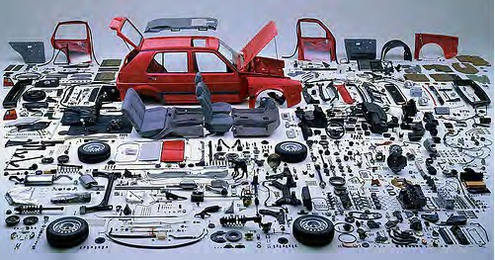](http://opentextbc.ca/teachinginadigitalage/wp-content/uploads/sites/29/2015/02/Disaggregation-2.jpg)

*Figure 12.5.3 Disaggregation*

*Image: ©* [*Aaron ‘tango’ Tan, Flickr*](https://www.flickr.com/photos/hahatango/2161518548/)*, CC Attribution 2.0*

##### Admission and career counselling

This is a service already offered by Empire State University, a part of the State University of New York, through its pre-enrollment advisers. Adult learners considering a return to study or a career change can receive mentoring about what courses and combinations they can take from within the college that fit with their previous life and their future wishes. In essence, within boundaries, potential students are able to design their own degree. In the future, some institutions might specialise in this kind of service at a system level.

##### Build a curriculum

Students could be advised on an appropriate curriculum that can be built to fit their needs. For instance, Dalhousie University’s Faculty of Computer Sciences has built a tool called [Daedalus](https://academics.cs.dal.ca/curriculum/browse) which basically enables the construction of a map showing the inter- relatedness between specific learning outcomes and course content, including course sequencing (see Contact North’s [Pockets of Innovation](https://teachonline.ca/pockets-innovation/daedalus-online-curriculum-mapping-tool-dalhousie-university-nova-scotia-canada) for more details).

Once such a map of a degree program or other qualification or curriculum has been built, students can then navigate their own choice of courses or route through a curriculum – and perhaps negotiate what is needed for a degree. This could just as easily be based on OER as classroom teaching.

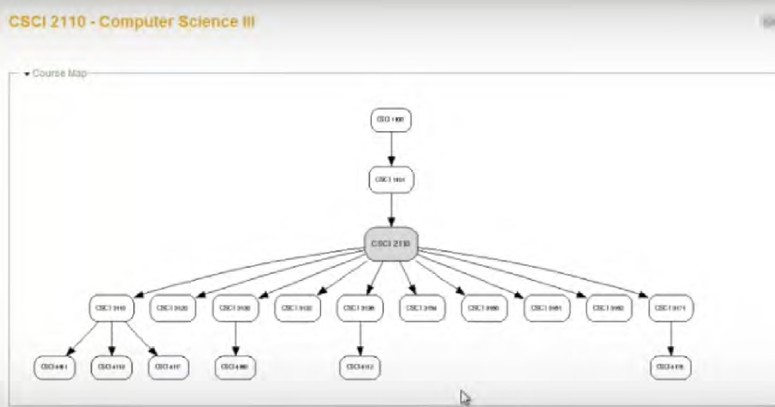

*Figure 12.5.4 Daedalus. This shows the relationship between the pre-requisite courses for CSCI 2110 (second level up) and the courses for which CSCI 2110 is a preparation (top two levels). By clicking on each of the courses listed, students can see the learning outcomes both needed before studying and what they should achieve after studying each course.*

##### Learner support

Students may have already determined what they want to study through the Internet, such as a MOOC. What they are looking for is help with their studies: how to write assignments, where to look for information, feedback on their work and thinking. They are not necessarily looking for a credit, degree or other qualification, but if they are, they will pay for assessment separately. Currently, students pay private tutors for this service. However, it is feasible that institutions could also provide this service, provided that a suitable business model can be built.

##### Assessment

Learners may feel that through prior study and work, they are able to take a challenge exam for credit. Alternatively, a learner may wish to present a portfolio of work to demonstrate their knowledge and skills. All they require from the institution is a chance to be assessed. Institutions such as Western Governors’ University or the Open Learning division of Thompson Rivers University are already offering this service, and this would be a logical next step for the many other universities or colleges with some form of prior learning assessment or PLAR.

##### ‘Assembled’ qualifications

Learners may have acquired a range of credits, badges or certificates (microcredentials) from a range of different institutions. The institution assesses these qualifications and experiences and helps the learner to take any further studies that are necessary, then awards a higher or more extensive qualification, such as a degree. Prior learning assessment or PLAR is one step in this direction, but not the only one.

##### A discount on fully online courses and programs

For learners who cannot or do not want to attend campus, the course fees would be lower for online courses than for students receiving a full campus experience.

##### Open access to content

In this case, the learner is not looking for any qualification, but wants access to content, particularly new and emerging knowledge. MOOCs are one example, but other examples include OpenLearn and open textbooks.

##### The full campus experience

This would be the ‘traditional’ integrated package that full-time, campus-based students now receive. This would, though, be fully costed and much more expensive than any of the other single disaggregated services.

##### Funding models

Note that I have been careful not to link any of these services to a specific funding model. This is deliberate, because it could be:

* + - * + covered through privatisation, where each service is separately priced and the user pays for that service (but not for others not used);
        + financed through a voucher system, whereby everyone at the age 18 is entitled to a notional amount of financial support from the state for post-secondary education, and can pay for a range of service from that voucher until their individual fund is exhausted;
        + all or some services would be available for free as part of a publicly funded open

education system;

* + - * + a mix of the above.

Whatever the funding model, institutions disaggregating services will need to be able to price different services accurately.

##### The argument against disaggregation

There are also strong arguments against the disaggregation of services. Gallagher ([2019](https://jhupbooks.press.jhu.edu/title/college-made-whole)) argues that the successful colleges and universities of the future will be integrated: coherently and cohesively designed to help students achieve a learning experience that is more than the sum of its parts and lasts for life.

However, this is not a question of either/or and should be driven to some extent by the needs of learners at different points in their learning cycle. Most younger students coming from high school probably will need an integrated college experience. However, working adults or students who have graduated may not want, need, nor can afford the full package. Disaggregation will provide the flexibility needed for lifelong learning.

##### The need for more flexibility in services

In any case, there is now an increasing diversity of learners’ needs, from high school students wanting full-time education, graduate students wanting to do research, and lifelong learners, most of whom will have already passed through a publicly funded higher education system, wanting to keep learning either for vocational or personal reasons. This increasing diversity of needs requires a more flexible approach to providing educational opportunities in a digital age. Disaggregation of services and new models of funding, combined with increased accessibility to free, open content, are some ways in which this flexibility can be provided. For alternative views on this issue, see Carey, [2015](https://www.amazon.com/End-College-Creating-University-Everywhere/dp/1594634041); Large, [2015](https://www.insidehighered.com/views/2015/04/07/essay-calls-rebundling-college-and-its-functions).

#### Conclusions

Despite all the hoopla around MOOCs, they are essentially a dead end with regard to providing learners who do not have adequate access to education with what they want: high quality qualifications. The main barrier to education is not lack of cheap content but lack of access to programs leading to credentials, either because such programs are too expensive, or because there are not enough qualified teachers, or both. Making content free is not a waste of time (if it is properly designed for secondary use), but it still needs a lot of time and effort to integrate it properly within a learning framework.

Open educational resources do have an important role to play in online education, but they need to be properly designed, and developed within a broader learning context that includes the critical activities needed to support learning, such as opportunities for student-instructor and peer interaction, and within a culture of sharing, such as consortia of equal partners and other frameworks that provide a context that encourages and supports sharing. In other words, OER need skill and hard work to make them useful, and selling them as a panacea for education does more harm than good.

Although open and flexible learning and distance education and online learning mean different things, the one thing they all have in common is an attempt to provide alternative means of high quality education or training for those who either cannot take conventional, campus-based programs, or choose not to.

Lastly, there are no insurmountable legal or technical barriers now to making educational material free. The successful use of OER does though require a particular mindset among both copyright holders – the creators of materials – and users – teachers and instructors who could use this material in their teaching. Thus the main challenge is one of cultural change.

In the end, a well-funded public higher education system remains the best way to assure access to higher education for the majority of the population. Having said that, there is enormous scope for improvements within that system. Open education and its tools offer a most promising way to bring about some much needed improvements.

#### The future is yours

This is just my interpretation of how approaches to ‘open’ content and resources could radically change the way we teach and how students will learn in the future. At the beginning of this chapter there is a scenario I created which suggests how this might play out in one particular program.

More importantly, there is not just one future scenario, but many. The future will be determined by a host of factors, many outside the control of teachers and instructors. But the strongest weapon we have as teachers is our own imagination and vision. Open content and open learning reflect a particular philosophy of equality and opportunity created through education. There are many different ways in which we as teachers, and even more our learners, can decide to apply that philosophy. However, the technology now offers us many more choices in making these decisions. Thus there is scope for many more scenarios that aim to extend access and educational opportunities.

#### References and further reading

Carey, K. (2015) [*The End of College*](https://www.amazon.com/End-College-Creating-University-Everywhere/dp/1594634041)New York: Riverhead Books

Gallagher, C. (2019) [*Integrative Learning for a Divided World*](https://jhupbooks.press.jhu.edu/title/college-made-whole)Baltimore ML: John Hopkins Press

Large, L. (2015) Rebundling College [*Inside Higher Ed*](https://www.insidehighered.com/views/2015/04/07/essay-calls-rebundling-college-and-its-functions), April 7

1. Re-read Scenario G Could you build a future scenario for your own courses and programs, that exploit fully the use of OER and different delivery modes?

(This will be easier and more effective if you could do this with a range of other faculty, instructional designers and web producers, through, for instance, a faculty development workshop).

*12.5 Building a course that is open in practice and in theory*

###### Key Takeaways

1. Open educational resources offer many benefits but they need to be well designed and embedded within a rich learning environment to be effective.
2. The increasing availability of OER, open textbooks, open research and open data means that in future, almost all academic content will be open and freely accessible over the Internet.
3. As a result, students will increasingly look to institutions for learning support and help with the development of skills needed in a digital age rather than with the delivery of content. This will have major consequences for the role of teachers/instructors and the design of courses.
4. OER and other forms of open education will lead to increased modularization and disaggregation of learning services, which are needed to respond to the increasing diversity of learner needs in a digital age.
5. MOOCs are essentially a dead end with regard to providing learners who do not have adequate access to education with high quality qualifications. The main value of MOOCs is in providing opportunities for non- formal education and supporting communities of practice.
6. OER, MOOCs, open textbooks and other digital forms of open-ness are important in helping to widen access to learning opportunities, but ultimately these are enhancements rather than a replacement for a well-funded public education system, which remains the core foundation for enabling equal access to educational opportunities.

## CHAPTER 13: ENSURING QUALITY TEACHING IN A DIGITAL AGE

When you have read this chapter, and in conjunction with what has been learned in previous chapters, you should be able to:

* define quality in terms of teaching in a digital age;
* determine what your preferred approaches are to teaching and learning;
* decide what mode of delivery is most appropriate for any course you are responsible for;
* understand why teamwork is essential for effective teaching in a digital age;
* make best use of existing resources for any course;
* choose and use the right technology and tools to support your learning;
* set appropriate learning goals for teaching in a digital age;
* design an appropriate course structure and set of learning activities;
* know when and how to communicate with learners;
* evaluate your teaching, make necessary improvements, and improve your teaching through further innovation

*The Purpose of this Chapter*

#### What is covered in this chapter

* 13.1 What do we mean by quality when teaching in a digital age?
* 13.2 Nine steps to quality teaching in a digital age
* 13.3 Step One: Decide how you want to teach
* 13.4 Step two: what kind of course or program?
* 13.5 Step three: work in a team
* 13.6 Step four: build on existing resources
* 13.7 Step five: master the technology
* 13.8 Step six: set appropriate learning goals
* 13.9 Step seven: design course structure and learning activities
* 13.10 Step eight: communicate, communicate, communicate
* 13.11 Step nine: evaluate and innovate
* 13.12 Building a strong foundation of course design

Also in this chapter you will find the following activities:

* Activity 13.1 Assessing quality in teaching and learning
* Activity 13.2 There is no activity for this section
* Activity 13.3 Re-thinking your teaching
* Activity 13.4 Which mode of delivery?
* Activity 13. 5 There is no activity for this section
* Activity 13.6 Building on existing resources
* Activity 13.7 Mastering the technology
* Activity 13.8 Setting learning goals
* Activity 13.9 Structuring your course or program
* Activity 13.10 Communicating with your students
* Activity 13.11 Evaluating your course or program
* Activity 13.12 Develop a future scenario for your teaching

###### Key Takeaways

* 1. For the purposes of this book, quality is defined as: *teaching methods that successfully help learners develop the knowledge and skills they will require in a digital age.*
  2. Formal national and institutional quality assurance processes do not guarantee quality teaching and learning. In particular, they focus on past ‘best’ practices, processes to be done before actual teaching, and often ignore the affective, emotional or personal aspects of learning. Nor do they focus particularly on the needs of learners in a digital age.
  3. New technologies and the needs of learners in a digital age require a re-thinking of traditional campus-based teaching, especially where it is has been based mainly on the transmission of knowledge. This means re- assessing the way you teach and determining how you would really like to teach in a digital age. This requires imagination and vision rather than technical expertise.
  4. It is important to determine the most appropriate mode of delivery, based on teaching philosophy, the needs of students, the demands of the discipline, and the resources available.
  5. It is best to work in a team. Blended and especially fully online learning require a range of skills that most instructors are unlikely to have. Good course design not only enables students to learn better but also controls teacher and faculty workload. Courses look better with good graphic and web design and professional video production. Specialist technical help frees up instructors to concentrate on the knowledge and skills that students need to develop.

1. Full use should be made of existing resources, including institutionally-supported learning technologies, open educational resources, learning technology staff, and the experience of your colleagues.
2. The main technologies you will be using should be mastered, so you are professional and knowledgeable about their strengths and weaknesses for teaching.
3. Learning goals that are appropriate for learners in a digital age need to be set. The skills students need should be embedded within their subject domain, and these skills should be formally assessed.
4. A coherent and clearly communicable structure and learning activities for a course should be developed that are manageable in terms of workload for both students and instructor.
5. Regular and on-going instructor/teacher presence, especially when students are studying partly or wholly online, is essential for student success. This means effective communication between teacher/instructor and students. It is particularly important to encourage inter-student communication, either face-to-face or online.
6. The extent to which the new learning goals of re-designed courses aimed at developing the knowledge and skills needed in a digital age have been achieved should be carefully evaluated and ways in which the course could be improved should be identified.

# What do we mean by quality when teaching in a digital age?

[](http://opentextbc.ca/teachinginadigitalage/wp-content/uploads/sites/29/2015/04/Quality-2.jpg)

*Figure 13.1.1 What do we mean by quality? Image: © Wikipedia Commons*

If you have followed the journey through all the previous chapters of this book, you will have been subject to a great deal of information: philosophical, empirical, technological, and administrative, set within a framework of issues related to the needs of learners in a digital age. It is now time to pull all this together into a pragmatic set of action steps that will enable you to apply these ideas and concepts within the everyday circumstances of teaching.

Thus the aim of this chapter is to provide some practical guidelines for teachers and

instructors to ensure quality teaching in a digital age. This will mean drawing on all the previous chapters in this book, so there will inevitably be some repetition in this chapter of the content of earlier chapters. Before I do this, however, it is necessary to clarify what is meant by ‘quality’ in teaching and learning, because I am using ‘quality’ here in a very specific way.

#### Definitions

Probably there is no other topic in education which generates so much discussion and controversy as ‘quality’. Many books have been written on the topic, but I will cut to the chase and give my definition of quality up-front. For the purposes of this book, quality is defined as:

*teaching methods that successfully help learners develop the knowledge and skills they will require in a digital age.*

This of course is my short answer to the question of what is quality. A longer answer means looking, at least briefly, at:

* quality assurance in state and provincial k-12/school systems
* institutional and degree accreditation;
* academic quality assurance processes;
* differences in quality assurance between traditional classroom teaching and online and distance education;
* the relationship between quality assurance processes and learning outcomes;
* ‘quality assurance fit for purpose’: meeting the goals of education in a digital age.

This will then provide the foundations for my recommendations for quality teaching that will follow in this chapter.

Most governments act to protect consumers in the education market by ensuring that schools, teachers, and institutions are properly accredited and the qualifications they award are valid and are recognised as of being of ‘quality.’ However, the manner in which accreditation and quality control are are managed varies a great deal not only between countries, but also between k-12/school systems and post-secondary education.

#### Quality assurance in state and provincial k-12/school systems

Governments and school boards wish to be assured that they are receiving value for money, whether the money comes through taxes or school fees. As a result, attempts are often made to provide ways of measuring the quality of either individual teachers, schools or whole school systems.

A state or provincial government may introduce legislation, regulations or policies specifically for online or e-learning. Even within a single country, there can be great variation in how online learning in k-12 school systems are regulated (see for instance Barbour et al, [2021,](https://k12sotn.ca/wp-content/uploads/2022/06/StateNation21.pdf) for an analysis of how online learning is regulated in the Canadian k-12 system).

However, the focus in this book is on teacher’s themselves being able to manage the quality of their teaching. In this chapter, then, I will suggest nine steps by which teachers themselves can ensure they are offering high quality teaching for a digital age. They are NOT meant to be used for external accreditation.

#### Institutional and degree accreditation

Once again, there are enormous differences in how different jurisdictions ensure quality in post-secondary institutions and in their degrees. The main difference is between the USA and virtually any other country. The U.S. Department of Education’s Network for Education Information states in its [description of accreditation and quality assurance](http://www2.ed.gov/about/offices/list/ous/international/usnei/us/edlite-accreditation.html) in the USA:

*Accreditation is the process used in U.S. education to ensure that schools, postsecondary institutions, and other education providers meet, and maintain, minimum standards of quality and integrity regarding academics, administration, and related services. It is a voluntary process based on the principle of academic self-governance. Schools, postsecondary institutions and programs ( faculties) within institutions participate in accreditation. The entities which conduct accreditation are associations comprised of institutions and academic specialists in specific subjects, who establish and enforce standards of membership and procedures for conducting the accreditation process.*

*Both the federal and state governments recognize accreditation as the mechanism by which institutional and programmatic legitimacy are ensured. In international terms, accreditation by a recognized accrediting authority is accepted as the U.S. equivalent of other countries’ ministerial recognition of institutions belonging to national education systems.*

In other words, in the USA, accreditation and quality assurance is effectively self- regulated by the educational institutions through their control of accreditation agencies, although the government does have some ‘weapons of enforcement’, mainly through the withdrawal of student financial aid for students at any institution that the U.S. Department of Education deems to be failing to meet standards.

In many other countries, government has the ultimate authority to accredit institutions and approve degrees, although in countries such as Canada and the United Kingdom, this too is often exercised by arm’s length agencies appointed by government, but consisting mainly of representatives from the various institutions within the system. These bodies have a variety of names, but Degree Quality Assurance Board is a typical title. However, in recent years, some regulatory agencies such as the United Kingdom’s [Quality Assurance](http://www.qaa.ac.uk/en) [Agency for Higher Education](http://www.qaa.ac.uk/en) have adopted formal quality assurance processes based on practices that originated in industry. The U.K. QAA’s revised [Quality Code for Higher](https://www.qaa.ac.uk/quality-code) [Education](https://www.qaa.ac.uk/quality-code) is set out below:

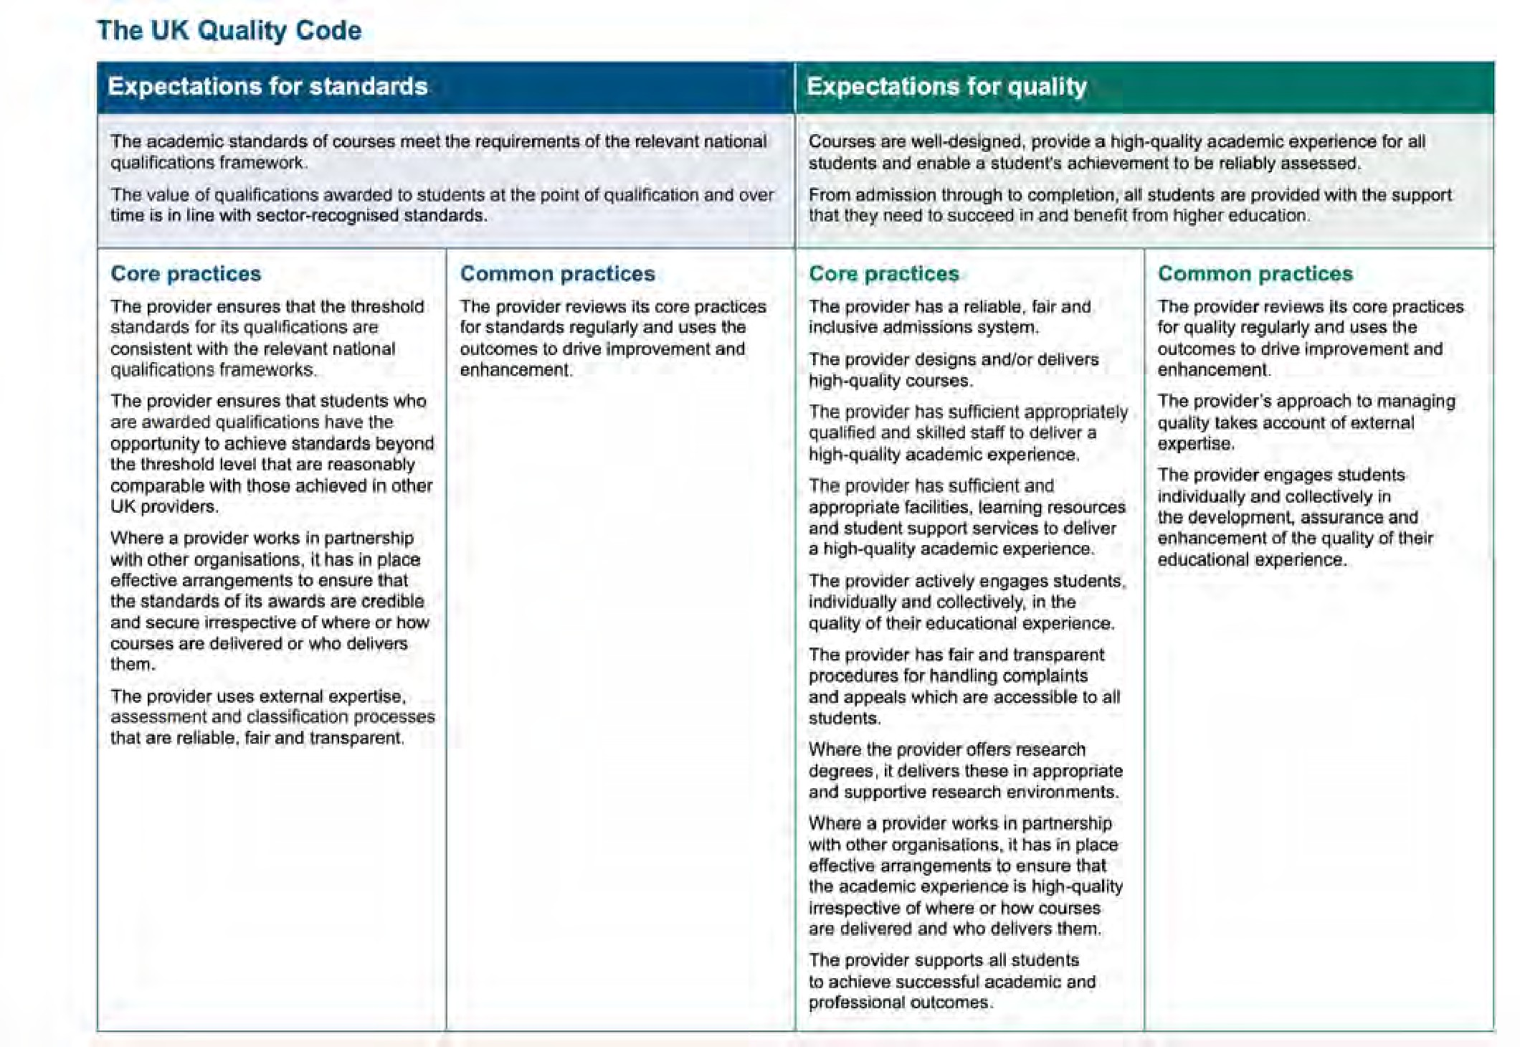

*Figure 13.1.2 The UK Higher Education Quality Code (accessed August, 2022)*

However, although hardly contentious, such system-wide codes are too general for the specifics of ensuring quality in a particular course. Many institutions as a result of pressure from external agencies have therefore put in place formal quality assurance processes over and beyond the normal academic approval processes (see Clarke-Okah and Daniel, [2010](http://www.cedol.org/wp-content/uploads/2012/02/19-20-2010.pdf), for a typical, low-cost example).

#### Internal quality assurance

It can be seen then that the internal processes for ensuring quality programs within a school or institution are particularly important. Although again the process can vary considerably between institutions, at least in universities the process is fairly standard.

##### Assuring the quality of a program

A proposal for a new degree will usually originate from a group of faculty/instructors within a department. The proposal will be discussed and amended at departmental and/ or Faculty meetings, then once approved will go to the university senate for final approval. The administration in the form of the Provost’s Office will usually be involved, particularly where resources, such as new appointments, are required.

Although this is probably an over-generalisation, significantly the proposal will contain information about who will teach the course and their qualifications to teach it, the content to be covered within the program (often as a list of courses with short descriptions), a set of required readings, and usually something about how students will be assessed. Increasingly, such proposals may also include broad learning outcomes for the program.

If there is a proposal for courses within a program or the whole program to be delivered fully online, it is likely that the proposal will come under greater internal scrutiny. What is unlikely to be included in a proposal though is what *methods* of teaching will be used. This is usually considered the responsibility of individual faculty members or the individual teacher (unless you are an adjunct or contract instructor). It is this aspect of quality – the effectiveness of the teaching method or learning environment for developing the knowledge and skills in a digital age – with which this chapter is concerned.

##### Assuring the quality of classroom teaching

There are many guidelines for quality traditional classroom teaching. Perhaps the most well known are those of Chickering and Gamson ([1987](http://www.lonestar.edu/multimedia/SevenPrinciples.pdf)), based on an analysis of 50 years of research into best practices in teaching. They argue that good practice in undergraduate education:

* + - * 1. Encourages contact between students and faculty.
        2. Develops reciprocity and cooperation among students.
        3. Encourages active learning.
        4. Gives prompt feedback.
        5. Emphasizes time on task.
        6. Communicates high expectations.
        7. Respects diverse talents and ways of learning.

##### Quality in online courses and programs

Because online learning was new and hence open to concern about its quality, there have also been many guidelines, best practices and quality assurance criteria created and applied to online programming. All these guidelines and procedures have been derived from the experience of previously successful online programs, best practices in teaching and learning, and research and evaluation of online teaching and learning. A comprehensive list of online quality assurance standards, organizations and research on online learning can be found in Appendix 2.

Jung and Latchem ([2012](https://www.routledge.com/Quality-Assurance-and-Accreditation-in-Distance-Education-and-e-Learning/Jung-Latchem/p/book/9780415887359)), in a review of quality assessment processes in a large number of online and distance education institutions around the world, make the following important points about quality assurance processes for online and distance education within institutions:

* focus on outcomes as the leading measure of quality;
* take a systemic approach to quality assurance;
* see QA as a process of continuous improvement;
* move the institution from external controls to an internal culture of quality;
* poor quality has very high costs so investment in quality is worthwhile.

Ensuring quality in online learning is not rocket science. There is no need to build a bureaucracy around this, but there does need to be some mechanism, some way of monitoring instructors or institutions when they fail to meet these standards. However, we should also do the same for campus-based teaching. As more and more already accredited (and ‘high quality’) campus-based institutions start moving into hybrid learning, the establishment of quality in the online learning elements of programs will become even more important.

#### Consistency in applying quality standards

There are many evidence-based guidelines for ensuring quality in teaching, both face-to- face and online. The main challenge then is to ensure that teachers and instructors are aware of these best practices and that institutions have processes in place to ensure that guidelines for quality teaching are implemented and followed.

Quality assurance methods are valuable for agencies concerned about rogue private providers, or worried about institutions using online learning to cut corners or reduce costs without maintaining standards (for instance, by hiring untrained adjuncts, and giving them an unacceptably high teacher-student ratio to manage). QA methods can be useful for providing instructors new to teaching with technology, or struggling with its use, with models of best practice to follow. Nevertheless, for any reputable school, university, or college, the same approach to quality assurance standards should apply equally to face- to-face, blended or online teaching, but adjusted for the difference in delivery method.

#### Quality assurance, innovation and learning outcomes

Most QA processes are front-loaded, in that they focus on inputs – such as the academic qualifications of faculty, or the processes to be adopted for effective teaching, such as clear learning objectives, or systems-based course design methods, such as ADDIE – rather than outputs, such as what students have actually learned. QA processes also tend to be backward-looking, that is, they focus on *past* best practices.

This needs to be considered especially when evaluating new teaching approaches. Butcher and Hoosen ([2014](https://www.oerafrica.org/resource/guide-quality-post-traditional-online-higher-education)) state:

*The quality assurance of post-traditional higher education is not straightforward, because openness and flexibility are primary characteristics of these new approaches, whereas traditional approaches to quality assurance were designed for teaching and learning within more tightly structured frameworks.*

However, Butcher and Hoosen ([2014](https://www.oerafrica.org/resource/guide-quality-post-traditional-online-higher-education)) go on to say that:

*fundamental judgements about quality should not depend on whether education is*

*provided in a traditional or post-traditional manner …the growth of openness is unlikely to demand major changes to quality assurance practices in institutions. The principles of good quality higher education have not changed…. Quality distance education is a sub-set of quality education…Distance education should be subject to the same quality assurance mechanisms as education generally.’*

Such arguments though offer a particular challenge for teaching in a digital age, where learning outcomes need to include the development of skills such as independent learning, facility in using social media for communication, and knowledge management, skills that have often not been explicitly identified in the past. Quality assurance processes are not usually tied to specific types of learning outcomes, but are more closely linked to general performance measures such as course completion rates, time to degree completion, or grades based on past learning goals.

Furthermore, we have already seen in Chapters 7 to 11 that new media and new methods of teaching are emerging that have not been around long enough to be subject to analysis of best practices. A too rigid view of quality assessment based on past practices could have serious negative implications for innovation in teaching and for meeting newly emerging learning needs. ‘Best practice’ may need occasionally to be challenged, so new approaches can be experimented with and evaluated.

#### Getting to the essence of quality

Institutional accreditation, internal procedures for program approval and review, and formal quality assurance processes, while important, particularly for external accountability, do not really get to the heart of what quality is in teaching and learning. They are rather like the pomp and circumstance of state occasions. The changing of the guard in front of the palace is ceremonial, rather than a practical defence against revolution, invasion or a terrorist attack on the President or the monarchy. As important as ceremonies and rituals are to national identity, a strong state is bound by deeper ties. Similarly, an effective school, college or university is much more than the administrative processes that regulate teaching and learning.

At its worst, quality management can end up with many boxes on a questionnaire being ticked, in that the management processes are all in place, without in fact investigating

whether students are really learning more or better as a result of using technology. In essence, teaching and learning are very human activities, often requiring for success a strong bond between teacher and learner. There is a powerful affective or motivational aspect of learning, which a ‘good’ teacher can tap into and steer.

One reason for the concern of many teachers and instructors about using technology for teaching is that it will be difficult or even impossible to develop that emotional bond that helps see a learner through difficulties or inspires someone to greater heights of understanding or passion for the subject. However, technology is now flexible and powerful enough, when properly managed, to enable such bonds to be developed, not only between teacher and learner, but also between learners themselves, even though they may never meet in person.

Thus any discussion of quality in education needs to recognise and accommodate these affective or emotional aspects of learning. This is a factor that is too often ignored in behaviourist approaches to the use of technology or to quality assurance. Consequently, in what follows in this chapter, as well as incorporating best practices in technical terms, the more human aspects of teaching and learning are considered, even or especially within technology-based learning environments.

#### Quality assurance: fit for purpose in a digital age

At the end of the day, the best guarantees of quality in teaching and learning fit for a digital age are:

* well-qualified subject experts also well trained in both teaching methods and the use of technology for teaching;
* highly qualified and professional learning technology support staff;
* adequate resources, including appropriate teacher/student ratios;
* appropriate methods of working (teamwork, project management);
* systematic evaluation leading to continuous improvement.

Much more attention needs to be directed at what campus-based institutions are doing when they move to hybrid or online learning. Are they following best practices, or even better, developing innovative, better teaching methods that exploit the strengths of both

classroom and online learning? The design of xMOOCs and the high drop-out rates in the USA of many two year colleges new to online learning suggest they are not.

If the goal or purpose is to develop the knowledge and skills that learners will need in a digital age, then this is the ‘standard’ by which quality should be assessed, while at the same time taking into account what we already know about general best practices in teaching. The recommendations for quality teaching in a digital age that follow in this chapter are based on this key principle of ‘fit for purpose’.

#### References and further reading

Barbour, M., Labonte, R and Nagle, J. [State of the Nation: K-12 eLearning in Canada 2021](https://k12sotn.ca/wp-content/uploads/2022/06/StateNation21.pdf) [Edition](https://k12sotn.ca/wp-content/uploads/2022/06/StateNation21.pdf) Halfmoon Bay, BC: CanElearn

Butcher, N. and Hoosen, S. (2014) [A Guide to Quality in Post-traditional Online Higher](https://www.oerafrica.org/resource/guide-quality-post-traditional-online-higher-education) [Education](https://www.oerafrica.org/resource/guide-quality-post-traditional-online-higher-education) Dallas TX: Academic Partnerships

Chickering, A., and Gamson, Z. (1987) [‘Seven Principles for Good Practice in Undergraduate](http://www.lonestar.edu/multimedia/SevenPrinciples.pdf) [Education’](http://www.lonestar.edu/multimedia/SevenPrinciples.pdf) *Washington Center News* (originally published in *AAHE Bulletin,* March 1987)

Clarke-Okah, W. and Daniel, J. (2010) [*The Commonwealth of Learning: Review and*](http://www.cedol.org/wp-content/uploads/2012/02/19-20-2010.pdf)[*Improvement Model*](http://www.cedol.org/wp-content/uploads/2012/02/19-20-2010.pdf)Burnaby BC: Commonwealth of Learning

Jung, I. and Latchem, C. (2012) [Quality Assurance and Accreditation in Distance Education](http://www.routledge.com/books/details/9780415887359/) [and e-Learning](http://www.routledge.com/books/details/9780415887359/) New York/London: Routledge

What do you think of the current system of

* institutional accreditation;
* internal quality assurance processes?

Do these current processes guarantee quality in teaching and learning for a digital age? If not, why not? I do not provide feedback on this activity.

*Activity 13.1 Assessing quality*

# Nine steps to quality teaching in a digital age

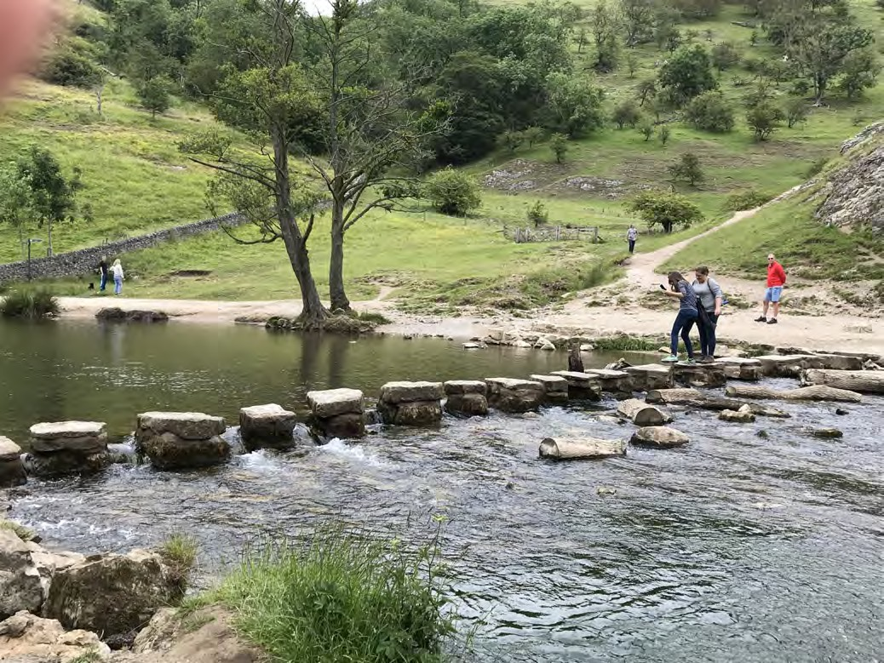

*Figure 13.2.1 Stepping stones, Dovedale, UK Image: Tony Bates*

In the previous section, I pointed out that there are lots of excellent quality assurance standards, organizations and research available online, and I’m not going to duplicate these. Instead, I’m going to suggest a series of practical steps towards *implementing* such standards.

#### An alternative to using the ADDIE model to assure quality

I am assuming that all the standard institutional processes towards program approval have been taken, although it is worth pointing out that it might be worth thinking through my nine steps outlined below before finally submitting a proposal for a new blended or online course or program. My nine steps approach would also work when considering the redesign of an existing course.

The ‘standard’ quality practice for developing a fully online course would be to develop a systems approach to design through something like the ADDIE model (see Chapter 4, Section 3). Puzziferro and Shelton ([2008](https://www.researchgate.net/publication/267195313_A_Model_for_Developing_High-Quality_Online_Courses_Integrating_a_Systems_Approach_with_Learning_Theory_A_MODEL_FOR_DEVELOPING_HIGH-QUALITY_ONLINE_COURSES_INTEGRATING_A_SYSTEMS_APPROACH_WITH_LEARNING_T)) provide an excellent example.

However, I have already pointed to some of the limitations of a systems approach in the volatile, uncertain, chaotic and ambiguous digital age (Chapter 4, Section 7), and in any case, I think we need a process that works not only for fully online courses but also for face-to-face, blended and hybrid courses and programs. So I am aiming for a more flexible but still systematic approach to quality course design, but broad enough to include a wide range of delivery methods. To get a sense of the difference in my approach to a ‘standard’ systems model, the ADDIE model wouldn’t kick in until around Step 6 below.

Furthermore, it is not enough just to look at the actual teaching of the course, but also at building a complete learning environment in which the learning will take place (see Chapter 6). So to provide a quality framework, I will outline nine steps, although they are more likely to be developed in parallel than sequentially. Nevertheless, there is a logic to the order.

1. Step 1: Decide how you want to teach
2. Step 2: Decide on mode of delivery
3. Step 3: Work in a Team
4. Step 4: Build on existing resources
5. Step 5: Master the technology
6. Step 6: Set appropriate learning goals
7. Step 7: Design course structure and learning activities
8. Step 8: Communicate, communicate, communicate
9. Step 9: Evaluate and innovate

These steps will draw on material from earlier in this book. Indeed, if you have been doing the activities thoroughly, you may already be able to answer the questions raised as you work through each of the nine steps.

#### Reference

Puzziferro, M., & Shelton, K. (2008). A model for developing high-quality online courses: Integrating a systems approach with learning theory [*Journal of Asynchronous Learning*](https://www.researchgate.net/publication/267195313_A_Model_for_Developing_High-Quality_Online_Courses_Integrating_a_Systems_Approach_with_Learning_Theory_A_MODEL_FOR_DEVELOPING_HIGH-QUALITY_ONLINE_COURSES_INTEGRATING_A_SYSTEMS_APPROACH_WITH_LEARNING_T)[*Networks*](https://www.researchgate.net/publication/267195313_A_Model_for_Developing_High-Quality_Online_Courses_Integrating_a_Systems_Approach_with_Learning_Theory_A_MODEL_FOR_DEVELOPING_HIGH-QUALITY_ONLINE_COURSES_INTEGRATING_A_SYSTEMS_APPROACH_WITH_LEARNING_T), Vol. 12, Nos. 3-4

# Step One: Decide how you want to teach

[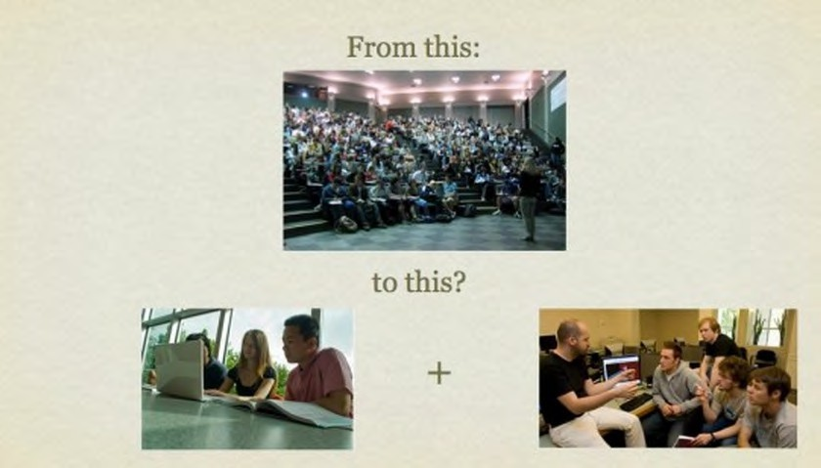](http://opentextbc.ca/teachinginadigitalage/wp-content/uploads/sites/29/2015/02/Changing-teaching-methods-2.jpg)

* + 1. *How do I want to teach?*

*Image: Remix © by Tony Bates, 2010: original photos: UBC Library*

Of all the nine steps, this is the most important, and, for most teachers and instructors, the most challenging, as it may mean changing long established patterns of behaviour, or challenging established school curricula.

#### How would I really like to teach this course?

This question asks you to consider your basic teaching philosophy. What is my role as

a teacher or instructor? Do I take an objectivist view, that knowledge is finite and defined, that I am an expert in the subject matter who knows more than the students, and thus my job is to ensure that I transfer as effectively as possible that information or knowledge to the student? Or do I see learning as individual development where my role is to help learners to acquire the ability to question, analyse and apply information or knowledge?

Do I see myself more as a guide or facilitator of learning for students? Or maybe you would like to teach in the latter way, but you are faced in classroom teaching with a class of 200 students which forces you to fall back on a more didactic form of teaching. Or maybe you would like to combine both approaches but can’t because of the restrictions of timetables and curriculum.

Chapters 2, 3 and 4 set out some of the choices available to you in deciding how you want to teach, in terms of overall philosophy.

#### What’s wrong with the way I’m teaching at the moment?

Another place to start would be by thinking about what you don’t like about the current course(s) you are teaching. Is there too much content to be covered? Could you deal with this in another way, perhaps by getting students to find, analyse and apply content to solve problems or do research? Could you focus more on skills in this context? If so, how could you provide appropriate activities to enable students to practice these skills? How much of this could they do on their own, so you can manage your workload better?

Are the students too diverse, in that some students really struggle while others are impatient to move ahead? How could I make the teaching more personalised, so that students at all levels of ability could succeed in this course? Could I organise my teaching so that students who struggle can spend more time on task, or those that are racing ahead have more advanced work to do?

Or perhaps you are not getting enough discussion or critical thinking because the class is too large. Could you use technology and re-organise the class differently to get students studying in small groups, but in such a way you can monitor and guide the discussions? Can you break the work up into chunks that the students should be able to do on

their own, such as mastering the content, so you can focus on discussion and critical thinking with students when they come to class?

For instance, by moving a great deal of the content online, maybe you can free up more time for interaction with students, in large or smaller groups, either in class or online, and at the same time reduce the number of lectures to large classes. Some instructors have redesigned large lecture classes of 200 students, by breaking down the class into 10 groups, moving much of the lecture material online, and then the instructor spends at least one week with each of the 10 groups in online discussion, interaction and group activities, thus getting more interaction with all the students.

In another context, do you feel restricted by the limitations of what can be done in labs or workshops, because of the time it takes to set up experiments or equipment, or because students don’t really have enough hands-on time? Could I re-organise the teaching so that students do a lot of preparation online, so they can concentrate in the lab or workshop on what they have to do by hand? Could they report on their lab or workshop experiences afterwards, online, through an e-portfolio, for instance? Can I find good open educational resources, such as video or simulations, that would reduce the need for lab time? Or could I create good quality demonstration videos, so I can spend more time talking with students about the implications?

Finally, are you just overloaded with work on this course, because there are too many student questions to be answered, or too many assignments to mark? How could you re- organise the course to manage your work-load more easily? Could students do more by working together and helping each other? if so, how would you create groups that might meet this goal? Could you change the nature of the assignments so that students do more project work, and slowly build e-portfolios of their work during the course so you can more easily monitor their progress, while at the same time building up an assessment of their learning?

#### Use technology to re-think your teaching

Considering using new technologies or an alternative delivery method will give you an opportunity to rethink your teaching, perhaps to be able to tackle some of the limitations of classroom teaching, and to renew your approach to teaching. One way to help you

rethink how you want to teach is to think of how you could build a rich learning environment for the course (see Chapter 6).

Using technology or moving part or all of your course online opens up a range of possibilities for teaching that may not be possible in the confines of a school timetable or scheduled three credit weekly semester of lectures (see Chapter 4). It may mean not doing everything online, but focusing the campus experience on what can only be done on campus. Alternatively, it may enable you to totally rethink the curriculum, to exploit some of the benefits of online learning, such as getting students to find, analyse and apply information for themselves.

Thus if you are thinking about a new course, or redesigning one that you are not too happy with, take the opportunity before you start teaching the course or program to think about how you’d really like to be teaching, and whether this can be accommodated in a different learning environment. It’s not a decision you have to make immediately though. As you work through the nine steps, it will become easier to make this decision. The important point is to be open to doing things differently.

Chapter 4 and Chapters 11 and 12 suggest a variety of approaches to teaching that might fit with the answers to some of these questions.

#### What NOT to do

However, you can be sure of one thing. If you merely put your lecture notes up on the web, or record your 50 minute lectures for downloading, then you are almost certain to have lower student completion rates and poorer grades than for your face-to-face class. I make this point because it is tempting for face-to-face teachers or instructors merely to move their method of classroom teaching online, such as using lecture capture for students to download recorded classroom lectures at home, or using web conferencing to deliver live lectures over the internet. However there is much evidence to suggest that doing this does not lead to good results (see for instance, Figlio, Rush and Yin, [2010](https://pdfs.semanticscholar.org/884c/d264563c139045959db4ab12d228bd6825c9.pdf)).

The problem with just moving a face-to-face class online is that it fails to take account of a key requirement for most online learners: flexibility. When students are studying online, their needs are different from when they are in class. Restricted ‘office hours’

when the instructor is available for students do not provide the flexibility of contact that students need when working online. Students tend to work in smaller chunks of time when studying online, in several short bursts, and rarely more than an hour without a break. Online work then needs to be broken up into manageable ‘chunks.’ A synchronous web cast may be scheduled at times when online students are working. End-to-end synchronous classes lead to screen fatigue, as became evident during the Covid-19 pandemic. More importantly, online learning allows us to deliver content or information in ways that lead to better learning than through a one hour face-to-face class.

Thus it is important to *design* teaching in such a way that it best suits the different modes of learning that students will use. Fortunately, there has been a lot of experience and research that have identified the key design principles for both classroom and online teaching. This is what the next eight steps are about.

#### A chance to fly

Technologies and new modes of delivery open up wonderful opportunities to rethink completely the teaching process. Teachers and instructors with deep knowledge of their subject can now find many unique and exciting ways to open up their teaching and to integrate their research into their teaching. The main restriction now is not time nor money, but lack of imagination. Those with the imagination will be able to fly into previously unthinkable ways of teaching their subject.

#### Reference

Figlio, D., Rush, N. and Yin, L. (2010) [*Is it Live or is it Internet? Experimental Estimates of*](https://pdfs.semanticscholar.org/884c/d264563c139045959db4ab12d228bd6825c9.pdf)[*the Effects of Online Instruction on Student Learning*](https://pdfs.semanticscholar.org/884c/d264563c139045959db4ab12d228bd6825c9.pdf)Cambridge MA: National Bureau of Economic Research

1. Can you write down your philosophy of teaching – how you’d really like to teach your subject, if you weren’t constrained?
2. What are the main problems you are facing at the moment with your classroom teaching?
3. Now think whether, by moving a course online, you could teach in new ways that better fit your philosophy of teaching, with the increased flexibility of access and the resources available through the Internet. What would your teaching approach now look like?

There is no feedback provided for this activity: it is for your reflection.

*Activity 13.3 Re-thinking your teaching*

# Step two: what kind of course or program?

[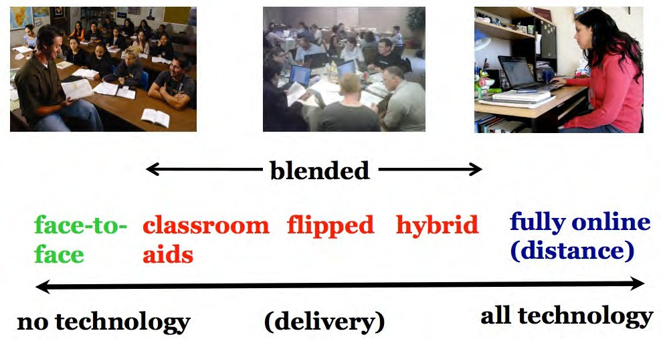](http://opentextbc.ca/teachinginadigitalage/wp-content/uploads/sites/29/2015/01/Continuum-of-technology-based-teaching-2.jpg)

*Figure 13.4.1 The continuum of technology-based teaching ( from Chapter 11)*

#### Choosing mode of delivery

Determining what kind of course in terms of the mix of face-to-face and online teaching is the natural next step after considering how you want to teach a course. This topic has been dealt with extensively in Chapter 11, so to summarise, there are four factors or variables to take into account when deciding what ‘mix’ of face-to-face and online learning will be best for your course:

* your preferred teaching philosophy – how you like to teach (see Step 1)
* the needs of the students (or potential students)
* the demands of the discipline
* the resources available to you.

Although an analysis of all the factors is an essential set of steps to take in making this decision, in the end it will come down to a mainly intuitive decision, taking into account all the factors. This becomes particularly important when looking at a program as a whole, rather than on an individual course basis.

#### Who should make the decision?

While individual instructors should be heavily involved in deciding the best mix of online and face-to-face teaching in their specific course, it is worth thinking about this on a program rather than an individual course basis. For instance, if we see the development of independent learning skills as a key program outcome, then it might make sense to start in the first year with mainly face-to-face classes, but gradually over the length of the program introduce students to more and more online learning, so that the end of a four year degree they are able and willing to take some of their courses fully online.

Certainly every program should have a mechanism for deciding not only the content and skills or the curriculum to be covered in a program, but also how the program will be delivered, and hence the balance or mix of online and face-to-face teaching throughout the program. This should become integrated into an annual academic planning process that looks at both methods of teaching as well as content to be covered in the program (see Bates and Sangrà, [2011](https://www.wiley.com/en-ca/Managing%2BTechnology%2Bin%2BHigher%2BEducation%3A%2BStrategies%2Bfor%2BTransforming%2BTeaching%2Band%2BLearning-p-9780470584729)).

#### Reference

Bates, A. and Sangrà, A. (2011) [*Managing Technology in Higher Education*](https://www.wiley.com/en-ca/Managing%2BTechnology%2Bin%2BHigher%2BEducation%3A%2BStrategies%2Bfor%2BTransforming%2BTeaching%2Band%2BLearning-p-9780470584729)San Francisco: Jossey-Bass/John Wiley and Co

If you did not do Activities 11.2, 11.3, 11.4, go back and do them now.

If you have done these activities, review your answers in terms of deciding on the best mix of face-to-face and online teaching for your course.

There is no feedback provided for this activity.

*Activity 13.4 Which mode of delivery?*

# Step three: work in a team

[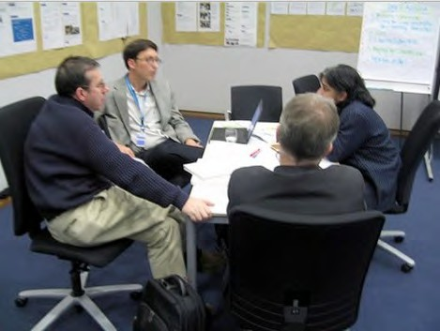](http://opentextbc.ca/teachinginadigitalage/wp-content/uploads/sites/29/2015/02/Course-team-2.jpg)

*Figure 13.5.1 Work in a team*

One of the strongest means of ensuring quality is to work as a team. This is addressed at several points in the book, such as Chapter 10, Section 7, Chapter 11, Section 4, and Chapter 14, Sections 3 and 5.

#### Why work in a team?

For many teachers and instructors, classroom teaching is an individual, largely private activity between the teacher/instructor and students. Teaching is a very personal affair. However, blended and especially fully online learning are different from classroom teaching. They require a range of skills that most teachers and instructors, and particularly those new to online teaching, are unlikely to have, at a least in a developed, ready-to-use form.

The way a teacher or instructor interacts online has to be organized differently from in class, and particular attention has to be paid to providing appropriate online activities for students, and to structuring content in ways that facilitate learning in an asynchronous online environment. Good course design is essential to achieve quality in terms of developing the knowledge and skills needed in a digital age. These are pedagogical issues, in which most post-secondary instructors have had little training. In addition, there are also technology issues. Novice teachers and instructors are likely to need help in developing graphics or video materials, for example.

Another reason to work in a team is to manage workload. There is a range of technological activities that are not normally required of classroom teachers and instructors. Just managing the technology will be extra work if instructors do it all themselves. Also, if the online component of a course is not well designed or integrated with the face-to-face component, if students are not clear what they should do, or if the material is presented in ways that are difficult to understand, the teacher or instructor will be overwhelmed with student e-mail or phone calls. Instructional designers, who work across different courses, and who have training in both course design and technology, can be an invaluable resource for novices teaching online for the first time.

Thirdly working with colleagues in the same department who are more experienced in online learning can be a very good means to get quickly to a high quality online standard, and again can save time. For instance, in one university I worked in, three faculty members in the same department were developing different courses with online components. However, these courses often needed graphics of the same equipment discussed in all three courses. The three instructors got together, and worked with a graphic designer to create high quality graphics that were shared between all three instructors. This also resulted in discussions about overlap and how best to make sure there was better

integration and consistency between the three courses. They could do this with their online courses more easily than with the classroom courses, because the online course materials can be more easily shared and observed.

Lastly, especially where large lecture classes are being re-designed, there may be a cohort of teaching assistants that may need to be trained, organised and managed. In some institutions, part-time adjunct faculty will also need to be involved. This means clarifying roles for the senior faculty member, the adjunct or contract faculty, the teaching assistants, and the learning technology support staff.

For many teachers and instructors, developing teaching in a team is a big cultural shift. However, the benefits of doing this for online or blended learning are well worth the effort. As teachers and instructors become more experienced in blended and online learning, there is less need for the help of an instructional designer, but many experienced instructors now prefer to continue working in a team, because it makes life so much easier for them.

#### Who is in the team?

This will depend to some extent on the size of the course. In most cases, for a blended or online course with one main faculty member or subject expert, and a manageable number of students, the instructor will normally work with an instructional designer, who in turn can call on more specialist staff, such as a web or graphic designer or a media producer, as needed.

If however it is a course with many students and several instructors, adjunct faculty and/ or teaching assistants, then they should all work together as a team, with the instructional designer. Also in some institutions a librarian is an important member of the team, helping identify resources, dealing with copyright issues and ensuring that the library is able to respond to learners’ needs when the course is being offered.

In a school, such help is likely to be more centralised and shared across schools – or may not exist at all. Some school boards now have a separate department or ‘online school’ for fully online courses. If possible, though, especially when re-designing a course for the

first time, a teacher will benefit from reaching out for support from such specialists, if it is available.

#### What about academic freedom? Do I lose it working in a team?

No. The instructor(s) will always have final say over content and how it is to be taught. Instructional designers are advisers but responsibility for the content of the course, the way it is taught, and assessment methods always remains with the faculty member.

However, instructional and media producers should not be treated as servants, but as professionals with specialized skills. They should be respected and listened to. Often the instructional designer will have more experience of what will work and what will not in blended or online learning. Surgeons work with anaesthetists and nurses, and trust them to do their jobs properly. The working relationship between instructors and instructional designers and media producers should be similar.

#### Conclusion

Working in a team makes life a lot easier for instructors when teaching blended or online courses. Good course design, which is the area of expertise of the instructional designer, not only enables students to learn better but also controls teacher and faculty workload. Courses look better with good graphic and web design and professional video production. Specialist technical help frees up instructors to concentrate on teaching and learning. What’s not to like?

This of course will depend heavily on the institution providing such support through a centre of teaching and learning. Nevertheless setting up an appropriate team is an important decision that needs to be implemented before course design begins.

There is no activity for this section.

*Activity 13.5 Working in a team*

# Step four: build on existing resources

[](https://www.youtube.com/watch?v=pcVbnhwn9Jw&ab_channel=AllAboutCircuits)

*Figure 13.6.1 Radiating charge simulation, phET: click on image to run simulation Image: © University of Colorado-Boulder*

The importance of using existing resources has been stressed in several parts of the book, particularly Chapters 8 and 12.

#### Moving content online

Time management for teachers and instructors is critical. A great deal of time can be spent converting classroom material into a form that will work in an online environment, but this can really increase workload. For instance, PowerPoint slides without a commentary often either miss the critical content, or fail to cover nuances and emphasis. This may mean either using lecture capture to record the lecture, or having to add a recorded commentary over the slides at a later date. Transferring lecture notes into pdf files and loading them up into a learning management system is also time consuming. However, this is not the best way to develop online materials, both for time management and pedagogical reasons.

In Step 1 I recommended rethinking teaching, not just moving recorded lectures or class PowerPoint slides online, but developing materials in ways that enable students to learn better. Now in Step 4 I appear to be contradicting that by suggesting that you should use existing resources. However, the distinction here is between using existing resources that do not transfer well to an online learning environment (such as a 50 minute recorded lecture), and using materials already specifically developed or suitable for learning in an online environment.

#### Use existing online content

The Internet, and in particular the World Wide Web, has an immense amount of content already available, and this was discussed extensively in Chapter 11. Much of it is freely available for educational use, under certain conditions (e.g. acknowledgement of the source – look for the Creative Commons license usually at the end of the web page). You will find such existing content varies enormously in quality and range. Top universities such as MIT, Stanford, Princeton and Yale have made available recordings of their classroom lectures , etc., while distance teaching organizations such as the UK Open University have made all their online teaching materials available for free use. Much of this can be found at these sites:

* [OpenCourseWare](http://ocw.mit.edu/index.htm) (MIT)
* [iTunesU](https://itunes.apple.com/ca/genre/itunes-u/id40000000?mt=10)
* [OpenLearn](http://www.open.edu/openlearn/) (U.K. Open University)
* [The Open Education Consortium](http://www.oeconsortium.org/) (courses in STEM: science, technology, engineering, math)
* [Open Learning Initiative](http://oli.cmu.edu/courses/) (Carnegie Mellon)
* [MERLOT](https://www.merlot.org/merlot/)

However, there are now many other sites from prestigious universities offering open course ware. (A Google search using ‘open educational resources’ or’ OER’ will identify most of them.)

In the case of the prestigious universities, you can be sure about the quality of the content – it’s usually what the on-campus students get – but it often lacks the quality needed in terms of instructional design or suitability for online learning (for more discussion on this see Hampson ([2015](https://medium.com/synapse/masterclass-moocs-notes-on-the-role-of-production-value-in-online-learning-bfc5b1914034)); or [OERs: The Good, the Bad and the Ugly](http://www.tonybates.ca/2011/02/06/oers-the-good-the-bad-and-the-ugly/)). Open resources from institutions such as the UK Open University or Carnegie Mellon’s Open Learn Initiative usually combine quality content with good instructional design.

Where open educational resources are particularly valuable are in their use as interactive simulations, animations or videos that would be difficult or too expensive for an individual instructor to develop. Examples of simulations in science subjects such as biology and physics can be found here: [PhET](http://phet.colorado.edu/en/simulations/category/new), or at the [Khan Academy](http://phet.colorado.edu/en/simulations/category/new) for mathematics, but there are many other sources as well.

However, as well as open resources designated as ‘educational’, there is a great deal of ‘raw’ content on the Internet that can be invaluable for teaching. The main question is whether you as the instructor need to find such material, or whether it would be better to get students to search, find, select, analyze, evaluate and apply information. After all, these are key skills for a digital age that students need to have.

Certainly at k-12, two-year college or undergraduate level, most content is not unique or original. Most of the time we are standing on the shoulders of giants, that is, organizing and managing knowledge already discovered. Only in the areas where you have unique, original research that is not yet published, or where you have your own ‘spin’ on content, is it really necessary to create ‘content’ from scratch. Unfortunately, though, it can still be difficult to find exactly the material you want, at least in a form that would be appropriate for your students. In such cases, then it will be necessary to develop your own materials,

and this is discussed further in Step 7. However, building a course around already existing materials will make a lot of sense in many contexts.

#### Conclusion

You have a choice of focusing on content development or on facilitating learning. As time goes on, more and more of the content within your courses will be freely available from other sources over the Internet. This is an opportunity to focus on what students need to know, and on how they can find, evaluate and apply it. These are skills that will continue well beyond the memorisation of content that students gain from a particular course. So it is important to focus just as much on student activities, what they need to do, as on creating original content for our courses. This is discussed in more detail in Steps 6, 7 and 8.

So a critical step before even beginning to teach a course is look around and see what’s available and how this could potentially be used in the course or program you are planning to teach.

#### References

Hampson, K. (2015) [Masterclass & MOOCs: Notes on the Role of Production Value in](https://medium.com/synapse/masterclass-moocs-notes-on-the-role-of-production-value-in-online-learning-bfc5b1914034) [Online Learning](https://medium.com/synapse/masterclass-moocs-notes-on-the-role-of-production-value-in-online-learning-bfc5b1914034) *The Synapse*, July 31

1. How original is the content you are teaching? Could students learn just as well from already existing content? If not, what is the ‘extra’ you are adding? How will you incorporate the added value of your own contribution in your course design?
2. Does the content you are already thinking of covering already exist on the web? Have you looked to see what’s already there? What if any are the restrictions on its re-use for educational purposes?
3. What are your colleagues doing online – or indeed in the classroom, with respect to digital teaching? Could you work together to jointly develop and/or share materials?

*Activity 13.6 Building on existing resources*

If you feel that your course is currently too much work, then maybe the answers to these questions may indicate where the problem lies.

There is no feedback provided for this activity.

# Step five: master the technology

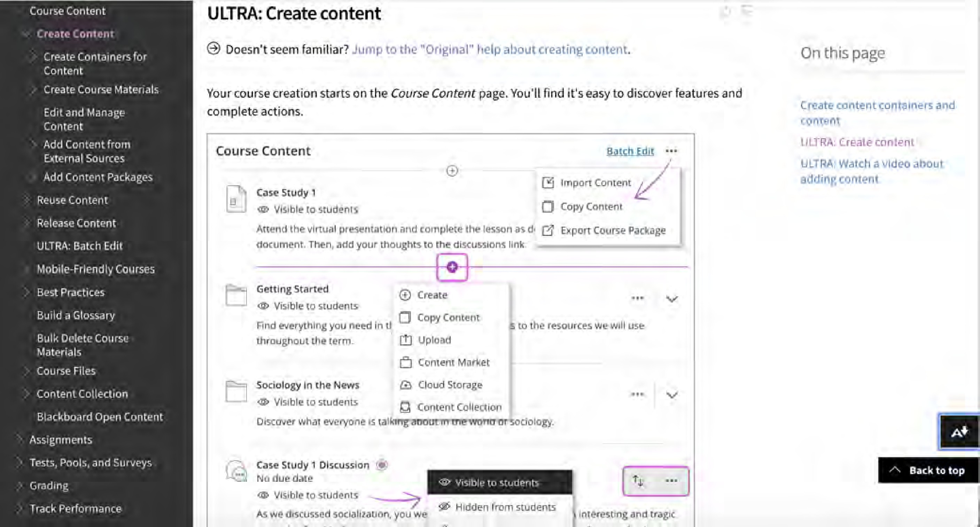

*Figure 13.7.1 A ‘help’ page from Blackboard Learn*

Taking the time to be properly trained in how to use standard learning technologies will in the long run save you a good deal of time and will enable you to achieve a much wider range of educational goals than you would otherwise have imagined.

#### The exponential growth in learning technologies

There are now many common technologies available for educational use:

* learning managements systems (such as [Blackboard Learn](https://www.blackboard.com/blackboard-learn/index.html), [Moodle](https://moodle.org/), [Brightspace/D2L](https://www.d2l.com/), [Instructure/Canvas](https://www.instructure.com/canvas/?newhome=canvas));
* synchronous technologies (such as [Blackboard Collaborate](https://www.blackboard.com/online-collaborative-learning/blackboard-collaborate.html), [Adobe Connect](https://www.adobe.com/products/adobeconnect.html), [Big Blue](https://bigbluebutton.org/)

[Button,](https://bigbluebutton.org/) [ZOOM,](https://zoom.us/zoomrooms/?zcid=1173&creative=377971278716&keyword=zoom&matchtype=e&network=g&device=c&gclid=EAIaIQobChMIgOL_qNX55AIVkrfsCh03IAO1EAAYASAAEgKTE_D_BwE) [GoToMeeting](https://www.gotomeeting.com/en-ca), [Microsoft Team](https://products.office.com/en-ca/microsoft-teams/group-chat-software)s);

* lecture recording technologies (such as [GarageBand](https://www.apple.com/ca/mac/garageband/) or [Audacity](https://www.audacityteam.org/) for podcasts and [Echo360](https://echo360.com/lecturecapture/) for lecture capture);
* tablets and mobile devices, such as iPads, mobile phones, and the apps that run on them;
* MOOCs and their many variants (SPOCs, TOOCs, etc.);
* other social media, including blogging software such as [WordPress](https://wordpress.com/create/?sgmt=gb&utm_source=google&utm_campaign=google_wpcom_search_brand_desktop_ca_en&utm_medium=paid_search&keyword=wordpress&creative=353006544959&campaignid=647897994&adgroupid=52795498939&matchtype=e&device=c&network=g&cpn=647897994&device=c&pl&targetid=kwd-313411415&locationid=9001554&gclid=EAIaIQobChMIhMjkyNf55AIVdx-tBh2R4Q70EAAYASAAEgK93PD_BwE&gclsrc=aw.ds), wikis such as [MediaWik](https://www.mediawiki.org/wiki/MediaWiki)i, [Google Docs](https://www.google.com/docs/about/), and [Twitter](https://twitter.com/Twitter?ref_src=twsrc%5Egoogle%7Ctwcamp%5Eserp%7Ctwgr%5Eauthor);
* learner-generated tools, such as e-portfolios (for example, [Mahara](https://mahara.org/))
* search engines and translation tools, such as Google Search and Google Translate.

It is not necessary to use all or any of these tools, but if you do decide to use them, you need to know not only how to operate such such technologies well, but also their pedagogical strengths and weaknesses (see Chapter 7, Chapter 8 and Chapter 9). Although the technologies listed above will change over time, the general principles discussed in this section will continue to apply to other new technologies as they become available.

#### Use the existing institutional technology

If your school system or institution already has a learning management system such as Blackboard Learn, Moodle, Instructure, or Brightspace, use it. Don’t get drawn into arguments about whether or not it is the best tool. Frankly, in functional terms, there are few important differences between the main LMSs. You may prefer the interface of one rather than another, but this will be more than overwhelmed by the amount of effort trying to use a system not supported by your institution. LMSs are not perfect but they have evolved over the last 20 years and in general are relatively easy to use, both by you and more importantly by the students. They provide a useful framework for organizing your online teaching, and if the LMS is properly supported you can get help when needed. There is enough flexibility in a learning management system to allow you to teach in a variety of different ways. In particular, take the time to be properly trained in how to use the LMS. A couple of hours of training can save you many hours in trying to get it to work the way you want.

A more important question to consider is whether you need to use an LMS at all – but

that question should only be considered if the institution is willing to support alternatives, such as WordPress or Google Docs, otherwise you could end up spending too much time dealing with pure technology issues.

The same applies to synchronous web technologies such as Blackboard Collaborate, Adobe Connect, Big Blue Button or ZOOM. I have my preferences but they all do more or less the same thing. The differences in technology are nothing compared with the different ways in which you can use these tools. These are pedagogical or teaching decisions. Focus on these rather than finding the perfect technology.

Indeed, think carefully about when it would be best to use synchronous rather than asynchronous online tools. Synchronous tools are useful when you want to get a group of students together at one time, but such synchronous tools tend to be instructor- dominated (delivering lectures and controlling the discussion) and require students to be available at a set time. However, you could encourage students working in small teams on a project to use Collaborate or another synchronous tool such as ZOOM, which allows for setting up small sub-groups, to decide roles, discuss a topic and form a group view, or to finalize a project assignment, for instance. On the other hand, asynchronous tools such as an LMS provide learners with more flexibility than synchronous tools, and enable them to work more independently (an important skill for students to develop). And of course both synchronous and asynchronous tools can be used in conjunction, but that requires working out what each is best for.

#### Deceptively easy technology

Most of these technologies are deceptively easy to use, in the sense of getting started. They have been designed so that anyone without a computer science background can use them. However, over time they tend to become more sophisticated with a wide range of different functions. You won’t need to use all the functions, but it will help if you are aware that they exist, and what they can and can’t do. If you do want to use a particular feature, it is best to get training so that you can use it quickly and effectively.

#### Keep current, as far as possible

New technologies keep arriving all the time. It is best to focus on new tools that seem functionally different from existing tools, rather than trying to check every new synchronous meeting system, for instance. It is too difficult for any single teacher or instructor to keep up to date with newly emerging technologies and their possible relevance for teaching. This is really the job of any well-run learning technology support unit. So make the effort to attend a once-a-year briefing on new technologies, then follow-up with a further session on any tool that might be of interest.

This kind of briefing and training should be provided by the centre or unit that provides learning technology support. If your institution does not have such a unit, or such training, think very carefully about whether to use technology extensively in your teaching – even teachers and instructors with a lot of experience in using technology for teaching need such support.

Furthermore, new functions are constantly being added to existing tools. For instance, if you are using Moodle, there are ‘plug-ins’ (such as Mahara) that allow students to create and manage their own e-portfolios or electronic records of their work. Learning analytics software for LMSs, which allow you to analyze the way students are using the LMS and how this relates to their performance, is another recent wave of plug-ins.

Thus a session spent learning the various features of your learning management system and how best to use them will be well worthwhile, even if you have been using it for some time, but didn’t have a full training on the system. Particularly important is knowing how to integrate different technologies, such as online videos within an LMS, so that the technology appears seamless to students.

Lastly, don’t get locked into using only your favourite technology, and keeping a closed mind against anything else. It is is a natural tendency to try to protect the use of a technology that has taken a good deal of time and effort to master, especially if it has served you and your students well in the past, and new technology is not necessarily better for teaching than old technology. Nevertheless, game-changers do come along occasionally, and may well have educational benefits that were not previously considered. One tool is unlikely to do everything you need as a teacher; a well-chosen mix of tools is likely to be more effective. Keep an open mind and be prepared to make a shift if necessary.

#### Relate your technology training to how you want to teach

There are really two distinct but strongly related components of using technology:

* how the technology works; and
* what it should be used for.

##### Focus on the learning outcomes

The tools described in this section are designed to assist you, so you have to be clear as to what you are trying to achieve with the tools. This is an instructional or pedagogical issue. Thus if you want to find ways to engage students, or to give them practice in developing skills, such as solving quadratic equations, learn what the strengths or weaknesses are of the various technologies for doing this (see Chapter 7, Chapter 8 and Chapter 10 for more on this).

This is somewhat of an iterative process. When a new tool or a new feature is being described or demonstrated, think of how this might fit with or facilitate one of your teaching goals. But also be open to possibly changing your goals or methods to take advantage of a tool in enabling you to do something you had not thought of doing before. For example, an e-portfolio plug-in might lead you to change the way you assess students, so that learning outcomes are more ‘authentic’ and evidence-based than say with a written essay. (This will be discussed further in the next step ‘Setting appropriate goals for learning.’)

##### Avoid duplicating your classroom teaching

Podcasts and lecture capture enable lectures to be recorded, stored and downloaded by students. So why bother to learn how to use other online technologies such as an LMS? In Chapter 3, Section 3, evidence-based research on the limitations of lectures was discussed. In brief, students in general don’t learn well online using recordings of ‘transmissive’ classroom lectures. Perhaps of equal importance, you are likely to end up

doing more work because you are likely to be inundated with individual e-mails asking for clarification, or have a very high student failure rate, if you do not adapt the lecture to the online learning environment.

This is not to say that the occasional recording from you as the instructor would not be valuable. However, it is best to keep it to 10-15 minutes maximum, and it should add something unique to the course, such as being about your own research, or a guest professor being interviewed, or your relating a news item to issues or principles being studied in the course. It may even be better as an audio-only podcast, so students can concentrate on the words and possibly relate them to other learning materials, such as diagrams, graphics or animations on a web site.

If you must use lecture capture, think about structuring your in-class lecture so that it can be edited into separate sections of say 10-15 minutes. One way of doing this is pausing at an appropriate point to ask for questions from the classroom students, thus providing a clear ‘editing’ point for the video version. Then provide online work to follow up each of the recorded components, such as a topic for discussion on an online forum, some online student research or further reading on the topic.

However, in general, delivery of content is much better done through a learning management system, where it is permanent, organized and structured (see Step 7 later), available in discrete amounts, can be accessed at any time, and can be repeated as often as is needed by the learner. Or it may be even better to get students to find, analyse and organise content for themselves, in which case you may need tools other than an LMS, such as blog software such as WordPress, an e-portfolio or wiki. Again, the decision should be driven by pedagogical thinking, rather than trying to make one tool fit every circumstance.

#### Benefits of mastering the technology

Online learning technologies such as learning management systems have been designed to fit the online learning environment. This requires some adjustment and learning on the part of teachers and instructors whose primary experience is in classroom teaching.

Like any tool, the more you know about it the better you are likely to use it. Thus formal

training on the technology is necessary but need not be onerous. Usually a total of two hours specific and well organized instruction should be sufficient on how to use any particular tool, such as a learning management or lecture capture system, e-portfolio or synchronous webinar tool, with a one hour review session every year.

The harder part will be figuring out how best to use the tools educationally. This requires you to bring a clear conception of how students best learn (Chapter 2 and Chapter 6), what methods you need to match how students learn (Chapter 3 and Chapter 4), and how to design such teaching through the use of learning technologies (Chapter 7, Chapter 8 and Chapter 10). Whenever you receive training on a new tool, try to apply what you have learned in these chapters to how you may be able best to use that tool in the future.

1. How much formal training have you had on your institutional learning management, lecture capture systems or video conferencing/synchronous technologies? Is this enough or are you now fully confident that you know all the features and how best to use them?
2. When should you use a synchronous technology such as Zoom? What are the disadvantages of synchronous technologies for online students? (See Chapter 7.4 for more on this).
3. Should you rethink entirely your teaching when considering blended learning or could you use mainly your classroom material?
4. What would be the possible disadvantages of using recorded lectures online?

There is no feedback provided for this activity. The answers are in the chapters highlighted in this section.

*Activity 13.7 Mastering the technology*

# Step six: set appropriate learning goals

[](http://opentextbc.ca/teachinginadigitalage/wp-content/uploads/sites/29/2015/02/Goalposts-2.jpg)

*Figure 13.8.1 Set appropriate learning goals Image: ©* [*www.geograph.ie*](http://www.geograph.ie/)

#### Setting goals for learning in a digital age

In many school systems, curriculum and learning goals are already pre-determined by national, state or provincial curriculum committees and/or ministries of education. In many trades and vocational areas, industry training boards or employers’ associations set learning goals or desired outcomes or competencies that need to be followed for qualifications to be accredited. Even in a university, an instructor (particularly a contract instructor or adjunct) may ‘inherit’ a course where the goals are already set, either by a previous instructor or by the academic department.

Nevertheless, there remain many contexts where teachers and instructors have a degree

of control over the goals of a particular course or program. In particular, a new course or program – such as an online masters program aimed at working professionals – offers an opportunity to reconsider desired learning outcomes and goals. Especially where curriculum is framed mainly in terms of content to be covered rather than by skills to be developed, there may still be room for manoeuvre in setting learning goals that would also include, for instance, intellectual skills development. In other contexts, the development or focus may be on more affective skills, such as sympathy or empathy, or on the development of manual or operational skills.

#### Learning goals for a digital age

In Chapter 1, Section 2, I listed a number of skills that learners will need in a digital age, including:

* modern communication skills;
* independent learning;
* ethics and responsibility;
* teamwork and flexibility;
* thinking skills including:
  + critical thinking;
  + problem solving;
  + creative thinking;
  + strategising and planning;
* digital skills;
* knowledge management.

These are examples of the kinds of goal that need to be identified. More traditional goals might also be included, such as comprehension and application of specific areas of content. These goals or outcomes might be expressed in terms of Bloom’s taxonomy ([1956](https://link.springer.com/referenceworkentry/10.1007/978-1-4419-1428-6_141)) or the Royal Bank of Canada’s ([2018](https://www.rbc.com/dms/enterprise/futurelaunch/_assets-custom/pdf/RBC-Future-Skills-Report-FINAL-Singles.pdf)) or in a variety of other ways. All these skills need to be embedded or built within the needs of a specific subject domain. In other words, they are skills that need to be specific to a subject area rather than general. At the same time, students who develop such skills within any particular subject area will be better prepared for a digital age.

Your list of goals for a course may – indeed, should be – different from mine, but it will be essential to do the kind of analysis recommended in Step 1 (deciding how you want to teach), and then to decide on what the learning goals should be, based on:

* your understanding of the needs of the students;
* the needs of the the subject domain;
* the demands of the external world.

I have placed a particular emphasis on the development of intellectual skills. As with all learning goals, the teaching needs to be designed in such a way that students have opportunities to learn and practice such skills, and in particular, such skills need to be evaluated as part of the formal assessment process. Perhaps more challenging is to identify what you will be adding to general skills development such as critical thinking. What is the level of critical thinking skills that students will come with, and how do I make sure they progress in their ability in this skill during the course? This emphasises the value of having learning outcomes clearly identified for a whole program, perhaps using a curriculum mapping tool such as [Daedalus](https://teachonline.ca/pockets-innovation/daedalus-online-curriculum-mapping-tool-dalhousie-university-nova-scotia-canada).

What this means in terms of course design is using the Internet increasingly as a major resource for learning, giving students more responsibility for finding and evaluating information themselves, and instructors providing criteria and guidelines for finding, evaluating, analysing and applying information within a specific knowledge domain. This will require a critical approach to online searches, online data, news or knowledge generation in specific knowledge domains – in other words the development of critical thinking about the Internet and modern media – both their potential and limitations within a specific subject domain.

#### Bring in the outside world

One great characteristic of modern media is the opportunity to bring in the world to your teaching in many ways, for instance:

* by directing students to online sites, and encouraging them to identify and share relevant sites;
* students themselves can collect data or provide real world examples of concepts or

issues covered in the course, through the use of cameras in mobile phones, or audio interviews of local experts, or identifying relevant open educational resources;

* setting up a course wiki that both you and the students contribute to, and make it open to other professors and students to contribute to, depending on the topic;
* if you are teaching professional masters or diploma programs, or MOOCs, the students themselves will have very relevant world experiences that can be drawn into the program. This is a great way to enable students to evaluate and apply knowledge within their subject domain.

There are many other possible goals that are either impossible to meet without using the Internet, or would be very difficult to do in a purely classroom environment. The art of the instructor is to decide which are relevant, and which in particular could be key learning goals for the course.

[](http://opentextbc.ca/teachinginadigitalage/wp-content/uploads/sites/29/2015/04/Arab-Spring-4.jpg)

*Figure 13.8.2 Using social media during the Arab Spring in Egypt, 2011*

#### Learning goals: the same or different, depending on mode of delivery?

In many cases, it will be appropriate (indeed, essential) to keep the same teaching goals for an online course as in a similar face-to-face course. Many dual-mode institutions, campus-based institutions who also offer credit courses online, such as the University of British Columbia, Penn State, University of Nebraska, offer the same courses both face- to-face and online, particularly in the fourth year of an undergraduate program. Usually the transcript of the exam grade makes no distinction as to whether the course was done online or face-to-face, since the students take the same end of course exam, and the actual content covered is usually identical in each version.

Nevertheless, there may be occasions where some goals in the campus-based class may need to be sacrificed for different but equally valuable goals that can be achieved better online. It is also important to remember that although it may be possible to achieve the same goals online as in class, the design of the teaching will likely have to be different in the online environment. Thus often the goals remain the same, but the method changes. This will be discussed further in Steps 7 and 8. The important point is to be aware that some things can be more easily done in a campus environment, and others better done online, then to build your teaching around these somewhat different goals. Using a blended approach may enable you to widen the range of goals, but be careful not to overload students by doing this.

#### Assessment is the key

It is pointless to introduce new learning goals or outcomes then not assess how well students have achieved those goals. Assessment drives student behaviour. If they are not to be assessed on the skills outlined above, they won’t make the effort to develop them. The main challenge may not be in setting appropriate goals for online learning, but ensuring that you have the tools and means to assess whether students have achieved those goals.

And even more importantly, it is necessary to communicate very clearly to students these

new learning goals and how they will be assessed. This may come as a shock to many students who are used to being fed content then tested on their memory of it.

#### Conclusion

In some ways, with the Internet (as with other media), the medium is the message. Knowledge is not completely neutral. What we know and how we know it are affected by the medium through which we acquire knowledge. Each medium brings another way of knowing. We can either fight the medium, and try to force old content into new bottles, or we can shape the content to the form of the medium. Because the Internet is such a large force in our lives, we need to be sure that we are making the most of its potential in our teaching, even if that means changing somewhat what and how we teach. If we do that, our students are much more likely to be better prepared for a digital age.

#### Reference

Bloom, B. S.; Engelhart, M. D.; Furst, E. J.; Hill, W. H.; Krathwohl, D. R[.](http://en.wikipedia.org/wiki/David_Krathwohl) (1956). [*Taxonomy*](https://link.springer.com/referenceworkentry/10.1007/978-1-4419-1428-6_141)[*of educational objectives: The classification of educational goals*](https://link.springer.com/referenceworkentry/10.1007/978-1-4419-1428-6_141)*. Handbook I: Cognitive domain.* New York: David McKay Company

Royal Bank of Canada (2018) [*Humans Wanted*](https://www.rbc.com/dms/enterprise/futurelaunch/_assets-custom/pdf/RBC-Future-Skills-Report-FINAL-Singles.pdf)Toronto ON: Royal Bank of Canada

1. Take a course you are teaching in class at the moment. Write down the learning goals. Given the need for developing the skills needed in a digital age, would you want to change the goals of this course? If so, would you have to change your teaching methods and/or use of technology?
2. If you could design this course from scratch, would the learning goals change or just the teaching methodology?
3. If you were to introduce some of the skills for a digital age listed in Chapter 1, Section 2, what activities would need to be built into the course to enable students to develop such skills? How would you assess these skills?

Again there is no feedback on this activity; other chapters in the book contain some guidelines or answers.

*Activity 13.8 Setting learning goals*

# Step seven: design course structure and learning activities

[](http://opentextbc.ca/teachinginadigitalage/wp-content/uploads/sites/29/2015/02/Structure-Arisean-Reach-2.jpg)

*Figure 13.9.1 A good structure is critical for a quality course or program Image: © Arisean Reach, 2012*

The importance of providing students with a structure for learning and setting appropriate learning activities is probably the most important of all the steps towards quality teaching and learning, and yet the least discussed in the literature on quality assurance.

* 1. Step seven: design course structure and learning

#### Some general observations about structure in teaching

First a definition, since this is a topic that is rarely directly discussed in either face-to-face or online teaching, despite structure being one of the main factors that influences learner success. Three dictionary definitions of structure are as follows:

* + - 1. Something made up of a number of parts that are held or put together in a particular way.
      2. The way in which parts are arranged or put together to form a whole.
      3. The interrelation or arrangement of parts in a complex entity.

Teaching structure would include two critical and related elements:

* + - * + the choice, breakdown and sequencing of the curriculum (content);
        + the deliberate organization of student activities by teacher or instructor (skills development; and assessment).

The structure of a course can be either *strong* or *loose*. In a strong teaching structure, students know exactly what they need to learn, what they are supposed to do to learn this, and when and where they are supposed to do it. In a loose structure, student activity is more open and less controlled by the teacher (although a student may independently decide to impose his or her own ‘strong’ structure on their learning). The choice of teaching structure of course has implications for the work of teachers and instructors as well as students.

In terms of the definition, ‘strong’ teaching structure is not inherently better than a ‘loose’ structure (see Section 13.9.5 below), nor inherently associated with either face-to- face or online teaching. The choice (as so often in teaching) will depend on the specific circumstances. However, choosing the optimum or most appropriate teaching structure is critical for quality teaching and learning, and while the optimum structures for online teaching share many common features with face-to-face teaching, in other ways they differ considerably.

The three main determinants of teaching structure are:

1. the organizational requirements of the institution;
2. the preferred philosophy of teaching of the teacher or instructor;
3. the teacher’s or instructor’s perception of the needs of the students.

#### Institutional organizational requirements of face-to-face teaching

Although the institutional structure in face-to-face teaching is so familiar that it is often unnoticed or taken for granted, institutional requirements are in fact a major determinant of the way teaching is structured, as well as influencing both the work of teachers and the life of students. I list below some of the institutional requirements that influence the structure of face-to-face teaching in post-secondary education:

* the minimum number of years of study required for a degree;
* the program approval and review process;
* the number of credits required for a degree;
* the relationship between credits and contact time in the class;
* the length of a semester and its relationship to credit hours;
* instructor:student ratios;
* the availability of classroom or laboratory spaces;
* time and location of examinations.

There are probably many more. There are similar institutional organizational requirements in the school system, including the length of the school day, the timing of holidays, and so on. (To understand the somewhat bizarre reasons why the Carnegie Unit based on a Student Study Hour came to be adopted in the USA, see [Wikipedia](http://en.wikipedia.org/wiki/Carnegie_Unit_and_Student_Hour).)

As our campus-based institutions have increased in size, so have the institutional organizational requirements ‘solidified’. Without this structure it would become even more difficult to deliver consistent teaching services across the institution. Also such organizational consistency across institutions is necessary for purposes of accountability, accreditation, government funding, credit transfer, admission to graduate school, and a host of other reasons. Thus there are strong systemic reasons why these organizational requirements of face-to-face teaching are difficult if not impossible to change, at least at the institutional level.

Thus any teacher is faced by a number of massive constraints. In particular, the curriculum needs to fit within the time ‘units’ available, such as the length of the semester and the number of credits and contact hours for a particular course. The teaching has to take into account class size and classroom availability. Students (and teachers and instructors) have to be at specific places (classrooms, examination rooms, laboratories) at specific times.

Thus despite the concept of academic freedom, the structure of face-to-face teaching is to a large extent almost predetermined by institutional and organizational requirements. I am tempted to digress to question the suitability of such structural limitations for the needs of learners in a digital age, or to wonder whether faculty unions would accept such restrictions on academic freedom if they did not already exist, but the aim here is to identify which of these organizational constraints apply also to online learning, and which do not, because this will influence how we can structure teaching activities.

#### Institutional organizational requirements of online teaching

One obvious challenge for online learning, at least in its earliest days, was acceptance. There was (and still is) a lot of skepticism about the quality and effectiveness of online learning, especially from those that have never studied or taught online. So initially a lot of effort went into designing online learning with the same goals and structures as face-to- face teaching, to demonstrate that online teaching was ‘as good as’ face-to-face teaching (which, research suggests, it is).

However, this meant accepting the same course, credit and semester assumptions of face-to-face teaching. It should be noted though that as far back as 1971, the UK Open University opted for a degree program structure that was roughly equivalent in total study time to a regular, campus-based degree program, but which was nevertheless structured very differently, for instance, with full credit courses of 32 weeks’ study and half credit courses of 16 weeks’ study. One reason was to enable integrated, multi-disciplinary foundation courses. The Western Governors’ University, with its emphasis on competency-based learning, and Empire State College in New York State, with its emphasis on learning contracts for adult learners, are other examples of institutions that have different structures for teaching from the norm.

If online learning programs aim to be at least equivalent to face-to-face programs, then they are likely to adopt at least the minimum length of study for a program (e.g. four years for a bachelor’s degree in North America), the same number of total credits for a degree, and hence implicit in this is the same amount of study time as for face-to-face programs. Where the same structure begins to break down though is in calculating ‘contact time’, which by definition is usually the number of hours of classroom instruction. Thus a 13 week, 3 credit course is roughly equal to three hours a week of classroom time over one semester of 13 weeks.

There are lots of problems with this concept of ‘contact hours’, which nevertheless is the standard measuring unit for face-to-face teaching. Study at a post-secondary level, and particularly in universities, requires much more than just turning up to lectures. A common estimate is that for every hour of classroom time, students spend a minimum of another two hours on readings, assignments, etc. Contact hours vary enormously between disciplines, with usually arts/humanities having far less contact hours than engineering or science students, who spend a much larger proportion of time in labs. Another limitation of ‘contact hours’ is that it measures input, not output.

When we move to blended or hybrid learning, we may retain the same semester structure, but the ‘contact hour’ model starts to break down. Students may spend the equivalent of only one hour a week in class, and the rest online – or maybe 15 hours in labs one week, and none the rest of the semester.

A better principle would be to ensure that the students in blended, hybrid or fully online courses or programs work to the same academic standards as the face-to-face students, or rather, spend the equivalent ‘notional’ time on doing a course or getting a degree. This means structuring the courses or programs in such a way that students have the equivalent amount of work to do, whether it is online, blended or face-to-face. However, the way that work will be distributed can very considerably, depending on the mode of delivery.

#### How much work is an online course?

Before decisions can be made about the best way to structure a blended or an online course, some assumption needs to be made about how much time students should expect

to study on the course. We have seen that this really needs to be equivalent to what a full- time student would study. However, just taking the equivalent number of contact hours for the face-to-face version doesn’t allow for all the other time face-to-face students spend studying.

A reasonable estimate is that a three credit undergraduate course is roughly equivalent to about 8-9 hours study a week, or a total of roughly 100 hours over 13 weeks. (A full-time student then taking 10 x 3 credits a year, with five 3 credit courses per semester, would be studying between 40-45 hours a week during the two semesters, or slightly less if the studying continued over the inter-semester period.).

Now this is my guideline. You don’t have to agree with it. You may think this is too much or too little for your subject. That doesn’t matter. You decide the time. The important point though is that you have a fairly specific target of total time that should be spent on a course or program by an average student, knowing that some will reach the same standard more quickly and others more slowly. This total student study time for a particular chunk of study such as a course or program provides a limit or constraint within which you must structure the learning. It is also a good idea to make it clear to students from the start how much time each week you are expecting them to work on the course.

Since there is far more content that could be put in a course than students will have time to study, this usually means choosing the minimum amount of content for the course for it to be academically sound, while still allowing students time for activities such as individual research, assignments or project work. In general, because instructors are experts in a subject and students are not, there is a tendency for instructors to underestimate the amount of work required by a student to cover a topic. Again, an instructional designer can be useful here, providing a second opinion on student workload.

#### Strong or loose structure?

Another critical decision is just how much you should structure the course for the students. This will depend partly on your preferred teaching philosophy and partly on the needs of the students.

If you have a strong view of the content that must be covered in a particular course, and

the sequence in which it must be presented (or if you are given a mandated curriculum by an accrediting body), then you are likely to want to provide a very strong structure, with specific topics assigned for study at particular points in the course, with student work or activities tightly linked.

If on the other hand you believe it is part of the student’s responsibility to manage and organize their study, or if you want to give students some choice about what they study and the order in which they do it, so long as they meet the learning goals for the course, then you are likely to opt for a loose structure.

This decision should also be influenced by the type of students you are teaching. If students come without independent learning skills, or know nothing about the subject area, they will need a strong structure to guide their studies, at least initially. If on the other hand they are fourth year undergraduates or graduate students with a high degree of self-management, then a looser structure may be more suitable to their needs. Another determining factor will be the number of students in your class. With large numbers of students, a strong, well defined structure will be necessary to control your workload, as loose structures require more negotiation and support for individual students.

My preference is for a strong structure for fully online teaching, so students are clear about what they are expected to do, and when it has to be done by, even at graduate level. The difference is that with post-graduates, I will give them more choices of what to study, and longer periods to complete more complex assignments, but I will still define clearly the desired learning outcomes in terms of skill development in particular, such as research skills or analytical thinking, and provide clear deadlines for student work, otherwise I find my workload increases dramatically.

[ETEC 522](https://met.ubc.ca/courses/etec-522/) at the University of British Columbia is a loosely structured graduate course, in that students organize their own work around the course themes. The course design changes every year because the course deals with a fast-changing study domain (the potential of new technologies for education), an example of agile design.

[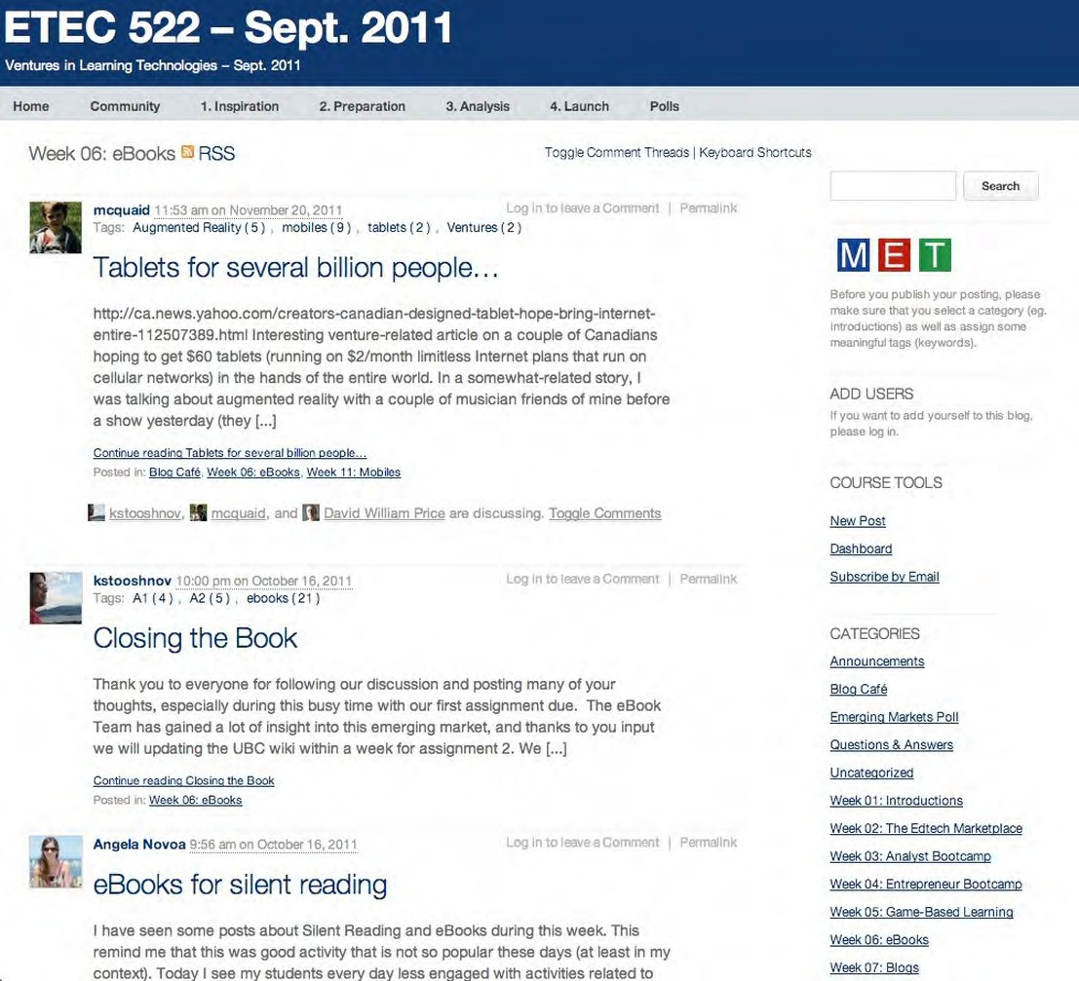](http://opentextbc.ca/teachinginadigitalage/wp-content/uploads/sites/29/2015/02/ETEC-522-2011-2.jpg)

*Figure 13.9.2 The University of British Columbia’s ETEC 522*

The web page illustrated in Figure 13.9.2 though from the 2011 version of the course demonstrates clearly a relatively loose structure. The weekly topic structure is on the right, covering seven weeks of the course, the remaining six being time for students to work on their projects. The outcomes of student activities are in the main body, posted by students through their blogs. Note this is not using a learning management system, but WordPress, a content management system, which allows students more easily to post and organize their activities.

Blended learning provides an opportunity to enable students to gradually take more

responsibility for their learning, but within a ‘safe’ structure of a regularly scheduled classroom event, where they have to report on any work they have been required to do on their own or in small groups. This means thinking not just at a course level but at a program level, especially for undergraduate programs. A good strategy would be to put a heavy emphasis on face-to-face teaching in the first year, and gradually introduce online learning through blended or hybrid classes in second and third year, with some fully online courses in the fourth year, thus preparing students better for lifelong learning.

#### Moving a face-to-face course online

This is the easiest way to determine the structure for an online course. The structure of the course will have already been decided to a large extent, in that the content of each week’s work is clearly defined by lecture topics. The main challenge will not be structuring the content but ensuring that students have adequate online activities (see later). Most learning management systems enable the course to be structured in units of one week, following the classroom topics. This provides a clear timetable for the students. This applies also to alternative approaches such as problem-based learning, where student activities may be broken down almost on a daily basis.

However, it is important to ensure that the face-to-face content is moved in a way that is suitable for online learning. For instance, Powerpoint slides may not fully represent what is covered in the verbal part of a lecture. This often means reorganizing or redesigning the content so that it is complete in an online version (your instructional designer should be able to help with this). At this point, you should look at the amount of work the online students will need to do in the set time period to make sure that with all the readings and activities it does not exceed the rough average weekly load you have set. It is at this point you may have to make some choices about either removing some content or activities, or making the work ‘optional.’ However, if optional it should not be assessed, and if it’s not assessed, students will quickly learn to avoid it. Doing this time analysis incidentally sometimes indicates that you’ve overloaded the face-to-face component as well.

It needs to be constantly in your mind that students studying online will almost certainly study in a more random manner than students attending classes on a regular basis. Instead of the discipline of being at a certain place at a certain time, online students still need clarity about what they are supposed to do each week or maybe over a longer time

period as they move into later levels of study. What is essential is that students do not procrastinate online and hope to catch up towards the end of the course, which is often the main cause of failure in online courses (as in face-to-face classes).

We will see that defining clear activities for students is critical for success in online learning. We shall see when we discuss student activities below that there is often a trade- off to be made between content and activities if the student workload is to be kept to manageable proportions.

#### Structuring a blended learning course

Many blended learning courses are designed almost by accident, rather than deliberately. Online components, such as a learning management system to contain online learning materials, lecture notes or online readings, are gradually added to regular classroom teaching. There are obvious dangers in doing this if the face-to-face component is not adjusted at the same time. After a number of years, more and more materials, activities and work for students is added online, often optional but sometimes essential for assignments. Student workloads can increase dramatically as a result – and so too can the instructor’s, with more and more material to manage.

Rethinking a course for blended learning means thinking carefully about the structure and student workload. Means et al. ([2009](https://www2.ed.gov/rschstat/eval/tech/evidence-based-practices/finalreport.pdf)) hypothesised that one reason for better results from blended learning was due to students spending more time on task; in other words, they worked harder. This is good, but not if *all* their courses are adding more work. It is essential therefore when moving to a blended model to make sure that extra work online is compensated by less time in class (including travel time).

#### Designing a new online course or program

If you are offering a course or program that has not to date been offered on campus (for instance a professional or applied master’s program) then you have much more scope for developing a unique structure that best fits the online environment and also the type of students that may take this kind of course (for example, working adults).

The important point here is that the way this time is divided up does not have to be the same as for a face-to-face class, because there is no organizational need for the student to be at a particular time or place in order to get the instruction. Usually an online course will be ‘ready’ and available for release to the students before the course officially begins. Students could in theory do the course more quickly or more slowly, if they wished. Thus the instructor has more options or choices about how to structure the course and in particular about how to control the student workflow.

This is particularly important if the course is being taken mainly by lifelong learners or part-time students, for instance. Indeed, it may be possible to structure a course in such a way that different students could work at different speeds. Competency-based learning means that students can work through the same course or program at very different speeds. Some open universities even have continuous enrolment, so they can start and finish at different times. Most students opting for an online course are likely to be working, so you may need to allow them longer to complete a course than full-time students. For instance, if on-campus masters’ programs need to be completed in one or two years, students may need up to five years to complete an online professional masters program.

#### Key principles in structuring a course

Now there may be good reasons for not doing some of these things, but this will be because of pedagogical rather than institutional organizational reasons. For instance, I’m not keen on continuous enrollment, or self-paced instruction, because especially at graduate level I make heavy use of online discussion forums and online group work. I like students to work through a course at roughly the same pace, because it leads to more focused discussions, and organizing group work when students are at different points in the course is difficult if not impossible. However, in other courses, for instance a math course, self-paced instruction may make a lot of sense.

I will discuss other non-traditional course structures when we discuss student activities below. However you structure the course, though, two basic principles remain:

* there must be some notional idea of how much time students should spend each week on the course;
* students should be clear each week about what they have to do and when it needs to be done.

#### Designing student activities

This is the most critical part of the design process, especially for fully online students, who do not have the regular classroom structure, nor the campus environment for contact with the instructor and other students, nor the opportunity for spontaneous questions and discussions in a face-to-face class. Regular student activities though are critical for keeping all students engaged and on task, irrespective of mode of delivery. These can include:

* assigned readings, with some activity that enables students to demonstrate their understanding;
* simple multiple choice self-assessment tests of understanding with automated feedback, using the computer-based testing facility within a learning management system;
* questions requiring short paragraph answers which may be shared with other students for comparison or discussion;
* formally marked and assessed monthly assignments in the form of short essays or reports;
* individual or group project work spaced over several weeks;
* an individual student blog or e-portfolio that enables the student to reflect on their recent learning, and which may be shared with the instructor or other students;
* online discussion forums, which the instructor will need to organize and monitor.

There are many other activities that instructors can devise to keep students engaged. However, all such activities need to be clearly linked to the stated learning outcomes for the course and can be seen by students as helping them prepare for any formal assessment. If learning outcomes are focused on skills development, then the activities should be designed to give students opportunities to develop or practice such skills.

These activities also need to be regularly spaced and an estimate made of the time

students will need to complete the activities. In step eight, we shall see that student engagement in such activities will need to be monitored by the instructor.

It is at this point where some hard decisions may need to be made about the balance between ‘content’ and ‘activities’. Students must have enough time to do regular activities (other than just reading) once each week at least, or their risk of dropping out or failing the course will increase dramatically. In particular they will need some way of getting feedback or comments on their activities, either from the instructor or from other students, so the design of the course will have to take account of the instructors’ workload as well as the students’.

In my view, most university and college courses are overstuffed with content and not enough consideration is given to what students need to do to absorb, apply and evaluate such content. I have a very rough rule of thumb that students should spend no more than half their time reading content and attending lectures, the rest being spent on interpreting, analyzing, or applying that content through the kinds of activities listed above. As students become more mature and more self-managed the proportion of time spent on activities can increase, with the students themselves being responsible for identifying appropriate content that will enable them to meet the goals and criteria laid down by the instructor. However, that is my personal view. Whatever your teaching philosophy though, there must be plenty of activities with some form of feedback for online students, or they will drop like flies on a cold winter’s day.

#### Many structures, one high standard

There are many other ways to ensure an appropriate structure for an online course. For instance, the Carnegie Mellon [Open Learning Initiative](https://oli.cmu.edu/) provides a complete course ‘in a box’ for standard first and second year courses in two year colleges. These include

a learning management system site with content, objectives and activities pre-loaded, with an accompanying textbook. The content is carefully structured, with in-built student activities. The instructors’ role is mainly delivery, providing student feedback and marking where needed. These courses have proved to be very effective, in that most students successfully complete such programs.

The History instructor in Scenario D kept a normal three lectures a week structure for

the first three weeks, then students worked entirely online in small groups on a major project for five weeks, then returned to class for one three-hour session a week for five weeks for students to report back on and discuss their projects as a whole class group.

We saw that in competency-based learning, students can work at their own speed through highly structured courses academically, in terms of topic sequences and learner activities, that nevertheless have flexibility in the time students can take to successfully complete a competency.

The [Integrated Science Program](https://science.mcmaster.ca/sis/undergraduate/isci.html) at McMaster University is built around 6-10 week undergraduate research projects.

cMOOC’s such as Stephen Downes, George Siemen’s, and Dave Cormier’s [#Change](https://worklearn.wordpress.com/2012/12/19/change-11-srl-mooc-study-initial-findings/)

[11](https://worklearn.wordpress.com/2012/12/19/change-11-srl-mooc-study-initial-findings/) (Milligan, [2012](https://worklearn.wordpress.com/2012/12/19/change-11-srl-mooc-study-initial-findings/)) have a loose structure, with different topics with different contributors each week, but student activities, such as blog posts or comments, are not organized by the course designers but left to the students. However, these are not credit courses, and few students work all the way through the whole MOOC, and that is not their intent. The Stanford and MIT xMOOC’s on the other hand are highly structured, with student activities, and the feedback is fully automated. Less than 10 per cent of students who start these MOOCs successfully complete them, but they too are non-credit courses.

Increasingly MOOCs are becoming shorter, some of as little as three or four weeks in length.

Online learning enables teachers and instructors to break away from a rigid three semester, 13 week, three lectures a week structure, and build courses around structures that best meet the needs of learners and the preferred teaching method of the teacher or instructor. My aim in a credit course or program is to ensure high academic quality *and* high completion rates. For me that means developing an appropriate structure and related learning activities as a key step in achieving quality in credit online courses.

#### References

Means, B. et al. (2009) [*Evaluation of Evidence-Based Practices in Online Learning: A Meta-*](http://www2.ed.gov/rschstat/eval/tech/evidence-based-practices/finalreport.pdf)[*Analysis and Review of Online Learning Studies*](http://www2.ed.gov/rschstat/eval/tech/evidence-based-practices/finalreport.pdf)Washington, DC: US Department of Education

Milligan, C. (2012) [Change 11 SRL-MOOC study: initial findings](https://worklearn.wordpress.com/2012/12/19/change-11-srl-mooc-study-initial-findings/) *Learning in the Workplace*, December 19

1. How many hours a week should a typical student spend studying a three credit course? If your answer differs from mine (8-9 hours), why?
2. If you were designing an online credit program from scratch, would you need to follow a ‘traditional’ structure of three credits over 13 weeks? If not, how would you structure such a program, and why?
3. Do you think most credit courses are ‘overstuffed’ with content and do not have enough learning activities? Do we focus too much on content and not enough on skills development in higher education? How does that affect the structure of courses? How much does it affect the quality of the learning?

Again, no feedback provided on this activity.

*Activity 13.9 Structuring your course or program*

# Step eight: communicate, communicate, communicate

[](http://opentextbc.ca/teachinginadigitalage/wp-content/uploads/sites/29/2015/02/Older-woman-studying-2.jpg)

*Figure 13.10.1 Communicate!*

*Image: Care2, 2012*

Some methods of teaching, such as online collaborative learning (Chapter 4, Section 4), depend on high quality discussion between instructor and students. However, there is substantial research evidence to suggest that ongoing, continuing communication between teacher/instructor and students is essential in *all* online learning. At the same time it needs to be carefully managed in order to control the teacher/instructor’s workload.

#### The concept of ‘teacher presence’

In a classroom environment, the presence of the teacher or instructor is taken for granted. Usually, the teacher is at the front of the class and at the centre of attention. Students may want to ignore a teacher but that is not always easy to do, even in a very large lecture theatre. The instructor just being there in the room is often considered to be enough. We can learn a lot though about the important pedagogical aspects of teacher presence from the research into online learning, where teacher or instructor presence has to be worked at.

#### Teacher presence and the loneliness of the long distance learner

Research has clearly indicated that ‘perceived instructor presence’ is a critical factor for online student success and satisfaction (Jonassen et al., [1995](https://www.tandfonline.com/doi/abs/10.1080/08923649509526885); Anderson et al., [2001](https://www.researchgate.net/publication/228749393_Assessing_Teaching_Presence_in_a_Computer_Conferencing_Context); Garrison and Cleveland-Innes, [2005](https://www.tandfonline.com/doi/abs/10.1207/s15389286ajde1903_2); Baker, 2010; Sheridan and Kelly, [2010](http://jolt.merlot.org/vol6no4/sheridan_1210.htm)). Students need to know that the teacher or instructor is following the online activities of students and that the teacher/instructor is actively participating during the delivery of the course.

The reasons for this are obvious. Online students often study from home, and if they are fully online may never meet another student on the same course. They do not get the important non-verbal cues from the teacher/instructor or other students, such as the stare at a stupid question, the intensity in presentation that shows the passion of the instructor for the topic, the ‘throwaway’ comment that indicates the instructor doesn’t have much time for a particular idea, or the nodding of other students’ heads when another student makes a good point or asks a pertinent question. An online student does not have the opportunity for a spontaneous discussion by bumping into the teacher or instructor in the corridor.

However, a skilled teacher can create just as compelling a learning environment online, but it needs to be deliberately planned and designed, and be done in such a way that the their workload can be controlled.

#### Setting students’ expectations

It is essential right at the start of a course for the teacher or instructor to make it clear to students what is expected of them when they are studying online, whether in a blended or fully online course. (On reflection, why would we not do the same for face-to-face teaching?)

Most institutions have a code of behaviour for the use of computers and the Internet, but these are often lengthy documents written in a bureaucratic language, and are more concerned with spam, general online behaviour such as ‘flaming’ or bullying, or hacking. Although necessary, this is not sufficient for teaching purposes. Thus teachers or instructors are advised to develop a set of specific requirements for student behaviour that is related to the needs of the particular course, and deals with the academic requirements of studying online. Some guidelines or principles for developing meaningful online discussion can found in Chapter 4, Section 4.4.4. However, there are some other specific actions that teachers and instructors can take to ensure teacher presence.

A small task can be set in the first week of a course that sets up student expectations for the rest of the course. For instance students can be asked to post their bio and respond to other students bio posts, or can be asked to comment on a topic related to the course and their views on this before the course really begins, using the discussion forum facility in the learning management system. It is important to pay particular attention to this activity, because research indicates that online students who do not respond to set activities in the first week are at high risk of non-completion. Teachers or instructors should follow up with a phone call or e-mail to non-respondents at the end of the first week, and ensure that each student is following the guidelines or doing the task set, even if students are experienced in studying online. Students know that the teacher/instructor is then following what they do (or more importantly don’t do) from the outset.

Different courses may require different guidelines. For instance a math or science course may not put so much emphasis on discussion forums, but more on self-assessed computer-marked multiple choice questions. It should be made clear whether students must do these or if they are optional, or how much time should be spent as a minimum on doing such non-graded activities, and the relationship of non-graded activities to activities that are graded or assessed. They should get such an activity within the first

week of a course, and the teacher/instructor should follow up with those that avoid the activity or have difficulties with it.

Lastly, teachers/instructors should follow their own guidelines. Your comments should be helpful and constructive, rather than negative. You should actively encourage discussion by being ‘present’ and stepping in on a discussion where necessary – for instance if the comments are getting off topic or too personal.

#### Teaching philosophy and online communication

Teachers/instructors who have a more objectivist approach to teaching are more likely to focus on whether students are not only covering the necessary content but are also understanding it. This often requires students going back over content, providing misunderstood or difficult content in an alternative manner (e.g. a video as well as text), and instructor or automated (computer-based) feedback. Most LMSs will provide summaries of student activities, and it is important to track each individual student’s progress. Teachers/instructors with a more constructivist approach are more likely to emphasize online discussion and argument.

Whatever your approach, students want to know where you stand on some of the topics. Thus while it is necessary often to present content objectively with an ‘on the one hand… on the other…’ approach, students usually feel more committed to a course where the teacher’s/instructor’s own views or approach to a topic are made clear. This can be done in a variety of ways, such as a podcast on a topic, or an intervention in a discussion, or a short video of how you would go about solving an equation. These personal interventions have to be carefully judged, but can make a big difference to student commitment and participation.

#### Choice of medium for teacher/instructor communication

There is now a wide variety of media by which teachers/instructors can communicate with students, or students can communicate with each other. Basically, though, they fall into four categories:

* face-to-face, such as set office hours, scheduled classes or serendipity (bumping into each other in the corridor);
* synchronous communication media, including voice phone calls, text and audio conferencing over the web (for example, Blackboard Collaborate), or even video- conferencing (for example, ZOOM);
* asynchronous communication media, including e-mail, podcasts or recorded video clips, and online discussion forums within an LMS;
* social media, such as blogs, wikis, text or voice messages on mobile phones, Facebook and Twitter.

In general, I much prefer asynchronous communication for two reasons. Online or even on-campus, nominally full-time students are often working and have busy lives; asynchronous discussion, questions and answers are more convenient for them. Asynchronous communications can be accessed at any time. Also, they are much more convenient for me as a teacher or instructor. For instance I can go to a conference even in another country yet still log on to my course when I have some free time. I also have a record of what I have said to students. If using an LMS, it is password protected and communications can be kept within the class group.

However, asynchronous communication can be frustrating for students when complex decisions need to be made within a tight timescale, such as deciding the roles and responsibilities for group work, the final draft of a group assignment, or a student’s lack of understanding that is blocking any further progress on the topic. Then face-to-face or technology-based synchronous communication is better, depending on whether it is a blended or fully online course.

In a fully online course, I also sometimes use a conferencing system such as ZOOM to bring all the students together once or twice during a semester, to get a feeling of community at the start of a course, to establish my ‘presence’ as a real person with a face or voice at the start of a course, or to wrap up a course at the end, and I try to provide plenty of opportunity for questions and discussion by the students themselves. However, these synchronous ‘lectures’ are always optional as there will always be some students who cannot be present (although they can be made available in recorded format).

For a blended course, though, I would organise a series of relatively small face-to-face group sessions in the first or second week of a course, so students can get to know each

other as well as me, then keep them in the same groups online for any group work or discussions.

Blogs or e-portfolios can be used by students to record their learning or to reflect on what they have learned, and blogs can be a useful way for the instructor to comment on news or events relevant to a course, but care is needed to keep a clear separation between students’ private lives and conversations, and the more formal in-class communications.

#### Managing online discussion

Whole books have been written on this topic (see Salmon, [2000](https://www.taylorfrancis.com/books/9780203816684), Paloff and Pratt, [2007](https://books.google.ca/books/about/Building_Online_Learning_Communities.html?id=Ztcp8E8T-M4C&hl=en); Harasim, [2017](https://www.routledge.com/Learning-Theory-and-Online-Technologies-2nd-Edition/Harasim/p/book/9781138860001)) and this is discussed in detail in Chapter 4, Section 4.4.4. However, there are some basic guidelines to follow.

##### Threaded discussion

Use the *threaded discussion* forum facility in the LMS (in some LMSs the instructor has to choose to switch this on).

Figure 13.10.2 Example of a threaded discussion topic. This is an old LMS (WebCT) but illustrates clearly the value of a threaded discussion.

Although LMSs are losing some of their original appeal, with more and more instructors using WordPress or other content management systems, I like to use the LMS forum discussion tool because I can organize the discussion by separate topics (a forum for each topic).

In a threaded discussion, a student comment on someone else’s post on a topic is posted next to the post, allowing either the student making the original post or other students to respond to the comment. This way a ‘thread’ of comments linked to a specific topic can be followed. A well chosen topic or sub-topic will often have ten or more threaded comments, and the instructor can tell at a glance which topics have gained ‘traction’.

The alternative, comments posted in time order, as in comments on a blog, for instance, make it difficult to follow a thread of an argument. Also I like to keep a least some of the discussion ‘private’, just between me and the students on the course, as I am using the discussion forum to identify areas of misunderstanding and to develop skills such as critical thinking and clear communication.

##### Be there!

By that I mean ensure that students are aware of your regular *online presence*. This means monitoring the discussions on a regular basis, and occasionally intervening when appropriate, without hogging the discussion.

For more guidance on handling online communication with students, take a look particularly at the books by Gilly Salmon, Rena Paloff and Keith Pratt, and Linda Harasim in the references below.

#### Cultural and other student differences

The most interesting and exciting online courses that I have taught have included a wide range of international students from different countries. However, even if all the students are within one hour’s commute of the institution, they will have different learning styles and approaches to studying online. This is why it is important to be clear about the desired learning outcomes, and the goals for discussion forums.

Students learn in different ways. If one of the desired learning outcomes is critical thinking, students can achieve that in different ways. Some may prefer to discuss course issues with other students over a coffee. Some may do a lot of reading, seeking out different viewpoints. Others may prefer to work mainly in the online discussion forums. Some students learn a lot by lurking online but never contribute directly. Now if you are trying to improve international students’ language skills, then you may require them to participate in the online discussions, and will assess them on their contributions.

However, I try not force students to participate. I see it as my challenge to make the

topic interesting enough to draw them in. I don’t really care how they achieve the learning outcomes so long as they do.

Having said that, much can be done to facilitate or encourage students to participate. I taught one graduate course where I had about 20 of the 30 students in my class with Chinese surnames. From the student records and the short bios they posted I noted that a few students were from the Chinese mainland, several more were living in Hong Kong, and the rest had Canadian addresses. However even the latter consisted of two quite different groups: recent immigrants to Canada, and at least one student whose great grandfather had been one of the first immigrants to Canada in the 19th century.

Although it is dangerous to rely on stereotypes, I noticed that the further away ‘psychologically’ or geographically the student was, the less they were initially inclined to participate online. This was partly a language issue but also a cultural issue. The mainland Chinese in particular were very reluctant to post comments. Fortunately we had a visiting Chinese scholar with us and she advised us to get the three mainland Chinese women on the course to develop a collective contribution to the discussion and then ask them to send it to me to check that it was ‘appropriate’ before they posted. I made a few comments then sent it back and they then posted it. Gradually by the end of the course they each had the confidence to post individually their own comments. But it was a difficult process for them. (On the other hand, I had Mexican students who commented on everything, whether it was about the course or not, and especially about the World Cup soccer tournament that was on at the time).

Students differences (and possibly stereotypes) also change over time. I am not sure whether 20 years later the differences would apply to students with Chinese names today. The important point is that different students respond differently to online discussion and the instructor needs sensitivity to these differences, and strategies to ensure participation from everyone.

#### Conclusion

This is a big topic and difficult to cover adequately in one section. However, the importance of teacher/instructor presence cannot be overemphasized for getting students successfully to complete any course with an online component. The lack of

instructor online presence in xMOOCs is one reason so few students complete the courses.

There is an unlimited number of ways in which you, as a teacher or instructor, can communicate now with students, but it is also essential at the same time to control your workload. You cannot be available 24×7, and this means designing the online delivery in such a way that your ‘presence’ is used to best effect. At the same time, communication with online students can end up being the most interesting and satisfying part of teaching.

#### References and further reading

(This is just a small sample of many publications on this topic,)

Anderson, T., Rourke, L., Garrison, R., & Archer, W. (2001). [Assessing teaching presence in](https://www.researchgate.net/publication/228749393_Assessing_Teaching_Presence_in_a_Computer_Conferencing_Context) [a computer conferencing context](https://www.researchgate.net/publication/228749393_Assessing_Teaching_Presence_in_a_Computer_Conferencing_Context) *Journal of Asynchronous Learning Networks*, Vol. 5, No.2.

Baker, C. (2010) [The Impact of Instructor Immediacy and Presence for Online Student](https://files.eric.ed.gov/fulltext/EJ904072.pdf) [Affective Learning,](https://files.eric.ed.gov/fulltext/EJ904072.pdf) [Cognition, and Motivation](https://files.eric.ed.gov/fulltext/EJ904072.pdf) *The Journal of Educators Online* Vol. 7, No. 1

Garrison, D. R. & Cleveland-Innes, M. (2005). [Facilitating cognitive presence in online](https://www.tandfonline.com/doi/abs/10.1207/s15389286ajde1903_2) [learning: Interaction is not enough](https://www.tandfonline.com/doi/abs/10.1207/s15389286ajde1903_2) *American Journal of Distance Education,* Vol. 19, No. 3

Harasim, L. (2017) [*Learning Theory and Online Technologies 2nd edition*](https://www.routledge.com/Learning-Theory-and-Online-Technologies-2nd-Edition/Harasim/p/book/9781138860001)New York/London: Taylor and Francis

Jonassen, D., Davidson, M., Collins, M., Campbell, J. and Haag, B. (1995) ‘[Constructivism and](https://www.tandfonline.com/doi/abs/10.1080/08923649509526885) [Computer-mediated Communication in Distance Education](https://www.tandfonline.com/doi/abs/10.1080/08923649509526885)’, *American Journal of Distance Education*, Vol. 9, No. 2, pp 7-26.

Paloff, R. and Pratt, K. (2007) [*Building Online Learning Communities*](http://books.google.ca/books/about/Building_Online_Learning_Communities.html?id=Ztcp8E8T-M4C)San Francisco: John Wiley and Co.

Salmon, G. (2000) [*E-moderating*](https://www.taylorfrancis.com/books/mono/10.4324/9780203465424/moderating-gilly-salmon-gilly-salmon)London/New York: Taylor and Francis

Sheridan, K. and Kelly, M. (2010) [The Indicators of Instructor Presence that are Important](https://jolt.merlot.org/vol6no4/sheridan_1210.htm) [to Students in Online Courses](https://jolt.merlot.org/vol6no4/sheridan_1210.htm) *MERLOT Journal of Online Learning and Teaching*, Vol. 6, No. 4

###### Activity 13.10 Communicating with your students

1. How could you apply some of the principles of teacher presence in an online course to a large lecture class?
2. In a blended class where students have at least one classroom session once a week, how would you decide what interactions with students should be done on campus, and what online? What are the reasons for your decision? Does it matter?
3. How important is student discussion in your subject area? What learning goals does it support? How can you help students to achieve these goals through discussion?
4. Interaction/communication between students and teachers/instructors is one of the main cost drivers of education. Could the goals that justify the use of discussion or other forms of communication between learners and teachers or instructors be achieved in other, less costly, ways? Could this be replaced by computers, for instance? If not, why not?

For feedback on this activity, click on the podcast below:

*One or more interactive elements has been excluded from this version of the text. You can view them online here:* [*https://pressbooks.bccampus.ca/teachinginadigitalagev3m/?p=424#audio-424-1*](https://pressbooks.bccampus.ca/teachinginadigitalagev3m/?p=424&audio-424-1)

# Step nine: evaluate and innovate

[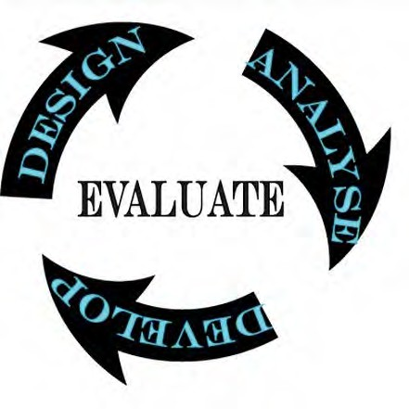](http://opentextbc.ca/teachinginadigitalage/wp-content/uploads/sites/29/2015/03/Evaluation-2.jpg)

*Figure 13.11.1 Evaluate and innovate Image: Hilary Page-Bucci, 2002*

The last key ‘fundamentals’ of quality teaching and learning in a digital age are evaluation and innovation: assessing what has been done, and then looking at ways to improve on it (for a more in-depth discussion of the issues involved in evaluating online learning, see Gunawardena et al., [2000](https://files.eric.ed.gov/fulltext/ED444552.pdf)).

#### Course evaluation

##### Why evaluation is important

For tenure and promotion, it is important if you are teaching to be able to provide evidence that the teaching has been successful. New tools and new approaches to teaching are constantly coming available. They provide the opportunity to experiment a little to see if the results are better, and if we do that, we need to evaluate the impact of using a new tool or course design. It’s what professionals do. But the main reason is that teaching is like golf: we strive for perfection but can never achieve it. It’s always possible to improve, and one of the best ways of doing that is through a systematic analysis of past experience.

##### What to evaluate: summative

In Step 1, I defined quality very narrowly:

*teaching methods that successfully help learners develop the knowledge and skills they will require in a digital age.*

It will be clear from reading this book that I believe that to achieve these goals, it will be necessary to re-design most courses and programs. So it will be important to know whether these redesigned courses are more effective than the ‘old’ courses. One way of evaluating these new courses is to see how they compared with the older courses, for instance:

* + - * + *completion rates will be at least as good if not better for the new version of the course(s)*
        + *grades or measures of learning will be at least as good if not better for the new version.*

The first two criteria are relatively easily measured in quantitative terms. We should be aiming for completion rates of at least 85 per cent, which means of 100 students starting the course, 85 complete by passing the end of course assessment (unfortunately, many current courses fail to achieve this rate, but if we value good teaching, we should be trying to bring as many students as possible to the set standard).

The second criterion is to compare the grades. We would expect at least as many As and Bs in our new version as in the old classroom version, while maintaining the same (hopefully high) standards or higher.

However, to be valid the evaluation will also would need to define the knowledge and skills within a course that meet the needs of a digital age, then measuring how effective the teaching was in doing this. Thus a third criterion would be:

* + - * + *the new design(s) will lead to new and different learning outcomes that are more relevant to the needs of a digital age.*

This third criterion is more difficult, because it suggests a change in the intended learning goals for courses or programs. This might include assessing students’ communication skills with new media, or their ability to find, evaluate, analyze and apply information appropriately within the subject domain (knowledge management), which have not previously been (adequately) assessed in the classroom version. This requires a qualitative judgement as to which learning goals are most important, and this may require endorsement or support from a departmental curriculum committee or even an external accreditation body.

With a new design, and new learning outcomes, it may be difficult to reach these standards immediately, but over two or three years it should be possible.

##### What to evaluate: formative

However, even if we measure the course by these three criteria, we will not necessarily

know what worked and what didn’t in the course. We need to look more closely at factors that may have influenced students’ ability to learn. We have laid out in steps 1-8 some of these factors. Some of the questions for which you may want answers are as follows:

* + - * + Were the learning outcomes or goals clear to students?
        + What learning outcomes did most students struggle with?
        + Was the teaching material clear and well structured?
        + Were the learning materials and tools students needed easily accessible and available 24 x 7?
        + What topics generated good discussion and what didn’t?
        + Did students draw appropriately on the course materials in their discussion forums or assignments?
        + Did students find their own appropriate sources and use them well in discussions, assignments and other student activities?
        + Which student activities worked well, and which badly? Why?
        + Of the supplied learning materials, what did students make most and least use of?
        + Did the assignments adequately assess the knowledge and skills the course was aiming to teach?
        + Were the students overloaded with work?
        + Was it too much work for me as an instructor?
        + If so, what could I do to better manage my workload (or the students’) without losing quality?
        + How satisfied were the students with the course?
        + How satisfied am I with the course?

I will now suggest some ways that these questions can be answered without again causing a huge amount of work.

##### How to evaluate factors contributing to or inhibiting learning

There is a range of resources you can draw on to do this. Indeed, there are more resources for evaluating online learning than for evaluating traditional face-to-face courses, because online learning leaves a traceable digital trail of evidence:

* + - * + individual student participation rates in online activities, such as self-assessment questions, discussion forums, podcasts;
        + qualitative analysis of the discussion forums, for instance the quality and range of comments, indicating the level or depth of engagement or thinking;
        + student e-portfolios, assignments and exam answers;
        + student questionnaires;
        + focus groups;
        + student grades.

However, before starting, it is useful to draw up a list of questions as in the previous section, and then look at which sources are most likely to provide answers to those questions.

[](http://opentextbc.ca/teachinginadigitalage/wp-content/uploads/sites/29/2015/03/exams-2.jpg)

*Figure 13.11.2 Analysis of a sample of exam answers will often provide information about course structure and the presentation of materials*

At the end of a course, I tend to look at the student grades, and identify which students did well and which struggled. This depends of course on the number of students in a class.

In a large class I might sample by grades. I then go back to the beginning of the course and track their online participation as far as possible (learning analytics make this much easier, although it can also be done manually if a learning management system is used). I find that some factors are student specific (e.g. a gregarious student who communicates with everyone) and some are course factor specific, for example, related to learning goals or the way I have explained or presented content. This qualitative approach will often suggest changes to the content or the way I interacted with students for the next version of the course. I may for instance determine next time to manage more carefully students who ‘hog’ the conversation.

Many institutions have a ‘standard’ student reporting system at the end of each course. These are often useless for the purposes of evaluating courses with an online component. The questions asked need to be adapted to the mode of delivery. However, because such questionnaires are used for cross course comparisons, the people who manage such evaluation forms are often reluctant to have a different version for online teaching. Secondly, because these questionnaires are usually voluntarily completed by students after the course has ended, response rates are often notoriously low (less than 20 per cent). Low response rates are usually worthless or at best highly misleading. Students who have dropped out of the course won’t even get the questionnaire in most cases. Low response rates tend to be heavily biased towards successful students. It is the students who struggled or dropped out that you need to hear from.

I find small focus groups work better than student questionnaires, and for this I prefer either face-to-face or synchronous tools such as Zoom. I will deliberately approach 7-8 specific students covering the full range of achievement, from drop-out to A, and conduct a one hour discussion around specific questions about the course. If one selected student does not want to participate, I try to find another in the same category. If you can find the time, two or three such focus groups will provide more reliable feedback than just one.

#### Innovate

Usually I spend quite a bit of time at the end of the first presentation of a redesigned course evaluating it and making changes in the next version, usually working with a trusted instructional designer. After that I concentrate mainly on ensuring completion rates and grades are at the standard I have aimed for.

What I am more likely to do in the third or subsequent offerings is to look at ways to improve the course that are the result of new external factors, such as new software (for instance. an e-portfolio package), or new processes (for instance, student-generated content, using mobile phones or cameras, collecting project-related data). This keeps the course ‘fresh’ and interesting. However, I usually limit myself to one substantive change, partly for workload reasons but also because this way it is easier to measure the impact of the change.

It is indeed an exciting time to be an instructor. In particular, the constant evolution of mobile phone apps, new, instructor-focused ‘lightweight’ LMSs such as Instructure/ Canvas, open educational resources, new hardware such as VR headsets, MOOCs, and emerging technologies such as serious games, virtual and augmented reality and artificial intelligence, all offer a wide variety of opportunities for innovation and experiment. These can be either be integrated within the existing LMS and existing course structure, or designs can be more radical. Chapters 3 to 5 discuss a wide range of possible designs.

However, it is important to remember that the aim is to enable students to learn effectively. We do have enough knowledge and experience to be able to design ‘safe’, effective learning around standard LMSs. New is not always better. Thus for instructors starting in online learning, I would urge caution. Follow the experienced route, then gradually add and evaluate new tools and new approaches to learning as you become more experienced.

Lastly, if you do make an interesting innovation in your course, make sure you properly evaluate it as suggested above, then share these findings with colleagues and help them either include the innovation within their own course, or help them make the innovation even better through their own modifications. That way we can all learn from each other.

#### Reference

Gunawardena, C., Lowe, C. & Carabajal, K. (2000) [Evaluating Online Learning: models](https://files.eric.ed.gov/fulltext/ED444552.pdf) [and methods](https://files.eric.ed.gov/fulltext/ED444552.pdf) in D. Willis et al. (eds.), *Proceedings of Society for Information Technology & Teacher Education International Conference 2000* San Diego CA

1. Design and conduct an evaluation of your course using the questions in section 13.11.1.3 and the data and methods suggested in section 13.11.1.4. What changes, if any, will you make as a result?

There is no feedback provided for this activity.

*Activity 13.11 Evaluating your course or program*

# Building a strong foundation of course design

[](http://opentextbc.ca/teachinginadigitalage/wp-content/uploads/sites/29/2015/03/foundations-building-2.jpg)

*Figure 13.12 Building a strong foundation for quality teaching Image: © Wikipedia Commons*

The emphasis in this series of steps has been on getting the fundamentals of teaching right. The nine steps are based on two foundations:

* effective strategies resulting from learning theories tested in both classroom and online environments;
* experience of successfully teaching both in classrooms and online (best practices).

The discerning reader will have noted that there isn’t much in this chapter about exciting new tools, MOOCs, the Khan Academy, Coursera or edX, mobile learning, artificial

intelligence, and many other new developments. These tools and new programs offer great potential and these have been discussed extensively in other chapters. However, it doesn’t matter what revolutionary tools or teaching approaches are being used, what we know of how people learn does not change a great deal over time, and we do know that learning is a process, and you ignore the factors that influence that process at your peril.

A subsidiary aim is to encourage you to work with other professionals, such as instructional and web designers and media producers, and preferably in a team with other online teachers and instructors.

I have focused mainly on using learning management systems, because that is what most institutions currently have, and LMSs provide an adequate ‘framework’ within which the key processes of teaching and learning can be managed, whatever the mode of delivery. I have more difficulty with integrating lecture capture or web conferencing within the nine steps, because the pedagogy they require is not always suitable for developing the skills needed in a digital age.

But if you get the fundamentals of the nine steps right, they will transfer well to the use of new tools, and the design of new courses and new programs; if they don’t transfer well, such tools are likely to be a passing fad and will eventually fade away in education, because they don’t enable the key processes that support learning for a digital age. For example, MOOCs may reach hundreds of thousands of students, but if there is no suitable communication with or ‘online presence’ from an instructor, then most students will fail or lose interest (as is the case at the moment), unless there is significant support from other, more experienced, co-learners, as in cMOOCs. However, this support needs to be structured and organised for effective learning to take place.

The approach I have suggested is quite conservative, and some may wish to jump straight into what I would call second generation flexible learning, based on social media such as mobile learning, blogs and wikis, and so on. These do offer intriguing new possibilities and are worth exploring. Nevertheless, whether or not an LMS is used, for learning leading to qualifications, it is important to remember that most students need:

* well-defined learning goals;
* a clear timetable of work, based on a well-structured organization of the curriculum;
* manageable study workloads appropriate for their conditions of learning;
* regular teacher/instructor communication and presence;
* a social environment that draws on, and contributes to, the knowledge and experience of other students;
* a skilled teacher or instructor;
* other motivated learners to provide mutual support and encouragement.

There are many different ways these criteria can be met, with many different tools.

###### Key Takeaways

* 1. For the purposes of this book, quality is defined as: *teaching methods that successfully help learners develop the knowledge and skills they will require in a digital age.*
  2. Formal national and institutional quality assurance processes do not guarantee quality teaching and learning. In particular, they focus on past ‘best’ practices, processes to be done before actual teaching, and often ignore the affective, emotional or personal aspects of learning. Nor do they focus particularly on the needs of learners in a digital age.
  3. New technologies and the needs of learners in a digital age require a re-thinking of traditional campus-based teaching, especially where it is has been based mainly on the transmission of knowledge. This means re- assessing the way you teach and determining how you would really like to teach in a digital age. This requires imagination and vision rather than technical expertise.
  4. It is important to determine the most appropriate mode of delivery, based on teaching philosophy, the needs of students, the demands of the discipline, and the resources available.
  5. It is best to work in a team. Blended and especially fully online learning require a range of skills that most instructors are unlikely to have. Good course design not only enables students to learn better but also controls faculty workload. Courses look better with good graphic and web design and professional video production. Specialist technical help frees up instructors to concentrate on the knowledge and skills that students need to develop.
  6. Full use should be made of existing resources, including institutionally-supported learning technologies, open educational resources, learning technology staff, and the experience of your colleagues.
  7. The main technologies you will be using should be mastered, so you are professional and knowledgeable about their strengths and weaknesses for teaching.
  8. Learning goals that are appropriate for learners in a digital age need to be set. The skills students need should be embedded within their subject domain, and these skills should be formally assessed.
  9. A coherent and clearly communicable structure and learning activities for a course should be developed that are manageable in terms of workload for both students and instructor.
  10. Regular and on-going instructor/teacher presence, especially when students are studying partly or wholly online, is essential for student success. This means effective communication between teacher/instructor and students. It is particularly important to encourage inter-student communication, either face-to-face or online.
  11. The extent to which the new learning goals of re-designed courses aimed at developing the knowledge and

skills needed in a digital age have been achieved should be carefully evaluated and ways in which the course could be improved should be identified.

## CHAPTER 14: SUPPORTING TEACHERS AND INSTRUCTORS IN A DIGITAL AGE

When you have read this chapter, you should be able to:

* recognise the need for professional development and training in teaching and define your own needs;
* recognise the role and importance of learning technology support systems;
* be able to design a team approach to teaching large classes;
* understand the need for an institutional strategy to support teaching and learning in a digital age;
* press for changes within your organisation to ensure that quality teaching is properly supported.

*The purpose of the chapter*

#### What is covered in this chapter

* 14.1 Are you a super-hero?
* 14.2 The development and training of teachers and instructors in a digital age
* 14.3 Learning technology support
* 14.4 Conditions of employment
* 14.5 Team teaching
* 14.6 An institutional strategy for teaching in a digital age

Also in this chapter you will find the following activities

* Activity 14.1 There is no activity for this section
* Activity 14.2 Identifying your professional training needs
* Activity 14.3 Learning technology support
* Activity 14.4 Conditions of employment
* Activity 14.5 Designing a team approach
* Activity 14.6 Developing an institutional strategy for supporting teaching and learning

This chapter focuses on the key support teachers and instructors will need from their employers to enable the development of the knowledge and skills students will need in a digital age. This support includes:

* pre-service and in-service training that focuses on digital and online teaching
* provision of specialist learning technology support units that can assist teachers and instructors teaching digitally
* ensuring teacher:student ratios that enable the interaction required to develop 21st century skills
* the use of team teaching and sessional instructors for very large classes using blended or hybrid learning
* a system- or institution-wide strategy/plan for the implementation and tracking of digital learning

*Key Takeaways*

# Are you a super-hero?

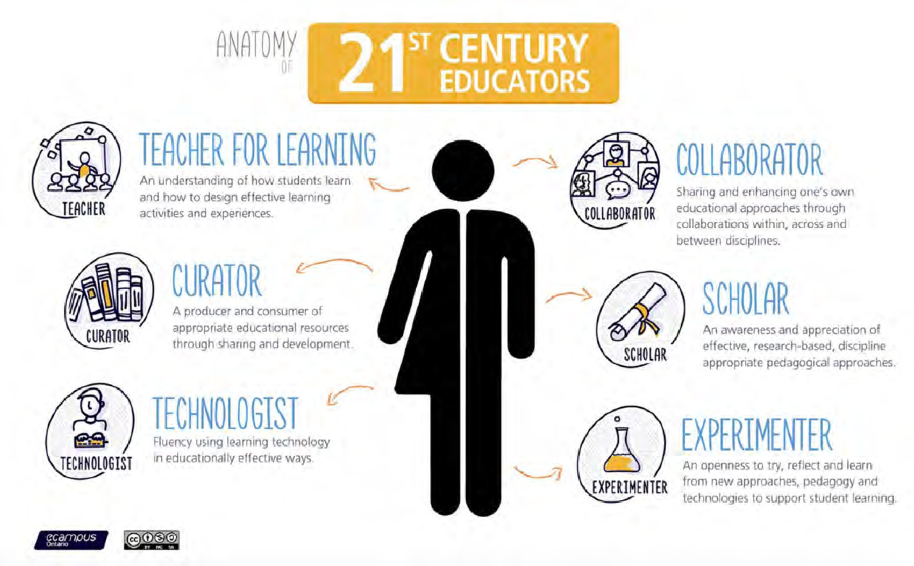

*Figure 14.1.1 Image: © Simon Bates/eCampus Ontario, 2016*

[Figure 14.1.1](https://www.slideshare.net/EdPER_talks/the-21st-century-educator-students-as-partners-in-teaching-and-learning), developed by Simon Bates, Associate Provost, Teaching and Learning at UBC, encapsulates well the role of a teacher or instructor in a digital age. At this point in the book, you might be forgiven for thinking that this is all too much, especially if you are a university professor whose passion is the discipline in which you are an expert, and whose priority is to extend the boundaries of knowledge in that subject through research or other scholarly work. Where an earth will you find the time to become expert in teaching if this means completely changing the teaching model you have become comfortable with?

You are not alone in thinking this. Martha Cleveland-Innes ([2013](https://coi.athabascau.ca/books/book-educational-communities-of-inquiry/)) writes:

*It is unrealistic to expect higher education faculty to have sound, current, content expertise, a productive research program, an active service commitment AND be expert online teachers. The biggest lie in the academy is that the role of faculty, and its rewards and responsibilities, is made up of a seemingly balanced set of activities around teaching, research and service … With some variation across type of institution, research is the most valued work and most notably rewarded. While this reality has not changed “…classroom teaching and course materials (have become) more sophisticated and complex in ways that translate into new forms of faculty work. such new forms are*

*not replacing old ones, but instead are layered on top of them, making for more work.” (Rhoades, 2000, p, 38). It is time to clarify this reality and consider how, if at all, changes in teaching are, or may be, integrated into the role of faculty member.*

Similarly, if you are a teacher of a mixed age class in a small rural school (as I was once) with poor or non-existent Internet access and basically just your colleagues, students and their parents for support, then how can you possibly cope with all these changes coming down the pipeline?

This chapter then focuses on the changes that are needed to support instructors or classroom teachers in a digital age. It is *not* realistic to expect all teachers to be super- heroes (even if you are the exception), but it *is* realistic to expect all teachers and instructors to be competent and professional in a digital age, and to receive the support they need from their employers.

The good news though is that by the time you have read your way through all the chapters in this book, you will have done what you need to do to be competent and professional for teaching in a digital age, and will certainly be ahead of 99 per cent of your colleagues on this (at least until they have also read this book). At the same time, there is much your employing organisation and senior administrators can do to help you in this, which is the focus of the rest of this chapter.

#### References

Bates, S. (2016) [The 21st Century Educator](https://www.slideshare.net/EdPER_talks/the-21st-century-educator-students-as-partners-in-teaching-and-learning) Burnaby BC: BCIT Faculty of Nursing Scholarship Day, May

Cleveland-Innes, M. (2013) ‘[Teaching in an online community of inquiry: institutional](http://www.diva-portal.org/smash/record.jsf?pid=diva2%3A801705&dswid=-9371) [and individual adjustment in the new higher education’](http://www.diva-portal.org/smash/record.jsf?pid=diva2%3A801705&dswid=-9371), in Akyol, Z. & Garrison, R.D. (eds.)*Educational communities of inquiry: theoretical framework, research and practice*, (pp. 389-400). Hershey, PA: IGI Global

Rhoades, G. (2000) ‘The changing role of faculty’ in Losco, J. and Fife, B. (eds.) [*Higher*](https://epdf.pub/higher-education-in-transition-the-challenges-of-the-new-millennium.html)[*Education in Transition: the challenges of the new millennium*](https://epdf.pub/higher-education-in-transition-the-challenges-of-the-new-millennium.html)Westport CT: Bergin and Garvey

# The development and training of teachers and instructors in a digital age

[](http://opentextbc.ca/teachinginadigitalage/wp-content/uploads/sites/29/2015/03/Faculty-development-workshop-2.jpg)

*Figure 14.2.1 A faculty development workshop*

#### The need

By mid-August in most countries in the northern hemisphere, teachers’ professional development and faculty development workshops and conferences have ended, and everyone has headed off for a well earned vacation. Many thousands will have learned how to use a learning management or a video-conferencing system for the first time, and hundreds of others will have been introduced to new technologies such as e-portfolios, mobile learning, and open educational resources. A smaller but significant number will have been introduced to new methods of teaching built around the potential of new technologies. All good stuff – and all totally inadequate for the needs facing teachers and instructors in a digital age.

14.2 The development and training of teachers and instructors in a

#### The reality

##### A broken professional development model in post-secondary education

In universities, faculty are trained, through the doctoral route, to do research, but there is no requirement to be trained in teaching methods. At best faculty development is voluntary for faculty once appointed, and although post-doctoral students may be offered short courses or in some instances even a certificate in preparation for classroom teaching, this is usually voluntary and minimal. Indeed, post-graduate students interested in experimenting with learning technologies or taking professional courses or programs in teaching are often deliberately discouraged by their supervisors from doing so, as it would detract from their research. Increased use of adjunct/contract faculty exacerbates the problem (see Chapter 14.4). Being on contract, they require payment for any training, but institutions are often reluctant to train contract workers who may then leave at the end of the contract and take their training and skills to a competitor.

The situation is somewhat different in two year colleges. Many jurisdictions (but by no means all) have a regional, state or provincial Instructor Diploma Program that some colleges require instructors to take on appointment or shortly afterwards. However, many of these programs have not been adapted to take account of online or digital learning, and probably none are yet up to date on blended learning. I was an external reviewer for one such program a while ago, and there was almost no mention of online or blended learning. Most of the technologies discussed in this program were at least 20 years old.

The lack of comprehensive and systematic training at a pre-service level places a disproportionate burden on ongoing professional development, which is at best ad hoc and variable in both quantity and quality. Above all, it is an entirely voluntary system – in other words, teachers or instructors can choose not to take any in-service workshops or courses on teaching, if they decide – as most do – that their professional development time will be better spent focusing on research rather than teaching. Christensen Hughes and Mighty ([2010](https://www.mqup.ca/taking-stock-products-9781553392712.php?page_id=46)) argue that less than 10 per cent of all university instructors take professional development activities focused on improving their teaching, and the faculty

that do opt in are often those in least need of training as they are often already excellent teachers.

Lastly, most faculty and instructors do not base their teaching practice on empirically- based evidence or research on the effectiveness of different approaches. Christensen Hughes and Mighty ([2010](https://www.mqup.ca/taking-stock-products-9781553392712.php?page_id=46)) have edited a collection of studies on research on teaching and learning in higher education. In the opening chapter the editors state:

*…researchers have discovered much about teaching and learning in higher education, but that dissemination and uptake of this information have been limited. As such, the impact of educational research on faculty-teaching practice and student-learning experience has been negligible.*

In the same book, Christopher Knapper (also of Queens University) states (p. 229-230):

*There is increasing empirical evidence from a variety of international settings that prevailing teaching practices in higher education do not encourage the sort of learning that contemporary society demands….Teaching remains largely didactic, assessment of student work is often trivial, and curricula are more likely to emphasize content coverage than acquisition of lifelong and life-wide skills….*

*[However] there is an impressive body of evidence on how teaching methods and curriculum design affect deep, autonomous and reflective learning. Yet most faculty are largely ignorant of this scholarship, and instructional practices are dominated by tradition rather than research evidence.*

##### Less than adequate training for digital and online learning in the school sector

In the school/k-12 system, training in online and digital learning is a little better, but still hit-and-miss. An increasing number of Bachelor of Education programs are including courses on online and digital learning, and some school districts or k-12 educational conferences provide some in-service professional development in online or digital learning. However, the pandemic clearly indicated how unprepared were most teachers and school administrators for providing quality digital learning for school children.

For instance, Barbour et al. (2021), following a national survey of school jurisdictions in Canada in 2020, reported:

*Instead of benefiting from the experience of their online learning programs and educators, many jurisdictions scrambled to reinvent what had already existed in successful, existing e-Learning infrastructure. Some jurisdictions did rely on their existing online learning programs that resulted in an increase in enrolment, but did not necessarily negate the need for remote learning during school closures. Finally, some jurisdictions developed models of instructional delivery that had not previously existed (or had only existed in the most isolated cases). However, overall what occurred in most jurisdictions when school closures were required was still remote learning*

*— and not online learning — because it was still viewed as temporary in nature. It remained an attempt to project a classroom instructional model to students at a distance with limited success.*

This book has shown that we do not have to invent or discover what’s needed to teach well in a digital age. There is a well-established literature and generally agreed best practices (see Chapter 13 and Appendix 2), yet, as Christensen Hughes and Mighty have pointed out, many if not a majority of teachers and instructors are unaware or continue to ignore these standards.

#### Why the system needs to change

When university education was limited to an elite few students, where faculty had a close, one-on-one relationship with students, it was possible to manage quite effectively without formal training in teaching. That is not the case today. Faculty are challenged by large classes, and heterogeneous students who learn in a variety of ways, with different learning skills and abilities. The emphasis is changing from knowledge as content to knowledge as process. Teaching methods need to be chosen that will develop the skills and competencies needed in a knowledge-based society, and on top of all this, constantly changing technology requires instructors to have analytical frameworks to help choose and use technologies appropriately for teaching.

In particular, the profound effect of the Internet on scholarship, research, work and leisure requires major reconsideration of our teaching methods, at all levels, if we are to

develop the skills and knowledge our students will need in a knowledge-based society. This requires comprehensive and systematic training of our teachers and instructors, not a system that depends heavily on opting-in, and that fails to reward adequately excellence in teaching as measured by the standards required in today’s context.

Moving to blended, hybrid and online learning requires a much higher standard of training for all teachers and instructors. It is not just a question of learning how to use a learning management system or an iPad. The use of technology needs to be combined with an understanding of how students learn, how skills are developed, how knowledge is represented through different media and then processed, and how learners use different senses for learning. It means examining different approaches to learning, such as the construction of knowledge compared with a transmission model of teaching, and how technology best works with either approach. Above all, it means linking the use of technology to the specific requirements of a particular knowledge domain or subject area.

The expansion into blended and online learning has been facilitated mainly by the establishment of separate learning technology support units to support faculty and instructors who do not have the experience or skills to teach online, or by enthusiastic and dedicated teachers often working in isolation. Although learning technology support units are essential, at both the school and institutional level, it will be prohibitively expensive to continue to expand such units as blended and online learning continues to grow (Bates and Sangrà, [2011](https://www.wiley.com/WileyCDA/WileyTitle/productCd-0470584726%2CminiSiteCd-JBHIGHERED.html)). It is much more cost-effective to provide adequate initial pre-service training so that learning technology units can concentrate on training, professional development and R&D into new methods of teaching and learning as new technologies develop.

#### What needs to be done

Identifying the problem is much easier than fixing it. In particular, the culture especially of universities protects the existing system. Academic freedom is often used as an argument for the status quo, and unions in the college system rightly insist on payment for instructors for any time spent on training over and above their normal teaching load. As Bates and Sangrà ([2011](https://www.wiley.com/WileyCDA/WileyTitle/productCd-0470584726%2CminiSiteCd-JBHIGHERED.html)) have pointed out, this is a systemic problem. It is difficult for a university, for example, to change for fear that their best young researchers will move to another institution where training in teaching is not demanded.

There are many different ways to address this challenge. I set out one possible strategy below.

##### Recognize that there’s a problem

First, it has to be recognized and accepted by institutional leaders, teachers, instructors and faculty, the relevant unions, quality assurance boards, school districts, Ministries of Education, and state funding agencies that there is a major problem here. Johnson ([2019](http://www.cdlra-acrfl.ca/wp-content/uploads/2020/07/2019_national_en.pdf)) in a national survey of post-secondary institutions in Canada, found that while 71 per cent of all institutions rated online learning as very or extremely important for their long-term future, 79 per cent reported that the main barrier to greater adoption of online learning was inadequate training, and in only 29 per cent of institutions was it required in order to teach online.

Developing skilled teachers (and that’s what we need in schools, colleges and universities) is as much an economic development as an educational issue. If we want people with the knowledge and skills needed in a digital age, then teachers must get the knowledge themselves about how to develop such skills, and in particular recognize that learning technologies and online learning are critical components in the development of such skills.

##### Start in graduate school and schools of education

It is much more economical and effective to prepare teachers and instructors properly at the start of their careers than to try to get large chunks of their time for training while in their mid or late careers. Although technology will change over time, the basic essentials of teaching and learning are relatively stable. Thus the problem needs to be tackled at the pre-service level. For those wishing to work as faculty in universities, we need to examine the post-graduate degree and in particular the Ph.D., to ensure that there is adequate time for courses on and practice in post-secondary teaching, or develop a parallel route for developing teaching and research skills. For school teachers, bachelor and continuing education programs must include basic training in online and digital learning.

##### Adopt a system-wide approach

Ideally the state or provincial Council of Universities or Colleges, or school boards, should get together and develop a comprehensive system of training for all teachers and ensure that such programs are continually updated. Similarly, a common plan and set of standards needs to be established across a jurisdiction for hiring and promotion linked to proper training in teaching and learning, through the establishment of appropriate working groups that would include professionals from learning technology units and professional development offices.

##### Self-help

We need to walk the talk, and use technology to support professional development. Increasingly, centres for teaching and learning are creating web sites with ‘on-demand’ resources for faculty and instructors, such as best practices in using video, [podcast](http://diy.open.ubc.ca/audio/create-it/podcasting-basics/) [production](http://diy.open.ubc.ca/audio/create-it/podcasting-basics/), or [designing a course with technology.](https://www.bcit.ca/ltc/resources/) Too often, though, other faculty development support sites focus on the technical operation of technology or just provide a schedule of faculty development workshops, rather than providing pragmatic advice on best educational practice in the use of a particular technology or medium. Also, teachers and instructors need to know about such sites – and use them.

##### Set standards

The system-wide working groups should agree on a ‘core’ curriculum, minimum standards, and measures of performance for pre-service training in teaching for each sector. These standards should include knowledge and skills needed by learners in a digital age. No person should be hired to new positions that have a major teaching component without recognized training in teaching, once the training system is in place.

ALT (Association of Learning Technologists), UK, provides [professional accreditation of](https://www.alt.ac.uk/certified-membership) [learning technologists](https://www.alt.ac.uk/certified-membership), operating at three levels (novice, career, advanced) through certified membership of ALT (Association of Learning Technologists). It uses a

combination of personal portfolios of work and peer assessment. A similar program could be extended to teachers and instructors, enabling a form of accreditation based on practice as well as taking courses.

For in-service professional development, one strategy would be to require an individual professional development plan for every teacher or instructor annually negotiated between the teacher and their head of department. This plan would include regular up- dating in new teaching methods and technologies, similar to the compulsory professional development programs for medical practitioners. Different individual professional development plans will be needed for different subject areas.

##### Government as watch dog and enforcer

Governments should exert pressure on school boards, colleges and universities to ensure that an adequate pre-service and in-service training system is in place, as a condition of future funding. Governments should refuse to fund any public institution that does not follow the standards for training in teaching set and endorsed by the relevant system- wide authorities.

##### Integrate internally

Blended and fully online teaching and learning technologies should be seen as integral components of professional development, not as separate activities. Therefore faculty development offices should be integrated with learning technology support units into Centres for Teaching and Learning (either centrally or divisionally, depending on the size of the institution), where this has not already occurred.

[](http://opentextbc.ca/teachinginadigitalage/wp-content/uploads/sites/29/2015/03/Brainstorming-2.jpg)

*Figure 14.2.2 Teachers brainstorming about using technology for teaching*

#### Conclusion

We would not dream of allowing doctors or pilots do their work without formal training related to their main work activities, yet this is exactly the situation regarding teaching in post-secondary education. We have to move from a system of voluntary amateurism to a professional, comprehensive system of training for teaching in post-secondary education, and a modern, up-to-date curriculum for pre-service and in-service training of school teachers. This book attempts to provide at least a basic curriculum for this kind of training.

I have suggested some solutions to the systemic problem. Others support the professional communities of practice route (see for instance Carvalho-Fino et al., [2019)](https://www.tandfonline.com/doi/abs/10.1080/0142159X.2018.1552782?journalCode=imte20), which is

more culturally acceptable to university faculty, but does not meet the test of being comprehensive and systematic.

Online learning and new learning technologies are not the cause of the problem nor the solution, but they do provide a necessary catalyst for change. Our students deserve no less than properly trained teachers. The current situation, particularly but not exclusively, in post-secondary education, is increasingly unacceptable, a truth no-one dares to speak. It’s about time we dealt with it.

#### References

Barbour, M. LaBonte, R. and Nagle, J. (2021) [*State of the Nation: K-12 e-Learning in Canada*](https://k12sotn.ca/wp-content/uploads/2022/06/StateNation21.pdf)[*2021 Edition*](https://k12sotn.ca/wp-content/uploads/2022/06/StateNation21.pdf)Halfmoon Bay, BC: CanElearn

Bates, A. and Sangrà, A. (2011) [*Managing Technology in Higher Education: Strategies for*](https://www.wiley.com/WileyCDA/WileyTitle/productCd-0470584726%2CminiSiteCd-JBHIGHERED.html)[*Transforming Teaching and Learning*](https://www.wiley.com/WileyCDA/WileyTitle/productCd-0470584726%2CminiSiteCd-JBHIGHERED.html)San Francisco: Jossey-Bass/John Wiley & Co.

Carvalho-Fina, M. et al. (2019) [Twelve tips for implementing a community of practice for](https://www.tandfonline.com/doi/abs/10.1080/0142159X.2018.1552782?journalCode=imte20) [faculty development](https://www.tandfonline.com/doi/abs/10.1080/0142159X.2018.1552782?journalCode=imte20) *Medical Teacher*, February 1

Christensen Hughes, J. and Mighty, J. (eds.) (2010) [*Taking Stock: Research on Teaching and*](http://mqup.mcgill.ca/book.php?bookid=2425)[*Learning in Higher Education*](http://mqup.mcgill.ca/book.php?bookid=2425)Montreal QC and Kingston ON: McGill-Queen’s University Press, 350 pp

Johnson, N. (2019) [*Tracking Online and Distance Education in Canadian Universities and*](http://www.cdlra-acrfl.ca/wp-content/uploads/2020/07/2019_national_en.pdf)[*Colleges: 2019 Canadian National Survey of Online and Distance*](http://www.cdlra-acrfl.ca/wp-content/uploads/2020/07/2019_national_en.pdf)Education Halifax NS: Canadian Digital Learning Research Association

Knapper, C. (2010) ‘Changing Teaching Practice: Barriers and Strategies’ in ChristensenHughes, J. and Mighty, J. eds. [*Taking Stock: Research on Teaching and Learning*](https://www.mqup.ca/taking-stock-products-9781553392712.php?page_id=46)[*in Higher Education*](https://www.mqup.ca/taking-stock-products-9781553392712.php?page_id=46)Toronto ON: McGill-Queen’s University Press

1. Do you believe the professional development system is ‘broken’? Is this as true for school teacher education as it is for post-secondary education? Or does the training system in your organisation work reasonably well for teaching in a digital age?
2. Would it be better not to train faculty in universities to teach, but just put them in working groups with instructional designers and media producers?
3. Having read this book (or parts of it) can you now define your own professional training needs? Can you get support for this where you work?
4. In universities, faculty themselves control appointment, tenure and promotion committees. What could be done to make teaching count for more in appointments, tenure and promotion without weakening the academic status or standing of a university?

There is no feedback for this activity; my views on this should be clear from this section!

*Activity 14.2 Identifying your professional training needs*

# Learning technology support

[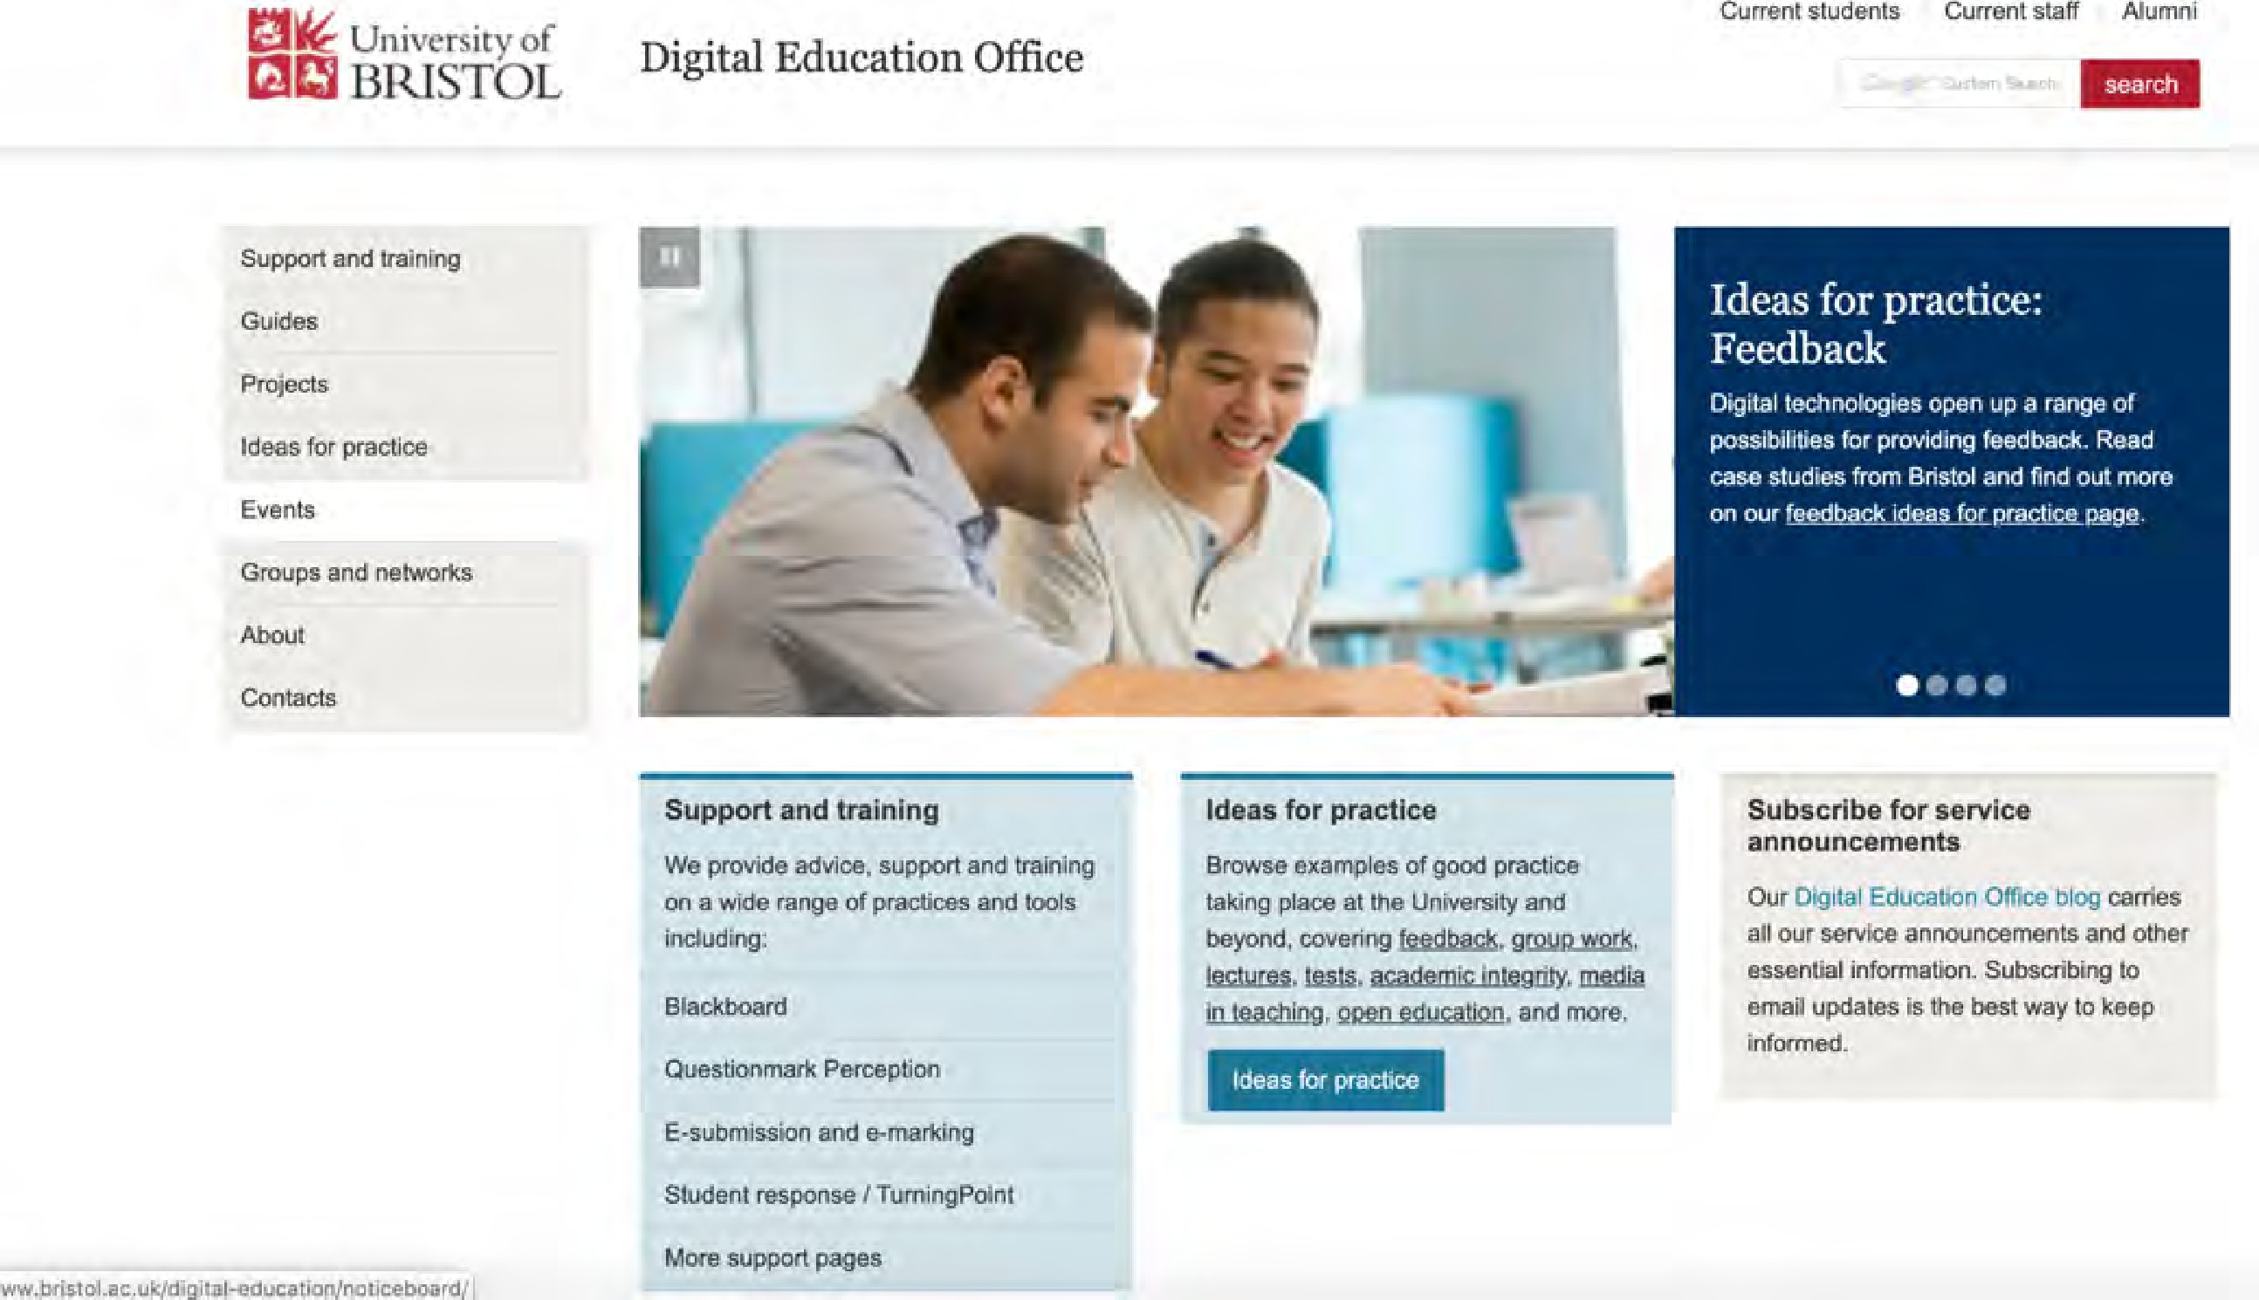](http://www.bristol.ac.uk/digital-education/)

*Figure 14.3.1 The University of Bristol Digital Education support site. Click on image to go to web site.*

#### The need for learning technology support systems

There have been many references in this book to the need for teachers and instructors to work, wherever possible, with instructional designers and media producers when teaching in a digital age. The reasons for this are fairly obvious:

* no teacher can be an expert on everything; working in a team covers a wider a range of skills and knowledge;
* technology should be used to decrease instructor and faculty workload, not to increase it; instructional designers in particular should be able to help teachers and faculty to manage their workload while still producing high quality teaching; media

producers enable subject experts to focus on content and skills development;

* team teaching, with different skills within the team (two or more subject experts, instructional designer, media producer) will lead to higher quality teaching.

As a result, over the last ten to twenty years, there has been a rapid expansion in the number of learning technology support systems, both in school systems and higher education institutions. Over time, separate units focusing on faculty development, learning technology support, and distance education have become merged or integrated into multi-functional units, under a variety of names, although legacy systems can sometimes take a long while to make this shift.

#### The scaling problem

As the move to blended, hybrid and online learning increases, so does the demand for these support units, to such an extent that one university I know well now has over 60 support staff and a budget of over $12 million a year for its central Centre for Teaching, Learning and Technology, plus several ‘satellite’ units in the larger faculties. At the other end a small elementary school will be lucky to have one teacher with some training in maintaining the computers and the Internet added to their responsibilities. However, many school systems also have a central educational technology unit that can provide support to individual teachers and schools within the system.

Institutions are already spending a good deal to support just the fully online courses or programs. There are good models for such courses based on instructional designers and media specialists working in a team with instructors in developing fully online courses. This way, the special design requirements for students studying off campus can be met.

However, at the moment, fully online courses constitute somewhere around 10-15 per cent of all the credit-based teaching in North American universities and between 5-10% of courses in the school/k-12 systems. What happens when we go to 85 per cent or more of the teaching being blended? The current learning technology support model just won’t be able to handle this expansion, certainly not at the rate that it is being predicted. However, without a design strategy for blended learning, and adequate support for faculty and instructors, it is almost certain that the quality will be poor, and it is certain that all the

potential benefits of blended learning for transforming the quality of teaching will not be achieved.

Trying to extend the current support system from fully online to blended courses and programs will ultimately be unsustainable. Although support units will be essential to get blended learning successfully started, teaching activities must be economically sustainable, which means teachers and instructors will eventually need to become able to design and manage blended learning effectively without continuous and ongoing support from instructional designers and media producers. This will require a huge training and retraining effort.

#### Teacher or instructor training or support units? The need for balance

I am a strong supporter of such specialised units to work with teachers and instructors. However, this has to be balanced against the costs. Funding from these units usually comes from within the overall budget for teaching and learning which in the end results in larger classes. These support units grow in inverse proportion to the lack of pre-service and in-service training.

However, these learning technology support units are essential for the effective development of teaching in a digital age. Thus a balance needs to be found between the provision of training in the use of learning technologies and the need for learning technology support units, which is why faculty development and learning technology units have tended to become integrated, and why institutions need a defined strategy for supporting teaching and learning. Thus although it is possible for a particularly dedicated teacher to teach successfully without such support, learning technology support units are becoming an essential service for most teachers and instructors.

1. What kind of learning technology support can you readily access? Is there enough? Can it provide the help you need? Have you tried? Is it close at hand or distant?

*Activity 14.3 Learning technology support*

1. What kind of support would you like that isn’t being provided at the moment? Have you talked to your learning technology support unit about what kind of help you would like?
2. Does the unit combine professional development, learning technology support, and distance education, or are they all in separate units? Does this matter to you?

There is no feedback on this activity.

# Conditions of employment

[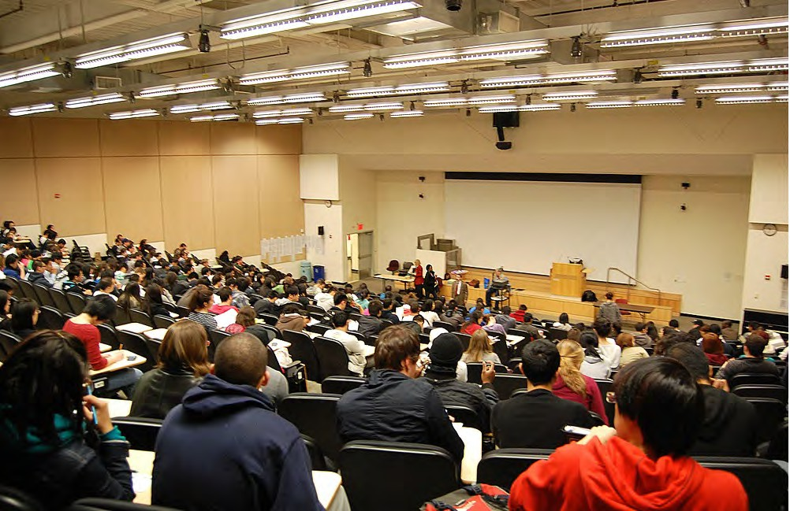](http://opentextbc.ca/teachinginadigitalage/wp-content/uploads/sites/29/2015/03/Lecture-theatre-2.jpg)

*Figure 14.4.1 Class size affects the capacity to develop the skills and knowledge needed in a digital age*

There are currently some major changes in conditions of employment that will influence the ability of individual teachers and instructors to deliver the kind of teaching needed in a digital age.

#### Class size

The most obvious is class size. Although some economies of scale are definitely achievable through the use of technology for teaching (see for instance, [Bates, 2013](http://www.tonybates.ca/2013/12/23/productivity-and-online-learning-redux/)), and there is

no magic number as to how many students there should be per teacher, we have seen in earlier chapters that teacher presence and the interaction between subject experts and students are critical factors in developing the knowledge and skills needed in a digital age.

Although technology can replace the need for teachers and instructors for the transmission of content, the need for ongoing communication between teacher and students for deep understanding and the development of skills, means that there soon becomes a limit, in terms of the number of students per teacher or instructor, beyond which the teaching rapidly starts to become ineffective, at least in terms of the knowledge and skills that matter most (Carey and Trick, [2013](http://www.heqco.ca/SiteCollectionDocuments/How_Online_Learning_Affects_Productivity-ENG.pdf)).

Thus the major challenge is in universities and some large two-year colleges, where first and second year classes can number in the thousands, and even in third or fourth year classes, in the hundreds. What can be done to ensure that teacher student ratios are kept to a manageable size? Institutions have taken a number of different approaches to this challenge.

#### The increased use of contract instructors and teaching assistants

One of the biggest changes to universities in North America over the last twenty years has been the growth of non-tenured teaching faculty in universities. An explosion in undergraduate enrolments across Canada – 400,000 more students from 2002 to 2012 – has come without a corresponding increase in tenure-track faculty. While the number of instructors doubled between the 1980s and 2006, there was a decline of 10 per cent in tenure and tenure-track faculty (Chiose, [2015](https://www.theglobeandmail.com/news/national/education/increased-pressures-class-sizes-taking-their-toll-on-faculties-in-academia/article22111189/)). The position is, if anything, even more dramatic in the USA, where universities and colleges were much harder hit by the economic crisis in 2008 than their Canadian counterparts, and are still in 2022 trying to recover from the effects of the large budget cuts in 2008.

In an article in Canada’s leading newspaper, the Globe and Mail, Simona Chiose wrote ([2018](https://www.theglobeandmail.com/news/national/education/increased-pressures-class-sizes-taking-their-toll-on-faculties-in-academia/article22111189/)):

*Canadian universities say they can no longer afford to deliver higher education through tenured academics who may spend more than a third of their time engaged in research.*

*Instead, most universities have decided that, to staff their classrooms at reasonable cost, they must turn, in varying degrees, to contract instructors and teaching-track faculty.*

Contract staff such as adjuncts or sessionals usually have either a doctoral degree in the subject area, or strongly related work experience for more vocational subjects. In Canada, the union representing contract instructors (CUPE) is fighting to get multiyear contracts for sessional instructors who now have to reapply each year for their jobs. Ideally, the union would like universities to give sessional instructors priority for teaching-track jobs, which do not have tenure, but have more job security than contract positions. With job security can come opportunities for training in teaching.

However, an even more alarming development in recent years has been an increasing tendency to use post-graduate students as teaching assistants, often responsible for delivering lectures to 200 students or more in first and second year courses. This model is also being increasingly used where institutions are moving to a hybrid model, combining both online and face-to-face components, especially where a former very large lecture- based course is being redesigned for hybrid learning. Even including the TAs, the instructor/student ratio is often 1:100 or higher for these large enrollment courses. There is usually no additional training for TAs about how to teach online, although in many – but by no means all – cases, they do get some kind of training in teaching face-to-face.

With fully online courses, though, a different model has often been used where the instructor:student ratio has been deliberately targeted at under 40 for undergraduate courses, and under 30 for graduate courses. Scaling up has been handled by hiring additional part-time adjunct or associate professors on contract. The adjuncts would be paid to take a short online briefing course on teaching online which sets out the expectations for online teaching. This was an affordable model because the additional student tuition fees would more than cover the cost of hiring additional contract instructors, once the course was developed (Bates and Poole, [2003](https://www.amazon.ca/Effective-Teaching-Technology-Higher-Education/dp/0787960349)).

However, this has been possible because most of such online courses have been aimed mainly at higher level undergraduate students or graduate students. With both blended and online courses now being targeted at large first and second year classes, new models are being developed that may not have the same level of quality as the ‘best practice’ online courses. This is a particularly difficult issue for several reasons:

* practices both for dealing with large face-to-face classes and with online classes

vary considerably within each form of delivery, and from one institution to another, so making generalizations is fraught with danger;

* decisions about whether to use teaching assistants or part-time, contract instructors, are driven more by financial considerations than by best pedagogical practice;
* there are other factors at work besides money and pedagogy in the use of teaching assistants and adjunct faculty, such as the desire to provide financial support to international and graduate students, the idea of apprenticeship in teaching, and the supply and demand effects on the employment of doctoral graduates seeking a career in university teaching and research;
* there is no golden mean for instructor/student ratios in either blended or online learning. In the mainly quantitative/STEM subjects, much higher ratios are sustainable without the loss of quality, through the use of automated marking and feedback, for the theory component, while the practical component requires much lower ratios due to the need to share equipment and monitor students;
* MOOCs are (wrongly) giving the impression that it is possible to scale up even credit-based online learning at lower cost, by eliminating learning support provided by tenured faculty.

Despite these caveats, there is a genuine concern that the over-reliance on teaching assistants for online and blended courses will have three negative consequences for both students and online learning in general:

* as with the large face-to-face classes, the pedagogy for online or blended courses will resort more to information transmission, due to the TAs’ lack of training and experience in teaching online;
* for the online or hybrid courses, student drop-out and dissatisfaction will increase because, especially in first and second year teaching, they will not get the learning support they need when studying online. As a result, faculty and students will claim that hybrid or fully online learning is inferior to classroom-based instruction;
* faculty and especially faculty unions will see online learning and blended learning being used by administrations to cut costs and over time to reduce the employment of tenured faculty, and will therefore try to block its implementation.

Why can’t TAs provide the support needed online if they can do this for face-to-face classes? First, it is arguable whether they do provide adequate support for students in

large first year classes, but in online courses in subject domains where discussion is important, where qualitative judgements and decisions have to be made by students and instructors, where knowledge needs to be developed and structured, in other words in any field where the learning requires more than the transmission and repetition of information, then students need to be able to interact with an instructor that has a deep understanding of the subject area. Thus there are good reasons to hire adjunct faculty (as usually they already have post-graduate qualifications) to teach online or in blended formats, but not TAs in general (although there will always be exceptions).

#### The elephant in the room

However, the discussion about the use of adjuncts and TAs masks a more significant issue. There are two factors that lead to the very large class sizes in first and second year that faculty and their unions really don’t want to talk about:

* the starvation of first and second year students of teaching resources; senior faculty concentrate more on upper level courses, and want to keep these class sizes smaller. As a consequence first and second year students suffer;
* teaching subsidizes research: too often tuition revenues get filtered off into supporting research activities. The most obvious case is that if teachers spent more time teaching and less doing research, there would be more faculty available for teaching. Teaching loads for experienced, tenured faculty are often quite light and as stated above, focused on small upper level classes. A report from the Higher Education Quality Council of Ontario (Jonker and Hicks, [2014](http://www.heqco.ca/SiteCollectionDocuments/FINAL%20Teaching%20Loads%20and%20Research%20Outputs%20ENG.pdf)) suggested that if professors whom it has classified as laggards in research doubled their teaching time, it would be the equivalent of adding 1,500 faculty members across the province, enough to staff an additional mid-sized university.

#### The increasing diversity of teachers

Much has been said in this book about the increasing diversity of students, and the implications for teaching. We should add to that the increasing diversity of teachers:

* fully tenured, research-focused faculty, with very high academic qualifications but relatively little or no training in teaching;
* contract adjunct or sessional instructors, highly qualified academically, but with little or no chance of professional development in the teaching area;
* teaching assistants, with mid-level academic qualifications and little or no training in teaching;
* work-experienced vocational and technical instructors, with a small amount of training in teaching;
* school teachers, well trained in general teaching methods, but few with training specifically for teaching in a digital age.

The reasons for and the significance of this increasing diversity of teachers and instructors is beyond the scope of this book. Nevertheless, without some kind of job security there is little opportunity or incentive for training in new technologies and teaching methods.

#### References

Bates, A. and Poole, G. (2003) [*Effective Teaching with Technology in Higher Education:*](https://www.amazon.ca/Effective-Teaching-Technology-Higher-Education/dp/0787960349)[*Foundations for Success*](https://www.amazon.ca/Effective-Teaching-Technology-Higher-Education/dp/0787960349)San Francisco: Jossey-Bass

Bates, T. (2013) [Productivity and online learning redux](https://www.tonybates.ca/2013/12/23/productivity-and-online-learning-redux/), *Online Learning and Distance Education Resources*, December 23

Carey, T., & Trick, D. (2013). [*How Online Learning Affects Productivity, Cost and Quality in*](http://www.heqco.ca/SiteCollectionDocuments/How_Online_Learning_Affects_Productivity-ENG.pdf)[*Higher Education: An Environmental Scan and Review of the Literature*](http://www.heqco.ca/SiteCollectionDocuments/How_Online_Learning_Affects_Productivity-ENG.pdf)*.* Toronto: Higher Education Quality Council of Ontario,

Chiose, S. (2018) [Increased pressures, class sizes, taking their toll on faculties in academia](https://www.theglobeandmail.com/news/national/education/increased-pressures-class-sizes-taking-their-toll-on-faculties-in-academia/article22111189/),

*Globe and Mail,* May 12

Jonker, L. and Hicks, M. (2014) [*Teaching Loads and Research Outputs of Ontario University*](http://www.heqco.ca/SiteCollectionDocuments/FINAL%20Teaching%20Loads%20and%20Research%20Outputs%20ENG.pdf)[*Faculty: Implications for Productivity and Differentiation*](http://www.heqco.ca/SiteCollectionDocuments/FINAL%20Teaching%20Loads%20and%20Research%20Outputs%20ENG.pdf)Toronto: Higher Education Quality Council of Ontario

1. Why does class size matter particularly for developing the knowledge and skills needed in a digital age?
2. Some governments think online learning will enable larger classes. Do you agree? What are your reasons?
3. What are the advantages and disadvantages of having just teaching staff in universities, such as tenure track teaching professors and/or adjuncts/sessionals/contract instructors, in terms of the development of the knowledge and skills required in a digital age?

Click on the podcast below for my views on the above:

*Activity 14.4 Conditions of employment*

*One or more interactive elements has been excluded from this version of the text. You can view them online here:* [*https://pressbooks.bccampus.ca/teachinginadigitalagev3m/?p=444#audio-444-1*](https://pressbooks.bccampus.ca/teachinginadigitalagev3m/?p=444&audio-444-1)

# Team teaching

[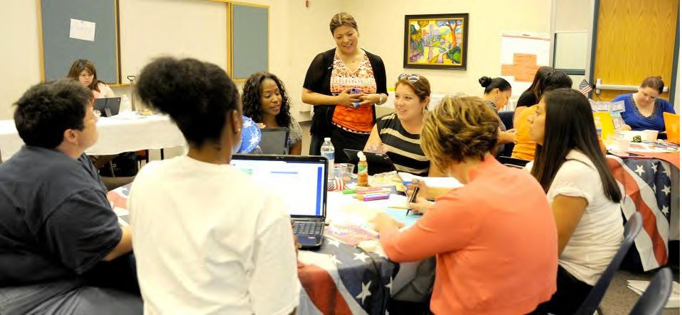](http://opentextbc.ca/teachinginadigitalage/wp-content/uploads/sites/29/2015/03/Group-work2.jpg)

*Figure 14.5.1 Breaking down a large lecture class into smaller groups Image: © University of Texas at San Antonio*

There is no easy solution to the problem of reducing class size to numbers that will ensure all students can be helped to develop the knowledge and skills needed in a digital age. Alex Usher in his blog [One Thought to Start Your Day](http://higheredstrategy.com/managing-class-sizes-part-1/) examines different ways to allocate teaching loads to instructors, resulting in classes of different sizes. However, teaching load is usually organised at a departmental level. Too often, an individual instructor has little choice over the size of class to which they are allocated.

Whatever the course design, face-to-face, blended or fully online, large numbers of students per instructor limits what is possible pedagogically. It is extremely difficult to teach the higher level skills of critical thinking, problem-solving and collaborative working in very large classes. Nevertheless, there are several successful approaches to re- designing these large introductory courses of 1,000 students or more, involving the use of blended learning. See for instance:

* the [National Center for Academic Transformation](http://www.thencat.org/articles.html)‘s course redesign process,
* [a large first year psychology course at McMaster University,](https://teachonline.ca/pockets-innovation/blended-learning-introductory-psychology)
* an [online large enrolment course in anatomy at Dalhousie University](https://teachonline.ca/pockets-innovation/teaching-online-large-enrolment-course-anatomy-dalhousie-university-nova-scotia-canada)

The following design attempts to build in at least some opportunities for the development of high level skills in a very large class:

* create a team to design, develop and deliver the course; the team will include a senior tenured professor, four TAs, plus an instructional designer and web/ multimedia designer allocated to help with the initial design;
* the senior professor acts as a teaching consultant, responsible for the overall design of the course, hiring and supervising the work of the TAs, and designing the assessment strategy/questions and rubrics, in consultation with the rest of the team;
* nearly all content is provided online through a combination of short videos and textual material designed and loaded on the LMS; this is largely the work of the senior professor working with the instructional designer, assisted by the TAs, before the course begins;
* computer-marked assignments are used to mark student comprehension and understanding, and to provide automated feedback/guidance; there is an end-of semester computer-marked assignment that provides an individual mark for each student;
* students are allocated to groups of 33, and each of the TAs is responsible for eight student groups, or 250 per TA;
* each TA acts as the day-to-day link for each of the 33 students in each of the eight groups they are responsible for;
* each class of 33 is divided into five sub-groups of six to seven students, who work on two projects a semester; the first project is not assessed, but is subject to student peer review, using guidelines/rubrics established by the senior professor; the second project is assessed by the TAs (roughly 40 assignments per TA), again using rubrics designed by the senior professor. The projects aim to develop specific, pre- identified skills, such as critical thinking, problem solving, and collaborative working.
* students in each group of six or seven work through online discussion forums or face-to-face on each project, depending on convenience to the students. The discussion forums are lightly moderated by the TAs, mainly to ensure that students are on topic and respectful to each other; if serious issues arise, these are referred to

the senior professor;

* TAs mark the group assignments, following rubrics decided earlier, and the senior professor monitors and calibrates the marking between instructors; for each student their group mark (50%) is added to their individual mark (50%) from the end-of- semester computer-marked assignment;
* the senior professor meets for one hour a week with a different group of 33 students three times a week either face-to-face or synchronously online; this means that every student gets at least one hour of personal interaction with the senior professor during the semester. The sessions are used to discuss key issues in the course and focus on the pre-determined skills development.

Whatever detailed design is done, these large courses should have a clear business model to work with, which basically provides an overall budget for the course, that includes the cost of the TAs, and takes account of the students numbers (more students, more budgeted money), but allowing the senior professor to build the team as best as possible within that budget. TAs would receive a briefing on responsibilities, online mentoring, assessment marking, for which they would be paid in addition to or as part of their teaching contract.

Ideally though the organization of teaching should not result in such very large classes, if at all possible. However, the principle of team teaching should be considered for all classes with more than 30 or so students.

#### Reference

Sana, F. et al. (2011) [A Case Study of the Introductory Psychology Blended Learning Model](https://ir.lib.uwo.ca/cjsotl_rcacea/vol2/iss1/6/) [at McMaster University](https://ir.lib.uwo.ca/cjsotl_rcacea/vol2/iss1/6/) *The Canadian Journal for the Scholarship of Teaching and Learning*, Vol. 2, No.1

Usher, A. (2019) [Managing Class Size](http://higheredstrategy.com/managing-class-sizes-part-1/) *One Thought to Start Your Day*[,](http://higheredstrategy.com/managing-class-sizes-part-1/) Higher Education Strategy Associates, September 18

1. Assume you have a class of 1,600 students for which you are responsible. You have the resources to hire two adjunct faculty and six TAs. How would you design the class?

There is no feedback for this activity.

*Activity 14.5 Designing a team approach*

# An institutional strategy for teaching in a digital age

[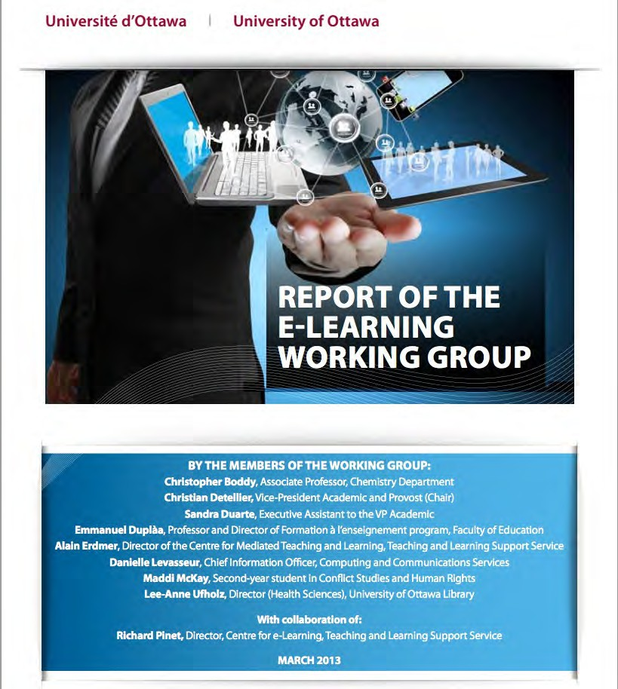](https://ucarecdn.com/82cc3ceb-11a1-40ed-b578-1294ed74589c/)

*Figure 14.6.1* [*The University of Ottawa’s e-learning plan, 2013*](https://ucarecdn.com/82cc3ceb-11a1-40ed-b578-1294ed74589c/)*. Click on the graphic to access the plan. In 2017, the UOttawa* [*reviewed the success of the plan*](https://tlss.uottawa.ca/site/files/docs/TLSS/blended-report/Rapport_Initiative_Hybride_English.pdf)

It can be seen that issues around faculty development and training, class size, hiring

of contract instructors and teaching assistants, and team work will influence the organisation’s capacity to do the kind of teaching that will develop the knowledge and skills needed in a digital age (or any other age, for that matter). It may be possible for you, particularly if you are tenured faculty working in a university, individually to make the necessary changes to your teaching to fit the needs of a digital age, but for the majority of teachers and instructors, the institution and the system as a whole needs to support the necessary changes to teaching. It can do this best by having a formal plan or strategy that sets out:

* the rationale for changes;
* the goals or outcomes that such changes will lead to (for example, learners with specified skills and competencies);
* actions that will support the changes (for example, funding for new course design, re-organisation of services);
* a financial strategy to support the intended changes, such as funding for innovation in teaching;
* a way of measuring successful implementation of the strategy.

There are various ways in which such a strategy may be developed (see Bates and Sangrà, [2011](https://www.wiley.com/WileyCDA/WileyTitle/productCd-0470584726%2CminiSiteCd-JBHIGHERED.html)), including top-down and bottom-up processes for setting overall goals, but in a university it may be through an annual academic planning process where departments/ faculties must submit their plans for the next three years, including resources needed, based on meeting the overall academic goals set by the university. In such a planning cycle, it is important to include the goals for meeting the needs of learners in a digital age as ‘targets’ for departments when drawing up their plans. These plans should indicate not only content to be covered but also delivery and teaching methods to be used, with a rationale for them.

Many universities and colleges are in the process of developing or implementing such plans, such as the University of British Columbia’s [Flexible Learning Initiative](http://flexible-learning2015.sites.olt.ubc.ca/files/2015/04/fl_strategy_september_2014.pdf) and the University of Ottawa’s [e-learning plan](http://www.uottawa.ca/vr-etudes-academic/en/documents/e-learning-working-group-report.pdf). Indeed, at least in Canada, most institutions have recognised the need for a strategic plan for ‘e-learning’. Johnson ([2019](https://onlinelearningsurveycanada.ca/)) found that 71 per cent of responding post-secondary institutions reported that online learning is very or extremely important for the institution’s long-term strategic or academic plan. However, only 42 per cent actually had implemented or were implementing a strategic plan for e- learning, and it is not known how closely these plans are tied to the development of the

knowledge and skills needed in a digital age, or whether they focus mainly on resources or organizational issues. Nevertheless, a good plan, preferably dynamic and continually reviewed, is essential for such developments.

Lastly, it is of course important for anyone who has read this book to make sure they are actively engaged in such processes, to help shape policy and direction. Without institutional support, it will be difficult to make significant changes.

#### References

Bates, A. and Sangrà, A. (2011) [*Managing Technology in Higher Education: Strategies for*](https://www.wiley.com/WileyCDA/WileyTitle/productCd-0470584726%2CminiSiteCd-JBHIGHERED.html)[*Transforming Teaching and Learning*](https://www.wiley.com/WileyCDA/WileyTitle/productCd-0470584726%2CminiSiteCd-JBHIGHERED.html)San Francisco: Jossey-Bass/John Wiley & Co.

Johnson, N. (2019) [*Tracking Online and Distance Education in Canadian Universities and*](https://onlinelearningsurveycanada.ca/)[*Colleges: 2019 Canadian National Survey of Online and Distance*](https://onlinelearningsurveycanada.ca/)Education Halifax NS: Canadian Digital Learning Research Association

University of British Columbia (2014) [Flexible Learning – Charting a strategic vision for](http://flexible-learning2015.sites.olt.ubc.ca/files/2015/04/fl_strategy_september_2014.pdf) [UBC (Vancouver Campus)](http://flexible-learning2015.sites.olt.ubc.ca/files/2015/04/fl_strategy_september_2014.pdf) Vancouver BC: Flexible Learning Implementation Team

University of Ottawa (2013) [*Report of the e-Learning Working Group*](https://ucarecdn.com/82cc3ceb-11a1-40ed-b578-1294ed74589c/)Ottawa ON: The University of Ottawa

University of Ottawa (2017) [Report on the Blended Learning Initiative, 2013-2016](https://tlss.uottawa.ca/site/files/docs/TLSS/blended-report/Rapport_Initiative_Hybride_English.pdf) Ottawa ON: The University of Ottawa

1. Does your organisation have a strategy for teaching and learning? Is it any good? Does it deal with the needs of learners in a digital age?
2. If you could design or change your organisation’s strategy for teaching and learning, what would you include? There is no feedback provided on this activity.

*Activity 14.6 Developing an institutional strategy for supporting teaching and learning*

This chapter focuses on the key support teachers and instructors will need from their employers to enable the development of the knowledge and skills students will need in a digital age. This support includes:

* pre-service and in-service training that focuses on digital and online teaching
* provision of specialist learning technology support units that can assist teachers and instructors teaching digitally
* ensuring teacher:student ratios that enable the interaction required to develop 21st century skills
* the use of team teaching and sessional instructors for very large classes using blended or hybrid learning
* a system- or institution-wide strategy/plan for the implementation and tracking of digital learning

*Key Takeaways*

## THE BOOK IN A NUTSHELL

When you have read this chapter you should be able to:

* summarise the main argument in the book as to why teaching needs to change to be fit for a digital age
* design your own course that fully exploits the potential of digital learning for developing the knowledge and skills that students will need in a digital age.

*The purpose of this chapter*

#### What is covered in this chapter

* 15.1 Building the future
* Scenario H: Stopping the flu

Also in this chapter you will find the following activity

* Activity 15.1 Develop a future scenario for your teaching

1. There is increasing pressure from employers, the business community, learners themselves, and also from a significant number of educators, for learners to develop the type of knowledge and the kinds of skills that they will need in a digital age.
2. The knowledge and skills needed in a digital age, where all ‘content’ will be increasingly and freely available over the Internet, requires graduates with expertise in:
   * knowledge management (the ability to find, evaluate and appropriately apply knowledge);
   * IT knowledge and skills;
   * inter-personal communication skills, including the appropriate use of social media;
   * independent and lifelong learning skills;
   * a range of intellectual skills, including:

*Key Takeaways (from the book as a whole)*

* + knowledge construction;
  + reasoning;
  + critical analysis;
  + problem-solving;
  + creativity;
* collaborative learning and teamwork;
* multi-tasking and flexibility.

These are all skills that are relevant to any subject domain, and need to be embedded within that domain. With such skills, graduates will be better prepared for a volatile, uncertain, complex and ambiguous world.

1. To develop such knowledge and skills, teachers and instructors need to set clear learning outcomes and select teaching methods that will support the development of such knowledge and skills, and, since all skills require practice and feedback to develop, learners must be given ample opportunity to practice such skills. This requires moving away from a model of information transmission to greater student engagement, more learner- centred teaching, and new methods of assessment that measure skills as well as mastery of content.
2. Because of the increased diversity of students, from full-time campus-based learners to lifelong learners already with high levels of post-secondary education to learners who have slipped through the formal school system and need second-chance opportunities, and because of the capacity of new information technologies to provide learning at any time and any place, a much wider range of modes of delivery are needed, such as campus-based teaching, blended or hybrid learning and fully online courses and programs, both in formal and in non-formal settings.
3. The move to blended, hybrid and online learning and a greater use of learning technologies offers more options and choices for teachers and instructors. In order to use these technologies well, teachers and instructors require not only to know the strengths and weaknesses of different kinds of technology, but also need to have a good grasp of how students learn best. This requires knowing about:

* the research into teaching and learning;
* different theories of learning related to different concepts of knowledge (epistemology);
* different methods of teaching and their strengths and weaknesses.

Without this basic foundation, it is difficult for teachers and instructors to move away from the only model that many are familiar with, namely the lecture and discussion model, which is limited in terms of developing the knowledge and skills required in a digital age.

1. The challenge is particularly acute in universities. There is no requirement to have any training or qualification in teaching to work in a university in most Western countries. Nevertheless teaching will take up a minimum of 40 per cent of a faculty member’s time, and much more for many adjunct or contract faculty or full time college instructors. However, the same challenge remains, to a lesser degree, for school teachers and college instructors: how to ensure that already experienced professionals have the knowledge and skills required to teach well in a digital age.
2. Institutions can do much to facilitate or impede the development of the knowledge and skills required in a digital age. They need to:

* ensure that all levels of teaching and instructional staff have adequate training in the new technologies and methods of teaching necessary for the development of the knowledge and skills required in a digital

age;

* ensure that there is adequate learning technology support for teachers and instructors;
* ensure that conditions of employment and in particular class size enable teaching and instructional staff to teach in the ways that will develop the knowledge and skills needed in a digital age;
* develop a practical and coherent institutional strategy to support he kind of teaching needed in a digital age.

1. Although governments, institutions and learners themselves can do a great deal to ensure success in teaching and learning, in the end the responsibility and to some extent the power to change lies within teachers and instructors themselves.
2. It will be the imagination of teachers inventing new ways of teaching that will eventually result in the kinds of graduates the world will need in the future.

# Building the future

[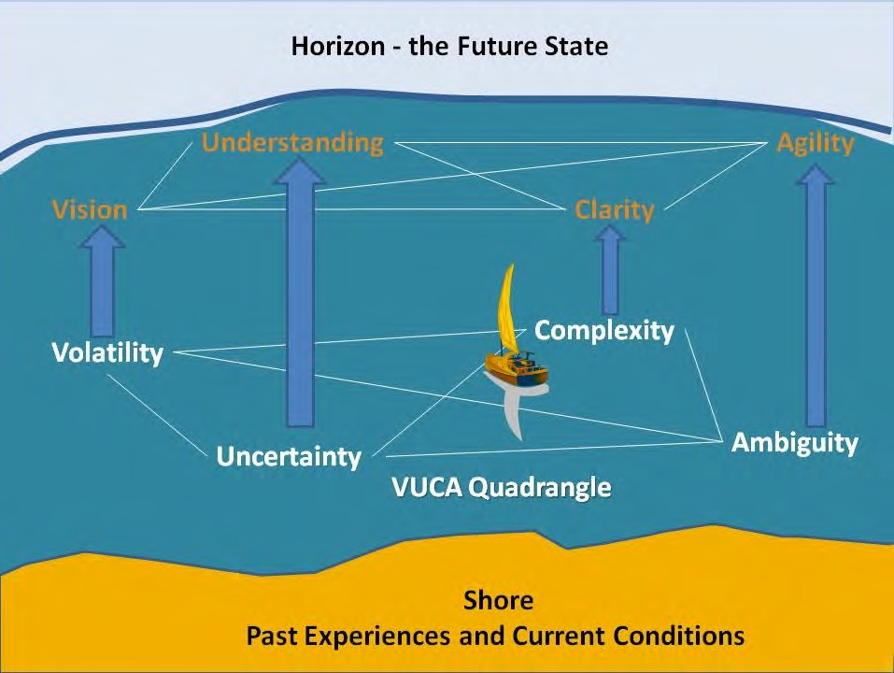](http://opentextbc.ca/teachinginadigitalage/wp-content/uploads/sites/29/2014/11/VUCA-2.jpg)

*Figure 15.1 Navigating a volatile, uncertain, complex and ambiguous world Image: © Carol Mase, Free Management Library, 2011, used with permission*

#### 15.1 The rationale for change

This book sets out the case for increased training in teaching methods, or more accurately a different approach to training, for teachers, instructors and faculty, if students are to be fully prepared for life in a digital age. The argument goes like this:

1. There is increasing pressure from employers, the business community, learners themselves, and also from a significant number of educators, for learners to develop the type of knowledge and the kinds of skills that they will need in a digital age.
2. The knowledge and skills needed in a digital age, where all ‘content’ will be increasingly and freely available over the Internet, requires graduates with expertise in:
   * knowledge management (the ability to find, evaluate and appropriately apply knowledge);
   * IT knowledge and skill;
   * inter-personal communication skills, including the appropriate use of social media;
   * independent and lifelong learning skills;
   * a range of intellectual skills, including:
     + knowledge construction;
     + reasoning;
     + critical analysis;
     + problem-solving;
     + creativity;
   * collaborative learning and teamwork;
   * multi-tasking and flexibility.

These are all skills that are relevant to any subject domain, and need to be embedded within that domain. With such skills, graduates will be better prepared for a volatile, uncertain, complex and ambiguous world.

1. To develop such knowledge and skills, teachers and instructors need to set clear learning outcomes and select teaching methods that will support the development of such knowledge and skills, and, since all skills require practice and feedback to develop, learners must be given ample opportunity to practice such skills. This requires moving away from a model of information transmission to greater student engagement, more learner-centred teaching, and new methods of assessment that measure skills as well as mastery of content.
2. Because of the increased diversity of students, from full-time campus-based learners to lifelong learners already with high levels of post-secondary education to learners who have slipped through the formal school system and need second-chance opportunities, and because of the capacity of new information technologies to provide learning at any

time and any place, a much wider range of modes of delivery are needed, such as campus- based teaching, blended or hybrid learning and fully online courses and programs, both in formal and in non-formal settings.

1. The move to blended, hybrid and online learning and a greater use of learning technologies offers more options and choices for teachers and instructors. In order to use these technologies well, teachers and instructors require not only to know the strengths and weaknesses of different kinds of technology, but also need to have a good grasp of how students learn best. This requires knowing about:
   * the research into teaching and learning;
   * different theories of learning related to different concepts of knowledge (epistemology);
   * different methods of teaching and their strengths and weaknesses.

Without this basic foundation, it is difficult for teachers and instructors to move away from the only model that many are familiar with, namely the lecture and discussion model, which is limited in terms of developing the knowledge and skills required in a digital age.

1. The challenge is particularly acute in universities. There is no requirement to have any training or qualification in teaching to work in a university in most Western countries. Nevertheless teaching will take up a minimum of 40 per cent of a faculty member’s time, and much more for many adjunct or contract faculty or full time college instructors. However, the same challenge remains, to a lesser degree, for school teachers and college instructors: how to ensure that already experienced professionals have the knowledge and skills required to teach well in a digital age.
2. Institutions can do much to facilitate or impede the development of the knowledge and skills required in a digital age. They need to:
   * ensure that all levels of teaching and instructional staff have adequate training in the new technologies and methods of teaching necessary for the development of the knowledge and skills required in a digital age;
   * ensure that there is adequate learning technology support for teachers and instructors;
   * ensure that conditions of employment and in particular class size enable teaching

and instructional staff to teach in the ways that will develop the knowledge and skills needed in a digital age;

* + develop a practical and coherent institutional strategy to support the kind of teaching needed in a digital age.

#### 13.7.2 Building your own future

Although governments, institutions and learners themselves can do a great deal to ensure success in teaching and learning, in the end the responsibility and to some extent the power to change lies within teachers and instructors themselves. In probably no other profession is there such an opportunity to work in the way that you choose.

To help you create the kind of teaching needed in a digital age, Chapter 6, Section 10 provides an exercise for building a rich learning environment for your students, applying the guidelines outlined in this book.

Although a sound basis of knowledge and experience is important, no other quality in teachers is more important than vision and imagination. This book attempts to provide a glimpse into the possibilities of teaching in the future, but that future still needs to be invented. The demands of the market, the ethical and moral challenges of society, changing technologies, and the diversity of learning needs are all components in a complex mix of factors that require an appropriate response from teachers and instructors.

This book attempts to provide some foundations for decision-making in this volatile, uncertain, complex and ambiguous world, and I end with Scenario H that aims to suggest one possibility for the future, but it will be the imagination of you and other teachers inventing new ways of teaching that will eventually result in the kind of graduates the world will need in the future. I hope this book in some small way will help you along this road.

1. Read Scenario H and/or the other scenarios in this book. Now write your own scenario for your own teaching. Do NOT take into account current resources or institutional policies.
2. What would have to change in your organisation to make your scenario possible? There is no feedback provided for this activity.

*Activity 15.1 Develop a future scenario for your teaching*

# Scenario H: Stopping the flu

[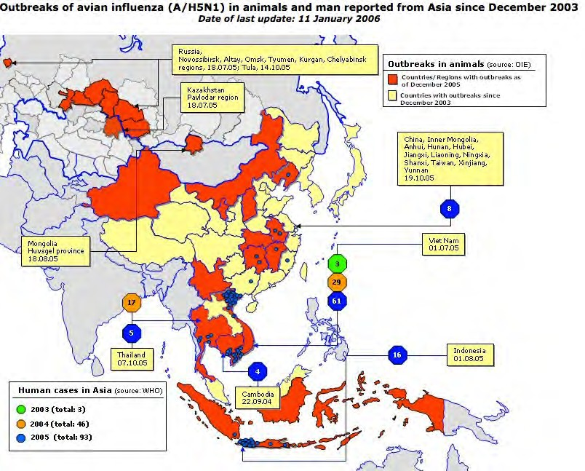](http://opentextbc.ca/teachinginadigitalage/wp-content/uploads/sites/29/2015/03/Flu-avian-2.jpg)

*Figure H.I Stopping the flu*

*Image: © European Commission, 2015*

*Hi, Chris, you asked for an update on what I’m studying at the University of Central Canada. Well, I’m about half-way through a really neat program called Global Science. We get to choose from about five or six problems to research. At the moment, the problem I’ve chosen is called ‘Stopping the flu.’ Basically, we’re looking at the influenza virus, and how to prevent pandemics. I thought when I started it would be all medicine, but I’m having to do math, geography, agriculture, even management and*

*communications, as well as other types of science because they are all related in some way to the problem we are looking at. We work as a group on defining the problem, collecting data, and interpreting the results.*

*I’m in a group of 25 students, and they are from all over the world. Altogether there are over 2,000 students taking the program. My main instructor, Dr. Madelaine McVicar, who is responsible for my group of 25, is based the other side of the country in a hospital in Halifax, but really she’s more like a conductor of an orchestra, because the course uses experts from all over the world, some of whom come in with just short podcasts or YouTube videos, while others run webinar sessions that deal with specific questions as they come up in our research. Dr. McVicar is great at finding resources to help us, and we also occasionally get sessions online with some of the professors at UCC who helped design the program.*

*What threw me at the beginning was the lack of lectures or pre-determined weekly study topics. Although we all had to do a set of modules on basic research methods, and we have a sort of program guide on the web designed by the UCC profs, we choose study topics and are provided with a guide to a wide range of resources, mainly free stuff available all over the Internet, such as published papers in open access journals or stuff in MOOCs that will directly help us with the research problem we are tackling. The course web site gave us some leads as to where to look, and we had to provide an interim report early on to Dr. McVicar that listed the resources we were accessing or looking for. Some of these topics, such as the molecular structure of the flu virus, are pretty obvious, but other topics we had to identify ourselves. I was particularly interested in the link between international travel and the spread of flu. One of the things we have to do always is to provide an evaluation of the sources we use and their reliability.*

*Each month the group has to create our own online reports – called e-portfolios – which shows the progress we’ve made on the research question each month. In the end, we get 50 per cent of our marks from the monthly group e-portfolios and the other 50 per cent from an individual e-portfolio we each create summarizing the whole project and our individual contribution to the project. Dr. McVicar does the marking and grading.*

*There’s about 20 other student groups from UCC researching the same question, and we are sharing data across the groups, so we get great help and feedback from the other groups as well, through a discussion forum and a shared web site for the monthly e- portfolios. Because of my job, I’m particularly interested in mortality rates from different*

*kinds of flus and I was able to hook up with another student in another group who turns out to be a specialist in that subject, working for a Swiss insurance company – it might even lead to a job for me!*

*Because of the agreements UCC has made with many hospitals and health authorities around the world, we’re getting access to some great data. We often have to go and find local data ourselves, such as the number of local hospital admissions for flu in a particular week. For instance, we were able to track the spread of a particular strain from the first week of our course, when it was identified in China, across the world over the following five months. UCC also has an agreement with IBM to load the data and use some of their analytics as well. Apparently UCC got money from one of the research councils to support some of the research on this program because of the ability to draw on so many sources of relatively raw data from around the world, which means my group sometimes get Skyped by one of the UCC profs who wants access to our data! Another group even got asked by the WHO (the World Health Organization, not the rock group) for their data.*

*Many of the international students are in other universities, and will transfer the credits into their own program, although a lot of the students are also sponsored by employers, such as hospitals or government agencies. You can in fact get a badge for successfully completing just one of the research problems, and a diploma for doing all three. However, the final 60 credits of the degree program requires me to do my own, individual research project, and I think I’ll try and do that, because I need that to go on to grad school, although everyone says that doing the individual research project is pretty tough, as the standard is very high.*

*But what I really like about this program is that I’m learning so much, so quickly. We’re dealing with a real problem, and you know, having so many people from such different backgrounds all working on the same problem means that I feel we are actually making a difference, as well as studying.*

Acknowledgement: This scenario was originally developed for the U.K. Open University well before the Covid-19 pandemic and is used with their permission. The scenario was influenced by McMaster University’s integrated science program. However, the McMaster program is an on-campus program limited to a highly selected group of 50 students.

## APPENDIX 1: QUESTIONS TO GUIDE MEDIA SELECTION AND USE

The questions on the following pages should be used in conjunction with Chapter 10, and address a real context that you may be facing, such as designing a new course.

It is recommended you work through each question one by one, possibly making notes of your answers. It is also recommended that you do this in a fairly systematic manner the first two or three times when faced with a possible choice of media for a whole course or program. This could take a few days, allowing time for thinking. Some questions may need to wait until other questions have been answered. It will likely to be an iterative process.

After you have worked through the questions, give yourself a day or two if possible before thinking about what media or technology will best fit with your course or program. Discuss your thoughts about media use with other instructors and with any professionals such as an instructional designer or media designer before the design of the course. Leave yourself open to making more final decisions as you start designing/developing and delivering the course, with the option of checking back with your notes and more details in Chapter 10.

After the first two or three times of working through the questions, you will be able to be less systematic and quicker in making decisions, but the questions and answers to the questions should always be in your head when making decisions about media for teaching.

# S: Who are your students?

1. What is the mandate or policy of your institution, department or program with respect to access? How will students who do not have access to a chosen technology be supported?
2. What are the likely demographics of the students you will be teaching? How appropriate is the technology you are thinking of using for these students?
3. If your students are to be taught at least partly off campus, to which technologies are they likely to have convenient and regular access at home or work?
4. If they are to be taught at least partly on campus, what is – or should be – your or your department’s policy with regard to students’ access to learning technologies in class?
5. What digital skills do you expect your students to have before they start the program?
6. If students are expected to provide their own access to technology, will you be able to provide unique teaching experiences that will justify the purchase or use of such technology?
7. What prior approaches to learning are the students likely to bring to your program? How suitable are such prior approaches to learning likely to be to the way you need to teach the course? How could technology be used to cater for student differences in learning?

# E: Ease of use

1. How intuitively easy to use is the technology you are considering, both by students and by yourself?
2. How reliable is the technology?
3. How easy is it to maintain and up-grade the technology?
4. The company that is providing the critical hardware or software you are using: is it a stable company that is not likely to go out of business in the next year or two, or is it a new start-up? What strategies are in place to secure any digital teaching materials you create should the organisation providing the software or service cease to exist?
5. Do you have adequate technical and professional support, both in terms of the technology and with respect to the design of materials?
6. How fast developing is this subject area? How important is it to regularly change the teaching materials? Which technology will best support this?
7. To what extent can the changes be handed over to someone else to do, and/or how essential is it for me to do them myself?
8. What rewards am I likely to get for using new technology in my teaching? Will use of a new technology be the only innovation, or can I also change my way of teaching with this technology to get better results
9. What are the risks in using this technology?

# C: What is the cost in money and time?

1. Which media are likely to take a lot of your time to develop? Which could you do quickly and easily?
2. How much time do you spend preparing lectures? Could that time be better spent preparing learning materials, then using the time saved from delivering lectures on interaction with students (online and/or face-to-face)?
3. Is there a possibility of extra funding for innovative teaching or technology applications? How could you best use that funding?
4. What kind of help can you get in your institution from instructional designers and media professionals for media design and development?
5. What open educational resources could be used for this course? Could you use an open textbook, thereby saving students the cost of buying textbooks? Can the library or your learning technology support group help identify potential OERs for your course?

# T: Teaching and other pedagogical factors

1. What are the desired learning outcomes from the teaching in terms of content and skills?
2. What instructional strategies will be employed to facilitate the learning outcomes?
3. What unique pedagogical characteristics of text will be appropriate for this course, in terms of content presentation and skills development?
4. What unique pedagogical characteristics of audio will be appropriate for this course, in terms of content presentation and skills development?
5. What unique pedagogical characteristics of video will be appropriate for this course, in terms of content presentation and skills development?
6. What unique pedagogical characteristics of computing will be appropriate for this course, in terms of content presentation and skills development?
7. What unique pedagogical characteristics of social media will be appropriate for this course, in terms of content presentation and skills development?
8. What really must be done face-to-face on this course?

# I: Interaction

1. In terms of the skills I am trying to develop, what kinds of interaction will be most useful? What media or technology could I use to facilitate that kind of interaction?
2. In terms of the effective use of my time, what kinds of interaction will produce a good balance between student comprehension and student skills development, and the amount of time I will be interacting personally or online with students?

# O: Organisational issues

1. How much and what kind of help can I get from the institution in choosing and using media for teaching? Is help easily accessible? How good is the help? Do they have the media professionalism I will need? Are they up to date in the use of new technologies for teaching?
2. Is there possible funding available to ‘buy me out’ for a semester and/or to fund a teaching assistant so I can concentrate on designing a new course or revising an existing course? Is there funding for media production?
3. To what extent will I have to follow ‘standard’ technologies, practices and procedures, such as using a learning management system, or lecture capture system, or will I be encouraged and supported to try something new?

# N: Networking

1. How important is it to enable learners to network beyond a course, with others such as subject specialists, professionals in the field, and relevant people in the community? Can the course, or student learning, benefit from such external connections?
2. If this is important, what’s the best way to do this? Use social media exclusively? Integrate it with other standard course technology? Delegate responsibility for its design and/or administration to students or learners?

# S: Security and privacy

1. What student information am I obliged to keep private and secure? What are my institution’s policies on this?
2. What is the risk that by using a particular technology my institution’s policies concerning privacy could easily be breached? Who in my institution could advise me on this?
3. What areas of teaching and learning, if any, need I keep behind closed doors, available only to students registered in my course? Which technologies will best allow me to do this?

These 39 questions are just suggestions. You may wish to add other questions (or ignore some of mine) depending on the context in which you will be working.

## APPENDIX 2 ONLINE LEARNING QUALITY STANDARDS, [ORGANISATIONS AND RESEARCH](http://www.tonybates.ca/wp-content/uploads/Quality-guarantee.jpg)

All sites accessible 22 August, 2022. Please report any dead or new links to [tony.bates@ubc.ca](mailto:tony.bates@ubc.ca)

Canada

Barker, K. (2001) [Creating quality guidelines for online education and training:](http://futured.com/form/englishhome.html) [consultation workbook](http://futured.com/form/englishhome.html) Vancouver BC: Canadian Association for Community Education

BC Ministry of Education (2010) [Standards for K-12 Distributed Learning in British](https://www2.gov.bc.ca/assets/gov/education/administration/kindergarten-to-grade-12/distributed-learning/dl_standards.pdf) [Columbia v3.0](https://www2.gov.bc.ca/assets/gov/education/administration/kindergarten-to-grade-12/distributed-learning/dl_standards.pdf) Victoria BC: BC Ministry of Education (still current in 2019). More about quality can be found on the BC Ministry of Education [Online Learning web site](https://www2.gov.bc.ca/gov/content/education-training/k-12/support/classroom-alternatives/online-learning)

USA

Quality Matters <http://www.qmprogram.org/rubric>

Europe

[European Association for Quality Assurance in Higher Education](https://www.enqa.eu/the-review-process/)

New Zealand

Marshall, S. (2006). [E-Learning Maturity Model Version Two: New Zealand Tertiary](https://www.educationcounts.govt.nz/publications/tertiary_education/e-learning/58139) [Institution E-Learning Capability: Informing and Guiding E-Learning Architectural](https://www.educationcounts.govt.nz/publications/tertiary_education/e-learning/58139) [Change and Development Project Report.](https://www.educationcounts.govt.nz/publications/tertiary_education/e-learning/58139) Wellington NZ: New Zealand Ministry of Education

Australia

[Vocational Education and Training E-standards for Training](https://www.voced.edu.au/content/ngv%3A65708)

South Africa

[Framework for Institutional Audits 2021](https://www.ufs.ac.za/docs/default-source/ufs-che-institutional-audit-2022/acrobat-document.pdf?sfvrsn=500b4f20_0)

[Quality Assurance Guidelines for Emergency Remote Teaching and Learning and](https://heltasa.org.za/wp-content/uploads/2020/12/CHE-quality-assurance-guide.pdf) [Assessment](https://heltasa.org.za/wp-content/uploads/2020/12/CHE-quality-assurance-guide.pdf)

Commonwealth of Learning

[Quality Assurance Toolkit for Open Schools](https://open.saide.ngo/repository/opensaide/pubQAOSToolkit.pdf) [Quality Assurance Microsite](http://oasis.col.org/handle/11599/2046)

[Quality Assurance Toolkit: Teacher Education](http://oasis.col.org/handle/11599/108)

Online education services for students

There are also other conditions beyond management and teaching that contribute toward high quality e-learning and online learning systems. Flexible transfer of credits that recognise qualifications taken online as well as face-to-face, and government web sites that provide accurate and reliable information about the quality of online programs available within their jurisdiction, are also essential components of a high quality digital learning system. For examples, see:

[BC Transfer Guide](http://www.bctransferguide.ca/) [Education Planner](http://www.educationplanner.ca/) [BCCampus](http://www.bccampus.ca/) [Contact North](http://www.contactnorth.ca/)

Research on quality assurance

Probably the best coverage of quality issues in both formal (for-credit) and ‘post- traditional’ (open, non-credit) online learning are the two papers published by Academic Partnerships:

Butcher, N. and Wilson-Strydom, M. (2013) [A Guide to Quality in Online Learning](https://www.oerafrica.org/system/files/9822/newbooklet15singleb.pdf?file=1&type=node&id=9822) Dallas TX: Academic Partnerships

Butcher, N. and Hoosen, S. (2014) [A Guide to Quality in Post-traditional Online Higher](https://www.oerafrica.org/resource/guide-quality-post-traditional-online-higher-education) [Education](https://www.oerafrica.org/resource/guide-quality-post-traditional-online-higher-education) Dallas TX: Academic Partnerships

If you use the category search on “quality” or “quality assurance” on my personal web site, [tonybates.ca](http://www.tonybates.ca/), you will find almost 60 articles or postings about this topic on this site.

## APPENDIX 3: INDEPENDENT REVIEWS

### The independent review process

#### Commercial versus open publishing

Usually, before publishing an academic book or a textbook, commercial publishers will seek independent reviews at two stages of the process: when an author submits a proposal for a book, and then when the first complete draft is sent to the publisher. As well as external reviewers, the publishing company will have an in-house specialist editor who will be the main person in the decision-making process, and but even then an editor will usually take the final proposal to an internal committee or even a board meeting for final approval. Each of these stages can take up to three months, sometimes longer for the second stage, much longer if the author is required to make substantial changes before publication. Lastly, after the book is published, it may be reviewed, again independently, in academic journals specializing in the field.

Although this lengthy approval and review process can be very frustrating for an author, the process does ensure that the author gets a lot of feedback, and above all it is part of the quality control process, which is one reason why books count so much in the academic tenure and promotion process.

Self-published books need not follow any of this process, although open textbooks, such as those from OpenStax or the BCcampus open textbook project, are nearly always independently reviewed by faculty in the jurisdiction where these books may be adopted.

However, this book is somewhat different. It was written from scratch for a different market, faculty and instructors, rather than students, and it is not part of the BC government’s open textbook project that BCcampus manages. Although BCcampus

offered essential technical services, they were not responsible for editing or reviewing the book.

I decided therefore to obtain three independent reviews, and, as with the BCcampus textbooks, these reviews would be published without changes as part of the book.

#### Criteria for selecting reviewers

In approaching potential reviewers, the following criteria were used:

##### Independence

Obviously, for an independent review it is necessary to find reviewers who will be as objective as possible. I needed to find professionals in the subject area who had not been closely associated with me during my 40 years working in the field and who would be seen as being objective and sufficiently ‘distant’ from me and my career.

##### Qualified or experienced in the subject domain

In terms of qualification, I needed reviewers who were also experts in the field of digital teaching and learning, instructional design, online learning or open education area. Although there are many who meet this criteria, they must also be seen to be independent.

Also, because the book is also targeted at faculty and instructors, it was important to find at least one reviewer who is a mainline faculty member interested in teaching and learning but who did not know or was not involved with my previous work, and who would judge it strictly from a faculty or instructor perspective.

##### Willingness and availability

The amount of work involved in reviewing a 500 page textbook is quite significant. Usually publishers pay a small fee for external reviewers, which no way compensates for the work involved, but at least it helps sweeten the pot. However, if I paid the reviewers as an author, that may have been seen as unduly influencing the independence of the reviewer.

I approached a total of four reviewers who met one or both of the two criteria above, and three immediately agreed to review the book. None of the reviewers I approached requested or even mentioned a fee. Each of the three who agreed to do a review submitted their review within one month of being asked. Brief descriptions of each reviewer is given as an introduction to the following reviews.

#### Guidelines for the review

Commercial publishers, when commissioning reviewers, usually send a letter or a standard document that sets out guidelines for reviewing a book in its first, full draft before printing and distribution, to ensure both consistency between reviewers, and to identify to reviewers what the publisher is looking for. Although sometimes the publishing editor will require responses to elements that are specific to a particular book, there are also a number of guidelines that are generic.

The situation is somewhat different for a self-published textbook, where it is the responsibility of the author to decide whether to get independent reviews and if so, to provide appropriate guidelines to the reviewers. Although I encouraged reviewers to use their own criteria, I sent them some suggested guidelines, set out below, adapted from the guidelines used by BCcampus for external reviewers of open textbooks:

1. To what extent is the book successful in meeting the needs of its primary market (faculty and instructors)?
2. Does the book meet the requirements of a scholarly work? Is it research and evidence-based, and does it provide a critical analysis of the key issues in the field?
3. Does it provide evidence-based, practical guidelines for faculty and instructors that will help them improve their teaching?
4. Does it cover adequately the main contemporary issues in teaching in a digital age?
5. Is the book well written? Does it read well? Is it well organized and structured? Are there errors of grammar or serious typographical errors? Are the graphics and cases appropriately chosen?
6. What major changes, if any, are needed before you can recommend this book? What minor changes would you like to see?
7. If this book were to be offered to a commercial publisher, would you recommend it for publication?

Each of the book reviews is published separately, as received, in the following sections.

# A review from a faculty perspective: Professor James Mitchell

[**James Mitchell**](http://www.drexel.edu/cae/contact/faculty/MitchellJames/)**,** *Professor and Director of the Architectural & Environmental Engineering Program, Drexel University, Pennsylvania, USA.*

Many of us recognize that much has changed, is changing, and will continue to change in our professional environment. Even those who are not so old depend on tools that didn’t exist when we were children: Google searches; shared documents, analytic tools, simulations, videos and the not-so-lowly cell phone. We suspect those changes should be reflected in who, what, and how we teach. *Teaching in a Digital Age* is Dr. Tony Bates’ field guide for those wishing to explore this new continent. Perhaps in a hundred years there will be the same retrospective guffaws that we experience when reading of early European opinions of the Americas they’d never visited or perhaps trod lightly on a sliver of the eastern shore. It’s hard, however, to imagine a better guide than Dr. Bates.

Is author credible? Can you check what he asserts? Does he present it in an organized manner? Does he have relevant experience? Has he practiced what he preached? Does this “book” exemplify the changed approach for which he argues? The answer to all of these questions is “yes.” There are some splendid “no” opinions as well. Technology will not solve all problems. Critical thinking shouldn’t be abandoned.

**First, is Dr. Bates credible?** It’s difficult to imagine someone with better, experience. In a career of fifty years he’s taught in elementary school, helped start the UK’s Open University, developed and taught online and blended courses, consulted worldwide. He’s written multiple [academic papers and books](http://www.tonybates.ca/tonys-publications/). He’s paid his dues.

**Can you check what he asserts?** Yes. Wherever possible this book cites sources with active links to make checking the source easy. He’s consistent and thorough throughout.

**Is the material presented in an organized manner?** Yes. A review of the [Table of Contents](http://opentextbc.ca/teachinginadigitalage/) shows that he proceeds from addressing the question of change, through an examination of the nature of knowledge, on to the ways that teaching can occur both face-to-face and online, to detailed considerations of the differences between media, and finally to the methods for choosing, assessing and supporting the varied approaches. He has covered

A review from a faculty perspective: Professor James

the range in a manner that allows the reader to move progressively and also to jump rapidly to an area of particular interest.

**Does this document progress beyond the traditional book? Does Dr. Bates practice what he preaches?** Yes. The Table of Contents (TOC) reads much like a traditional book, but he has taken advantage of the online experience. The TOC is always present in a sidebar with active links. Tony has inserted his voice in audio clips. Videos illustrate his point where appropriate. The references are links wherever possible. More subtly, but equally important, the book is a live document. It was drafted online via a blog, with readers invited to enhance the book by responding (that’s how this reviewer became involved, an engineer no less). It is presented under a Creative Commons license so that anyone may use pieces of it with appropriate attribution. Further, the online version is structured so it can evolve.

**Does technology answer all questions?** Where Dr. Bates long experience and strong British fundamentals enhance his approach shows most beneficially in his recognition of the importance of the teacher’s epistemological approach as well as the tradition of education. He values, as the book shows, the second order thinking represented by the abstractions of academic discourse. He understands that a belief in a behaviorist’s tabula rasa is going to produce a very different understanding of what’s important in education from that of a constructivist or connectivist. He addresses those differences and attempts valiantly to include them in the many detailed discussions of the many media now available. Although Bates doesn’t mention him I suspect he’d be very sympathetic to this reviewer’s favorite teaching reference, *The Art of Teaching* by Gilbert Highet (1950), written well before computer technology complicated matters.

**Are There Important Topics Not Included?** Yes, not surprisingly. First, there is comparatively little attention paid to what we know from good research about how the individual student learns, what motivates them, what impedes them, how to determine when they’re ready for a particular approach, and the many ways to approach the same goals. Certainly the many media he presents are vehicles to address the requirements of each student, but Bates’ focus is more on the delivery tools than on understanding the students’ needs. Is that bad? No. Had he attempted that as well, this already ample document would have been far, far longer. *How Learning Works* (Ambrose, Bridges, DiPietro, Lovett, Norman 2010) would be a splendid companion to *Teaching in a Digital Age.*

Similarly, how to change existing institutions so that they truly embrace and act on these new modes of education is minimally addressed. The explicit audience of this document is the individual instructor or graduate student, not the person with budget power. Undoubtedly this was a conscious decision since Dr. Bates has spent many years working with academic decision makers. Here he’s attempting to empower the individual, quite possibly hoping they’ll become the decision maker of the next generation.

**Should you read it, and will you enjoy it?** Emphatically yes if you share an unease about making elegant barouches while Mr. Ford is introducing the Model-T. Most importantly, Dr. Bates’ thinking is grounded, organized and inclusive. His writing is clear, the references abundant, the variety of examples edifying. Your efforts will be well rewarded.

Received: 7 June 2015

# A review from an open and distance education perspective: Sir John Daniel

**By** [**Sir John Daniel**](https://sirjohn.ca/bio/)**,** *former President of the Commonwealth of Learning, former Vice Chancellor of the UK Open University, and former Assistant Director-General, Education at UNESCO, currently Senior Advisor to Academic Partnerships International and Education Master in the Beijing DeTao Masters Academy, China.*

Tony Bates, one of the world’s most knowledgeable and thoughtful commentators on educational technology, has distilled the wisdom acquired over 50 years of work into this magisterial book. Although once a sceptic about Open Education Resources, he has published *Teaching in a Digital Age* as an open textbook through BCcampus, making this admirable work available to a global readership as a dynamic, living project.

Four features make this book stand out in the growing literature on online learning. First, it addresses cogently the changing skill and content requirements for teaching and learning in the 21st century. Second, it offers direct help to academics in a variety of institutional settings who are grappling with the challenges and opportunities of integrating technology into their teaching. Third, it provides a 50-year historical perspective on the use of technology in teaching, citing research on student use of media from the 1970s onwards that is as relevant as ever. Finally, the beautiful structure and scaffolding of this e-Textbook reflect great credit on the author and his BCcampus editorial team.

Of the book’s twelve chapters the first five address the purposes and requirements of teaching in a digital age. It begins with a discussion of the fundamental changes taking place in education, exploring contemporary structural changes in economies and societies in order to draw out the skills needed in a digital age, identify the right relationship between education and the job market and assess the impact of expanding enrolments on teaching methods. Is the nature of knowledge evolving and how should different views about it modify our approaches to teaching?

This first chapter, which notes that ‘students are probably the most changed part of higher education in the last 50 years’, sets the stage for what follows. The challenge today is to enable growing numbers of increasingly diverse students to achieve success.

A review from an open and distance education perspective: Sir

Attempts to reinforce elite systems by ‘dialling the clock back to the 1950s’ (Bates’ comment on current UK policy) will not serve 21st century societies well.

Chapter 2 dives into epistemology and provides a thorough and well-researched account of theories of learning: objectivism, behaviourism, cognitivism, constructivism and connectivism. It summarises lucidly the important debate about whether knowledge is changing. The author concludes that the times require more emphasis on developing the skills of applying knowledge rather than merely teaching content. But he argues that the values and goals of academic knowledge do not – and should not – change much, although the way it is represented and applied must evolve.

The strengths and weaknesses of different methods of teaching are divided helpfully between Chapter 3 on solely campus-based instruction and Chapter 4 on fully online teaching. This is the second admirable aspect of the book: it starts where people – particularly academic faculty members – really are. Especially enjoyable are the occasional scenarios – doubtless only semi-fictional – which capture, candidly and entertainingly, the tenor of conversations at dinner parties, in staff common rooms and in the privacy of homes when academics discuss the impact of technology on their work and the latest bees in their deans’ bonnets.

Bates is an acute commentator on the strengths and weaknesses of MOOCs and devotes chapter 5 to them. The ongoing media coverage of MOOCs has stimulated interest in online teaching everywhere and made them a driver of change. But they are at an early stage of maturation and have major structural limitations for developing deep or transformative learning, or for developing the high-level knowledge and skills needed in a digital age. As the design of MOOCs improves they may come to occupy a significant niche and replace some forms of traditional teaching such as large lecture classes. But the most promising applications of MOOCs may well not be in higher education but in tackling large global problems through community action.

Chapters 6 to 9 will be especially useful to those who are designing teaching for the online space. In summarising decades of research on educational technology – to which he has been a notable contributor – Bates observes that technologies are vehicles for various media, which he helps us examine in terms of their formats, symbols systems, and cultural values. Chapter 8, where he presents the SECTIONS model for media selection that he has refined over many years, is particularly compelling, while Chapter 9 explores choices of modes of delivery.

The three concluding chapters look at trends in open education, the challenge of ensuring quality and the need to support teachers and instructors in this digital age. Developments in open educational resources, open textbooks, open research and open data will be more important than MOOCs – and far more revolutionary because they will shift power from teachers to students. He defines quality as ‘teaching methods that successfully help learners develop the knowledge and skills they will require in a digital age’ and argues for newer concepts of quality that recognise and accommodate the affective or emotional aspects of learning. The design of many MOOCs and the high dropout rates in US two- year colleges new to online learning suggest that institutions are not yet following best practices or developing teaching methods that exploit the strengths of both classroom and online learning.

Finally, the author argues that we must get real about the need to train teachers for the digital age. ‘We have to move from a system of voluntary amateurism to a professional, comprehensive system of training for teaching in post-secondary education, and a modern, up-to-date curriculum for pre-service and in-service training of school teachers’. This impressive book provides a curriculum for such training. It is a splendid work, replete with engaging scenarios and lived experiences. Tony Bates shows us how to ‘walk the talk’ about teaching in a digital age.

Received: 21 June, 2015

# A review from a digital education perspective: Digital Education Strategies, Ryerson University

By Leonora Zefi and the team at [Digital Education Strategies](https://de.ryerson.ca/), the G. Raymond Chang School of Continuing Education, Ryerson University, Toronto, Ontario, Canada

As a team dedicated to supporting instructors in using educational technology as a vehicle for instruction, our collective review of Tony Bates’ latest work, *Teaching in a Digital Age,* has been anchored in the practical realities of supporting pedagogical change in higher education. After decades of contributions to the evolving knowledge base and discourse around educational technology, including twelve texts related to the subject, Bates has now provided educators worldwide with the gift of a resource for moving forward in somewhat perplexing times. This book is a model in many respects. It is published in open format – an increasingly adopted, if somewhat debated, mode of knowledge dissemination with which anyone in research and education today must familiarize themselves.

Bates (2014) offers the book as a “coach” to support instructors in fostering the required “thinking and knowledge” for student success in learning environments that are increasingly impacted by technology (p. 1). The work lives up to this coaching analogy to the extent that it offers a rounded and realistic training regimen of sorts, to help strengthen the instructional design and decision making skills of instructors and educational administrators; however, just as the artifacts and content of technology- enhanced teaching must be strategically organized and presented to best support learners, Bates’ ideas and commentary require further organization and clarification to optimize their benefit to his audience.

One of the greatest strengths of *Teaching in a Digital Age* is that Bates “walks the talk” of active facilitation of learning rather than the passive transmission of knowledge. From the very beginning, Bates makes clear why his selected topics and stated objectives matter and how they will make a meaningful difference in the professional practice of his intended audience. To support his own work and observations, he guides readers, through references and web links, to many valuable, supplementary resources. He brings theories

A review from a digital education perspective: Digital Education

and concepts alive through vignette-like scenarios, practical real-world examples, and case studies from a range of institutions of higher education. Like any good facilitator, Bates presents content in a range of formats, including text and rich media such as videos, photos, diagrams and illustrations. Learning activities and reflective questions motivate readers to immediately apply Bates’ ideas to their own work and context. As such, the book is a tremendous primer in effective pedagogy for all modes of teaching and learning.

Chapters 6 to 8 of *Teaching in a Digital Age* guide the reader through the world of educational technology and new media. For instructors and course designers who are exploring different media to enhance their courses, these chapters are “must reads.” Bates presents his previously published SECTIONS model as a framework for when, how and why media should be used in instruction, and realistically conveys the complications that can surround its implementation. While these chapters are comprehensive and provide varied practical supports to decision making, the book would benefit from additional examination of issues such as the impact of mobile technologies on media selection and compliance requirements for accessibility.

It may be that Bates’ strategic choice of an open and transparent authoring process precipitated certain challenges to organization and clarity for the book. Prior to its official launch, the book was circulated for feedback among Bates’ colleagues and, through his blog, the wider professional community. The type of commentary emerging from these consultations, while undeniably valuable, cannot replace the adept, professional editing that typically accompanies commercial publishing. For example, after establishing a solid theoretical and practical foundation in teaching theory and methods in Chapters 1 to 4, Bates offers a full and lengthy chapter examining the unavoidable and controversial topic of Massive Open Online Courses or MOOCs (Chapter 5). There is no question that a book such as this one should acknowledge and examine this trend, given its extensive reach and impact on the field (and Bates does so throughout many of his other chapters); however, the flow of the book would be well served if some of his key messages from Chapter 5 could be redistributed where relevant throughout the book. Similarly, Chapter 9, which looks at modes of delivery, might integrate more effectively if placed earlier in the book, i.e., adjacent to the chapters on teaching methods (Chapters 3 and 4). Additionally, the “Key Takeaways” section – a very helpful feature of the book – is provided at both the beginning and the end of each chapter. Offering just one instance of this section, at the end of each chapter, might help to streamline the content. Addressing issues of sequencing and repetition such as these will enhance the overall impact of Bates’ message.

Having identified some highlights and drawbacks of the book, the fact remains that Bates has shared his singular abundance of knowledge in an engaging and accessible way. Readers who may not be familiar with his earlier publications are brought up to speed with key issues to consider in the area of educational technology, while loyal followers of his past work will find Bates’ analysis of the current state of the field to be as helpful and practical as ever. Ultimately, because of the book’s open format, readers may take from it that which best suits their own learning needs, their professional style and their teaching context. In fact, Bates states in the Introduction that there are many ways in which the book may be used. Given that Bates has acknowledged the book as a “work in progress”, some additional attention to the organization and sequencing of his materials will help to ensure that readers gain equal value from each and every element of the work.

A sign of true passion for one’s life’s work is an unfailing commitment to the advancement and evolution of the field. Tony Bates is an outstanding example of this type of passion and demonstrates it through this book and through his dedication to its continuous improvement.

Received: 26 June, 2015

# MERLOT II Peer Review



MERLOT is a curated collection of free and open online teaching, learning, and faculty development services contributed and used by an international education community. All MERLOT materials, unlike the materials in other learning materials collections, are examined in various ways to ensure that they are useful for the MERLOT community. The Peer Review process is led by an Editor, and includes editorial board members and peer reviewers.

This book was independently selected and reviewed by MERLOT. The original review can be accessed here: [https://www.merlot.org/merlot/](https://www.merlot.org/merlot/viewCompositeReview.htm?id=1356177) [viewCompositeReview.htm?id=1356177](https://www.merlot.org/merlot/viewCompositeReview.htm?id=1356177)

A shortened version of the review is reproduced here:

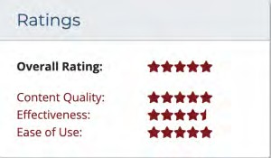

**Reviewed**: Jan 5, 2018 by Teacher Education

**Type of Material**: Open (Access) Textbook

**Recommended Uses:** Course reading and class discussions, professional development and continuing education material

**Technical Requirements**: Can be read online at https://opentextbc.ca/

teachinginadigitalage/ or downloaded as a PDF (requiring PDF reader software, which is freely available).

**Target Student Population**: This book is appropriate for use by teacher educators, instructional designers, curriculum designers, practicing instructors, administration, those who support teachers, and those who are studying in the field of education.

**Identify Major Learning Goals:** The book examines the underlying principles that guide effective teaching in an age when everyone, and in particular the students we are teaching, are using technology. A framework and a set of guidelines are suggested for making decisions about your teaching, while understanding that every subject is different, and every teacher and instructor has something unique and special to bring to their teaching.

**Prerequisite Knowledge or Skills**: Familiarity with basic pedagogical theory and practice is helpful.

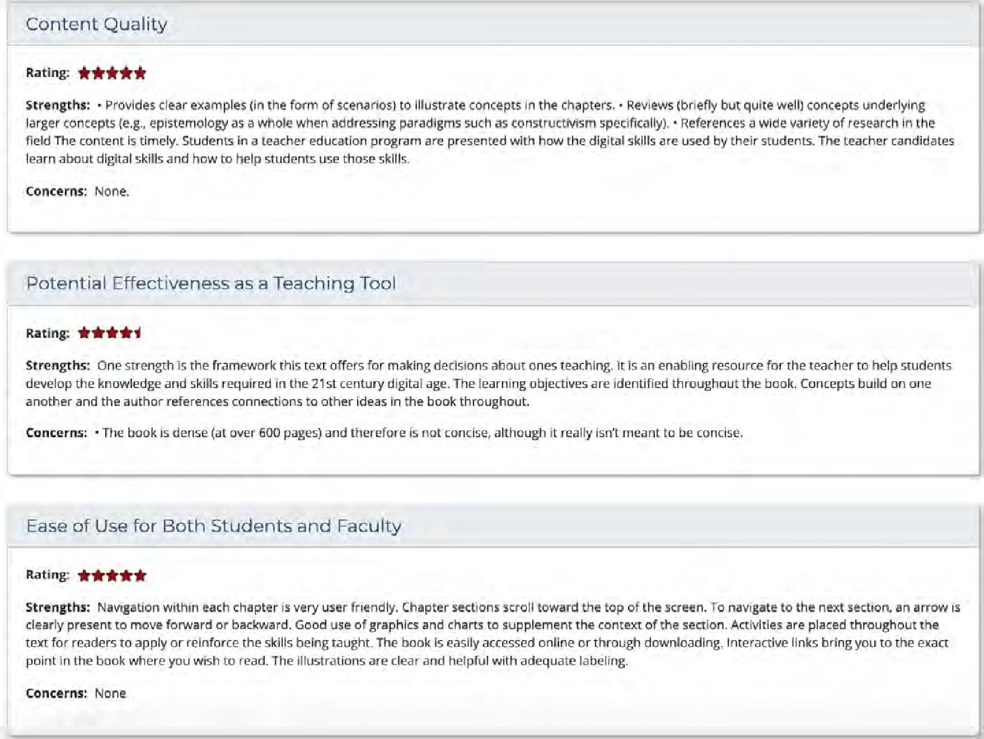

APPENDIX 4: FEEDBACK ON ACTIVITIES

# Appendix 4: Feedback on Activity 1.9 Main conclusions from Chapter 1

Write down at least five conclusions you would draw as an instructor from this chapter (besides the Key Takeaways)

*Activity 1.9 Main conclusions from Chapter 1*

There are many possible conclusions one could draw, but here are mine:

1. Universities and colleges have a broader purpose than just meeting short-term labour market demands. On the other hand, there is a ‘hidden contract’ between the expansion of post-secondary education, and the need to create a work-force that is skilled, adaptable and competitive. I don’t see a necessary conflict here. Many of the activities we consider to be central to the purpose of a university can fulfill these work-force needs with relatively little tweaking.
2. The diversity of the student body and the easy availability of content raises the importance of good quality teaching based on sound pedagogical principles and research in learning. This means professionalizing teaching in post-secondary education.
3. Technology change is constant. Indeed if anything it is accelerating. New technologies that could be applied in education are being developed all the time. So technology is not going away. It’s no use shutting your eyes and hoping that you can manage without making some decisions about whether to use technology or not in your teaching. The pressure to use technology is going to increase, rather than ease up.
4. Relatively few technologies are designed specifically for education. There is more push from manufacturers and technology advocates than pull from instructors. Nevertheless it is clear that over time, many technologies have proved valuable educational tools.
5. There’s a lot to choose from, and there are some major differences between tools.

Researchers and instructors need to understand the educational differences, if any, between different technologies.

1. It is only in the last few years that technology has started to make major changes to the way we deliver education. Distance education and online learning were more of a fringe or peripheral activity to the main provision of learning, which was in classrooms and on campuses. But this is definitely beginning to change. Technology is forcing us to examine more fundamentally the purpose and process of teaching, what constitutes valid knowledge, and how best to acquire it.
2. All this means you need some kind of framework for making decisions about whether or not to use a technology, and how best to use it. This is the main purpose of this book.

# Appendix 4: Feedback on Activity 7.1 How many technologies can you see in Figure 7.1?

Well, this is an unfair question, partly because the photo doesn’t show all the technologies, and also because you wouldn’t know what software or services were included, but just for the record, here’s my list:

Hardware

1. Laptop computer
2. Music CD
3. Book: yes, a printed book is a technological artefact! It doesn’t have to be digital to be a technology.
4. Mobile phone
5. Satellite receiver/converter
6. Television monitor
7. DVD player
8. Apple TV box
9. Audio-visual receiver/control box with 7 channels, 1080p HDMI, Dolby and DTS format support
10. Loudspeakers (3 in picture, including a woofer, back right)
11. Remote control (one: for all equipment except computer, mobile phone and book)

Software

Almost impossible to list and unobservable anyway, but would include iTunes, iPhoto (uses

photos from iPhoto library as a screen saver for the TV monitor when music is playing), digital conversion in the A/V receiver, etc., etc.

**Networks** Wi-fi Internet Telephone Radio

Satellite TV (could have been cable, or broadband telephone, but isn’t)

Services

Satellite broadcast television channels Radio stations (global choice, via Sonos)

Apple TV (including Netflix and other streaming services)

Sonos music (including Deezer, a service similar to Netflix for music)

Necessary for integration

Single remote control (eHarmony) Audio-visual receiver

Apple TV

Apple Mac Pro laptop computer

Mobile phone (controls Sonos and iTunes)

**My wish for the future**: one portable box, please!!!!!!!!

I think whoever owns this home entertainment system could do with a model for technology selection (OK, I’ll admit it, it’s mine). Or is it that the home entertainment industry needs to get its act together regarding standardization? But I digress. All this changed in 2016, when my Internet provider upgraded to fibre optic and 5G from coaxial

cable and 2.4G and offered a ‘deal’ on integrated services. I decided at the same time to upgrade the whole system with a new TV monitor, control box, modem, speaker system, and more apps such as Amazon Prime and DAZN, but the ‘live’ cable television programs are still just as awful as before!

# Appendix 4: Feedback on Activity 7.5 Broadcast or interactive communications

From the list below:

* a learning management system
* a blog
* online collaborative learning
* Twitter
* virtual worlds
* a podcast
* an open textbook

1. Determine which is a medium and which a technology, or which could be both, and under what conditions.

|  |  |
| --- | --- |
| learning management system | either: technology as software, medium when used for course delivery |
| blog | medium (WordPress or other blog software is the technology) |
| online collaborative learning | medium |
| Twitter | either, but mainly a medium |
| Virtual worlds | medium |
| podcast | medium |
| open textbook | medium |

1. **Decide where, from your experience, each medium or technology should be placed on Figure 7.5.3. Write down why.**

Appendix 4: Feedback on Activity 7.5 Broadcast or interactive

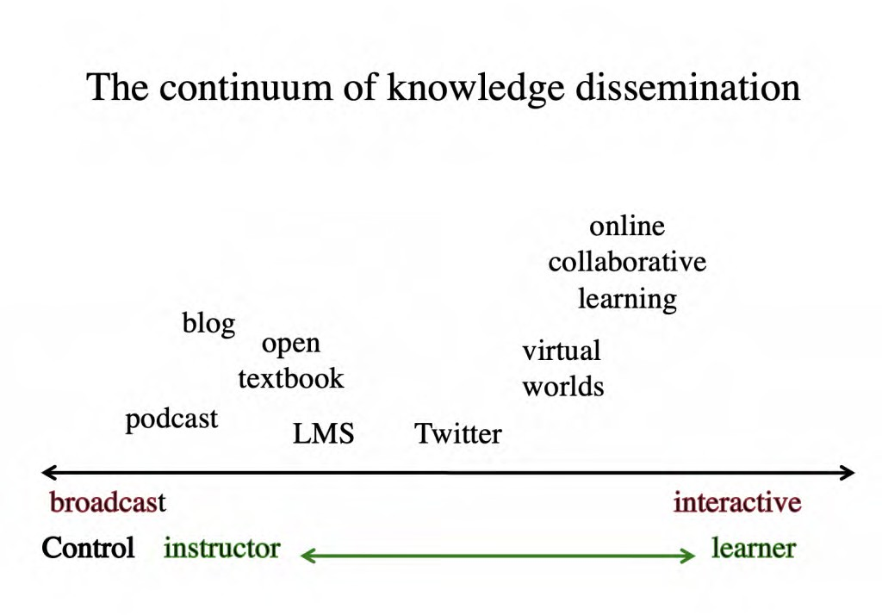

1. Which were easy to categorize and which difficult?

Difficult:

* + online collaborative learning, because it is highly communicative but the teacher has a good deal of control over the medium
  + Twitter, because it is definitely under the control of the user and is a one-to-many medium, but it is also as much an interactive medium as a broadcast medium
  + virtual worlds, because the overall design cannot be changed (broadcast) but users are very interactive with the learning environment
  + blogs can be used both by an instructor or by a learner. Comments can be made to blog posts by others than the author, but only the author can change the blog post itself.

1. How useful?

Understanding where different media are likely to fit on the broadcast/interactive communications dimension will help in choosing media, depending on my epistemological position. If I want a high level of student activity and interaction I would tend toward more interactive communications media. If I am more concerned with information transmission and comprehension, I would tend to use more broadcast media. However, in most cases I would want a mix of both. Knowing where each medium ‘fits’ on this dimension is one component I could use in my decision-making.

# Bibliography

**Note: at the end of each reference is a link to the relevant chapter(s) (e.g. Adamson, 4.7 = Chapter 4, Section 7).**

**All links operational on date of publication (August 2022). Please contact** [**tony.bates@ubc.ca**](mailto:tony.bates@ubc.ca) **if link is dead.**

Adamson, C. (2012) [Learning in a VUCA world,](https://oeb.global/oeb-insights/learning-in-a-vuca-world-how-knowledge-workers-learn-to-innovate/) *Online Educa Berlin News Portal*, November 13, 4.7

AlDahdouh, A., et al. (2015) [Understanding knowledge network, learning and](https://papers.ssrn.com/sol3/papers.cfm?abstract_id=3063495) [connectivism](https://papers.ssrn.com/sol3/papers.cfm?abstract_id=3063495), *International Journal of Instructional Technology and Distance Learning*, Vol. 12, No.10, 2.6

Allen, I, and Seaman, J. (2012) [*Conflicted: Faculty and Online Education*](https://www.bayviewanalytics.com/reports/conflicted.pdf), Babson Survey Research Group, 11.2

Allen, I. and Seaman, J. (2014) [*Grade Change: Tracking Online Learning in the United States*](https://onlinelearningconsortium.org/survey_report/2013-survey-online-learning-report/)Wellesley MA: Babson College/Sloan Foundation, 1.7, 5.5,

Allen, I. and Seaman, J. (2017) [*Digital Learning Compass: Distance Education Enrollment Report 2017*](http://onlinelearningsurvey.com/reports/digtiallearningcompassenrollment2017.pdf)

Babson Survey Research Group/eLiterate/WCET, 11.3

Anastasiadis, T. et al. (2018) [Digital Game-based Learning and Serious Games in](https://ijasre.net/index.php/ijasre/article/view/814) [Education](https://ijasre.net/index.php/ijasre/article/view/814) *International Journal of Advances in Scientific Research and Engineering*, Vol. 4, No. 12, 9.2

Anderson, C. (2008) [The End of Theory: The Data Deluge Makes the Scientific Method](http://archive.wired.com/science/discoveries/magazine/16-07/pb_theory) [Obsolete](http://archive.wired.com/science/discoveries/magazine/16-07/pb_theory) *Wired Magazine,* 16.07, 2.7,

Anderson, L. and Krathwohl, D. (eds.) (2001). [*A Taxonomy for Learning, Teaching, and Assessing: A*](https://www.amazon.ca/Taxonomy-Learning-Teaching-Assessing-Educational/dp/080131903X)[*Revision of Bloom’s Taxonomy of Educational Objectives*](https://www.amazon.ca/Taxonomy-Learning-Teaching-Assessing-Educational/dp/080131903X)New York: Longman, 2.4

Anderson, T. (ed.) (2008) [*The Theory and Practice of Online Learning*](http://www.aupress.ca/index.php/books/120146)Athabasca AB: Athabasca University Press, 11.2

Anderson, T., Rourke, L., Garrison, R., & Archer, W. (2001) [Assessing teaching presence in a computer](https://www.researchgate.net/publication/228749393_Assessing_Teaching_Presence_in_a_Computer_Conferencing_Context) [conferencing context](https://www.researchgate.net/publication/228749393_Assessing_Teaching_Presence_in_a_Computer_Conferencing_Context) *Journal of Asynchronous Learning Networks*, Vol. 5, No.2, 13.10

Arenas, E. (2015) [Affordances of Learning Technologies in Higher Education Multicultural](https://pdfs.semanticscholar.org/17a4/638de9c2018a364c22e70bf20f343513229b.pdf) [Environments](https://pdfs.semanticscholar.org/17a4/638de9c2018a364c22e70bf20f343513229b.pdf) *The Electronic Journal of e-Learning* Volume 13 No. 4 (pp 217-227), 8.6

Arnab, S. et al. (2014) [Mapping learning and game mechanics for serious games analysis](https://onlinelibrary.wiley.com/doi/abs/10.1111/bjet.12113). *British Journal of Educational Technology*, Vol. 46, No. 2, pp 391–411, 9.2

Arnett, T. (2021) [A better way to do online learning](https://www.bostonglobe.com/2022/01/13/opinion/better-way-do-online-learning/), *Boston Globe*, January 13, 11.1

Ausubel, D., Novak, J., & Hanesian, H. (1978). [*Educational Psychology: A Cognitive View* (2nd Ed.](https://www.worldcat.org/title/educational-psychology-a-cognitive-view/oclc/3516993)). New York: Holt, Rinehart & Winston, 3.4

Badia, A., Barberà, E., Guasch, T., Espasa, A. (2011). [Technology educational affordance: Bridging the](https://pdfs.semanticscholar.org/0a5c/bdb6c5449eab63808c481f80af5f7d1e493e.pdf) [gap between patterns of interaction and technology usage](https://pdfs.semanticscholar.org/0a5c/bdb6c5449eab63808c481f80af5f7d1e493e.pdf) in: *Digital Education Review*, Vol.19, pp 20-35, 8.6

Baker, C. (2010) [The Impact of Instructor Immediacy and Presence for Online Student Affective](https://files.eric.ed.gov/fulltext/EJ904072.pdf) [Learning, Cognition, and Motivation](https://files.eric.ed.gov/fulltext/EJ904072.pdf) *The Journal of Educators Online* Vol. 7, No. 1, 13.10

Baker, R. and Passmore, D. (2016) [Value and Pricing of MOOCs](https://www.researchgate.net/publication/303597368_Value_and_Pricing_of_MOOCs) *Education Sciences*, 27 May, 5.4

Balash, D. et al. (2021) [Examining the Examiners: Students’ Privacy and Security Perceptions of](https://www.usenix.org/system/files/soups2021-balash.pdf) [Online Proctoring Services](https://www.usenix.org/system/files/soups2021-balash.pdf) *USENIX Proceedings of the Seventeenth Symposium on Usable Privacy and Security*, August 9, 6.8

Balfour, S. P. (2013) [Assessing writing in MOOCs: Automated essay scoring and calibrated peer](https://www.semanticscholar.org/paper/How-Does-AES-Work-Balfour/2c0381a33a503179eaa74630576cc7be5dc23eb4?p2df) [review](https://www.semanticscholar.org/paper/How-Does-AES-Work-Balfour/2c0381a33a503179eaa74630576cc7be5dc23eb4?p2df) *Research & Practice in Assessment,* Vol. 8, 5.4

Banchi, H., and Bell, R. (2008) ‘[The Many Levels of Inquiry](https://eric.ed.gov/?id=EJ815766)’ *Science and Children*, Vol. 46, No. 2, 3.5

Banks, C. and Meinert, E. (2016) [The acceptability of MOOC certificates in the workplace](https://files.eric.ed.gov/fulltext/ED571496.pdf)

*International Conference eLearning 2016*, 5.3

Barbour, M. and LaBonte, R. (2019) [*State of the Nation:K-12 eLearning in Canada: 2019 edition*](https://k12sotn.ca/wp-content/uploads/2020/02/StateNation19.pdf)

CANeLearn, 1.7, 1.8

Barbour, M., LaBonte, R. and Nagle, J. (2021) [*State of the Nation: K-12 e-Learning in Canada, 2021*](https://k12sotn.ca/wp-content/uploads/2022/06/StateNation21.pdf)[*edition*](https://k12sotn.ca/wp-content/uploads/2022/06/StateNation21.pdf)Halfmoon Bay, BC: The Canadian eLearning Network, 11.1, 11.2, 13.1, 14.2

Barkley, E., Major, C.H., and Cross, K.P. (2014) [*Collaborative Learning Techniques*](https://www.wiley.com/en-us/Collaborative%2BLearning%2BTechniques%3A%2BA%2BHandbook%2Bfor%2BCollege%2BFaculty%2C%2B2nd%2BEdition-p-9781118761557)San Francisco: Jossey-Bass/Wiley, 4.4, 5.4

Bates, A. (1981) ‘[Some unique educational characteristics of television and some implications for](https://www.tandfonline.com/doi/abs/10.1080/1358165810070302) [teaching or learning](https://www.tandfonline.com/doi/abs/10.1080/1358165810070302)‘ *Journal of Educational Television* Vol. 7, No.3, 7.4

Bates, A. (1984) [*Broadcasting in Education: An Evaluation*](https://www.worldcat.org/title/broadcasting-in-education-an-evaluation/oclc/11411151)London: Constables, 5.4, 7.2, 7.3,8.1, 8.3, 8.4

Bates, A. (1995) [*Technology, Open Learning and Distance Education*](https://www.amazon.com/Technology-Learning-Distance-Education-Routledge/dp/0415127998)London/New York: Routledge, 10.1,

Bates, A. (2005) [*Technology, e-Learning and Distance Education*](https://www.routledge.com/Technology-e-learning-and-Distance-Education/Bates/p/book/9780415284370?source=igodigital)London/New York: Routledge, 8.3, 8.4, 10.4, 11.2

Bates, A. (2011) ‘[Understanding Web 2.0 and Its Implications for e-Learning](https://www.tandfonline.com/doi/abs/10.1080/08923647.2010.545602)’ in Lee, M. and McCoughlin, C. (eds.) *Web 2.0-Based E-Learning* Hershey NY: Information Science Reference, 8.6, 9.1

Bates, A. and Gallagher, M. (1977) *Improving the Effectiveness of Open University Television Case- Studies and Documentaries* Milton Keynes: The Open University (I.E.T. Papers on Broadcasting, No. 77), 7.7, 8.1, 8.4 (out of print – copies available from [tony.bates@ubc.ca).](mailto:tony.bates@ubc.ca)

Bates, A. and Poole, G. (2003) [*Effective Teaching with Technology in Higher Education: Foundations*](https://www.amazon.ca/Effective-Teaching-Technology-Higher-Education/dp/0787960349)[*for Success*](https://www.amazon.ca/Effective-Teaching-Technology-Higher-Education/dp/0787960349)San Francisco: Jossey-Bass, 4.4, 10.1, 14.4

Bates, A. and Sangrà, A. (2011) [*Managing Technology in Higher Education*](https://www.wiley.com/en-us/Managing%2BTechnology%2Bin%2BHigher%2BEducation%3A%2BStrategies%2Bfor%2BTransforming%2BTeaching%2Band%2BLearning-p-9780470584729)San Francisco: Jossey-Bass/ John Wiley and Co, 5.4 6.7, 10.4, 10.7, 13.4, 14.2, 14.6

Bates, A. et al. (2018) [*Tracking Online and Distance Education in Canadian Universities and Colleges:*](http://www.cdlra-acrfl.ca/wp-content/uploads/2020/07/2017_national_en.pdf)[*2017*](http://www.cdlra-acrfl.ca/wp-content/uploads/2020/07/2017_national_en.pdf)Halifax NS: Canadian Digital Learning Research Association, 1.7 4.2

Bates, S. (2016) [The 21st Century Educator](https://www.slideshare.net/EdPER_talks/the-21st-century-educator-students-as-partners-in-teaching-and-learning) Burnaby BC: BCIT Faculty of Nursing Scholarship Day, May, 14.1

Bates, T. (2011) [Cloud-based educational technology and privacy: a Canadian perspective](http://www.tonybates.ca/2011/03/25/cloud-based-educational-technology-and-privacy-a-canadian-perspective/), *Online Learning and Distance Education Resources*, March 25, 10.9

Bates, T. (2011) [Marshall McLuhan and his relevance to teaching with technology](http://www.tonybates.ca/2011/07/20/marshall-mcluhan-and-his-relevance-to-teaching-with-technology/), *Online Learning and Distance Education Resources*, July 20, 7.3

Bates, T. (2012) [Pedagogical roles for video in online learning](http://www.tonybates.ca/2012/03/10/pedagogical-roles-for-video-in-online-learning/), *Online Learning and Distance Education Resources,* March 10, 7.3

Bates, T. (2012) [What’s right and what’s wrong with Coursera-style MOOCs](http://www.tonybates.ca/2012/08/05/whats-right-and-whats-wrong-about-coursera-style-moocs/) *Online Learning and Distance Education Resources*, August 5, 5.5

Bates, T. (2013) [Productivity and online learning redux](http://www.tonybates.ca/2013/12/23/productivity-and-online-learning-redux/), *Online Learning and Distance Education Resources*, December 23, 14.4

Bates, T. (2015) [Writing an online, open textbook: is it worth it?](https://www.tonybates.ca/2015/06/10/writing-an-online-open-textbook-is-it-worth-it/) *Online Learning and Distance Education Resources*, June 10,

Bates, T. (2015) [Thinking about theory and practice](https://www.tonybates.ca/2015/07/29/thinking-about-theory-and-practice-in-online-learning/), *Open Learning and Distance Education Resources*, July 29, 2.8

Bates, T. (2020) [Online learning and Covid-19: Internet coverage in Canada](https://www.tonybates.ca/2020/04/28/online-learning-and-covid-19-internet-coverage-in-canada/) *Online Learning and Distance Education Resources*, April 28, 1.8

Bates, T. (2021) [Research showing that virtual learning is less effective than classroom teaching –](https://www.tonybates.ca/2021/08/26/research-showing-that-virtual-learning-is-less-effective-than-classroom-teaching-right/) [right?](https://www.tonybates.ca/2021/08/26/research-showing-that-virtual-learning-is-less-effective-than-classroom-teaching-right/) *Online Learning and Distance Education Resources*, August 26, 1.8, 7.4

Bates, T. (2021b) [Online learning in (k-12) schools: advice for decision-makers](https://www.tonybates.ca/2021/01/21/online-learning-in-k-12-schools-7-advice-for-decision-makers/) *Online Learning and Distance Education Resources,* January 21, 1.8

Bayne, S. (2015) [*Teacherbot: interventions in automated teaching*](https://www.tandfonline.com/doi/full/10.1080/13562517.2015.1020783)*,* Teaching in Higher Education, Vol.

20, No.4, pp. 455-467, 5.4, 9.4

Baytak, A. (undated) [Media selection and design: a case in distance education](https://www.academia.edu/1285461/Media_Selection_and_Design_A_Case_in_Distance_Education) *Academia.edu*[*,*](http://www.academia.edu/1285461/Media_Selection_and_Design_A_Case_in_Distance_Education) *10.1*

Beasley-Murray, J. (2008) Was introducing Wikipedia to the classroom an act of madness leading only to mayhem if not murder? *Wikipedia,* March 18, 10.8

Beattie, E. (2018) [Open textbooks make education more accessible and affordable](https://bccampus.ca/2018/06/07/open-textbooks-make-education-more-accessible-and-affordable/), *BCcampus*, June 7, 12.3

Berk, R.A. (2009) [Multimedia teaching with video clips: TV, movies, YouTube and mtvU in the college](https://www.researchgate.net/publication/228349436_Multimedia_Teaching_with_Video_Clips_TV_Movies_YouTube_and_mtvU_in_the_College_Classroom) [classroom](https://www.researchgate.net/publication/228349436_Multimedia_Teaching_with_Video_Clips_TV_Movies_YouTube_and_mtvU_in_the_College_Classroom), *International Journal of Technology in Teaching and Learning*, Vol. 91, No. 5, 8.1

Bernard, R., et al. (2004) [How Does Distance Education Compare With Classroom Instruction? A](https://journals.sagepub.com/doi/10.3102/00346543074003379) [Meta-Analysis of the Empirical Literature](https://journals.sagepub.com/doi/10.3102/00346543074003379) *Review of Educational Research*, Vol. 74., No.3, 1.8

Bernard, R. et al. (2014) [Detecting bias in meta-analyses of distance education research: big pictures](https://www.tandfonline.com/doi/abs/10.1080/01587919.2015.957433) [we can rely on](https://www.tandfonline.com/doi/abs/10.1080/01587919.2015.957433) *Distance Education* Vol. 35, No. 3, 11.2

Bertram, J. (2013) [*Agile Learning Design for Beginners*](http://www.bottomlineperformance.com/what-is-agile-learning-design/)New Palestine IN: Bottom Line Performance, 4.6

Bishop, J. (2011) Facebook Privacy Policy: Will Changes End Facebook for Colleges? [*The Higher Ed*](http://blog.thehigheredcio.com/2011/10/04/facebook-privacy-policy/)[*CIO*](http://blog.thehigheredcio.com/2011/10/04/facebook-privacy-policy/), October 4, 10.9 [no longer available; see note on 10.9]

Bligh, D. (2000) [*What’s the Use of Lectures?*](http://books.google.ca/books/about/What_s_the_use_of_lectures.html?id=nXEmAQAAIAAJ&redir_esc=y)San Francisco: Jossey-Bass, 1.5, 3.3

Bloom, B. S.; Engelhart, M. D.; Furst, E. J.; Hill, W. H.; Krathwohl, D. R[.](http://en.wikipedia.org/wiki/David_Krathwohl) (1956). [*Taxonomy of educational*](https://www.amazon.com/Taxonomy-Educational-Objectives-Handbook-Cognitive/dp/0582280109/bigdogsbowlofbis/)[*objectives: The classification of educational goals. Handbook I: Cognitive domain.*](https://www.amazon.com/Taxonomy-Educational-Objectives-Handbook-Cognitive/dp/0582280109/bigdogsbowlofbis/)New York: David McKay Company, 2.4 3.6, 8.1, 13.8

Book, P. (2014) [*All Hands on Deck: Ten Lessons from Early Adopters of Competency-based Education*](https://files.eric.ed.gov/fulltext/ED546830.pdf)

Boulder CO: WCET, 4.5

Boswell, J. (1791), [*The Life of Samuel Johnson*](https://www.penguinrandomhouse.com/books/304096/the-life-of-samuel-johnson-by-james-boswell/9780140436624/), New York: Penguin Classics (edited by Hibbert, C., 1986), 3.3

Brandaõ, G. et al. (2018) [Virtual Reality as a Tool for Teaching Architecture](https://link.springer.com/chapter/10.1007/978-3-319-91803-7_6#targetText%3DBroadly%2C%20virtual%20reality%20(VR)%2Creal%20presence%20in%20those%20spaces) in *Design, User Experience, and Usability: Designing Interactions* Las Vegas NV: Proceedings of 7th International Conference, DUXU 2018, held as Part of HCI International 2018, 9.3

Brindley, J., Walti, C. and Blashke, L. (2009) [Creating Effective Collaborative Learning Groups in an](https://www.irrodl.org/index.php/irrodl/article/view/675/1271) [Online Environment](https://www.irrodl.org/index.php/irrodl/article/view/675/1271) *International Review of Research in Open and Distance Learning*, Vol. 10, No. 3, 4.4, 6.6

Brokop, F. (2008) [*Accessibility to E-Learning for Persons With Disabilities: Strategies, Guidelines, and*](https://www.norquest.ca/NorquestCollege/media/pdf/centres/learning/Accessibility-to-E-Learning-for-Persons-With-Disabilities-Strategies%2C-Guidelines-and-Standards.pdf)[*Standards*](https://www.norquest.ca/NorquestCollege/media/pdf/centres/learning/Accessibility-to-E-Learning-for-Persons-With-Disabilities-Strategies%2C-Guidelines-and-Standards.pdf)Edmonton AB: NorQuest College/eCampus Alberta, 10.2

Brooks, D.C. (2021) [EDUCAUSE QuickPoll Results: Artificial Intelligence Use in Higher](https://er.educause.edu/articles/2021/6/educause-quickpoll-results-artificial-intelligence-use-in-higher-education?utm_source=Selligent&utm_medium=email&utm_campaign=er_content_alert_newsletter&utm_content=1-12-22&utm_term=_&m_i=ql0qyLqb7NRI734Hxp7zW17YHfx4hQS_iGR1dCyexnEyHu_wuH663dC2pmFAmaDX4WAZIjjr7KXkDHRi2lmrZ7xFlPMStn8qqv&M_BT=5551576762) [Education](https://er.educause.edu/articles/2021/6/educause-quickpoll-results-artificial-intelligence-use-in-higher-education?utm_source=Selligent&utm_medium=email&utm_campaign=er_content_alert_newsletter&utm_content=1-12-22&utm_term=_&m_i=ql0qyLqb7NRI734Hxp7zW17YHfx4hQS_iGR1dCyexnEyHu_wuH663dC2pmFAmaDX4WAZIjjr7KXkDHRi2lmrZ7xFlPMStn8qqv&M_BT=5551576762), *EDUCAUSE Review*, June 11, 9.4

Brown, J. and Duguid, Paul (2000). [Balancing act: How to capture knowledge without killing it](https://hbswk.hbs.edu/archive/balancing-act-capturing-knowledge-without-killing-it).

*Harvard Business Review,* 4.6

Butcher, N. and Hoosen, S. (2014) [*A Guide to Quality in Post-traditional Online Higher Education*](https://www.oerafrica.org/resource/guide-quality-post-traditional-online-higher-education)

Dallas TX: Academic Partnerships, 13.1

Cambridge, D., Kaplan, S. and Suter, V. (2005) [*Community of Practice Design Guide*](https://library.educause.edu/resources/2005/1/community-of-practice-design-guide-a-stepbystep-guide-for-designing-cultivating-communities-of-practice-in-higher-education)Louisville CO: EDUCAUSE, 4.6

Cañado, P. and Luisa, M. (eds.) (2013) [*Competency-based Language Teaching in Higher Education*](https://www.springer.com/gp/book/9789400753853)New York: Springer, 4.5

Candy, P. (1991) [*Self-direction for lifelong learning*](https://www.amazon.com/Self-Direction-Lifelong-Learning-Comprehensive-Education/dp/1555423035)San Francisco: Jossey-Bass, 9.1

Carey, K. (2015) [*The End of College*](https://www.amazon.com/End-College-Creating-University-Everywhere/dp/1594634041)New York: Riverhead Books, 12.5

Carey, T., & Trick, D. (2013). [*How Online Learning Affects Productivity, Cost and Quality in Higher*](http://www.heqco.ca/SiteCollectionDocuments/How_Online_Learning_Affects_Productivity-ENG.pdf)[*Education: An Environmental Scan and Review of the Literature*](http://www.heqco.ca/SiteCollectionDocuments/How_Online_Learning_Affects_Productivity-ENG.pdf)*.* Toronto: Higher Education Quality Council of Ontario, 14.4

Carvalho-Fina, M. et al. (2019) [Twelve tips for implementing a community of practice for faculty](https://www.tandfonline.com/doi/abs/10.1080/0142159X.2018.1552782?journalCode=imte20) [development](https://www.tandfonline.com/doi/abs/10.1080/0142159X.2018.1552782?journalCode=imte20) *Medical Teacher*, February 1, 14.2

Castells, M. (2009) [*The Rise of the Network Society*](https://www.wiley.com/en-us/The%2BRise%2Bof%2Bthe%2BNetwork%2BSociety%2C%2B2nd%2BEdition%2C%2Bwith%2Ba%2BNew%2BPreface-p-9781405196864)Hoboken NJ: Wiley, 2.7

Caulfield, M. (2015) [Asking What Students Spend on Textbooks Is the Wrong Question](http://hapgood.us/2015/11/09/asking-what-students-spend-on-textbooks-is-the-wrong-question/), *Hapgood*, November 9, 12.3

Cellini, R. S. (2021) [How does virtual learning impact students in higher education?](https://www.brookings.edu/blog/brown-center-chalkboard/2021/08/13/how-does-virtual-learning-impact-students-in-higher-education/?mkt_tok=MTgwLUxTVi02NzIAAAF_A3OOXuyioNBvchfceM6KddgjwoMWjgrJQ8T2Rl22F4nOyGhZZArpCpzYQyWNlP6Ujma_kC6gTwIQGCX1xB_jSUIgXWLvqyGWvOxZnYYg7X6LPw) *Brown Center Chalkboard, Brookings*, August 13, 1.8

Chickering, A., and Gamson, Z. (1987) ‘[Seven Principles for Good Practice in Undergraduate](https://www.lonestar.edu/multimedia/SevenPrinciples.pdf) [Education](https://www.lonestar.edu/multimedia/SevenPrinciples.pdf)’ *Washington Center News* (originally published in *AAHE Bulletin,* March 1987), 13.1

Chiose, S. (2018) [Increased pressures, class sizes, taking their toll on faculties in academia](https://www.theglobeandmail.com/news/national/education/increased-pressures-class-sizes-taking-their-toll-on-faculties-in-academia/article22111189/), *Globe and Mail,* May 12, 14.4

Christensen, C. (2016) [*Disrupting Class, Expanded Edition: How Disruptive Innovation Will Change*](https://www.amazon.com/Disrupting-Class-Expanded-Disruptive-Innovation/dp/1259860884)[*the Way the World Learns: Expanded Edition*](https://www.amazon.com/Disrupting-Class-Expanded-Disruptive-Innovation/dp/1259860884)New York: McGraw-Hill, 5.2 5.5

Christensen Hughes, J. and Mighty, J. (2010) [*Taking Stock: Research on Teaching and Learning in*](http://www.mqup.ca/taking-stock-products-9781553392712.php?page_id=46)[*Higher Education*](http://www.mqup.ca/taking-stock-products-9781553392712.php?page_id=46)Montreal and Kingston: McGill-Queen’s University Press, 1.6, 14.2

Clark, D. et al. (2016) [Digital Games, Design, and Learning: A Systematic Review and Meta-](https://journals.sagepub.com/doi/10.3102/0034654315582065) [Analysis](https://journals.sagepub.com/doi/10.3102/0034654315582065) *Review of Educational Research,* Vol. 86, No. 1, 9.2

Clark, R. (1983) [Reconsidering research on learning from media](https://journals.sagepub.com/doi/10.3102/00346543053004445) *Review of Educational Research*, Vol.

53. No. 4, 7.3, 8.1

Clarke-Okah, W. et al. (2014) [*The Commonwealth of Learning Review and Improvement Model for*](https://www.cedol.org/wp-content/uploads/2012/02/19-20-2010.pdf)[*Higher Education Institutions*](https://www.cedol.org/wp-content/uploads/2012/02/19-20-2010.pdf)Vancouver BC: Commonwealth of Learning, 13.1

Cleveland-Innes, M. (2013) ‘[Teaching in an online community of inquiry: institutional and individual](http://www.diva-portal.org/smash/record.jsf?pid=diva2%3A801705&dswid=-9371) [adjustment in the new higher education’](http://www.diva-portal.org/smash/record.jsf?pid=diva2%3A801705&dswid=-9371), in Akyol, Z. & Garrison, R.D. (eds.)*Educational communities of inquiry: theoretical framework, research and practice*, (pp. 389-400). Hershey, PA: IGI Global, 14.1.

Collins, E. (2013) [*SJSU Plus Augmented Online Learning Environment Pilot Project Report*](https://www.sjsu.edu/people/elaine.collins/research/AOLE%20Report%20Final%20Version_Jan%201_2017.pdf)San Jose CA: San Jose State University, 5.2

Colvin, K. et al. (2014) [Learning an Introductory Physics MOOC: All Cohorts Learn Equally, Including](http://www.irrodl.org/index.php/irrodl/article/view/1902/3009) [On-Campus Class](http://www.irrodl.org/index.php/irrodl/article/view/1902/3009), *IRRODL*, Vol. 15, No. 4, 5.4

Conference Board of Canada (2014) [*Employability Skills*](https://www.conferenceboard.ca/futureskillscentre/tools/employability-skills)Ottawa ON: Conference Board of Canada, 1.2

Connolly, B. (2018) [How virtual reality is transforming learning at the University of Newcastle,](https://www.cio.com/article/202009/how-virtual-reality-is-transforming-learning-at-the-university-of-newcastle.html) CIO, 8 March, 9.3

Conole, G. (2014) [The 7Cs of Learning Design – a new approach to rethinking design practice](http://www.networkedlearningconference.org.uk/past/nlc2014/abstracts/pdf/conole.pdf) *9th International Conference on Networked Learning*, Edinburgh, 12.4

Contact North (2019) [*Searchable Directory of More than 65 Open Universities Worldwide*](https://teachonline.ca/tools-trends/universities)Sudbury ON: Teachonline.ca, 12.1

Coolidge, A. et al (2018) [B.C. Open Textbook Accessibility Toolkit](http://opentextbc.ca/accessibilitytoolkit/) Victoria BC: BCcampus, 10.2

Couey, C. (2022) [Distance Learning: Asynchronous vs. Synchronous Learning](https://www.softwareadvice.com/resources/asynchronous-vs-synchronous-learning/), *Software Advice*, March 31, 7.4

Council of Ontario Universities (2012) [*Increased numbers of students heading to Ontario universities*](https://cou.ca/articles/increased-numbers-of-students-heading-to-ontario-universities/)

Toronto ON: COU, 1.6

Cross, J. (2022) [What does too much screen time do to children’s brains?](https://healthmatters.nyp.org/what-does-too-much-screen-time-do-to-childrens-brains/) *Health Matters, New York- Presbyterian,* 4.2

Crowther, G. (1969) This is the Open University, London, UK, 23 July, 12.4

Dabbagh, N. (2007). [The online learner: characteristics and pedagogical implications](http://www.editlib.org/p/22904/). *Contemporary Issues in Technology and Teacher Education*, Vol. 7, No. 3, pp 217- 226, 11.3

Daniel, J. (1998) [*Mega-Universities and Knowledge Media: Technology Strategies for Higher Education*](https://eric.ed.gov/?id=ED408915).

London: Kogan Page, 12.1

Daniel, J. (2012) [*Making sense of MOOCs: Musings in a maze of myth, paradox and possibility*](https://jime.open.ac.uk/articles/10.5334/2012-18/)Seoul: Korean National Open University, 5.5

DeRosa, R. and Robison, S. (2017) [From OER to Open Pedagogy: Harnessing the Power of Open](https://doi.org/10.5334/bbc.i) in Jhangiani, R S. and Biswas-Diener, R. (2017[*:*](https://doi.org/10.5334/bbc) *The Philosophy and Practices that are Revolutionizing Education and Science* London: Ubiquity Press, 12.4

Deterding, S. et al. (2011) [Gamification: Using Game Design Elements in Non-Gaming](http://gamification-research.org/wp-content/uploads/2011/04/01-Deterding-Sicart-Nacke-OHara-Dixon.pdf) [Contexts](http://gamification-research.org/wp-content/uploads/2011/04/01-Deterding-Sicart-Nacke-OHara-Dixon.pdf) in *PART 2-Proceedings of the 2011 annual conference extended abstracts on Human Factors in Computing Systems* Vancouver BC: CHI, 9.2

Dewey, J. (1938). [*Experience & Education*](https://www.worldcat.org/title/experience-and-education/oclc/755363). New York, NY: Macmillan, 3.5

Dichev, C. and Dicheva, D. (2017) [Gamifying education: what is known, what is believed and what](https://educationaltechnologyjournal.springeropen.com/articles/10.1186/s41239-017-0042-5) [remains uncertain: a critical review](https://educationaltechnologyjournal.springeropen.com/articles/10.1186/s41239-017-0042-5) *International Journal of Educational Technology in Higher Education*, Vol. 14, No. 9, 9.2

Dick, W., and Carey, L. (2004). [*The Systematic Design of Instruction*](https://www.amazon.com/Systematic-Design-Instruction-Walter-Dick/dp/0205412742)Allyn & Bacon; 6 edition Allyn & Bacon, 4.3

Digital Learning Compass (2017) [Distance Education Enrolment Report 2017](https://onlinelearningsurvey.com/reports/digtiallearningcompassenrollment2017.pdf) Wellesley MA, 1.7

Dingyloudi, F. and Strijbos, J. (2015) [Examining value creation in a community of learning practice:](http://www.seminar.net/104-frontpage/253-examining-value-creation-in-a-community-of-learning-practice-methodological-reflections-on-story-telling-and-story-reading) [Methodological reflections on story-telling and story-reading](http://www.seminar.net/104-frontpage/253-examining-value-creation-in-a-community-of-learning-practice-methodological-reflections-on-story-telling-and-story-reading) *Seminar.net*, Vol. 11, No.3, 4.6

Djafarova, N. et el. (2018) [*The Art of Serious Game Design*](https://de.ryerson.ca/games/research/)Toronto ON: Chang School of Continuing Studies, Ryerson University, 9.2

Donaldson, R., Opper, J. and Sen, E. (2019) [*2019 Florida Student Textbook and Course Materials Survey*](https://dlss.flvc.org/documents/210036/1314923/2018%2BStudent%2BTextbook%2Band%2BCourse%2BMaterials%2BSurvey%2BReport%2B--%2BFINAL%2BVERSION%2B--%2B20190308.pdf/07478d85-89c2-3742-209a-9cc5df8cd7ea)

Tallahassee: Florida Virtual Campus, 12.3

Donovan, T. et al. (2018) [*Tracking Online and Distance Education in Canadian Universities and*](http://www.cdlra-acrfl.ca/wp-content/uploads/2020/07/2018_national_en.pdf)[*Colleges: 2018*](http://www.cdlra-acrfl.ca/wp-content/uploads/2020/07/2018_national_en.pdf)Halifax NS: Canadian Digital Learning Research Association, 5.5, 11.1, 11.3, 12.1, 12.3

Downes, S. (2007) [What connectivism is](http://halfanhour.blogspot.co.uk/2007/02/what-connectivism-is.html) *Half An Hour*, February 3, 2.6, 2.7

Downes, S. (2012) [E-learning Generations](https://halfanhour.blogspot.com/2012/02/e-learning-generations.html) *Half-an-hour*, February 11, 7.2

Downes, S. (2014) [The MOOC of One](http://www.downes.ca/presentation/336), *Stephen’s Web*, March 10, 2.6, 5.3

Downes, S. (2018) [Online learning and MOOCs: Visions and Pathways](https://www.downes.ca/post/69604), *Stephen’s Web,* May 2, 5.1

Downs, L. (2020) [New Regulations #3: Direct Assessment and Competency-Based Education](https://wcetfrontiers.org/2020/04/13/new-regulations-3-direct-assessment-cbe/) *WCET Frontiers*, April 13, 4.5

Durbridge, N. (1983) *Design implications of audio and video cassettes* Milton Keynes: Open University Institute of Educational Technology, 7.4 (out of print)

Durbridge, N. (1984) Audio cassettes, in Bates, A. (ed.) [*The Role of Technology in Distance Education*](https://www.taylorfrancis.com/books/e/9781315738598)

London: Routledge (re-published in 2014), 7.7, 8.3

EAB (2015) [*Three Myths About Competency-Based Education*](https://www.eab.com/research-and-insights/continuing-and-online-education-forum/white-papers/2015/three-myths-about-competency-based-education)Washington DC: Education Advisory Board, 4.5

Earle, L. (2003) [*Assessment as Learning*](http://us.corwin.com/en-us/nam/assessment-as-learning/book220774)Thousand Oaks CA: Corwin Press, 6.8

EDUCAUSE Learning Initiative (2005) [*Seven things you should know about… podcasting*](http://www.educause.edu/ir/library/pdf/ELI7003.pdf)Boulder CO: *EDUCAUSE*, June, 8.3

Elmqadden, N. (2019) [Augmented Reality and Virtual Reality in Education: Myth or](https://online-journals.org/index.php/i-jet/article/view/9289/5456) [Reality?](https://online-journals.org/index.php/i-jet/article/view/9289/5456) *International Journal of Emerging Technologies in Learning*, Vol. 14, No. 3, 9.3

Engle, W. (2104) [*UBC MOOC Pilot: Design and Delivery*](https://open.library.ubc.ca/soa/cIRcle/collections/ubccommunityandpartnerspublicati/52387/items/1.0107914)Vancouver BC: University of British Columbia, 5.2, 5.4, 10.4

Entwistle, N. (2000) [*Promoting deep learning through teaching and assessment: conceptual*](https://www.researchgate.net/publication/241049278_Promoting_deep_learning_through_teaching_and_assessment_Conceptual_frameworks_and_educational_contexts)[*frameworks and educational contexts*](https://www.researchgate.net/publication/241049278_Promoting_deep_learning_through_teaching_and_assessment_Conceptual_frameworks_and_educational_contexts)Leicester UK: TLRP Conference, 4.4

Entwistle, N. (2010) ‘Taking Stock: An Overview of Research Findings’ in Christensen Hughes, J. and Mighty, J. (eds.) [*Taking Stock: Research on Teaching and Learning in Higher Education*](http://www.mqup.ca/taking-stock-products-9781553392712.php?page_id=46)Montreal and Kingston: McGill-Queen’s University Press, 2.8

Entwistle, N. and Peterson, E. (2004) [Conceptions of Learning and Knowledge in Higher Education:](https://www.researchgate.net/publication/223178863_Conceptions_of_Learning_and_Knowledge_in_Higher_Education_Relationships_with_Study_Behaviour_and_Influences_of_Learning_Environments) [Relationships with Study Behaviour and Influences of Learning Environments](https://www.researchgate.net/publication/223178863_Conceptions_of_Learning_and_Knowledge_in_Higher_Education_Relationships_with_Study_Behaviour_and_Influences_of_Learning_Environments) *International Journal of Educational Research,* Vol. 41, No. 6, pp. 407-428, 3.4

Eradze M., Tammets K. (2017) [Learning Analytics in MOOCs: EMMA Case](https://link.springer.com/chapter/10.1007/978-3-319-55477-8_18). In: Lauro N., Amaturo E., Grassia M., Aragona B., Marino M. (eds) *Data Science and Social Research: Studies in Classification, Data Analysis, and Knowledge Organization* Springer: Cham, 5.3

Evans, T., Haughey, M. and Murphy, D. (2008) [*International Handbook of Distance Education*](https://trove.nla.gov.au/work/32022735?selectedversion=NBD43316248)Bingley UK: Emerald Publishing, 11.2

Fain, P. (2019) [Positive returns for direct assessment](https://www.insidehighered.com/digital-learning/article/2019/08/28/students-move-faster-and-spend-less-direct-assessment-programs) *Inside Higher Education*, August 27, 4.5

Falchikov, N. and Goldfinch, J. (2000) [Student Peer Assessment in Higher Education: A Meta-Analysis](http://rer.sagepub.com/content/70/3/287.short) [Comparing Peer and Teacher Marks](http://rer.sagepub.com/content/70/3/287.short) *Review of Educational Research*, Vol. 70, No. 3, 5.4

Falconer, I. et al. (2013) [*Overview and Analysis of Practices with Open Educational Resources in*](https://www.oerknowledgecloud.org/archive/JRC85471.pdf)[*Adult Education in Europe*](https://www.oerknowledgecloud.org/archive/JRC85471.pdf)Seville, Spain: European Commission Institute for Prospective Technological Studies, 12.2

Fallow, S. and Stevens, C. (2000) [*Integrating key skills in higher education*](http://books.google.ca/books?hl=en&lr&id=ldBTAQAAQBAJ&oi=fnd&pg=PP1&dq=Books%2B2012%3A%2Bskills%2Bdevelopment%2B&ots=ynzUemTGgy&sig=BbIrHGgmA3GJ0rzn9PJw7AonV3E%23v%3Donepage&q&f=false)Sterling VA/London: Routledge, 1.2

Fayed, I. and Cummings, J. (2021) [*Teaching in the Post Covid 19 Era*](https://link.springer.com/book/10.1007/978-3-030-74088-7)Springer: Cham, Switzerland, 764 pp, 11.1, 11.2

Feathers, T. (2019) [Flawed Algorithms Are Grading Millions of Students’ Essays](https://www.vice.com/en_us/article/pa7dj9/flawed-algorithms-are-grading-millions-of-students-essays), *Motherboard: Tech by Vice*, 20 August, 9.4

Federal Trade Commission, USA (2019) [*FTC Imposes $5 billion Penalty and Sweeping New Privacy*](https://www.ftc.gov/news-events/news/press-releases/2019/07/ftc-imposes-5-billion-penalty-sweeping-new-privacy-restrictions-facebook)[*Restrictions on Facebook*](https://www.ftc.gov/news-events/news/press-releases/2019/07/ftc-imposes-5-billion-penalty-sweeping-new-privacy-restrictions-facebook)Washington DC: Federal Trade Commission, 10.9

Figlio, D., Rush, N. and Yin, L. (2010) [I*s it Live or is it Internet? Experimental Estimates of the Effects of*](http://www.nber.org/papers/w16089)[*Online Instruction on Student Learning*](http://www.nber.org/papers/w16089)Cambridge MA: National Bureau of Economic Research, 4.2, 13.3

Finnie, R. et al. (2018) [*Measuring Critical-thinking Skills of Postsecondary Students*](http://www.heqco.ca/SiteCollectionDocuments/Formatted_PAWS_FINAL_FIX.pdf)Toronto ON: HEQCO, 1.2

Firmin, R. et al. (2014) [Case study: using MOOCs for conventional college coursework](https://www.tandfonline.com/doi/abs/10.1080/01587919.2014.917707) *Distance Education*, Vol. 35, No. 2, 5.4

Fischer, K. (1980) [A Theory of Cognitive Development: The Control and Construction of Hierarchies](http://www.gse.harvard.edu/~ddl/articlesCopy/FischerTheoryCognDev1980.pdf) [of Skills](http://www.gse.harvard.edu/~ddl/articlesCopy/FischerTheoryCognDev1980.pdf), *Psychological Review*, Vol. 87, No. 6, 1.2

Fontana, D. (1981) [*Psychology for Teachers*](https://link.springer.com/book/10.1007/978-1-349-24139-2)London: Macmillan/British Psychological Society, 2.4

Fox, K., Bryant, G., Lin, N., Srinivasan, N. (2020). [Time for Class – COVID-19 Edition Part 1: A National](https://www.everylearnereverywhere.org/resources/time-for-class-covid-19-edition/)

[Survey of Faculty during COVID-19](https://www.everylearnereverywhere.org/resources/time-for-class-covid-19-edition/). *Tyton Partners and Every Learner Everywhere*, July 8, 1.8, 11.2

Frenette, M. (2017) [*Postsecondary Enrolment by Parental Income: Recent National and Provincial*](https://www150.statcan.gc.ca/n1/pub/11-626-x/11-626-x2017070-eng.htm)[*Trends*](https://www150.statcan.gc.ca/n1/pub/11-626-x/11-626-x2017070-eng.htm)Ottawa: Statistics Canada 1.1

Friedman, T. (2013) [Revolution Hits the Universities](http://www.nytimes.com/2013/01/27/opinion/sunday/friedman-revolution-hits-the-universities.html?_r=1) *New York Times*[,](http://www.nytimes.com/2013/01/27/opinion/sunday/friedman-revolution-hits-the-universities.html?_r=0) January 26, 5.2, Scenario F

Freire, P. (2004). [*Pedagogy of Indignation*](https://www.amazon.ca/gp/product/1594510512/ref%3Dx_gr_w_bb?ie=UTF8&tag=x_gr_w_bb_ca-20&linkCode=as2&camp=15121&creative=330641). Boulder CO: Paradigm, 3.7

Fukuyama, F. (2011) [*The Origins of Political Order: From Prehuman Times to the French*](https://www.amazon.com/Origins-Political-Order-Prehuman-Revolution/dp/0374533229)[*Revolution*](https://www.amazon.com/Origins-Political-Order-Prehuman-Revolution/dp/0374533229)New York: Farrar Strauss and Giroux, 3.2

Fukuyama, F. (2014) [*Political Order and Political Decay: From the Industrial Revolution to the*](https://www.amazon.ca/Political-Order-Decay-Industrial-Globalization/dp/1491584874)[*Globalisation of Democracy*](https://www.amazon.ca/Political-Order-Decay-Industrial-Globalization/dp/1491584874)New York: Farrar Strauss and Giroux, 3.2

Gallagher, C. (2019) [*Integrative Learning for a Divided World*](https://jhupbooks.press.jhu.edu/title/college-made-whole)Baltimore ML: John Hopkins Press, 12.5

Gallup, A. et al. (2019) [Contagious yawning in virtual reality is affected by actual, but not simulated,](https://www.nature.com/articles/s41598-018-36570-2.epdf) [social presence](https://www.nature.com/articles/s41598-018-36570-2.epdf) Nature: Scientific Reports, 22 January, 9.3

Gardner, H. (1983) [*Frame of Mind: The Theory of Multiple Intelligences*](https://www.amazon.ca/Frames-Mind-Theory-Multiple-Intelligences/dp/0465024335/ref%3Dasc_df_0465024335/?tag=googleshopc0c-20&linkCode=df0&hvadid=292953695483&hvpos=1o1&hvnetw=g&hvrand=11800804732809664815&hvpone&hvptwo&hvqmt&hvdev=c&hvdvcmdl&hvlocint&hvlocphy=9001554&hvtargid=pla-432330388706&psc=1)New York: Basic Books, 10.1

Gardner, H. (2006) [*Multiple Intelligences: New Horizons and Theory in Practice*](https://www.amazon.ca/Multiple-Intelligences-Horizons-Theory-Practice/dp/0465047688)New York: Basic Books, 10.1

Garrett, R. and Lurie, H. (2016) [*Deconstructing CBE: An Assessment of Institutional Activity, Goals and*](https://onlinelibrary.wiley.com/doi/full/10.1002/cbe2.1047)[*Challenges in Higher Education*](https://onlinelibrary.wiley.com/doi/full/10.1002/cbe2.1047)Boston MA: Ellucian/Eduventures, 4.5

Garrison, R., Anderson, A. and Archer, W. (2000) [Critical Inquiry in a Text-based Environment:](https://www.sciencedirect.com/science/article/abs/pii/S1096751600000166) [Computer Conferencing in Higher Education](https://www.sciencedirect.com/science/article/abs/pii/S1096751600000166) *The Internet and Higher Education*, Vol. 2, No. 3, 4.4, 10.6

Garrison, D. R. & Cleveland-Innes, M. (2005). [Facilitating cognitive presence in online learning:](https://www.tandfonline.com/doi/abs/10.1207/s15389286ajde1903_2) [Interaction is not enough](https://www.tandfonline.com/doi/abs/10.1207/s15389286ajde1903_2). *American Journal of Distance Education*, Vol. 19, No. 3, 13.10

Gatuguta-Gitau, S. (2017) [MOOCs: Employers View, a brief snapshot](https://www.qs.com/moocs-employers-view-a-brief-snapshot/) *QS*, London, UK, 5.3

Gibson, J.J. (1979) [*The Ecological Approach to Visual Perception*](https://onlinelibrary.wiley.com/doi/abs/10.1002/bs.3830260313)Boston: Houghton Mifflin, 8.1

Gilbert, J. (2005) [*Catching the Knowledge Wave: the Knowledge Society and the Future of Education*](https://www.nzcer.org.nz/nzcerpress/catching-knowledge-wave-knowledge-society-and-future-education)

Wellington, NZ: New Zealand Council for Educational Research, 2.7

Gijselaers, W., (1995) ‘[Perspectives on problem-based learning](https://books.google.ca/books?id=09ka_UL6xRoC&pg=PA39&lpg=PA39&dq=Gijselaers%2C%2BW.%2C%2B(1995)%2B%E2%80%98Perspectives%2Bon%2Bproblem-based%2Blearning%E2%80%99%2Bin%2BGijselaers%2C%2BW%2C%2BTempelaar%2C%2BD%2C%2BKeizer%2C%2BP%2C%2BBlommaert%2C%2BJ%2C%2BBernard%2C%2BE%2B%26%2BKapser%2C%2BH%2B(eds)%2BEducational%2BInnovation%2Bin%2BEconomics%2Band%2BBusiness%2BAdministration%3A%2BThe%2BCase%2Bof%2BProblem-Based%2BLearning.%2BDordrecht%2C%2BKluwer.&source=bl&ots=qggk0-Muhk&sig=ACfU3U3MA3V5YvcBi8N67YCa1jmvnHn98Q&hl=en&sa=X&ved=2ahUKEwjM5v3muM7iAhVCGDQIHbw-BvwQ6AEwA3oECAYQAQ%23v%3Donepage&q=Gijselaers%2C%20W.%2C%20(1995)%20%E2%80%98Perspectives%20on%20problem-based%20learning%E2%80%99%20in%20Gijselaers%2C%20W%2C%20Tempelaar%2C%20D%2C%20Keizer%2C%20P%2C%20Blommaert%2C%20J%2C%20Bernard%2C%20E%20%26%20Kapser%2C%20H%20(eds)%20Educational%20Innovation%20in%20Economics%20and%20Business%20Administration%3A%20The%20Case%20of%20Problem-Based%20Learning.%20Dordrecht%2C%20Kluwer.&f=false)’ in Gijselaers, W, Tempelaar, D, Keizer, P, Blommaert, J, Bernard, E & Kapser, H (eds) *Educational Innovation in Economics and Business Administration: The Case of Problem-Based Learning.* Dordrecht, Kluwer, 3.5

Golding, W. (1954) [*The Lord of the Flies*](https://www.abebooks.com/book-search/title/lord-flies/author/golding/publisher/faber/)London: Faber and Faber, 9.1

Gordon, A. (2018) ‘[Micromasters surge as MOOCs go from education to qualification](https://www.forbes.com/sites/adamgordon/2018/02/13/voice-of-employers-rings-out-as-moocs-go-from-education-to-qualification/#5f48fb21564b)‘, *Forbes*, 13 February, 5.3

Green, K. (2013) [Mission, money and MOOCs](http://agb.org/trusteeship/2013/1/mission-moocs-money) *Association of Governing Boards Trusteeship*, No. 1, Volume 21, 5.3

Gross-Loh, C. (2016) [Should colleges really eliminate the college lecture?](http://www.theatlantic.com/education/archive/2016/07/eliminating-the-lecture/491135/) *The Atlantic*, 14 July, 3.3

Grundin, H. 1981) *Open University Broadcasting Times and their Impact on Students’ Viewing/ Listening* Milton Keynes: The Open University Institute of Educational Technology (out of print), 7.4

Guhlin, M. (2011) [Education Experiment Ends](http://www.mguhlin.org/2011/09/education-experiment-ends.html), *Around the Corner – MGuhlin.org*, September 22, 7.3

Gunawardena, C., Lowe, C. & Carabajal*,* K. (2000). [Evaluating Online Learning: models and methods.](https://www.learntechlib.org/p/15887/) In Willis, D. et al. (eds.), PROCEEDINGS OF SOCIETY FOR INFORMATION TECHNOLOGY & TEACHER EDUCATION INTERNATIONAL CONFERENCE 2000 (pp. 1677-1684). Chesapeake, VA: AACE, 13.11

Hamari, J., et al. (2016) [Challenging games help students learn: An empirical study on engagement,](https://www.researchgate.net/publication/280294047_Challenging_games_help_students_learn_An_empirical_study_on_engagement_flow_and_immersion_in_game-based_learning) [flow and immersion in game-based learning](https://www.researchgate.net/publication/280294047_Challenging_games_help_students_learn_An_empirical_study_on_engagement_flow_and_immersion_in_game-based_learning) *Computers in Human Behavior*, Vol. 54, 9.2

Halverson, L. R., Graham, C. R., Spring, K. J., & Drysdale, J. S. (2012). ‘[An analysis of high impact](https://www.tandfonline.com/doi/abs/10.1080/01587919.2012.723166) [scholarship and publication trends in blended learning](https://www.tandfonline.com/doi/abs/10.1080/01587919.2012.723166)‘ *Distance Education*, Vol. 33, No. 3, 11.2

Hampson, K. (2013) [*The next chapter for digital instructional media: content as a competitive*](https://www.tonybates.ca/2013/10/26/examining-the-potential-and-reality-of-open-educational-resources-the-2013-cohere-conference/)[*difference*](https://www.tonybates.ca/2013/10/26/examining-the-potential-and-reality-of-open-educational-resources-the-2013-cohere-conference/)Vancouver BC: COHERE 2013 conference, 12.2

Hampson, K. (2015) [Masterclass & MOOCs: Notes on the Role of Production Value in Online](https://medium.com/synapse/masterclass-moocs-notes-on-the-role-of-production-value-in-online-learning-bfc5b1914034) [Learning](https://medium.com/synapse/masterclass-moocs-notes-on-the-role-of-production-value-in-online-learning-bfc5b1914034) *The Synapse*, July 31, 13.6

Harasim, L. (2017) [*Learning Theory and Online Technologies 2nd edition*](https://www.routledge.com/Learning-Theory-and-Online-Technologies-2nd-Edition/Harasim/p/book/9781138860001)New York/London: Taylor and Francis, 2.2, 3.4, 4.4, 5.4, 11.2, 13.10

Haynie, D. (2014). [State Department hosts ‘MOOC Camp’ for online learners](http://www.usnews.com/education/online-education/articles/2014/01/20/state-department-hosts-mooc-camp-for-online-learners-abroad) *US News*, January 20, 5.4

Hegarty, B. (2015) [Attributes of open pedagogy: a model for using open educational](https://upload.wikimedia.org/wikipedia/commons/c/ca/Ed_Tech_Hegarty_2015_article_attributes_of_open_pedagogy.pdf) [resources](https://upload.wikimedia.org/wikipedia/commons/c/ca/Ed_Tech_Hegarty_2015_article_attributes_of_open_pedagogy.pdf) *Educational Technology*, July-August, 12.4

Hendry, J. (2018) [Govts dump NAPLAN robo marking plans](https://www.itnews.com.au/news/govts-dump-naplan-robo-marking-plans-482044) *itnews*, 30 January, 9.4

Herreid, C. F. (2007). [*Start with a story: The case study method of teaching college science*.](http://pal.lternet.edu/docs/outreach/educators/education_pedagogy_research/start_with_a_story.pdf) Arlington VA: NSTA Press, 3.5

Heslop, J. (2016) [*Education Pathways for High School Graduates and Non-Graduates*](https://www2.gov.bc.ca/assets/gov/education/post-secondary-education/data-research/stp/educ_pathways_of_grads_and_nongrads.pdf)Victoria BC: Student Transitions Project, Government of British Columbia, 1.6

Hill, P. (2012) [Four Barriers that MOOCs Must Overcome to Build a Sustainable Model](http://mfeldstein.com/four-barriers-that-moocs-must-overcome-to-become-sustainable-model/) *e-Literate*, July 24, 5.5

Hill, P. (2013) [Some validation of MOOC student patterns graphic](http://mfeldstein.com/validation-mooc-student-patterns-graphic/), *e-Literate*, August 30, 5.4

Hill, P. (2015) [How Much Do College Students Actually Pay For Textbooks?](https://eliterate.us/how-much-do-college-students-actually-pay-for-textbooks/) *e-Literate*, March 25, 12.3

Hilton, J., Wiley, D., Stein, J., & Johnson, A. (2010). [The four R’s of openness and ALMS Analysis:](https://www.tandfonline.com/doi/abs/10.1080/02680510903482132) [Frameworks for open educational resources.](https://www.tandfonline.com/doi/abs/10.1080/02680510903482132) *Open Learning: The Journal of Open and Distance Learning,* Vol. 25, No. 1, 12.2

Hiltz, R. and Turoff, M. (1978) [*The Network Nation: Human Communication via Computer*](https://www.amazon.com/Network-Nation-Revised-Communication-Computer/dp/0262581205)Reading MA: Addison-Wesley, 4.4 7.2, 11.2

Ho, A. et al. (2014) [*HarvardX and MITx: The First Year of Open Online Courses Fall 2012-Summer*](http://papers.ssrn.com/sol3/papers.cfm?abstract_id=2381263)[*2013*](http://papers.ssrn.com/sol3/papers.cfm?abstract_id=2381263) *(HarvardX and MITx Working Paper No. 1)*, January 21, 5.4

Hofer, B. and Pintrich, P. (1997) [‘The development of epistemological theories: beliefs about](https://journals.sagepub.com/doi/10.3102/00346543067001088) [knowledge and knowing and their relation to learning’](https://journals.sagepub.com/doi/10.3102/00346543067001088) *Review of Educational Research* Vol. 67, No. 1, pp. 88-140, 2.2

Hollands, F. and Tirthali, D. (2014) [*MOOCs: Expectations and Realities*](https://files.eric.ed.gov/fulltext/ED547237.pdf)New York: Columbia University Teachers’ College, 5.4

Holmberg, B. (1989) [*Theory and Practice of Distance Education*](https://www.amazon.com/Practice-Distance-Education-Routledge-Studies/dp/0415112923)New York: Routledge, 11.2

Hülsmann, T. (2000) [*The Costs of Open Learning: A Handbook*](http://www.c3l.uni-oldenburg.de/literat/t-costs.pdf)Oldenburg: Bibliotheks- und Informationssytem der Universität Oldenburg, 10.4

[Hülsmann](http://www.c3l.uni-oldenburg.de/literat/t-costs.pdf), T. (2003) [Costs without camouflage: a cost analysis of Oldenburg University’s two](http://www.c3l.uni-oldenburg.de/cde/webvol6.pdf) [graduate certificate programs offered as part of the online Master of Distance Education](http://www.c3l.uni-oldenburg.de/cde/webvol6.pdf) (MDE): a case study, in Bernath, U. and Rubin, E., (eds.) [*Reflections on Teaching in an Online*](https://uol.de/fileadmin/user_upload/c3l/MDE/Download/asfvolume6_ebook.pdf)[*Program: A Case Study*](https://uol.de/fileadmin/user_upload/c3l/MDE/Download/asfvolume6_ebook.pdf)Oldenburg, Germany: Bibliothecks-und Informationssystem der Carl von Ossietsky Universität Oldenburg, 5.4, 10.4

Hunicke, R., LeBlanc, M., & Zubek, R. (2004). MDA: [A formal approach to game design and game](https://citeseerx.ist.psu.edu/viewdoc/download?doi=10.1.1.79.4561&rep=rep1&type=pdf) [research](https://citeseerx.ist.psu.edu/viewdoc/download?doi=10.1.1.79.4561&rep=rep1&type=pdf), in *Proceedings of the Challenges in Game AI Workshop*, San Jose CA: Nineteenth National Conference on Artificial Intelligence, 9.2

Illich, I. (1971) [*Deschooling Society*](https://www.worldcat.org/title/deschooling-society/oclc/154591), New York: Harper and Row, 3.7

International Telecommunications Union (2018) [UN Broadband Commission sets global broadband](https://www.itu.int/en/mediacentre/Pages/2018-PR01.aspx) [targets to bring online the world’s 3.8 billion not connected to the Internet](https://www.itu.int/en/mediacentre/Pages/2018-PR01.aspx) Davos: United Nations Broadband Commission, 10.2

Irby, D. (1994) [Three exemplary models of case-based teaching](https://www.bumc.bu.edu/facdev-medicine/files/2010/06/3-models-of-case-based-learning-irby.pdf) *Academic Medicine*, Vol. 69, No. 12, 3.5

Jamison, D. and Klees, S. (1973) [*The Cost of Instructional Radio and Television for Developing*](https://www.jstor.org/stable/23368147?seq=1&page_scan_tab_contents)

Countries Stanford CA: Stanford University Institute for Communication Research, 7.2 Jaschik, S. (2013) [MOOC Mess](https://www.insidehighered.com/news/2013/02/04/coursera-forced-call-mooc-amid-complaints-about-course), *Inside Higher Education*, February 4, 5.4

Jaschik, S. and Letterman, D. (2014) [*The 2014 Inside Higher Ed Survey of Faculty Attitudes to*](https://www.insidehighered.com/sites/default/server_files/files/IHE-FacTechSurvey2014%20final.pdf)[*Technology*](https://www.insidehighered.com/sites/default/server_files/files/IHE-FacTechSurvey2014%20final.pdf)Washington DC: Inside Higher Ed, 11.2

Jhangiani, R. and Biswas-Diener, R. (eds.) (2017) [*Open: The Philosophy and Practices that are*](https://doi.org/10.5334/bbc)[*Revolutionizing Education and Science*](https://doi.org/10.5334/bbc)London: Ubiquity Press, 12.4.

Jhangiani, R. and Jhangiani, S. (2017) [Investigating the Perceptions, Use, and Impact of Open](http://www.irrodl.org/index.php/irrodl/article/view/3012/4214) [Textbooks: A survey of Post-Secondary Students in British Columbia](http://www.irrodl.org/index.php/irrodl/article/view/3012/4214) *International Review of Research in Open and Distributed Learning,* Vol. 18, No.4, 12.3

Johnson, H. and Mejia, M. (2014) [*Online learning and student outcomes in California’s community*](http://www.ppic.org/content/pubs/report/R_514HJR.pdf)[*colleges*](http://www.ppic.org/content/pubs/report/R_514HJR.pdf)San Francisco CA: Public Policy Institute of California, 1.7

Johnson, N. (2019) [*Tracking Online Education in Canadian Universities and Colleges: National Survey*](http://www.cdlra-acrfl.ca/wp-content/uploads/2020/07/2019_national_en.pdf)[*of Online and Digital Learning*](http://www.cdlra-acrfl.ca/wp-content/uploads/2020/07/2019_national_en.pdf)Halifax: Canadian Digital Learning Research Association, 1.7, 7.4, 11.1, 12.2, 14.2, 14.6

Johnson, N. (2020) [*Tracking Online Education in Canadian Universities and Colleges: 2019 National*](http://www.cdlra-acrfl.ca/wp-content/uploads/2020/07/2019_national_en.pdf)[*Report*](http://www.cdlra-acrfl.ca/wp-content/uploads/2020/07/2019_national_en.pdf)Halifax: Canadian Digital Learning Research Association, 1.7

Johnson, N., Seaman, J. and Veletsianos, G. (2021) [Teaching during a pandemic: Spring Transition,](https://www.bayviewanalytics.com/reports/teachingduringapandemic.pdf) [Fall Continuation, Winter Evaluation](https://www.bayviewanalytics.com/reports/teachingduringapandemic.pdf) *Bay View Analytics*: Oakland CA, March 25, pp. 53, 1.8

Jonassen, D., Davidson, M., Collins, M., Campbell, J. and Haag, B. (1995) ‘[Constructivism and](https://www.tandfonline.com/doi/abs/10.1080/08923649509526885) [Computer-mediated Communication in Distance Education](https://www.tandfonline.com/doi/abs/10.1080/08923649509526885)’, *American Journal of Distance Education*, Vol. 9, No. 2, pp 7-26, 13.10

Jones, C. and Shao, B. (2011) [*The Net Generation and Digital Natives: Implications for Higher*](http://oro.open.ac.uk/30014/)[*Education*](http://oro.open.ac.uk/30014/)Milton Keynes: Open University/Higher Education Academy, 10.2

Jonker, L. and Hicks, M. (2014) [*Teaching Loads and Research Outputs of Ontario University Faculty:*](http://www.heqco.ca/SiteCollectionDocuments/FINAL%20Teaching%20Loads%20and%20Research%20Outputs%20ENG.pdf)[*Implications for Productivity and Differentiation*](http://www.heqco.ca/SiteCollectionDocuments/FINAL%20Teaching%20Loads%20and%20Research%20Outputs%20ENG.pdf)Toronto: Higher Education Quality Council of Ontario, 14.4

Jordan, S. (2011) [Using interactive computer‐based assessment to support beginning distance](https://www.researchgate.net/publication/233279437_Using_interactive_computer-based_assessment_to_support_beginning_distance_learners_of_science) [learners of science](https://www.researchgate.net/publication/233279437_Using_interactive_computer-based_assessment_to_support_beginning_distance_learners_of_science) *Open Learning*, Vol. 26, No. 2, 8.5

Jung, I. and Gunawardena, C. (eds.) (2014) [*Culture and Online Learning: Global Perspectives and*](https://www.tandfonline.com/doi/abs/10.1080/08923647.2016.1164507)[*Research*](https://www.tandfonline.com/doi/abs/10.1080/08923647.2016.1164507)Sterling VA: Stylus, 4.4

Jung, I. and Latchem, C. (2012) [*Quality Assurance and Accreditation in Distance Education and e-*](http://www.routledge.com/books/details/9780415887359/)[*Learning*](http://www.routledge.com/books/details/9780415887359/)New York/London: Routledge, 13.1

Kamenetz, A. (2010) [*DIY U: Edupunks, Edupreneurs, and the Coming Transformation of Higher*](https://www.amazon.ca/DIY-Edupunks-Edupreneurs-Transformation-Education/dp/1603582347)[*Education*](https://www.amazon.ca/DIY-Edupunks-Edupreneurs-Transformation-Education/dp/1603582347)White River Junction VT: Chelsea Green, 1.4

Kao, J. (2019) [Ontario’s 2019 budget reveals plan to significantly tie university funding to](https://thevarsity.ca/2019/04/11/ontarios-2019-budget-reveals-plan-to-significantly-tie-university-funding-to-performance-outcomes/) [performance outcomes](https://thevarsity.ca/2019/04/11/ontarios-2019-budget-reveals-plan-to-significantly-tie-university-funding-to-performance-outcomes/) *The Varsity*, University of Toronto 1.5

Kaplan, A. and Haenlein, M. (2010) [Users of the world, unite! The](http://www.sciencedirect.com/science/article/pii/S0007681309001232) [challenges and opportunities of](http://www.sciencedirect.com/science/article/pii/S0007681309001232) [social media](http://www.sciencedirect.com/science/article/pii/S0007681309001232), *Business Horizons,* Vol. 53, No. 1, pp. 59-68, 7.2

Keegan, D. (ed.) (1990) [*Theoretical Principles of Distance Education*](https://www.amazon.com/Theoretical-Principles-Distance-Education-Routledge/dp/0415089425)London/New York: Routledge, 11.2

Keen, A. (2007) [*The Cult of the Amateur: How Today’s Internet is Killing our Culture*](https://www.amazon.ca/Cult-Amateur-MySpace-user-generated-destroying/dp/0385520816)New York/ London: Doubleday, 9.1

Kennepohl, D. (2010) [*Accessible Elements: Teaching Science Online and at a Distance*](http://www.aupress.ca/index.php/books/120162)Athabasca AB: Athabasca University Press, 11.4

Kimmons, R. and Veletsianos, G. (2021) [Proctoring Software in Higher Ed: Prevalence and](https://er.educause.edu/articles/2021/2/proctoring-software-in-higher-ed-prevalence-and-patterns?utm_source=Selligent&utm_medium=email&utm_campaign=er_content_alert_newsletter&utm_content=1-12-22&utm_term=_&m_i=B6iBrHzc9Msiq8B6blxtTEDbz_IAedUKtK_Wsk7RWZH5K7Z7E6UwvzCwH1%2B3EeRG9HO6EdIMzXlqmpfN1Na1QGg8i5Wc1PiBBx&M_BT=5551576762) [Patterns](https://er.educause.edu/articles/2021/2/proctoring-software-in-higher-ed-prevalence-and-patterns?utm_source=Selligent&utm_medium=email&utm_campaign=er_content_alert_newsletter&utm_content=1-12-22&utm_term=_&m_i=B6iBrHzc9Msiq8B6blxtTEDbz_IAedUKtK_Wsk7RWZH5K7Z7E6UwvzCwH1%2B3EeRG9HO6EdIMzXlqmpfN1Na1QGg8i5Wc1PiBBx&M_BT=5551576762), *EDUCAUSE Review*, February 23, 6.8

Kirshner, P., Sweller, J. and Clark, R. (2006) [Why Minimal Guidance During Instruction Does Not](https://www.tandfonline.com/doi/abs/10.1207/s15326985ep4102_1) [Work: An Analysis of the Failure of Constructivist, Discovery, Problem-Based, Experiential, and](https://www.tandfonline.com/doi/abs/10.1207/s15326985ep4102_1) [Inquiry-Based Teaching](https://www.tandfonline.com/doi/abs/10.1207/s15326985ep4102_1) *Educational Psychologist*, Vo. 41, No.2, 3.5

Klassen, V. (2011) *Privacy and Cloud-Based Educational Technology in British Columbia* Vancouver BC: BCCampus, 10.9 [Retrieved from BCcampus website: [http://www.bccampus.ca/assets/](http://www.bccampus.ca/assets/Content/Whitepapers/Background-Paper-Privacy-and-Ed-Tech.pdf) [Content/Whitepapers/Background-Paper-Privacy-and-Ed-Tech.pdf](http://www.bccampus.ca/assets/Content/Whitepapers/Background-Paper-Privacy-and-Ed-Tech.pdf) in 2017 – no longer available; see note in Chapter 10, Section 9]

Klein, J. and DeSchryver, D. (2019) [*Moving competency-based education forward: lessons from five*](https://www.cbenetwork.org/wp-content/uploads/2022/03/moving-competency-based-education-forward.pdf)[*years of direct assessment implementatio*](https://www.cbenetwork.org/wp-content/uploads/2022/03/moving-competency-based-education-forward.pdf)[*n*](https://www.whiteboardadvisors.com/sites/default/files/Capella_Whitepaper_FINAL.pdf)Whiteboard Advisors/Capella University: Washington DC, 4.5

Klutka, J. et al. (2018) [Artificial Intelligence in Higher Education: Current Uses and Future](https://www.learninghouse.com/knowledge-center/research-reports/artificial-intelligence-in-higher-education/) [Applications](https://www.learninghouse.com/knowledge-center/research-reports/artificial-intelligence-in-higher-education/) Louisville Ky: Learning House, 9.4 (accessed 19 April, 2019, but no longer available.)

Knapper, C. (2010) ‘Changing Teaching Practice: Barriers and Strategies’ in Christensen-Hughes, J. and Mighty, J. eds. [*Taking Stock: Research on Teaching and Learning in Higher Education*](https://www.mqup.ca/taking-stock-products-9781553392712.php?page_id=46)Toronto ON: McGill-Queen’s University Press, 14.2

Knowles, M. (1984) [*Andragogy in Action. Applying modern principles of adult education*](https://www.amazon.ca/Andragogy-Action-Applying-Principles-Learning/dp/0875896219), San Francisco: Jossey Bass, 3.7

Knox, J. (2014) [Digital culture clash: ‘massive’ education in the e-Learning and Digital](https://www.tandfonline.com/doi/full/10.1080/01587919.2014.917704) [Cultures](https://www.tandfonline.com/doi/full/10.1080/01587919.2014.917704) *Distance Education*, Vol. 35, No. 2, 5.4

Koller, D. (2102) [What we’re learning from online education](http://www.ted.com/talks/daphne_koller_what_we_re_learning_from_online_education) *TED talks*, June 2012, 5.1

Kolb. D. (1984) [*Experiential Learning: Experience as the source of learning and development*](http://ptgmedia.pearsoncmg.com/images/9780133892406/samplepages/9780133892406.pdf)

Englewood Cliffs NJ: Prentice Hall, 3.5, 10.2

Kop, R. (2011) [The Challenges to Connectivist Learning on Open Online Networks: Learning](http://www.irrodl.org/index.php/irrodl/article/view/882/1823) [Experiences during a Massive Open Online Course](http://www.irrodl.org/index.php/irrodl/article/view/882/1823) *International Review of Research into Open and Distance Learning*, Vol. 12, No. 3, 5.4

Koumar, V. and Boulanger, D. (2020) [Explainable Automated Essay Scoring: Deep Learning Really Has](https://www.frontiersin.org/articles/10.3389/feduc.2020.572367/full) [Pedagogical Value](https://www.frontiersin.org/articles/10.3389/feduc.2020.572367/full) *Frontiers in Education*, 6 October, 9.4

Koumi, J. (1994) [Media comparisons and deployment: a practitioner’s view](https://onlinelibrary.wiley.com/doi/abs/10.1111/j.1467-8535.1994.tb00088.x) *British Journal of Educational Technology*, Vol. 25, No. 1, 8.2, 10.1

Koumi, J. (2006) [*Designing video and multimedia for open and flexible learning*](https://www.routledge.com/Designing-Video-and-Multimedia-for-Open-and-Flexible-Learning-1st-Edition/Koumi/p/book/9780415383035)*.* London: Routledge, 8.1, 8.2, 8.3, 8.4, 10.1

Koumi, J. (2015) [Learning outcomes afforded by self-assessed, segmented video-print combinations](https://www.tandfonline.com/doi/full/10.1080/2331186X.2015.1045218)

*Cogent Education*, Vol. 2, No.1, 8.1, 8.2, 10.1

Kozma, R. (1994) [‘Will Media Influence Learning? Reframing the Debate’](https://link.springer.com/article/10.1007/BF02299087), *Educational Technology Research and Development*, Vol. 42, No. 2, pp. 7-19, 7.3

Krathwohl, D.R. (2002) [*A Revision of Bloom’s Taxonomy: An Overview*](https://www.depauw.edu/files/resources/krathwohl.pdf)in *Theory into Practice,* Vol. 41, No. 4, College of Education, The Ohio State University, 8.1

Lambert, S. and Williams R. (1999) [*A model for selecting educational technologies to improve student*](https://participativelearning.org/pluginfile.php/538/mod_resource/content/3/Lambert%2C%20Williams%20-%201999%20-%20A%20Model%20for%20Selecting%20Educational%20Technologies%20to%20Improve%20Student%20Learning.pdf)[*learning*](https://participativelearning.org/pluginfile.php/538/mod_resource/content/3/Lambert%2C%20Williams%20-%201999%20-%20A%20Model%20for%20Selecting%20Educational%20Technologies%20to%20Improve%20Student%20Learning.pdf)Melbourne, Australia: HERDSA Annual International Conference, July, 10.1

Large, L. (2015) [Rebundling College](https://www.insidehighered.com/views/2015/04/07/essay-calls-rebundling-college-and-its-functions) *Inside Higher Ed*, April 7, 12.5

Larman, C. and Vodde, B. (2009) [*Scaling Lean and Agile Development*](https://www.amazon.ca/Scaling-Lean-Agile-Development-Organizational/dp/0321480961)New York: Addison-Wesley, 4.7

Larmer, J. and Mergendoller, J. (2010) [Seven essentials for project-based learning](https://www.ascd.org/el/articles/seven-essentials-for-project-based-learning) *Educational Leadership*, Vol. 68, No. 1, 3.5

Laucius, J. (2019) [Ontario is poised to require every high school student take four online courses](https://ottawacitizen.com/news/local-news/ontario-is-poised-to-require-every-high-school-student-take-four-online-courses-what-does-it-mean).

What does it mean? *Ottawa Citizen*, March 22, 11.3

Laurillard, D. (2001) [*Rethinking University Teaching: A Conversational Framework for the Effective*](http://www.amazon.co.uk/Rethinking-University-Teaching-Routledge-2001/dp/B00DHO14WY/ref%3Dsr_1_fkmr0_2?s=books&ie=UTF8&qid=1402428736&sr=1-2-fkmr0&keywords=Laurillard%2C%2BD.%2B%282001%29%2BRethinking%2BUniversity%2BTeaching%3A%2BA%2BConversational%2BFramework%2Bfor%2Bthe%2BEffective%2BUse%2Bof%2BLearning%2BTechnologies)[*Use of Learning Technologies*](http://www.amazon.co.uk/Rethinking-University-Teaching-Routledge-2001/dp/B00DHO14WY/ref%3Dsr_1_fkmr0_2?s=books&ie=UTF8&qid=1402428736&sr=1-2-fkmr0&keywords=Laurillard%2C%2BD.%2B%282001%29%2BRethinking%2BUniversity%2BTeaching%3A%2BA%2BConversational%2BFramework%2Bfor%2Bthe%2BEffective%2BUse%2Bof%2BLearning%2BTechnologies)New York/London: Routledge, 1.4, 2.7, 3.4, 4.4, 10.2

Lave, J. and Wenger, E. (1991) [*Situated Learning: Legitimate Peripheral Participation*](http://books.google.com/?id=CAVIOrW3vYAC)Cambridge: Cambridge University Press 5.4

Laveti, R. et al. (2017) [Implementation of learning analytics framework for MOOCs using state-of-](https://ieeexplore.ieee.org/document/8074997) [the-art in-memory computing](https://ieeexplore.ieee.org/document/8074997), *IEEE Xplore*, 19 October, 5.3

Lazandic, G., Justus, J.-A., and Rabinowitz, S. (2018) [*NAPLAN Online Automated Scoring Research*](https://www.nap.edu.au/docs/default-source/default-document-library/naplan-online-aes-research-report-final.pdf?sfvrsn=0)[*Program: Research Report*](https://www.nap.edu.au/docs/default-source/default-document-library/naplan-online-aes-research-report-final.pdf?sfvrsn=0), Canberra, Australia: Australian Curriculum, Assessment and Reporting Authority, 9.4

Lederman, D. (2019) [Professors’ Slow, Steady Acceptance of Online Learning: A Survey](https://www.insidehighered.com/news/survey/professors-slow-steady-acceptance-online-learning-survey) *Inside Higher Education*, 30 October, 11.2

Lederman, D. (2021) [2U completes purchase of edX](https://www.insidehighered.com/news/2021/11/17/2u-completes-purchase-edx-creating-free-degree-platform) *Inside Higher Education*, 17 November, 2021, 5.1

Ledwon, H. and Ma, R. (2022) [[2022] 70+ Legit Online Master’s Degrees](https://www.classcentral.com/report/mooc-based-masters-degree/), *The Report by ClassCentral*, 12 January, 5.5

Lee, M. and McCoughlin, C. (eds.) [*Web 2.0-Based E-Learning*](https://www.tandfonline.com/doi/abs/10.1080/08923647.2010.545602)Hershey NY: Information Science Reference, 9.1

Linderoth, J. (2013) Open letter to Dr. Ruben Puentedura *Spelvetenskapliga betraktelser*, 17 October, 10.11

Living Heritage (undated) [*Going to school: the 1870 Education Act*](https://www.parliament.uk/about/living-heritage/transformingsociety/livinglearning/school/overview/1870educationact/), London: UK Parliament, 12.1

Lynch, J. (2017) [How AI will destroy education](https://buzzrobot.com/how-ai-will-destroy-education-20053b7b88a6), *buZZrobot*, 13 November, 9.4 (accessed 15 February, 2019 – no longer available.)

Lyotard, J-J. (1979) [*La Condition postmoderne: rapport sur le savoir:*](http://www.leseditionsdeminuit.fr/livre-La_Condition_postmoderne-2180-1-1-0-1.html)Paris: Minuit, 5.5

Lyotard, J-J. (1984) [*The Post-Modern Condition: A Report on Knowledge*](https://www.amazon.ca/s?k=9780816611737&i=stripbooks&linkCode=qs)Manchester: Manchester University Press, 2.7

Ma, R. (2022) [Massive List of Chinese Language MOOC Platforms in 2022](https://www.classcentral.com/report/chinese-mooc-platforms/), *The Report by class central*, 19 January, 5.1

Macdonald, B. (2015) [*Peer assessment that works: A guide for teachers*](https://rowman.com/isbn/9781475820911/peer-assessment-that-works-a-guide-for-teachers)Lanham MD: Rowan and Littlefield, 6.8

Mackenzie, W. (2002) [*Multiple Intelligences and Instructional Technology: A Manual for Every Mind*](http://elearning.fit.hcmup.edu.vn/~longld/References%20for%20TeachingMethod%26EduTechnology%20-%20Tai%20lieu%20PPDH%20%26%20Cong%20Nghe%20Day%20Hoc/(Book)%20-%20Sach%20tham%20khao%20-%20Technology-enhanced%20Learning%20(TEL)/2005%20McKenzie%20-%20Multiple%20Intelligences%20and%20Instructional%20Technology.pdf).

Eugene, Oregon: ISTE, 10.1

Mackness, J. (2013) [cMOOCs and xMOOCs – key differences](http://jennymackness.wordpress.com/2013/10/22/cmoocs-and-xmoocs-key-differences/), *Jenny Mackness*, October 22, 5.3

Mak, S. et al. (2010). [Blogs and forums as communication and learning tools in a MOOC](https://www.lancaster.ac.uk/fss/organisations/netlc/past/nlc2010/abstracts/PDFs/Mak.pdf) in L. Dirckinck-Holmfeld et al. (Eds.), Proceedings of the 7th International Conference on Networked Learning 2010 (pp. 275–284), 12.4

Manguel, A. (1996) [*A History of Reading*](https://www.amazon.ca/s?k=9780002550062&i=stripbooks&linkCode=qs)London: Harper Collins, 7.2, 8.2

Marcus, G., Taylor, R. and Ellis, R. (2004) [*Implications for the design of online case-based learning*](https://www.ascilite.org/conferences/perth04/procs/pdf/marcus.pdf)[*activities based on the student blended learning experience*](https://www.ascilite.org/conferences/perth04/procs/pdf/marcus.pdf): Perth, Australia: Proceedings of the ASCILITE conference, 2004, 3.5

Marshall, K. (2010) [Employment patterns of post-secondary students,](https://www150.statcan.gc.ca/n1/pub/75-001-x/2010109/article/11341-eng.htm) *Statistics Canada*, September, 6.3, 11.3

Marshall, L. and Rowland, F. (1993) [*A Guide to learning independently*](https://www.amazon.com/Guide-Learning-Independently-Lorraine-Marshall/dp/0335203663)Buckingham UK: Open University Press, 9.1

Marshall, S. (2009) [*E-Learning Maturity Model Version Two: New Zealand Tertiary Institution E-*](https://www.educationcounts.govt.nz/publications/tertiary_education/e-learning/58139)[*Learning Capability: Informing and Guiding E-Learning Architectural Change and*](https://www.educationcounts.govt.nz/publications/tertiary_education/e-learning/58139)[*Development*](https://www.educationcounts.govt.nz/publications/tertiary_education/e-learning/58139)Wellington NZ: Victoria University of Wellington, 10.7

Marton, F. and Saljö, R. (1997) ‘Approaches to learning’, in Marton, F., Hounsell, D. and Entwistle, N. (eds.) [*The experience of learning*](https://www.worldcat.org/title/experience-of-learning/oclc/12123325)Edinburgh: Scottish Academic Press, 3.4, 4.4, 8.1

Mayer, R. E. (2020_ [*Multimedia learning* (3rd ed)](https://www.cambridge.org/highereducation/books/multimedia-learning/FB7E79A165D24D47CEACEB4D2C426ECD#overview). New York: Cambridge University Press, 8.1, 8.3, 8.4, 10.1, 10.5

Mayfield, E. (2013) [Six ways the edX Announcement Gets Automated Essay Grading Wrong](http://mfeldstein.com/si-ways-the-edx-announcement-gets-automated-essay-grading-wrong/), *e- Literate*, April 8, 9.4

McCoughlin, C. (1999) [The implications of the research literature on learning styles for the design of](https://ajet.org.au/index.php/AJET/article/view/1859) [instructional material](https://ajet.org.au/index.php/AJET/article/view/1859) *Australian Journal of Educational Technology*, Vol. 15, No. 3, 10.2

McCoughlin, C. and Lee, M. (2011) ‘Pedagogy 2.0: Critical Challenges and Responses to Web 2.0 and

Social Software in Tertiary Teaching’, in Lee, M. and McCoughlin, C. (eds.) [*Web 2.0-Based E-*](https://www.tandfonline.com/doi/abs/10.1080/08923647.2010.545602)[*Learning*](https://www.tandfonline.com/doi/abs/10.1080/08923647.2010.545602)Hershey NY: Information Science Reference, 9.1

McKeachie, W. and Svinicki, M. (2006) [*McKeachie’s Teaching Tips: Strategies, Research and Theory for*](https://trove.nla.gov.au/work/20556164)[*College and University Teachers*](https://trove.nla.gov.au/work/20556164)Boston/New York: Houghton Mifflin, 3.3

McLuhan, M. (1964) [*Understanding Media*](https://www.amazon.com/dp/0415253977/ref%3Dpd_lpo_sbs_dp_ss_3?pf_rd_p=b4bbef4e-170e-463d-8538-7eff3394b224&pf_rd_s=lpo-top-stripe-1&pf_rd_t=201&pf_rd_i=B001PB7N0S&pf_rd_m=ATVPDKIKX0DER&pf_rd_r=MB6WAC4GWFJ8W443A29V&pf_rd_r=MB6WAC4GWFJ8W443A29V&pf_rd_p=b4bbef4e-170e-463d-8538-7eff3394b224)London/New York: Routledge, 2.7

Means, B. et al. (2010) [*Evaluation of Evidence-Based Practices in Online Learning: A Meta-Analysis*](http://www2.ed.gov/rschstat/eval/tech/evidence-based-practices/finalreport.pdf)[*and Review of Online Learning Studies*](http://www2.ed.gov/rschstat/eval/tech/evidence-based-practices/finalreport.pdf)Washington, DC: US Department of Education, 1.8, 7.3, 7.4, 10.6, 11.2, 13.9

Means, B., & Neisler, J. (2021). [Teaching and learning in the time of COVID: The student](https://doi.org/10.24059/olj.v25i1.2496) [perspective](https://doi.org/10.24059/olj.v25i1.2496). *Online Learning*, Vol, 25, No.1, 1.8

Meier, D. (2000) [*The Accelerated Learning Handbook*](http://www.amazon.com/Accelerated-Learning-Handbook-Designing-Delivering/dp/0071355472/ref%3Dsr_1_1?ie=UTF8&qid=1318343928&sr=8-1/bigdogsbowlofbis/)New York: McGraw-Hill, 4.7

Mendez, M.C. (2019) [In India, MOOCs Are Now Part of the Education System](https://www.classcentral.com/report/swayam-for-credit/) *The Report by class central,* 2 April

Milligan, C. (2012) [Change 11 SRL-MOOC study: initial findings](https://worklearn.wordpress.com/2012/12/19/change-11-srl-mooc-study-initial-findings/) *Learning in the Workplace*, December 19, 13.9

Milligan, C., Littlejohn, A. and Margaryan, A. (2013) [Patterns of engagement in connectivist MOOCs](http://jolt.merlot.org/vol9no2/milligan_0613.htm),

*Merlot Journal of Online Learning and Teaching*, Vol. 9, No. 2, 5.4

Milman, N. et al. (2020) [7 things you should know about the HyFlex course model](https://library.educause.edu/resources/2020/7/7-things-you-should-know-about-the-hyflex-course-model), *EDUCAUSE Review*, July 7, 11.1

Moon, J.A. (2004) [*A Handbook of Reflective and Experiential Learning: Theory and Practice*](http://perpustakaandeajulia.weebly.com/uploads/1/8/2/6/18261275/a_handbook_of_reflective_and_experiential_learning_-_theory_and_practice.pdf)New York: Routledge, 3.5

Moore, M.G. (1973) [Toward a Theory of Independent Learning and Teaching](https://www.tandfonline.com/doi/abs/10.1080/00221546.1973.11776906), *Journal of Higher Education*, Volume 44, No. 9, 9.1

Moore, M.G. (1989) [Three types of interaction](https://www.tandfonline.com/doi/abs/10.1080/08923648909526659) *American Journal of Distance Education*, Vol.3, No.2, 10.6

Moore, M.G. and Kearsley, G. (1996) [*Distance Education: A Systems View*](https://www.amazon.ca/Distance-Education-Systems-Online-Learning/dp/1111520992)Belmont CA: Wadsworth, 11.2

Moore, M.G. and Thompson, M. (1990) [*The Effects of Distance Education: A Summary of the Literature*](https://eric.ed.gov/?id=ED330321)

University Park, PA: American Center for Distance Education, Pennsylvania State University, 9.1

Moore, S., Trust, T., Lockee, B., Bond, A., and Hodges. C. (2021) [One Year Later . . . and Counting:](https://er.educause.edu/articles/2021/11/one-year-later-and-counting-reflections-on-emergency-remote-teaching-and-online-learning?utm_source=Selligent&utm_medium=email&utm_campaign=er_content_alert_newsletter&utm_content=1-12-22&utm_term=_&m_i=TknzPXwAVh5HPGEVcRNoVptepEIgTuJyFFqvK0xfUCMc_0zxhSuKLbz7LXtkqet4XSKRsNNcmO1AonNdfPfVPYWVDjk3GlnTTg&M_BT=5551576762) [Reflections on Emergency Remote Teaching and Online Learning](https://er.educause.edu/articles/2021/11/one-year-later-and-counting-reflections-on-emergency-remote-teaching-and-online-learning?utm_source=Selligent&utm_medium=email&utm_campaign=er_content_alert_newsletter&utm_content=1-12-22&utm_term=_&m_i=TknzPXwAVh5HPGEVcRNoVptepEIgTuJyFFqvK0xfUCMc_0zxhSuKLbz7LXtkqet4XSKRsNNcmO1AonNdfPfVPYWVDjk3GlnTTg&M_BT=5551576762), *EDUCAUSE Review*, November 10, 1.9

Morgan, T. (2017) [Reflections on #OER17 – From Beyond Content to Open Pedagogy](https://homonym.ca/uncategorized/reflections-on-oer17-from-beyond-content-to-open-pedagogy/) *Explorations in the Ed Tech World,* 13 April, 12.4

Morrison, Gary R. (2010) [*Designing Effective Instruction*,](https://www.amazon.com/Designing-Effective-Instruction-Gary-Morrison/dp/0470522828) [*6th Edition*](https://www.amazon.com/Designing-Effective-Instruction-Gary-Morrison/dp/0470522828)New York: John Wiley & Sons, 4.3

Murphy, E. (2013) [*Day 2 panel discussion*](https://www.tonybates.ca/2013/10/26/examining-the-potential-and-reality-of-open-educational-resources-the-2013-cohere-conference/)Vancouver BC: COHERE 2013 conference, 12.3

Naffi, N. (2020) [*Disruption in and by Centres for Teaching and Learning During the COVID-19*](https://observatoire-ia.ulaval.ca/en/whitepaper-leading-the-future-of-higher-ed/)[*Pandemic: Leading the Future of Higher Ed*](https://observatoire-ia.ulaval.ca/en/whitepaper-leading-the-future-of-higher-ed/)Québec City: L’Observatoire Internationale sur les Impacts Sociétaux de l’IA et du Numerique and the Government of Québec, 24 August, 1.8

Nigam, A., Pasricha, R., Singh, T. and Churi, P. (2021) [A Systematic Review on AI-based Proctoring](https://link.springer.com/article/10.1007/s10639-021-10597-x) [Systems: Past, Present and Future,](https://link.springer.com/article/10.1007/s10639-021-10597-x) *Education and Information Technologies*, Vol. 26, June 23, 9.4

Norquest College (2008) [Accessibility to E-Learning for Persons With Disabilities: Strategies,](https://www.norquest.ca/NorquestCollege/media/pdf/centres/learning/Accessibility-to-E-Learning-for-Persons-With-Disabilities-Strategies%2C-Guidelines-and-Standards.pdf) [Guidelines, and Standards](https://www.norquest.ca/NorquestCollege/media/pdf/centres/learning/Accessibility-to-E-Learning-for-Persons-With-Disabilities-Strategies%2C-Guidelines-and-Standards.pdf) Edmonton AB: Norquest College, 10.2

O’Connor, M. et al. (2018) [Sampling molecular conformations and dynamics in a multiuser virtual](http://advances.sciencemag.org/content/4/6/eaat2731) [reality framework](http://advances.sciencemag.org/content/4/6/eaat2731), *Science Advances*, Vol. 4, No.6, 29 June, 9.3

OECD (2013a) [*OECD Skills Outlook 2013 First results From the Survey of Adult Skills*](https://www.oecd.org/skills/oecd-skills-outlook-e11c1c2d-en.htm)Paris: OECD 1.1

OECD (2013b) [*Competition Policy and Knowledge-Based Capital: Key Findings*](http://www.oecd.org/daf/competition/Knowledge-based-capital-%20KeyFindings2013.pdf)Paris: OECD 1.1

OECD (2017) [*OECD Principles and Guidelines for Access to Research Data from Public Funding*](http://www.oecd.org/sti/inno/38500813.pdf)Paris FR: OECD, 12.3

OECD (2021) [*The state of school education: one year into the Covid pandemic*](https://www.oecd.org/education/state-of-school-education-one-year-into-covid.htm)Paris, France: OECD, 1.8

Olson, D. and Bruner, J. (1974) ‘Learning through experience and learning through media’, in Olson,

D. (ed.) *Media and Symbols: the Forms of Expression* Chicago: University of Chicago Press, 8.1 (out of print)

Ongweso jr. E. (2019) [Racial Bias in AI Isn’t Getting Better and Neither Are Researchers’](https://www.vice.com/en_us/article/8xzwgx/racial-bias-in-ai-isnt-getting-better-and-neither-are-researchers-excuses) [Excuses](https://www.vice.com/en_us/article/8xzwgx/racial-bias-in-ai-isnt-getting-better-and-neither-are-researchers-excuses) *Motherboard: Tech by Vice, July 29, 9.4*

Ontario (2011) [*Fact Sheet Summary of Ontario eLearning Surveys of Publicly Assisted PSE Institutions*](http://www.tonybates.ca/wp-content/uploads/Fact-Sheet-Feb-22-Final.pdf)

Toronto: Ministry of Training, Colleges and Universities, 5.5, 11.2

Paloff, R. and Pratt, K. (2005) [*Collaborating Online: Learning Together in Community*](https://www.amazon.com/Collaborating-Online-Learning-Together-Community/dp/0787976148)San Francisco: Jossey-Bass, 13.10

Paloff, R. and Pratt, K. (2007) [*Building Online Learning Communities: Effective Strategies for the*](https://www.amazon.ca/Building-Online-Learning-Communities-Strategies/dp/0787988251)[*Virtual Classroom*](https://www.amazon.ca/Building-Online-Learning-Communities-Strategies/dp/0787988251)San Francisco: Jossey-Bass, 4.4

Paquette, C. (1979) [Quelques fondements d’une pédagogie ouverte](https://www.erudit.org/fr/revues/qf/1979-n36-qf1208689/51334ac.pdf) *Québec Français*, Vol. 36, 12.4

Pask, G. (1975) [*Developments in Conversation Theory*](https://www.pangaro.com/pask/pask%20developments%20in%20conversation%20theory%20actual%20and%20potential%20applications.pdf)Amsterdam/London: Elsevier, 4.4

Patsula, P. (2002) [Practical guidelines for selecting media: An international perspective](http://www.patsulamedia.com/usefo/usableword/report20020201_mediaselection_criteria.shtml) *The Useableword Monitor*, February 1, 10.1

Perelman. L. (2013) Critique of Mark D. Shermis & Ben Hamner, [Contrasting State-of-the-Art](http://journalofwritingassessment.org/article.php?article=69) [Automated Scoring of Essays: Analysis](http://journalofwritingassessment.org/article.php?article=69), *Journal of Writing Assessment*, Vol. 6, No.1, 9.4

Perry, W. (1970) [*Forms of intellectual development and ethical development in the college years: a*](https://www.amazon.com/Forms-Ethical-Intellectual-Development-College/dp/0787941182)[*schem*](https://www.amazon.com/Forms-Ethical-Intellectual-Development-College/dp/0787941182)*e* New York: Holt, Rinehart and Winston, 10.2

Perry, W. (1976) [*The Open University*](https://www.biblio.com/book/open-university-personal-account-walter-perry/d/460514960)Milton Keynes: Open University Press, 12.1

Peters, O. (1983) [Distance education and industrial production](http://www.c3l.uni-oldenburg.de/cde/found/peters67.htm), in Sewart et al. (eds.) *Distance Education: International Perspectives* London: Croom Helm, 11.2

Peters, O. (2002) [*Distance Education in Transition: New Trends and Challenges*](http://oops.uni-oldenburg.de/550/2/petdis02.pdf)Oldenberg FGR: Biblothecks und Informationssystemder Carl von Ossietzky Universität Oldenberg, 11.2

Piaget, J. and Inhelder, B., (1958) [*The Growth of Logical Thinking from Childhood to Adolescence*](https://psycnet.apa.org/record/2004-16276-000)New York: Basic Books, 1958, 2.5

Picciano, A., Dziuban, C. and & Graham, C. (eds.), [*Blended Learning: Research Perspectives, Volume 2*](https://www.routledge.com/Blended-Learning-Research-Perspectives-Volume-2-1st-Edition/Picciano-Dziuban-Graham/p/book/9780415632515).

New York: Routledge, 2013, 11.2

Pickard, L. (2018) [Analysis of 450 MOOC-Based Microcredentials Reveals Many Options But Little](https://www.classcentral.com/report/moocs-microcredentials-analysis-2018/) [Consistency](https://www.classcentral.com/report/moocs-microcredentials-analysis-2018/), *Class Central*, July 18, 5.4

Pickard, L., Shah, D. and de Simone, J. (2018) M[apping Microcredentials Across MOOC](https://ieeexplore.ieee.org/document/8534617) [Platforms](https://ieeexplore.ieee.org/document/8534617) *IEEE Explore*, 15 November, 5.3

Piech, C., Huang, J., Chen, Z., Do, C., Ng, A., & Koller, D. (2013) [*Tuned models of peer assessment in*](http://www.stanford.edu/~cpiech/bio/papers/tuningPeerGrading.pdf)[*MOOCs*](http://www.stanford.edu/~cpiech/bio/papers/tuningPeerGrading.pdf). Palo Alto, CA: Stanford University, 5.4

Pilli, O. amd Admiraal, W. (2016) [A Taxonomy of Massive Open Online Courses](https://journals.sagepub.com/doi/full/10.1177/2332858420973577) *Contemporary Educational Technology,* Vol. 7, No. 3, pp. 223-240, 5.3

Postlethwaite, S. N. (1969) [*The Audio-Tutorial Approach to Learning*](https://eric.ed.gov/?id=ED033857)Minneapolis: Burgess Publishing Company, 8.3

Pratt, D. (1998) [*Five Perspectives on Teaching in Adult and Higher Education*](https://www.amazon.ca/Perspectives-Teaching-Adult-Higher-Education/dp/089464937X)Malabar FL: Krieger Publishing Company, 3.1, 3.7

Pratt, D. and Johnson, J. (1998) ‘The Apprenticeship Perspective: Modelling Ways of Being’ in Pratt, D. (ed.) [*Five Perspectives on Teaching in Adult and Higher Education*](https://www.amazon.ca/Perspectives-Teaching-Adult-Higher-Education/dp/089464937X)Malabar FL: Krieger Publishing Company, 3.6

Prensky, M. (2001) [Digital natives, Digital Immigrant](http://www.marcprensky.com/writing/Prensky%20-%20Digital%20Natives%2C%20Digital%20Immigrants%20-%20Part1.pdf)s *On the Horizon* Vol. 9, No. 5, 1.6, 6.3, 10.2

Puentedura, R. (2014) [SAMR and Bloom’s Taxonomy: Assembling the Puzzle](https://www.commonsense.org/education/articles/samr-and-blooms-taxonomy-assembling-the-puzzle) *common sense education*, September 24, 10.1, 10.11

Puzziferro, M., & Shelton, K. (2008). [A model for developing high-quality online courses: Integrating](https://www.researchgate.net/publication/267195313_A_Model_for_Developing_High-Quality_Online_Courses_Integrating_a_Systems_Approach_with_Learning_Theory_A_MODEL_FOR_DEVELOPING_HIGH-QUALITY_ONLINE_COURSES_INTEGRATING_A_SYSTEMS_APPROACH_WITH_LEARNING_T) [a systems approach with learning theory](https://www.researchgate.net/publication/267195313_A_Model_for_Developing_High-Quality_Online_Courses_Integrating_a_Systems_Approach_with_Learning_Theory_A_MODEL_FOR_DEVELOPING_HIGH-QUALITY_ONLINE_COURSES_INTEGRATING_A_SYSTEMS_APPROACH_WITH_LEARNING_T) *Journal of Asynchronous Learning Networks*, Vol. 12, Nos. 3-4, 13.2

Radianti, J. et al. (2020) [A systematic review of immersive virtual reality applications for higher](https://www.sciencedirect.com/science/article/pii/S0360131519303276?dgcid=rss_sd_oa&b32) [education: Design elements, lessons learned, and research agenda](https://www.sciencedirect.com/science/article/pii/S0360131519303276?dgcid=rss_sd_oa&b32) *Computers & Education*, Vol. 147, April, 9.3

Rawsthorne, P. (2012) [*Agile Instructional Design*](https://skat.ihmc.us/rid%3D1138653201078_1685458600_4043/Rawsthorne%2C%20P.%20(2005).%20Agile%20Instructional%20Design.pdf)St. John’s NF: Memorial University of Newfoundland, 4.7

Reich, J. and Ruipérez-Valente (2019) [The MOOC Pivot](https://www.science.org/doi/10.1126/science.aav7958), *Science*, Vol.363, No. 6423, 5.4

Rhoades, G. (2000) ‘The changing role of faculty’ in Losco, J. and Fife, B. (eds.) [*Higher Education in*](https://epdf.pub/higher-education-in-transition-the-challenges-of-the-new-millennium.html)[*Transition: the challenges of the new millennium*](https://epdf.pub/higher-education-in-transition-the-challenges-of-the-new-millennium.html)Westport CT: Bergin and Garvey, 14.1

Ries, E. (2011) [*The Lean Start-Up*](https://www.amazon.ca/Lean-Startup-Entrepreneurs-Continuous-Innovation/dp/0307887898)New York: Crown Business/Random House, 4.7

Rivas, M., Baker, R. and Evans, B. (2020) [Do MOOCs Make You More Marketable? An Experimental](https://journals.sagepub.com/doi/full/10.1177/2332858420973577) [Analysis of the Value of MOOCs Relative to Traditional Credentials and Experience](https://journals.sagepub.com/doi/full/10.1177/2332858420973577) *AERA Open*, 26 November, 5.3

Rivera, C. (2012) [Survey offers dire picture of California’s two-year colleges](https://www.latimes.com/archives/la-xpm-2012-aug-28-la-me-0829-college-survey-20120829-story.html) *Los Angeles Times*, August 28, 5.5, 12.1

Robbins, L. (1963) [*Higher Education Report*](http://www.educationengland.org.uk/documents/robbins/robbins1963.html)London: Committee on Higher Education, HMSO, 1.6

Robinson, B. and Moore, A. (2006) [Virginia Tech: the Math Emporium](https://www.educause.edu/ir/library/pdf/pub7102.Pdf), in Oblinger, D. (ed.), *Learning Spaces*, Louisville CO: EDUCAUSE, 11.1

Robinson, J. (1982) *Broadcasting Over the Air* London: BBC, 7.2 (out of print)

Rogers, C. (1969) [*Freedom to Learn*](https://www.abebooks.co.uk/book-search/title/freedom-to-learn/author/carl-rogers/)Columbus, OH: Charles E. Merrill Publishing Co, 2.5

Rolfson, E. (2019) [People think and behave differently in virtual reality than they do in real life](https://news.ubc.ca/2019/01/24/people-think-and-behave-differently-in-virtual-reality-than-they-do-in-real-life/) *UBC News, 24 January, 9.3*

Rothwell, W. and Graber, J. (2010) [*Competency-Based Training Basics*](https://www.amazon.com/Competency-Based-Training-Basics-William-Rothwell/dp/1562866982)Alexandria VA: ADST, 4.5

Rouse, M. (2019) [What is a chatbot?](http://searchcrm.techtarget.com/definition/chatbot) *Techtarget Network Customer Experience*, 5 January, 9.4

Rousseau, J.-J. (1762) [*Émile, ou de l’Éducation*](https://www.amazon.ca/Emile-Education-Jean-jacques-Rousseau/dp/0465019315)(Trans. Allan Bloom). New York: Basic Books, 1979, 3.7, 12.4

Royal Bank of Canada (2018) [*Humans Wanted*](https://www.rbc.com/dms/enterprise/futurelaunch/_assets-custom/pdf/RBC-Future-Skills-Report-FINAL-Singles.pdf)Toronto ON: Royal Bank of Canada, 1.2, 13.8

Rugg, G. (2014) [Education versus training, academic knowledge versus craft skills: Some useful](https://hydeandrugg.wordpress.com/2014/02/23/education-versus-training-academic-knowledge-versus-craft-skills-some-useful-concepts/) [concepts](https://hydeandrugg.wordpress.com/2014/02/23/education-versus-training-academic-knowledge-versus-craft-skills-some-useful-concepts/) *Hyde and Rugg*, February 23, 2.7

Rumble, G. (2001) [The costs and costing of networked learning](http://www.c3l.uni-oldenburg.de/cde/media/readings/rumb01d.pdf), *Journal of Asynchronous Learning Networks*, Vol. 5, No. 2, 5.4, 10.4

Russell, S. and Norvig, P. (2010) [*Artificial Intelligence – A Modern Approach*](https://www.pearson.com/us/higher-education/program/Russell-Artificial-Intelligence-A-Modern-Approach-3rd-Edition/PGM156683.html)New Jersey: Pearson Education, 9.4

Russell, T. L. (1999) [*The No Significant Difference Phenomenon*](https://www.amazon.com/Significant-Difference-Phenomenon-Reported-Summaries/dp/0966893603)Raleigh, NC: North Carolina State University, Office of Instructional Telecommunication, 7.3

Saettler, P. (1990) [*The Evolution of American Educational Technology*](https://www.amazon.com/Evolution-American-Educational-Technology-Saettler/dp/0872876136)Englewood CO: Libraries Unlimited, 7.2

Salman, J. (2022) [How one city closed the digital divide for nearly all its students](https://hechingerreport.org/how-one-city-closed-the-digital-divide-for-nearly-all-its-students/) *The Hechinger Report*, April 14, 6.3

Salmon, G. (2000) [*e-Moderating: The Key to Teaching and Learning Online*](http://oro.open.ac.uk/1559/)London: Taylor and Francis, 4.4, 7.3, 13.10

Salmon, G. and Edirisingha, P. (2008) [*Podcasting for Learning in Universities*](http://www.amazon.ca/Podcasting-Learning-Universities-Gilly-Salmon/dp/0335234291#reader_0335234291)Milton Keynes: Open University Press, 8.3

Salomon, G. (1979) [*Interaction of Media, Cognition and Learning*](https://www.amazon.com/Interaction-Media-Cognition-Learning-Exploration/dp/0805815457)San Francisco: Jossey-Bass, 8.1

Salomon, G. (1981) *Communication and Education* Beverley Hills CA/London: Sage, 8.1 (out of print) Sana, F. et al. (2011) [A Case Study of the Introductory Psychology Blended Learning Model at](https://ir.lib.uwo.ca/cjsotl_rcacea/vol2/iss1/6/)

[McMaster University](https://ir.lib.uwo.ca/cjsotl_rcacea/vol2/iss1/6/) *The Canadian Journal for the Scholarship of Teaching and Learning*, Vol. 2, No.1, 14.5

Sarma, S. (2013) [*The Magic Beyond the MOOCs*](https://linc.mit.edu/linc2013/proceedings/LINC-2013-Proceedings.pdf)Boston MA: LINC 2013 conference, 11.2, 11.5

Scardamalia, M. and Bereiter, C. (2006) [Knowledge Building: Theory, pedagogy and technology](http://ikit.org/fulltext/2006_KBTheory.pdf) in Sawyer, K. (ed.) *Cambridge Handbook of the Learning Sciences* New York: Cambridge University Press, 4.4

Schmidt, S. and Shea, P. (2015) [NANSLO Web-based Labs: Real Equipment, Real Data, Real People!](https://wcetblog.wordpress.com/2015/04/07/nanslo-web-based-labs/)

*WCET Frontiers,* 11.4

Schön, D. (1983) [*The Reflective Practitioner: How Professionals Think in Action*](https://www.amazon.ca/Reflective-Practitioner-Professionals-Think-Action/dp/0465068782)New York: Basic Books, 3.6

Schramm, W. (1972) [*Quality in Instructional Television*](https://eric.ed.gov/?id=ED079937)Honolulu HA: University Press of Hawaii, 11.2

Schramm, W. (1977) [*Big Media, Little Media*](https://www.abebooks.co.uk/book-search/title/big-media-little-media/author/schramm/)Beverly Hills CA/London: Sage, 7.3, 8.1

Schroeder, C. (1993) New students – new learning styles, *Change,* Sept.-Oct, 10.2

Schunk, D. (2016) [*Learning Theories: An Educational Perspective: 7th edition*](https://www.amazon.ca/Learning-Theories-Educational-Perspective-Loose-Leaf/dp/0134013484)London: Pearson Education, 2.2

Searle, J. (1996) [*The construction of social reality*](https://www.simonandschuster.com/books/The-Construction-of-Social-Reality/John-R-Searle/9780684831794). New York: Simon & Shuster, 2.5

Seaman, J.E., Allen, I.E., and Seaman, J. (2018) [*Grade Increase: Tracking Distance Education in the*](https://babson.qualtrics.com/jfe/form/SV_djbTFMIjZGYDNVb)[*United States*](https://babson.qualtrics.com/jfe/form/SV_djbTFMIjZGYDNVb)Wellesley MA: The Babson Survey Research Group, 11.1

Seidel, R. and Chatelier, P. (1997) [*Virtual Reality, Training’s Future?: Perspectives on Virtual Reality*](https://link.springer.com/book/10.1007%2F978-1-4899-0038-8)[*and Related Emerging Technologies*](https://link.springer.com/book/10.1007%2F978-1-4899-0038-8)Berlin: Springer Science & Business Media, 9.3

Selwood, D. (2014) [What does the Rosetta Stone tell us about the Bible? Did Moses read hieroglyphs](https://www.dominicselwood.com/my-journalism/what-does-the-rosetta-stone-tell-us-about-the-bible-did-moses-read-hieroglyhs/)[?](http://blogs.telegraph.co.uk/news/dominicselwood/100279781/what-does-the-rosetta-stone-tell-us-about-the-bible-did-moses-read-hieroglyphs/) (originally published in *The Telegraph*, July 15), 7.2

Shah, D., (2021a) [Massive List of MOOC-based Microcredentials](https://www.classcentral.com/report/list-of-mooc-based-microcredentials/) *The Report by ClassCentral*, 28 July, 5.5

Shah, D. (2021,b) [Coursera Q3 2021: $109.9M Revenue, $32.5M in Losses, 16K Degree Students](https://www.classcentral.com/report/coursera-q3-2021/), *The Report by Class Central*, 9 November, 5.5

Shah, D., Pickard, L. and Ma, R. (2022) [Massive List of MOOC Platforms Around The World in](https://www.classcentral.com/report/mooc-platforms/) [2022](https://www.classcentral.com/report/mooc-platforms/), *The Report by class central*, 11 January, 5.1, 5.5

Shapiro, D., et al. (2016) [*Time to Degree: A National View of the Time Enrolled and Elapsed for*](https://nscresearchcenter.org/signaturereport11/)[*Associate and Bachelor’s Degree Earners*](https://nscresearchcenter.org/signaturereport11/) *(Signature Report No. 11)*. Herndon, VA: National Student Clearinghouse Research Center, 1.6

Shea, P. et al. (2010) [Online Instructional Effort Measured through the Lens of Teaching Presence](http://www.irrodl.org/index.php/irrodl/article/view/915) [in the Community of Inquiry Framework: A Re-Examination of Measures and](http://www.irrodl.org/index.php/irrodl/article/view/915) [Approach](http://www.irrodl.org/index.php/irrodl/article/view/915) *International Review of Research in Open and Distributed Learning*, Vol. 11, No. 3, 6.6

Sheridan, K. and Kelly, M. (2010) [The Indicators of Instructor Presence that are Important to](http://jolt.merlot.org/vol6no4/sheridan_1210.htm) [Students in Online Courses](http://jolt.merlot.org/vol6no4/sheridan_1210.htm) *MERLOT Journal of Online Learning and Teaching*, Vol. 6, No. 4, 13.10

Siemens, G. (2005) [Connectivism: a theory for the digital age](https://www.itdl.org/Journal/Jan_05/article01.htm) *International Journal of Instructional Technology and Distance Learning,* Vol. 2, No. 1., 2.6

Siemens, G., Downes, S., and Cormier, D. (2011) [*Connectivism and Connective Knowledge*](https://cck11.mooc.ca/)(a MOOC)**, 5.1**

Simon Fraser University (2010) *Task Force on Teaching and Learning: Recommendations Report*

Burnaby BC: Simon Fraser University, 3.5 (accessed 17 July 2017; no longer available) Skinner, B. (1968) [*The Technology of Teaching*](https://www.bfskinner.org/product/the-technology-of-teaching-e-book/), 1968. New York: Appleton-Century-Crofts, 2.3

Smith, M. K. (2003) ‘Communities of practice’, *the encyclopedia of informal education*, accessed 26 September, 2014, but no longer in press, 4.6

Stacey, P. (2018) [Global Education Commons Steward](https://edtechfrontier.com/) *Musings on the Ed Tech Frontier,* February 8, 12.4

Steelcase Education (undated) [*Active Learning Spaces*](https://www.steelcase.com/content/uploads/2015/01/Steelcase-Education-Insights-Guide-Version-4.pdf)Michigan: Grand Rapids, 11.5

Steelcase Education (undated) [*Rethinking Space: Sparking Creativity*](https://www.steelcase.com/content/uploads/sites/10/2021/01/16-E0000213EN.pdf)Michigan: Grand Rapids, 11.5

Strobel, J., and van Barneveld, A. (2009). When is PBL More Effective? A Meta-synthesis of Meta- analyses Comparing PBL to Conventional Classrooms. [*Interdisciplinary Journal of Problem-*](http://dx.doi.org/10.7771/1541-5015.1046)[*based Learning*](http://dx.doi.org/10.7771/1541-5015.1046)*,* Vol. 3, No. 1, 3.5

Suen, H. (2014) [Peer assessment for massive open online courses (MOOCs](http://www.irrodl.org/index.php/irrodl/article/view/1680/2904) *International Review of Research into Open and Distance Learning*, Vol. 15, No. 3, 5.4

Surowiecki, J. (2004) [*The Wisdom of Crowds: Why the Many Are Smarter Than the Few and How*](https://www.penguinrandomhouse.com/books/175380/the-wisdom-of-crowds-by-james-surowiecki/9780385721707/)

[*Collective Wisdom Shapes Business, Economies, Societies and Nations*](https://www.penguinrandomhouse.com/books/175380/the-wisdom-of-crowds-by-james-surowiecki/9780385721707/)New York: Random House, 2.7

Sweller, J. (1988) [Cognitive load during problem solving: effects on learning](https://onlinelibrary.wiley.com/doi/abs/10.1207/s15516709cog1202_4), *Cognitive Science*, Vol.

12, 7.7

Tan, C.-M. (2012) [*Search Inside Yourself*](https://www.harpercollins.com/9780062116925/search-inside-yourself/)New York: Harper Collins, 3.7

Tamim, R. et al. (2011) ‘[What Forty Years of Research Says About the Impact of Technology on](https://journals.sagepub.com/doi/abs/10.3102/0034654310393361) [Learning: A Second-Order Meta-Analysis and Validation Study](https://journals.sagepub.com/doi/abs/10.3102/0034654310393361)‘ *Review of Educational Research*, Vol. 81, No. 1, 11.2

Tapscott, D. (2008) [*Grown Up Digital*](http://socium.ge/downloads/komunikaciisteoria/eng/Grown_Up_Digital_-_How_the_Net_Generation_Is_Changing_Your_World_(Don_Tapscott).pdf)New York: McGraw Hill, 6.3, 10.2

Tapscott, D. (undated) The transformation of education [*dontapscott.com*](http://dontapscott.com/speaking/the-transformation-of-education/) *5.5*

Thompson, N. (2022) [What is automated essay scoring?](https://assess.com/automated-essay-scoring/), *ASC,* April 22, 9.4

To, K. (2014) [UC Regents announce online course expansion](http://ucsdguardian.org/2014/02/uc-regents-announce-online-course-expansion/), *The Guardian*, UC San Diego, undated, but probably February 5, *5.5*

Topping, K. (2108) [*Using Peer Assessment to Inspire Reflection and Learning*](https://www.crcpress.com/Using-Peer-Assessment-to-Inspire-Reflection-and-Learning/Topping/p/book/9780815367659)London UK: Routledge, 6.8

Trenaman, J. (1967) [*Communication and Comprehension*](https://www.amazon.com/Communication-comprehension-J-M-Trenaman/dp/B0000CNO5B)London: Longmans, 8.1

UBC Wikis (2014)*Documentation: Design Principles for Multimedia* Vancouver BC: University of British Columbia, 10.1

U.K. Department of Education (2018) [*Participation Rates in Higher Education: Academic Years 2006/*](https://assets.publishing.service.gov.uk/government/uploads/system/uploads/attachment_data/file/744087/Main_text_participation_rates_in_higher_education_2006_to_2017_.pdf)[*2007 – 2017/2018 (Provisional)*](https://assets.publishing.service.gov.uk/government/uploads/system/uploads/attachment_data/file/744087/Main_text_participation_rates_in_higher_education_2006_to_2017_.pdf)London: Department of Education HE Statistics, 12.1

UNESCO (2014) *Education for All, 2000-2015: achievements and challenges* Paris FR: The UNESCO 2015 EFA Global Monitoring Report team, 12.1

UNESCO (2018) [*One in Five Children, Adolescents and Youth is Out of School*](http://uis.unesco.org/sites/default/files/documents/fs48-one-five-children-adolescents-youth-out-school-2018-en.pdf)Paris FR: UNESCO Institute for Statistics Fact Sheet No 42, 12.1

United States Department of Education (2020) [*Digest of Education Statistics 2020*](https://nces.ed.gov/programs/digest/d20/tables/dt20_311.15.asp), Washington DC: National Center for Education Statistics. [Table 311.15](https://nces.ed.gov/programs/digest/d20/tables/dt20_311.15.asp)., 5.2

University of British Columbia (2014) [Flexible Learning – Charting a strategic vision for UBC](http://flexible-learning2015.sites.olt.ubc.ca/files/2015/04/fl_strategy_september_2014.pdf) [(Vancouver Campus)](http://flexible-learning2015.sites.olt.ubc.ca/files/2015/04/fl_strategy_september_2014.pdf) Vancouver BC: Flexible Learning Implementation Team, 14.6

University of British Columbia (2022) [*University of British Columbia Annual Enrolment Report 2021/*](https://pair.ubc.ca/wp-content/uploads/sites/145/2022/02/2021-22-Enrolment-Report.pdf)[*22*](https://pair.ubc.ca/wp-content/uploads/sites/145/2022/02/2021-22-Enrolment-Report.pdf)Vancouver BC: University of British Columbia, 1.6, 6.3

University of Ottawa (2013) [*Report of the e-Learning Working Group*](https://ucarecdn.com/82cc3ceb-11a1-40ed-b578-1294ed74589c/)Ottawa ON: University of Ottawa, 1.7, 5.4, 10.4, 14.6

University of Ottawa (2017) [*Report on the Blended Learning Initiative, 2013-2016*](https://tlss.uottawa.ca/site/files/docs/TLSS/blended-report/Rapport_Initiative_Hybride_English.pdf)Ottawa ON: The University of Ottawa, 14.6

Usher, A. (2013) [Financing Canadian Universities: A Self-Inflicted Wound (Part 5)](http://higheredstrategy.com/financing-canadian-universities-a-self-inflicted-wound-part-5/) *Higher Education Strategy Associates One Thought a Day Blog*, September 13, 1.5

Usher, A. (2019) [Managing Class Size](http://higheredstrategy.com/managing-class-sizes-part-1/) *One Thought to Start Your Day*[,](http://higheredstrategy.com/managing-class-sizes-part-1/) Higher Education Strategy Associates, September 18, 14.5

Usher, A. and Sullivan, M. (2021) [Examining Learning Experiences during Covid](https://myemail.constantcontact.com/One-Thought-to-Start-Your-Day--Examining-Learning-Experiences-During-COVID.html?soid=1103080520043&aid=JI-HiuKn8LI), *One Thought to Start Your Day*, *Higher Education Strategy Associates,* January 28, 1.8

van Zundert, M., Sluijsmans, D., van Merriënboer, J. (2010). [Effective peer assessment processes:](https://www.sciencedirect.com/science/article/pii/S0959475209000814?via%3Dihub) [Research findings and future directions](https://www.sciencedirect.com/science/article/pii/S0959475209000814?via%3Dihub) *Learning and Instruction, 20,* 270-279, 5.4

Vesin, B. at al. (2018) [Learning in smart environments: user-centered design and analytics of an](https://link.springer.com/article/10.1186/s40561-018-0071-0) [adaptive learning system](https://link.springer.com/article/10.1186/s40561-018-0071-0) *Smart Learning Environments*, Vol. 5, No. 24, 6.6

Vygotsky, L. (1978) [*Mind in Society: Development of Higher Psychological Processe*](https://www.hup.harvard.edu/catalog.php?isbn=9780674576292)*s* Cambridge MA: Harvard University Press, 2.5, 6.3

Vygotsky, L.S. (1987). Thinking and speech, in R.W. Rieber & A.S. Carton (eds.), [*The collected works*](https://www.springer.com/gp/book/9780306424410)[*of L.S. Vygotsky, Volume 1: Problems of general psychology (pp. 39–285)*](https://www.springer.com/gp/book/9780306424410). New York: Plenum Press. (Original work published 1934.), 7.7

Watters, A. (2012) [Top 10 Ed-Tech Trends of 2012: MOOCs](https://www.insidehighered.com/blogs/hack-higher-education/top-ed-tech-trends-2012-moocs) *Hack Education*, December 3, 5.5

Wedemeyer, C. (1981) [*Learning at the Back Door: Reflections on Non-traditional Learning in the*](https://trove.nla.gov.au/work/25014103?selectedversion=NBD2004939)[*Lifespan*](https://trove.nla.gov.au/work/25014103?selectedversion=NBD2004939)Madison: University of Wisconsin Press, 11.2

Weinbren, D. (2015) [*The Open University: A Histor*y](https://manchesteruniversitypress.co.uk/9780719096273/) Manchester UK: Manchester University Press/ The Open University, 12.1

Weiner, B. (2009) [A theory of organizational readiness for change](http://www.implementationscience.com/content/4/1/67) *Implementation Science*, Vol. 4, No.

67, 1.4

Weingarten, H. et al. (2018) [*Measuring Essential Skills of Postsecondary Students: Final Report of the*](http://www.heqco.ca/SiteCollectionDocuments/FIXED_English_Formatted_EASI%20Final%20Report%282%29.pdf)[*Essential Adult Skills Initiative*](http://www.heqco.ca/SiteCollectionDocuments/FIXED_English_Formatted_EASI%20Final%20Report%282%29.pdf)Toronto ON: HEQCO, 1.2, 1.3

Weise, M. (2014) [Got Skills? Why Online Competency-Based Education Is the Disruptive Innovation](http://www.educause.edu/ero/article/got-skills-why-online-competency-based-education-disruptive-innovation-higher-education) [for Higher Education](http://www.educause.edu/ero/article/got-skills-why-online-competency-based-education-disruptive-innovation-higher-education) *EDUCAUSE Review,* November 10, 4.5

Weller, M. (2020) [*25 Years of Ed Tech*](https://www.aupress.ca/books/120290-25-years-of-ed-tech/)Edmonton: Athabasca University Press, 7.2

Wenger, E. (2000) [*Communities of Practice: Learning, Meaning and Identity*](https://www.amazon.ca/Communities-Practice-Learning-Meaning-Identity/dp/0521663636)Cambridge UK: Cambridge University Press, 4.6

Wenger, E. (2014) [*Communities of practice: a brief introduction*](http://wenger-trayner.com/wp-content/uploads/2013/10/06-Brief-introduction-to-communities-of-practice.pdf), accessed 26 September, 2014, 4.6

Wenger, E., McDermott, R., and Snyder, W. (2002) [*Cultivating Communities of Practice*](http://books.google.com/?id=m1xZuNq9RygC&dq=cultivating%2Bcommunities%2Bof%2Bpractice&printsec=frontcover&q)Harvard Business Press, 4.6

Wenger, E., Trayner, B. and de Laat, M. (2011)[*Promoting and assessing value creation in communities*](https://www.researchgate.net/publication/220040553_Promoting_and_Assessing_Value_Creation_in_Communities_and_Networks_A_Conceptual_Framework)[*and networks: a conceptual framework*](https://www.researchgate.net/publication/220040553_Promoting_and_Assessing_Value_Creation_in_Communities_and_Networks_A_Conceptual_Framework)Heerlen NL: The Open University of the Netherlands, 4.6

West, C. (2021) [How to do online learning well? A California district has some answers](https://hechingerreport.org/how-to-do-online-learning-well-a-california-district-has-some-answers/) *The Hechinger Report*, December 19, 4.5

Wiley, D. (2013) [What is Open Pedagogy](https://opencontent.org/blog/archives/2975), *improving learning,* October 21, 12.4

Wiley, D. (2017) [When opens collide](https://opencontent.org/blog/archives/4990), *iterating toward openness*, 21 April, 12.4

Winkler, R. and Söllner, M. (2018): [Unleashing the Potential of Chatbots in Education: A State-Of-](https://www.alexandria.unisg.ch/254848/1/JML_699.pdf) [The-Art Analysis](https://www.alexandria.unisg.ch/254848/1/JML_699.pdf). *Academy of Management Annual Meeting (AOM)* Chicago: Illinois, 6..6, 9.4

Winn, B. (2009) ‘The design, play and experience framework’, in R. Ferdig (Ed.)[,](https://www.igi-global.com/book/handbook-research-effective-electronic-gaming/459) [*Handbook of research*](https://www.igi-global.com/book/handbook-research-effective-electronic-gaming/459)[*on effective electronic gaming in education*.](https://www.igi-global.com/book/handbook-research-effective-electronic-gaming/459) Hershey, PA: IGI Global (pp. 388–401), 9.2

Woodley, A. and Simpson, O. (2014) ‘Student drop-out: the elephant in the room’ in Zawacki-Richter,

O. and Anderson, T. (eds.) (2014) [*Online Distance Education: Towards a Research Agenda*](http://www.aupress.ca/index.php/books/120233)

Athabasca AB: AU Press, pp. 508, 12.1

Yousef, A. et al. (2014) [*MOOCs: A Review of the State-of-the-Art*](https://www.slideshare.net/eraser/csedu-2014-proceedings-of-the-6th-international-conference-on-computer-supported-education-barcelona)Proceedings of 6th International Conference on Computer Supported Education – CSEDU 2014, Barcelona, Spain, 5.3

Zaied, A. (2007) [A Framework for Evaluating and Selecting Learning Technologies](http://ccis2k.org/iajit/PDF/vol.4%2Cno.2/8-Zaied.pdf) *The International Arab Journal of Information Technology*, Vol. 4, No. 2, 10.1

Zawacki-Richter, O. and Anderson, T. (eds.) (2014) [*Online Distance Education: Towards a Research*](http://www.aupress.ca/index.php/books/120233)[*Agenda*](http://www.aupress.ca/index.php/books/120233)Athabasca AB: AU Press, pp. 508, 11.2

Zawacki-Richter, O. et al. (2019) [Systematic review of research on artificial intelligence applications](https://educationaltechnologyjournal.springeropen.com/articles/10.1186/s41239-019-0171-0) [in higher education – where are the educators?](https://educationaltechnologyjournal.springeropen.com/articles/10.1186/s41239-019-0171-0) *International Journal of Technology in Higher Education* Vo.16, No. 39, 9.4

Zeide, E. (2019) [Artificial Intelligence in Higher Education: Applications, Promise and Perils, and](https://er.educause.edu/articles/2019/8/artificial-intelligence-in-higher-education-applications-promise-and-perils-and-ethical-questions) [Ethical Questions](https://er.educause.edu/articles/2019/8/artificial-intelligence-in-higher-education-applications-promise-and-perils-and-ethical-questions) *EDUCAUSE Review*, Vol. 54, No. 3, August 26, 9.4

Zhonggen, Y. (2019) [A Meta-Analysis of Use of Serious Games in Education over a](https://www.hindawi.com/journals/ijcgt/2019/4797032/) [Decade](https://www.hindawi.com/journals/ijcgt/2019/4797032/), *International Journal of Computer Games Technology*, vol. 2019, Article ID 4797032, 9.2

# Index

There is no need for an index in a digital textbook.

Use the search engine [Search in book (Q)] located at the top right of each section. Type in the term or name you are looking for. It will provide a list of the sections where this term or name is used.